

Student book with teacher notes

**English Ready**

22636VIC Course in Initial EAL  
VU23489 Recognise letters of the alphabet and their sounds in extremely familiar words

Letter sounds

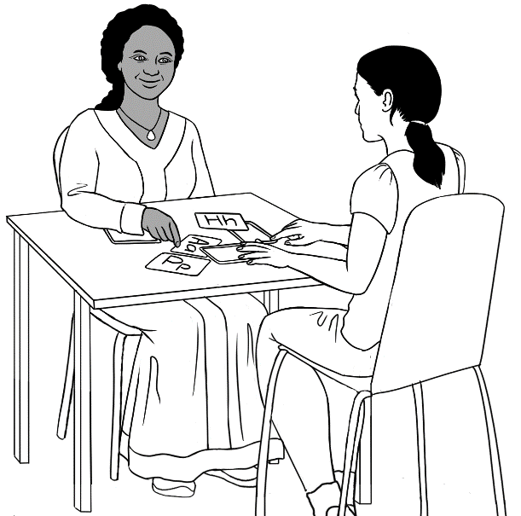

apple a

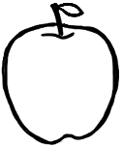

**Name** _____________________________________________

**Teacher** _________________________________________   
**Class** ______________________________________________

**Date**________________________________________________

**Design team:** Vicki Hambling, Sue Paull, Frida Dean, Glenise Kleehammer and Mary Wallace

This book is supported by additional work on sounds

in the **Letter Sounds** book.

*This workbook is designed to be used with the support of a teacher.*

**Illustrations:** Madelena Scott  
 **Acknowledgements:** The design team would like to thank the AMEP service providers and practitioners who participated in the trial and gave valuable feedback. The team would also like to acknowledge the use of the EAL Framework which underpins the design of this book.

Copyright of the EAL Framework is reserved to the Crown in the right of the State of Victoria. © State of Victoria (Department of Education and Training) 2023.  
__________________________________________________________________________________

This English Ready Resource is licensed under a Creative Commons Attribution-NoDerivs 3.0 Australia licence (More information is available [here](http://creativecommons.org/licenses/by-nd/3.0/au/)). You are free to use, copy and distribute to anyone in its original form as long as you attribute Department of Home Affairs as the author and you license any derivative work you make available under the same licence.

© Commonwealth of Australia 2023



With the exception of the Commonwealth Coat of Arms, the department’s logo, any material protected by a trade mark and where otherwise noted all material presented in this document is provided under a Creative Commons Attribution 4.0 International (<https://creativecommons.org/licenses/by/4.0/>) licence.

The details of the relevant licence conditions are available on the Creative Commons website (accessible using the links provided) as is the full legal code for the CC BY 4.0 licence. (<https://creativecommons.org/licenses/by/4.0/legalcode>).

Use of all or part of this document must include the following attribution:   
© Commonwealth of Australia 2023

As far as practicable, material for which the copyright is owned by a third party will be clearly labelled. The department has made all reasonable efforts to ensure that this material has been reproduced in this document with the full consent of the copyright owners.

Copyright requests and enquiries concerning usage not addressed by the CC BY 4.0 licence should be addressed to: [*comms@homeaffairs.gov.au*](mailto:comms@homeaffairs.gov.au) *at the Department of Home Affairs.*

The terms of use for the Commonwealth Coat of Arms are available from the [It's an Honour](http://www.itsanhonour.gov.au/) website.

Where a copyright owner, other than the Commonwealth, is identified with respect to this material, please contact that third party copyright owner directly to seek permission.



**Table of contents**

1 Instructions 1

2 The first sounds 2

3 Practise the first sounds. 8

4 Consonant sounds 21

5 Vowel sounds 35

6 Listen to the sounds. 45

7 Consonant blends 47

8 Two consonants make one sound. 56

# Instructions

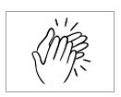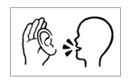

The arrow is a reminder to read from left to right.

|  |  |
| --- | --- |
| 1.  listen | 2.  say |
| 3.  copy | 4.  match |
| 5.  colour | 6.  circle |
| 7.  trace | 8.  tick  🗸 |
| 9.  point | 10.  clap |

# The first sounds

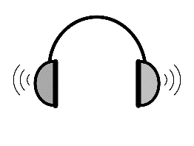

**Audio** – A female voice and then a male voice reads the sounds of all the letters in the pattern below. A time gap after each sound allows time for students to repeat. Encourage students to record the sounds on their phones.

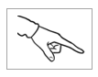

The vowels are gold, consonants blue.

|  |  |  |
| --- | --- | --- |
| a | **a**pple | a |
| b | **b**ag | b |
| c | **c**up | c |
| d | **d**oor | d |

Introduce the sounds gradually and contextualise them as much as possible.



|  |  |  |
| --- | --- | --- |
| e | **e**gg | e |
| f | **f**amily | f |
| g | **g**lasses | g |
| h | **h**ome | h |

|  |  |  |
| --- | --- | --- |
| i | **i**nk | i |
| j | **j**acket | j |
| k | **k**ids | k |
| l | **l**emon | l |
| m | **m**an | m |



|  |  |  |
| --- | --- | --- |
| n | **n**o | n |
| o | **o**range | o |
| p | **p**encil | p |
| q | **q**ueen | q |

|  |  |  |
| --- | --- | --- |
| r | **r**ubber | r |
| s | **s**tudent | s |
| t | **t**eacher | t |
| u | **u**mbrella | u |
| v | **v**an | v |



|  |  |  |
| --- | --- | --- |
| w | **w**oman | w |
| x | bo**x** | x |
| y | **y**es  **0** | y |
| z | **z**ero | z |

# Practise the first sounds.

`

Pages 9 – 19  
Say and repeat each sound, word and sound 3 times.  
In the box, copy the first sound.



|  |  |  |  |
| --- | --- | --- | --- |
| a |  | apple | a |
| b |  | bag | b |
| c |  | cup | c |

Pages 9 – 19  
Say a sound and then the word.   
Students circle the sound.

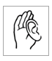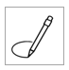

|  |  |  |
| --- | --- | --- |
| a | b | c |



|  |  |  |  |
| --- | --- | --- | --- |
| d |  | door | d |
| e |  | egg | e |
| f |  | family | f |
| g |  | glasses | g |



|  |  |  |  |
| --- | --- | --- | --- |
| d | e | f | g |

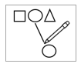

|  |
| --- |
| cup |
| door |
| apple |
| bag |
| family |
| glasses |
| egg |



|  |  |  |  |
| --- | --- | --- | --- |
| h |  | home | h |
| i |  | ink | i |
| j |  | jacket | j |
| k |  | kids | k |



|  |  |  |  |
| --- | --- | --- | --- |
| h | i | j | k |



|  |  |  |  |
| --- | --- | --- | --- |
| l |  | lemon | l |
| m |  | man | m |
| n |  | no | n |



|  |  |  |
| --- | --- | --- |
| l | m | n |



|  |
| --- |
| jacket |
| lemon |
| home |
| man |
| ink |
| no |
| kids |



|  |  |  |  |
| --- | --- | --- | --- |
| o |  | orange | o |
| p |  | pencil | p |
| q |  | queen | q |



|  |  |  |
| --- | --- | --- |
| o | p | q |



|  |  |  |  |
| --- | --- | --- | --- |
| r |  | rubber | r |
| s |  | student | s |
| t |  | teacher | t |



|  |  |  |
| --- | --- | --- |
| r | s | t |



|  |
| --- |
| pencil |
| rubber |
| teacher |
| orange |
| queen |
| student |



|  |  |  |  |
| --- | --- | --- | --- |
| u |  | umbrella | u |
| v |  | van | v |
| w |  | woman | w |



|  |  |  |
| --- | --- | --- |
| u | v | w |



|  |  |  |  |
| --- | --- | --- | --- |
| x |  | box | x |
| y |  | yes | y |
| z | **0** | zero | z |



|  |  |  |
| --- | --- | --- |
| x | y | z |



|  |
| --- |
| woman |
| umbrella |
| box  **0** |
| zero |
| van |
| yes |

|  |  |  |  |  |  |  |
| --- | --- | --- | --- | --- | --- | --- |
| a |  | m | n | o |  | Finish |
| b |  | l |  | p |  | z |
| c |  | k |  | q |  | y |
| d |  | j |  | r |  | x |
| e |  | i |  | s |  | w |
| f | g | h |  | t | u | v |

A game for 2 - 4 students, counters and dice for each group. Students take turns to throw the dice and say the word and the sound where they land.

Start

# Consonant sounds

Pages 22, 24, 26, 28, 30, 32 & 34: Say the sound, each word and the sound again. Students repeat. On the board, compile a list of words students already know that begin with the same consonant sound. Copy the sound in the box.   
Vowels are introduced in the next section.



|  |  |  |
| --- | --- | --- |
| b | bag | bed |
|  |  |  |
| c | cup | cat |
|  |  |  |
| d | door | dog |

|  |  |  |
| --- | --- | --- |
|  |  |  |
| bed | cat | dog |
| ___ ed | ___ at | ___ og |
| ___ ed | ___ at | ___ og |
| ___ ed | ___ at | ___ og |

4.



Pages 23, 25, 27, 29, 31, 33 & 35:

Students listen, repeat and copy the initial sound  
in the boxes, saying the sound and word as they copy.



5.

Say a word and the sound; students repeat, and point to the picture and sound.   
Then match pictures and sounds.

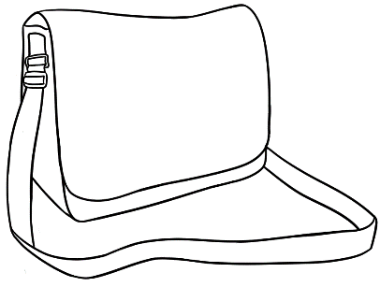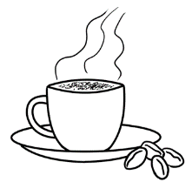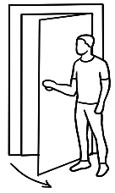

b

c

d

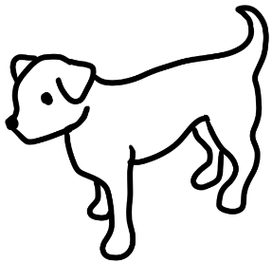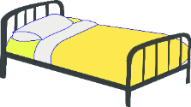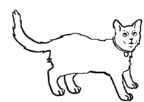

|  |  |  |
| --- | --- | --- |
|  | family | fan |
|  |  |  |
| g | glasses  f | gate |
|  |  |  |
| h | home | Shape  Description automatically generated with low confidencehat |
|  |  |  |



4.



|  |  |  |
| --- | --- | --- |
|  |  |  |
| fan | gate | Shape  Description automatically generated with low confidencehat |
| ___ an | ___ ate | ___ at |
| ___ an | ___ ate | ___ at |
| ___ an | ___ ate | ___ at |

5.

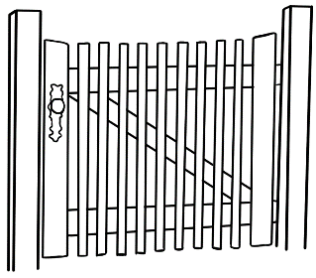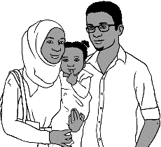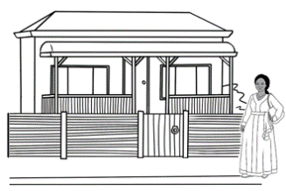

f

g

h

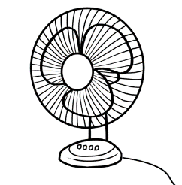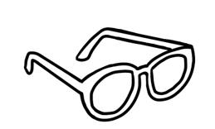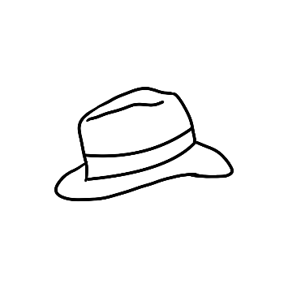

|  |  |  |  |
| --- | --- | --- | --- |
| j | jacket | jug | |
|  |  |  | |
| k | kids | key | |
|  |  |  | |
| l | lemon | | lips | |
|  |  | |  |

4.



|  |  |  |
| --- | --- | --- |
|  |  |  |
| jug | key | lips |
| ___ ug | ___ ey | ___ ips |
| ___ ug | ___ ey | ___ ips |
| ___ ug | ___ ey | ___ ips |

5.

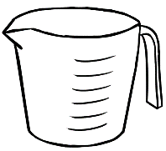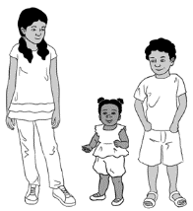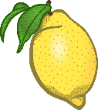

j

k

l

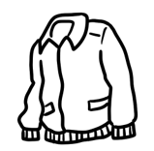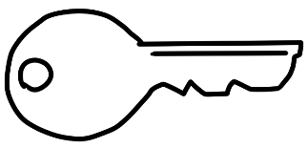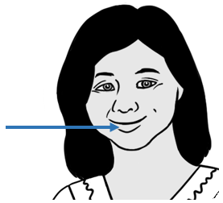

|  |  |  |  |
| --- | --- | --- | --- |
| m | man | mop | |
|  |  |  | |
| n | no | net | |
|  |  |  | |
| p | pencil | | pizza | |
|  |  | |  |

|  |  |  |
| --- | --- | --- |
|  |  |  |
| mop | net | pizza |
| ___ op | ___ et | ___ izza |
| ___ op | ___ et | ___ izza |
| ___ op | ___ et | ___ izza |

4.



5.



m

n

p

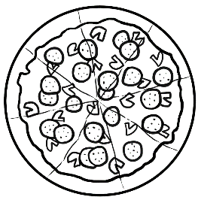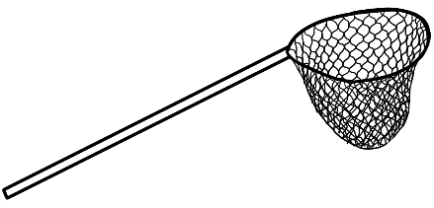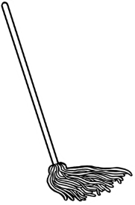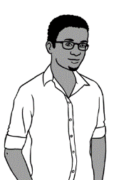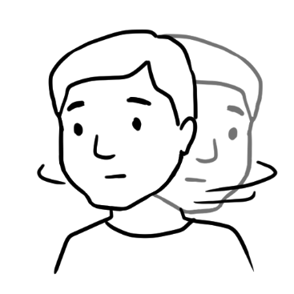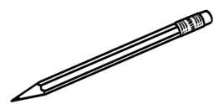

|  |  |  |  |
| --- | --- | --- | --- |
| q | queen | question | |
|  |  |  | |
| r | rubber | run | |
|  |  |  | |
| s | student | | sun | |
|  |  | |  |



4.



|  |  |  |
| --- | --- | --- |
|  |  |  |
| question | run | sun |
| ___ uestion | ___ un | ___ un |
| ___ uestion | ___ un | ___ un |
| ___ uestion | ___ un | ___ un |

5.



q

r

s

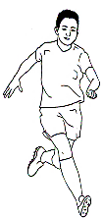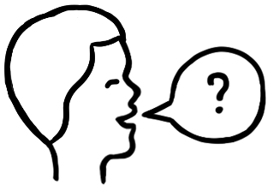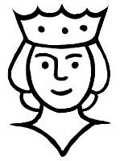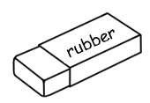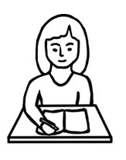

|  |  |  |  |
| --- | --- | --- | --- |
| t | teacher | time | |
|  |  |  | |
| v | van | |  |  |  |  |  | | --- | --- | --- | --- | --- | | a | e | i | o | u |   vowels | |
|  |  |  | |
| w | woman | | window |
|  |  | |  |

4.



|  |  |  |
| --- | --- | --- |
|  |  |  |
| time | van | window |
| ___ ime | ___ an | ___ indow |
| ___ ime | ___ an | ___ indow |
| ___ ime | ___ an | ___ indow |

5.



t

v

w

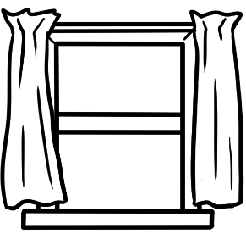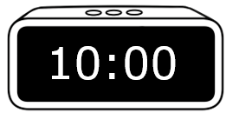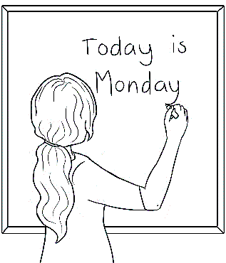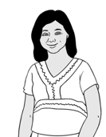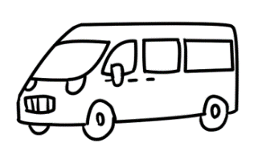

|  |  |  |  |  |
| --- | --- | --- | --- | --- |
| a | e | i | o | u |



|  |  |  |  |
| --- | --- | --- | --- |
| x | box | fox | |
|  |  |  | |
| y | yes | yam | |
|  | **0** |  | |
| z | zero | | zip |
|  |  | |  |

|  |  |  |
| --- | --- | --- |
|  |  |  |
| fox | yam | zip |
| fo ___ | ___ am | ___ ip |
| fo ___ | ___ am | ___ ip |
| fo ___ | ___ am | ___ ip |

4.



5.



x

y

z

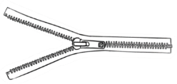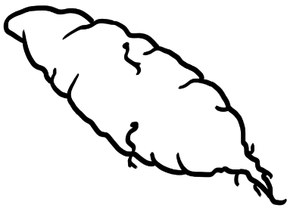

**0**

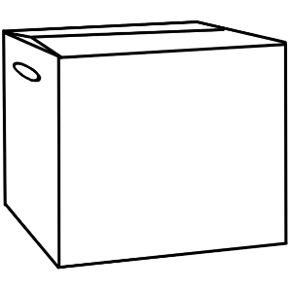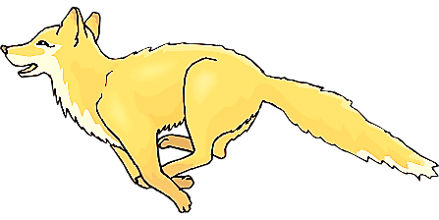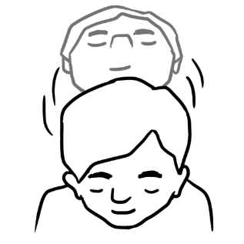

# Vowel sounds

1. 

Pages 36, 38, 40, 42 & 44:  
Say the word, sound the letters, say the word.

**a**pple **a**

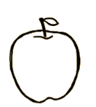

|  |  |  |  |  |  |  |  |  |  |
| --- | --- | --- | --- | --- | --- | --- | --- | --- | --- |
|  | hat | h | | a | | t | | hat | |
|  |  |  |  | |  | |  | |
|  | cat | c | | a | | t | | cat | |
|  |  |  |  | |  | |  | |
|  | fan | f | | a | | n | | fan | |
|  |  |  |  | |  | |  | |
|  | man | m | | a | | n | | man | |



hat cat  
 h __ t c__ t

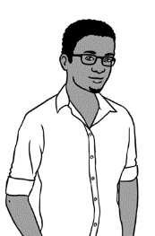

 fan man  
 f__ n m__ n





hat cat

________ ________



fan man

________ _ _________



|  |  |  |  |  |  |
| --- | --- | --- | --- | --- | --- |
| hat | h | u | a | p | t |
| cat | e | c | a | d | t |
| fan | l | r | f | a | n |
| man | m | a | w | o | n |



**e**gg **e**

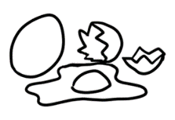

Colour the shapes red.

|  |  |  |  |  |  |  |  |  |  |
| --- | --- | --- | --- | --- | --- | --- | --- | --- | --- |
|  | bed | b | | e | | d | | bed | |
|  |  |  |  | |  | |  | |
|  | red | r | | e | | d | | red | |
|  |  |  |  | |  | |  | |
|  | pen | p | | e | | n | | pen | |
|  | **10** |  |  | |  | |  | |
|  | ten | t | | e | | n | | ten | |



2.



bed red  
 b__ d r__ d

**10**

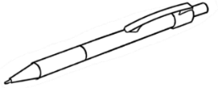 pen ten  
 p__ n t__ n





bed red

________ ________

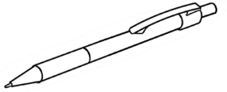pen ten

_________ ________



|  |  |  |  |  |  |
| --- | --- | --- | --- | --- | --- |
| bed | l | b | e | r | d |
| red | r | e | a | d | b |
| pen | l | p | o | e | n |
| ten  **10** | m | t | e | a | n |

1. 

**i**nk **i**



|  |  |  |  |  |  |  |  |  |
| --- | --- | --- | --- | --- | --- | --- | --- | --- |
|  | in |  | i | | n | | in | |
|  |  |  |  |  | |  | |
|  | bin | b | i | | n | | bin | |
|  |  |  |  |  | |  | |
|  | lip | l | i | | p | | lip | |
|  |  |  |  |  | |  | |
|  | zip | z | i | | p | | zip | |



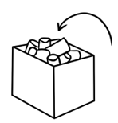

in bin  
__ n b__ n



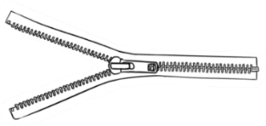lip zip

l__ p z__ p





inbin

_________ _________

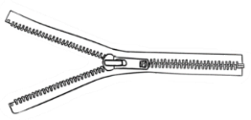lip zip

_________ __________

|  |  |  |  |  |  |
| --- | --- | --- | --- | --- | --- |
| in | l | i | a | k | n |
| bin | b | c | i | n | d |
| lip | p | f | l | i | p |
| zip | z | i | w | p | n |



.



**o**range **o**

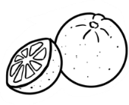

Colour all stop   
signs red.

|  |  |  |  |  |  |  |  |  |  |  |  |  |  |
| --- | --- | --- | --- | --- | --- | --- | --- | --- | --- | --- | --- | --- | --- |
|  | old |  | | o | | l | | d | | old | | | |
|  |  |  |  | |  | |  | |  | | |
|  | cold | c | | o | | l | | d | | | cold | | | |
|  |  |  |  | |  | |  | |  | | |
|  | mop |  | | m | | o | | p | | mop | | |
|  |  |  |  | |  | |  | |  | | |
|  | stop | s | | t | | o | | p | | stop | | | |



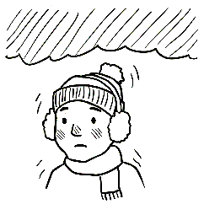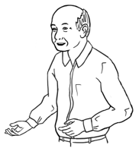old cold

__ld c__ ld

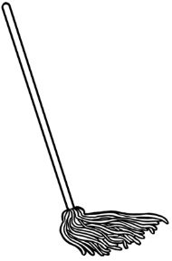

mop stop

m__ p st__ p





old cold

___________ ___________

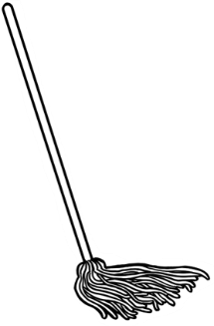

mop stop

___________ _____________



|  |  |  |  |  |  |
| --- | --- | --- | --- | --- | --- |
| old | a | o | l | p | d |
| cold | c | m | o | l | d |
| mop | l | m | o | a | p |
| Shape, rectangle  Description automatically generatedstop | s | t | w | o | p |

**u**mbrella **u**



1. 

|  |  |  |  |  |  |  |  |  |
| --- | --- | --- | --- | --- | --- | --- | --- | --- |
|  | up |  | u | | p | | up | |
|  |  |  |  |  | |  | |
|  | cup | c | u | | p | | cup | |
|  |  |  |  |  | |  | |
|  | run | r | u | | n | | run | |
|  |  |  |  |  | |  | |
|  | sun | s | u | | n | | sun | |



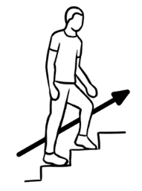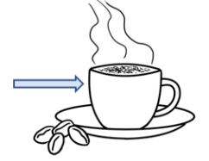up cup

__ p c__ p

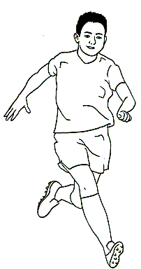run sun

r__ n s__ n



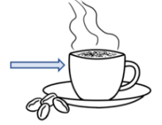

 up cup

__________ __________



run sun

___________ __________



|  |  |  |  |  |  |
| --- | --- | --- | --- | --- | --- |
| up | a | u | v | p | c |
| cup | c | i | u | d | p |
| run | s | r | b | u | n |
| sun | s | u | m | o | n |

# Listen to the sounds.



1. Listen, point to and repeat every word and   
   sound about 3 times.   
   e.g. #1 bag b, bag b, bag b / cup c, cup c, cup c
2. Students listen and circle the sound you read.

|  |  |  |
| --- | --- | --- |
|  | **b**ag  **b** | **c**up  **c** |
|  | **d**og  **d** | **f**amily  **f** |
|  | **g**ate  **g** | **l**emon  **l** |
|  | **m**op  **m** | **d**oor  **d** |
|  | **b**in  **b** | **r**ubber  **r** |
|  | **v**an  **v** | **c**old  **c** |



|  |  |  |
| --- | --- | --- |
|  | **b**ed  **b** | **Shape  Description automatically generated with low confidence h**at  **h** |
|  | **c**at  **c** | **r**ed  **r** |
|  | **r**un  **r** | **f**an  **f** |
|  | **n**o  **n** | **s**un  **s** |
|  | **y**am  **y** | **w**indow  **w** |
|  | **z**ip  **z** | **m**an  **m** |

# Consonant blends



Sound the consonants separately, then together. Finally say the word. Pages 48, 49, 51, 52, 53 - Fill in the initial consonants with colour to aid memory. Copy the consonants.

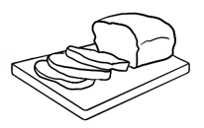

**b r**

**br**

|  |  |  |
| --- | --- | --- |
|  |  |  |
| bread | brush | broom |
| __ __ ead | __ __ ush | __ __ oom |
| __ __ ead | __ __ ush | __ __ oom |
| __ __ ead | __ __ ush | __ __ oom |

|  |  |  |  |  |
| --- | --- | --- | --- | --- |
| br | br | br | br | br |
| br |  |  |  |  |



Listen and repeat the words.   
Say the sounds while copying.



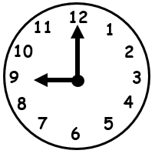

**c l**

**cl**

|  |  |  |  |  |
| --- | --- | --- | --- | --- |
| cl | cl | cl | cl | cl |
| cl |  |  |  |  |



|  |  |  |
| --- | --- | --- |
|  |  |  |
| clock | clap | close |
| __ __ ock | __ __ ap | __ __ ose |
| __ __ ock | __ __ ap | __ __ ose |
| __ __ ock | __ __ ap | __ __ ose |

The teacher says one word on each line. e.g. clock   
The students circle the word.



|  |  |
| --- | --- |
| 1. A picture containing text, appliance     Description automatically generatedbrush | clock |
| 1. broom | clap |
| 1. bread | close |
| 1. broom | clock |
| 1. bread | clap |



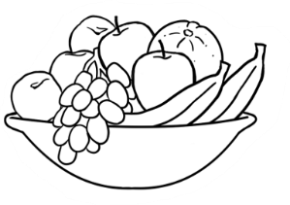

**f r**

**fr**

|  |  |  |  |  |
| --- | --- | --- | --- | --- |
| fr | fr | fr | fr | fr |
| fr |  |  |  |  |



|  |  |  |
| --- | --- | --- |
|  |  |  |
| fruit | friend | Friday |
| __ __ uit | __ __ iend | __ __ iday |
| __ __ uit | __ __ iend | __ __ iday |
| __ __ uit | __ __ iend | __ __ iday |



Colour the stop signs red.

**s t**

**st**

|  |  |  |  |  |
| --- | --- | --- | --- | --- |
| st | st | st | st | st |
| st |  |  |  |  |

|  |  |  |
| --- | --- | --- |
|  |  |  |
| stop | stand | study |
| __ __ op | __ __ and | __ __ udy |
| __ __ op | __ __ and | __ __ udy |
| __ __ op | __ __ and | __ __ udy |



1. 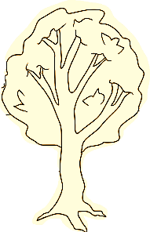



**t r**

**tr**

|  |  |  |  |  |
| --- | --- | --- | --- | --- |
| tr | tr | tr | tr | tr |
| tr |  |  |  |  |



|  |  |  |
| --- | --- | --- |
|  |  |  |
| tree | train | truck |
| __ __ ee | __ __ ain | __ __ uck |
| __ __ ee | __ __ ain | __ __ uck |
| __ __ ee | __ __ ain | __ __ uck |

****The teacher says one word on each line. e.g. friend   
The students circle the word.

|  |  |
| --- | --- |
| 1. friend | stand |
| 1. train | fruit |
| 1. Shape, rectangle     Description automatically generatedstop | truck |
| 1. friend | study |
| 1. tree | Friday |



|  |  |
| --- | --- |
| clock  __ock |  |
| tree  __ee |  |
| bread  __ead |  |
| fruit  __uit |  |
| stand  __and |  |

br

cl

st

tr

fr



|  |  |
| --- | --- |
| stop  __op |  |
| brush  __ush |  |
| train  __ain |  |
| friend  __iend |  |
| clap  __ap |  |

br

cl

st

tr

fr

# Two consonants make one sound.

Pages 57, 58, 59, 61 & 62:   
Make the double consonant sound three times. Finally say the word. Fill in the two consonants with colour to aid memory. Copy the consonants.



1. A picture containing clipart

   Description automatically generated

**ch**

**ch**

**ch**

|  |  |  |  |  |
| --- | --- | --- | --- | --- |
| ch | ch | ch | ch | ch |
| ch |  |  |  |  |

Listen and repeat the words.   
Say the sounds while copying.



|  |  |  |
| --- | --- | --- |
|  |  |  |
| chips | chicken | chair |
| __ __ ips | __ __ icken | __ __ air |
| __ __ ips | __ __ icken | __ __ air |
| __ __ ips | __ __ icken | __ __ air |



1. 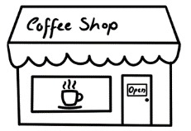

**sh**

**sh**

**sh**

|  |  |  |  |  |
| --- | --- | --- | --- | --- |
| sh | sh | sh | sh | sh |
| sh |  |  |  |  |



|  |  |  |
| --- | --- | --- |
|  |  |  |
| shop | shoe | fish |
| __ __ op | __ __ oe | fi __ __ |
| __ __ op | __ __ oe | fi __ __ |
| __ __ op | __ __ oe | fi __ __ |



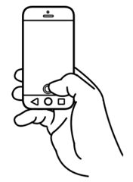

**ph**

**ph**

**ph**

|  |  |  |  |  |
| --- | --- | --- | --- | --- |
| ph | ph | ph | ph | ph |
| ph |  |  |  |  |



|  |  |
| --- | --- |
|  |  |
| phone | photo |
| __ __ one | __ __ oto |
| __ __ one | __ __ oto |
| __ __ one | __ __ oto |

****The teacher says one word on each line. e.g. chicken   
The students circle the initial consonants in that word.

|  |  |
| --- | --- |
| 1. shop | chicken |
| 1. chips | phone |
| 1. fish | chair |
| 1. shoe | chicken |
| 1. photo | shop |



See the Teacher Resources for notes about   
the pronunciation of the voiced and unvoiced *th*.   
The *th* in *thirty* and *Thursday* is unvoiced*.* Additional words are *thirteen*, *thirty* and *thanks*.

3

**th**

**th**

**th**

|  |  |  |  |  |
| --- | --- | --- | --- | --- |
| th | th | th | th | th |
| th |  |  |  |  |



|  |  |  |
| --- | --- | --- |
| th | 3 |  |
| three  __ __ ree  __ __ ree  __ __ ree | Thursday  __ __ ursday __ __ ursday __ __ ursday |



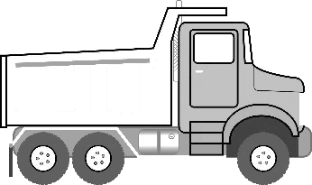

**ck**

**ck**

**ck**

|  |  |  |  |  |
| --- | --- | --- | --- | --- |
| ck | ck | ck | ck | ck |
| ck |  |  |  |  |



|  |  |  |
| --- | --- | --- |
|  |  |  |
| truck | clock | bucket |
| tru __ __ | clo __ __ | bu__ __et |
| tru __ __ | clo __ __ | bu__ __et |
| tru __ __ | clo __ __ | bu__ __et |



|  |  |
| --- | --- |
| chips  __ips |  |
| phone  __one |  |
| shop  __op |  |
| clock  clo__ |  |
| three  __ree | 3 |

sh

ch

th

ck

ph



|  |  |
| --- | --- |
| photo  __oto |  |
| bucket  bu__et |  |
| Thursday  __ursday |  |
| shoe  __oe |  |
| chair  __air |  |

sh

ch

th

ck

ph