

Student book with teacher notes

|  |
| --- |
| **English Ready**  **22637VIC Course in EAL  VU23494 Use strategies to develop language learning with support** |

**Learning Steps**

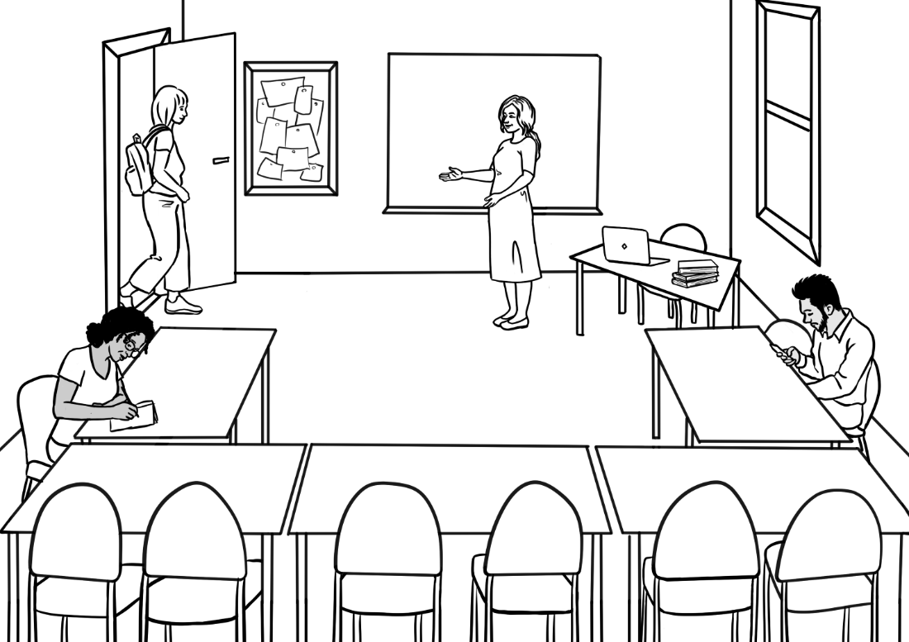

**Student ___________________________________________________**

**Teacher ___________________________________________________**

**Class ______________________________________________________**

**Date ______________________________________________________**

This workbook is designed to be used with the support of a teacher.

**Design team:** Vicki Hambling, Sue Paull, Frida Dean, Janice Langley, Glenise Kleehammer and Mary Wallace

**Illustrations:** Madelena Scott

**Acknowledgements:** The design team would like to thank the AMEP service providers and practitioners who participated in the trial and gave valuable feedback. The team would also like to acknowledge the use of the EAL Framework which underpins the design of this book.

Copyright of the EAL Framework is reserved to the Crown in the right of the State of Victoria. © State of Victoria (Department of Education and Training) 2023.  
_________________________________________________________________________________________

This English Ready Resource is licensed under a Creative Commons Attribution-NoDerivs 3.0 Australia licence (More information is available [here](http://creativecommons.org/licenses/by-nd/3.0/au/)). You are free to use, copy and distribute to anyone in its original form as long as you attribute Department of Home Affairs as the author and you license any derivative work you make available under the same licence.  
  
© Commonwealth of Australia 2023

With the exception of the Commonwealth Coat of Arms, the department’s logo, any material protected by a trade mark and where otherwise noted all material presented in this document is provided under a Creative Commons Attribution 4.0 International (<https://creativecommons.org/licenses/by/4.0/>) licence.

The details of the relevant licence conditions are available on the Creative Commons website (accessible using the links provided) as is the full legal code for the CC BY 4.0 licence (<https://creativecommons.org/licenses/by/4.0/legalcode>).

Use of all or part of this document must include the following attribution:   
© Commonwealth of Australia 2023

As far as practicable, material for which the copyright is owned by a third party will be clearly labelled.  The department has made all reasonable efforts to ensure that this material has been reproduced in this document with the full consent of the copyright owners.

Copyright requests and enquiries concerning usage not addressed by the CC BY 4.0 licence should be addressed to:

[*comms@homeaffairs.gov.au*](mailto:comms@homeaffairs.gov.au) *at the Department of Home Affairs.*

The terms of use for the Commonwealth Coat of Arms are available from the [It's an Honour](http://www.itsanhonour.gov.au/) website.

Where a copyright owner, other than the Commonwealth, is identified with respect to this material, please contact that third party copyright owner directly to seek permission.

**Table of Contents**

1. Instructions 1

2. Meet the people 2

3. English class 4

4. Sahra can’t come to class today. 7

5. What do you need in class? 8

6. Can you ask for help? 9

7. Writing basics 10

8. School 12

9. What can you do? 14

10. What do you want to learn? 16

11. Who can help you learn? 18

12. Where can you learn? 20

13. What helps you learn? 21

14. Learning steps 23

15. At the end of the term. 25

# Instructions

|  |
| --- |
|  |

Project and mime each instruction.

|  |  |  |  |  |  |  |
| --- | --- | --- | --- | --- | --- | --- |
|  |  | listen |  | |  | say |
|  |  | copy |  | |  | match |
|  |  | read |  | |  | circle |
|  |  | ask |  | |  | tick |
|  |  | spell |  | |  | record |
|  |  | work with a partner |  |  | | write |

# Meet the people

|  |
| --- |
|  |

Project the page. Students point to the students and teacher. Name the characters. Create sentences.   
e.g. *Ming is a student.*

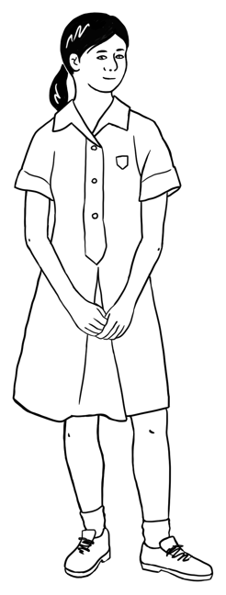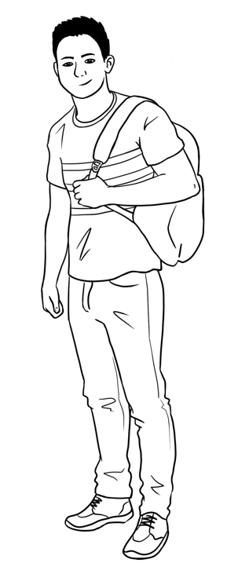

This is **Ming**.This is **Lan**.This is **Mai**.This is **Bao**.

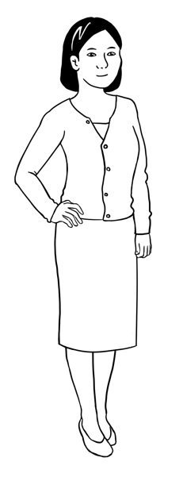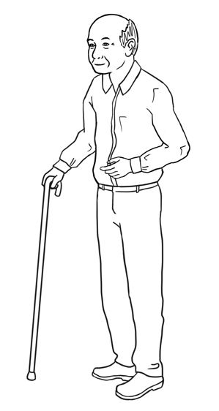

**Ming’s family**

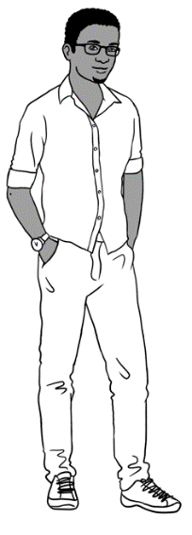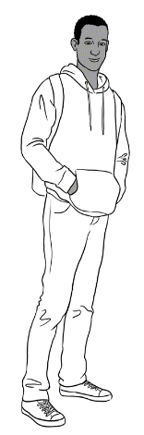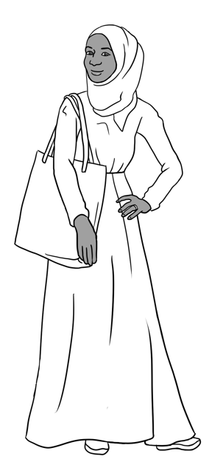

**Sahra’s family**

This is **Sahra**.

This is **Hani**.

This is **Tahiil**.

This is **Abdi**.

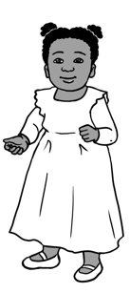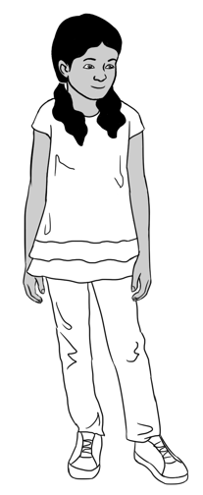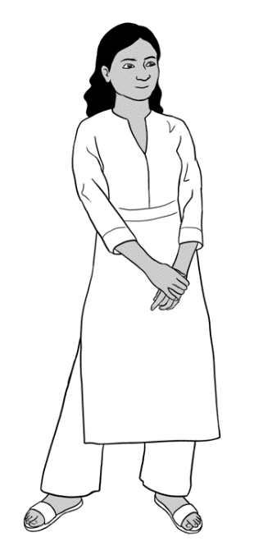

**Nisha’s family**

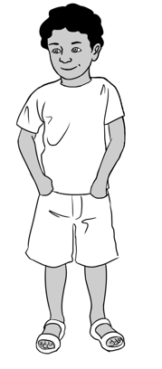

This is **Nisha.** This is **Pari.** This is **Dev**.

**Anika**

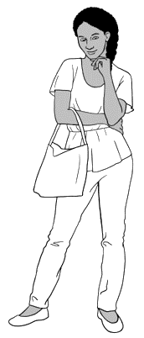

This is **Anika**.

**Jenny is a teacher.**

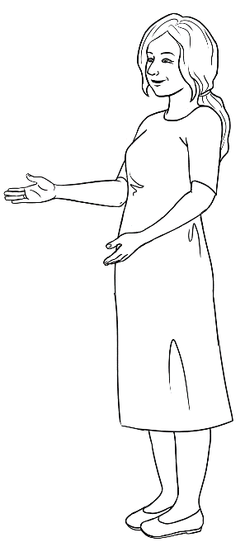

This is **Jenny**.

**Carim’s family**

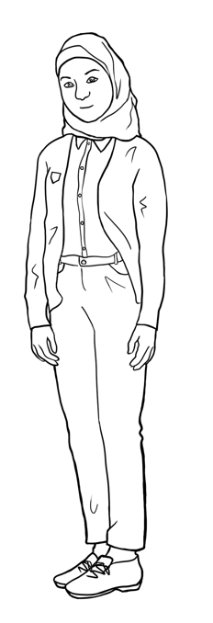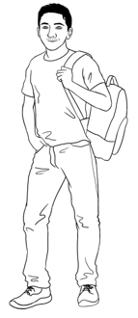

This is **Carim**. This is **Fatima**.

# English class

Show students how to use their phones to record the teacher’s voice. Ask the students to record as you say the name of the days. Ask students to copy the days in the space provided and mention that days of the week start with capital letter. Encourage students to listen to their recording at home.

Ask students to open their timetable and tick the days they go to class. Encourage students to compare their tables with their partners.

When do **you** go to class?

|  |  |  |
| --- | --- | --- |
| A black and white drawing of papers and a pencil  Description automatically generated  Copy the days. | | Monday  Monday |
| Tuesday  _______________ | Wednesday  ________________ | Thursday  ________________ |
| Friday  ________________ | Saturday  _________________ | Sunday  _________________ |

|  |  |  |
| --- | --- | --- |
| A black check mark on a white background  Description automatically generated  Tick the days. | | Monday |
| Tuesday | Wednesday | Thursday |
| Friday | Saturday | Sunday |

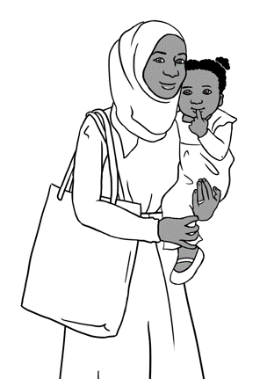

I go to class on **Monday** and **Tuesday**.

Hani goes to childcare.

Childcare is free.

Read the sentences above and ask students to repeat it. Encourage students to complete the sentence below.

Sahra goes to class on Monday and __________________.

Read the sentences and ask students to listen and repeat. Point to the day in bold.

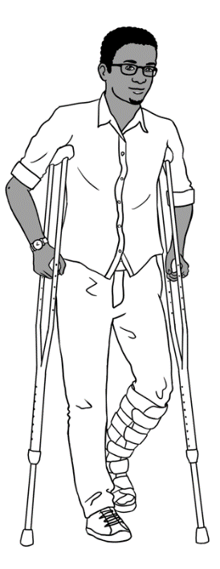

I have a broken foot.

I can’t go to my evening class.

I do Distance Learning on my laptop.

I have a volunteer tutor on **Thursday**.

Childcare is free.

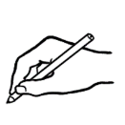

Ask students to write the day in the blank provided.

Tahiil has a volunteer tutor on_________________.

Read the sentences and ask students to listen and repeat. Point to the day in bold.

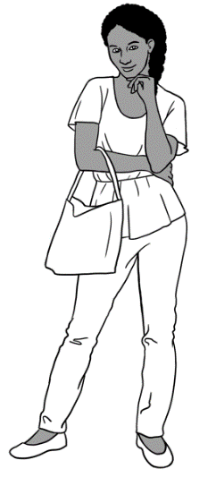

I want a job.

I want to learn quickly.

I go to school on **Monday**, **Tuesday**, **Wednesday** and **Thursday**.



Ask students to write the days in the blanks provided.

Anika goes to class on ___________________,

____________________, ____________________

and ___________________.



Encourage students to check their timetable. Ask students to complete the sentence about themselves.

I go to class on __________________________________________

___________________________________________________________.

Read the sentences below and point to the day and start and finish time. Ask students to read the sentences.

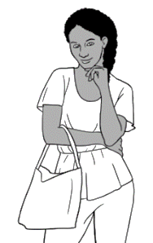

I go to class four days a week.

My class starts at 9:00 on Monday.

My class finishes at 2:30.

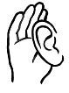

**This is your timetable.**

Encourage students to check their timetable. Ask students to tick the days, write the start, finish time and room number in the table below.

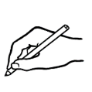

|  |  |  |  |  |  |
| --- | --- | --- | --- | --- | --- |
| **Day** | **Monday** | **Tuesday** | **Wednesday** | **Thursday** | **Friday** |
| **Start** |  |  |  |  |  |
| **Finish** |  |  |  |  |  |
| **Room** |  |  |  |  |  |

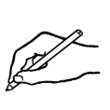

Discuss the start and end of term dates, public holidays and special days e.g. birthdays or a cultural celebration. Ask students to write the dates on the lines provided. Dates are explained in detail in book ‘VU23496-VU23498 Conversation, messages and forms’.

The last day of term is _____________________________________.

The public holidays are ___________________________________

__________________________________________________________.

The special days are ______________________________________.

Our excursion day is _______________________________________.

# A hand holding a hand up Description automatically generated with medium confidenceSahra can’t come to class today.

Project the page. Point to Sahra’s messages. Read the sentences and check understanding by asking follow-up questions e.g. Who is this message for?

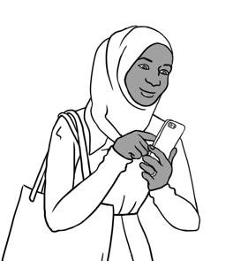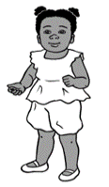

**Why can’t Sahra come to class?**

Hani is sick today.

Sahra sends a message   
to the childcare centre and her teacher.

Hi Nisha,

Hani is sick today.

Sahra Elmi

Hi Teacher,

I can’t come to class today.

Sahra Elmi

Ask students to write their own name and copy the message in the space provided.

________________________________________________________________________________________________________________________________________________________________________________________________________________________________________________________

Hi Teacher,

I can’t come to class today.

_____________

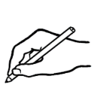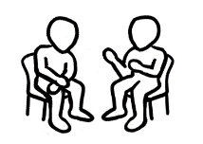

Encourage students to read the message with their partners.

Hi Nisha,

Hani is sick today.

Sahra Elmi

# What do you need in class?

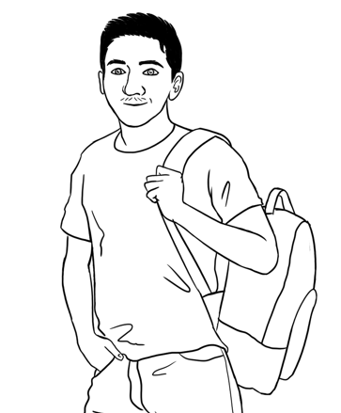

It’s Monday.

I’m ready for class.

I have 12 things in my backpack.

Point to the stationary items and say the words. Ask students to repeat them. The activities below reinforce the need to come prepared to class. Encourage students to tick what they have in their pencil case/ bags.

|  |  |  |  |
| --- | --- | --- | --- |
| a pencil  Rubber | a rubber | a sharpener | a pencil case |
| a highlighter | a pen | a workbook | a notebook |
| a ruler | a phone | glasses | water |

|  |
| --- |
|  |

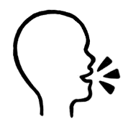

I have a pencil, a rubber,   
a pencil case, a workbook,   
a notebook and a phone.

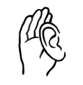

Encourage students to work with a partner and say what they have in their pencil case/ bags.

# Can you ask for help?

Project the page and explain how to ask for help politely by emphasising the use of ‘please’ in the sentences below. Students can then repeat the sentences after the teacher and practice saying them to their partner.

|  |
| --- |
|  |

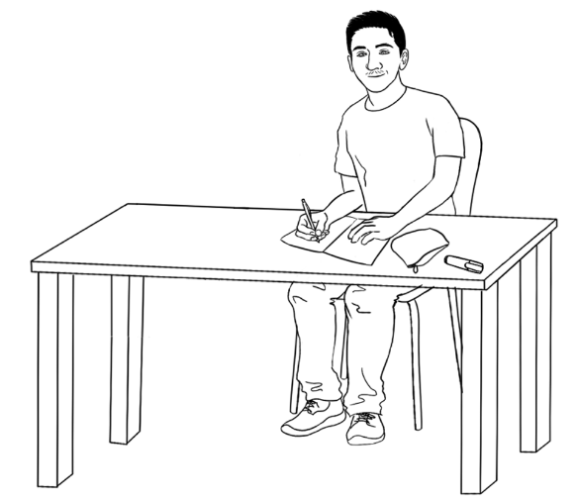

Can you say that **again** please?

Can you **check**   
my work please?

Can you help me **please**?

I don’t **understand**.

|  |  |
| --- | --- |
| **1** | I don’t understand . |
| **2** | Can you say that __________________please? |
| **3** | Can you help me ___________________? |
| **4** | Can you _________________my work please? |

Ask students to complete the sentences below.

Ask students to put the words in order and then write the sentences.

|  |  |  |  |  |  |  |  |  |  |  |  |  |
| --- | --- | --- | --- | --- | --- | --- | --- | --- | --- | --- | --- | --- |
| **1** | again | please? | | | say | | you | | | Can | | that |
| Can you say that again please? | | | | | | | | | | | | |
| **2** | please? | | help | | | me | | Can | | | you | |
|  | | | | | | | | | | | | |
| **3** | understand. | | | I | | | | | don’t | | | |
|  | | | | | | | | | | | | |
| **4** | check | Can | | | you | | please? | | | work | | my |
|  | | | | | | | | | | | | |
|  | | | | | | | | | | | | |

# Writing basics

Read the alphabet and ask students to repeat after you. Point to the vowels (A, E, I, O and U in bold). Point to capital and small letters. More activities on ‘The Alphabet’ can be found in Course in Initial Teacher resources units VU23489, VU23491 and VU23492.

|  |
| --- |
|  |

**Capital letters**

**A** B C D **E** F G H **I** J K

L M N **O** P Q R S T **U** V

W X Y Z

**Small letters**

**a** b c d **e** f g h **i** j k

l m n **o** p q r s t **u** v

w x y z

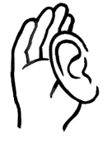

Read out selected capital letters randomly and ask students to circle them.

**A** B C D **E** F G H **I** J K

L M N **O** P Q R S T **U** V

W X Y Z

**

Read out selected small letters randomly and ask students to circle them.



**a** b c d **e** f g h **i** j k

l m n **o** p q r s t **u** v

w x y z

Ask students to write the first names of the students and the teachers in the class in alphabetical order.

|  |  |  |  |
| --- | --- | --- | --- |
| **A** |  | **B** |  |
| **C** |  | **D** |  |
| **E** |  | **F** |  |
| **G** |  | **H** |  |
| **I** |  | **J** |  |
| **K** |  | **L** |  |
| **M** |  | **N** |  |
| **O** |  | **P** |  |
| **Q** |  | **R** |  |
| **S** |  | **T** |  |
| **U** |  | **V** |  |
| **W** |  | **X** |  |
| **Y** |  | **Z** |  |

# School

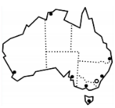

|  |
| --- |
|  |

Read the sentences below and point to the bolded words. Ask students to repeat the sentences.

|  |  |
| --- | --- |
| **Pari Dev** | Pari is 9 years old.  Dev is 7 years old.  They go to **primary school.** |
| **Mai Fatima** | Mai and Fatima are 15.  They go to **secondary school**. |
| **Bao Abdi** | Bao and Abdi are 19.  They go to **university**. |

Ask students to match the words with the pictures.

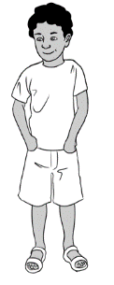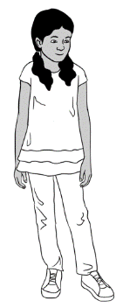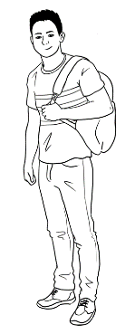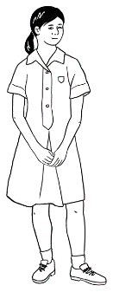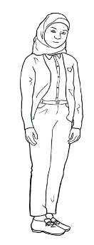

primary school

secondary school

university

Pari

Dev

Bao

Abdi

Fatima

Mai

**School in Australia**

Read the dialogue and ask students to practice with their partners. Encourage the students to answer the questions in the table below about themselves.

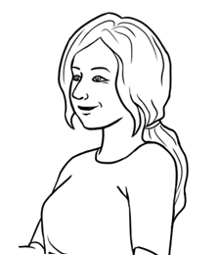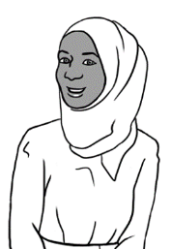

Did you go to school in your country Sahra?

Yes. I went to primary school.

Did you learn English?

No, I didn’t.

|  |  |  |
| --- | --- | --- |
| A black check mark on a white background  Description automatically generated  Read the questions and tick Yes or No. | **Yes** | **No** |
| 1. Did you go to **primary school**? |  |  |
| 1. Did you go to **secondary school**? |  |  |
| 1. Did you go to **university**? |  |  |
| 1. Did you learn **English**? |  |  |

**Did you go to school in your country**?

# What can you do?

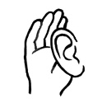

Read the following sentences, point to the pictures and ask students to repeat.

|  |
| --- |
|  |

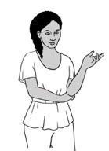

I can use

a computer.

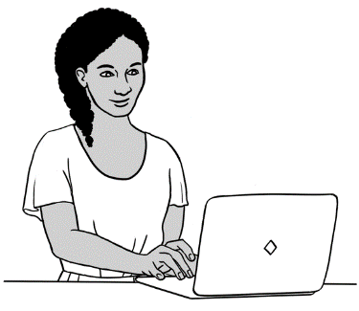

I can repair things.

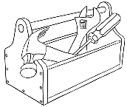

What can **you** do?

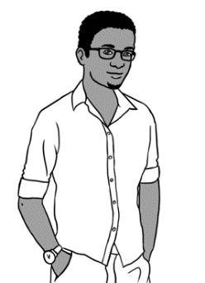



On pages 14 and 15 encourage students to tick what they can do.

|  |  |  |
| --- | --- | --- |
| **1**  I can drive a car. | **2**  I can cook. | **3**  I can use a computer. |
| **4**  I can garden. | **5**  I can swim. | **6**  I can repair things. |

|  |  |  |
| --- | --- | --- |
| **7**  Oromo  Somali  Arabic | **8** | **9** |
| I can sew. | I can speak other languages. | I can ride a bike. |
| **10** | **11** | **12** |
| I can play soccer. | I can play games. | I can play  an instrument. |

Ask students to complete the sentences about what they can do.

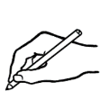

Give instructions to write what they can do.

1. I can ______________________________________________________.
2. ____________________________________________________________.
3. ____________________________________________________________.

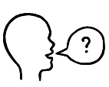

What can you do?

Encourage students to work with a partner and ask questions about what their partner can do.

My partner can ______________________________________________, ______________________________ and ___________________________

.

|  |
| --- |
|  |

# What do you want to learn?

The activities on pages 16 to 22 help learners understand different learning steps. The teachers can change these activities to suite their students.

Project the page and mime each activity. Read the sentences below and ask students ‘What do you want to learn?’

|  |  |  |  |  |
| --- | --- | --- | --- | --- |
| Hello.  Hi. | to listen |  | to speak clearly | |
|  | to read |  | to write | |
|  | to learn  new words |  | | to spell |
|  | to use  a computer |  | | to have conversations |

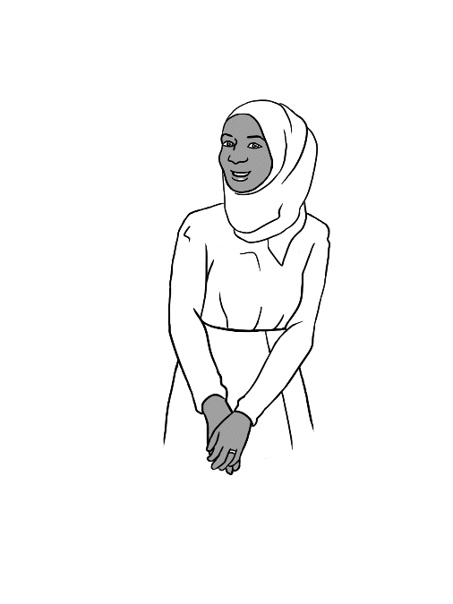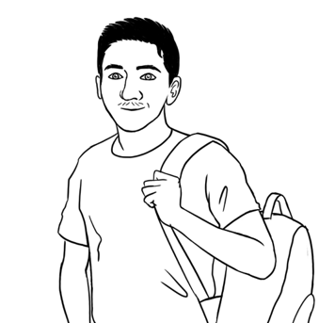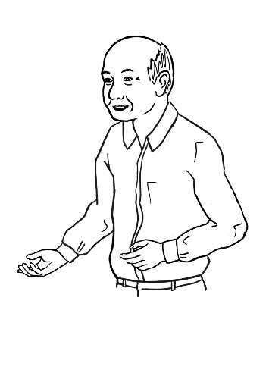

I want to have conversations in English.

I want to write in English.

I want to read books in English.

|  |
| --- |
|  |

Encourage students to read the sentences below and ask them to tick three things that they want to learn.

|  |  |  |
| --- | --- | --- |
|  | |  |
|  | I want to listen to English. |  |
|  | I want to speak English. |  |
|  | I want to read in English. |  |
|  | I want to write in English. |  |
|  | I want to learn new English words. |  |
|  | I want to spell English words. |  |
|  | I want to use a computer. |  |
|  | I want to have conversations. |  |

Encourage students to work with a partner and read three sentences about themselves.



# Who can help you learn?

Point to the picture, say the word and ask students to repeat. Read the sentences and ask students to repeat. Check understanding by asking question ‘Who can help you learn?’

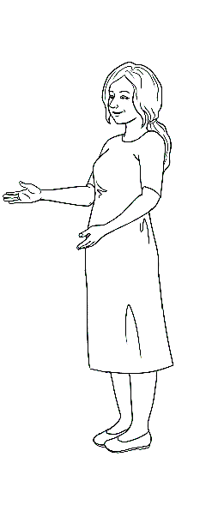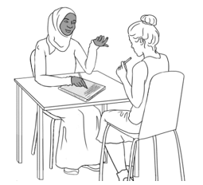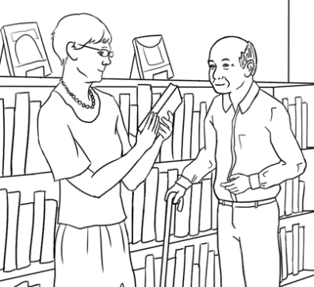

|  |  |  |  |
| --- | --- | --- | --- |
|  |  |  | |
| my teacher | my classmates | the librarian | |
|  |  |  | |
| my neighbour | my family | | my volunteer tutor |

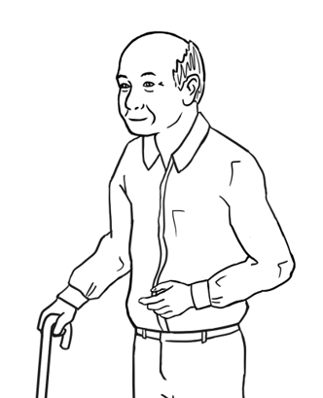

The librarian   
can help me learn.

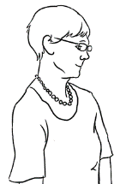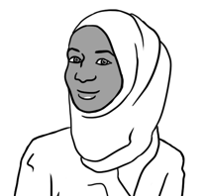

My friend Pam   
can help me learn.

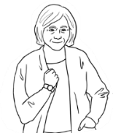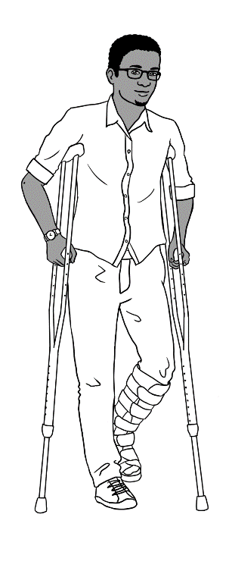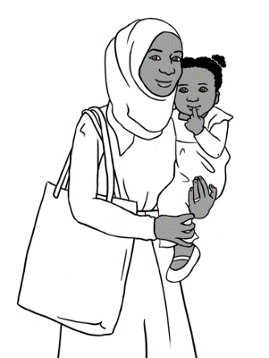

Who can help **me** learn?

Who can help **you** learn?

Who can help **me** learn?



Ask students to listen as you read and tick who can help ‘You’?

|  |  |  |  |
| --- | --- | --- | --- |
| **Who can help?** | **Sahra** | **Tahiil** | **You** |
| the teacher | **🗸** | **🗸** |  |
| a volunteer tutor |  | **🗸** |  |
| the librarian | **🗸** |  |  |
| family | **🗸** | **🗸** |  |
| a neighbour | **🗸** |  |  |



Who can help you learn?

Encourage students to work with a partner and ask the question.

|  |
| --- |
|  |

# A black check mark on a white background Description automatically generatedWhere can you learn?

Point to the pictures and read the sentences. Ask students to repeat and tick places where they can learn.

|  |  |
| --- | --- |
| **1** | **2** |
|  |  |
| I can learn in class. | I can learn in the library. |
| **3** | **4** |
|  |  |
| I can learn at home. | I can learn on the computer. |
| **5** | **6** |
|  |  |
| I can learn on my phone. | I can learn at work. |

Encourage students to work with a partner and ask the question.

Where can you learn?



# What helps you learn?



What helps you learn **in class**?

|  |
| --- |
|  |

Read the question and point to ‘in class’.

Point to the pictures and read the sentences. Ask students to repeat.

|  |  |  |
| --- | --- | --- |
| **1**  Listen. | **2** | **3** |
| I come to class  on time. | I bring my books  and pencil case. | I listen to  the teacher. |
| Today is Tuesday. |  |  |
| I copy from  the board. | I ask for help. | I copy new words. |
| What does this word mean?  I don’t understand. |  | 1. Square     Description automatically generated with medium confidence |
| I ask questions. | I work with my classmates. | I record my teacher. |

What helps you learn **after class**?



|  |
| --- |
|  |

Read the question and point to ‘after class’.

Point to the pictures and read the sentences. Ask students to repeat.

|  |  |  |
| --- | --- | --- |
| What’s  the time?  What’s  the time? |  |  |
| I work at home. | I read my workbooks. | I copy words. |
|  |  |  |
| I listen to the teacher  on my phone. | I listen and repeat. | I use AMEP online. |
|  |  |  |
| I talk to friends. | I read books. | I listen to the audio. |



What helps you learn?

Encourage students to work with a partner and ask the question.

# Learning steps

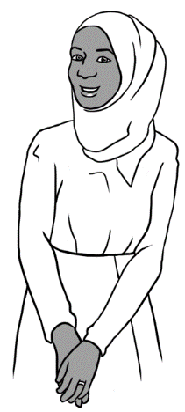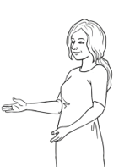

**How** can you learn?

I want to have conversations in English.

**What** do you want to learn Sahra?



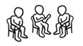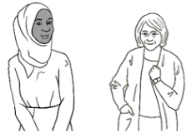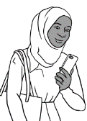

Ask students to listen as you read the dialogue between Sahra and her teacher and the sentences below.

|  |  |
| --- | --- |
| **1** | I talk to my teacher and my classmates. |
| **2** | I talk to my neighbour. |
| **3** | I record my teacher on my phone. |
| **4** | I listen and repeat at home. |

|  |
| --- |
| Can you say this please?  Can I record you on my phone please?  I live at Unit 6  50 Baker Road  Kellivale. |

Read the conversation below and explain that Sahra is asking politely to record her teacher’s voice. Ask students to practice saying the sentences in green bubbles. Point to the word ‘please’. Students can practice recording their teacher’s voice as the teacher reads the conversation below.

1. Sahra asks her teacher,
2. Sahra records her teacher.
3. She listens and repeats at home.

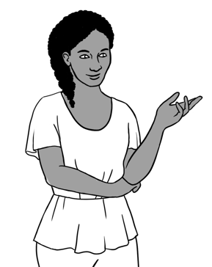

I want to learn new words.

**How** can you learn?

**What** do you want to learn Anika?



Ask students to listen as you read the conversation and the sentences 1 to 3. Point to ‘What’ and ‘How’.

|  |  |
| --- | --- |
| **1** | I copy words from the board  in my notebook. |
| **2** | I copy words from my workbook  again and again. |
| **3** | I write new words on my word list. |



Ask students to copy the words three times in the space provided.

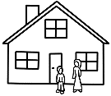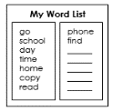

|  |  |  |
| --- | --- | --- |
| read | home | copy |
| read |  |  |
| read |  |  |
| read |  |  |
| find | words | phone |
|  |  |  |
|  |  |  |
|  |  |  |

# At the end of the term.

Point to ‘in class’. Read questions 1 to 8 and encourage students to answer about themselves by ticking ‘Yes’ or ‘No’. Ask students to compare their answers with a partner.



|  |  |  |  |
| --- | --- | --- | --- |
|  | | **Yes** | **No** |
|  | 1. Do you ask questions? |  |  |
|  | 1. Do you ask for help? |  |  |
|  | 1. Do you copy from the board? |  |  |
|  | 1. Do you copy new words  on your word list? |  |  |
|  | 1. Do you record your teacher  on your phone? |  |  |
|  | 1. Do you work with your classmates? |  |  |
|  | 1. Do you bring your books  and pencil case? |  |  |
|  | 1. Do you come to class on time? |  |  |



Point to ‘after class’. Read questions 1 to 7 and encourage students to answer about themselves by ticking ‘Yes’ or ‘No’. Ask students to compare their answers with a partner.

|  |  |  |  |
| --- | --- | --- | --- |
|  | | **Yes** | **No** |
|  | 1. Do you work at home? |  |  |
|  | 1. Do you borrow books from the library? |  |  |
|  | 1. Do you read the books?   Do you listen to the audio? |  |  |
|  | 1. Do you read your workbook  and notebook? |  |  |
|  | 1. Do you listen to your teacher  on your phone? |  |  |
|  | 1. Do you copy words on your  word list? |  |  |
|  | 1. Do you use AMEP online? |  |  |

Encourage students to ask the teacher to check their work.

Can you check my work please?



I need to practise my writing.

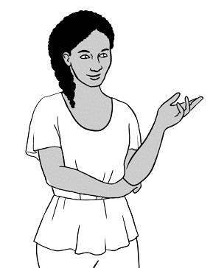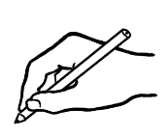

Encourage students to think about what skills they need to improve and complete the sentence.

I need to practise my ____________________________.

Ask students to read Anika’s plan and complete the table by writing ‘Your plan’.

|  |  |  |
| --- | --- | --- |
| **When** | **Anika’s plan** | **Your plan** |
| **Today** | Copy sentences from the board. |  |
| **Tomorrow** | Ask the teacher  to check my work. |  |
| **Next week** | Copy sentences from my workbook. |  |

Ask students to complete the sentences using the words from the box. Encourage the students to put a tick next to the word that they have used.

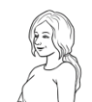

Don’t forget.

class ✓

time

help

check

|  |  |  |
| --- | --- | --- |
| Come to class .  Can you ____________  my work please?  on __________. | Ask for ___________. | Ask the teacher |