

Student book with teacher notes

|  |
| --- |
| **English Ready**  **22637VIC Course in EAL  VU23495 Begin language learning with support** |

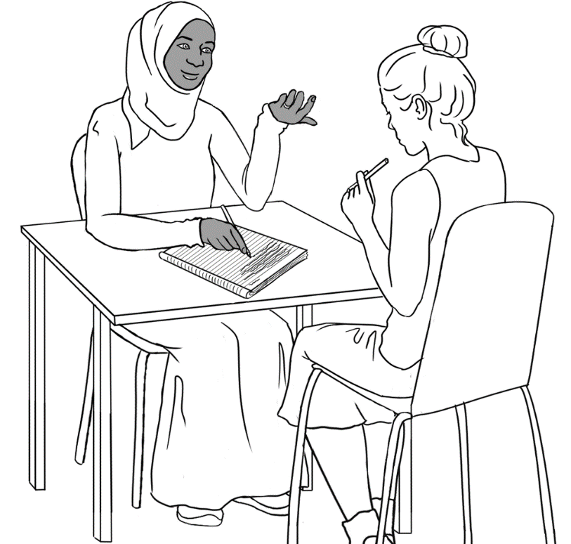**Learn English**

**Student ___________________________________________________**

**Teacher ___________________________________________________**

**Class ______________________________________________________**

**Date ______________________________________________________**

**Design team:** Vicki Hambling, Sue Paull, Frida Dean, Janice Langley, Glenise Kleehammer and Mary Wallace

This workbook is designed to be used with the support of a teacher.

**Illustrations:** Madelena Scott

**Image acknowledgements:**

Police logo - Standards Australia, CC BY 3.0 AU <https://creativecommons.org/licenses/by/3.0/au/deed.en>, via Wikimedia Commons   
Toilet sign - [This Photo](http://nvda.in.th/s449400-skpnwybqyijoeewsap/) by Unknown Author is licensed under [CC BY](https://creativecommons.org/licenses/by/3.0/)

**Acknowledgements:** The design team would like to thank the AMEP service providers and practitioners who participated in the trial and gave valuable feedback. The team would also like to acknowledge the use of the EAL Framework which underpins the design of this book.

Copyright of the EAL Framework is reserved to the Crown in the right of the State of Victoria. © State of Victoria (Department of Education and Training) 2023.  
_________________________________________________________________________________________

This English Ready Resource is licensed under a Creative Commons Attribution-NoDerivs 3.0 Australia licence (More information is available [here](http://creativecommons.org/licenses/by-nd/3.0/au/)). You are free to use, copy and distribute to anyone in its original form as long as you attribute Department of Home Affairs as the author and you license any derivative work you make available under the same licence.  
© Commonwealth of Australia 2023

With the exception of the Commonwealth Coat of Arms, the department’s logo, any material protected by a trade mark and where otherwise noted all material presented in this document is provided under a Creative Commons Attribution 4.0 International (<https://creativecommons.org/licenses/by/4.0/>) licence.

The details of the relevant licence conditions are available on the Creative Commons website (accessible using the links provided) as is the full legal code for the CC BY 4.0 licence (<https://creativecommons.org/licenses/by/4.0/legalcode>).

Use of all or part of this document must include the following attribution:   
© Commonwealth of Australia 2023

As far as practicable, material for which the copyright is owned by a third party will be clearly labelled.  The department has made all reasonable efforts to ensure that this material has been reproduced in this document with the full consent of the copyright owners.

Copyright requests and enquiries concerning usage not addressed by the CC BY 4.0 licence should be addressed to:

[*comms@homeaffairs.gov.au*](mailto:comms@homeaffairs.gov.au) *at the Department of Home Affairs.*

The terms of use for the Commonwealth Coat of Arms are available from the [It's an Honour](http://www.itsanhonour.gov.au/) website.

Where a copyright owner, other than the Commonwealth, is identified with respect to this material, please contact that third party copyright owner directly to seek permission.

**Table of Contents**

1. Instructions 1

2. Meet the people. 2

3. The alphabet 5

4. The sounds of the alphabet 11

5. Important words 15

6. Learning in Australia 18

7. My word list 21

# Instructions

|  |  |
| --- | --- |
| |  | | --- | |  |   Project and mime each instruction. |

|  |  |  |  |  |  |  |  |  |
| --- | --- | --- | --- | --- | --- | --- | --- | --- |
|  |  | listen |  | | |  | | say |
|  |  | copy |  | | |  | | match |
|  |  | read |  | | |  | | circle |
|  |  | ask |  | | |  | | tick |
|  |  | spell |  | | |  | | record |
|  |  | work with a partner | |  |  | | write | |

# Meet the people.

Project the page. Students point to the students and teacher. Name the characters. Create sentences.   
e.g. *Ming is a student.*

|  |
| --- |
|  |

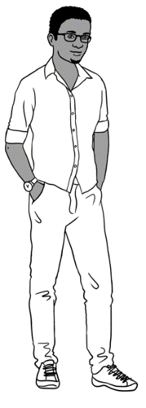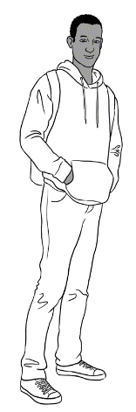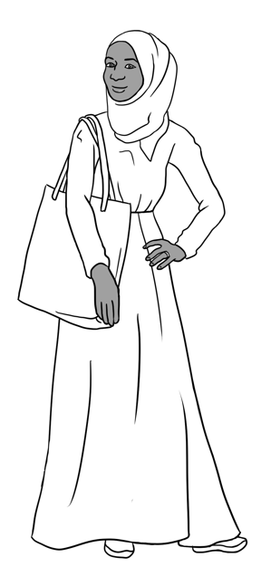

Sahra’s family comes from Somalia.

This is **Sahra**.

This is **Hani**.

This is **Tahiil**.

This is **Abdi**.

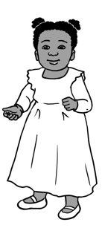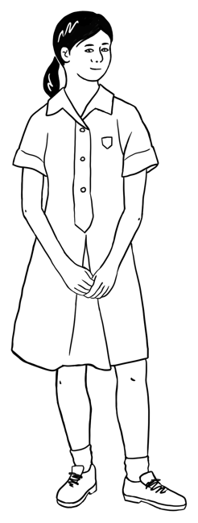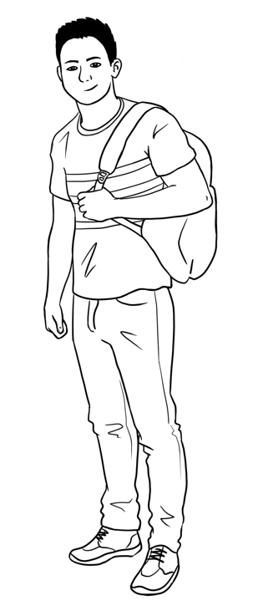

This is **Ming**.This is **Lan**.This is **Mai**.This is **Bao**.

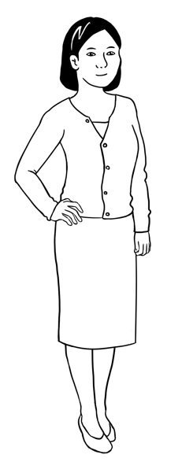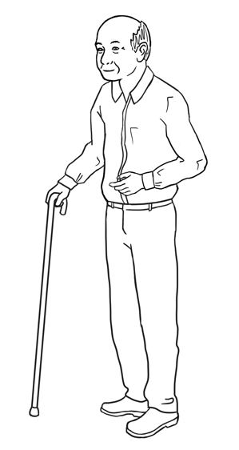

Ming’s family comes from China.

Carim’s family comes from Syria.

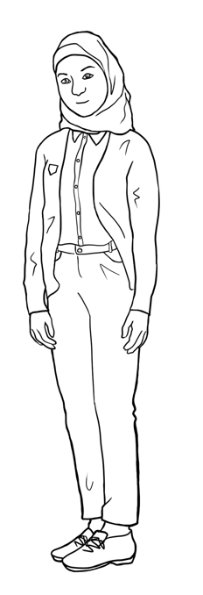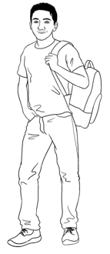

This is **Carim**.

This is **Fatima**.

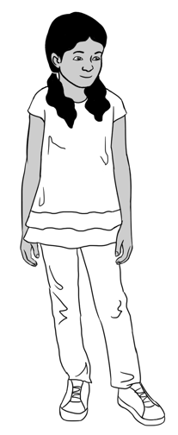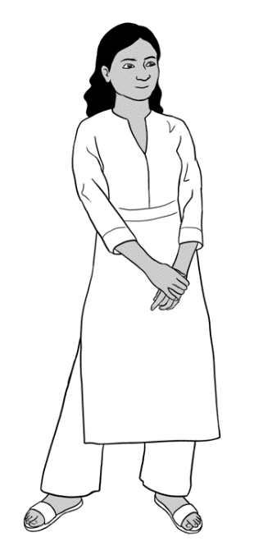

Nisha’s family comes from India.

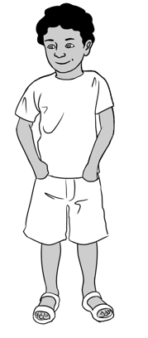

This is **Nisha.** This is **Pari.** This is **Dev**.

Anika comes from Ethiopia.

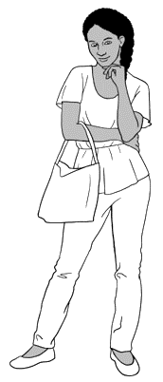

This is **Anika**.

Jenny is a teacher.   
She is from Australia.

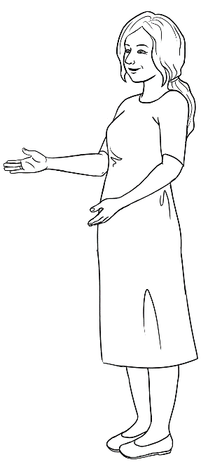

This is **Jenny**.

This is **Carim**. This is **Fatima**.

Project this page. Read the instructions below and mime them in class. Check understanding by asking students to follow the instructions.

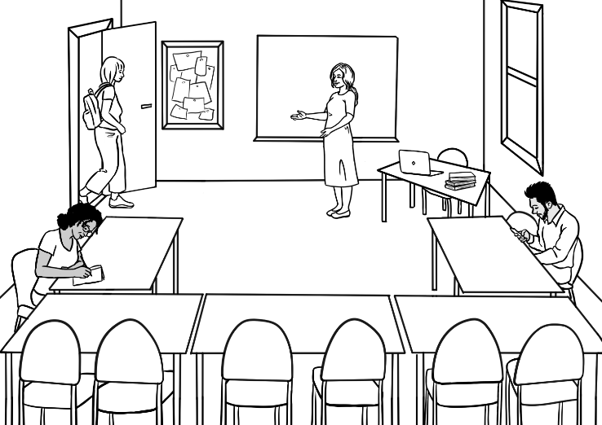

Come in.

|  |
| --- |
|  |

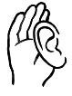

|  |  |
| --- | --- |
| Stand up.  **1** | Sit down.  **2** |
| Open your workbook.  **3** | Close your workbook.  **4** |
| Look at the board.  **5** | Listen to  the teacher.  Listen.  **6** |
| Stand in a line.  **7** | Stand in a circle.  **8** |

# The alphabet

Read the alphabet and ask students to repeat after you. Point to the vowels (A, E, I, O and U in bold). Explain that these are capital letters. Read out selected letters randomly and ask students to circle them. More activities on ‘The Alphabet’ can be found in Course in Initial Teacher resources units VU23489, VU23491 and VU23492.

|  |
| --- |
|  |

|  |  |  |  |  |  |  |  |  |  |  |  |  |
| --- | --- | --- | --- | --- | --- | --- | --- | --- | --- | --- | --- | --- |
| **A** | B | C | D | **E** | F | G | H | **I** | J | K | L | M |
| N | **O** | P | Q | R | S | T | **U** | V | W | X | Y | Z |

**Capital letters**

Ask students to copy the capital letters in the spaces provided.

|  |  |  |  |  |  |  |  |  |  |  |  |  |  |
| --- | --- | --- | --- | --- | --- | --- | --- | --- | --- | --- | --- | --- | --- |
|  | **A** | **B** | **C** | **D** | **E** | **F** | **G** | **H** | **I** | **J** | **K** | **L** | **M** |
| **1** | A | B |  | D | E |  | G | H |  | J | K |  | M |
| **2** | A |  | C |  |  | F |  |  | I |  |  | L |  |
| **3** |  |  |  |  |  |  |  |  |  |  |  |  |  |

|  |  |  |  |  |  |  |  |  |  |  |  |  |  |  |
| --- | --- | --- | --- | --- | --- | --- | --- | --- | --- | --- | --- | --- | --- | --- |
|  | **N** | **O** |  | **P** | **Q** | **R** | **S** | **T** | **U** | **V** | **W** | **X** | **Y** | **Z** |
| **4** | N |  |  | P | Q | R |  | T | U |  | W |  | Y | Z |
| **5** |  | O |  |  |  |  | S |  |  | V |  | X |  |  |
| **6** |  |  |  |  |  |  |  |  |  |  |  |  |  |  |

Encourage students to read the letters with a partner.

|  |
| --- |
|  |

Read the alphabet and ask students to repeat after you. Point to the vowels (A, E, I, O and U in bold). Explain that these are small letters. Read out selected letters randomly and ask students to circle them.

**Small letters**

|  |  |  |  |  |  |  |  |  |  |  |  |  |
| --- | --- | --- | --- | --- | --- | --- | --- | --- | --- | --- | --- | --- |
| **a** | b | c | d | **e** | f | g | h | **i** | j | k | l | m |
| n | **o** | p | q | r | s | t | **u** | v | w | x | y | z |

Ask students to copy the small letters in the spaces provided.

|  |  |  |  |  |  |  |  |  |  |  |  |  |  |
| --- | --- | --- | --- | --- | --- | --- | --- | --- | --- | --- | --- | --- | --- |
|  | **a** | **b** | **c** | **d** | **e** | **f** | **g** | **h** | **i** | **j** | **k** | **l** | **m** |
| **1** | a | b |  | d | e |  | g | h |  | j | k |  | m |
| **2** |  |  | c |  |  | f |  |  | i |  |  | l |  |
| **3** |  |  |  |  |  |  |  |  |  |  |  |  |  |

|  |  |  |  |  |  |  |  |  |  |  |  |  |  |
| --- | --- | --- | --- | --- | --- | --- | --- | --- | --- | --- | --- | --- | --- |
|  | **n** | **o** | **p** | **q** | **r** | **s** | **t** | **u** | **v** | **w** | **x** | **y** | **z** |
| **4** | n |  | p | q | r |  | t | u |  | w |  | y | z |
| **5** |  | o |  |  |  | s |  |  | v |  | x |  |  |
| **6** |  |  |  |  |  |  |  |  |  |  |  |  |  |

Encourage students to read the letters with a partner.

|  |  |  |  |  |  |  |
| --- | --- | --- | --- | --- | --- | --- |
| A a | B b | C c | D d | E e | F f | G g |
| H h | I i | J j | K k | L l | M m | N n |
| O o | P p | Q q | R r | S s | T t | U u |
| V v | W w | X x | Y y | Z z |  |  |

**Capital and small letters**

Ask students to match the capital and small letters.

|  |  |  |  |  |
| --- | --- | --- | --- | --- |
| A | b |  | N | p |
| B | d | O | n |
| C | a | P | t |
| D | c | Q | o |
| E | g | R | s |
| F | e | S | q |
| G | f | T | w |
| H | k | U | r |
| I | m | V | x |
| J | l | W | u |
| K | h | X | z |
| L | i | Y | v |
| M | j | Z | y |

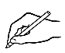

Ask students to write the small letter.

|  |  |  |  |  |  |  |
| --- | --- | --- | --- | --- | --- | --- |
| A a | B | C | D | E | F | G |
| H | I | J | K | L | M | N |
| O | P | Q | R | S | T | U |
| V | W | X | Y | Z |  |  |

Ask students to write the capital letter.

|  |  |  |  |  |  |  |
| --- | --- | --- | --- | --- | --- | --- |
| a A | b | c | d | e | f | g |
| h | i | j | k | l | m | n |
| o | p | q | r | s | t | u |
| v | w | x | y | z |  |  |

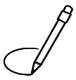

Ask students to circle the same letter.

|  |  |  |  |  |
| --- | --- | --- | --- | --- |
| b | d | b | p | q |
| f | h | k | f | l |
| m | n | w | m | u |
| y | u | v | w | y |
| x | s | c | x | z |
| p | t | b | p | r |
| k | c | v | k | t |
| a | o | u | v | a |
| g | y | g | j | q |

Point to the letter arrangement on the keyboard. Read out selected letters randomly and ask students to circle them. This activity can be extended to computer classes where the teacher can ask the students to type each letter.

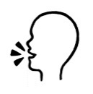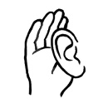

|  |
| --- |
|  |

**The computer keyboard**

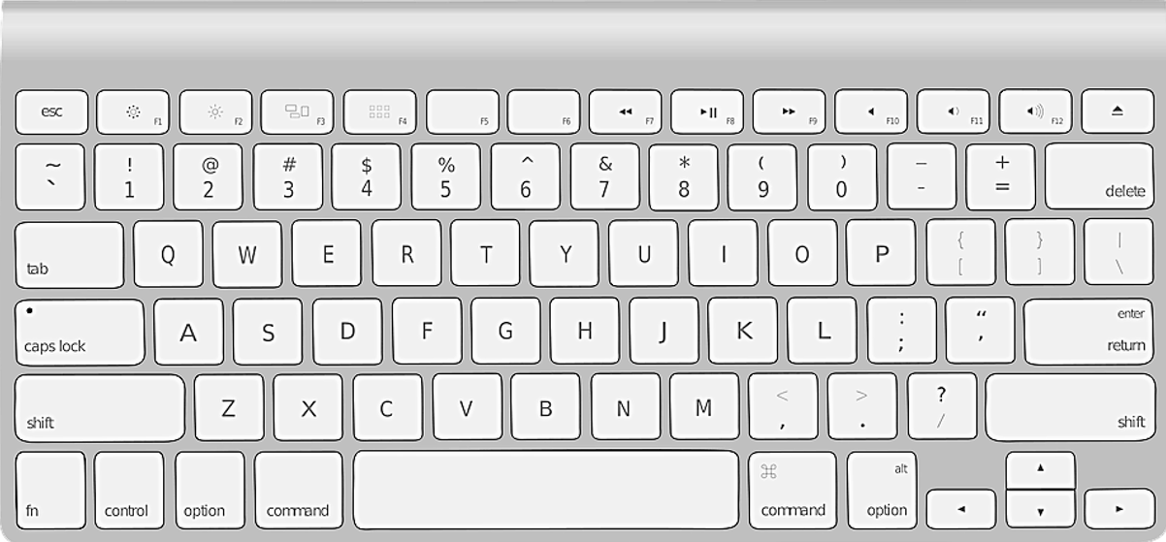

**G**

**W**

**E**

**R**

**T**

**Y**

**U**

**I**

**O**

**P**

**D**

**A**

**S**

**Q**

**F**

**H**

**R**

**Q**

**X**

**C**

**B**

**N**

**M**

**V**

**Z**

**K**

**J**

**L**



Ask students to write the missing capital letters. Encourage students to check with their partner using the top keyboard as an example.



**G**

**W**

E

**R**

**Y**

**I**

**P**

**D**

**A**

**Q**

**R**

**Q**

**C**

**B**

**M**

**Z**

**J**

**L**

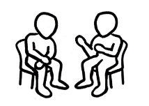

Encourage students to read the letters with a partner.

|  |  |  |  |  |  |  |  |  |  |  |  |  |
| --- | --- | --- | --- | --- | --- | --- | --- | --- | --- | --- | --- | --- |
| A | B | C | D | E | F | G | H | I | J | K | L | M |
| N | O | P | Q | R | S | T | U | V | W | X | Y | Z |



Point to capital letters in the table above. Read out selected letters randomly and ask students to write capital letters.

|  |  |  |  |  |  |
| --- | --- | --- | --- | --- | --- |
|  |  | **3.** | **4.** | **5.** | **6.** |
|  |  |  |  |  |  |

|  |  |  |  |  |  |
| --- | --- | --- | --- | --- | --- |
| **7.** | **8.** | **9.** | **10.** | **11.** | **12.** |
|  |  |  |  |  |  |

|  |  |  |  |  |  |  |  |  |  |  |  |  |
| --- | --- | --- | --- | --- | --- | --- | --- | --- | --- | --- | --- | --- |
| a | b | c | d | e | f | g | h | i | j | k | l | m |
| n | o | p | q | r | s | t | u | v | w | x | y | z |

**

Point to small letters in the table above. Read out selected letters randomly and ask students to write small letters.

|  |  |  |  |  |  |
| --- | --- | --- | --- | --- | --- |
| **1.** | **2.** | **3.** | **4.** | **5.** | **6.** |
|  |  |  |  |  |  |

|  |  |  |  |  |  |
| --- | --- | --- | --- | --- | --- |
| **7.** | **8.** | **9.** | **10.** | **11.** | **12.** |
|  |  |  |  |  |  |

# The sounds of the alphabet

|  |
| --- |
|  |

Project the page. Point to the picture, say the letters, sounds and words and ask students to repeat.

|  |  |  |
| --- | --- | --- |
| **A a**  **a**pple | **B b**  **b**ackpack | **C c**  **c**omputer |
| **D d**  **d**oor | **E e**  **e**ggs | **F f**  **f**ive |
| **G g**  **g**lasses | **H h**  **h**ighlighter | **I i**  **i**nsect |
| **J j**  **j**acket | **K k**  **k**ey | **L l**  **l**amp |

Ask students to match the words and the pictures.

|  |  |  |  |  |
| --- | --- | --- | --- | --- |
|  | **a**pple |  | **b**ackpack |  |
|  | **e**ggs | **d**oor |  |
|  | **i**nsect | **g**lasses |  |
|  | **h**ighlighter | **c**omputer |  |

|  |
| --- |
|  |

|  |  |  |
| --- | --- | --- |
| **M m**  **m**oney | **N n**  **n**otebook | **O o**  **o**range |
| **P p**  **p**encil | **Q q**  **q**uestion | **R r**  Rubber  **r**ubber |
| **S s**  **s**tudent | **T t**  **t**able | **U u**  **u**mbrella |
| **V v**  **v**an | **W w**  **w**ater | **X x**  **x**-ray |
| **Y y**  **y**am | **Z z**  **z**ero |  |

Ask students to match the words and the pictures.

Project the page. Point to the picture, say the letters, sounds and words and ask students to repeat.



|  |  |  |  |  |
| --- | --- | --- | --- | --- |
|  | **o**range |  | **p**encil |  |
|  | **u**mbrella | **r**ubber |  |
|  | **s**tudent | **t**able | Rubber |

Read the word and say the letter. Ask students to repeat and circle the first letter as you read it.

|  |  |  |  |
| --- | --- | --- | --- |
| **1** | **c** computer | **A picture containing text  Description automatically generated s** student | **Icon  Description automatically generated with medium confidencez** zero |
| **2** | **A picture containing knife  Description automatically generatedp** pencil | **A drawing of a child  Description automatically generated with low confidenceb**  backpack | **A picture containing clipart  Description automatically generatedd**  door |
| **3** | **Diagram  Description automatically generatedk**  key | **Icon  Description automatically generatedg**  glasses | **A picture containing text  Description automatically generatedj**  jacket |
| **4** | **A picture containing text, sign  Description automatically generatedn** notebook | **A picture containing text, metalware, gear  Description automatically generatedm** money | **Diagram, engineering drawing  Description automatically generatedh** highlighter |
| **5** | **i**  insect | **A picture containing shape  Description automatically generateda** apple | **A picture containing shape  Description automatically generatede** eggs |
| **6** | **u** umbrella | **w** water | **A picture containing text  Description automatically generatedv** van |

|  |
| --- |
|  |

Point to the diagraphs ‘sh’, ‘ch’ and ‘th’ and say the sound. Read the words and ask students to repeat. Ask students to circle the diagraph, e.g. ‘sh’ in ‘shop’.

|  |
| --- |
|  |

|  |  |  |  |
| --- | --- | --- | --- |
| **sh** | sharpener | shoe | shop |
| shirt | fish | Nisha |
| **ch** | child | children | teacher |
| chicken | chair | chips |
| **th** | three  3 | thirteen  13 | thirty  30 |
| Thursday  Wednesday  **Thursday**  Friday  Saturday | fourth | thank |

# Important words

Point to the table and explain personal information. As an example, the teacher can complete the table with their own information if they feel comfortable.

|  |
| --- |
|  |

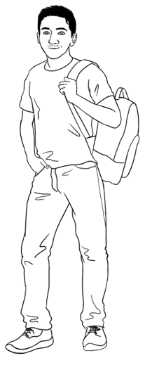

 Carim’s important words

|  |  |
| --- | --- |
| **First name** | Carim |
| **Family name** | Hamed |
| **Street** | North Street |
| **Town / Suburb** | Kellivale |



Ask students to complete the table with their personal information.

Can you check my spelling please?

Can you say the name of my street and suburb please?

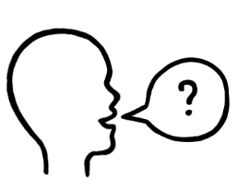

|  |  |
| --- | --- |
| **First name** |  |
| **Family name** |  |
| **Street** |  |
| **Town / Suburb** |  |

|  |
| --- |
|  |

Encourage students to ask the teacher to check their work.



Show students how to use their phones to record the teacher’s voice. Ask the students to record as you check the spelling of the street and suburbs. Encourage them to listen to their recording at home.

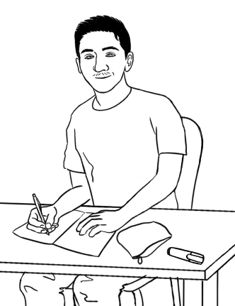

Can you spell your name please Carim?

Carim **C** - **a** - **r** - **i** - **m**

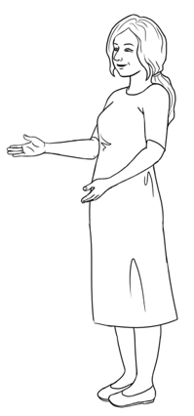

Point to the picture and read the dialogue.

The teacher can say, spell and write their own name on the board and practice with a student.

Encourage students to say, copy and spell their first name, family name and address in the table below. Students can use an ID card to spell their street and suburb or ask their teacher for help.

Explain to students what important words are by giving the examples of name, address and phone number.

**Learn your important words**.

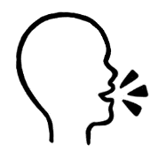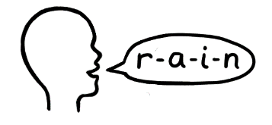

|  |  |
| --- | --- |
| **First Name** | **Family Name** |
|  |  |
|  |  |
|  |  |
|  |  |
|  |  |

|  |  |
| --- | --- |
| **Street** | **Town / suburb** |
|  |  |
|  |  |
|  |  |
|  |  |
|  |  |

|  |
| --- |
|  |



****

Project the signs on this page. Read the signs in a random order and ask students to repeat and tick the signs as they hear them.

|  |  |  |  |  |  |
| --- | --- | --- | --- | --- | --- |
| **1** | | **2** | | **3** | |
| **4** | **5** | | **6** | | **7** |

Aa Bb Cc Dd Ee Ff Gg Hh Ii Jj Kk Ll Mm

Nn Oo Pp Qq Rr Ss Tt Uu Vv Ww Xx Yy Zz

Ask students to write the sign words using small letters.

|  |  |  |
| --- | --- | --- |
| TOILETS | RECEPTION | FIRE EXIT |
| toilets. | __________________ | __________________ |
| DANGER | STOP | HOSPITAL |
| __________________ | __________________ | __________________ |

# A black check mark on a white background Description automatically generatedA hand holding a hand to the ear Description automatically generatedLearning in Australia

Is learning in Australia the same as   
learning in your country?

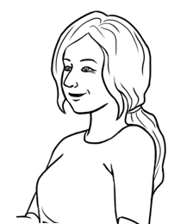

Project pages 18 to 20 and discuss learning in Australia by showing the pictures and reading the sentences. Ask students about learning in their country. Ask them to tick ‘Yes’ or ‘No’ as they hear the sentences.

|  |  |  |  |  |  |  |  |  |  |
| --- | --- | --- | --- | --- | --- | --- | --- | --- | --- |
| **Learning in Australia** | | | | | | | **In your country** | | |
| **Yes** | | **No** |
|  | Students come  to class on time. | | | | | |  | |  |
| Good morning Alina.  Good morning Jenny.  Teachers and  students use  their first names. | | | | | | |  | |  |
| Do you understand? | | | | | The teacher says,  Do you understand? | |  | |  |
| Sorry. I don’t  understand.  Students say,  Sorry. I don’t understand. | | | | | | |  | |  |
| **Learning in Australia** | | | | | | **In your**  **country** | | | |
| **Yes** | | **No** | |
| **Thank you**.  Can you  help me **please**? | | | | Teachers and students say please and thank you. | |  | |  | |
| Students ask questions. | | | Excuse me.  What is this word? | | |  | |  | |
|  | | Students work  with a partner. | | | |  | |  | |
| Men and women  work together. | | | | | |  | |  | |

|  |  |  |  |  |  |
| --- | --- | --- | --- | --- | --- |
| **Learning in Australia** | | | | **In your**  **country** | |
| **Yes** | **No** |
| Students work  in groups. |  | | |  |  |
|  | | | Students and  teachers work together. |  |  |
| Students go on excursions. | | | |  |  |
|  | | Students study  at home. | |  |  |

# 7. My word list

|  |  |  |
| --- | --- | --- |
|  |  |  |
|  |  |  |
|  |  |  |
|  |  |  |
|  |  |  |
|  |  |  |
|  |  |  |
|  |  |  |
|  |  |  |
|  |  |  |
|  |  |  |
|  |  |  |
|  |  |  |