

Student book with teacher notes

|  |
| --- |
| **English Ready**  [**22637VIC**](https://training.gov.au/Training/Details/22637VIC) **Course in EAL  VU23496 Communicate basic personal details and needs**  **VU23498 Read and write short highly familiar messages and forms** |

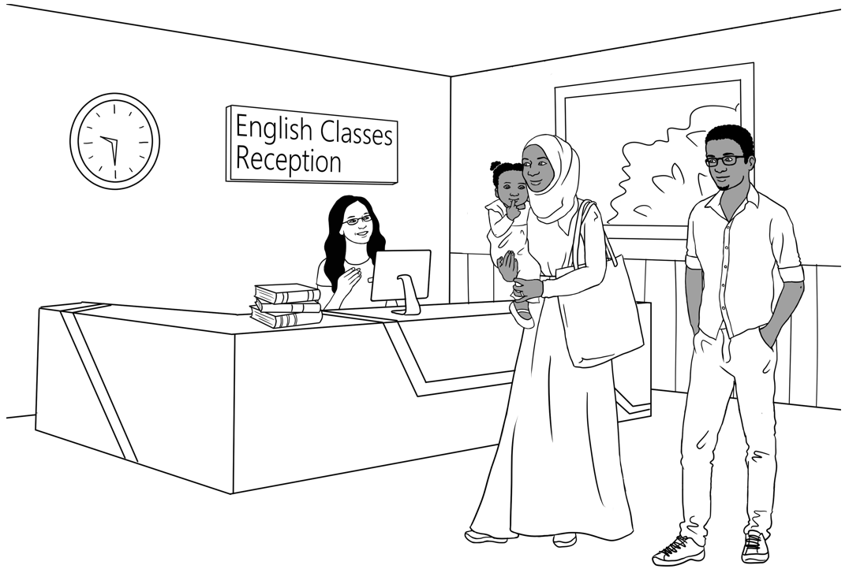**Conversation, Messages and Forms**

**Student ___________________________________________________**

**Teacher ___________________________________________________**

**Class ______________________________________________________**

**Date ______________________________________________________**

*This workbook is designed to be used with the support of a teacher.*

**Design team:** Vicki Hambling, Sue Paull, Frida Dean, Janice Langley, Glenise Kleehammer   
and Mary Wallace

**Illustrations:** Madelena Scott

**Acknowledgements:** The design team would like to thank the AMEP service providers and practitioners who participated in the trial and gave valuable feedback. The team would also like to acknowledge the use of the EAL Framework which underpins the design of this book.

Copyright of the EAL Framework is reserved to the Crown in the right of the State of Victoria. © State of Victoria (Department of Education and Training) 2023.  
_________________________________________________________________________________________

This English Ready Resource is licensed under a Creative Commons Attribution-NoDerivs 3.0 Australia licence (More information is available [here](http://creativecommons.org/licenses/by-nd/3.0/au/)). You are free to use, copy and distribute to anyone in its original form as long as you attribute Department of Home Affairs as the author and you license any derivative work you make available under the same licence.  
  
© Commonwealth of Australia 2023

With the exception of the Commonwealth Coat of Arms, the department’s logo, any material protected by a trade mark and where otherwise noted all material presented in this document is provided under a Creative Commons Attribution 4.0 International (<https://creativecommons.org/licenses/by/4.0/>) licence.

The details of the relevant licence conditions are available on the Creative Commons website (accessible using the links provided) as is the full legal code for the CC BY 4.0 licence (<https://creativecommons.org/licenses/by/4.0/legalcode>).

Use of all or part of this document must include the following attribution:   
© Commonwealth of Australia 2023

As far as practicable, material for which the copyright is owned by a third party will be clearly labelled.  The department has made all reasonable efforts to ensure that this material has been reproduced in this document with the full consent of the copyright owners.

Copyright requests and enquiries concerning usage not addressed by the CC BY 4.0 licence should be addressed to: [comms@homeaffairs.gov.au](mailto:comms@homeaffairs.gov.au) *at the Department of Home Affairs.*

The terms of use for the Commonwealth Coat of Arms are available from the [It's an Honour](http://www.itsanhonour.gov.au/) website.

Where a copyright owner, other than the Commonwealth, is identified with respect to this material, please contact that third party copyright owner directly to seek permission.

**Table of Contents**

1. Instructions 1

2. Meet the people. 2

3. Do you understand? 4

4. Introductions 5

5. The alphabet 6

6. Have a conversation. 9

7. English class 13

8. When, where, who, what, why? 14

9. People in a family 15

10. Break words into syllables. 19

11. What do you like? 21

12. Months of the year 25

13. Syllables – strong and weak 27

14. Words on forms 28

15. An English class for Sahra 29

16. The days 33

17. The time 35

18. Messages 37

19. Two letter sounds 40

20. How many? 41

21. What colour? 42

22. At the childcare centre 43

23. Tahiil’s week 47

24. Tahiil plays soccer. 48

25. Signs at the Hospital 54

26. Don’t come to class 56

27. Where and when? 59

28. Word Lists 61

# 1. Instructions

|  |  |  |  |  |  |  |
| --- | --- | --- | --- | --- | --- | --- |
| |  | | --- | |  |   Project and mime each instruction. | | | | | |
| 1. |  | Listen | 2. |  | Say |
| 3. |  | Read | 4. |  | Write |
| 5. |  | Ask | 6. |  | Spell |
| 7. |  | Work with a partner | 8. |  | Clap |
| 9. |  | Copy | 10. |  | Match |
| 11. |  | Tick | 12. |  | Circle |
| 13. |  | Point | 14. |  | Record |
| 15. |  | Colour | 16. |  | Underline |
| 17. |  | Notebook |  |  |  |

# 2. Meet the people.

|  |
| --- |
|  |

Project the page. Students point to the students and teacher. Name the characters. Create sentences.   
e.g. *Ming is a student.*

Ming’s family comes from China.

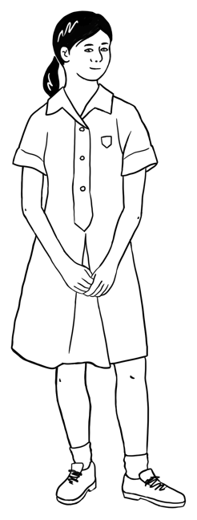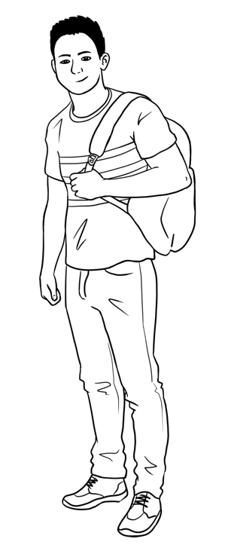

This is **Ming**.This is **Lan**.This is **Bao**.This is **Mai**.

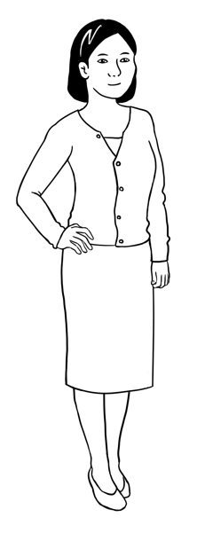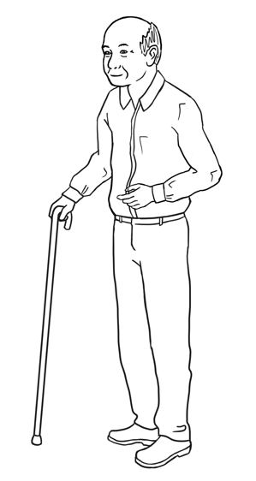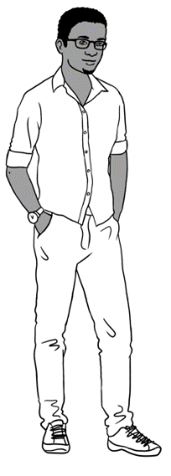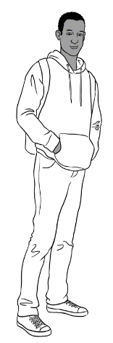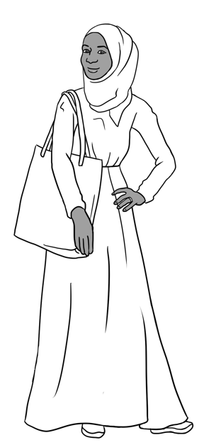

Sahra’s family comes from Somalia.

This is **Sahra**.

This is **Hani**.

This is **Tahiil**.

This is **Abdi**.

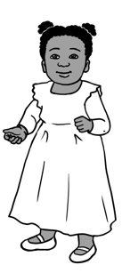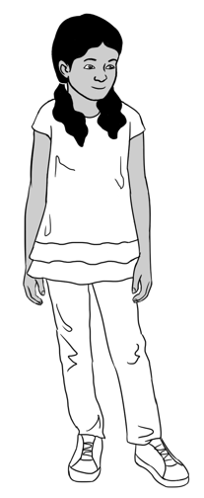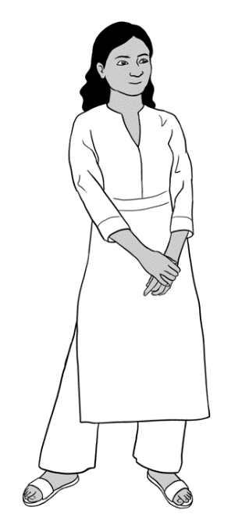

Nisha’s family comes from India.

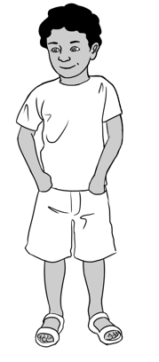

This is **Nisha.** This is **Pari.** This is **Dev**.

Anika comes from Ethiopia.

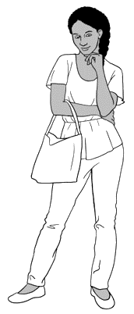

This is **Anika**.

Jenny is a teacher.   
She is from Australia

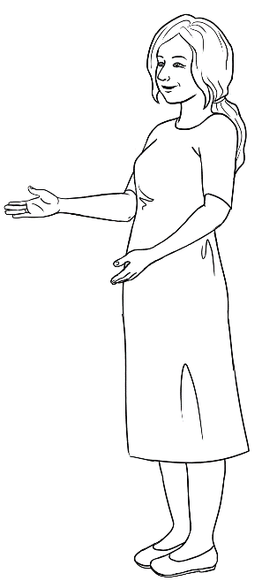

This is **Jenny**.

Pam is from Australia. neighboureighbourneigh

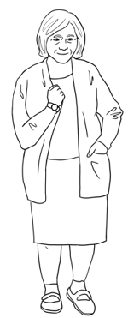

This is **Pam**.

# 3. Do you understand?

|  |
| --- |
|  |

Ask students to listen to the sentences and repat them.

Sorry. I **don’t** understand.

Can you say that **again** please?

Can you speak **slowly** please?

Can you **help me** please?

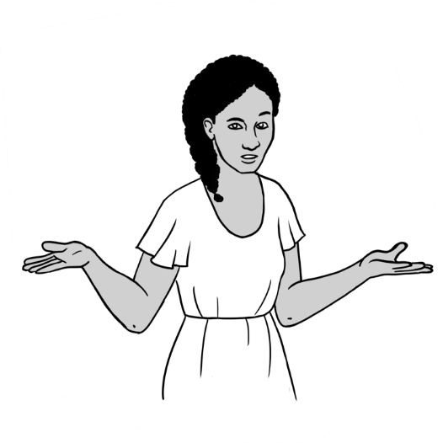

|  |  |  |
| --- | --- | --- |
| 1. Sorry. |  | that **again** please? |
| 1. Can you speak | I **don’t** understand. |
| 1. Can you say | please? |
| 1. Can you **help me** | **slowly** please? |

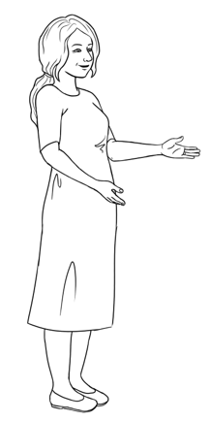

Do you understand?

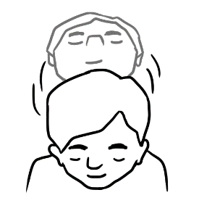

**Yes**

*Nod your head.*

Explain to students that they can use body language e.g. nodding their head would mean Yes and shaking their head would mean No. Practice this in class.

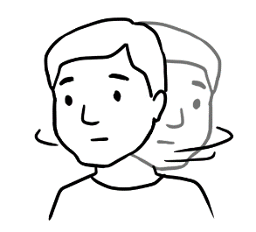

**No**

*Shake your head.*

# 4. Introductions

|  |
| --- |
|  |

Ask students to listen to the sentences and repeat them.



Hello. My name is Tahiil.

What’s your name?

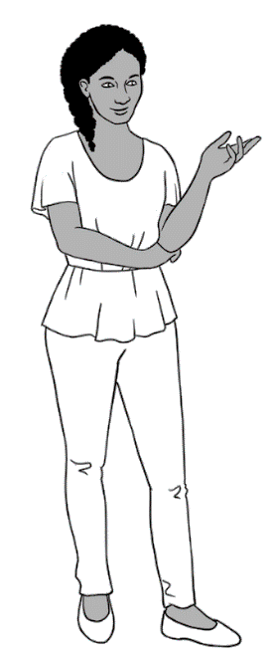

Hi. My name is Anika.

Nice to meet you.

Nice to meet you too.

Ask students to work with their partner and write their names on the form.

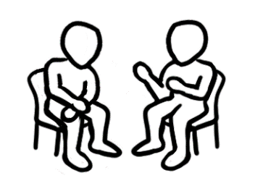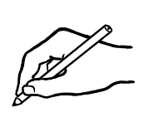

|  |
| --- |
| YouHello. My name is  **your name**  What’s your name?  Partner Hi. My name is  **your partner’s name**  YouNice to meet you.  Partner Nice to meet you too. |

Encourage students to read the form with their partners.



# 5. The alphabet

The Alphabet activities in this book are for revision. More activities can be found in Course in Initial Teacher resources units VU23489, VU23491 and VU23492.

|  |  |
| --- | --- |
|  | **Capital letters = BLOCK** letters |

|  |  |  |  |  |  |  |  |  |  |  |  |  |
| --- | --- | --- | --- | --- | --- | --- | --- | --- | --- | --- | --- | --- |
| **A** | B | C | D | **E** | F | G | H | **I** | J | K | L | M |
| N | **O** | P | Q | R | S | T | **U** | V | W | X | Y | Z |



**Small letters**

|  |  |  |  |  |  |  |  |  |  |  |  |  |
| --- | --- | --- | --- | --- | --- | --- | --- | --- | --- | --- | --- | --- |
| **a** | b | c | d | **e** | f | g | h | **i** | j | k | l | m |
| n | **o** | p | q | r | s | t | **u** | v | w | x | y | z |

Read out selected capital and small letters randomly and ask students to circle them.

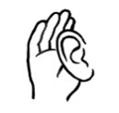

A B C D E F G H I J K L M

N O P Q R S T U V W X Y Z

a b c d e f g h i j k l m

n o p q r s t u v w x y z

Read out selected letters randomly and ask students to circle only the capital letters or small letters. e.g. small k or capital M.

A b c D e F g H i J k L M

n O p Q r s T U v W x Y z

Show students how to use their phones to record the teacher’s voice. Ask the students to record as you read the words. Encourage them to listen to their recording at home. Ask students to write a word with the same first sound in the spaces provided on the table.

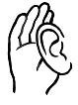

| **The sounds of the alphabet** | | | **Write** a word with  the same first sound. |
| --- | --- | --- | --- |
| **a** |  | **a**mbulance | apple |
| **b** |  | **b**all |  |
| **c** |  | **c**ake |  |
| **d** |  | **d**own |  |
| **e** |  | **e**ggs |  |
| **f** |  | **f**oot |  |
| **g** |  | **g**irl |  |
| **h** |  | **h**ome |  |
| **i** |  | **i**n |  |
| **j** |  | **j**uice |  |
| **k** |  | **k**ey |  |
| **l** |  | **l**amp |  |

|  |  |  |  |
| --- | --- | --- | --- |
| **m** |  | **m**an |  |
| **n** |  | **n**o |  |
| **o** |  | **o**ffice |  |
| **p** |  | **p**en |  |
| **q** | Rubber | **q**uestion |  |
| **r** |  | **r**ubber |  |
| **s** |  | **s**tudent |  |
| **t** |  | **t**ea |  |
| **u** |  | **u**p |  |
| **v** |  | **v**egetables |  |
| **w** |  | **w**orkbook |  |
| **x** |  | **x**-ray |  |
| **y** |  | **y**es |  |
| **z** |  | **z**ero |  |
|  |  |  |  |

# 6. Have a conversation.

|  |
| --- |
|  |

Encourage students to practice the conversation with their partners.

|  |
| --- |
| Good morning Alina.  Good morning.  **A** |
| Good afternoon. .  Good afternoon Jenny.  **B** |
| **C**  Hello.  Hi Sahra. |

|  |
| --- |
|  |

Point to the opening and closing of a conversation.   
Point to talking about the weather. Read the statements to the class, emphasising ‘very’. Ask students to practice the conversation with a partner. Emphasise the bolded words.

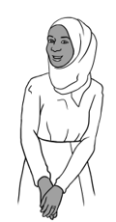

It’s hot today,   
isn’t it?

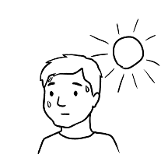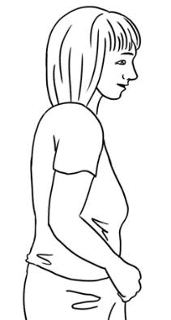

Yes, it is.

|  |  |
| --- | --- |
| 1. It’s **very** hot today, isn’t it? | Yes, it is. |
| 1. It’s cold today, isn’t it? |
| 1. It’s **very** cold today, isn’t it? |
| 1. It’s a beautiful day isn’t it? |



Nice to see you Alina.

See you later.

Bye for now.

Bye Sahra.

Project pages 11 and 12 and read conversations 1,2,3 and 4. Point to the opening and closing of each conversation and check students’ understanding. Encourage students to practice conversations 1, 2, 3 and 4 with a partner.

**1**

Bao Hello. My name’s Bao.

What’s your name?

Tahiil I’m Tahiil.

I come from Somalia.

Where are you from?

Bao I come from China.

Nice to meet you.

Tahiil Nice to meet you too.

****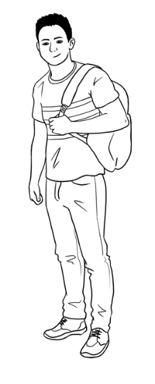

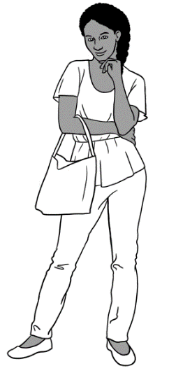

TahiilHi Anika. How are you?

Anika Fine thanks Tahiil.

And you?

Tahiil I’m fine too.

See you later.

Anika See ya.

**2**

**ya** = you

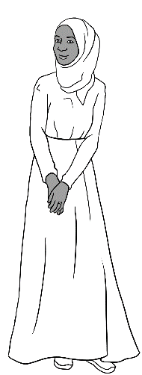

Pam Hello Sahra.

Sahra Hi Pam.

Pam It’s cold today, isn’t it?

Sahra Yes, it is.

Pam Nice to see you Sahra.

Sahra Nice to see you too.

Pam Bye for now.

Sahra Bye.

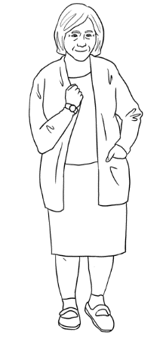

**3**

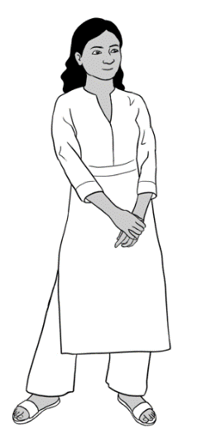

Nisha Hello Lan.

Lan Hi Nisha. How are you?

Nisha Fine thanks and you?

Lan Good thanks.

Nisha It’s a beautiful day, isn’t it? Lan Yes, it is.

Nisha See you later Lan.

Lan Bye Nisha.

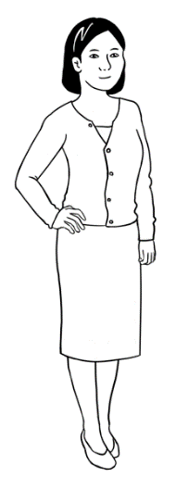

**4**

Ask students to fill in the blanks with their partners.



Give instruction to work with a partner and write the names.

|  |  |
| --- | --- |
|  |  |
| **Greeting** | You Hello ___________________________.  *your partner’s name*  Partner Hi ______________________________. How are you?  ***your name***  You Fine thanks and you?  Partner Good thanks. |
| **Talk about the weather.** | You It’s a beautiful day, isn’t it?  PartnerYes, it is. |
| **End the conversation.** | You See you later .  *your partner’s name*  PartnerBye *_____________________________.*  *your name* |
|  | Encourage students to read the conversation with their partner. |

# 7. English class

Point to the stationary items and say the words. Ask students to repeat and copy them. The activities below reinforce the need to come prepared to class.

|  |
| --- |
| I’m ready for class.  I have **9** things in my bag. |

|  |
| --- |
|  |

Ask students to show the teacher or each other what they have brought for class, stating the name of each item.

|  |  |  |  |
| --- | --- | --- | --- |
|  |  |  |  |
| pencil  pencil . | rubber ___________ | sharpener ___________ | pencil case _______________ |
|  |  |  |  |
| highlighter ___________ | pens ___________ | workbook ___________ | notebook ______________ |

Encourage students to read the conversation and practice with their partner.

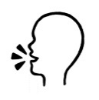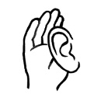

|  |
| --- |
|  |

Tahiil needs to borrow a pen and a pencil.

Yes. Here’s a pen.

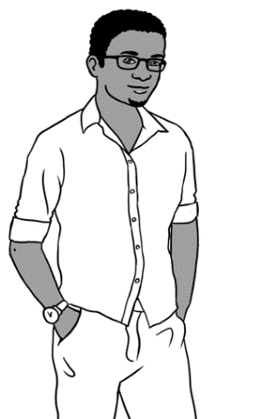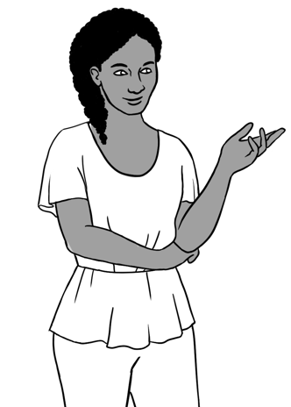

Anika. Can I borrow a pen please?

Can I borrow a pencil too?

Thanks a lot.

Oh no. Sorry Tahiil.



# 8. When, where, who, what, why?

Give instruction to listen and repeat.

Ask students to and write answers in the five rectangles and then compare answers with their partner. Finally, check the answers with the class as a whole.

|  |
| --- |
|  |

|  |  |  |  |
| --- | --- | --- | --- |
| **When** do you go to school? | Monday | Tuesday | Wednesday |
| Thursday | Friday | Saturday |

|  |  |  |  |
| --- | --- | --- | --- |
| **Where** is this?  Australia  the garden  the park✓ | the park . | ______________ | ______________ |

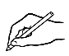

|  |  |  |  |
| --- | --- | --- | --- |
| **Who** is this?  Bao  Mai  Lan | ____________ | _____________ | ____________ |

|  |  |  |  |
| --- | --- | --- | --- |
| **What** do you  have in your bag? |  |  |  |
|  |  |  |

|  |  |  |  |
| --- | --- | --- | --- |
| **Why** do you learn English? | to work | to study | to make friends |

# 9. People in a family

Project conversations on pages 15, 16 and 17. Ask students to listen to these conversations as you read them. Point to the family words on page 15. Encourage students to find family words on pages 16 and 17 and to practice the conversations with a partner.

|  |
| --- |
|  |

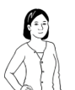

My name’s Ming.

This is my **daughter** Lan.

I am a **grandfather**.

This is my **granddaughter** Mai

and my **grandson** Bao.

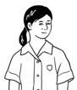

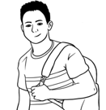



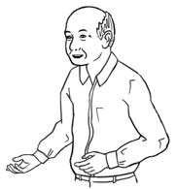

My name’s Lan.

Ming is my **father**.



I am a **mother**.

This is my **daughter** Mai

and my **son** Bao.



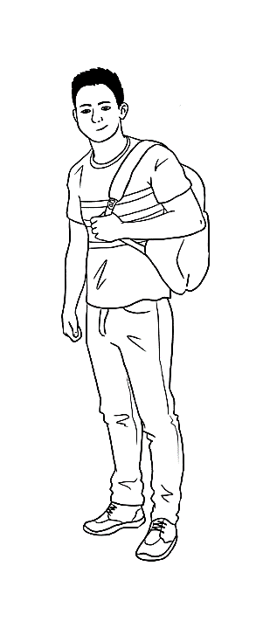

My name’s Bao.

Mai is my **sister**.

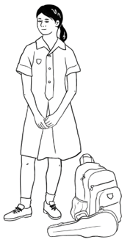

My name’s Mai.

Bao is my **brother**.

**f**

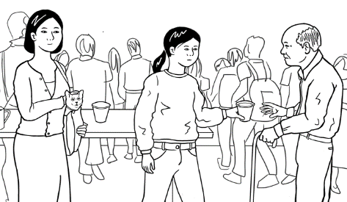

Yes.

This is my grandfather Ming,

my sister Mai and my mother Lan.

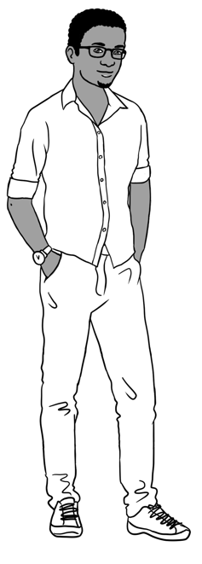

Is your sister’s name Mai?

Is this your family Bao?

Yes. Her name is Mai.

Ask students to write Bao’s family words.

|  |
| --- |
| mother |
| family **** |
| sister |
| grandfather |

* + 1. This is my family .
    2. This is my _______________________ Ming.
    3. This is my _______________________ Lan.
    4. This is my _______________________Mai.

Ask students to read the conversation with a partner and copy in their notebook.

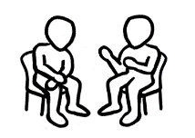

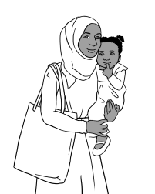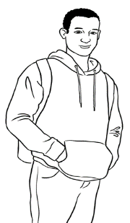

Is this your family Tahiil?

Yes.

This is my wife Sahra and   
my daughter Hani.

Abdi is Sahra’s brother.

Ah. Abdi is Sahra’s brother?

Yes. He is.

Ask students to write Tahiil’s family words.

|  |
| --- |
| daughter |
| family **** |
| brother |
| wife |

1. This is my family .
2. This is my ___________________ Sahra.
3. This is my ___________________ Hani.
4. This is Sahra’s ___________________ Abdi.

Ask students to read the conversation with a partner and copy in their notebook. Encourage students to write about themselves and read with a partner if they are comfortable to do so.



|  |
| --- |
|  |



Point to the family words, read them and ask students to repeat after you. Ask students to copy the words on the lines.

|  |  |  |  |
| --- | --- | --- | --- |
| father  . | father . | mother | mother . |
| son | ____________ | daughter | ____________ |
| grandfather | _______________ | grandmother | ________________ |
| grandson | _____________ | granddaughter | ________________ |
| husband | ____________ | wife | ____________ |
| brother | ____________ | sister | ____________ |
| uncle | ____________ | aunt | ____________ |
| cousin | ____________ | cousin | ____________ |

Ask students to find and circle the family words in the table. All the words are horizontal.

|  |  |  |  |  |  |  |  |  |  |  |  |  |  |
| --- | --- | --- | --- | --- | --- | --- | --- | --- | --- | --- | --- | --- | --- |
| u | n | c | l | e | a | b | m | o | t | h | e | r | c |
| d | g | r | a | n | d | d | a | u | g | h | t | e | r |
| s | o | n | e | f | g | r | a | n | d | s | o | n | g |
| h | u | s | b | a | n | d | h | s | i | s | t | e | r |
| b | r | o | t | h | e | r | i | f | a | t | h | e | r |
| j | w | i | f | e | k | l | c | o | u | s | i | n | m |
| n | d | a | u | g | h | t | e | r | o | a | u | n | t |
| g | r | a | n | d | f | a | t | h | e | r | p | q | r |
| s | t | u | g | r | a | n | d | m | o | t | h | e | r |

# 10. Break words into syllables.

|  |  |
| --- | --- |
| Word | student |
| **Break** | **stu** **dent** |
| Syllables | stu dent  **1** **2** |

Listen and say the words. Clap the syllables. Point to the syllables in each word. Encourage students to clap with you.

|  |  |
| --- | --- |
|  |  |

Sahra Tahiil Hani Mai Bao Anika Abdi

|  |  |  |  |  |
| --- | --- | --- | --- | --- |
|  | **How many syllables?** | | | |
| **Names** | **1** | **2** | **3** | **4** |
| Sahra |  | Sahra |  |  |
| Tahiil |  | Tahiil |  |  |
| Hani |  | Hani |  |  |
| Mai | Mai |  |  |  |
| Bao | Bao |  |  |  |
| Anika |  |  | Anika |  |
| Abdi |  | Abdi |  |  |

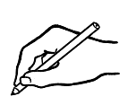

Ask students to write their name, say it and clap each syllable. They could also do this with their partner’s name.

Your name: __________________. My name has ________ syllables.

|  |  |
| --- | --- |
|  |  |

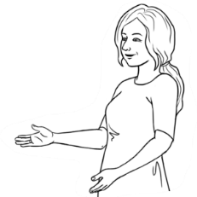

How many syllables?

Say the words.

Clap the syllables.

Listen and say the words. Ask students to clap the syllable. Point to the syllables in each word.

|  |  |  |  |
| --- | --- | --- | --- |
|  | **Syllables** | | |
| **Word** | **1** | **2** | **3** |
| pencil |  | pencil |  |
| pen |  |  |  |
| sharpener |  |  |  |
| workbook |  |  |  |
| wife |  |  |  |
| husband |  |  |  |
| son |  |  |  |
| daughter |  |  |  |
| grandfather |  |  |  |
| grandmother |  |  |  |
| brother |  |  |  |
| sister |  |  |  |
| uncle |  |  |  |
| aunt |  |  |  |
| cousin |  |  |  |

# 11. What do you like?

|  |  |
| --- | --- |
|  |  |
|  | | | **to like** | **to not like** | Explain simple expressions of like or dislike by pointing to ‘like’, ‘likes’, ‘don’t like’ and ‘doesn’t like’. ‘Subject-Verb’ agreement can also be explained by pointing to ‘s’ in ‘likes’ and comparing ‘don’t’ and ‘doesn’t’.  fruit. |
| **I** | | | like | don’t like |
| **You** | | | like | don’t like |
| **He, She, It** | | | like**s** | do**es**n’t like |
| **We** | | | like | don’t like |
| **They** | | | like | don’t like |

**Tick** what you like. **Cross** what you don’t like.

****

|  |  |  |
| --- | --- | --- |
| A black check mark on a white background  Description automatically generatedapples | bananas | ice cream  **X** |
| tea | coffee | orange juice |
| cake | pizza | hot chips |
| bread | rice | noodles |

|  |  |
| --- | --- |
|  | I like _______________________ and ______________________. |
|  | I don’t like _______________________. |

Encourage students to talk about what they like or don’t like to their partners.

|  |  |
| --- | --- |
|  |  |

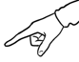

Students listen, repeat and point to the words. Suggestion for more advanced students: Students could add one more thing to this set of food that they like. The teacher can model this: *I like tea. I like chicken. I like …*

|  |  |  |
| --- | --- | --- |
| apples | bananas | ice cream |
| tea | coffee | Diagram  Description automatically generated with medium confidenceorange juice |
| cake | pizza | hot chips |
| Diagram  Description automatically generatedbread | rice | noodles |

|  |
| --- |
|   **1** |
|  |  |
|  **Tick** what people like.  **X** | | | **Cross** what people don’t like.  Ask students to pay attention to ‘tick and cross’. Point to ‘like’ and ‘don’t like’ and check understanding. Play Audio 1 and ask students to tick or cross as they listen. |

|  |  |  |  |  |  |
| --- | --- | --- | --- | --- | --- |
| **1** | ice cream | | | coffee | Tea |
|  |  | | |  |  |
| **2** | rice | | | cake | Coffee |
|  |  | | |  |  |
| **3** | noodles | | | hot chips | Rice |
|  |  | | |  |  |
| **4** | coffee | | | cake | bananas |
|   Yes, I do.  Sahra. Do you like reading?  No. I don’t.  Do you like gardening? | |  |

Ask students to listen to the conversations on pages 23 and 24. Point to use of gerunds after the verb ‘like’ to express like or dislike.

|  |  |  |
| --- | --- | --- |
| **** | **X** |  |
| gardening. | cooking | reading |
|  |  |  |
| walking in the park | playing soccer | playing games |
|  |  | C:\Users\v i c k y\Downloads\8.png |
| fishing | swimming | watching TV |

**Tick** what you like. **Cross** what you don’t like.

Ask students to complete the sentences about themselves.

I like .

I don’t like .

|  |  |
| --- | --- |
|  | Bao. Do you like gardening?  Yes. I do.  No. I don’t.  Do you like swimming? |

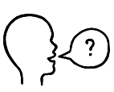

Ask students to work with their partners and ask the questions and complete the table below.

|  |  |  |
| --- | --- | --- |
| **Tick** yes or no. | ** Yes**. I do. | ****  **No**. I don’t. |
| 1. Do you like gardening? |  |  |
| 1. Do you like cooking? |  |  |
| 1. Do you like reading? |  |  |
| 1. Do you like walking in the park? |  |  |
| 1. Do you like playing soccer? |  |  |
| 1. Do you like playing games? |  |  |
| 1. Do you like fishing? |  |  |
| 1. Do you like swimming? |  |  |
| C:\Users\v i c k y\Downloads\8.png   1. Do you like watching TV? |  |  |

Ask students to complete the sentences about their partners.

My partner likes ________________________________________ .

He / She doesn’t like ___________________________________ .

# 12. Months of the year

Practice saying the months and numbers. Point to the short and long words and mention that months start with capital letter. Students repeat after you *‘January, Jan, February, Feb’* etc then practice in pairs.

|  |  |
| --- | --- |
|  |  |

|  |  |  |
| --- | --- | --- |
| The **number** of the month | **Copy** the **long words**. | **Short words** |
|  | January January . | Jan |
|  | February | Feb |
|  | March | Mar |
|  | April | Apr |
|  | May | May |
|  | June | June |
|  | July | July |
|  | August | Aug |
|  | September | Sept |
|  | October | Oct |
|  | November | Nov |
|  | December | Dec |

Ask students to match the short form of the month to its number.

|  |  |
| --- | --- |
| Jan | 5 |
| Feb | 1 |
| Mar | 6 |
| Apr | 4 |
| May | 2 |
| June | 3 |

|  |  |
| --- | --- |
| July | 8 |
| Aug | 11 |
| Sept | 10 |
| Oct | 7 |
| Nov | 12 |
| Dec | 9 |

|  |  |
| --- | --- |
|  |  |

|  |  |  |  |  |  |  |  |  |  |
| --- | --- | --- | --- | --- | --- | --- | --- | --- | --- |
|  | Point to the two ways of writing the date. | **Day** | | **Month** | | **Year** | | | |
| This is the **full date.** |  | 21 | | July | | 2022 | | | |
| This isthe **date in numbers.** |  | 2 | 1 | 0 | 7 | 2 | 0 | 2 | 2 |

Ask students to match the full date to the date in numbers.

|  |  |  |
| --- | --- | --- |
| **Full date** |  | **Date in numbers** |
| 25 December 2016 | 19. 01.1978 |
| 15 September 2022 | 13. 05.2023 |
| 19 January 1978 | 15. 09.2022 |
| 21 October 2006 | 21. 10.2006 |
| 13 May 2023 | 25. 12.2016 |
| 24 June 2021 | 13. 02.1986 |
| 13 February 1986 | 24. 06.2021 |

|  |  |
| --- | --- |
|  |  |

Encourage the students to write the dates and read them. Students can also write their birthday (if they know it) or today’s date.

|  |  |
| --- | --- |
| **Full date** | **Day. Month. Year** |
| 9 May 1986 | 09.05.1986 |
| 19 September 1995 |  |
| 6 June 2023 |  |
| 18 March 1970 |  |
| 1. February 2015 |  |

# 13. Syllables – strong and weak

|  |  |
| --- | --- |
|  |  |



Some syllables are **strong.**

Some syllables areweak**.**

Point to the strong syllables, clap and say the words. Ask students to repeat.

|  |  |  |  |
| --- | --- | --- | --- |
| **wal**king | **gar**dening | **rea**ding | **coo**king |
| **play**ing | **fi**shing | **swim**ming | **wa**tching |

|  |  |
| --- | --- |
|  |  |

Ask students to underline the strong syllables in the words. Encourage them to read, clap and circle the strong syllables.



|  |  |  |  |  |
| --- | --- | --- | --- | --- |
| Monday | Tuesday | Saturday | January | April |
| July | August | September | thirteen | thirty |
| fourteen | forty | sixteen | sixty | hundred |

Ask students to read the sentences with a partner and copy them in their notebooks.



1. 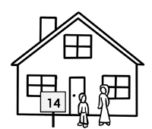Today is **Tues**day.
2. My birthday is in **Au**gust.
3. My house number is four**teen**, not **for**ty.

# 14. Words on forms

|  |  |
| --- | --- |
|  |  |

This is an introduction to words on forms. Ask students to record your voice as you read the words on the form. Ask students to translate these words in their own language and write in the spaces.



|  |  |
| --- | --- |
| Family Name [Surname] |  |
| First Name [Given name] |  |
| Title |  |
| Country of birth |  |
| Date of birth |  |
| Address |  |
| Street |  |
| Suburb |  |
| Postcode |  |
| Phone number |  |
| Signature |  |

|  |  |
| --- | --- |
|  |  |

Point to the instructions. Point to ‘Capital’ and ‘Block’ letters and ‘black pen’.

**Instructions on forms**



**1**. *PLEASE USE* ***CAPITAL*** *LETTERS*.

**2**. *PLEASE USE* ***BLOCK*** *LETTERS.*

**3**. *Please use a* ***black pen****.*

**4**. ***Tick*** *the box.*

Please note for the first activity if the student is preliterate or building literacy, they will need assistance from a volunteer or another student with the same language background. If that is not possible, student can use the recording to translate and get help from friends or family after class.

# 15. An English class for Sahra

|  |  |
| --- | --- |
|  |  |

Project the page and point to the picture. Read the sentence and check understanding.

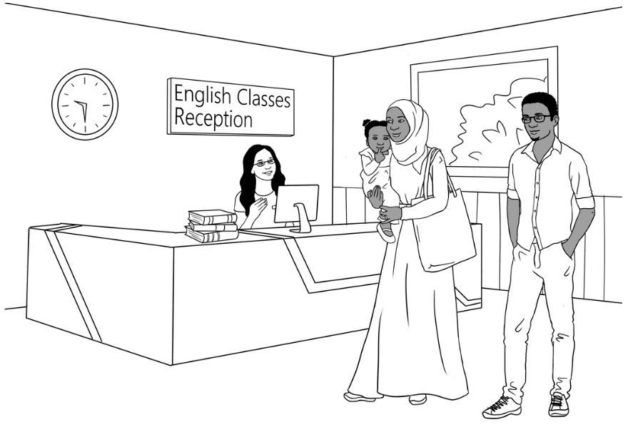Tahiil, Sahra and Hani go to the TAFE College.

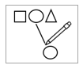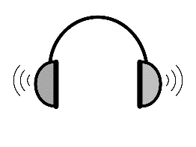

**2**

|  |
| --- |
|  |

Play Audio 2 and ask students to match the two parts of the sentences.

|  |  |
| --- | --- |
| * + - 1. Hello. My name | my wife Sahra. |
| * + - 1. This is | is Tahiil. |
| * + - 1. She needs | childcare? |
| 1. We have | an English class. |
| 1. Do you have | a daughter. |

|  |
| --- |
|  |

Play Audio 2 again and ask students to fill the blanks with the correct words from the box.



**2**

|  |  |  |  |  |
| --- | --- | --- | --- | --- |
| meet | fill | here | help | have |
| name | wife | Yes | class | have |

|  |  |
| --- | --- |
| Tahiil | Hello. My name is Tahiil.  This is my __________ Sahra.  She needs an English _____________. |
| Receptionist | Hello. Nice to _____________ you.  You can enrol in an English class __________. |
| Tahiil | Thank you. We ____________ a daughter.  Do you ___________ childcare? |
| Receptionist | Yes, we have childcare.  Can you ________ in this form please Sahra? |
| Sahra | Mmm. Can you __________ me please? |
| Receptionist | __________. I can. |

Encourage student to practice reading the conversation with their partner.

Explain general information needed for filling a form. Point to information on Sahra’s form e.g. Family name, First name etc.

|  |  |  |  |  |  |
| --- | --- | --- | --- | --- | --- |
| **Student Enrolment Form**  *PLEASE USE* ***CAPITAL*** *LETTERS.*   ***Tick*** *the box.* | | | | | |
| 1. **Family name** | | ELMI | | | |
| 1. **First name** | | SAHRA | | | |
| 1. **Title** | | Mr | Miss | Mrs | Ms |
| 1. **Country of birth** | | SOMALIA  **** | | | |
| 1. **Date of Birth** | | 07. 07. 1996 | | | |
| 1. **Address** | **Street** | UNIT 6, 50 BAKER ROAD | | | |
| **Suburb** | KELLIVALE | | | |
| **Postcode** | 2421 | | | |
| 1. **Phone number** | | 0455 961 259 | | | |
| 1. **Signature** | | *Sahra Elmi* | | | |



Ask students to find and circle the information from the box in the form.

|  |  |  |
| --- | --- | --- |
| Country of birth | Date of birth | Postcode |



**This is your form.**

**Point** to the instructions.





Point to the instructions. Ask students to complete the form with their information.

|  |  |  |  |  |  |
| --- | --- | --- | --- | --- | --- |
| **Student Enrolment Form**  *PLEASE USE* ***CAPITAL*** *LETTERS.*   ***Tick*** *the box.* | | | | | |
| 1. **Family name** | |  | | | |
| 1. **First name** | |  | | | |
| 1. **Title** | | Mr | Miss | Mrs | Ms |
| 1. **Country of birth** | |  | | | |
| 1. **Date of Birth** | |  | | | |
| 1. **Address** | **Street** |  | | | |
| **Suburb** |  | | | |
| **Postcode** |  | | | |
| 1. **Phone number** | |  | | | |
| 1. **Signature** | |  | | | |

Encourage peer correction by getting students to ask their partners to check their work.

Can you check my work please?

*Can you check my work please*?

# 16. The days

|  |  |  |
| --- | --- | --- |
|  | Practice saying the days. Point to the short and long words and mention that days of the week start with capital letter. |  |

Ask students to circle the days of the week.

|  |  |
| --- | --- |
| **Full word** | **Short word** |
| Monday | Mon |
| Monday . | Mon . |
| Tuesday | Tues |
| ______________ | ________ |
| Wednesday | Wed |
| ______________ | ________ |
| Thursday | Thurs |
| ______________ | ________ |
| Friday | Fri |
| ______________ | ________ |
| Saturday | Sat |
| ______________ | ________ |
| Sunday | Sun |
| ______________ | ________ |

|  |
| --- |
| Tuesday |
| October |
| January |
| Wednesday |
| June |
| Monday |
| December |
| July |
| Saturday |
| April |
| Thursday |
| November |
| Sunday |
| February |
| March |
| Friday |

|  |  |
| --- | --- |
|  |  |



Ask students to use their phones to record as you read the words. Explain that they can listen again in class or at home.

|  |  |  |  |
| --- | --- | --- | --- |
| Monday  | Tuesday | Wednesday | Thursday |
| Friday | Saturday | Sunday |  |

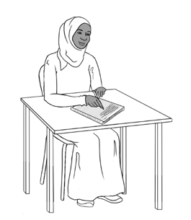



1. On Monday I go to English class.
2. On ___________________ I go to English class.
3. 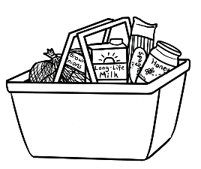On ___________________ I do my homework.
4. On ___________________ I like cooking.
5. On ___________________ I go shopping.
6. 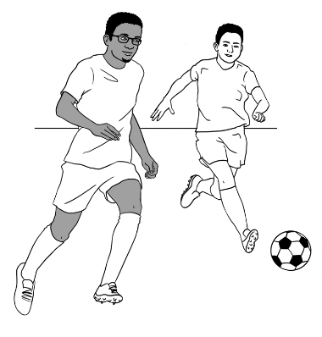On ___________________ I walk in the park.
7. On ___________________ I watch soccer.

Ask students to complete the sentences about themselves.

About you.

1. 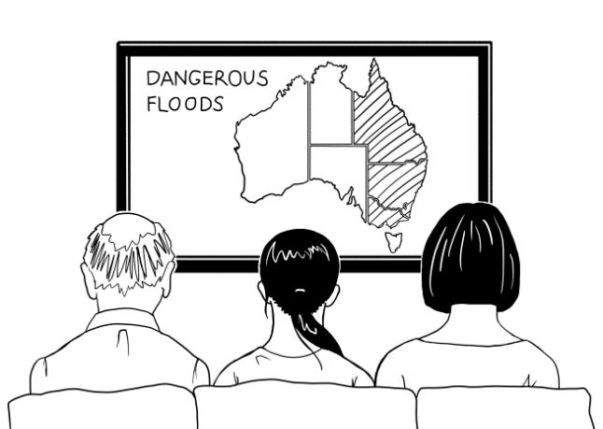On __________________ I go to English class.
2. On ___________________ do my homework.
3. On ___________________ I watch TV.
4. On ___________________ I _____________________________.

Encourage students to read the completed sentences to their partners and then copy in their notebooks.



# 17. The time

|  |
| --- |
|  |

Point to the days and times on the timetable. Explain about the start and finish times and room numbers.

This is my timetable.

I go to class on Monday and Tuesday.

|  |  |  |  |  |  |
| --- | --- | --- | --- | --- | --- |
|  | **Mon** | **Tues** | **Wed** | **Thurs** | **Fri** |
| **Morning**  Start  Finish | 9:00  12:00  ***Room 3*** | 9:30  12.30  ***Room 4*** |  |  |  |
| **Lunch break** | | | | | |
| **Afternoon**  Start  Finish | 12:30  2:30  ***Room 3*** | 1:00  3:00  ***Room 4*** |  |  |  |

|  |  |
| --- | --- |
| * + - 1. I go to class | on Monday. |
| * + - 1. I am in Room 3 | 9:00 on Monday morning. |
| * + - 1. I am in Room 4 | on Monday and Tuesday. |
| * + - 1. I start at | 2:30 on Monday afternoon. |
| * + - 1. I finish at | on Tuesday. |

Ask students to match first part of the sentence to the second part.

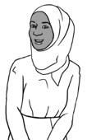

Ask students to complete the sentences about themselves.

I go to class on ________________________________________________________.

Students match the times with the pictures. At the start and end of the class over the next few days, use the classroom clock to check the time and reinforce the start and finish time of class.

|  |  |  |
| --- | --- | --- |
| 12  1  11  6  3  2  10  9  8  5  7  4  12  1  11  6  3  2  10  9  8  5  7  4  **1:00**  **9:30 am**  Mon 7 Sept  20**°**C | **Monday morning**  9:00  12:00  **Monday afternoon**  12:30  2:30  **Tuesday morning**  9:30  12:30  **Tuesday afternoon**  1:00  3:00 | **9:00**  **12:30 pm**  Mon 7 Sept  20**°**C  12  1  11  2  10  3  9  8  4  5  7  6  12  1  11  6  3  2  10  9  8  5  7  4 |

Ask students to complete the sentences about themselves.



|  |  |
| --- | --- |
|  |  |
|  | Today I start class at ___________________ . |
|  | Today I finish class at ___________________ .  Encourage students to read the sentences with their partners. |
|  |  |
|  | On Monday Sahra starts class at **9:00** in the morning. |
|  | She finishes at **2:30** in the afternoon. |

# 18. Messages

|  |  |
| --- | --- |
|  |  |

Project the message. Point to the greeting and ending in a message. Read the message for the students and ask follow-up questions.

Hello Sahra,

Your class starts on Monday 13 July.

Please come to Room 3 at 9:00.   
Your teacher Jenny

**Greeting**

**Ending**

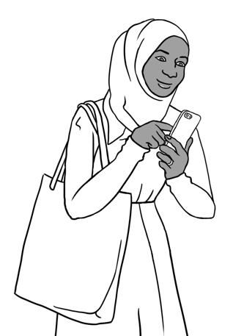



**Circle** the greeting. the ending.

**Tick** one.

****

This is a form.

a text message.

a Medicare card.

Ask students to read the message and write the answers.

1. Who is this message to?
2. Who is this message from?
3. When does Sahra’s class start?   
   Date ___________________________ Time __________________

|  |  |
| --- | --- |
|  |  |

Project the message. Read the message for the students and ask follow-up questions.

Hi Jenny,

I can’t come to class tomorrow. Sorry.  
My baby is sick.

Sahra Elmi



Encourage students to write a message to their teacher, explaining why they can’t come to class.

**You can’t come to class tomorrow**.

_______________________________________________________________________________________________________________________________________________________________________________________________________________

1. **Tick** why.

* I am sick.
* My child is sick.
* My mother is sick.
* I have a doctor’s appointment.

****



1. ** Write** a message   
   to your teacher here.

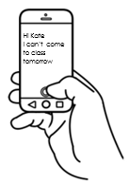

1. **Copy** your message   
   on your phone.
2. **Send** the message   
   to your teacher.

|  |  |
| --- | --- |
|  |  |

Project and read the note in class. Ask students follow-up questions about the note.

Tuesday 22 July

Hello students

Our class is in Room 3 today.

Your teacher Jenny



**Room change**

****

**Tick.**

|  |  |  |  |  |
| --- | --- | --- | --- | --- |
| 1. Who is the note **for**? |  | Jenny | **** | students |
| 1. Who is the note **from**? |  | Jenny |  | students |
| 1. Who is Jenny? |  | a student |  | a teacher |
| 1. Where is the class today? |  | Room 3 |  | Room 4 |
| 1. Where is the note? |  | on the door  of Room 3 |  | on the door of Room 4 |

Ask students to ask and answer the questions with their partners.



# 19. Two letter sounds

Point to the digraphs and read the sounds and the words. Ask students to repeat the sounds and the words. Ask students to circle the words in the sentences.

|  |  |
| --- | --- |
|  |  |

|  |  |  |
| --- | --- | --- |
| **Sounds** | **Words** | **Circle the words.** |
| **ch** | **ch**ange | There is a room **ch**ange today. |
| **sh** | **sh**e | **Sh**e reads the note. |
| **th** (1) | **th**ree | Please go to room **th**ree. |
| **th** (2) | **th**e | **Th**e note is on **th**e door. |
| **wh** | **Wh**at  **Wh**ere | **Wh**at is the room number today?  **Wh**ere is the note? |
| **ph** | **ph**one | What’s your **ph**one number? |

|  |
| --- |
| **Th**e |
| **th**e |
| **ch**ange |
| **wh**at |
| **ph**one |
| **wh**ere |
| **th**ree |
| **sh**e |

Ask students to complete the sentences using the words from the box. Encourage the students to put a tick next to the word that they have used.

1. There is a room change today.
2. __________ reads the note.
3. Our class is in room _______________.
4. __________ note is on ___________ door.
5. ___________ is the room number today?
6. ____________ is the note?
7. What ’s your _______________ number.



Encourage students to read the completed sentences to their partners and then copy in their notebooks.

# 20. How many?

Point to the picture and drill the words from the box. Ask students to count them e.g. tree and write the numbers. Read the numbers and point to the letter and number format.



|  |  |  |
| --- | --- | --- |
| seat | dog | tree |
| cloud  | bird | flower |

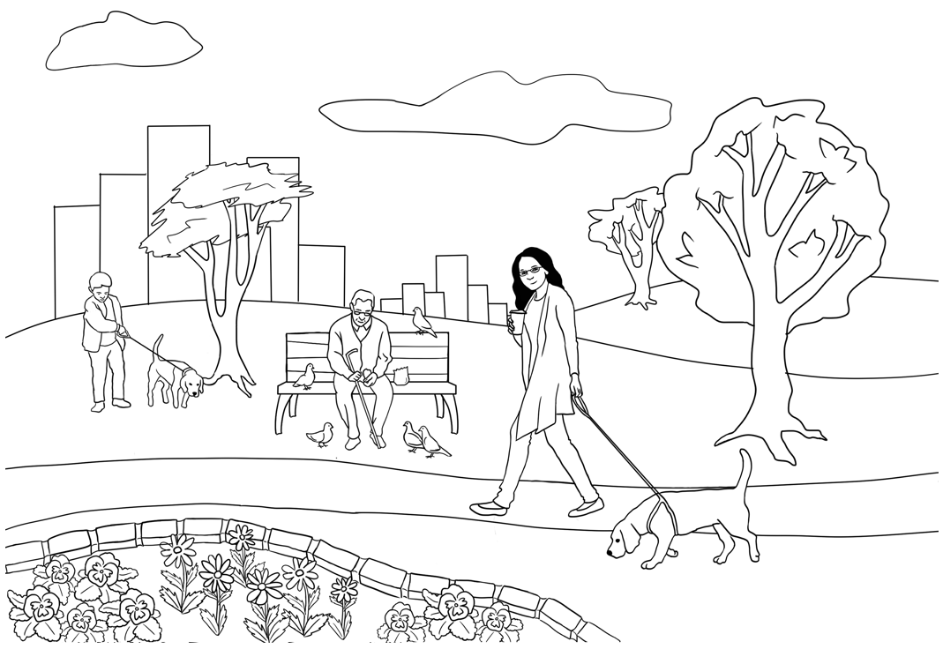

cloud

|  |  |  |  |  |
| --- | --- | --- | --- | --- |
| 1  Ask students to complete the sentences using the words from the box. Encourage the students to put a tick next to the word that they have used. |  one |  | 8 | eight |
| 2 | two | 9 | nine |
| 3 | three | 10 | ten |
| 4 | four | 11 | eleven |
| 5 | five | 12 | twelve |
| 6 | six | 13 | thirteen |
| 7 | seven | 14 | fourteen |

There is _____one seat.

There are ____________ dog**s**.

There are ____________cloud**s**.

There are ____________ tree**s**.

There are _______________ bird**s**.

There are _______________ flower**s**.

# 21. What colour?

Ask students to colour the boxes and then the picture below.

|  |  |  |  |  |
| --- | --- | --- | --- | --- |
|  | | | | |
| black |  |  | light blue |  |
| white |  | dark blue |  |
| grey |  | yellow |  |
| red |  | orange |  |
| pink |  | light green |  |
| Purple |  |  | Dark green |  |

Colouring helps student develop the fine motor skills required for pencil grip.

**Write** sentences   
with numbers and colours in your notebook.



One dog is _______________________**.**

Two birds are **_____________________.**

Three flowers are _________________**.**

# 22. At the childcare centre

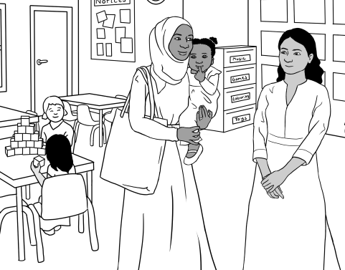

Ask students to listen and record as you read the conversation.

|  |  |
| --- | --- |
|  |  |

Sahra meets Nisha

at the childcare centre.

|  |  |
| --- | --- |
|  |  |

Encourage students to read the conversation by themselves and/ or in pairs and record their voice.

Nisha Hi. Can I help you?

Sahra Can I have childcare for my daughter please?

Nisha Yes, you can. What’s your daughter’s name?

Sahra Hani Jama

Nisha How old is your daughter?

Sahra Two

Nisha What’s her date of birth?

Sahra 24th June 2021

Nisha Good. What days do you need?

Sahra Monday and Tuesday

Nisha Do you have a Medicare card?

Sahra Mmm yes. Here it is.

Nisha Thank you. Can you fill in this form please?

Sahra Oh. Can you help me please?

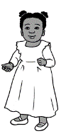

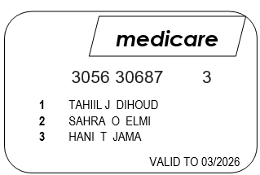



|  |  |
| --- | --- |
|  |  |

**Say** the **bold** words **strongly**.

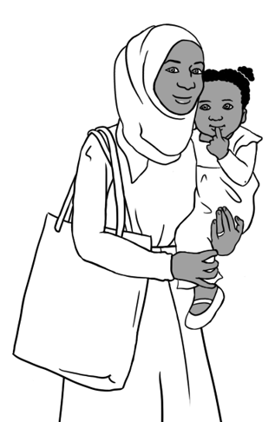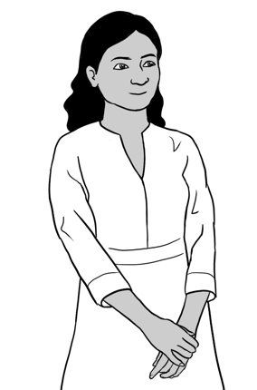

Can I **help** you?

What’s her **name**?

How **old** is your **daughter**?

What’s her **date** of **birth**?

What **days** do you **need**?

Do you **have** a **Medicare** card?

Can you **fill** in this **form** please?

Ask students to write Sahra’s answers. Encourage students to practice reading the conversation with a partner.

|  |  |
| --- | --- |
| **Nisha** | **Sahra** |
| Can I **help** you? | Can I have childcare for my daughter please? |
| What’s her **name**? |  |
| How **old** is your **daughter**? |  |
| What’s her **date** of **birth**? |  |
| What **days** do you **need**? |  |
| Do you **have** a **Medicare** card? |  |
| Can you **fill** in this **form** please? |  |

Ask students to put the words in order and then write the sentences.



you??

Can

**1**.

help

I

Can I help you? .

What’s

name?

her

**2**.

______________________________________________________.

daughter?

is

old

How

your

**3**.

________________________________________________________

date

What’s

**4**.

birth?

of

her

_________________________________________________________

**5**.

need?

daysq

What

do

you

_________________________________________________________.

card?

you

Medicare

a

have

Do

**6**.

_________________________________________________________.

please?

fill

**7.**

this

form

in

Can

you

_________________________________________________________

|  |  |
| --- | --- |
|  |  |



Project the message. Point to the greeting and ending in the message.

Read the message for the students and ask follow-up questions.

Hello Nisha,

Hani is sick.

She can’t come   
to childcare today.

Sahra Elmi



**Circle** the greeting. the ending.

Ask students to write the answers and match the greeting and ending words.

**1**. Who is the message to? _________________________

**2**. Why does Sahra send the message?

**3**. Hani is ____________________.

|  |  |
| --- | --- |
| 1. See you | next week. |
| 1. Good | soon. |
| 1. Good | later. |
| 1. See you | morning. |
| 1. See you | afternoon. |

**4**. She can’t come to _______________________ today.

# **23. Tahiil’s week**

|  |  |
| --- | --- |
|  |  |



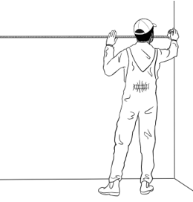

Explain that this is Tahiil’s week. Point to the days of the week and Tahiil’s actions. Encourage students to read with a partner.

1. I work on Monday.

1. I work and study on Tuesday.

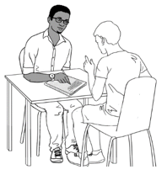

1. I work on Wednesday.

1. I work and study on Thursday.

1. I work on Friday.

1. I study on Saturday morning.

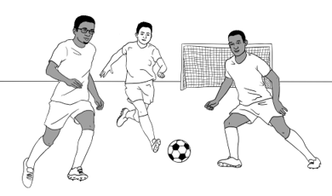

1. I play soccer on Sunday.



# 24. Tahiil plays soccer.

|  |  |
| --- | --- |
|  |  |

Read the conversation below. Point to the beginning and ending of the conversation. Encourage students to read the conversation.

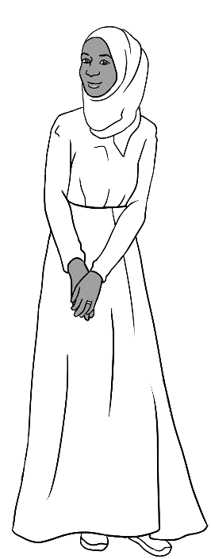Pam Good morning Sahra.

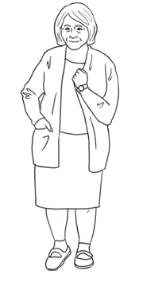Sahra Good morning Pam.

Pam It’s a beautiful day, isn’t it?

Sahra Yes, it is.

My husband Tahiil plays soccer today.

Pam It’s a good day for soccer.

Nice to see you Sahra.

Sahra Yes. See you soon Pam.

Ask students to complete the sentences using the words from the box. Encourage the students to put a tick next to the word that they have used.

Pam Good morning Sahra.

husband

morning

Good

soccer

is

day

soon

you

Sahra _________ morning Pam.

Pam It’s a beautiful _______, isn’t it?

Sahra Yes, it _____.

My _____________Tahiil plays soccer today.

Pam It’s a good day for _____________.

It’s nice to see _______ Sahra.

Sahra Yes. See you _________ Pam.

Encourage students to read the completed conversation with their partners.



|  |  |
| --- | --- |
|  |  |



Point to the new words and encourage students to copy them. Read the conversation below. Encourage students to read the conversation with a partner.

|  |  |
| --- | --- |
| to run  to run . | painful |
| to trip | to drive |
| to fall over | hospital |

|  |  |
| --- | --- |
|  |  |

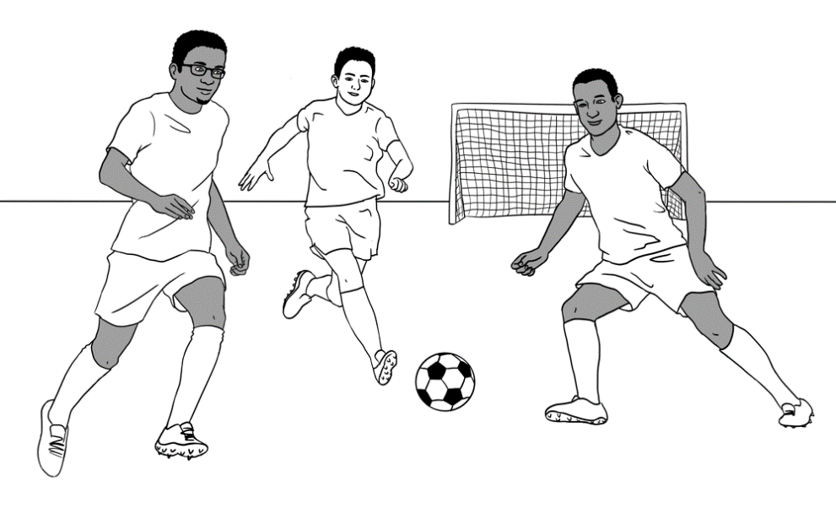

Tahiil plays soccer on Sunday.

Tahiil runs after the ball.   
He trips and falls over.

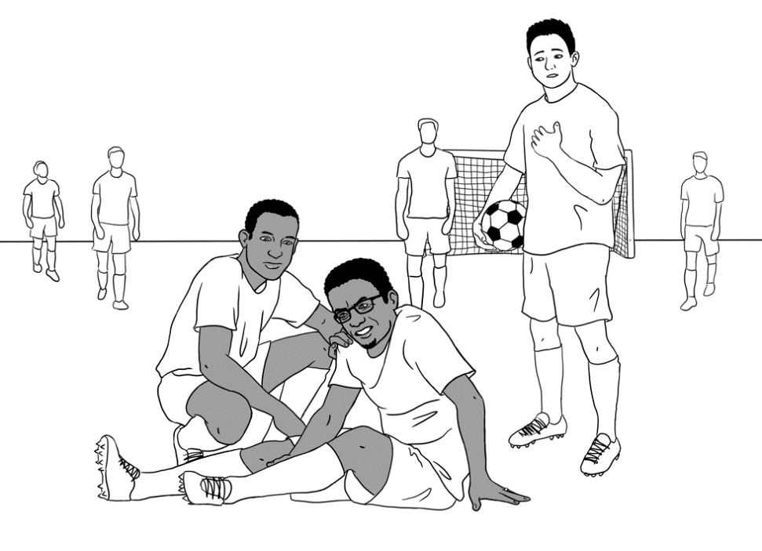

Can I help?

Are you OK Tahiil?

Oh. My foot is very painful.

Can you drive me to the hospital?

The Hospital Emergency

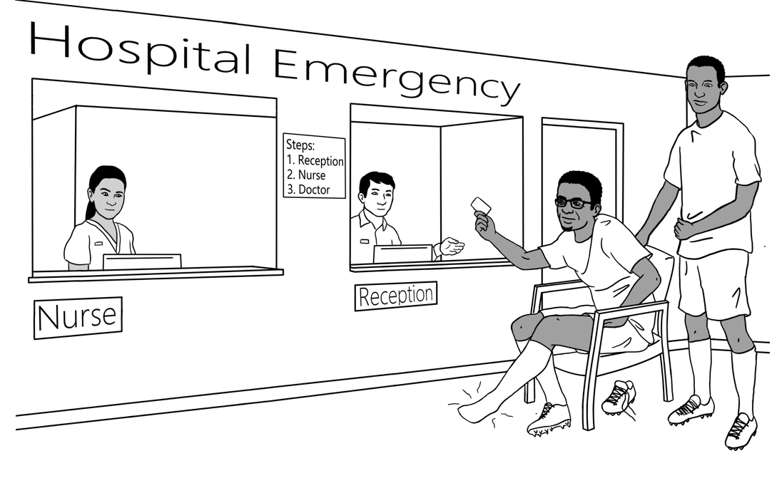

|  |  |
| --- | --- |
|  |  |

Read the sentences and point to the order of events, e.g. ‘first’ and ‘then’.

Abdi drives Tahiil to the hospital emergency.  
First, they go to reception.

Then Tahiil speaks to the nurse.

Then they wait for the doctor.



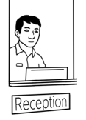

reception.

to

go

they

First,

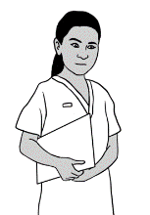 First, they go to reception. .

nurse.

Tahiil

to

the

speaks

Then

 ______________________________________________________________

doctor.

the

they

Then

wait

for

______________________________________________________________

|  |  |
| --- | --- |
|  |  |

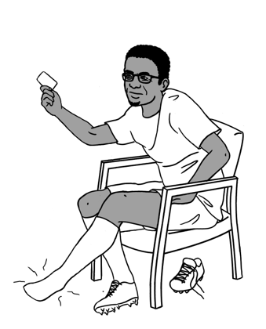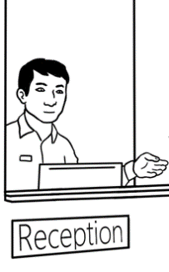

|  |
| --- |
| problem problem . |
| a lot of |
| to wait |

Ask students to record as you read the conversation. Encourage students to read the conversation with a partner and record their own voice as they are reading.



Reception Hello. What’s the problem?

Tahiil I hurt my foot playing soccer.

Reception Can you tell me your family name?

Tahiil Dihoud D – I – H – O – U - D

Reception What’s your first name?

Tahiil Tahiil T – A – H – I – I – L

Reception Do you have a Medicare card?

Tahiil Yes. Here it is.

Reception Are you in a lot of pain?

Tahiil Sorry, can you say that again, please?

Reception Is your foot painful?

Tahiil Yes. Very painful.

Reception Please sit there.

Fill in this form for the nurse.

Tahiil Thank you.

**

Ask students to complete the sentences using the words from the box. Encourage the students to put a tick next to the word that they have used.

first

problem 

foot

card

name

pain

your

fill in

sit

say

is

Reception Hello. What’s the problem ?

Tahiil I hurt my ________ playing soccer.

Reception Can you tell me your family ___________?

Tahiil Dihoud D – I – H – O – U - D

Reception And your __________ name?

Tahiil Tahiil T – A – H – I – I - L

Reception Do you have a Medicare ___________?

Tahiil Yes. Here it is.

Reception Are you in a lot of _________?

Tahiil Sorry, can you ________ that again, please?

Reception Is _______foot painful?

Tahiil Yes. My foot _______ very painful.

Reception Please ________ there.

_____ _____ this form for the nurse.

Tahiil Thank you.

Encourage students to read the completed conversation with their partners.



Point to the information on the form and check understanding.

**Tahiil fills in a form.**

|  |
| --- |
| **Hospital Patient Form**  *Write in CAPITAL LETTERS.*  *Tick the boxes*  ****  **Title** Mr Mrs Ms Miss  ****  **Family** **Name** DIHOUD  **Given** **Name** TAHIIL JAMA  **Date** **of** **Birth** 27/06/1994  **Address** UNIT 6, 50 BAKER ROAD  **Suburb** KELLIVALE **Postcode** 2421  **Phone** 0400 785 936  **Medicare** **Number**3056 30687 3 **Valid** **to** 06/2031 |



Ask students to circle the information from the form and put a tick next to the correct box.

****

1. Tahiil needs to fill in the form

 for Centrelink for the hospital  for TAFE classes

1.  Tahiil needs to fill in his

signature Medicare number title

email phone address country

Can you check my work please?

Encourage peer correction by getting students to ask their partners to check their work.



# 25. Signs at the Hospital

Project the signs on this page. Read the signs and ask students to repeat them. Ask the students to tick the signs they can see in their English Centre.

|  |  |  |  |
| --- | --- | --- | --- |
|  |  |  |  |
| **1** | Hospital | **2** | Exit |
| **3** | No Entry | First Aid | Buy Now | Discount Safety Signs Australia**4** | First Aid |
| **5** | Men’s toilet | **6** | Women’s toilet |
| **7** | No Smoking | **8** | Wash your hands. |
| **9** | Wet floor | **10** | Wear a face mask. |

**🗸**

**Tick** the signs in your English centre.

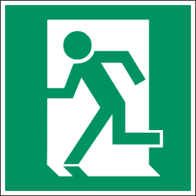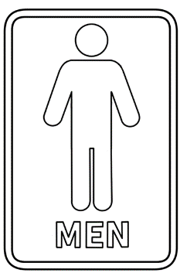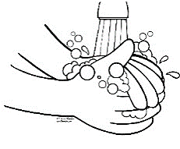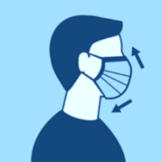

|  |  |
| --- | --- |
|  | No smoking |
|  | Wet floor |
| First Aid | Buy Now | Discount Safety Signs Australia | Hospital |
|  | Men’s toilet |
|  | Wear a face mask |
|  | No Entry |
|  | Women’s toilet |
|  | First Aid |
|  | Exit |
|  | Wash your hands |

# 26. Tahiil can’t come to class

|  |  |
| --- | --- |
|  |  |

A message from Tahiil to his teacher David**.**

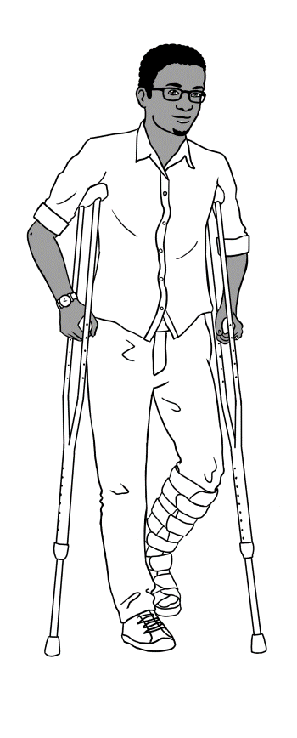

Hi David,

I hurt my foot.  
I can’t walk.   
I can’t come to class for 8 weeks.

I am very sorry.

Tahiil Dihoud

Project the message.

Read the message for the students and ask follow-up questions.

 **Circle** the greeting. the ending.



|  |
| --- |
| foot |
| Tahiil |
| David |
| 8 |
| walk |

**Write**.

1. This message is to David .
2. This message is from _______________
3. Tahiil hurt his ________________.
4. He can’t __________________.
5. He can’t come to class for ______ weeks.

****

**Tick** one.

Why does Tahiil write this message?

He can’t come to class for 3 weeks.

He can’t come to class tomorrow.

He can’t come to class for 8 weeks.

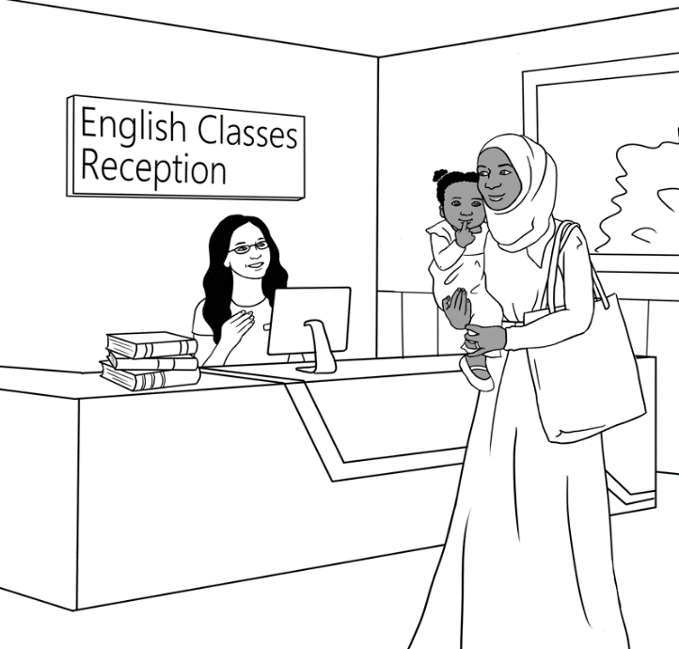

Project the conversation and read in class. Point to greeting and ending. Ask follow-up questions. Encourage students to read and practice the conversation with their partner and copy in their notebook.

Sarah Good morning.

Receptionist Good morning Sahra.

How are you?

Sahra I’m fine thanks.

Tahiil can’t come to class.

Receptionist Oh? Why?

Sahra He hurt his foot.

He can’t walk.

He can’t come to class for eight weeks.

Receptionist That’s not good.

Sahra I have his form for a volunteer tutor.

Receptionist Ah. Good. Thank you Sahra.

Sahra Thank you.



Ask students to complete the sentences using the words from the box. Encourage the students to put a tick next to the word that they have used.



|  |
| --- |
| you |
| Why |
| walk |
| morning |
| weeks |
| come |
| Thank |
| foot |
| form |
| not |

Sarah Good morning.

Receptionist Good morning Sahra.

How are _________?

Sahra I’m fine thanks.

Tahiil can’t _________ to class.

Receptionist Oh? ________?

Sahra

He hurt his ___________.

He can’t ____________.

He can’t come to class

for eight _____________.

Receptionist That’s ________ good.

Sahra I have his __________ for   
a volunteer tutor.

Receptionist Ah. Good. _____________ you Sahra.

Sahra Thank you.

Ask the students to copy the conversation in their notebooks.

# 27. Where and when?

Explain that ‘Wh’ questions such as **Wh**ere and **Wh**en are used when we want to ask for more information. Explain that ‘Where’ is used to ask about a place. Then read the sentences and emphasize the place. Ask students follow up questions to check understanding.

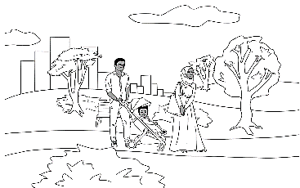

walking

**in** the park.

They

like



**1.**

They like walking in the park. .

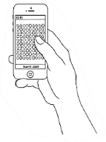

playing

**on** the phone.

He

games

likes

**2.**

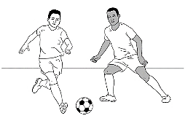

soccer

**in** the park.

They

playing

like

**3.**

Sahra

**to** childcare.

her

takes

daughter

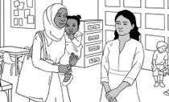

**4.**



Bao’s

**from** China.

comes

family

**5.**

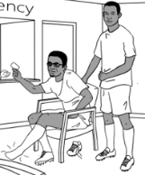

Abdi

**to** the hospital.

Tahiil

drives

**6.**

Explain that ‘Wh’ questions such as **Wh**ere and **Wh**en are used when we want to ask for more information. Explain that ‘When’ is used to ask about time. Then read the sentences and emphasize the time. Ask students follow up questions to check understanding.



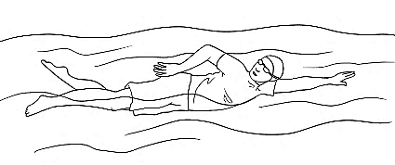

**on** Saturday.

morning

swimming

likes

He

**1.**

He likes swimming on Saturday morning. .



We

**in** the afternoon.

watch cccocouchcouchcouch

TV

**2.**

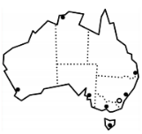

**in** March 2016.

came cccocouchcouchcouch

to

I

Australia

**3.**

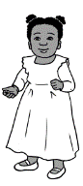

**4.**

**on** 24 June 2021.

was cccocouchcouchcouch

born

Hani

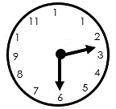

**on** Monday.

finishes

Sahra

**at** 2:30

**5.**

class

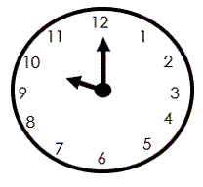

**at** 10

can

**on** Tuesday.

come

Anika

**6.**

# 28. Word Lists

|  |  |  |
| --- | --- | --- |
| **Family** | **Instructions** | **Adjectives** |
| wife  husband  daughter  son  mother  father  sister  brother  uncle  aunt  cousin  ________________  granddaughter  grandson  grandmother  grandfather  boy  girl  baby  child | read  write  say  ask  listen  point  spell  repeat  record  ________________  copy  check  circle  underline  clap  tick  colour | hot  warm  cold  beautiful  nice  fine  good  __________________  colour  black  white  grey  red  pink  purple  light blue  dark blue  yellow  orange  light green  dark green |

|  |  |  |
| --- | --- | --- |
| **School** | **When** | **Where** |
| workbook  notebook  pen  pencil  pencil case  rubber  sharpener  highlighter | time  year  month  week  day  morning  afternoon  today  tomorrow  next week | home  school  English class  reception desk  room  childcare  the garden  the park  hospital  Australia |

|  |  |  |
| --- | --- | --- |
| **Polite words** | **Food** | **Work and study** |
| excuse me  please  thank you  sorry | fruit  apples  bananas  bread  cake  coffee  hot chips  ice cream  noodles  orange juice  pizza  rice  tea | student  teacher  receptionist  doctor  nurse  painter  volunteer tutor |

|  |  |  |
| --- | --- | --- |
| **Verbs** | | **Words on forms** |
| to meet  to come  to do  to have  to go  to be  to like  to live  to learn  _________________  to study to work  to understand  to borrow  to need  to start  to finish  to send | to play  to walk  to run  to trip  to fall  to break  to hurt  to drive  _______________  to sit  to wait  to see  to fill in  to watch  to cook  to swim  to fish | full name  first name  given name  family name  surname  title  place of birth  date of birth  age  country  language  _______________  address  street  suburb  postcode  phone number  email  signature  married  emergency |



