

|  |
| --- |
| **English Ready**  [**22637VIC**](https://training.gov.au/Training/Details/22637VIC) **Course in EAL  VU23496 Communicate basic personal details and needs**  **VU23498 Read and write short highly familiar messages and forms** |

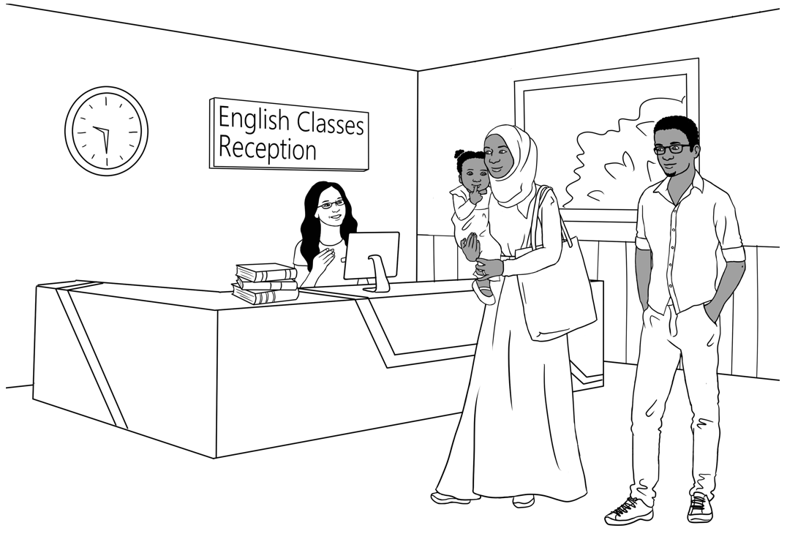**Conversation, Messages and Forms**

**Teacher Resources**

**Design team:** Vicki Hambling, Sue Paull, Frida Dean, Janice Langley, Glenise Kleehammer   
and Mary Wallace

**Illustrations:** Madelena Scott

**Acknowledgements:** The design team would like to thank the AMEP service providers and practitioners who participated in the trial and gave valuable feedback. The team would also like to acknowledge the use of the EAL Framework which underpins the design of this book.

Copyright of the EAL Framework is reserved to the Crown in the right of the State of Victoria. © State of Victoria (Department of Education and Training) 2023.  
_________________________________________________________________________________________

This English Ready Resource is licensed under a Creative Commons Attribution-NoDerivs 3.0 Australia licence (More information is available [here](http://creativecommons.org/licenses/by-nd/3.0/au/)). You are free to use, copy and distribute to anyone in its original form as long as you attribute Department of Home Affairs as the author and you license any derivative work you make available under the same licence.  
  
© Commonwealth of Australia 2023

With the exception of the Commonwealth Coat of Arms, the department’s logo, any material protected by a trade mark and where otherwise noted all material presented in this document is provided under a Creative Commons Attribution 4.0 International (<https://creativecommons.org/licenses/by/4.0/>) licence.

The details of the relevant licence conditions are available on the Creative Commons website (accessible using the links provided) as is the full legal code for the CC BY 4.0 licence (<https://creativecommons.org/licenses/by/4.0/legalcode>).

Use of all or part of this document must include the following attribution:   
© Commonwealth of Australia 2023

As far as practicable, material for which the copyright is owned by a third party will be clearly labelled.  The department has made all reasonable efforts to ensure that this material has been reproduced in this document with the full consent of the copyright owners.

Copyright requests and enquiries concerning usage not addressed by the CC BY 4.0 licence should be addressed to: comms@homeaffairs.gov.au at the Department of Home Affairs.

The terms of use for the Commonwealth Coat of Arms are available from the [It's an Honour](http://www.itsanhonour.gov.au/) website.

Where a copyright owner, other than the Commonwealth, is identified with respect to this material, please contact that third party copyright owner directly to seek permission.

**Introduction**

**The Teacher Book**

This book is an electronic reference. Print pages as only needed. It includes materials and activities for:

* pair work and class work
* revision and homework
* pronunciation
* extension

The book also contains audio transcripts and links to the audio MP3 files.

**The Student Workbook**

This book requires teacher direction and is **not** intendedfor independent learning. It is also not intended to be the only material used to teach these units. The activities included are not suitable to be used for assessment. The book is available as a Word document so that teachers can:

* localise and update the content
* adjust the material to suit the requirements of particular classes
* delete or add materials as required



At the back of the book are two emojis to give feedback to the teacher. Students can hold up the emoji which best reflects how they feel about an activity or a lesson.

**Table of Contents**

1. Meet the people 3

2. Do you understand? 7

3. Introductions 9

4. Instructions in the workbook 10

5. The Alphabet 11

6. Have a conversation 21

7. English class 23

8. When, where, who, what, why? 26

9. People in a family 29

10. Break words into syllables 32

11. What do you like? 33

12. Months of the year 37

13. Syllables – strong and weak 45

14. Words on Forms 46

15. An English Class for Sahra 53

16. The Days 65

17. The Time 67

18. Messages 69

19. Two-letter sounds 70

20. How many? 72

21. What colour? 78

22. At the Childcare Centre 81

23. Tahiil’s week 87

24. Tahiil plays soccer 88

25. The Hospital Emergency 90

26. Tahiil can’t come to class 99

27. Where and when? 103

28. Audio files and transcripts 108

# Meet the people

**Drawings of the characters**

The characters and scenes have been included so that teachers can produce their own materials as needed. A chart with the bio data [pages 5-6] was created to maintain consistency of information throughout the booklets. It may be useful to update character information to make it more relevant to the time of use.

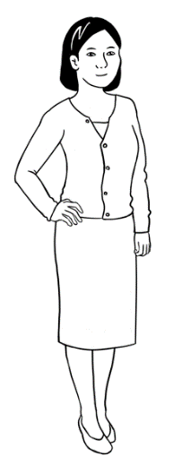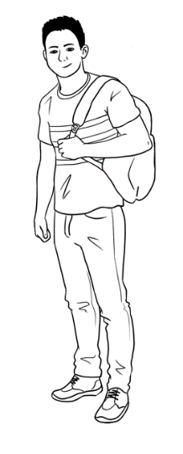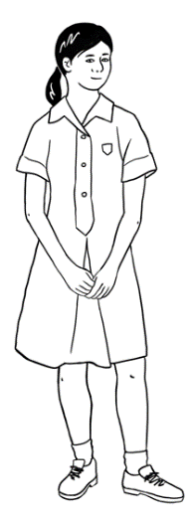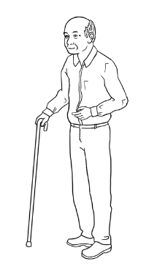

Bao

Mai

Lan

Ming

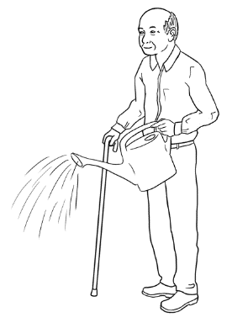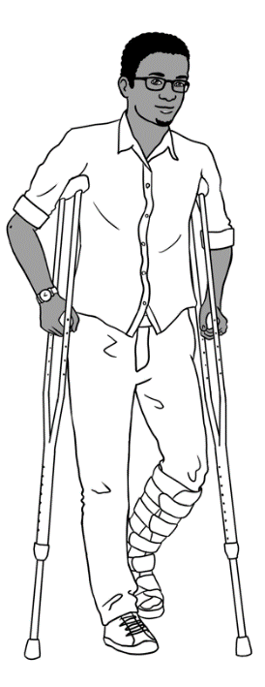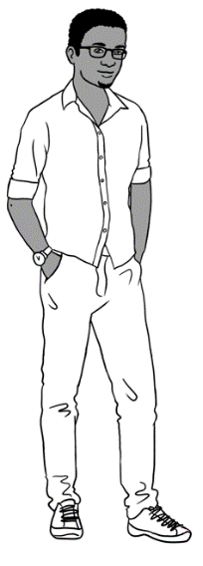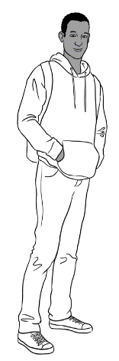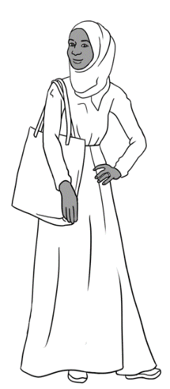

Sahra

Hani

Tahiil

Abdi

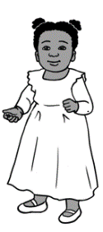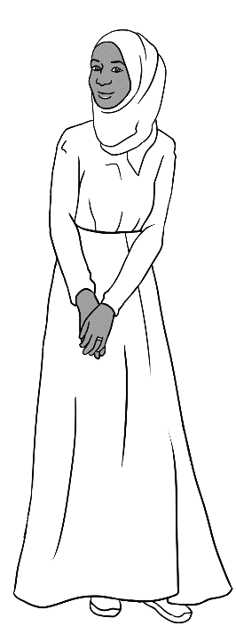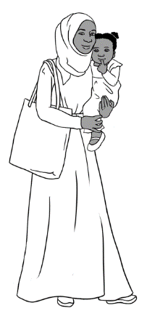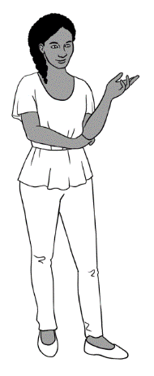

Anika

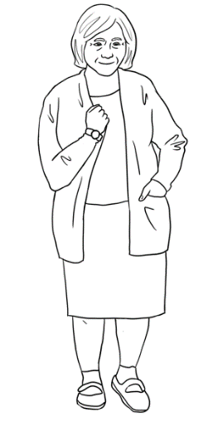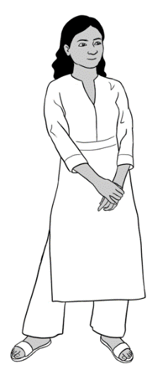

Nisha

Pam

Jenny

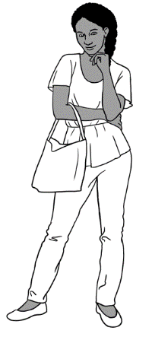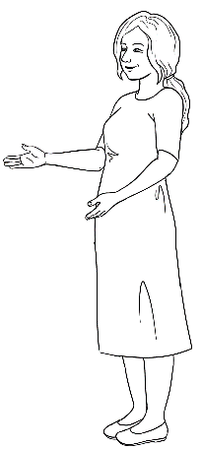

_______________________________________________________________________

**Characters in scenes**

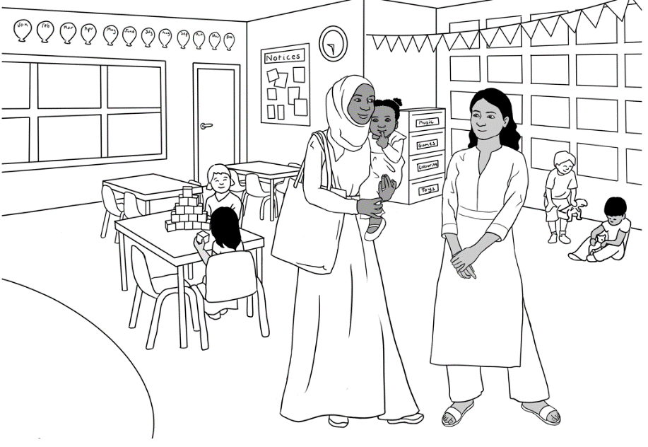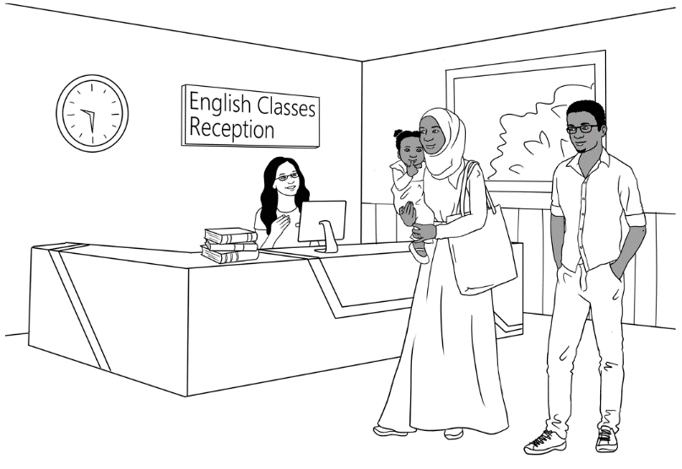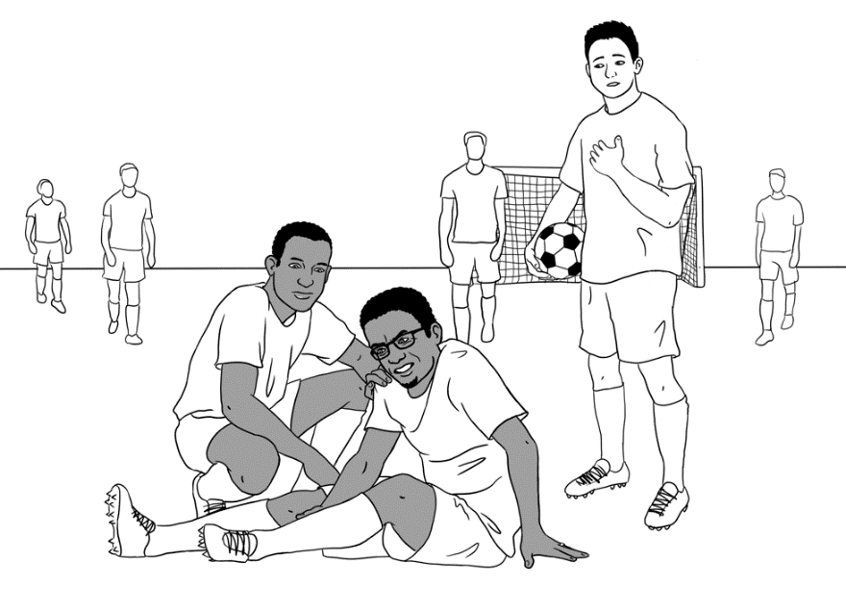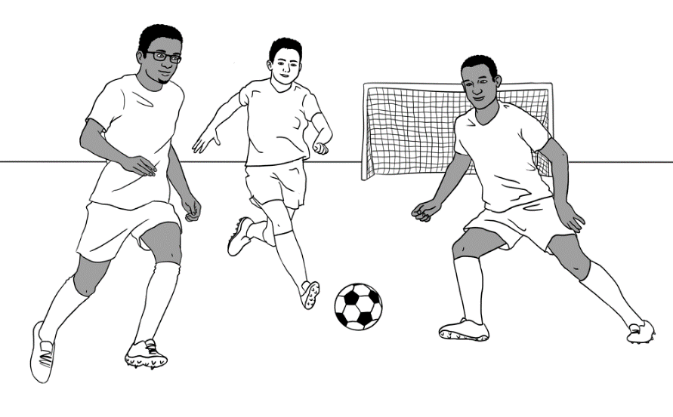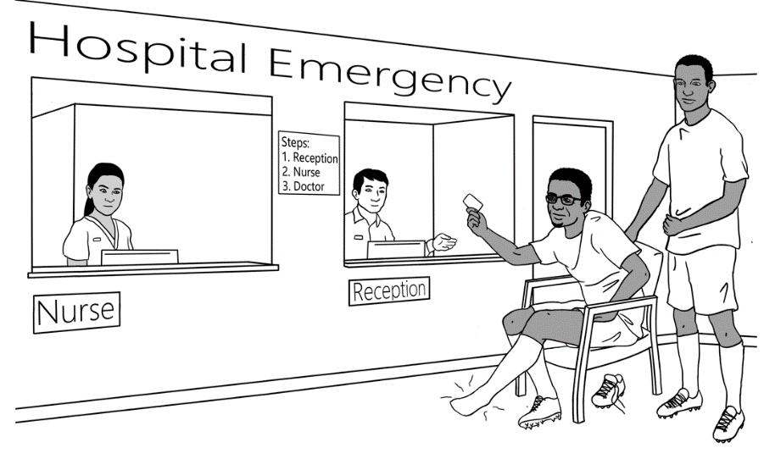

w



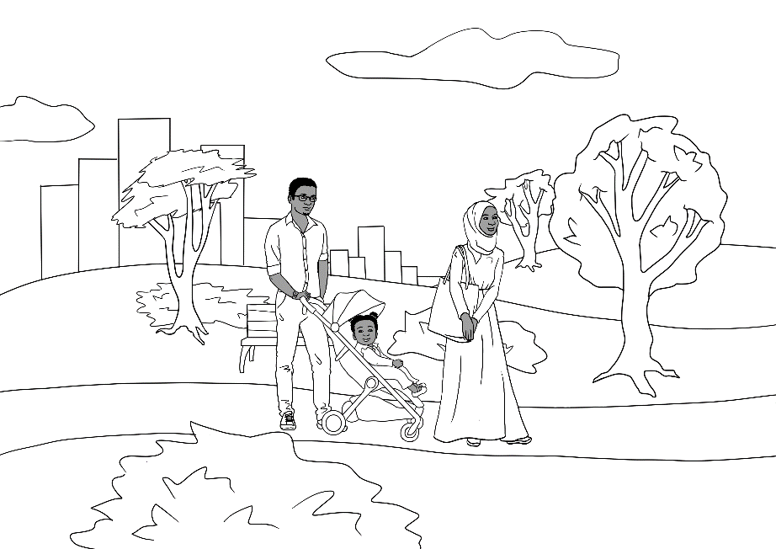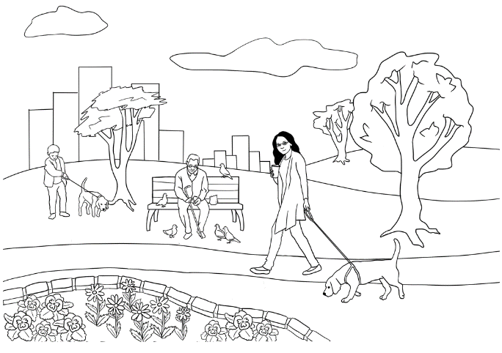

|  |  |  |  |  |  |
| --- | --- | --- | --- | --- | --- |
| **Personal details of the characters** | | | | | |
| **Name** | **Country**  **of origin** | **\*Age** &/or **Date**  **of birth** | **Date**  **of arrival** | **Address in Kellivale** | **Phone** |
| **Tahiil** Jama Dihoud | Somalia | 27.6.94 | 09.06.22 | Unit 6,  50 Baker Rd | 0400 785 936 |
| **Sahra** Omar Elmi | Somalia | 7.7.96 | 09.06.22 | Unit 6,  50 Baker Rd | 0455 961 259 |
| **Hani** Tahiil Jama | Somalia | 2 years 24.06.21 | 09.06.22 | Unit 6,  50 Baker Rd | _ |
| **Abdi** Omar Elmi | Somalia | 4.8.04 | 13.10.15 | Unit 1,  50 Baker Rd | 0465 971 356 |
| **Ming** Wu | China | 27.3.1959 | 07.05.19 | 70 Wattle St | 0418 335 748 |
| **Lan** Wu | China | 6.6.78 | 11.07.14 | 70 Wattle St | 0488 872 951 |
| **Bao** Wu | China | 19 years 13.05.2004 | 11.07.14 | 70 Wattle St | 0409 188 674 |
| **Mai** Wu    3065 75221 3  1. Tahiil Jama Dihoud  2. Sahra Omar Elmi  3. Hani Tahiil Jama  VALID 06/2025  ***medicare*** | China | 16 years 19 April | 11.07.14 | 70 Wattle St | 0487 592 811 |

|  |  |  |  |  |  |
| --- | --- | --- | --- | --- | --- |
| **Personal details of the characters** *[continued]* | | | | | |
| **Nisha** Kumar | India | 19.01.1978 | 06.04.13 | 56 North St | 0411 825 999 |
| **Pari** Kumar | India | 9 years |  | 56 North St |  |
| **Dev** Kumar | India | 7 years |  | 56 North St |  |
| **Anika** | Ethiopia | 30.09.1995 | 15.10.22 | 56 North Street | 0477 193 286 |
| **Fatima**  Khalil Hamed | Syria | 15 years  13 July | 16.11.2008 | 260 North St |  |
| **Carim**  Khalil Hamed | Syria | 19 years | 30.06.2004 | 260 North St | 0469 455 218 |
| **Jenny** *[Teacher]* | Australia | - | - | - | - |
| **Pam** *[Sahra’s neighbour]* | Australia | 02.02.1956 | _ | Unit 5,  50 Baker Rd | 0407 165 972 |
| **Paul**  *[VTS]* | Australia | _ | _ | _ | 0431 978 352 |

**\*Note 1**: Where dates of birth have been used in the booklets, they have been recorded here as exact figures. The age of the characters is relevant for the younger characters as they either attend childcare, primary school, secondary school or uni. All dates may be adjusted to make them more relevant to the time the resource is being used.

**Note 2**: Characters shaded in this colour are not introduced in this booklet.

# Do you understand?

**Activity - Make requests for repetition or clarification**

* Teach students the requests for clarification and repetition introduced in the student workbook
* Print the requests on the following page, laminate and cut up. [The request in greyscale is not in the workbook]
* Build confidence in using the expressions through regular class practice:
* Give the five expressions to five students. Select the most confident students at first.
* Ask these students to use their expression at least once during the class – initially with the teacher and later with each other.
* Give the expressions to different students in following classes.
* Teach additional expressions when appropriate.

|  |
| --- |
| Sorry. I don’t understand. |
| Can you help me please? |
| Can you say that again please? |
| Can you speak slowly please? |
| Can you spell that please? |

# Introductions

**Introductions and learning names**

Student names provide a practical vocabulary for building many skills:

1. **Word stress** – Write student names on the board in lists according to the number of syllables. Mark the stress and practise together. Clap, stamp feet or use a rubber band to mark the main stress with a large circle.

Mai Abdi Anika

1. **Build class connection by learning names - name cards**   
   - With ½ A4 page, fold and create name cards for each student.

Mark the stress pattern on the cards and collect at the end of each class.

1. **Teach how to introduce someone.**

* Write on the board, ‘*My name is___________.*’ Go round the class, with students introducing themselves.
* Next, on the board write, ‘*My name is______________, and this is ______________.’* Demonstrate how to introduce someone with an outstretched hand towards the person, palm up. Round the class, students introduce themselves and the person next to them. This introduction can be revised when a new student joins the class, and extended to include where a student comes from, their likes and dislikes, favourite colour etc.

1. **Use a ball for a different activity**. Ask students to stand in a circle. The student with the ball introduces themself, and then says   
   ‘*and this is ______________*’ and throws the ball to the student named. Continue the game till most students have introduced themselves.

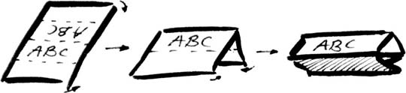

# Instructions in the workbook

|  |  |  |  |
| --- | --- | --- | --- |
|  | read |  | write |
|  | listen |  | say |
|  | spell |  | Ask questions. |
| **🗸** | tick |  | Colour |
|  | circle |  | underline |
|  | point |  | copy |
|  | Work with  a partner. |  | Record |
|  | Clap |  | Match |
|  | Notebook |

# The Alphabet

**Alphabet pictures**

The following pictures may be cut up by the students and matched to their initial sounds. There are two pictures for each sound. Words for the first set of pictures are in the student workbook on pages 7 & 8. Words for both set of pictures are on the following pages. Students can add the words for the second set of pictures to the table in their workbook.

**Picture set 1** – These pictures are in the student workbook.

|  |  |  |  |
| --- | --- | --- | --- |
|  |  |  |  |
|  |  |  |  |
|  |  |  |  |
|  |  |  |  |
|  | Rubber |  |  |
|  |  |  |  |
|  |  |  |  |

**Picture set 1** – These words are in the student workbook.

|  |  |  |  |
| --- | --- | --- | --- |
| **ambulance** | **ball** | **cake** | **down** |
| **eggs** | **foot** | **girl** | **home** |
| **in** | **juice** | **key** | **lamp** |
| **man** | **no** | **office** | **pen** |

|  |  |  |  |
| --- | --- | --- | --- |
| **question** | **rubber** | **student** | **tea** |
| **up** | **vegetables** | **workbook** | **x-ray** |
| **yes** | **zero** |  |  |

**Picture set 2-**  New pictures not in the student workbook

|  |  |  |  |
| --- | --- | --- | --- |
|  |  |  |  |
|  | **5** |  |  |
|  |  |  |  |
|  | **9** |  |  |

|  |  |  |  |
| --- | --- | --- | --- |
|  |  |  |  |
|  |  |  |  |
|  |  |  |  |

**Set 2 words –** These words can be added to the student workbook.

|  |  |  |  |
| --- | --- | --- | --- |
| **apple** | **banana** | **car** | **door** |
| **exit** | **five** | **glasses** | **hat** |
| **insect** | **jacket** | **kite** | **leg** |
| **mouse** | **nine** | **orange** | **pencil** |

|  |  |  |  |
| --- | --- | --- | --- |
| **queen** | **rain** | **strawberry** | **table** |
| **umbrella** | **van** | **window** |  |
| **yellow** | **zipper** |  |  |

|  |  |  |  |
| --- | --- | --- | --- |
| **a** | **b** | **c** | **d** |
| **e** | **f** | **g** | **h** |
| **i** | **j** | **k** | **l** |
| **m** | **n** | **o** | **p** |
| **q** | **r** | **s** | **t** |
| **u** | **v** | **w** | **x** |
| **y** | **z** |  |  |

# Have a conversation

**Activity 1** – **A short conversation** for role play and sequencing

**Activity 2** – **How to be polite**

The following page can be projected and used for a class exercise.

Bao: G’day Abdi.   
How’s it going?

Abdi: Great. How about you?

Bao: I’m OK.   
Do you wanna play soccer today?

Abdi: Sorry. I can’t play today.   
I can play tomorrow.

Bao: OK. See ya tomorrow.

Abdi: See ya.



wanna = want to

|  |
| --- |
| G’day Abdi.  How’s it going? |
| Great. How about you? |
| I’m OK.  Do you wanna play soccer today? |
| Sorry. I can’t play today.  I can play tomorrow. |
| OK. See ya tomorrow. |
| See ya. |

**How to be polite**

|  |  |
| --- | --- |
| Greeting | Good morning / Good afternoon |
| End the conversation. | Nice to see you. Bye. |
| Ask a question. | Hi. How are you?  Good thanks, and you? |
| Say ‘please’. | Can you shut the door **please**? |
| Say ‘thank you’. | Yes. **Thank you.** |
| Say ‘Excuse me’. | **Excuse me**, can I sit here? |

**What is polite**? **Tick.**

|  |  |
| --- | --- |
| **1**  **🗸** | **2** |
| Nice to meet you.  **🗸** | Yes. |
| Open the door. | Can you open the door please? |
| Can you give me the rubber please? | Give me the rubber. |
| Speak slowly. | Can you speak slowly please? |
| Excuse me, can you  repeat that please? | What? |

# English class

**Activity – ‘Can I borrow________? Pair work**

***Preparation***

1. Copy the page of classroom objects so each pair of students has:

* a set of cards
* a master sheet with all the objects.

1. Pre-teach the new additions to those in the student book, a pair of scissors, a pair of glasses, a ruler, a USB and an umbrella. Also teach the use of *your* in front of *notebook* and *workbook*,
2. Revise the questions and responses in the workbook.

***Activity***

1. Students cut up the cards and put them in a pile face down.
2. Each student selects three cards only, leaving six cards unselected.
3. Students look at their cards and the list of objects on the master sheet.   
   They then take turns to ask their partner:

* *Can I borrow* ***a/an*** *_____________ please?*
* *Can I borrow* ***your*** *______________ please?*

Their partner responds:

* *Yes, here’s a/an______________.*[Then gives their partner the object.]   
   object

**or**

* *Oh no. Sorry _______________.   
   name of partner*

|  |  |
| --- | --- |
| a highlighter | an umbrella |
| three pencils | a sharpener |
| a rubber | two pens |
| a ruler | a USB |
| A picture containing text, sign  Description automatically generatedyour notebook | your workbook |
| a pair of scissors | a pair of glasses |

**Object cards**

**Master sheet with all objects**

|  |  |
| --- | --- |
| a highlighter | your workbook |
| three pencils | a sharpener |
| a rubber | two pens |
| a ruler | a USB |
| A picture containing text, sign  Description automatically generateda notebook | an umbrella |
| a pair of scissors | a pair of glasses |

# When, where, who, what, why?

**Activity 1 – Worksheet – When did you come to Australia?**

This worksheet uses the past tense which is not required at Course level.

However, it’s a question low-level students are often asked. The worksheet includes an oral activity in which students mix and interview a number of *classmates.* [the word *classmates* may need to be introduced.]

**Activity 2 – Worksheet – Where do you come from?**

The worksheet includes an oral activity in which students mingle and interview a number of classmates.

|  |
| --- |
|  |

**1. When did you come to Australia?**

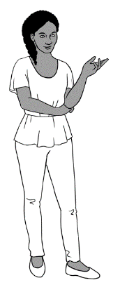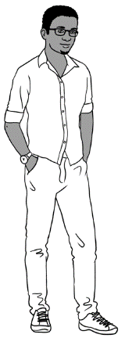

When did you come to Australia Tahiil?

I came to Australia in **June** 2022.

|  |
| --- |
|  |
|  |
|  |

I came to Australia in

*month year*

When did **you** come to Australia?

|  |  |
| --- | --- |
| **Month** | **🗸 Tick the months.** |
| January |  |
| February |  |
| March |  |
| April |  |
| May |  |
| June |  |
| July |  |
| August |  |
| September |  |
| October |  |
| November |  |
| December |  |

**2**. **Where do you come from?**

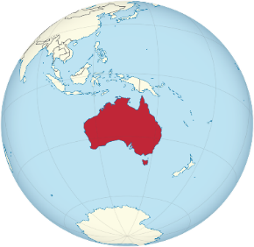

**?**

|  |
| --- |
|  |

I come from ___________________________.

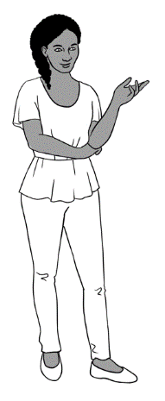

Where do you come from Tahiil?

I come from Somalia.

How do you spell Somalia?

Somalia S-O-M-A-L-I-A

|  |
| --- |
|  |

|  |  |
| --- | --- |
| **What’s your name?** | **Where do you come from?** |
|  |  |
|  |  |
|  |  |
|  |  |
|  |  |
|  |  |
|  |  |

|  |  |  |  |  |  |  |  |  |  |  |  |  |
| --- | --- | --- | --- | --- | --- | --- | --- | --- | --- | --- | --- | --- |
| Aa | Bb | Cc | Dd | Ee | Ff | Gg | Hh | Ii | Jj | Kk | Ll | Mm |
| Nn | Oo | Pp | Qq | Rr | Ss | Tt | Uu | Vv | Ww | Xx | Yy | Zz |

# People in a family

**Activity – Introduce your family**

As some students in the class may have suffered trauma, family loss and separation in their previous homeland or in Australia, there are two options for introducing a family. Students may choose to introduce:

* Mai’s family [This can be used as a model and completed together.]
* their own family

Copy enough of each worksheet so that students can choose the option with which they feel most comfortable.

The teacher can explain instructions to the students.

|  |
| --- |
|  |

**Mai’s family**

grandfather

grandmother

grandson

granddaughter

mother

father

son

daughter

brother

sister

husband

wife

uncle

aunt

cousin

Show this picture of Mai’s family.

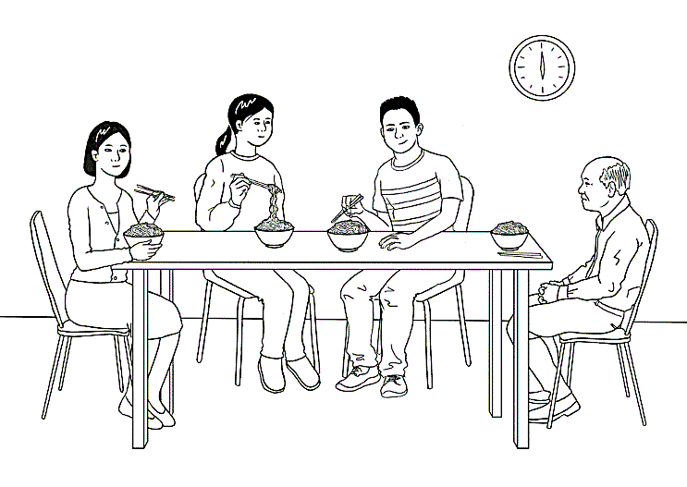

|  |
| --- |
|  |

This is Mai’s family.



This is her_______________________.

This is her_____________________________.

This is her__________________________.

They come from China.

**Introduce Mai’s family** to your partner.

|  |  |  |
| --- | --- | --- |
|  |  |  |

|  |  |  |
| --- | --- | --- |
| mother | grandfather | brother |
| mother |  |  |
|  |  |  |
|  |  |  |

|  |
| --- |
|  |

grandfather

grandmother

grandson

granddaughter

mother

father

son

daughter

brother

sister

husband

wife

uncle

aunt

cousin

**My family**

Show a photo of your family.



|  |
| --- |
|  |

about three people in your family.

This is my family.

This is my _________________________________.

This is my___________________________________.

This is my___________________________________.

We come from _____________________________.

**Introduce your family** to your partner.

|  |  |  |
| --- | --- | --- |
|  |  |  |

|  |  |  |
| --- | --- | --- |
|  |  |  |
|  |  |  |
|  |  |  |
|  |  |  |

# Break words into syllables

**Teaching syllables**

1. Say a word from the list below or any words introduced in class.   
   Repeat it, breaking it into syllables.
2. Demonstrate the syllables physically by:
   * tapping your hand, a pen or a ruler on the table
   * clapping
   * punching the air
   * stamping your feet
   * taking a step for each syllable.
3. Ask students to repeat the word with the action several times.
4. Count the syllables as you clap or tap etc
5. Create a table on the board similar to the one below. Write the word in the correct column.
6. Repeat the process with the remaining words.

In a later class, the words could be enlarged and written on paper. Students could then attach the words to the board in the right column using magnets or copy the words in the column.

|  |  |  |
| --- | --- | --- |
| **Syllables** | | |
| **1** | **2** | **3** |
| read | copy | afternoon |
| write | circle | tomorrow |
| spell | workbook | understand |
| clap | notebook | underline |
| tick | classmates | syllable |
|  | question |  |
|  | answer |  |
|  | morning |  |
|  | student |  |

# What do you like?

**Activity 1 –Vowels**

This section provides some basic words to focus on vowels.

**Activity 2 – Using body language – Pair work**

Student A & B have different questions to ask. Students need to use body language to convey meaning – no words. Demonstrate the activity with a confident student.

|  |  |  |  |  |  |  |  |  |  |  |  |  |
| --- | --- | --- | --- | --- | --- | --- | --- | --- | --- | --- | --- | --- |
| **Aa** | Bb | Cc | Dd | **Ee** | Ff | Gg | Hh | **Ii** | Jj | Kk | Ll | Mm |
| Nn | **Oo** | Pp | Qq | Rr | Ss | Tt | **Uu** | Vv | Ww | Xx | Yy | Zz |

**1. Vowels**

|  |  |  |  |
| --- | --- | --- | --- |
| apples | bananas | cake | orange  juice |
| noodles | rice | pizza | coffee |
| ice cream | tea | hot chips | bread |

|  |  |  |  |
| --- | --- | --- | --- |
|  |  |  | **a e i o u** |

|  |
| --- |
|  |

|  |  |  |  |
| --- | --- | --- | --- |
| _ ppl _ s | b _ n _ n _ s | c _ k _ | _ r _ ng _  j _ _ c _ |
| n _ _ dl _ s | r_ c _ | p_ zz _ | c _ ff _ _ |
| _c_  cr_ _ m | t_ _ | h _ t  ch _ ps | br _ _ d |

**2. Use body language – Pair work**

**Student A**

|  |  |  |
| --- | --- | --- |
| **Body Language** | | |
| **?**  Yes, I do. | I’m not sure. | No, I don’t. |

|  |  |  |
| --- | --- | --- |
|  |  |  |

Do you like ________________?

|  |  |  |  |  |  |  |  |  |
| --- | --- | --- | --- | --- | --- | --- | --- | --- |
| bread | | | hot chips | | | coffee | | |
| Yes | **?** | No | Yes | **?** | No | Yes | **?** | No |

|  |  |  |  |  |  |  |  |  |
| --- | --- | --- | --- | --- | --- | --- | --- | --- |
| cooking | | | fishing | | | gardening | | |
| Yes | **?** | No | Yes | **?** | No | Yes | **?** | No |

|  |
| --- |
|  |

My partner likes _____________________ and _____________________.

My partner doesn’t like ________________ and ____________________.

**Student B**

|  |  |  |
| --- | --- | --- |
| **Body Language** | | |
| Yes, I do. | **?**  I’m not sure. | No, I don’t. |

|  |  |  |
| --- | --- | --- |
|  |  |  |

Do you like ________________?

|  |  |  |  |  |  |  |  |  |
| --- | --- | --- | --- | --- | --- | --- | --- | --- |
| cake | | | orange juice | | | bananas | | |
| Yes | **?** | No | Yes | **?** | No | Yes | **?** | No |

|  |  |  |  |  |  |  |  |  |
| --- | --- | --- | --- | --- | --- | --- | --- | --- |
| reading | | | playing soccer | | | swimming | | |
| Yes | **?** | No | Yes | **?** | No | Yes | **?** | No |

|  |
| --- |
|  |

My partner likes _____________________ and _____________________.

My partner doesn’t like ________________ and ____________________.

# Months of the year

**Activity 1 – The months - long and short forms**

The strips can be cut up and used for matching and ordering.

|  |  |
| --- | --- |
| **January** | **February** |
| **March** | **April** |
| **May** | **June** |
| **July** | **August** |
| **September** | **October** |
| **November** | **December** |

|  |  |
| --- | --- |
| **Jan** | **Feb** |
| **Mar** | **Apr** |
| **May** | **June** |
| **July** | **Aug** |
| **Sept** | **Oct** |
| **Nov** | **Dec** |

**Activity 2 - Ordinals**

*Teach the patterns:*

* Numbers ending with one, two and three are irregular   
  e.g.1 *first*, 2 *second* and 3 *third* - 21 twenty first, 22 twenty second, 23 twenty third etc

Exceptions to this rule -11 *eleventh, 12 twelfth and 13 thirteenth*.

* Multiples of 10 are pronounced differently - *twentieth and thirtieth*

*Practise activities:*

* Matching – enlarge on A3 paper and cut up. Practise saying the numbers.
* Memory/concentration game – use a portion of the numbers   
  e.g. 1-10.
* Write the word for the ordinal number on the board e.g. *first*, and ask a question using the ordinal number   
  e.g. ‘*What’s your* ***first*** *name? or What’s the* ***first*** *month of the year?*
* Use a calendar and ask students to point to *the* ***thirtieth*** *day of November* or point to a day and ask, ‘*What day is this?*’
* Bingo – Play first as a class. Then play in small groups. One student to say the numbers for the group.

|  |  |  |  |  |  |  |
| --- | --- | --- | --- | --- | --- | --- |
| 1 | fir**st** | 1**st** |  | See the source image | | |
| 2 | seco**nd** | 2**nd** | 17 | seventeenth | 17th | |
| 3 | thi**rd** | 3**rd** | 18 | eighteenth | 18th | |
| 4 | fourth | 4th | 19 | nineteenth | 19th | |
| 5 | fifth | 5th | 20 | twentieth | 20th | |
| 6 | sixth | 6th | 21 | twenty fir**st** | 21**st** | |
| 7 | seventh | 7th | 22 | twenty seco**nd** | 22**nd** | |
| 8 | eighth | 8th | 23 | twenty thi**rd** | 23**rd** | |
| 9 | ninth | 9th | 24 | twenty fourth | 24th | |
| 10 | tenth | 10th | 25 | twenty fifth | 25th | |
| 11 | eleventh | 11th | 26 | twenty sixth | 26th | |
| 12 | twelfth | 12th | 27 | twenty seventh | 27th | |
| 13 | thirteenth | 13th | 28 | twenty eighth | 28th | |
| 14 | fourteenth | 14th | 29 | twenty ninth | 29th | |
| 15 | fifteenth | 15th | 30 | thirtieth | 30th | |
| 16 | sixteenth | 16th | 31 | thirty fir**st** | 31**st** | |

|  |  |  |  |  |  |  |  |  |
| --- | --- | --- | --- | --- | --- | --- | --- | --- |
|  |  |  |  |  |  |  | |  |
| When you have **nine circles** on your card: | | | | | **Bingo.** | |  | |

**Bingo**

|  |  |  |  |  |  |  |
| --- | --- | --- | --- | --- | --- | --- |
| **Card 1** | | |  |  | **Card 2** |  |
| 31st | 22nd | 15th |  | 4th | 5th | 2nd |
| 11th | 24th | 9th |  | 30th | 3rd | 28th |
| 12th | 5th | 16th |  | 1st | 29th | 26th |
|  | **Card 3** |  |  |  | **Card 4** |  |
| 13th | 19th | 29th |  | 3rd | 18th | 14th |
| 6th | 10th | 21st |  | 27th | 8th | 20th |
| 12th | 7th | 26th |  | 17th | 23rd | 25th |

|  |
| --- |
|  |
|  |
|  |

**Activity 3 – Write and say the date - Pair work**

Revise the difference between writing and saying the date.

***Write*** the date 13 February [or 13th February]

***Say*** the date

* Explain the grid system if this is new for the class.
* Demonstrate the activity with a confident student. The first example is done for both Student A & B.

**Activity 4 – Dates and months game** [page 44]

**the** thirteenth **of** February

**Student A**

|  |  |  |  |  |
| --- | --- | --- | --- | --- |
| January | Jan |  | July | July |
| February | Feb | August | Aug |
| March | Mar | September | Sept |
| April | Apr | October | Oct |
| May | May | November | Nov |
| June | June | December | Dec |

|  |  |  |
| --- | --- | --- |
|  | What date is in **B1**? |  |
|  | The thirteenth of February |  |

|  |  |  |  |  |
| --- | --- | --- | --- | --- |
|  | **A** | **B** | **C** | **D** |
| **1** | 2 Aug | 13 Feb |  | 12 Jan |
| **2** |  |  | 9 Mar | 11 Nov |
| **3** |  | 5 Oct |  | 7 Feb |
| **4** | 1 May |  | 22 June |  |

|  |
| --- |
|  |

**Student B**

|  |  |  |  |  |
| --- | --- | --- | --- | --- |
| January | Jan |  | July | July |
| February | Feb | August | Aug |
| March | Mar | September | Sept |
| April | Apr | October | Oct |
| May | May | November | Nov |
| June | June | December | Dec |

|  |  |  |
| --- | --- | --- |
|  | What date is in **A1**? |  |
|  | The second of August. |  |

|  |  |  |  |  |
| --- | --- | --- | --- | --- |
|  | **A** | **B** | **C** | **D** |
| **1** | 2 August | 13 Feb | 5 April |  |
| **2** | 4 Nov | 1 Jan |  |  |
| **3** | 10 June |  | 15 Nov |  |
| **4** |  | 12 July |  | 3 Mar |

|  |
| --- |
|  |

**FINISHST**

**What month is before November?**

**What is the first month?**

**What is the date tomorrow?**

**Can you say 10th January 2015?**

**What year is it?**

**Dates and Months Game**

**What is the 5th month?**

**What is the date today?**

**When is your birthday?**

**What month is your birthday?**

**What month is after April?**

**What is the 2nd month?**

**Spell January.**

**Can you say 16th August 2023?**

**What month is after June?**

**Spell March.**

**Can you say all the months?**

**START**

# Syllables – strong and weak

**Extension work on syllables –** Add words introduced during classwork.

|  |  |  |
| --- | --- | --- |
|  |  |  |

**Clap** the strong syllable **strongly**.

|  |  |  |
| --- | --- | --- |
| **Word** | **How many syllables**? | **Copy the word.**  **Underline the strong syllable.** |
| granddaughter | 3 | granddaughter |
| grandson |  |  |
| father |  |  |
| mother |  |  |
|  |  |  |
|  |  |  |
|  |  |  |
|  |  |  |
|  |  |  |
|  |  |  |
|  |  |  |
|  |  |  |

# Words on Forms

**Activity 1 – A record of important personal information**

On the form on the following page, students can record their important personal information. Check all the student’s details are correct and the spelling of names is the same as on their passport. Students can take a photo of their details, or cut it out for safe-keeping. The completed form can be used for accurate copying and checking of information in a variety of situations both inside and outside the classroom.

**Activity 2 – Class exercise - Common information questions**

Copy and cut up the questions on page 48, enough so that each student has a question. Students walk round the room asking other students their question.

**Activity 3 – A game with *wh* questions**

Copy and cut up the question cards from activity 2. Add more questions if necessary. Students play in groups of 3 or 4.

**Activity 4 – Ask your teacher questions.**

* Read through the questions together
* Set a time limit e.g. 10 minutes.
* The student asks you as many questions as they can in the time limit given. Write the answers on the board for the students to copy.
* The students can also add their own questions in the space provided.

**Activity 5 – Pair work – Dates of birth and phone numbers**

The information activity on page 51 & 52 gives students an opportunity to practise reading, saying and writing dates and phone numbers. Using the personal details of the characters in the workbook removes the privacy problem of students needing to share their own personal details.

Pre teaching:

* practise the questions together. Note that Student A asks questions about women and Student B asks questions about men. This focuses on the use of *her* and *his*.
* Demonstrate the activity with a confident student.

|  |
| --- |
|  |

**My information**

**1**

First Name

Family Name

Address Street

Suburb _____________________________ Postcode _________

Date of Birth

Country

Phone Number

Emergency contact name:

Emergency contact number

Can you check my work please?

|  |
| --- |
|  |

|  |
| --- |
|  |



First Name __________________________________________________  
Family Name: _________________________________________________  
Address Street _______________________________________________  
 Suburb __________________________ Postcode _________

Date of Birth ___________________________________________________  
Country _______________________________________________________

Phone Number _______________________________________________

Emergency contact name ____________________________________

Emergency contact number __________________________________

Can you check my work please?

|  |
| --- |
|  |

Class exercise – common information questions

|  |
| --- |
| What’s your given name?  **2** |
| What’s your first name? |
| What’s your family name? |
| What’s your surname? |
| Where were you born? |
| What month were you born in? |
| What languages do you speak? |
| When did you come to Australia? |
| What’s your post code? |
| Do you have children? |

**1**

**START**

**2**

**?**

**3**

**4**

**?**

**5**

**6**

**?**

**7**

**8**

**?**

**26**

**END**

**25**

**24**

**?**

**23**

**?**

**22**

**9**

**10**

**11**

**?**

**12**

**?**

**21**

**?**

**20**

**19**

**18**

**?**

**17**

**?**

**16**

**?**

**Red - Miss a go.**

**Pick up a card and answer the question.**

**Green - Go forward 2 spaces.**

**15**

**?**

**13**

**14**

**?**

**3**

**Ask your teacher questions.**

**4**

|  |  |
| --- | --- |
| **Question** | **Answer** |
| Where do you come from? |  |
| Where do you live? What suburb? |  |
| When did you come to Australia? |  |
| Do you have children? |  |
| Do you drive to school? |  |
| What food do you like? |  |
| What do you do on the weekend? |  |
|  |  |
|  |  |

**Digital option:**

* Transfer the questions to one of the following sites:

<https://wordwall.net/> - choose Random wheel **\***

<https://wheeldecide.com/wheels/board-games/scattegories-spinner/>

* Send link to student via text, WhatsApp etc. Students can take turns asking other students questions.

**\*** The 10-minute video below gives a step-by-step guide on how to use Wordwall. Instructions about the Random Wheel starts at 7 minutes into the video.

<https://www.teachertrainingvideos.com/complete_wordwall>

**Student A**

**5**

|  |  |  |  |
| --- | --- | --- | --- |
|  |  |  |  |

What’s **Nisha’s** date of birth?

What’s **her** phone number?

|  |  |  |  |
| --- | --- | --- | --- |
|  | **Abdi** | **Ming** | **Bao** |
| **Date of birth** | 04.08.2004 | 27.03.1959 | 13.05.2004 |
| **Phone number** | 0465 971 356 | 0418 335 748 | 0409 188 674 |
|  | **Nisha** | **Anika** | **Pam** |
| **Date of birth** |  |  |  |
| **Phone number** |  |  |  |

**Student B**

What’s **Abdi’s** date of birth?

|  |  |  |  |
| --- | --- | --- | --- |
|  |  |  |  |

What’s **his** phone number?

|  |  |  |  |
| --- | --- | --- | --- |
|  | **Abdi** | **Ming** | **Bao** |
| **Date of birth** |  |  |  |
| **Phone number** |  |  |  |
|  | **Nisha** | **Anika** | **Pam** |
| **Date of birth** | 19.01.1978 | 30.09.1995 | 02.02.1956 |
| **Phone number** | 0411 825 999 | 0477 193 286 | 0407 165 972 |

Can you check my work please?

|  |  |  |  |
| --- | --- | --- | --- |
|  |  |  |  |

|  |  |
| --- | --- |
|  |  |

# An English Class for Sahra

**Activity 1 – Exercises for audio in the student book**

There are two listening exercises:

* Cutting up and ordering the conversation in pairs.
* A cloze exercise

**Activity 2 – Audio The receptionist helps Sahra**

This conversation is an extension exercise. The language in the conversation and the cloze on the form may be too difficult for some students. There are three listening exercises to follow up the conversation audio.

1. Cut up the questions and answers. Order with a partner.
2. Cloze with question words
3. Word order for questions

**Activity 3 - Sahra’s Form**

**Activity 4 – Can and can’t**

* Practise questions with *can* in a variety of contexts, and the short answers *Yes, I can. No, I can’t*.
* There are two scenarios. Students take turns to play the role of the receptionist and the student.
* Copy scenario 1 and cut it in half.
* The available days for classes are in white and the unavailable days   
  in grey.
* Divide the class into pairs and give each student half the worksheet.
* Demonstrate the information gap activity with a confident student.   
  The first example is completed for both students.

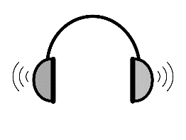

**3**



Listening Exercise 1

**Cut up** the sentences.

|  |
| --- |
|  |

|  |  |
| --- | --- |
| **Tahiil** | Thank you. We have a daughter.  Do you have childcare? |
| **Receptionist** | Yes. I can. |
| **Tahiil** | Hello. My name is Tahiil.  This is my wife Sahra.  She needs an English class. |
| **Receptionist** | Yes, we have child care.  Can you fill in this form please Sahra? |
| **Sahra** | Mmm. Can you help me please? |
| **Receptionist** | Hello. Nice to meet you.  You can enrol in English class here. |

|  |  |
| --- | --- |
|  |  |

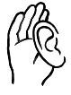

Listening Exercise 2

|  |  |  |  |  |
| --- | --- | --- | --- | --- |
| meet | fill | nice | help | please |
| name | enrol | please | English | have |

|  |  |
| --- | --- |
| **Tahiil** | Hello. My ____________ is Tahiil.  This is my wife Sahra.  She wants to _________ in an _________class. |
| Receptionist | Hello. __________ to _____________ you.  You can enrol in English class here. |
| **Tahiil** | Thank you. We have a daughter.  Do you __________ childcare? |
| Receptionist | Yes, we have child care.  Can you ________ in this form ____________ Sahra? |
| **Sahra** | Mmm. Can you ________ me __________? |
| Receptionist | Yes, I can. |

**The receptionist helps Sahra.**

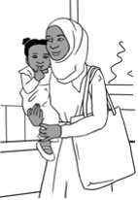

**3**

**Listen** to the conversation.

Receptionist: What’s your full name?

Sahra: My name is Sahra Omar Elmi.

Receptionist: Where were you born?

Sahra: I was born in Somalia.

Receptionist: When were you born?

Sahra: I was born on the 7th of July 1996.

Receptionist: What languages do you speak?

Sahra: I speak Somali and Arabic.

Receptionist: When did you arrive in Australia?

Sahra: Sorry. Can you say that again please?

Receptionist: When did you come to Australia?

Sahra: Umm. On the 9th of June 2022.

Receptionist: Are you married or single?

Sahra: I am married.

Receptionist: How many children do you have?

Sahra: I have one child.

Receptionist: What is your address and phone number?

Sahra: Mmm. It’s here on my card.

Receptionist: Oh yes. Thank you Sahra.

Please sign the form here.

Sahra: Yes. Thank you

|  |  |
| --- | --- |
|  |  |



Listening exercise 1

**Cut up** the sentences.

|  |  |
| --- | --- |
|  |  |

|  |
| --- |
| Receptionist: What’s your full name? |
| Sahra: I was born in Somalia. |
| Receptionist: Where were you born? |
| Sahra: My name is Sahra Omar Elmi. |
| Receptionist: When did you come to Australia? |
| Sahra: I was born on the 7th of July 1996. |
| Receptionist: What languages do you speak? |
| Sahra: Sorry. Can you say that again please? |
| Receptionist: When did you arrive in Australia? |

|  |
| --- |
| Sahra: I am married. |
| Receptionist: When did you come to Australia? |
| Sahra: I have one child. |
| Receptionist: How many children do you have? |
| Sahra: I speak Somali and Arabic. |
| Receptionist: Oh yes. Thank you Sahra.   Please sign the form here. |
| Sahra: Um. On the 9th of June 2021. |
| Receptionist: What is your address and phone number? |
| Sahra: Mm. It’s here on my card. |
| Receptionist: Are you married or single? |
| Sahra: Yes. Thank you. |

Listening exercise 2

|  |
| --- |
|  |

|  |  |  |  |  |
| --- | --- | --- | --- | --- |
| How | When | What | Are you | Where |
| When | What | Please | What | When |

Receptionist: ______________is your full name?

Sahra: My name is Sahra Omar Elmi.

Receptionist: _________________ were you born?

Sahra: I was born in Somalia.

Receptionist: ___________________ were you born?

Sahra: I was born on the 7th of July 1996.

Receptionist: ______________ languages do you speak?

Sahra: I speak Somali and Arabic.

Receptionist: ___________________ did you arrive in Australia?

Sahra: Sorry. Can you say that again please?

Receptionist: ______________ did you come to Australia?

Sahra: Um. On the 9th of June 2021.

Receptionist: _______ _______ married or single?

Sahra: I am married.

Receptionist: ___________________ many children do you have?

Sahra: I have one child.

Receptionist: _____________ is your address and phone number?

Sahra: Mmm. It’s here on my card.

Receptionist: Oh yes. Thank you Sahra.

________________ sign the form here.

Sahra: Yes. Thank you.

|  |
| --- |
|  |

Listening exercise 3

name?

What

is

full

your

What is your full name? .

born?

Where

were

you

__________________________________________________________

you

What

speak?

do

languages



_______________________________________________________________

arrive

you

did

in

Australia?

When



____________________________________________________________________

or

single?

married

Are

you

____________________________________________________________________

number?

your

phone

and

is

address

What



________________________________________________________________________

|  |
| --- |
|  |

**This is Sahra’s form.**

**3**

|  |
| --- |
| **Student Enrolment Form**  *PLEASE USE CAPITAL LETTERS.*  **🗸**  *Tick the box.*  Full Name: SAHRA OMAR ELMI  Country of birth: SOMALIA  **Date of Birth:**  Languages: SOMALI, ARABIC  **Date of arrival in Australia:**  **Marital Status**: Married Single  **Number of children:**  Address: UNIT 6, 50 BAKER ROAD  Suburb : KELLIVALE Postcode: 2421  Phone number: 0455 961 259  Signature: Sahra Elmi |

|  |  |
| --- | --- |
|  | **🗸** |

|  |  |
| --- | --- |
|  |  |

 For the doctor? For childcare? for English class?

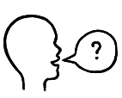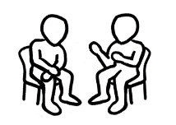

Can you check my work please?

*Can you check my work please*?

**Can and can’t**

**4**

**Scenario 1**



Can you come to class   
on **Monday afternoon**?

**Receptionist**

|  |
| --- |
|  |

|  |  |  |  |  |  |  |
| --- | --- | --- | --- | --- | --- | --- |
|  | **Monday** | **Tuesday** | **Wednesday** | **Thursday** | **Friday** | **Saturday** |
| **morning** |  | class | class | class | class | class |
| **afternoon** |  | class |  | class |  |  |
| **evening** | class |  | class |  |  |  |



**Yes**, I can.

**No**, I can’t.

**Student**

|  |  |
| --- | --- |
|  |  |

**Student**

|  |  |  |  |  |  |  |
| --- | --- | --- | --- | --- | --- | --- |
|  | **Monday** | **Tuesday** | **Wednesday** | **Thursday** | **Friday** | **Saturday** |
| **morning** |  | No | No |  | No |  |
| **afternoon** | 🗸 | No | No |  | No |  |
| **evening** |  |  |  |  |  |  |

**Scenario 2**



Can you come to class   
on **Monday morning**?

**Receptionist**

|  |
| --- |
|  |

|  |  |  |  |  |  |  |
| --- | --- | --- | --- | --- | --- | --- |
|  | **Monday** | **Tuesday** | **Wednesday** | **Thursday** | **Friday** | **Saturday** |
| **morning** |  | class | class | class |  | class |
| **afternoon** | class | class |  | class | class |  |
| **evening** |  | class | class |  |  |  |



**No**, I can’t.

**Yes**, I can*.*

|  |  |
| --- | --- |
|  |  |

**Student**

|  |  |  |  |  |  |  |
| --- | --- | --- | --- | --- | --- | --- |
|  | **Monday** | **Tuesday** | **Wednesday** | **Thursday** | **Friday** | **Saturday** |
| **morning** | 🗸 |  |  | No |  |  |
| **afternoon** |  |  | No | No | No |  |
| **evening** | No | No | No |  | No |  |

# The Days

**Intonation**

Demonstrate how the voice rises at the end of closed *yes/no* questions

and falls at the end of open *wh* questions and also at the end of answers and statements.

* Project the following page.
* Read each question and response clearly showing the intonation; use hand movements to show the rise and fall. Students repeat each question and response using similar hand movements.
* Divide the class in two, with one section reading Nisha’s questions and the other reading Sahra’s responses.
* Swap roles.

**Intonation**

What do you do on Monday?



On Monday? I go to class.

|  |  |
| --- | --- |
| **Nisha** | **Sahra** |
| What do you do on Monday? | On Monday?  I go to class. |
| What do you do on Tuesday? | On Tuesday?  I go to class. |
| What do you do on Wednesday? | On Wednesday?  I study at home. |
| What do you do on Thursday? | On Thursday?  I clean the house. |
| What do you do on Friday? | On Friday?  I go shopping. |
| What do you do on Saturday? | On Saturday?  I go to the park. |
| What do you do on Sunday? | On Sunday? I watch soccer. |

# The Time

**Activity 1 – Correctional stress – class activity**

Write about 10 words, letters or numbers on the whiteboard – a mix of what’s been already covered in class. e.g. numbers, letters, names, weather, days, months, times, colours.

These words, letters, numbers on the board provide the correct answers   
to the questions the teacher will ask. When introducing this activity, point to the answer after asking the question. Students answer, placing **stress** on the corrected word.

|  |  |  |
| --- | --- | --- |
|  | **Teacher questions** | **Student answers** |
| **1** | Today is Tuesday. *[It’s Monday.]* | No, it’s **Monday**. |
| **2** | It’s 11 o’clock. *[It’s 12 o’clock.]* | No, it’s **12** o’clock. |
| **3** | This is Hani. *[Holds up a picture of Sahra.]* | No, it’s **Sahra**. |
| **4** | This is green. *[Holds up something red.]* | No, it’s **red**. |
| **5** | It’s hot today, isn’t it? *[It’s a cold day.]* | No, it’s **cold.** |
| **6** | This is a small e. *[Holds up capital E.]* | No, it’s a **capital E**. |
| **7** | This is thir**teen**. *[Holds up the number 30.]* | No, it’s **thir**ty. |

**Activity 2 – What time do you get up on Monday?**

The worksheet includes a short survey of students.

January

Monday

Sahra

red

12 o’clock

E

30

5 June

2022

cold

|  |  |
| --- | --- |
|  |  |



I get up at 6:30.

What time do you get up on Monday?

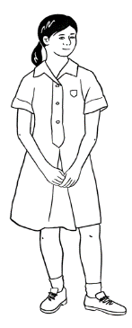

I get up at 7:00.

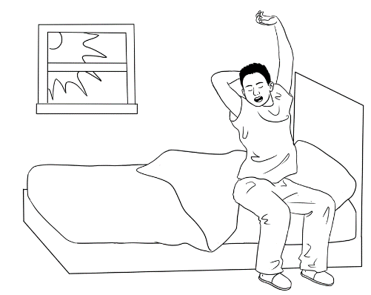

I get up at 8:30.

|  |  |
| --- | --- |
|  | I get up at _____________ on Monday. |
|  |  |
|  | What time do you get up on Monday? |

|  |  |
| --- | --- |
| **Student name** | **Write the time.** |
|  |  |
|  |  |
|  |  |
|  |  |
|  |  |
|  |  |

|  |
| --- |
|  |

**Write how many.**

___________ students get up at ____________ on Monday.

___________ students get up at ____________ on Monday.

___________ students get up at ____________ on Monday.

___________ students get up at ____________ on Monday.

# Messages

**Activity – A writing model**

1. Write the message on the board with the students. Read it together a number of times. Ask the students to copy it.
2. Ask which words could be changed for a different message. Underline those words in the original text. e.g *Teacher, Tuesday, doctor’s appointment, 2:30, Sahra*
3. Students write a message to you using the model. Write on paper, then on the phone and show you. Ask students not to send the message. This is the reason for the message:
4. An extension is to send a message to a classmate to ask them   
   to tell the teacher they can’t come to class. This would require   
   a new model for students to work from.

Hi Teacher

I can’t come to class on Tuesday.

I have a doctor’s appointment at 2.30pm.

Sahra



I can’t come to class on Thursday.

I have an appointment at Centrelink at 9.30.

# **Two-letter sounds**

**Activity – Pronunciation *th***

The letters **th** make two different sounds:

* Unvoiced as in **three**
* Voiced as in **the**.

Both sounds are made by separating the top and bottom teeth with the tip of the tongue and blowing air through the small gap over the tongue.

The unvoiced sound as in **three** is made by simply blowing air. Demonstrate by saying the word into the palm of the hand to feel the airflow.

The voiced sound as in **the** is made with the addition of the voice and vocal chords. Demonstrate by placing the palm over the throat to feel the vibrations.

Say each **th** word listed below, and ask students if the word is voiced or unvoiced. Write the word in the correct column.

|  |  |  |  |
| --- | --- | --- | --- |
| **th unvoiced** | | **th voiced** | |
| **th**ree | **th**irteen | **th**e | **th**at |
| **th**irty | **th**ird | **th**ey | **th**en |
| **th**anks | **Th**ursday | **th**em | **th**is |

**Two-letter consonant sounds reference lists**

The two-letter consonant sounds on the reference lists can be found throughout the Student Book. The lists can be used for a variety of activities and expanded as new words are introduced.

**Two-letter consonant sounds picture reference list**

|  |  |  |
| --- | --- | --- |
| **ch**ips | c**h**air | **ch**ild |
| **bl**ack | **bl**ue |  |
| bla**ck** | ti**ck**  **🗸** |  |
| **cl**ock | **cl**ap | **cl**oud |
| **dr**ive | **fr**iend | **fr**uit |
| **ph**one | **ph**oto | **pl**ay |
| **sh**arpener | **sh**op | fi**sh** |
| **st**op | **st**reet | **st**and |
| **st**udent | **sw**im |  |
| **th**ree  **3** | **tr**ee |  |

| **Sounds** | **Two-letter consonant words** |
| --- | --- |
| **bl** | **bl**ack, **bl**ock, **bl**ue |
| **br** | **br**other, **br**eak, **br**ing, **br**ick, **br**ead |
| **ch** | **ch**ild, **ch**ips, **ch**ildcare, **ch**ange, **Ch**ina, **ch**ildren |
| **ck** | bla**ck**, blo**ck**, ti**ck**, bri**ck,** si**ck** |
| **cl** | **cl**ass, **cl**oud, **cl**ap |
| **cr** | **cr**oss |
| **dr** | **dr**ive |
| **fr** | **fr**uit, **fr**om, **fr**iends, **Fr**iday |
| **gr** | **gr**andson, **gr**eat, **gr**ey, **gr**eeting |
| **ph** | **ph**one, **ph**oto |
| **pl** | **pl**ease, **pl**ay |
| **pr** | **pr**actise, **pr**oblem |
| **sh** | **sh**ake**,** **sh**arpener, **sh**e, **sh**op, fi**sh,** fi**sh**ing |
| **sl** | **sl**owly |
| **sm** | **sm**all |
| **sp** | **sp**ell |
| **st** | **st**op, **st**udent, **st**udy, **st**art, **st**reet |
| **sw** | **sw**im, **sw**ap |
| **th (1)** | **th**ree, **th**ings, **Th**ursday |
| **th (2)** | **th**e, **th**is |
| **tr** | **tr**ee, **tr**ip |
| **wh** | **wh**at, **wh**en, **wh**ite |

# How many?

**Pronunciation *b* and *p*** *[Commonly confused by Arabic speakers]*

It’s a good idea to do some pronunciation practice on the sounds ***p*** and ***b*** in this section.

Give each student a tissue to demonstrate the difference between the sounds **b** and **p**. Both sounds are made by pressing the lips together, then pushing them open with a puff of air. Show the lip formation and demonstrate the movement of air by holding a tissue in front of the mouth.

* The sound **p** is unvoiced as in **play.** **P** produces a puff of air and the tissue moves.
* The sound **b** is voiced as in **baby**. **B** is made by the addition of the voice and vocal chords. **B** does notproduce a strong puff of air, so there is little to no movement of the tissue.

Say each **b** or **p** word listed below, and ask students if the word is voiced or unvoiced. Write the word in the correct column.

|  |  |  |  |
| --- | --- | --- | --- |
| **p unvoiced** | | **b voiced** | |
| **p**artner | **p**ark | **b**anana | **b**us |
| **p**lease | **p**roblem | **b**oy | **b**rother |
| **p**lay | **p**izza | **b**all | **b**aby |
| **p**oint | **p**urple | **b**lack | **b**orrow |
| **p**en | **p**ink | **b**read | **b**lue |
| **p**encil | **p**ractise |  |  |

* Level A - pictures and words
* Level B - words and no pictures.

Students need to remember to add an s when necessary.

**Activity 1– Plurals memory game #1**

* Give each student a picture of one of the objects on the following page.
* Project the image on page 76 and give students a minute to count their objects. Close the image.
* Elicit the numbers of each object from the relevant students.

**Activity 2 – Plurals memory game #2**

Repeat the exercise by projecting the image on page 77. This has the same objects, but different numbers of each. Hand out either a level A or level B worksheet once the objects are no longer visible. Depending on their level, students can add the number of objects to either:

* Level A - pictures and words
* Level B - words and no pictures.

Students need to remember to remove an s when necessary.

Pictures of objects to cut up and distribute.

|  |  |  |
| --- | --- | --- |
|  |  |  |
| ball | apple | banana |
|  |  |  |
| key | ice cream | student |
|  |  |  |
| rubber | pen | pencil |
|  |  |  |
| workbook | notebook | phone |

Plurals Memory Game #1

|  |
| --- |
|  |
|  |
|  |

Plurals Memory Game #2

|  |
| --- |
|  |
|  |
|  |

|  |  |  |
| --- | --- | --- |
|  | How many? |  |

**Level A**

|  |  |  |  |
| --- | --- | --- | --- |
| balls | notebooks | keys | pens |
| students | bananas | rubbers | apples |
| phones | workbooks | ice creams | pencils |

|  |  |  |  |
| --- | --- | --- | --- |
| balls | A picture containing text, sign  Description automatically generatednotebooks | keys | pens |
| students | bananas | rubbers | apples |
| phones | workbooks | ice creams | pencils |

**Level B**

|  |  |  |
| --- | --- | --- |
|  | How many? |  |

# What colour?

**Activity – a colour dictation**

This is a listening and speaking exercise to revise the colours and vocabulary introduced in this section and section 20.

* Divide the class into pairs.
* Project Student A’s worksheet and explain that the six instructions in grey boxes need to be given to Student B. Student B must follow the instructions to colour thepicture at the top of the page.
* Once the six instructions have been given and Student B has completed colouring, the roles are reversed. Student A must then colour the picture at the bottom of the page by following Student B’s instructions.

|  |  |  |
| --- | --- | --- |
|  |  |  **|

**Student A**

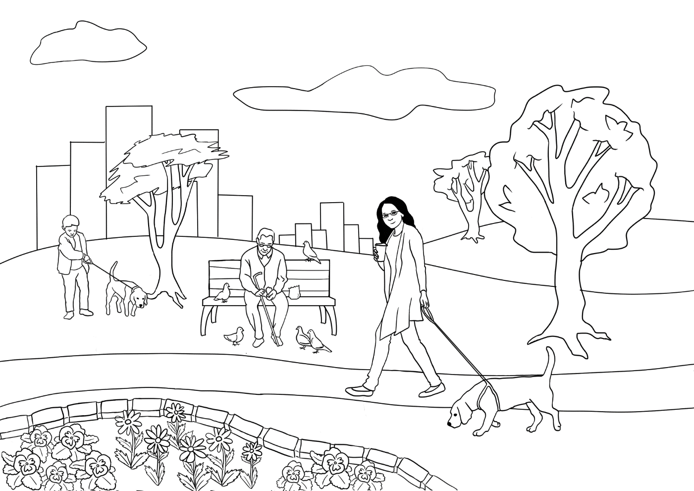

**5**. Colour 6 flowers yellow.

1. Colour the seat red.

**2**. Colour the tree light green.

**3**. Colour her jacket pink.

**6**. Colour 3 birds dark blue.

**4**. Colour the dog black.

**__________________________________________________________**

|  |  |  |
| --- | --- | --- |
|  |  |  **|



|  |  |  |
| --- | --- | --- |
|  |  |  **|



**Student B**



**_________________________________________________________**

|  |  |
| --- | --- |
|  |  |



**5**. Colour 6 flowers orange.

1. Colour the seat yellow.

**2**. Colour the tree dark green.

**3**. Colour her jacket purple.

**6**. Colour 3 birds light blue.

**4**. Colour the dog grey.

# At the Childcare Centre

**Activity 1 – Conversations at the childcare centre**

The following conversations would be particularly helpful for mothers with children in childcare. After listening, students can cut up and sequence each conversation. Some students may also be able to copy the dialogues into their notebooks. There is audio for both conversations.

* Conversation 1 – In the morning at the childcare centre - Audio
* Conversation 2 – In the afternoon – Audio

**Activity 2 – Asking for clarification - ‘I don’t understand’**

On page 87, there are three conversations in which students can practise asking for clarification when they don’t understand.



**4**



**5**

1. 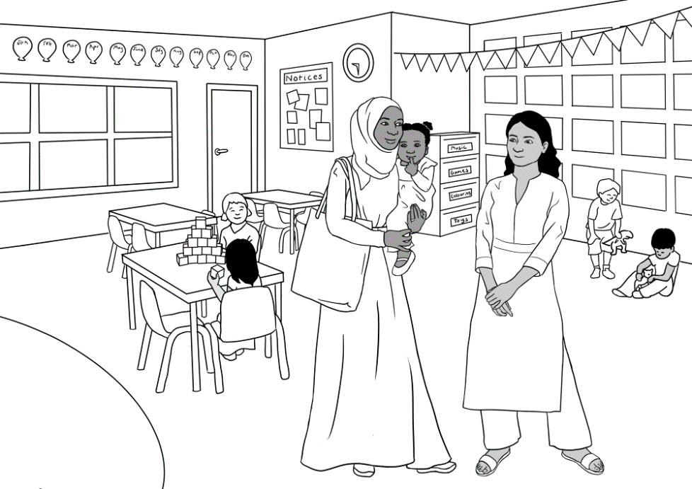**In the morning at the childcare centre**

**Listen**.



**4**

**Nisha:** Good morning Sahra. How are you?

**Sahra**: Good thanks Nisha.

**Nisha**: Sahra, do you have   
 Hani’s bag and water bottle?

**Sahra**: Yes, here they are.

**Nisha**: Can you put them here please?

**Sahra**: Ok. Here’s Hani’s hat.

**Nisha**: Good. Put her hat on now.

**Sahra**: Ok. Have a good day.

**Nisha**: You too. See you later.





**In the morning**

|  |  |
| --- | --- |
| Good morning Sahra.  How are you? | Ok. Here’s Hani’s hat. |
| Sahra, do you have Hani’s bag and water bottle? | Yes, here they are. |
| Can you put them here please? | Ok, have a good day. |
| Good. Put her hat on now. | Good thanks Nisha. |
| You too. See you later. |  |

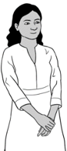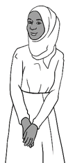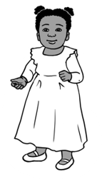

1. **In the afternoon at the childcare centre**



**5**

**Listen**.

**Nisha**: Hi Sahra. How was your day?

**Sahra**: Good thanks.

**Nisha**: Hani is very happy today.

**Sahra**: She loves playing with the children.

**Nisha**: Does she like fruit?

**Sahra:** Sorry. What do you mean?

**Nisha:** Does she like apples?

**Sahra:** Yes, she likes apples and bananas.

**Nisha**: Ok, thank you. See you tomorrow.

**Sahra**: See you tomorrow.



1. **In the afternoon**



|  |  |
| --- | --- |
| Hi Sahra.  How was your day? | She loves playing with the children. |
| Hani is very happy today. | Yes, she likes apples and bananas. |
| Does she like fruit? | See you tomorrow. |
| Does she like apples? | Good thanks. |
| Ok thank you.  See you tomorrow. | Sorry. What do you mean? |

**I don’t understand.**

|  |  |
| --- | --- |
|  |  |

|  |  |  |  |  |
| --- | --- | --- | --- | --- |
| **1** |  | Pam | Does it get hot in Somalia? |  |
| Sahra | **Sorry, can you say that again please?** |
| Pam | Is it hot in Somalia? |
| Sahra | The weather in Somalia is beautiful. |

|  |  |  |
| --- | --- | --- |
| **2** | Receptionist | When did you arrive  in Australia? |
| Sahra | **Sorry. Can you say that  again please?** |
| Receptionist | When did you come  to Australia? |
| Sahra | Um. On the 9th of June 2022. |



|  |  |  |  |
| --- | --- | --- | --- |
| **3** | Nisha | Does Hani like fruit? |  |
| Sarah | **Sorry. What do you mean?** |
| Nisha | Does she like apples? |
| Sahra | Yes, she likes apples and bananas. |

# Tahiil’s week

**Activity - Dictation**  
This short dictation tests the work in section 23 in the Student Book.   
All words are provided for students to copy – either from the column of days on the side or within the dictation itself. More confident students can fold or cover the column of days.

|  |  |  |  |  |  |  |  |  |  |  |  |  |
| --- | --- | --- | --- | --- | --- | --- | --- | --- | --- | --- | --- | --- |
| **Aa** | Bb | Cc | Dd | **Ee** | Ff | Gg | Hh | **Ii** | Jj | Kk | Ll | Mm |
| Nn | **Oo** | Pp | Qq | Rr | Ss | Tt | **Uu** | Vv | Ww | Xx | Yy | Zz |

|  |  |
| --- | --- |
| I work on _ o _ _ _ _. | Monday |
| I _ _ _ _ and study on _ u e _ _ _ _. | Tuesday |
| _ _ _ _ _ _ _ _ _ d _ e _ _ _ _. | Wednesday |
| I work and study on _ _ u r _ _ _ _. | Thursday |
| _ _ _ _ _ on _ r _ _ _ _. | Friday |
| I _ _ _ _ _ _ _  _ _ _ u r _ _ _ morning. | Saturday |
| I play soccer _ _ _ _ _ _ _ _. | Sunday |

# Tahiil plays soccer

**Vocabulary revision**

The vocabulary lists below include words introduced in previous sections and are grouped according to grammar or topic. The words can be given to students for homework to practice prior to the game below:

**The Fly Slap Game**

**\*** You will need two new different coloured fly swats and a whiteboard.

* Divide the class into two teams, named after the colours of the swats.
* Write the revision words randomly over the board. Say the words as you write and ask students to repeat. Elicit sentences with each word.
* A student from each team stands at the board holding their team’s swat.
* Students in the class take turns to call out a word. The first student at the board to slap the word wins a point for their team.
* Rotate students after about four words until everyone [if possible] has had a turn with the swats.
* Keep score on the board.

*Extension:* An extra point can be won if a team creates a sentence containing the word.

|  |  |  |  |
| --- | --- | --- | --- |
| beautiful | good | dark | orange |
| painful | black | light | nice |
| hot | cold | blue | green |
|  | | | |
| play | trip | run | break |
| fall | help | drive | work |
| study | come | see | send |
|  | | | |
| soccer | ball | hospital | message |
| form | room | door | note |
| phone | school | baby | student |
|  | | | |
| wife | daughter | son | husband |
| brother | sister | mother | father |
| uncle | grandson | granddaughter | grandfather |

# The Hospital Emergency

**Activity 1 – Conversations with the nurse and the doctor**

The following conversations, which include audio, continue the hospital scenario in the student workbook. Both dialogues include exercises.

*Conversation 1 : The nurse* *Audio*

*Conversation 2: The doctor* *Audio*

**Activity 2 – Ask questions about words on forms**

This activity includes the hospital form in the student workbook with some added details. It gives students some questions to ask when they don’t understand the language used on forms.

**Activity 3 – A text message from the hospital outpatients**

The message includes some common abbreviations on more formal text messages.

**Activity 4 – A get well card**

This provides a model for students to write a get-well card.



**6**



**7**



**6**

**Listen.**

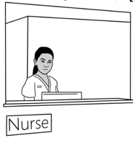Nurse Tahiil Dihoud?

Tahiil Yes.

Nurse What’s the problem Tahiil?

Tahiil I hurt my foot at soccer today.

Nurse Can you walk?

Tahiil No. It’s very painful.

Nurse OK. Please wait to see a doctor.

Tahiil Thank you.

**Match**.

|  |  |  |
| --- | --- | --- |
| What’s |  | walk? |
| I hurt my foot | very painful. |
| Can you | the problem Tahiil? |
| No. It’s | at soccer today. |
| OK. Please wait | to see the doctor. |

|  |  |
| --- | --- |
|  |  |

|  |  |
| --- | --- |
| **Student A** | **Student B** |
| What’s the problem? | I hurt my foot. |
| What’s the problem? | I hurt my hand. |
| What’s the problem? | I feel sick. |
| What’s the problem? | I have a bad headache. |

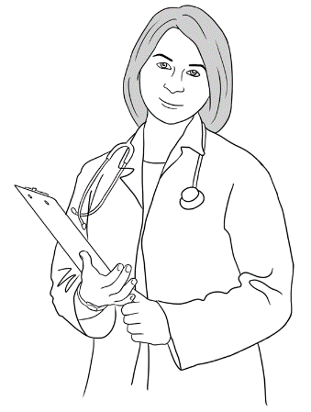



**7**

**Listen**.

|  |
| --- |
|  |

|  |
| --- |
| Doctor _____________. I’m the doctor.  ________name’s Elena.  What’s your __________?  name  foot  My  need  problem  wait  Hello  Tahiil Tahiil Dihoud  Doctor What’s the ____________ Tahiil?  Tahiil I hurt my _________ at soccer.  Doctor We __________ to x-ray your foot.  Tahiil OK.  Doctor Please ________ here.  ___________________________________________________________________________________________________________________________________________________________________________________________________________________________________  **After the x-ray**  you  school  walk  don’t  break  work  foot  go  weeks  eight  Doctor: Tahiil, your foot has a bad __________.  Do ________ work?  Tahiil: I’m a house painter.  I go to _____________too.  Doctor: You **can’t** __________.  You can’t __________.  You can’t __________ to school.  Tahiil: I _____________understand.  Doctor: Your ________ has a **very** bad break.  You can’t walk for __________ weeks.  Tahiil: Eight ____________? Oh no! |

|  |  |
| --- | --- |
|  |  |

**With the doctor**



**Cut up** the sentences.



**Order** the sentences with a partner.



**Listen** again.

|  |
| --- |
| **Doctor**: We need to x-ray your foot. |
| **Tahiil:** I hurt my foot at soccer. |
| **Doctor:** Please wait here. |
| **Tahiil:** Tahiil Dihoud |
| **Doctor**: Hello. I’m the doctor.  My name’s Elena.  What’s your name? |
| **Tahiil**: OK. |
| **Doctor**: What’s the problem Tahiil? |

**After the x-ray**



**Cut up** the sentences.



**Order** the sentences with a partner.



**Listen** again.

|  |
| --- |
| **Doctor:** You **can’t** walk.   You can’t work.  You can’t go to school. |
| **Tahiil:** I’m a house painter.  I go to school too. |
| **Doctor:** Your foot has a **very** bad break.  You can’t walk for eight weeks. |
| **Tahiil**: I don’t understand. |
| **Doctor**: Tahiil, your foot has a bad break.  Do you work? |
| **Tahiil:** Eight weeks? Oh no! |

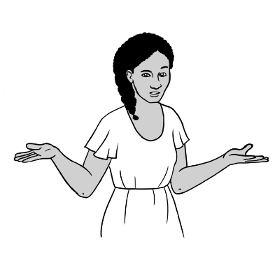**Ask questions about words on forms.**

I don’t understand the words on the form.

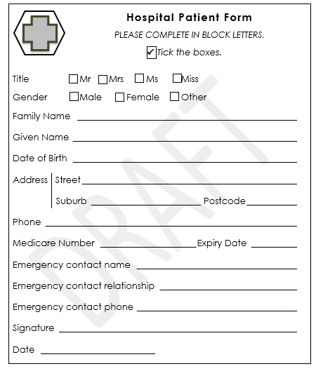

*Excuse me. What does this mean?*

*Sorry. I don’t understand this word.*

*I don’t understand this.   
Can you help me please*?

*Can you explain*

*this please*?

|  |  |
| --- | --- |
|  |  |

**Learn** the questions for homework.

*How many*?

|  |
| --- |
| **Hospital Patient Form**  *PLEASE COMPLETE IN BLOCK LETTERS.*  **🗸**  *Tick the boxes.*  Title Mr Mrs Ms Miss  Gender Male Female Other  Family Name  Given Name  Date of Birth  Address Street  Suburb Postcode  Phone  Medicare Number Expiry Date  Emergency contact name  Emergency contact relationship  Emergency contact phone  Signature  Date |

|  |
| --- |
|  |

Can you check my work please?

|  |
| --- |
|  |

Can you check my work please?

|  |
| --- |
|  |

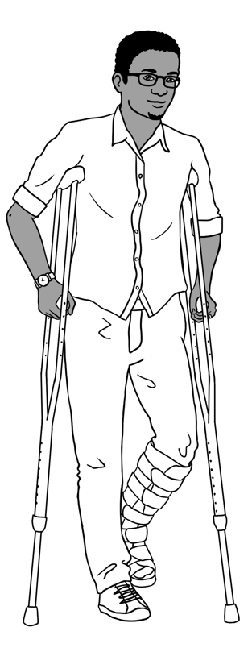 Tahiil 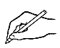gets a text message from the hospital.

**Reminder**

Mr Tahiil Dihoud  
Your **appt**at Kellivale Outpatients is   
at 9.30**am**   
on Mon12 Feb

Reply **Y** or **N**

Kellivale Outpatients

reminder

am = before midday

Y = yes

N = no

appt = appointment

**Match** the answers to the questions.

|  |  |
| --- | --- |
| **Questions** | **Answers** |
| 1. What is this? | Mr Tahiil Dihoud |
| 1. Who is the message **to**? | 9.00am |
| 1. Who is the message **from**? | a text message |
| 1. When is the appointment? | Kellivale Outpatients |
| 1. What time is the appointment? | Mon 12 Feb |
| 1. What does **Y** mean? | No |
| 1. What does **N** mean? | Yes |

|  |
| --- |
|  |

The English class writes a get-well card to Tahiil.

Dear Tahill

We are sorry about your foot.   
Get well quickly.   
Come back to class.   
We miss you.

Your classmates



|  |
| --- |
|  |

**Write** a get-well card for your classmate Hassan.

He has a bad break in his arm.

He can’t come to school.



# Tahiil can’t come to class

These activities have not been included in the student workbook due to their added complexity. However, it’s necessary for students to be aware of the Home Tutor scheme and how they can access it if necessary. Activities here include:

1. A volunteer tutor application form with comprehension questions
2. A text message from the home tutor to Tahiil arranging the day and times for tutor sessions

|  |
| --- |
|  |



Tahiil can’t walk.

He can’t go to his English class.

|  |
| --- |
| **VTS**  **Application for a Volunteer Tutor**  *Use BLOCK LETTERS and a black pen.* *Tick the box.*  **🗸**  **Family Name** DIHOUD  **Given Name** TAHIIL JAMA  **🗸**  **Gender** Male Female Other    **Date of Birth** 27 JUNE 1994  **Languages** SOMALI, ARABIC  **Address** **Street** UNIT 6, 50 BAKER RD  **Suburb** KELLIVALE **Postcode:** 2421  **Phone number** 0400 785 936  **Email** tjdihoud27@gmail.com  **Emergency Contact Name** SAHRA ELMI  **Emergency Contact Phone** 0455 961 259  **Signature** TJ Dihoud |

He fills in a form for a volunteer tutor.

|  |  |
| --- | --- |
|  |  |

What are the instructions on the form?

* Use __________________ LETTERS and a ___________ pen.
* _____________ the box.

1. What is Tahiil’s date of birth? _________________________
2. What languages does he speak?

___________________________ _________________________

1. Who is his emergency contact? _________________________

**🗸**

**Tick** one.

1. Why does Tahiil fill in the form?

* He needs a doctor.
* He needs childcare for his daughter.
* He needs a volunteer tutor.

1. What is this? [TJDihoud27@gmail.com](mailto:TJDihoud27@gmail.com)
   * + - an email address
       - a phone number
       - a house address

|  |
| --- |
|  |

**Ask** the teacher

Can you check my work please?

|  |
| --- |
|  |

**A message from a volunteer tutor**



Hi Tahiil,

I am a volunteer tutor.   
My name is Paul.

I can work with you for one hour a week.

What day and time is OK for you?

Please text me on   
0431 978 352.

Paul



**Circle** the greeting.

 the ending.

**Write** answers.

1. Who is the message to?
2. Who is it from?
3. Who is Paul?
4. What’s Paul’s phone number?

**Tick** one.

**🗸**

Paul asks Tahiil about the day and time   
 to play soccer. to learn English. to work.

# Where and when?

**Worksheets – Places to study**

The worksheets in this section aim to:

* emphasise the importance of learning beyond the classroom.
* alert the students to the learning opportunities available through the AMEP.

Select the worksheets relevant to your students.

Alternatively, use the characters below to create your own worksheets to meet the requirements of your site. These characters have no developed storyline within the books. The girl on the left has been called ‘Alina’ in some scenes.

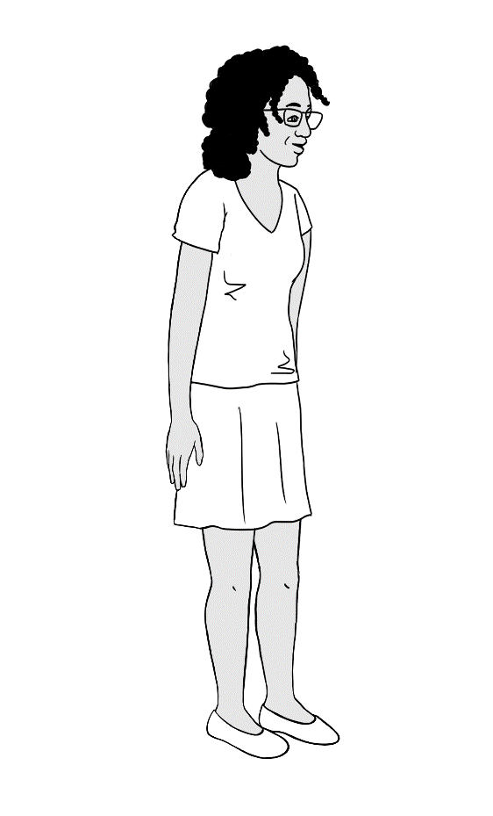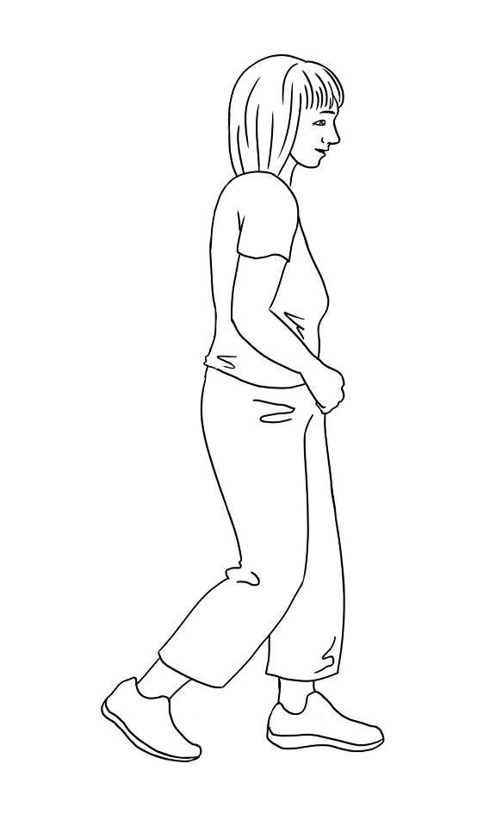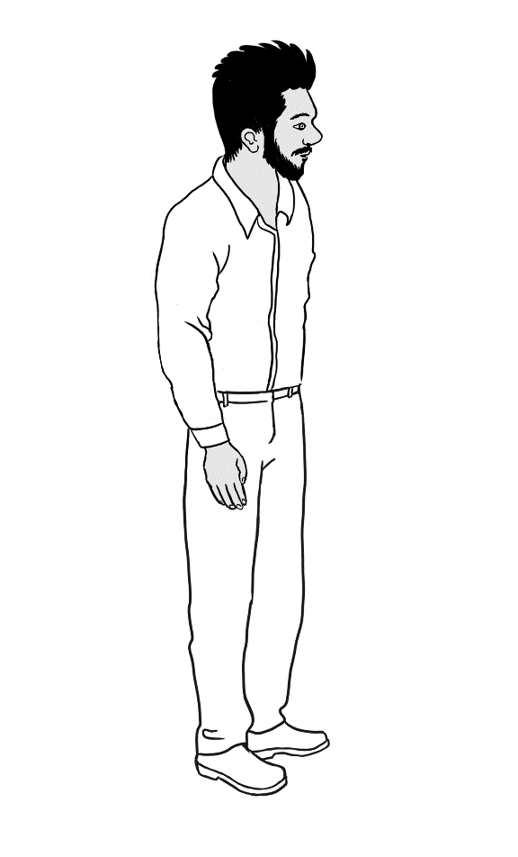



|  |
| --- |
|  |

Tahill breaks his foot.

He can’t walk.

He can’t go to class.

Where can he learn English?

|  |  |
| --- | --- |
| Thursday | Monday Tuesday Wednesday |
|  |  |
| Tahiil learns at home  with a volunteer tutor. | He learns online. |

|  |
| --- |
|  |

|  |
| --- |
| 1. On __________________________, Tahiil learns at home  with a volunteer tutor. |
|
| 1. A couple of people sitting in chairs     Description automatically generatedHe learns online on ___________________, ____________________ and ____________________________.  |  |  | | --- | --- | |  |  | |  |  | |
|

|  |
| --- |
|  |

Sahra has a little girl.

She can go to class part-time.

Where can she learn English?

|  |  |  |
| --- | --- | --- |
| Monday Tuesday | Wednesday | Saturday |
| Excuse me.  What does this mean? |  |  |
| Sahra goes to class. | She learns with  a friend. | She talks with  her neighbour. |

|  |
| --- |
|  |

1. Sahra goes to class on ________________________ and __________________________.
2. On __________________________ she learns with a friend.
3. On __________________________ she talks with her neighbour.

|  |  |
| --- | --- |
|  |  |

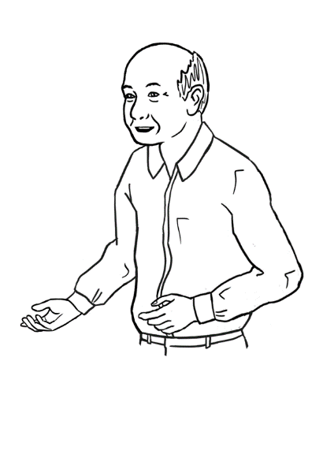

My name is Ming.

Where can I learn English?

|  |  |  |
| --- | --- | --- |
| Tuesday morning  Friday morning Wednesday afternoon | Monday  Thursday  Saturday | Sunday |
|  |  |  |
| Ming learns at the community centre. | He learns  at home. | Ming goes to the library. |

|  |
| --- |
|  |

1. Ming learns at the community centre on _____________________

and _______________________ morning.

1. He learns at the community centre on ________________________ afternoon.
2. He learns at home on ___________________, ____________________ and _______________________.
3. Ming goes to the library on _________________________.

|  |  |
| --- | --- |
|  |  |

|  |
| --- |
|  |

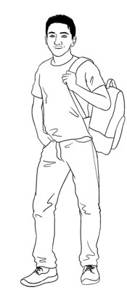

My name is Carim.

Where can I **study**?

**study** = learn

|  |  |  |
| --- | --- | --- |
| Monday to Friday | Saturday Sunday | after class |
|  |  |  |
| Carim studies  full time at TAFE. | Carim studies  in the library. | Carim studies  at home. |

|  |
| --- |
|  |

1. Carim studies full time from ____________________ to

____________________.

1. He studies in the library on _____________________ and

______________________.

|  |  |
| --- | --- |
|  |  |

1. He studies at home ________________ __________________.

# Audio files and transcripts



**1**

**What food do you like?** [Student Book - Section 11, Page 22]

 

**MP3 files**

 

 

 

**Transcripts**

**Conversation 1**

Pam Sahra, what food do you like?

Sahra I like bananas and icecream.

Pam Do you like tea?

Sahra No. I don’t like tea. I like coffee.

**Conversation 2**

Tahiil Anika, what food do you like

Anika I like pizza and cake.

Tahiil Do you like orange juice?

Anika No. I don’t like orange juice. I like coffee.

**Conversation 3**

Lan Nisha, what food do you like?

Nisha I like noodles and rice.

Lan Do you like bread? .  
Nisha No. I don’t like bread. I like hot chips.

**Conversation 4**

Abdi Bao, what food do you like?

Bao I like pizza and coffee.

Abdi Do you like cake?

Bao No. I don’t like cake. I like bananas.

**An English class for Sahra** [Student Book - Section 15, Page 29]



**2**

 

**MP3 files**

|  |  |
| --- | --- |
| Tahiil | Hello. My name is Tahiil.  This is my wife Sahra. She needs an English class. |
| Receptionist | Hello. Nice to meet you.  You can enrol in an English class here. |
| Tahiil | Thank you. We have a daughter.  Do you have childcare? |
| Receptionist | Yes, we have childcare.  Can you fill in this form please Sahra? |
| Sahra | Mmm. Can you help me please? |
| Receptionist | Yes. I can. |

**Transcript**



**3**

**The receptionist helps Sahra.** [Teacher resources Section 15, Page 56]

**MP3 files**

 

Receptionist What’s your full name?

Sahra My name is Sahra Omar Elmi.

Receptionist Where were you born?

Sahra I was born in Somalia.

Receptionist When were you born?

Sahra I was born on the 7th of July 1996.

Receptionist What languages do you speak?

Sahra I speak Somali and Arabic.

Receptionist When did you arrive in Australia?

Sahra Sorry. Can you say that again please?

Receptionist When did you **come to** Australia?

Sahra Umm. On the 9th of June 2022.

Receptionist Are you married or single?

Sahra I am married.

Receptionist How many children do you have?

Sahra I have one child.

Receptionist What is your address and phone number?

Sahra Mmm. It’s here on my card.

Receptionist Oh yes. Thank you Sahra.

Please sign the form here.

**Transcript**



**4**

**At the childcare centre in the morning** [Teacher resources – Section 22, Page 83]

**MP3 files**

 

Nisha Good morning Sahra. How are you?

Sahra Good thanks Nisha.

Nisha Sahra, do you have .  
 Hani’s bag and water bottle?

Sahra Yes, here they are.

Nisha Can you put them here please?

Sahra Ok. Here’s Hani’s hat.

Nisha Good. Put her hat on now.

Sahra Ok. Have a good day.

NishaYou too. See you later.

**Transcript**



**5**

**At the childcare centre in the afternoon** [Teacher resources – Section 22, Page 85]

 

Nisha Hi Sahra. How was your day?

Sahra Good thanks.

Nisha Hani is very happy today.

Sahra She loves playing with the children.

Nisha Does she like fruit?

Sahra Sorry. What do you mean?

Nisha Does she like apples?

Sahra Yes, she likes apples and bananas.

Nisha Ok, thank you. See you tomorrow.   
Sahra See you tomorrow.

**MP3 files**

**Transcript**



**6**

**Tahiil and the nurse** [Teacher resources – Section 25, Page 92]

 

**MP3 files**

Nurse Tahiil Dihoud?

Tahiil Yes.

Nurse What’s the problem Tahiil?

Tahiil I hurt my foot at soccer today.

Nurse Can you walk?

Tahiil No. It’s very painful.

Nurse OK. Please wait to see a doctor.

Tahiil Thank you.

**Transcript**



**7**

**Tahiil and the doctor** [Teacher resources – Section 25, Page 93]

 

**MP3 files**

 

**Transcript**

**Before the x-ray**

Doctor Hello. I’m the doctor. My name’s Elena.

What’s your name?

Tahiil Tahiil Dihoud

Doctor What’s the problem Tahiil?

Tahiil I hurt my foot at soccer.

Doctor We need to x-ray your foot.

Tahiil OK.

Doctor Please wait here.

**Transcript**

**After the x-ray**

Doctor Tahiil, your foot has a bad break.   
 Do you work?

Tahii: I’m a house painter. I go to school too.

Doctor You can’t walk.

You can’t work.

You can’t go to school.

Tahiil I don’t understand.

Doctor Your foot has a very bad break.

You can’t walk for eight weeks.

Tahii:Eight weeks? Oh no!