

Student book with teacher notes

|  |
| --- |
| **English Ready**  **22637 VIC Course in EAL  VU23497 Give and respond to short highly familiar information**  **VU23499 Read and write short, highly familiar factual texts** |

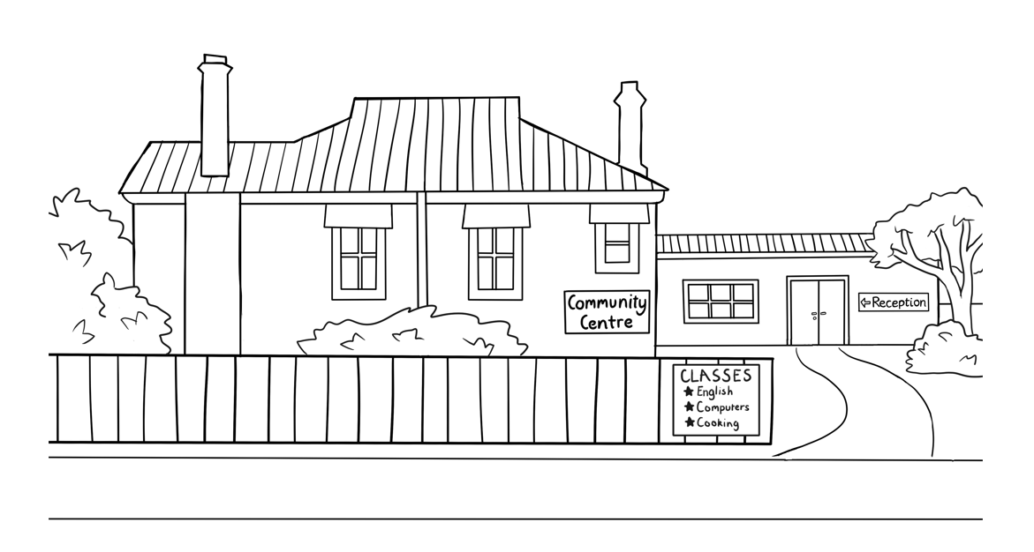**Information and Instructions**

**Student ___________________________________________________**

**Teacher ___________________________________________________**

**Class ______________________________________________________**

**Date ______________________________________________________**

This workbook is designed to be used with the support of a teacher.

**Design team:** Vicki Hambling, Sue Paull, Frida Dean, Janice Langley, Glenise Kleehammer   
and Mary Wallace

**Illustrations:** Madelena Scott

**Acknowledgements:** The design team would like to thank the AMEP service providers and practitioners who participated in the trial and gave valuable feedback. The team would also like to acknowledge the use of the EAL Framework which underpins the design of this book.

Copyright of the EAL Framework is reserved to the Crown in the right of the State of Victoria. © State of Victoria (Department of Education and Training) 2023.  
_________________________________________________________________________________________

This English Ready Resource is licensed under a Creative Commons Attribution-NoDerivs 3.0 Australia licence (More information is available [here](http://creativecommons.org/licenses/by-nd/3.0/au/)). You are free to use, copy and distribute to anyone in its original form as long as you attribute Department of Home Affairs as the author and you license any derivative work you make available under the same licence.  
  
© Commonwealth of Australia 2023

With the exception of the Commonwealth Coat of Arms, the department’s logo, any material protected by a trade mark and where otherwise noted all material presented in this document is provided under a Creative Commons Attribution 4.0 International (<https://creativecommons.org/licenses/by/4.0/>) licence.

The details of the relevant licence conditions are available on the Creative Commons website (accessible using the links provided) as is the full legal code for the CC BY 4.0 licence (<https://creativecommons.org/licenses/by/4.0/legalcode>).

Use of all or part of this document must include the following attribution:   
© Commonwealth of Australia 2023

As far as practicable, material for which the copyright is owned by a third party will be clearly labelled.  The department has made all reasonable efforts to ensure that this material has been reproduced in this document with the full consent of the copyright owners.

Copyright requests and enquiries concerning usage not addressed by the CC BY 4.0 licence should be addressed to:

[*comms@homeaffairs.gov.au*](mailto:comms@homeaffairs.gov.au) *at the Department of Home Affairs.*

The terms of use for the Commonwealth Coat of Arms are available from the [It's an Honour](http://www.itsanhonour.gov.au/) website.

Where a copyright owner, other than the Commonwealth, is identified with respect to this material, please contact that third party copyright owner directly to seek permission.

**Table of Contents**

1. Instructions 1

2. Meet the people 2

3. Do you understand? 4

4. Introductions 5

5. The alphabet 7

6. Numbers 11

7. The days 13

8. The time 14

9. The months 15

10. English class 17

11. Get ready for class. 19

12. How many? 23

13. Instructions in class 25

14. The community centre 29

15. Signs at the community centre 31

16. A class timetable 33

17. Talk about family and friends. 35

18. The weather 48

19. The medical centre 54

20. What’s this? 59

21. Word List 61

# Instructions

|  |
| --- |
|  |

Project and mime each instruction.

|  |  |  |  |  |  |  |  |  |
| --- | --- | --- | --- | --- | --- | --- | --- | --- |
|  |  | listen |  | | |  | | say |
|  |  | copy |  | | |  | | match |
|  |  | read |  | | |  | | circle |
|  |  | ask |  | | |  | | tick |
|  |  | colour |  | | |  | | record |
|  |  | work with a partner | |  |  | | write | |
|  |  | point | |  |  | | draw | |

|  |
| --- |
|  |

# Meet the people

Project the page. Students point to the students and teacher. Name the characters. Create sentences.   
e.g. *Ming is a student.*

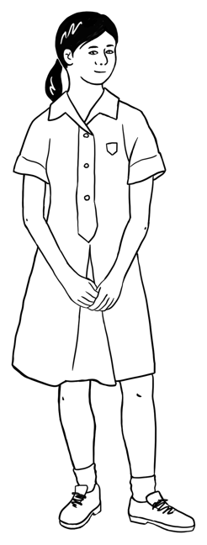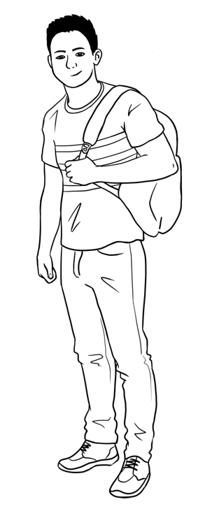

This is **Ming**.This is **Lan**.This is **Mai**.This is **Bao**.

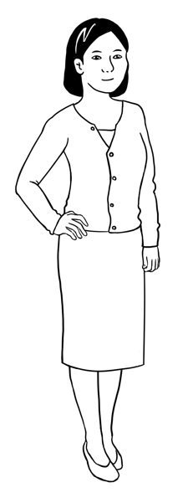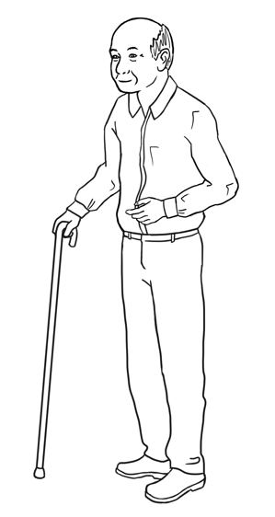

Ming’s family comes from China.

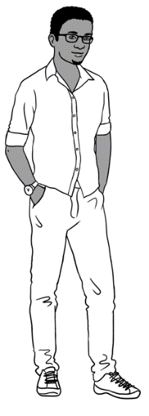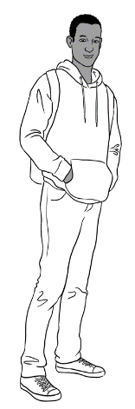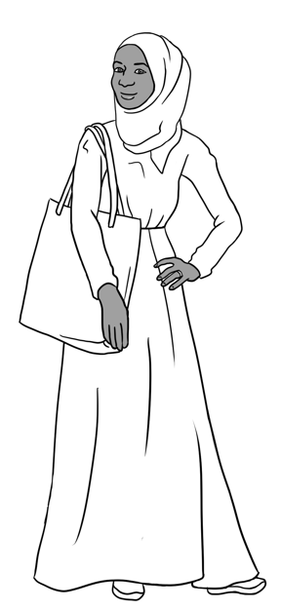

Sahra’s family comes from Somalia.

This is **Sahra**.

This is **Hani**.

This is **Tahiil**.

This is **Abdi**.

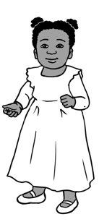

Anika comes from Ethiopia.

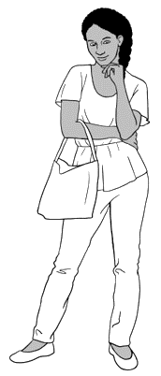

This is **Anika**.

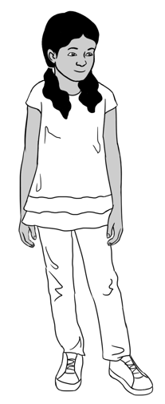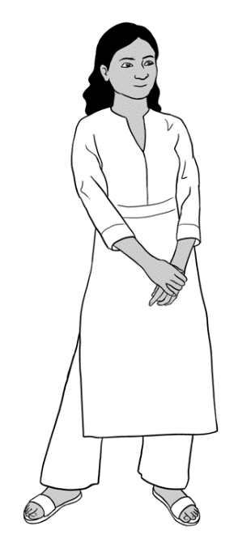

Nisha’s family comes from India.

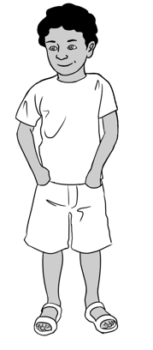

This is **Nisha.** This is **Pari.** This is **Dev**.

Carim’s family comes from Syria.

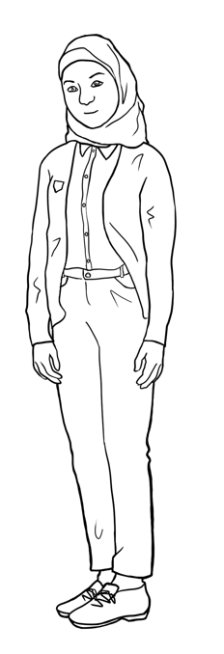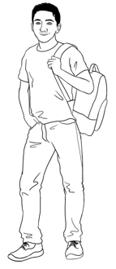

This is **Carim**.

This is **Fatima**.

Jenny is a teacher.   
She is from Australia.

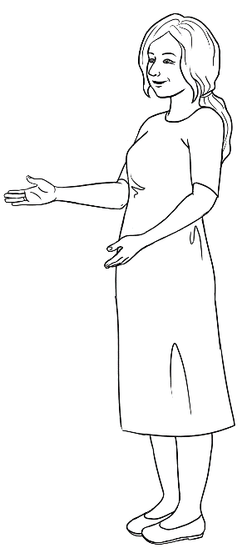

This is **Jenny**.

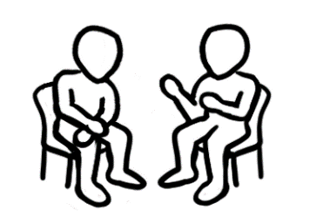

Give instructions to read with a partner.

|  |
| --- |
|  |

# Do you understand?

Ask students to listen to the sentences and repeat them.

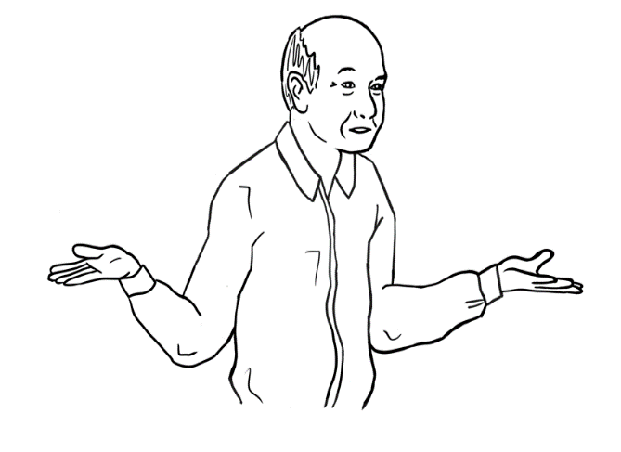

Sorry, I **don’t** understand.

Can you speak **slowly** please?

Can you say that **again** please? please?

Can you **help me** please?

|  |
| --- |
| 1. Can you say that again please? |
| 1. Can you speak **_________________** please? |
| 1. Sorry, I **________________**understand. |
| 1. Can you **____________ _______** please? |

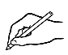

Ask students to complete the sentences using the words from the box. Encourage the students to put a tick next to the word that they have used.

|  |
| --- |
| **help me** |
| **don’t** |
| **slowly** |
| **again** **🗸** |

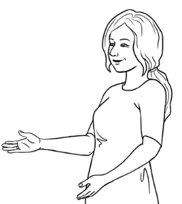

**Yes**.

Do you understand?

Nod your head.

**No**.

Explain to students that they can use body language e.g. nodding their head would mean Yes and shaking their head would mean No. Practice this in class.

Shake your head.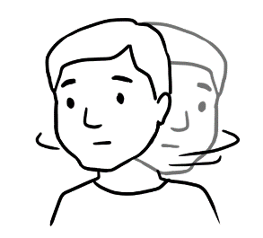

**No**.

# Introductions

|  |
| --- |
|  |

Ask students to listen to the sentences and repeat them. The teacher can mime with a student in class and encourage other students to listen and practice with their partners.

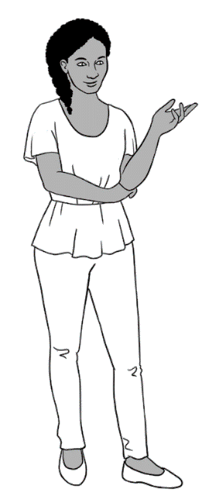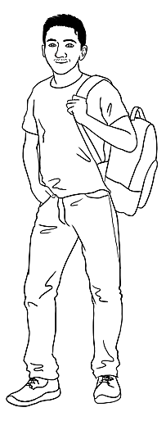

Hi. My name is Anika.

What’s your name?

Hi. My name is Carim.

Nice to meet you.

Nice to meet you too.



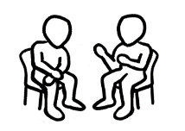

Ask students to work with a partner and write their names. Encourage students to read with their partners.

Hi. My name is _______________________.  
 your name

What’s your name?

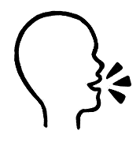

You

Hi. My name is _______________________.  
 your partner’s name

What’s your name?

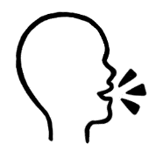

Your  
partner

Nice to meet you.

Nice to meet you too.

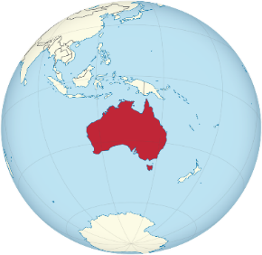

**?**

|  |
| --- |
|  |

Ask students to listen to the sentences and repeat them. The teacher can use or project a map of the world and point to different countries.

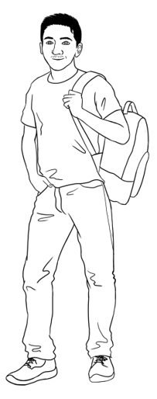

Where are you from Carim?

I am from Syria.

Can you spell that please?

Syria S y r i a

|  |  |  |  |  |  |  |  |  |  |  |  |  |
| --- | --- | --- | --- | --- | --- | --- | --- | --- | --- | --- | --- | --- |
| A a | B b | C c | D d | E e | F f | G g | H h | I i | J j | K k | L l | M m |
| N n | O o | P p | Q q | R r | S s | T t | U u | V v | W w | X x | Y y | Z z |



Ask students to complete the sentences about themselves. Students can ask two of their classmates ‘Where are you from?’ and complete the table below.

My name is__________________________.

I am from ____________________________.

Where are you from?

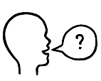

Can you spell that please?

|  |  |
| --- | --- |
| the student’s name | the country |
|  |  |
|  |  |

# The alphabet

|  |
| --- |
|  |

The Alphabet activities in this book are for revision. More activities can be found in Course in Initial Teacher resources, units VU23489, VU23491 and VU23492.

|  |  |  |  |  |  |  |  |  |  |  |  |  |
| --- | --- | --- | --- | --- | --- | --- | --- | --- | --- | --- | --- | --- |
| **A** | B | C | D | **E** | F | G | H | **I** | J | K | L | M |
| N | **O** | P | Q | R | S | T | **U** | V | W | X | Y | Z |

 **Capital letters**

**Small letters**

|  |  |  |  |  |  |  |  |  |  |  |  |  |
| --- | --- | --- | --- | --- | --- | --- | --- | --- | --- | --- | --- | --- |
| **a** | b | c | d | **e** | f | g | h | **i** | j | k | l | m |
| n | **o** | p | q | r | s | t | **u** | v | w | x | y | z |

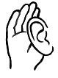

Read out selected capital letters randomly and ask students to circle them.

|  |  |  |  |  |  |  |  |  |  |  |  |  |
| --- | --- | --- | --- | --- | --- | --- | --- | --- | --- | --- | --- | --- |
| A | B | A white circle with black border  Description automatically generatedC | D | E | F | G | H | I | J | K | L | M |
| N | O | P | Q | R | S | T | U | V | W | X | Y | Z |

**

Read out selected small letters randomly and ask students to circle them.

|  |  |  |  |  |  |  |  |  |  |  |  |  |
| --- | --- | --- | --- | --- | --- | --- | --- | --- | --- | --- | --- | --- |
| a | A white circle with black border  Description automatically generatedb | c | d | e | f | g | h | i | j | k | l | m |
| n | o | p | q | r | s | t | u | v | w | x | y | z |



Point to the letter arrangement on the keyboard. Read out selected letters randomly and ask students to circle them. This activity can be extended to computer classes where teacher can ask the students to type each letter.

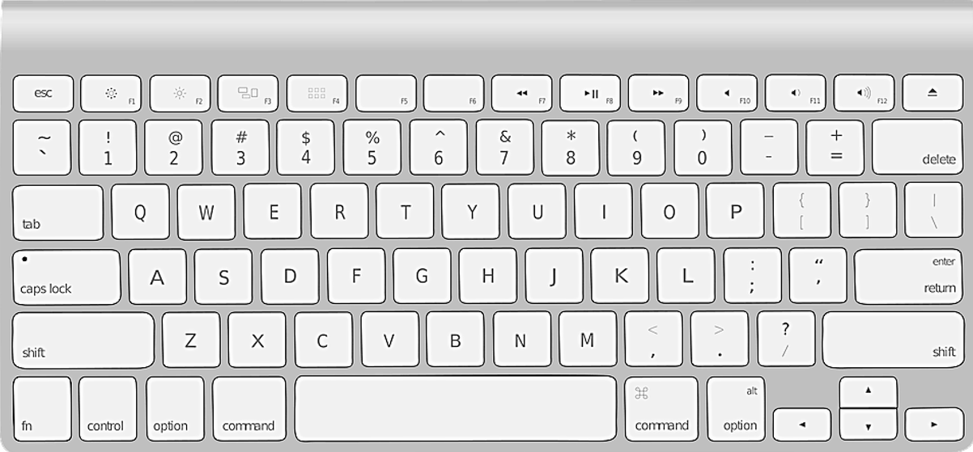

**G**

**W**

**E**

**R**

**T**

**Y**

**U**

**I**

**O**

**P**

**D**

**A**

**S**

**Q**

**F**

**H**

**R**

**Q**

**X**

**C**

**B**

**N**

**M**

**V**

**Z**

**K**

**J**

**L**



Ask students to write the small letters below the capital letters in the boxes provided.

**Q**

**R**

**O**

**I**

**U**

**Y**

**T**

**E**

**W**

**P**

q

w

**S**

**D**

**G**

**H**

**K**

**L**

**F**

**A**

**Z**

**V**

**M**

**N**

**B**

**C**

**X**



Encourage students to read the letters with a partner.

Show students how to use their phones to record the teacher’s voice. Ask the students to record as you read the words. Encourage them to listen to their recording at home. Ask students to write a word with the same first sound in the spaces provided on the table.



| **The sounds of the alphabet** | | | **Write** a word with  the same first sound. |
| --- | --- | --- | --- |
| **a** |  | **a**pple | ambulance |
| **b** |  | **b**anana |  |
| **c** |  | **c**ar |  |
| **d** |  | **d**og |  |
| **e** |  | **e**xit |  |
| **f** |  | **f**ish |  |
| **g** |  | **g**lasses |  |
| **h** |  | **h**at |  |
| **i** |  | **i**nsect |  |
| **j** |  | **j**acket |  |
| **k** |  | **k**ite |  |
| **l** |  | **l**emon |  |

|  |  |  |  |
| --- | --- | --- | --- |
| **m** |  | **m**oney |  |
| **n** |  | **n**ose |  |
| **o** |  | **o**range |  |
| **p** |  | **p**encil |  |
| **q** |  | **q**ueen |  |
| **r** |  | **r**ain |  |
| **s** |  | **s**tar |  |
| **t** |  | **t**able |  |
| **u** |  | **u**mbrella |  |
| **v** |  | **v**an |  |
| **w** |  | **w**indow |  |
| **x** |  | **x**-ray |  |
| **y** |  | **y**am |  |
| **z** |  | **z**ip |  |

# Numbers

The Numbers activities in this book are for revision. Ask students to complete the table with the correct numbers. More activities on numbers can be found in Course in Initial Teacher resources, unit VU23493.

|  |  |  |  |  |  |  |  |  |  |
| --- | --- | --- | --- | --- | --- | --- | --- | --- | --- |
|  | | | | | | | | | 0 |
| 1 | 2 | 3 | 4 | 5 |  | 7 | 8 |  | 10 |
| 11 |  | 13 | 14 |  | 16 |  | 18 | 19 | 20 |
| 21 | 22 |  | 24 | 25 |  | 27 |  |  | 30 |
| 31 |  | 33 | 34 |  | 36 |  | 38 | 39 | 40 |
|  | 42 | 43 |  | 45 | 46 | 47 |  |  | 50 |
| 51 |  |  | 54 | 55 |  | 57 | 58 | 59 |  |
|  | 62 | 63 | 64 |  | 66 |  |  | 69 | 70 |
| 71 | 72 |  | 74 |  |  | 77 | 78 | 79 | 80 |
|  |  | 83 |  | 85 | 86 | 87 |  |  | 90 |
| 91 | 92 |  | 94 |  | 96 |  | 98 |  | 100 |



Students listen as the teacher reads out randomly selected numbers, and students circle the correct number.

|  |
| --- |
|  |

Ask students to listen to the numbers and repeat after you.

|  |  |  |  |  |
| --- | --- | --- | --- | --- |
| 1. one | 1. two | 1. three | 1. four | 1. five |
| 1. six | 1. seven | 1. eight | 1. nine | 1. ten |

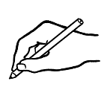

Ask the students to find the numbers from the grey box in the puzzle and then write them on the lines provided.

|  |  |  |  |  |  |  |  |  |  |  |
| --- | --- | --- | --- | --- | --- | --- | --- | --- | --- | --- |
| t | w | o | a | b | o | n | e | c | d | e |
| f | g | h | s | i | x | i | j | t | e | n |
| t | h | r | e | e | c | d | n | i | n | e |
| k | l | m | n | f | i | v | e | q | r | s |
| e | i | g | h | t | u | v | f | o | u | r |
| w | s | e | v | e | n | x | y | z | a | b |

1. __________
2. two .
3. ___________
4. ___________
5. ___________
6. ___________
7. ___________
8. ___________
9. ___________
10. A hand holding a pen

    Description automatically generated___________

Ask students to fill in the blanks with the correct letters in order to complete the words.

|  |  |  |  |  |
| --- | --- | --- | --- | --- |
| **1**  o n e | **2** ___wo | **3**  thre ___ | **4**  ___our | **5** fi___e |
| **6** ___i x | **7** ___even | **8**  eigh___ | **9** ni___e | **10** t___n |

# The days

Project the table below and say the name of days of the week and ask students to repeat after you. Point to the full word and the short word and mention that days of the week start with a capital letter. More activities on ‘Days’ can be found in Course in Initial Teacher resources for unit VU23490.

|  |
| --- |
|  |



|  |  |  |
| --- | --- | --- |
| **Full word** | | **Short word** |
| Monday | Monday | Mon |
| Monday . | _______________ | ___________ |
| Tuesday | Tuesday | Tues |
| _______________ | _______________ | ___________ |
| Wednesday | Wednesday | Wed |
| _______________ | _______________ | ___________ |
| Thursday | Thursday | Thurs |
| _______________ | _______________ | ___________ |
| Friday | Friday | Fri |
| _______________ | _______________ | ___________ |
| Saturday | Saturday | Sat |
| _______________ | _______________ | ___________ |
| Sunday | Sunday | Sun |
| _______________ | _______________ | ___________ |

Ask students to complete the sentences.

Today is _______________________________.

Tomorrow is ____________________________.

The weekend is Saturday and ____________________.

# The time

|  |
| --- |
|  |

Point to the pictures and the clocks. Read the conversation and ask the students to repeat after you. Ask students ‘What’s the time?’ and encourage them to practice in class with their partners.

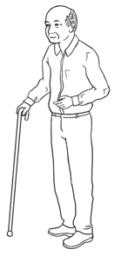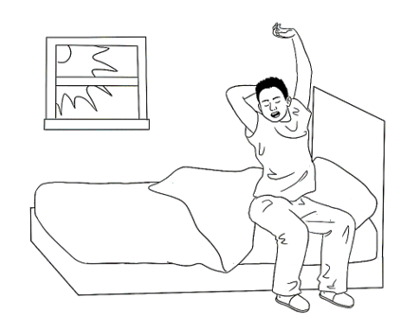

What’s the time?

It’s 8 o’clock.

St eight.

Read the dialogue box below. Ask the student ‘What time do you get up?’ and encourage them to practice in class with their partners.

|  |  |  |
| --- | --- | --- |
| 12  1  11  6  3  2  10  9  8  5  7  4 | **am** = morning  **8:30** | **9:00 am**  Mon 8 Feb  25**°**C |
| It’s 8 o’clock. It’s 8:00 am. | It’s eight thirty.  It’s half past eight. It’s 8:30 am. | It’s 9 o’clock.  It’s 9:00 am. |

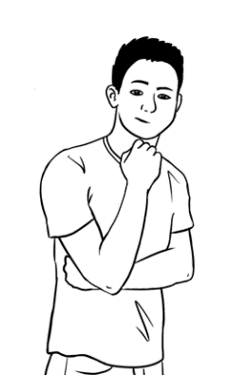

I get up at 8 o’clock on Monday.

What time do **you** get up?



 I get up at ___________________ on Monday.

What time do you get up?

St eight.

|  |
| --- |
|  |

# The months

Project the page, say the name of the months and ask students to repeat them. Point to the long words and short words and mention that months start with capital letters. Ask students to write the missing letters.

|  |  |  |
| --- | --- | --- |
| **Long words**. | | **Short words** |
|  | January Ja___uary . | Jan |
|  | February Fe___ruary | Feb |
|  | March ___arch | Mar |
|  | April A____ril | Apr |
|  | May M____y | May |
|  | June Ju____e | June |
|  | July Ju___y | July |
|  | August Au____ust | Aug |
|  | September Septem____er | Sept |
|  | October Oct____ber | Oct |
|  | November Nove____ber | Nov |
|  | December De____ember | Dec |

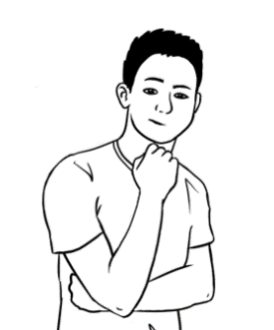

Ask students to write the name of the month. Encourage students to practice saying the months’ names.

What is this month?

What is next month?

This month is __________________________.

Next month is _________________________.

|  |
| --- |
|  |



Read the dialogue and ask the students to listen and repeat. Check understanding by pointing to the picture and ‘Birthdays’. Encourage students to practice reading with their partners.

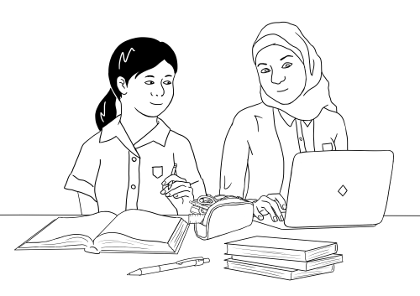

When is your birthday Fatima?

My birthday is in **April.**

My birthday is in **July**.

When is your birthday Mai?



Ask students to complete the sentences about May and Fatima. Encourage students to write the month of their own birthday.

Mai’s birthday is in April .

Fatima’s birthday is in ________________.

My birthday is in _________________________.

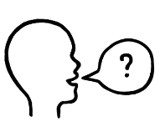

When is your birthday?



Encourage students to ask the teacher the question, ‘When is your birthday?’, and then their partner, and complete the sentences.

My teacher’s birthday is in _______________________.

My partner’s birthday is in **________________________**.

# English class

Project the page and read the sentences. Point to the centre details, such as address, phone number, days and times. Check understanding by asking follow-up questions.

|  |
| --- |
|  |

Ming wants to learn English.

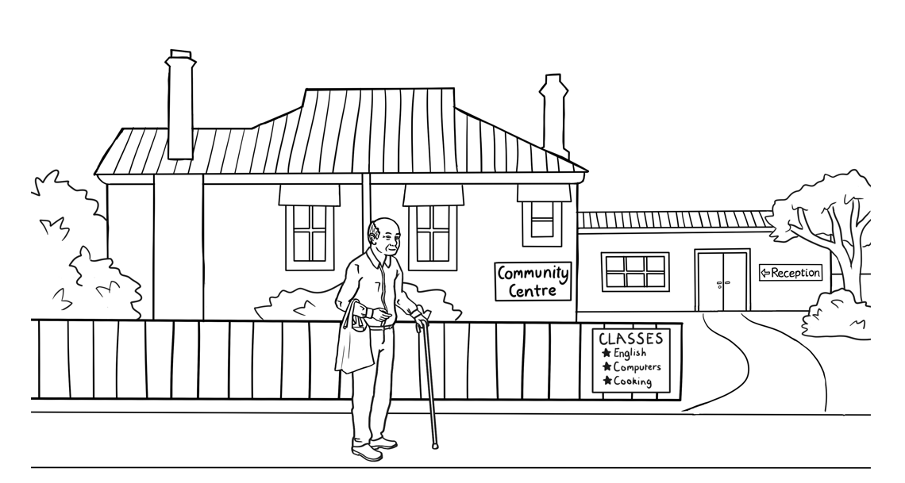He goes to the community centre.



**Kellivale Community Centre**

**Address** 50 Kemp St, Kellivale

**Phone** 6562 8261

**Hours** Monday 9am – 4pm

Tuesday 9am – 4pm

Wednesday 9am – 4pm

Thursday Closed

Friday 9am – 4pm

Saturday Closed

Sunday Closed



Ask students to read the sign and complete the sentences below.

The phone number is **____________________________**.

The centre is open on **___________________**, **____________________,**

**______________________** and **_______________________.**

|  |
| --- |
|  |

Project the page and read the sentences and the message. Point to the time, day and month. Ask students to read the message with their partners and underline the time, day and month. Encourage students to copy these details in the table provided.

Carim wants to learn English.

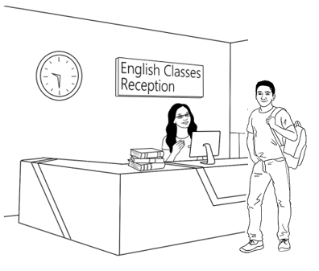He has an interview at TAFE.

Hi Carim

Your interview   
is on Thursday   
20 January   
at 9:30 am.

Go to reception.

Kellivale TAFE

****.

|  |  |  |
| --- | --- | --- |
| interview | Thursday | January |
| interview |  |  |
|  |  |  |
|  |  |  |



Ask students to complete the detail below and read with a partner.

1. When is the interview?

Day ___________________________

Date ___________________________

Time ___________________________

1. Where does Carim go to? _________________________.

# Get ready for class.

Project the catalogue and point to the stationary items on the catalogue. Read the words and the price and ask students to repeat after you. Ask students to practice pointing to and saying the words with a partner.

|  |
| --- |
|  |

Carim gets ready for class.

He reads the School Shop catalogue.

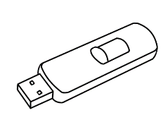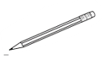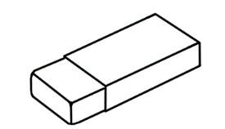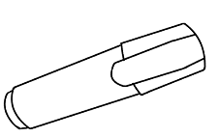

Pencil

50c

**Get ready for school**

Notebook

$5

USB

$8

Ruler

80c

Rubber

$1.50

pen

$2



Highlighter

$1

**The School Shop**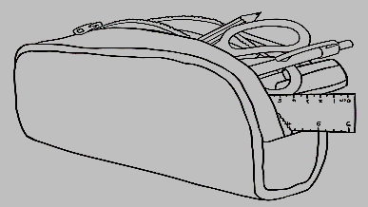

sharpener

$3

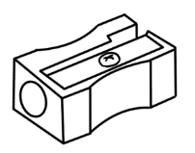

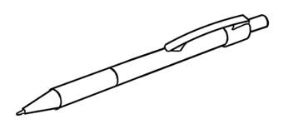

Ask students to match the price with the name of the stationary item.

|  |  |  |  |  |  |  |
| --- | --- | --- | --- | --- | --- | --- |
| 1. pencil |  | $1 |  | **5**. notebook |  | $3 |
| 1. rubber | $2 | **6**. sharpener | 80c |
| 1. highlighter | 50c | **7**. USB | $5 |
| 1. pen | $1.50 | **8**. ruler | $8 |

|  |
| --- |
|  |



Ask students to listen to the words, repeat them and copy the missing letters.

|  |  |
| --- | --- |
|  |  |
| pencil | rubber |
| p__ncil | r__bber |
|  |  |
| sharpener | pen |
| shar__ener | pe__ |
|  |  |
| highlighter | notebook |
| highligh__er | note__ook |
|  |  |
| ruler | USB |
| ru__er | US__ |

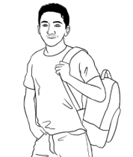

Ask students to complete the sentences. Encourage students to practice with a partner.

What do **you** buy?

I buy a __________________, a _________________

and a _______________________.

|  |
| --- |
|  |

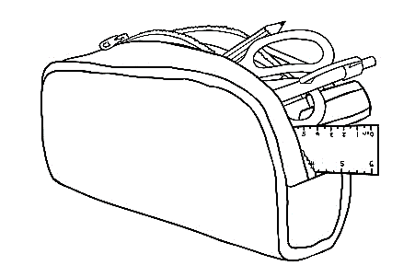

Read the two sentences and ask students to repeat.

Carim buys 8 things at the shop.

He puts 6 things in his pencil case.

Ask students to match the picture to the word.

|  |  |  |
| --- | --- | --- |
|  |  | pen |
|  | pencil |
|  | rubber |
|  | sharpener |
|  | notebook |
| 1. **A picture containing text, sign     Description automatically generated** | highlighter |
|  | USB |
|  | ruler |

|  |
| --- |
|  |



Read the sentence below for the students and ask them to check and write 5 things they have in their pencil case/ bags.

I have 6 things in my pencil case.

What’s in your pencil case?



Give instruction to write 5 things in students’ pencil case.

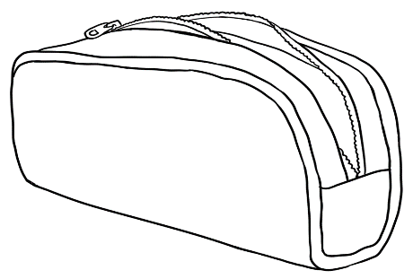



Ask students to write the words in the blanks provided. Encourage students to check spelling using the words on page 21.

I have a ________________________, a _________________________, a ___________________________, a ________________________ and   
a ___________________________ in my pencil case.

What’s in your pencil case?

Encourage students to work with their partner and ask the question above and complete the sentences. Encourage students to read the completed sentences and copy in their notebooks.



My partner has a ____________________, a ____________________, a ___________________________, a ________________________ and   
a ___________________________ .



# How many?

Project the page and read the two sentences. Ask students to repeat after you. Point to ‘one’ and ‘two’ and explain ‘singular’ and ‘plural’ nouns by pointing to ‘s’ in ‘bag**s’**. Encourage students to count the items in the table below and match to the correct words.

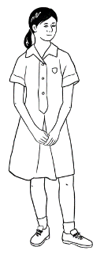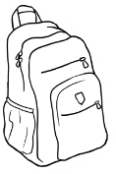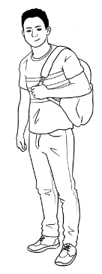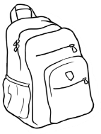

|  |
| --- |
|  |

Mai has **one** bag. Bao has **two** bag**s**.

**________________________________________________________________**

|  |
| --- |
| one ruler |
| two rubber**s** |
| three pen**s** |
| four pencil**s** |
| nine book**s** |

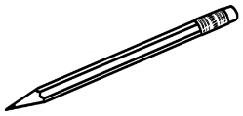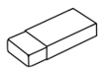

**_________________________________________________________________**

Encourage students to look around the class and count the students, tables and chairs.

_______ student**s**

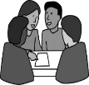

1. How many **students** are in your class?

______ table**s**

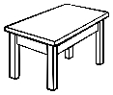

**2.** How many **tables** arein your room?

______chair**s**

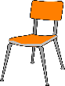

**3.** How many **chairs**?

|  |
| --- |
|  |



Project the picture and read the phrases. Ask students to repeat after you. You can use different items e.g. pens, books, or phones in class to check understanding by asking follow-up questions.

|  |  |  |
| --- | --- | --- |
|  |  |  |
| **on** the table | **under** the table | **next to** the table |
| on the table . | _________________ | ________________ |

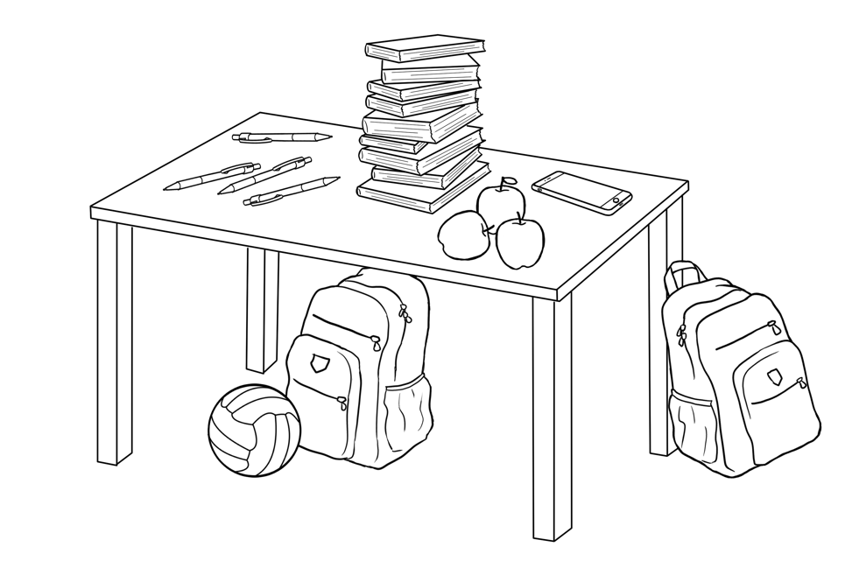

Ask students the question, encourage them to count the items and practice with a partner.

How many **pens** are on the table?

Ask students to match the sentences below.

|  |  |  |
| --- | --- | --- |
| 1. There is **one** ball |  | **on** the table. |
| 1. There is **one** phone |
| 1. There is **one** bag | **under** the table. |
| 1. There are **three** apple**s** |
| 1. There are **fou**r pen**s** | **next to** the table. |
| 1. There are **nine** book**s** |

Encourage the students to read the sentences with a partner.



# Instructions in class

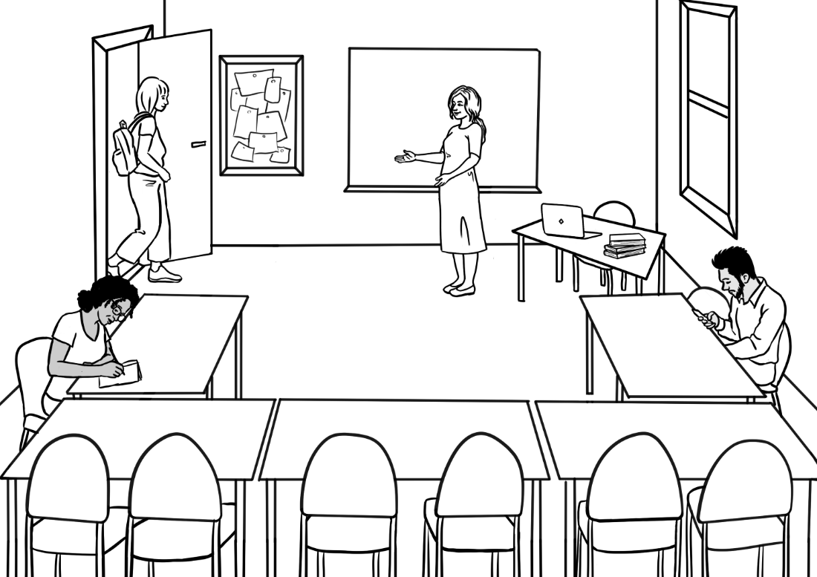

Come in Alina.

Please sit down.

|  |
| --- |
|  |

Project this page. Read the instructions below and mime them in class. Check understanding by asking students to follow the instructions.

|  |  |  |
| --- | --- | --- |
| **1** | **2** | **3** |
| Come in. | Sit down. | Stand up. |
| **4** | **5** | **6** |
| Open  your workbook. | Close  your workbook. | Look at  the board. |

|  |  |  |
| --- | --- | --- |
| **1** |  | Stand up.  Ask students to match the pictures to the instructions and copy the instruction in the space provided.  Stand up. . |
| **2** | Come in.  ______________ |
| **3** | Open your workbook.  ____________________________ |
| **4** | Sit down.  _______________________ |
| **5** | Look at the board.  ___________________________ |
| **6** | Close your workbook.  ______________________________ |



Read the sentences and point to the word ‘please’. Mention that this word is used to be polite.

**Please** sit down.

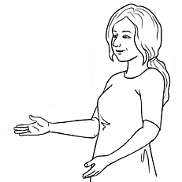

Look at the board **please.**

Open your workbook **please.**



Ask students to read the sentence with their partners.

|  |
| --- |
|  |

Read the instructions in class. Ask students to repeat after you. Ask students to repeat and follow the instructions with their partner.

|  |  |  |  |
| --- | --- | --- | --- |
| **1** | | **2** | **3** |
| Write on the board. | | Take a photo. | Record the teacher. |
| **4** | | **5** | **6** |
| Stand next to  the table. | | Stand in a line. | Stand in a circle. |
| **7** | | **8** | **9** |
| Go left. | | Go right. | Go straight ahead. |
| **10**  **11** | Turn the light on.  Turn the light off. | **12** | **13** |
| Walk slowly  to the door. | Walk quickly  to the door. |

***

Ask students to read, match and copy the instructions.

|  |  |  |
| --- | --- | --- |
| **1** |  | Take a photo.  Take a photo. . |
| **2** | Stand in a line.  __________________________________ |
| **3** | Write on the board.  ____________________________ |
| **4** | Go right.  _________________________ |
| **5** | Stand next to the table.  _____________________________ |
| **6** | Turn the light off.  ____________________________ |
| **7** | Go left.  ______________________________ |
| **8** | Go straight ahead.  _____________________________ |

Read the sentences and remind the students about being polite. Point to the word ‘please’.

**Can you** stand in a line **please**?

**Can you** turn on the light **please**?

# A picture containing text, cosmetic Description automatically generatedThe community centre

Ask students to colour the boxes and then the picture below.

|  |  |  |  |  |  |  |  |
| --- | --- | --- | --- | --- | --- | --- | --- |
| **red** |  |  | **green** |  |  | **brown** |  |
| **blue** |  | **yellow** |  | **black** |  |
| **orange** |  | **white** |  | **grey** |  |

Colouring helps students develop the fine motor skills required for pencil grip.



a red roof

a brown fence

a tree

a green door

a bush

a path

Play Audio 1 and ask students to circle as they listen. The teacher can repeat and pause the audio as many times as need be to check understanding.

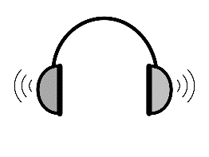

**1**

|  |  |  |  |  |
| --- | --- | --- | --- | --- |
| 1. The community centre is | in Kemp Road. | in Kemp Street. | | in Kemp Lane. |
| 1. The building is | old. | | new. | |
| 1. Near the door, there is | an old tree. | a big  tree. | | a small tree. |

Play Audio 1 and ask students to complete the sentences using the words from the box. Encourage the students to put a tick next to the word that they have used.



**1**

|  |
| --- |
| Street |
| red |
| centre 🗸 |
| old |
| fence |
| brown |
| small |
| roof |

Woman Excuse me.   
 Where is the community centre ?

Man The community centre?

Oh, it’s in Kemp ______________.

It’s an __________ building.

It has a ____________roof and   
a _____________ fence.   
There’s a ____________ tree   
near the front door.

Woman Did you say a red ______________?

Man Yes, that’s right and   
a brown ________________.

Woman Okay, thank you.

Ask students to put the words in order to make a sentence as per the model. Encourage them to read with a partner and copy the sentences.







building.

an

old

It’s

It’s an old building. .

a

It

red

roof.

has

______________________________________________________________________

a

brown

has

fence.

It

________________________________________________________________

# A black check mark on a white background Description automatically generated Signs at the community centre

Project the signs on this page. Read the signs and ask students to repeat them. Ask the students to tick the signs they can see in their English Centre.

|  |
| --- |
|  |

|  |  |  |  |
| --- | --- | --- | --- |
| **1** | No smoking | **2** | Exit |
| **3** | Men’s toilet | **4** | Women’s toilet |
| **5** | Do not put rubbish  in the toilet. |  **| Wash and dry your hands. |
| **7** | Wet floor | **8** | Wear a face mask. |
| **9** | Turn off  the sound  on your phone. | **10** | Put rubbish  in the bin. |

|  |  |  |
| --- | --- | --- |
| Ask students to match the words and the pictures. |  | Exit |
|  | Men’s toilet |
|  | No smoking |
|  | Women’s toilet |
|  | Wash and dry your hands. |
|  | Do not put rubbish in the toilet. |
|  | Wear a face mask. |
|  |  | Wet floor |
|  |  | Put rubbish in the bin. |
|  |  | Turn off the sound  on your phone. |

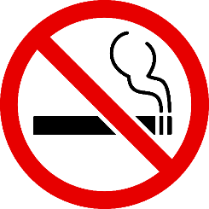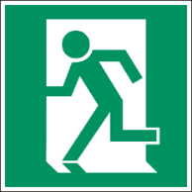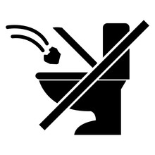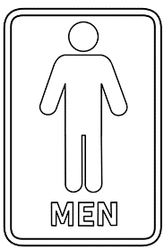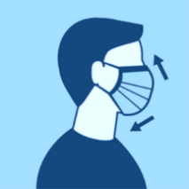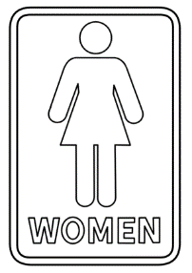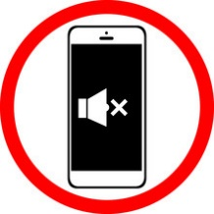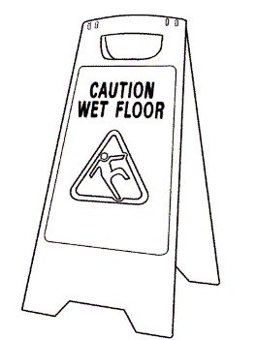

# A class timetable

Project the page below. Point to the timetable. Explain that this is Ming’s timetable.

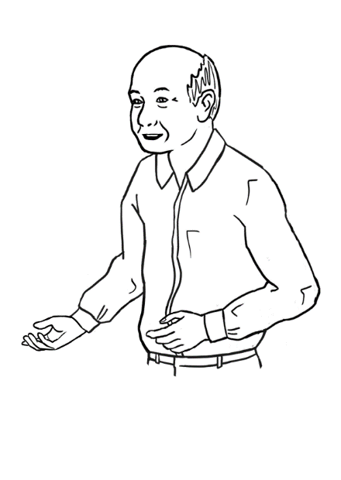

|  |
| --- |
|  |

Check understanding by asking follow-up questions about, time, day and room number. The teacher can extend these activities by asking students to look at their own timetables and asking follow-up questions e.g. When do you come to class?

This is my timetable.

I go to class on Tuesday,

Wednesday and Friday.

|  |  |  |  |  |  |
| --- | --- | --- | --- | --- | --- |
|  | **Monday** | **Tuesday** | **Wednesday** | **Thursday** | **Friday** |
| **Morning**  *am* |  | 9:00 -12:00  Room 4 |  | Closed | 9:30 -12:30  Room 3 |
| **Afternoon**  *pm* |  |  | 1:00 - 3:30  Room 4 | Closed |  |

Ask students to tick the answer.

1. When does Ming go to class?

Monday Tuesday Wednesday Friday

1. 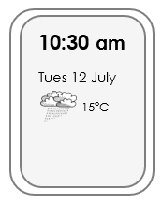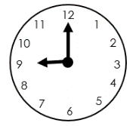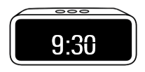What time does Ming start on Tuesday?

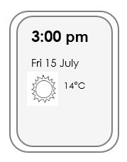

1. 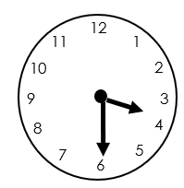What time does Ming finish on Wednesday?

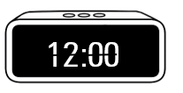

****

Ask students to match time and days with the pictures.

|  |  |  |
| --- | --- | --- |
|  | Tuesday  **12:00**  9:00  12:00  Wednesday  1:00  3:30  Friday  9:30  12:30 |  |
|  |  |
|  |  |

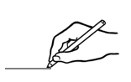

Using an analogue clock, show the students different times. Then ask the students to draw the clock arms in the pictures below.

12

1

11

2

10

3

9

8

4

5

7

6

|  |  |  |
| --- | --- | --- |
| 12  1  11  2  10  3  9  8  4  5  7  6 | 12  1  11  2  10  3  9  8  4  5  7  6 |  |
| 9:00 am | 9:30 am | 1:00 pm |



Ask students to check their timetables and write the start and finish time of the class.

1. Today I start class at ____________.
2. Today I finish class at ___________.

# Talk about family and friends.

Project page 35. Ask students to listen as you read and repeat. Point to the family words on page 35. Encourage students to find family words on page 36 and practice reading with a partner.

|  |
| --- |
|  |

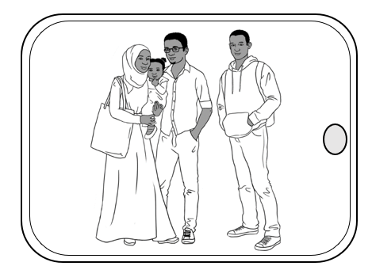

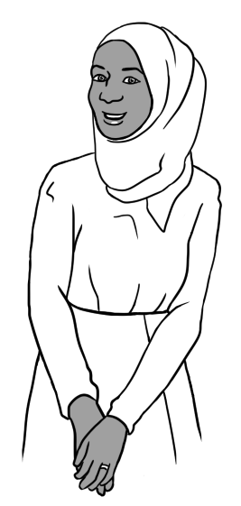

My name is Sahra.

This is my **family**.

I am married.

This is my **husband** Tahiil.

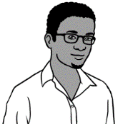

This is my **brother** Abdi.

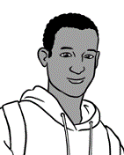

This is my **daughter** Hani.

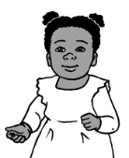

**___________________________________________________________________________**

Sahra is my **sister.**

Hani is my **niece.**

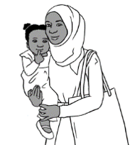

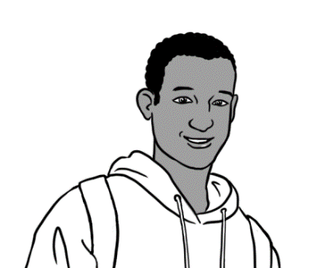

Tahiil is my **brother-in-law**.



|  |
| --- |
|  |

Project page 36 and read in class. Ask students to repeat the sentences. Point to the verbs and teach subject verb agreement by pointing to the noun, pronoun and the verb.

Fatima **is** my friend.   
She **comes** from Syria.

She **has** a brother.

His name **is** Carim.

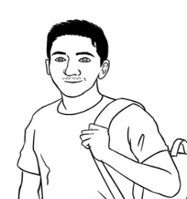

I **have** a brother too.

His name **is** Bao.

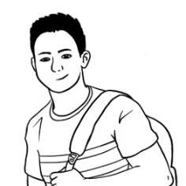

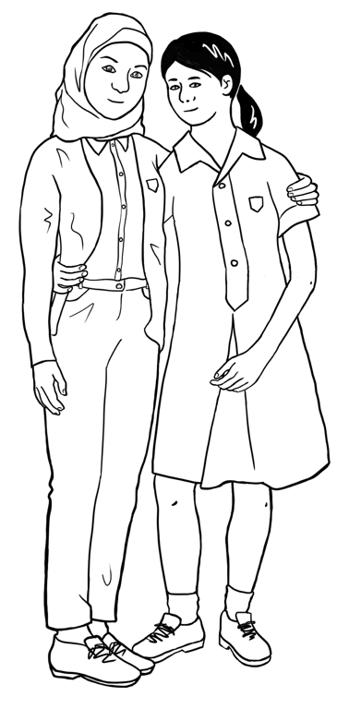

Ask students to match two parts of the sentence.

|  |  |  |
| --- | --- | --- |
| Fatima **is** |  | from Syria. |
| She **comes** | Carim. |
| She **has** | my friend. |
| His name **is** | a brother. |
| I **have** |  | Bao. |
| His name **is** | a brother too. |

 Fatima _______ Mai’s friend.

Ask students to complete the sentences and read them with their partners.

She ________________ from Syria.

She _______________ a brother.

 His name ________ Carim.

|  |
| --- |
|  |

Activities on pages 37 to 40 help students learn how to describe a person.

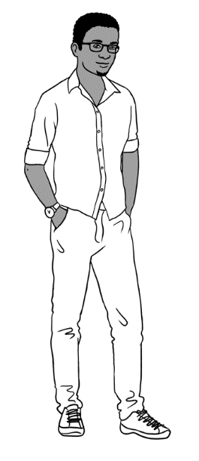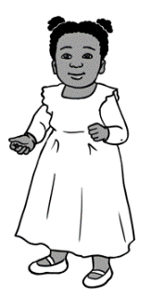

I am **tall**.

Hani is **short**.

Project the picture of Tahiil and Hani. Read the sentences and ask students to repeat after you. Check understanding by asking follow-up questions e.g. ‘Who is tall’ or ‘Who is short?’

Who is **tall**?

Ask students to tick the answer.

|  |  |  |  |  |  |
| --- | --- | --- | --- | --- | --- |
| **1** | | **2** | | **3** | |
| Abdi | Hani | Carim | Fatima | Nisha | Dev |
| 🗸 |  |  |  |  |  |



Ask students to write the answers and check with their partners.

tall

short

1. Abdi is tall . Hani is _________________.
2. Carim is ________________. Fatima is _______________.
3. 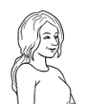Nisha is __________________. Dev is __________________.

Who is **tall** in your class?



Ask students to write the name of two of the tallest students in class as long as this will not be offensive to any students.

**___________________** and **____________________** are tall.

|  |
| --- |
|  |

Project the page and point to ‘Age’. Read the words and the sentences and point to the pictures.

|  |  |  |
| --- | --- | --- |
| **old** | **middle-aged** | **young** |
|  |  |  |
| MIng | Lan | Mai |

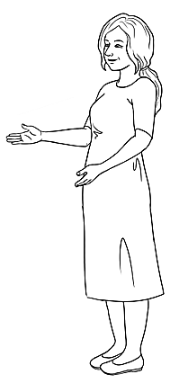

Check understanding by asking follow-up questions e.g. ‘Who is old?’ or ‘Is Ming Middle-aged?’

Ming is **old**.

Lan is **middle-aged**.

Mai is **young**.

I am **young.**

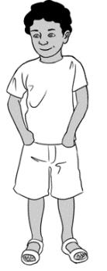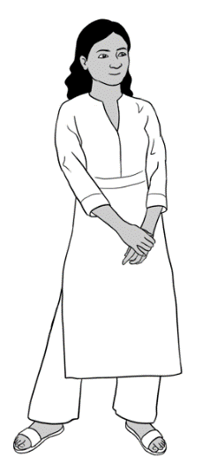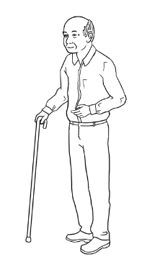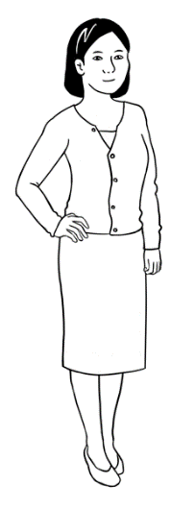

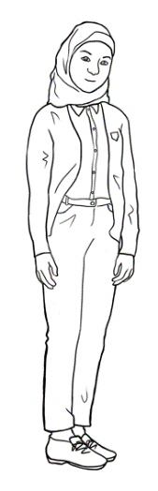

Ask students to match the words and the pictures.

Ask students to make sentences about the characters and write them in their notebooks.

|  |
| --- |
|  |

Project the page and point to ‘Hair’. Read the words and the sentences and point to the pictures.

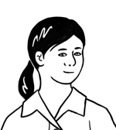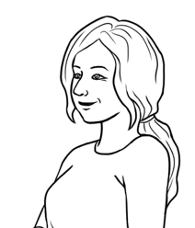

I have **long** hair.

Mai has **long** hair.

Carim has **short** hair.

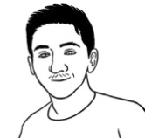

|  |  |
| --- | --- |
|  | 1. Nisha has long hair.  Nisha has long hair. . |
|  | 1. Anika has long hair.  _______________________________. |
|  | 1. Bao has short hair.  ________________________________. |



Ask students to copy the sentences in lines provided.



Say the words, read the sentences and ask the students to repeat them.

|  |  |  |
| --- | --- | --- |
| **1** | **2** | **3** |
| **straight** | **wavy** | **curly** |
| Lan has **straight** hair. | Nisha has **wavy** hair. | Dev has **curly** hair. |

Ask students to complete the sentence.

**1**. Lan has straight hair.

Give instruction to write.

**2.** Nisha has ______________ hair.

******3.** Dev has ________________ hair.

Encourage students to read with their partners and copy the sentences in their notebook.

Project the page and point to ‘Hair and eye colour’. Read the sentences and point to the words in bold font. Check understanding by pointing to your hair and eye colour and asking students about the colour.



|  |
| --- |
|  |

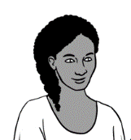

I have **blonde** hair.

Anika has **black** hair.

I have **blue** eyes.

Anika has **brown** eyes.

|  |  |
| --- | --- |
| **Hair colours** | |
| blonde |  |
| light brown |  |
| dark brown |  |
| black |  |
| grey |  |
| red |  |

Ask student to colour the table and the eyes.

|  |
| --- |
| **Eye colours** |
|   green eyes** |



Ask students to complete the sentences about themselves and copy in their notebooks.

I have _____________________________ hair.

I have _____________________________ eyes.

My teacher has _______________________ hair.

He / She has ________________________ eyes.

Encourage students to write about themselves and read with a partner if they are comfortable to do so.

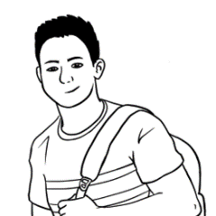

|  |
| --- |
|  |



Point to the bold words (adjectives) and check understanding of these words by pointing to the pictures. The teacher could also give examples using themselves or a student or two in the class if they think the students selected would be comfortable with this. E.g. I am short, Abdul is tall, Chin is short.

Read the sentences in class. Encourage students to repeat after you.

Bao is my son.

He is tall.

He has short hair and brown eyes.

Bao is **kind** and **helpful**.

He is **strong** and **healthy**.

|  |  |
| --- | --- |
|  |  |
| Bao is **kind** and **helpful**. | He is **strong** and **healthy**. |



Ask students to put the words in order to make a sentence as per the model. Encourage them to read with a partner and copy the sentences.

my

is

son.

Bao



Bao is my son. .

and

kind

He

is

helpful.



_________________________________________________________

healthy..

and

He

strong

is

___________________________________________________________________

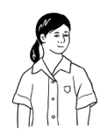

Point to the bold words (adjectives) and check understanding of these words by pointing to the pictures. Ask if students can find other words to describe people.

|  |
| --- |
|  |

Read the sentences in class. Encourage students to repeat after you.

Mai is my granddaughter.

She is short.

She has long hair and brown eyes.

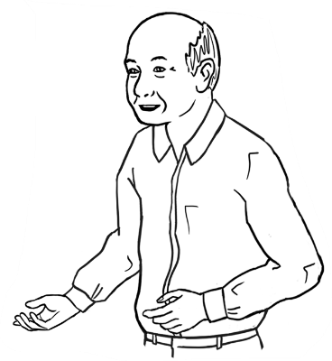

Mai is **hard-working.**

She is **friendly**.

He is **strong** and **healthy**.

|  |  |
| --- | --- |
|  |  |
| Mai is **hard-working**. | She is **friendly**. |



Ask students to put the words in order to make a sentence as per the model. Encourage them to read with a partner and copy the sentences.

is

my

granddaughter.

Mai

Mai is my granddaughter. .

She

is

hard-working.

_______________________________________________

friendly.

She

is

________________________________________________

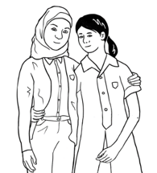

Play Audio 2 and ask students to tick as they listen. The teacher can repeat and pause all the audios as many times as need be to check understanding.



**2**

1. Fatima comes from Somalia. China. Syria.
2. She is tall short.
3. She has brown eyes. blue eyes. green eyes.
4. She is a Year 9 student. Year 10 student.

1. She plays netball on Monday. Thursday. Friday.

Ask students to complete the sentences using the words from the box. Encourage the students to put a tick next to the word that they have used.



|  |
| --- |
| comes |
| Friday |
| student |
| short |
| friendly |
| is🗸 |
| blue |

Fatima is my friend.

She ______________ from Syria.

She is ______________.

She has _______________eyes.

Fatima is a Year 9 __________________.

She plays netball on _______________.

She is hard-working and _________________.



Encourage students to read with a partner and copy the sentences in their notebook.

and copy the sentences into a notebook.

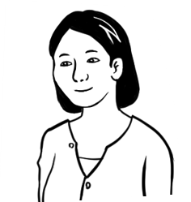



**3**

Play Audio 3 and ask students to tick as they listen.

1. Nisha comes from China. Syria. India.
2. She works in

a medical centre.

a childcare centre.

a community centre.

1. Nisha is tall. short.
2. She has long hair. short hair.
3. She has curly hair. wavy hair. straight hair.
4. She likes playing soccer. reading.

Ask students to complete the sentences using the words from the box. Encourage the students to put a tick next to the word that they have used.

|  |
| --- |
| centre |
| tall |
| friend 🗸 |
| reading |
| India |
| long |
| wavy |

* 1. Nisha is Lan’s friend. .
  2. She comes from __________________.
  3. She works in a childcare _______________.
  4. Nisha is ______________.
  5. She has _______________ , ________________ hair.
  6. She likes ______________________.

Encourage students to read with a partner and copy the sentences in their notebook.

and copy the sentences into a notebook.

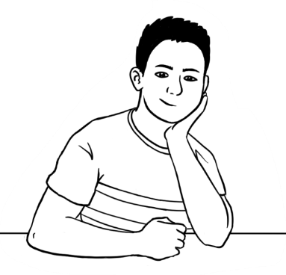

Play Audio 4 and ask students to tick as they listen.



**4**

1. Abdi comes from China. Somalia. Syria.

**uni** = university

1. He goes to school. work. uni.
2. Abdi is short. tall.
3. He has long hair. short hair.
4. He has curly hair. wavy hair. straight hair.
5. He likes playing soccer. reading.

Ask students to complete the sentences using the words from the box. Encourage the students to put a tick next to the word that they have used.

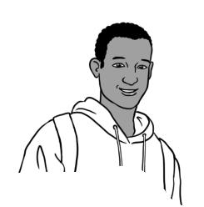

|  |
| --- |
| uni |
| tall |
| friend 🗸 |
| soccer |
| Somalia |
| good |
| short |
| curly |



* 1. Abdi is Bao’s friend .
  2. He comes from __________________.
  3. He goes to _______________.
  4. Abdi is ______________.
  5. He has _______________ , ________________ hair.
  6. He likes playing ___________________.
  7. Abdi is a ______________ friend.



Encourage students to read with a partner and copy the sentences in their notebook.

and copy the sentences into a notebook.

Read the conversation below and practice with one of the students. Ask students to practice with their partners and complete the table below.

|  |
| --- |
|  |

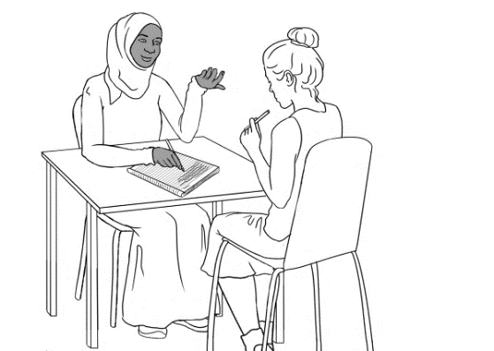

What is your name?

Where are you from?

Can you spell that please?



1. My partner’s name is ____________________________.
2. He / She comes from ____________________________.



Encourage the students to complete the sentences below about their partner.

|  |  |  |  |  |  |  |
| --- | --- | --- | --- | --- | --- | --- |
| 1. My partner is | old. | | middle-aged. | | | young. |
| 1. He / She is | tall. | | | short. | | |
| 1. He / She has | long hair. | | | short hair. | | |
| 1. He / She has | straight hair. | | wavy hair. | | | curly hair. |
| 1. He / She has | brown eyes. | | blue eyes. | | | green eyes. |
| 1. My partner is | kind and helpful. | | | | strong and healthy. | |
| hard-working. | | | | friendly. | |
| 1. My partner likes | reading. | cooking. | | | playing soccer. | |



Encourage students to read with a partner and copy the sentences in their notebook.

and copy the sentences into a notebook.

|  |
| --- |
|  |

Read the dialogue box below and practice with one of the students.

My name is Sahra.

I come from Somalia.

Ask students to complete the sentences about themselves.

1. My name is ____________________________.
2. I come from ____________________________.

Encourage the students to complete the sentences below about themselves.

|  |  |  |  |  |  |  |
| --- | --- | --- | --- | --- | --- | --- |
| 1. I am | old. | | middle-aged. | | | young. |
| 1. I am | tall. | | | short. | | |
| 1. I have | long hair. | | | short hair. | | |
| 1. I have | straight hair. | | wavy hair. | | | curly hair. |
| 1. I have | brown eyes. | | blue eyes. | | | green eyes. |
| 1. I am | kind and helpful. | | | | strong and healthy. | |
| hard-working. | | | | friendly. | |
| 1. I like | reading. | cooking. | | | playing soccer. | |

# The weather

|  |
| --- |
|  |

Project the page. Read the words as you point to the words and the pictures and ask students to repeat. The teacher can use weather app on their phone or project it on the board for more practice.

|  |  |  |  |  |
| --- | --- | --- | --- | --- |
|  |  |  |  |  |
| **sunny** | **cloudy** | **windy** | **rainy** | **stormy** |



Ask students to read the sentences and copy in the space provided.

|  |  |
| --- | --- |
| **Shape, circle  Description automatically generated1** | It is sunny.  It is sunny. . |
| **2** | It is cloudy.  ________________________ |
| **Diagram  Description automatically generated3** | It is windy.  ________________________ |
| **4** | It is rainy.  ________________________ |
| **Text  Description automatically generated with low confidence5** | It is stormy.  ________________________ |

Ask the students to tick the correct answer about today’s weather. The students can use their phones to check the weather app.

Today the weather is

sunny. cloudy. windy. rainy. stormy.

Encourage students to read the sentences with their partner.

|  |
| --- |
|  |

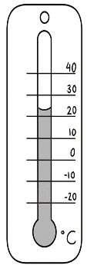

|  |  |  |  |  |
| --- | --- | --- | --- | --- |
|  |  |  |  |  |
| **warm** | **hot** | **very hot** | **cold** | **very cold** |

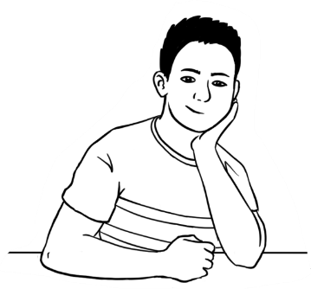

Project the page. Read the words as you point to them and the pictures and ask students to repeat.



What do you think?

Is it a **nice** day?

|  |  |  |  |
| --- | --- | --- | --- |
| A black check mark on a white background  Description automatically generated  Ask students to copy the sentences and tick Yes or No. | | **Yes.**  It is. | **No.**  It isn’t. |
| **1** | It is a warm day.  It is a warm day. . |  |  |
| **2** | It is a hot day.  _______________________________ |  |  |
| **3** | It is a very hot day.  _______________________________ |  |  |
| **4** | It is a cold day.  _______________________________ |  |  |
| **5** | It is a very cold day.  _______________________________ |  |  |



Encourage students to read the sentences with their partner and copy in their notebook.

|  |
| --- |
|  |

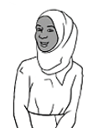

Project the page and point to the thermometer and ‘degree, °C’. Ask follow-up questions to check understanding.

Is it hot or cold today?

How many degrees?

**°**C= degrees

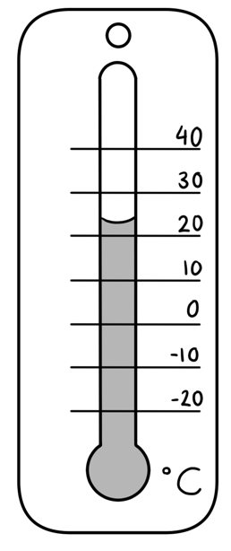

It is very hot.

It is ______°C.

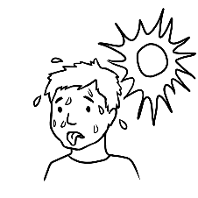

It ishot.

It is ______°C.

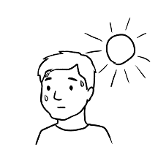

It iscold.

It is ______°C.

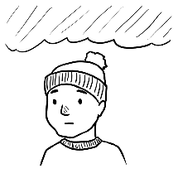

It isvery cold.

It is ______°C.

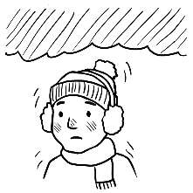

It iswarm.

It is ______°C.

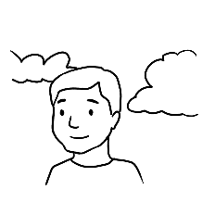



Ask the students to write the degrees in the blanks provided.

Put students in pairs. Encourage students to use the weather app on their phone or project/ write the weather on the board. Ask students to work with their partners to ask the questions and complete the sentences.

|  |  |  |
| --- | --- | --- |
| **Student A** | | **Student B** |
| **1** | What day is it today? | It is _______________________. |
| **2** | What is the date? | It is _____ ______________ ________.  day month year |
| **3** | Is it hot or cold today? | It is __________________. It is ______°C. |



Encourage students to read the sentences with their partner and copy in their notebook.

|  |
| --- |
|  |

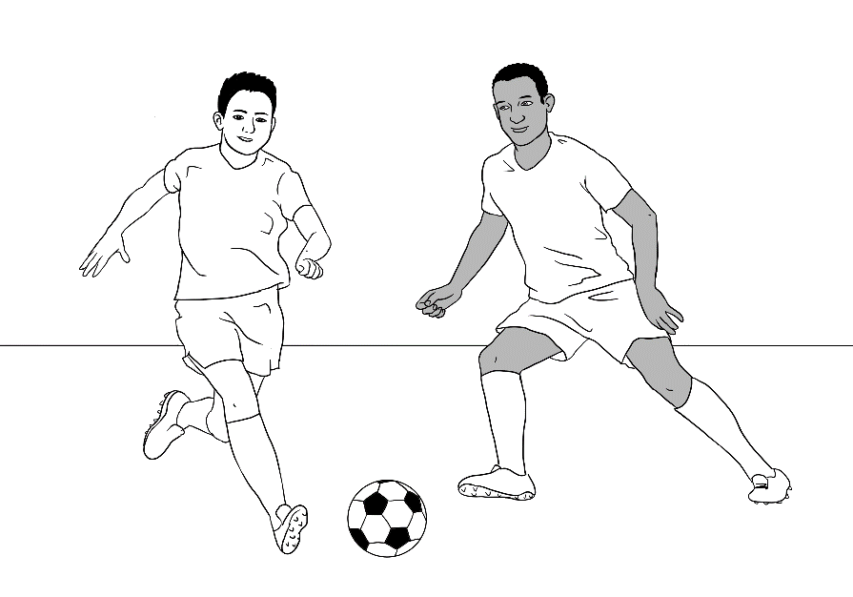

Read the sentences and ask students to repeat after you. Point to ‘Wh’ questions: Who, When and Where. Explain that they are used to ask for more information such as the person, time and place.

Bao and Abdi play soccer on the weekend.

They play at the park on sunny days.

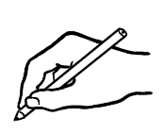

Ask students to answer the questions.

1. Who plays soccer? __________________________________
2. When do they play? ________________________________
3. Where do they play? _______________________________

Point to the weather on the mobile screen. Ask a follow-up question e.g. What is the weather on Saturday?

**Saturday**

Warm and sunny  
 20°C

___________

**Sunday**

Cold and stormy

13°C

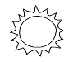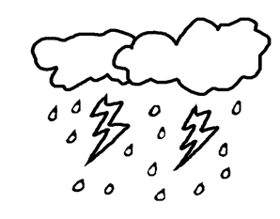

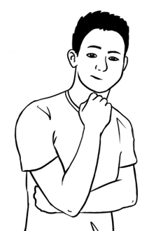



What is **a nice day**   
for soccer?



Ask students to complete the sentence.

________________________ is a nice day for soccer.

Encourage students to read the sentences with their partner.

|  |
| --- |
|  |

Read the sentences and ask students to tick the answer.

It is **cloudy** today.

It is **18°C**.

Is it a **nice** day?



|  |  |  |
| --- | --- | --- |
|  |  |  |
| **Yes, it is.** | **It’s OK.** | **No, it isn’t.** |

|  |  |  |  |
| --- | --- | --- | --- |
| **Student A** | **Student B 🗸** | | |
| A picture containing text, weapon  Description automatically generatedIt is cloudy today.  It is 11 °C.  Is it a nice day? | Yes,  it is. | It’s OK. | No,  it isn’t. |
| A black and white logo  Description automatically generated with low confidenceIt is rainy tomorrow.  It is 17 °C.  Is it a nice day? | Yes, it is. | It’s OK. | No,  it isn’t. |
| Shape  Description automatically generated with medium confidenceIt is sunny on Saturday.  It is 21°C.  Is it a nice day? | Yes, it is. | It’s OK. | No,  it isn’t. |

Put students in groups A and B. Student A reads the sentences and ask the question and student B ticks the answer. The students can then swap their roles.

|  |
| --- |
|  |

Project the page and point to the different cities and read the weather and temperature. Ask follow-up questions e.g. What is the weather in Brisbane?

**°**C= degrees

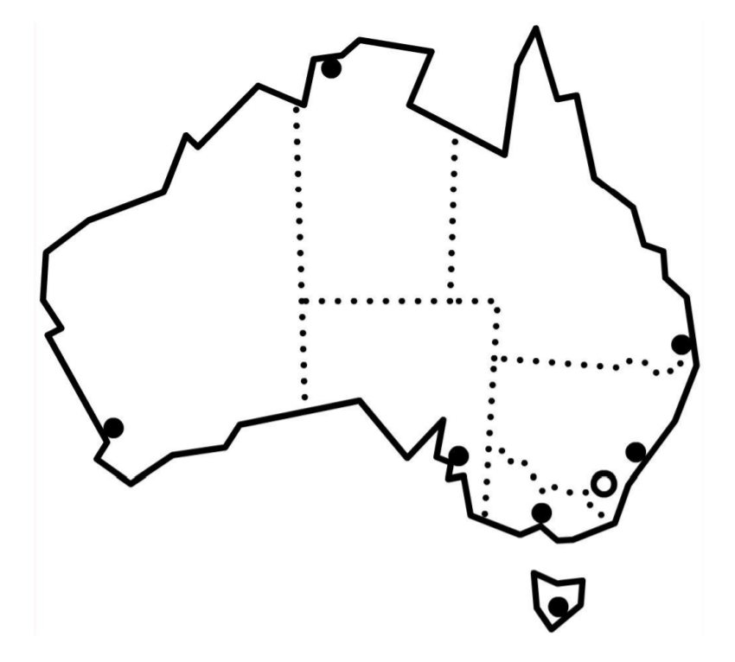

Darwin  
 stormy 32°C



Perth  
 rainy 21°C

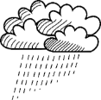

Adelaide cloudy 19°C



Brisbane   
 sunny 28°C

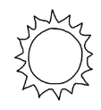

Sydney  
 rainy 23°C



Canberra  
 sunny 19°C

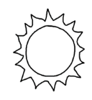

Melbourne  
 windy18°C

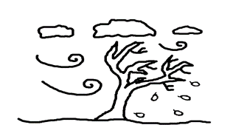

Hobart windy 16°C





Ask students to complete the sentences about the weather in different cities.

1. In Brisbane, it is sunny and 28 °C.
2. In Sydney, it is ________________ and _______°C.
3. In Canberra, it is ________________and _______°C.
4. In Melbourne, it is ________________and _______°C.
5. In Hobart, it is ________________and _______°C.
6. In Adelaide, it is ________________and _______°C.
7. In Perth, it is ________________and _______°C.
8. In Darwin, it is ________________and _______°C.

Encourage students to read the sentences with their partner.

|  |
| --- |
|  |

# The medical centre

Read the instruction below and ask students to repeat after you. Point to the instructions e.g. ‘Go straight ahead’. This activity can be extended by taking students around their English language centre (one floor) and practice giving instructions to e.g. the toilet or the reception.

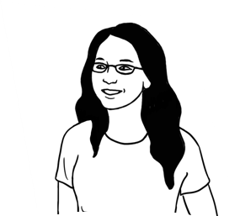

Excuse me.

Where’s the medical centre?

__________________________________________________________________________

Lan Excuse me.

Where’s the medical centre?

Woman The medical centre?

Go straight ahead.

Turn right.

It’s on your left.

LanThanks for your help.

WomanYou’re welcome.  
_____________________________________________________________________________________________

Encourage students to read the instructions with their partner and tick the correct map.



Which map shows me the way   
to the medical centre?

**X**

**Lan is here**.

**X**

**Lan is here.**

Map A

Map B

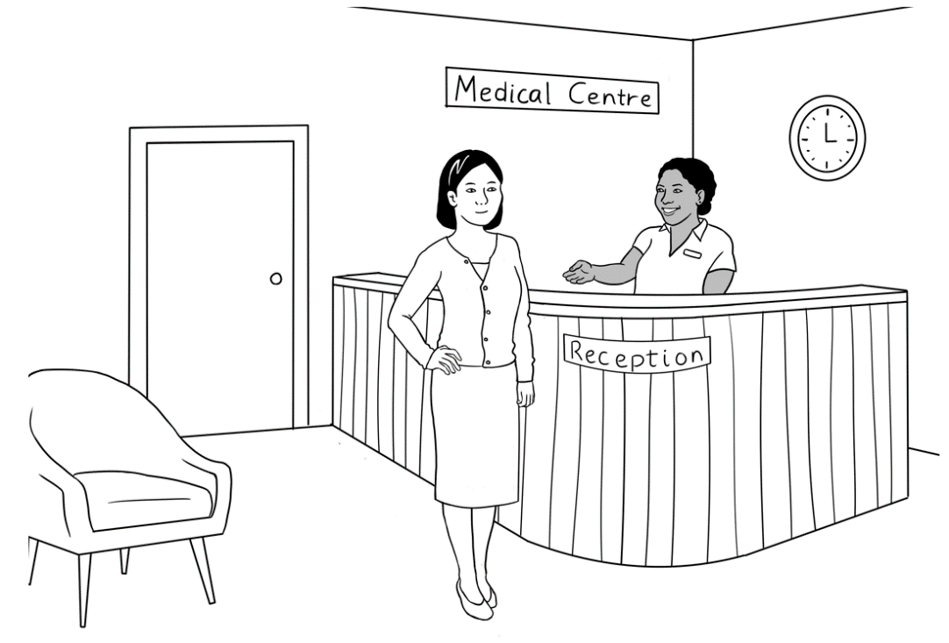

|  |
| --- |
|  |

Project the page and read the dialogue box. Ask students to repeat after you.



Please sit down.

Hello. My name is Lan Wu.

I have an appointment   
at 3 o’clock.

|  |  |  |
| --- | --- | --- |
| **Kellivale Medical Centre** | | |
| **Address** | 35 North Road, Kellivale | |
| **Phone** | 6527 8344 | |
| **Hours** | Monday | 8:00am – 6:00pm |
|  | Tuesday Wednesday | 8:30am – 5:30pm |
|  | Thursday Friday | 8:30am – 7:00pm |
|  | Saturday Sunday | Closed |



Ask students to look at ‘Kellivale Medical Centre’ above and complete the sentences with the correct information.

‘

1. When is the centre open on Monday?

From 8:00am to 6:00pm .

1. When is the centre open on Thursday?

From _____________to ______________

1. What days is the centre closed?

______________________ and ______________________

Read the conversation and ask students to repeat. Point to the Medicare card.

|  |
| --- |
|  |

Do you have   
a Medicare card?

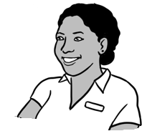

Yes. Here it is. .

What’s your number on the card? card?

My number is **one**.

valid = legal

***medicare***

3056 53521 3

1. LAN WU
2. BAO WU
3. MAI WU

VALID to **03/2026**

Medicare number

names

expiry date



Ask students to complete the sentences.

1. This is a Medicare card.
2. The names on the card are ______________________ ____________________and ________________________.
3. The Medicare number is _________________________.
4. The expiry date is ________________________.
5. Lan’s number is _________.
6. Bao’s number is _________.
7. Mai’s number is _________.



Encourage students to use their own Medicare card or healthcare card if they feel comfortable and complete information in the box below.

Card number _____________________________

Expiry date________________________________  
Your number on the card _______________



Project the appointment card, point to different parts of it and check understanding by asking follow-up questions.



This is my appointment card.

doctor’s address

**Dr James Brown**

35 North Road, Kellivale

Phone 6527 8344

Mrs Lan Wu

has an appointment

**at** 3:00 pm

**on** Thursday 14 April

doctor’s phone number

doctor

patient

time

day

date



Ask students to write about their doctor. The teacher can ask students to bring a card from their GP clinic to class or help them search their doctor’s name online.

Doctor’s name ____________________________________

Address ___________________________________________  
___________________________________________________

Phone number _____________________________________

Ask students to match the questions and answers. Encourage students to read the question and answer.

|  |  |
| --- | --- |
| **Question** | **Answer** |
| 1. What is this card? | 35 North Road, Kellivale |
| 1. Who is the patient? | an appointment card |
| 1. Who is the doctor? | Mrs Lan Wu |
| 1. What is the doctor’s address? | Dr J. Brown |
| 1. What is the phone number? | 3:00 pm |
| 1. What time is the appointment? | 14 April |
| 1. What day is the appointment? | 6527 8344 |
| 1. What date is the appointment? | Thursday |

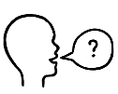

Encourage the students to ask their partner the above questions and then swap roles.

|  |
| --- |
| name |
| card🗸 |
| date |
| time |
| phone |



Ask students to complete the sentences using the words from the box. Encourage the students to put a tick next to the word that they have used.

1. It is an appointment card .
2. The doctor’s _______________ is Dr J. Brown.
3. The doctor’s _______________ number is 6527 8344.
4. The ___________ of the appointment is 3:00pm.
5. The ___________ of the appointment is 14 April.



Encourage students to read with a partner.

|  |
| --- |
|  |

# What’s this?

Read the sentences and point to the pictures. Ask students to repat and point to the pictures as you read.

What’s this?

|  |
| --- |
| 1. It is an appointment card. |
| 1. It is a Medicare card. |
| 1. It is a weather chart. |
| 1. It is a timetable. |
| 1. It is a sign. |

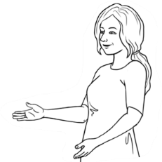

What’s this?

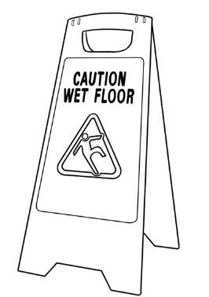

Ask students to match the pictures to the description.

It is a Medicare Care card.

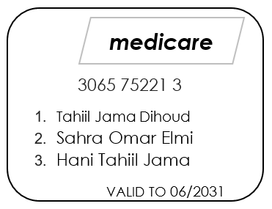

It is a sign.

It is a weather chart.

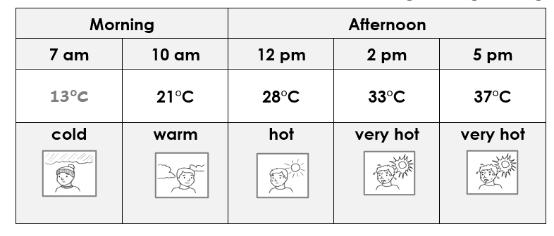

It is an appointment card.

It is a timetable.

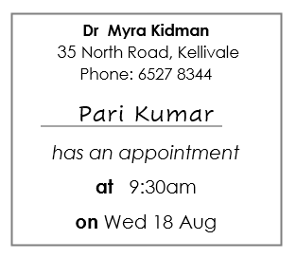

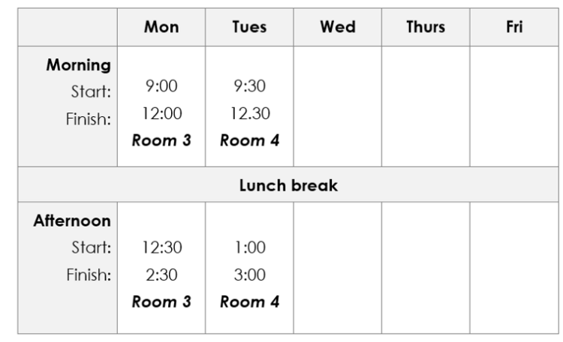

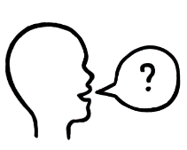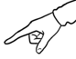

Encourage students to work with a partner and practice by asking ‘What’s this?’

What’s this?

It is a timetable.

# Word List

|  |  |  |
| --- | --- | --- |
| **When** | **Days** | **Months** |
| time  year  month  week  day  morning  afternoon  today  tomorrow  next week  weekend | Monday  Tuesday  Wednesday  Thursday  Friday  Saturday  Sunday    birthday | January  February  March  April  May  June  July  August  September  October  November  December |

|  |  |  |  |  |
| --- | --- | --- | --- | --- |
| **Timetable** | | **Appointment card** | | **Weather** |
| day  morning  afternoon  evening  start  finish  room | | doctor  patient  time  day  date  address  phone number | | hot  warm  Shape  Description automatically generated with medium confidencecold  sunny  cloudy  windy  rainy  stormy  nice |
| **Verbs** | **Workbook instructions** | | **Classroom instructions** | |
| to be  to have  to understand  to go  to come  to want  to buy  to put  to start  to finish  to talk  to play | read  write  copy  listen  say  repeat  ask  spell  ______________  tick  circle  underline  point  record  match  work  colour | | Come in.  Sit down.  Stand up.  Open your book.  Close your book.  Look at the board.  Write on the board.  Take a photo.  Record the teacher. ______________________  Stand next to the table.  Stand in a line.  Stand in a circle.  Walk slowly.  Walk quickly.  Turn the light on.  Turn the light off.  Go left.  Go right.  Go straight ahead. | |

|  |  |  |
| --- | --- | --- |
| **Colour** | **Talk about people** | **Family and friends** |
| A picture containing text, cosmetic  Description automatically generatedyellow  orange  white  blonde  light brown  dark brown  black  grey  red  green  blue | tall  short  old  middle aged  young  long hair  short hair  straight hair  curly hair  wavy hair  blonde hair  blue eyes  green eyes  brown eyes | husband  wife  father  mother  daughter  son  brother  sister  niece  nephew  brother-in-law  friend |
| **What do you think?** |
| kind  helpful  strong  healthy  friendly  hard working |

|  |  |
| --- | --- |
| **Useful Sentences** | |
| Sorry, I **don’t** understand.  Can you speak **slowly** please?  Can you say that **again** please?  Can you **help me** please?  Can you **spell** that please? | What’s your name?  Where are you from?  When is your birthday?  What’s the weather like? |



