

|  |
| --- |
| **English Ready**  **22637 VIC Course in EAL  VU23497 Give and respond to short highly familiar information**  **VU23499 Read and write short, highly familiar factual texts** |

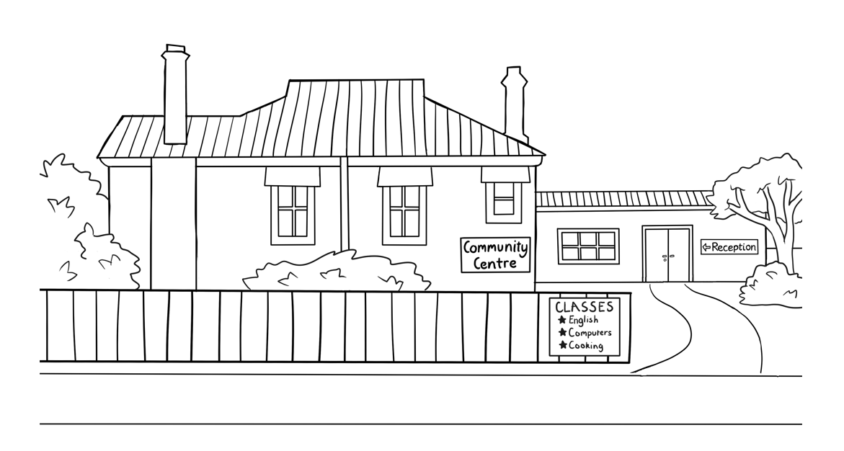**Information and Instructions**

**Teacher resources**

**Design team:** Vicki Hambling, Sue Paull, Frida Dean, Janice Langley, Glenise Kleehammer   
and Mary Wallace

**Illustrations:** Madelena Scott

**Image acknowledgements:**Australian Currency designs – Permission granted by the Royal Australian Mint, Approval # 9/45/432  
Coin with the Queen’s head - [This Photo](https://news.coinsblog.ws/2021/04/08/royal-mint-partner-with-canadian-mint-to-celebrate-the-queens-95th-birthday/the-95th-birthday-of-her-majesty-the-queen-2021-one-ounce-silver-proof-coin-reverse-with-edge-uk2195st-1200x1200-bd93c0f/) by Unknown Author is licensed under [CC BY-SA-NC](https://creativecommons.org/licenses/by-nc-sa/3.0/)

**Acknowledgements:** The design team would like to thank the AMEP service providers and practitioners who participated in the trial and gave valuable feedback. The team would also like to acknowledge the use of the EAL Framework which underpins the design of this book.

Copyright of the EAL Framework is reserved to the Crown in the right of the State of Victoria. © State of Victoria (Department of Education and Training) 2023.  
_________________________________________________________________________________________

This English Ready Resource is licensed under a Creative Commons Attribution-NoDerivs 3.0 Australia licence (More information is available [here](http://creativecommons.org/licenses/by-nd/3.0/au/)). You are free to use, copy and distribute to anyone in its original form as long as you attribute Department of Home Affairs as the author and you license any derivative work you make available under the same licence.  
  
© Commonwealth of Australia 2023

With the exception of the Commonwealth Coat of Arms, the department’s logo, any material protected by a trade mark and where otherwise noted all material presented in this document is provided under a Creative Commons Attribution 4.0 International (<https://creativecommons.org/licenses/by/4.0/>) licence.

The details of the relevant licence conditions are available on the Creative Commons website (accessible using the links provided) as is the full legal code for the CC BY 4.0 licence (<https://creativecommons.org/licenses/by/4.0/legalcode>).

Use of all or part of this document must include the following attribution:   
© Commonwealth of Australia 2023

As far as practicable, material for which the copyright is owned by a third party will be clearly labelled.  The department has made all reasonable efforts to ensure that this material has been reproduced in this document with the full consent of the copyright owners.

Copyright requests and enquiries concerning usage not addressed by the CC BY 4.0 licence should be addressed to:

[*comms@homeaffairs.gov.au*](mailto:comms@homeaffairs.gov.au) *at the Department of Home Affairs.*

The terms of use for the Commonwealth Coat of Arms are available from the [It's an Honour](http://www.itsanhonour.gov.au/) website.

Where a copyright owner, other than the Commonwealth, is identified with respect to this material, please contact that third party copyright owner directly to seek permission.

**Introduction**

**The Teacher Book**

This book is an electronic reference. Print pages as only needed. It includes materials and activities for:

* pair work and class work
* revision and homework
* pronunciation
* extension

The book also contains audio transcripts and links to the audio MP3 files.

**The Student Workbook**

This book requires teacher direction and is **not** intendedfor independent learning.   
It is also not intended to be the only material used to teach these units. The activities included are not suitable to be used for assessment. The book is available as a Word document so that teachers can:

* localise and update the content
* adjust the material to suit the requirements of particular classes
* delete or add materials as required



At the back of the book are two emojis to give feedback to the teacher. Students can hold up the emoji which best reflects how they feel about an activity or a lesson.

**Table of Contents**

1. Instructions 1

2. Meet the people 2

3. Do you understand? 7

4. Introductions 9

5. The Alphabet 10

6. Numbers 26

7. The days 35

8. The time 36

9. The months 42

10. English class 45

11. Get ready for class 49

12. How many? 55

13. Instructions in class 60

14. The community centre 65

15. Signs in the community centre 68

16. A class timetable 69

17. Talk about family and friends 71

18. The weather 76

19. The Medical Centre 83

20. Audio files and transcripts 87

# Instructions

|  |  |  |  |
| --- | --- | --- | --- |
|  | read |  | write |
|  | listen |  | say |
|  | match |  | ask |
| **🗸** | tick |  | draw |
|  | circle |  | colour |
|  | point |  | copy |
|  | Work with  a partner. |  | record |

# Meet the people

**Scenes with the characters**

Scenes from the student and teacher books have been included so that teachers can produce their own materials as needed. A chart with the bio data was created to maintain consistency of information throughout the book.   
It may be useful to update character information.

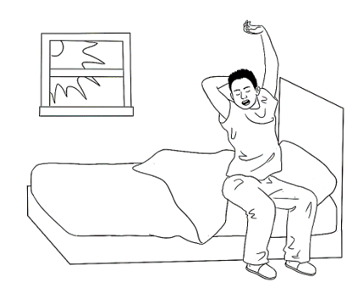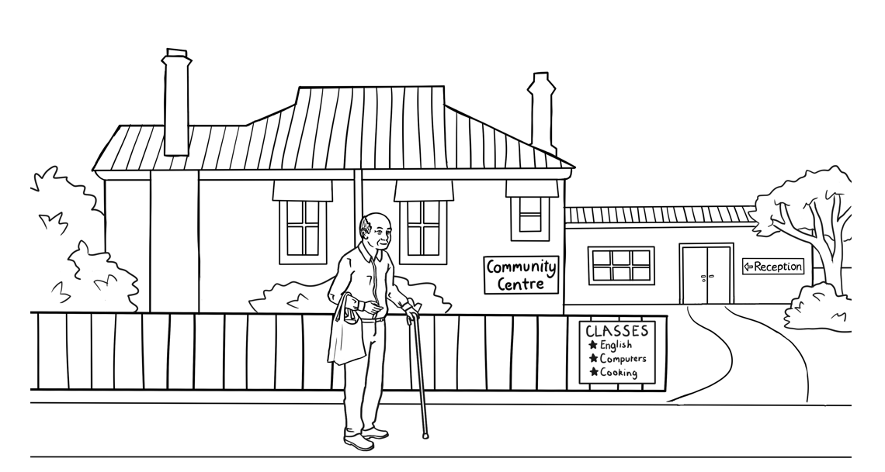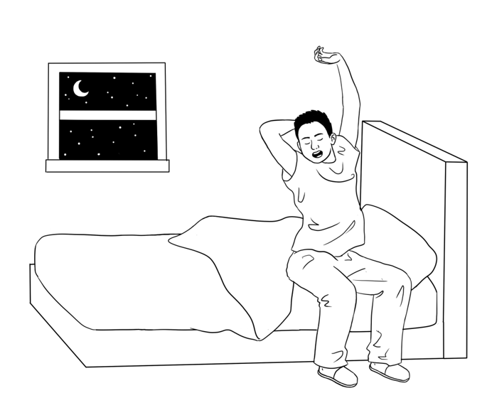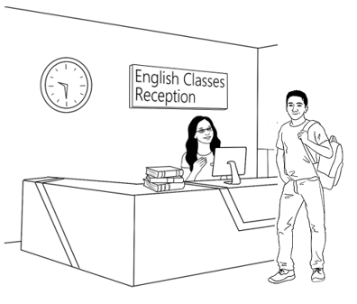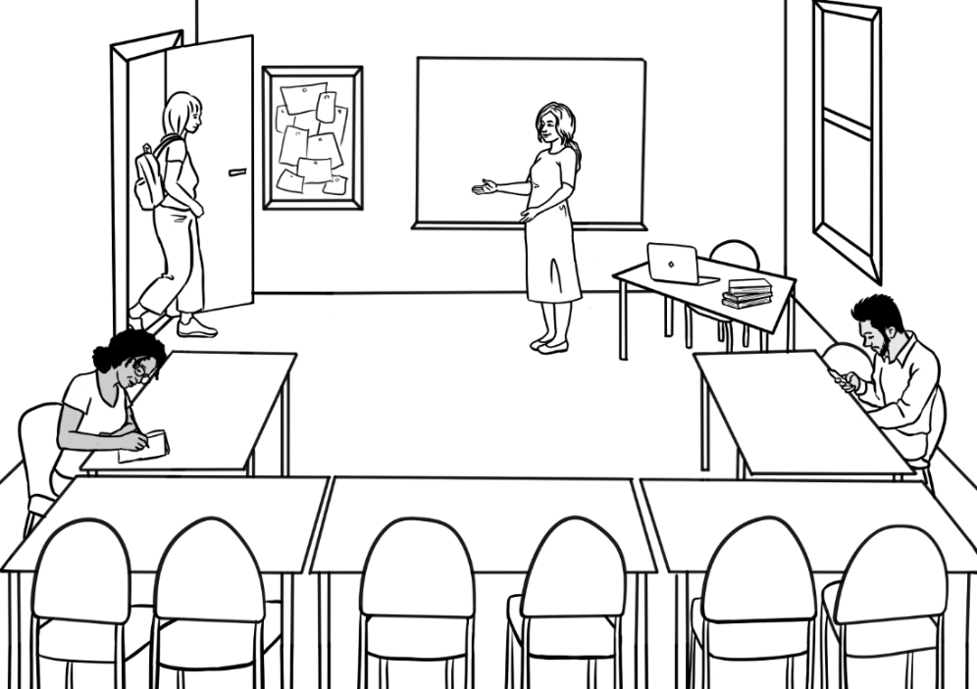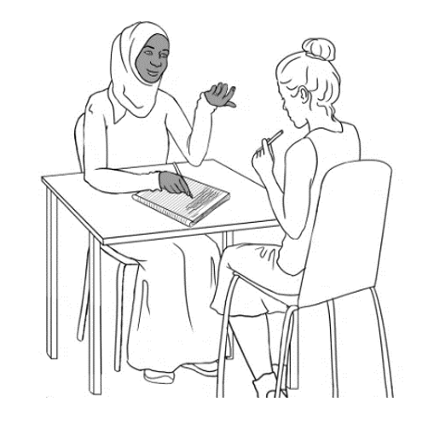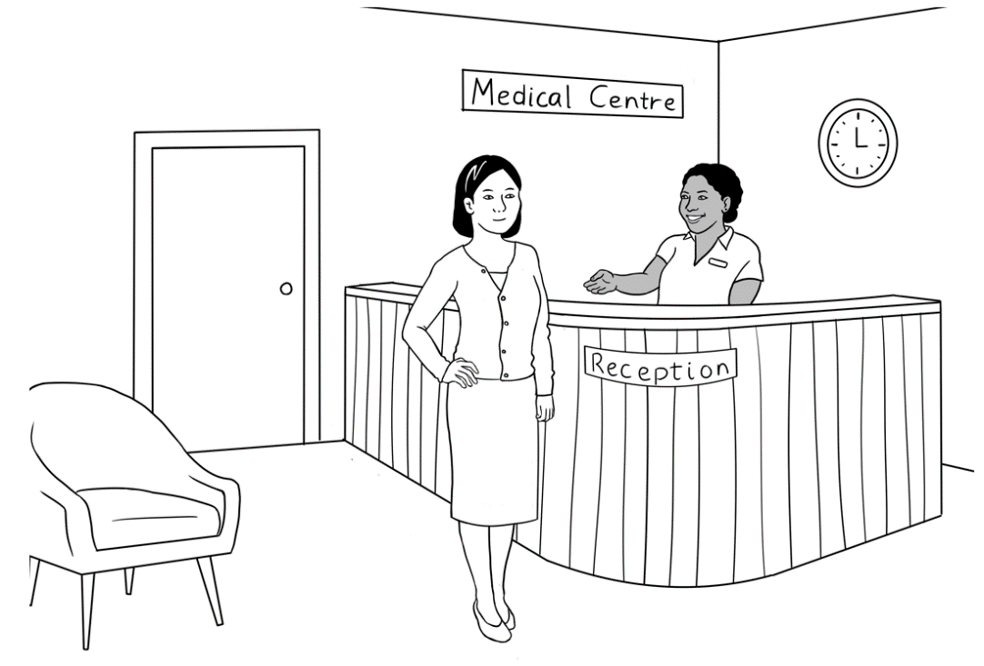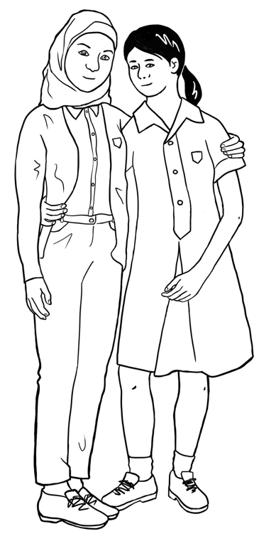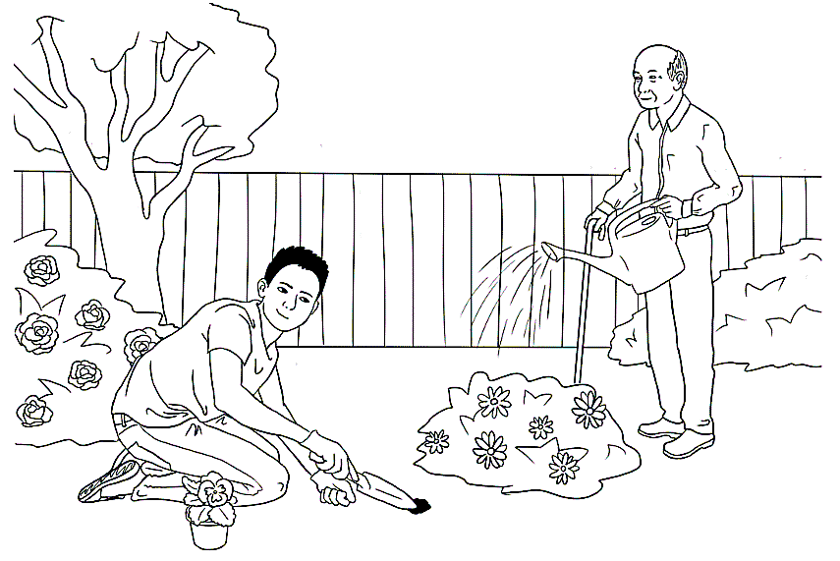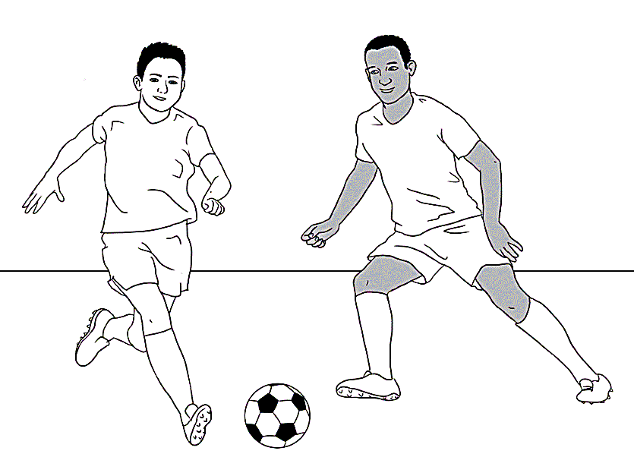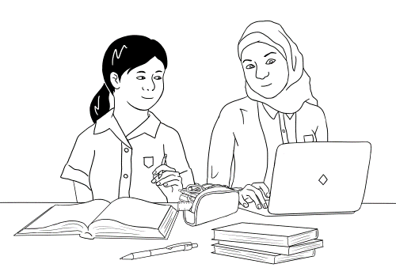

|  |  |  |  |  |  |
| --- | --- | --- | --- | --- | --- |
| **Personal details of the characters** | | | | | |
| **Name** | **Country**  **of origin** | **\*Age** &/or **Date of birth** | **Date**  **of arrival** | **Address in Kellivale** | **Phone** |
| **Tahiil** Jama Dihoud | Somalia | 27.6.94 | 9.6.22 | Unit 6,  50 Baker Rd | 0400 785 936 |
| **Sahra** Omar Elmi | Somalia | 7.7.96 | 9.6.22 | Unit 6,  50 Baker Rd | 0455 961 259 |
| **Hani** Tahiil Jama | Somalia | 2 years 24.06.21 | 9.6.22 | Unit 6,  50 Baker Rd | _ |
| **Abdi** Omar Elmi | Somalia | 4.8.04 | 13.10.15 | Unit 1,  50 Baker Rd | 0465 971 356 |
| **Ming** Wu | China | 27.3.1959 | 07.05.19 | 70 Wattle St | 0418 335 748 |
| **Lan** Wu | China | 6.6.78 | 11.07.14 | 70 Wattle St | 0488 872 951 |
| **Bao** Wu | China | 19 years 13.05.2004 | 11.07.14 | 70 Wattle St | 0409 188 674 |
| **Mai** Wu    3065 75221 3  1. Tahiil Jama Dihoud  2. Sahra Omar Elmi  3. Hani Tahiil Jama  VALID 06/2025  ***medicare*** | China | 16 years 19 April | 11.07.14 | 70 Wattle St | 0487 592 811 |

|  |  |  |  |  |  |
| --- | --- | --- | --- | --- | --- |
| **Personal details of the characters** *[continued]* | | | | | |
| **Nisha** Kumar | India | 19.01.1978 | 06.04.13 | 56 North St | 0411 825 999 |
| **Pari** Kumar | India | 9 years |  | 56 North St |  |
| **Dev** Kumar | India | 7 years 26 August |  | 56 North St |  |
| **Anika** | Ethiopia | 30.09.1995 | 15.10.22 | 56 North Street | 0477 193 286 |
| **Fatima**  Khalil Hamed | Syria | 15 years  13 July | 16/11/2008 | 260 North St |  |
| **Carim**  Khalil Hamed | Syria | 19 years | 30/06/2004 | 260 North St | 0469 455 218 |
| **Jenny** *[Teacher]* | Australia | - | - | - | - |
| **Pam** *[Sahra’s neighbour]* | Australia | 02.02.1956 | _ | Unit 5,  50 Baker Rd | 0407 165 972 |
| **Paul**  *[VTS]* | Australia | _ | _ | _ | 0431 978 352 |

**\*Note 1**: Where dates of birth have been used in the booklets, they have been recorded here as exact figures. The age of the characters is relevant for the younger characters as they either attend childcare, primary school, secondary school or uni. All dates may be adjusted to make them more relevant to the time the resource is being used.

**Note 2**: Characters shaded in this colour are not introduced in this booklet.

# Do you understand?

**Activity - Make requests for repetition or clarification**

* Teach students the requests for clarification and repetition introduced in the student workbook.
* Print the expressions on the following page, laminate and cut up.
* Build confidence in using the expressions through regular class practice:
* Give the four expressions to four students. Select the most confident students at first.
* Ask these students to use their expression at least once during the class – initially with the teacher and later with each other.
* Give the expressions to different students in following classes.
* Teach the additional expression when appropriate.

|  |
| --- |
| Sorry. I don’t understand. |
| Can you help me please? |
| Can you say that again please? |
| Can you speak slowly please? |
| Can you spell that please? |

# Introductions

**Introductions and learning names**

Student names provide a practical vocabulary for building many skills:

1. **Word stress** – Write student names on the board in lists according to the number of syllables. Mark the stress and practise together. Clap, stamp feet or stretch a rubber band to show the main stress with a large circle.

Mai Abdi Anika

1. **Build class connection by learning names - name cards**   
   - With ½ A4 page, fold and create name cards for each student.

Mark the stress pattern on the cards and collect at the end of each class.

1. **Teach how to introduce someone.**

* Write on the board, ‘*My name is___________.*’ Go round the class, with students introducing themselves.
* Next, on the board write, ‘*My name is______________, and this is ______________.’* Demonstrate how to introduce someone with an outstretched hand towards the person, palm up. Round the class, students introduce themselves and the person next to them. This introduction can be revised when a new student joins the class, and extended to include where a student comes from, their likes and dislikes, favourite colour etc.

1. **Use a ball for a different activity**. Ask students to stand in a circle. The student with the ball introduces themself, and then says ‘*and this is ______________*’ and throws the ball to the student named. Continue the game till most students have introduced themselves.

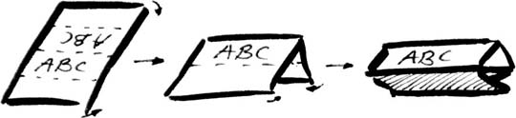

# The Alphabet

1. **Initial sounds of the alphabet - pictures and words**

The following pictures may be cut up by the students and matched to their initial sounds. There are two sets of pictures and words for each sound. Students could add the words for the second set of pictures to the table in their workbook.

**Picture set 1** – These pictures are in the student workbook on pages 12 & 13.

|  |  |  |  |
| --- | --- | --- | --- |
|  |  |  |  |
|  |  |  |  |
|  |  |  |  |
|  |  |  |  |
|  |  |  |  |
|  |  |  |  |
|  |  |  |  |

**Picture set 1** – These words are in the student workbook.

|  |  |  |  |
| --- | --- | --- | --- |
| **apple** | **banana** | **car** | **dog** |
| **exit** | **fish** | **glasses** | **hat** |
| **insect** | **jacket** | **kite** | **lemon** |
| **money** | **nose** | **orange** | **pencil** |

|  |  |  |  |
| --- | --- | --- | --- |
| **queen** | **rain** | **star** | **table** |
| **umbrella** | **van** | **window** | **x-ray** |
| **yam** | **zip** |  |  |

**Picture set 2-**  New pictures not in the student workbook

|  |  |  |  |
| --- | --- | --- | --- |
|  |  |  |  |
|  |  |  |  |
|  |  |  |  |
|  |  |  |  |
|  | Rubber |  |  |
|  |  |  |  |
|  |  |  |  |

**Set 2 words –** These words could be added to the student workbook on p9 - 10.

|  |  |  |  |
| --- | --- | --- | --- |
| **ambulance** | **ball** | **cake** | **down** |
| **eggs** | **foot** | **girl** | **home** |
| **in** | **juice** | **key** | **lamp** |
| **man** | **no** | **office** | **pen** |

|  |  |  |  |
| --- | --- | --- | --- |
| **question** | **rubber** | **student** | **tea** |
| **up** | **vegetables** | **workbook** |  |
| **yes** | **zero** |  |  |

**Upper and lower-case letters**

|  |  |  |  |
| --- | --- | --- | --- |
| **A** | **B** | **C** | **D** |
| **E** | **F** | **G** | **H** |
| **I** | **J** | **K** | **L** |
| **M** | **N** | **O** | **P** |
| **Q** | **R** | **S** | **T** |
| **U** | **V** | **W** | **X** |
| **Y** | **Z** |  |  |

|  |  |  |  |
| --- | --- | --- | --- |
| **a** | **b** | **c** | **d** |
| **e** | **f** | **g** | **h** |
| **i** | **j** | **k** | **l** |
| **m** | **n** | **o** | **p** |
| **q** | **r** | **s** | **t** |
| **u** | **v** | **w** | **x** |
| **y** | **z** |  |  |

**Sound chart**

|  |  |  |
| --- | --- | --- |
| **The sounds of the alphabet** | | |
| **A a** **a**pple | **B b** **b**anana | **C c** **c**ar |
| **D d**  **d**og | **E e  e**xit | **F f f**ish |
| **G g  g**lasses | **H h h**at | **I i i**nsect |
| **J j**  **j**acket | **K k k**ite | **L l l**emon |
| **M m m**oney | **N n n**ose | **O o**  **o**range |
| **P p p**encil | **Q q q**ueen | **R r r**ain |
| **S s st**ar | **T t t**able | **U u u**mbrella |
| **V v v**an | **W w  w**indow | **X x x**-ray |
| **Y y  y**am | **Z z  z**ip |  |

2. Handwriting guide A practice writing book is available at Initial level.

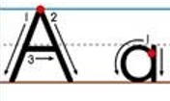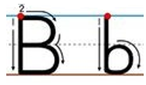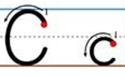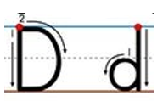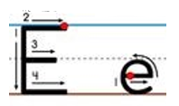

……………………………………………………………………………………………………………..

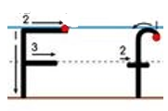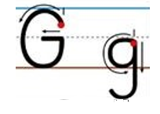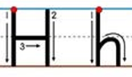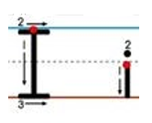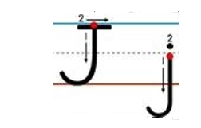

……………………………………………………………………………………………………………..

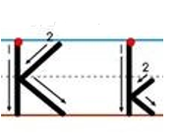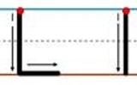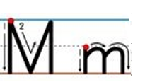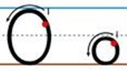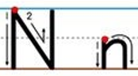

……………………………………………………………………………………………………………..

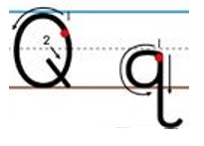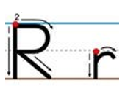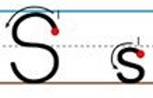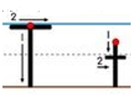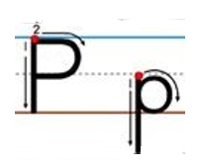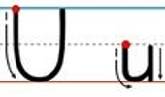

……………………………………………………………………………………………………………..

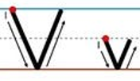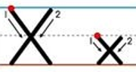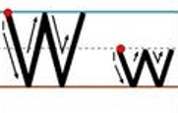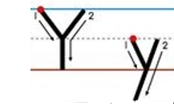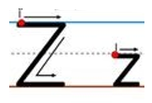

……………………………………………………………………………………………………………..

**Lined page for handwriting practice**

……………………………………………………………………………………………………………..

……………………………………………………………………………………………………………..

……………………………………………………………………………………………………………..

……………………………………………………………………………………………………………..

……………………………………………………………………………………………………………..

……………………………………………………………………………………………………………..

……………………………………………………………………………………………………………..

……………………………………………………………………………………………………………..

……………………………………………………………………………………………………………..

……………………………………………………………………………………………………………..

……………………………………………………………………………………………………………..

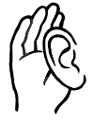**3. Listening to the letters – names or initial sounds**

**Listen**. **Circle** the letter.

|  |  |  |  |  |
| --- | --- | --- | --- | --- |
| **1** | G D E |  | **2** | S C Z |
| **3** | F K H |  | **4** | M N B |
| **5** | L I Y |  | **6** | T C B |
|  |  |  |  |  |
| **1** | B P C |  | **2** | Q K H |
| **3** | C S X |  | **4** | A H K |
| **5** | B D P |  | **6** | V W U |
|  |  |  |  |  |
| **1** | y w u |  | **2** | d b p |
| **3** | g j k |  | **4** | v c w |
| **5** | i e a |  | **6** | e a i |
|  |  |  |  |  |
| **1** | a o e |  | **2** | r a j |
| **3** | k g j |  | **4** | g j k |
| **5** | x s c |  | **6** | a i e |
|  |  |  |  |  |

# Numbers

1. **Pronunciation and word stress of numbers**

Distinguish between similar-sounding pairs such as 13 - 30, 14 -40, etc.

Say the numbers, exaggerating the pronunciation of '**teen**' of each number and the unstressed '**y**' on the 'tens'. Give each student a large rubber band to hold between their thumbs, and as they say the numbers with ‘teen’, they stretch the rubber band to show the stress. Then teach the students to say the numbers naturally.

12 - 20

13 - 30

14 - 40

15 - 50

16 - 60

17 - 70

18 - 80

19 – 90

If a word has more than one syllable, one of the syllables will be stressed. To show stress do one or more or the following:

* Make it louder
* Make it longer
* Make it higher in tone

Show stress using circles. Each circle is a syllable and the larger circle indicates the stressed syllable. Place the circles over the vowel in each syllable. e.g.

On the **thir**tieth of **Au**gust.

Thethir**teenth**?

**No** the  **thir**tieth**.**

Teach repetition as a way of checking understanding.

**2. Numbers tiles**

|  |  |  |  |
| --- | --- | --- | --- |
| **1** | **2** | **3** | **4** |
| **5** | **6** | **7** | **8** |
| **9** | **10** | **11** | **12** |
| **13** | **14** | **15** | **16** |
| **17** | **18** | **19** | **20** |

|  |  |
| --- | --- |
| **one** | **two** |
| **three** | **four** |
| **five** | **six** |
| **seven** | **eight** |
| **nine** | **ten** |

**3. Numbers maze**

This is a student-to-student dictation of numbers.

* Students work in pairs, sitting back-to-back, each with a copy of the maze, a pencil and a pen.
* In the first dictation, use a pencil.
* Student A begins at number one, and calls out each number slowly  
  as he/she moves in any direction along the lines through the maze, marking the route with a pencil.
* Student B listens, finds the number and draws the route on his/her maze.
* Continue in this way until the final row of pictures.
* When Student A identifies the picture he/she has landed on, both students check to see if their marked routes on the maze match.
* Swap roles and in the second dictation, use a pen to draw the route.

Numbers Maze

**47**

**1**

**22**

**35**

**15**

**39**

**27**

**16**

**45**

**30**

**11**

**38**

**8**

**29**

**44**

**21**

**7**

**9**

**3**

**49**

**4**

**34**

**9**

**32**

**22**

**18**

**35**

**13**

**7**

**28**

**6**

**36**

**25**

**26**

**23**

**12**

**7**

**22**

**41**

**20**

**2**

**5**

**40**

**31**

**42**

**17**

**37**

**22**

**43**

**10**

**24**

**48**

**14**

**28**

**19**

**13**

**33**

**50**

**46**

**22**

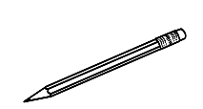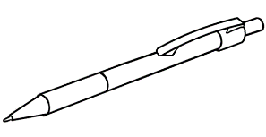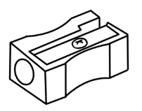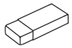

**4. Money**

The following notes and coins can be projected on the board or copied and used for matching exercises.

|  |
| --- |
| **$5** |
| **$10** |
| **$20** |
| **$50** |
| **$100** |

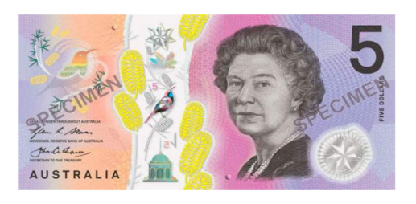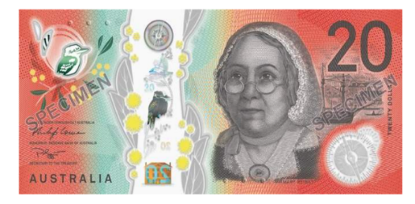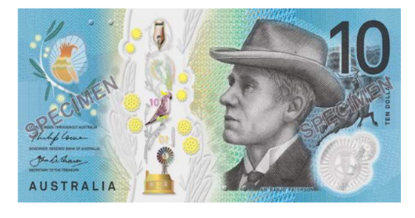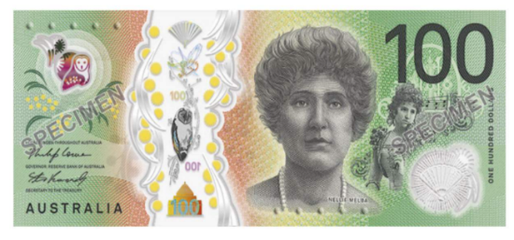

|  |  |  |  |  |
| --- | --- | --- | --- | --- |
|  | 5c |  |  | 50c |
|  | 10c |  |  | $1 |
|  | 20c |  |  | $2 |

**5. Listening and speaking – the years**

**Activity – Worksheet**

Before the activity, demonstrate and practise saying the years in the following way:

**2022** 20 22

**2021**  20 21

**2020**  20 20

Copy the worksheet on the following page for each student.

**Part A** – Read the years as shown above; students circle the year.

**Part B** – You may need to remind students to bring some coins to class in preparation for this activity. Ask students to take out some coins, find the years on the coins and write the years next to the coins on the worksheet. Students then read the years to their partner.

**Years**

**Listen**. **Circle** the year.

|  |  |  |  |
| --- | --- | --- | --- |
| **1**  **A** | 2023 | 2022 | 2021 |
| **2** | 2016 | 2018 | 2019 |
| **4** | 2010 | 2012 | 2011 |
| **5** | 2013 | 2015 | 2014 |
| **6** | 1990 | 1980 | 1970 |
| **7** | 1960 | 1950 | 1940 |

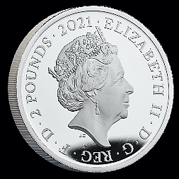

**B**

Look at some coins.

Write the years of the coins below.

|  |  |  |
| --- | --- | --- |
| **Coin** | **Year** | **Year** |
| **5c** |  |  |
| **10c** |  |  |
| **20c** |  |  |
| **50c** |  |  |
| **$1** |  |  |
| **$2** |  |  |

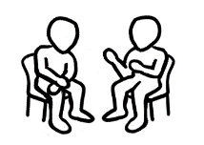 Read the years to your partner.

|  |
| --- |
| **Monday** |
| **Tuesday** |
| **Wednesday** |
| **Thursday** |
| **Friday** |
| **Saturday** |
| **Sunday** |
| **weekend** |
| **today** |
| **tomorrow** |

# **The days**

**Days tiles -**For matching, spelling and writing activities.

|  |
| --- |
| **Mon** |
| **Tues** |
| **Wed** |
| **Thurs** |
| **Fri** |
| **Sat** |
| **Sun** |

# The time

**Activity 1 – Reading an analogue clock**

***Materials***

* Copies of the clock faces on the following page. [Enough for the class.]
* Pins to attach the hands.
* A class set of scissors.
* Light cardboard
* Glue

***Activity***

* Each student makes a clock.
* Call out a time.
* Students turn the hands to show the time.
* They then hold up their clock to be checked.

**\*** This is a great activity to break up a long lesson.

**Activity 2 – Writing and reading the time**

Two worksheets for pair work – hours and half hours.

**Activity 3 – What time do you go to bed?**

This worksheet is a mirror image of the activity in the student workbook on page 14, but covers evening bedtime.

**Activity 4 – Prepositions of time**

This demonstrates a visual way to teach and for students to remember the three key prepositions of time – in, on, at**.**

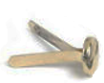

**1.**

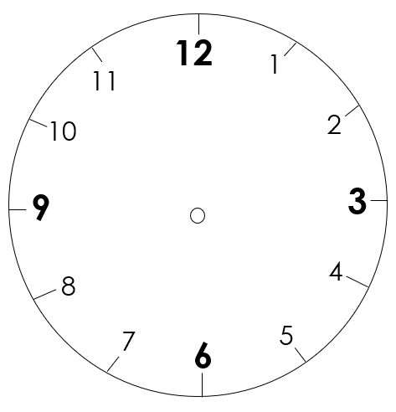

**2.**

**Write** the time.

**Point** to a clock. **Ask**

What’s the time?

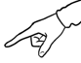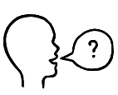

It’s 1 o’clock.

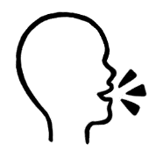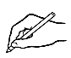

12

1

11

6

3

2

10

9

8

5

7

4

1:00

12

1

11

6

3

2

10

9

8

5

7

4

12

1

11

6

3

2

10

9

8

5

7

4

12

1

11

6

3

2

10

9

8

5

7

4

12

1

11

6

3

2

10

9

8

5

7

4

12

1

11

6

3

2

10

9

8

5

7

4

12

1

11

6

3

2

10

9

8

5

7

4

12

1

11

6

3

2

10

9

8

5

7

4

12

1

11

6

3

2

10

9

8

5

7

4

12

1

11

6

3

2

10

9

8

5

7

4

12

1

11

6

3

2

10

9

8

5

7

4

12

1

11

6

3

2

10

9

8

5

7

4

12.00

11.00

10.00

12

1

11

6

3

2

10

9

8

5

7

4

12

1

11

6

3

2

10

9

8

5

7

4

**Write** the time.

**Point** to a clock. **Ask**

What’s the time?



It’s half past one. o’clock.



12

1

11

6

3

2

10

9

8

5

7

4

12

1

11

6

3

2

10

9

8

5

7

4

12

1

11

6

3

2

10

9

8

5

7

4

1:30

12

1

11

6

3

2

10

9

8

5

7

4

12

1

11

6

3

2

10

9

8

5

7

4

12

1

11

6

3

2

10

9

8

5

7

4

12

1

11

6

3

2

10

9

8

5

7

4

12

1

11

6

3

2

10

9

8

5

7

4

12

1

11

6

3

2

10

9

8

5

7

4

12

1

11

6

3

2

10

9

8

5

7

4

12

1

11

6

3

2

10

9

8

5

7

4

12

1

11

6

3

2

10

9

8

5

7

4

**3.**

**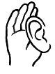Listen** and **repeat.**

I am tired.

It’s half past ten.

St eight.

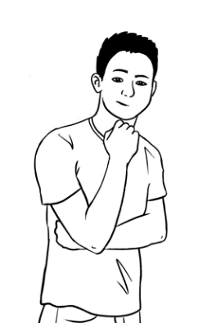

|  |  |  |
| --- | --- | --- |
|  | **pm** = afternoon  **11:000** | **11:30 pm**  Mon 8 Feb  25**°**C |
| It’s half past ten.  It’s ten thirty.  It’s 10:30 pm. | It’s 11 o’clock.  It’s 11 pm. | It’s half past eleven.  It’s eleven thirty.  It’s 11:30 pm. |

I go to bed at half past ten on Monday.

What time do **you** go to bed?



**Write** about you.

I go to bed at ___________________ on Monday.   
**Ask** your partner

What time do you go to bed?

St eight.

**Activity 4 - Prepositions of time**

Prepositions of time can be shown on three concentric circles which can work as a visual memory prompt.

* The larger outside circle represents **in,** usually for **longer lengths of time**   
  ***-*** *months, years, seasons, decades, morning, afternoon and evening*.
* The smaller middle circle represents **on**, for **shorter periods of time**  
  ***-*** *days of the week, the weekend and dates*
* The smallest circle represents **at** for **precise times**   
  - *9 o’clock, festivals, night*

The circles could be enlarged to poster-size and new lengths of time could be added to the circles as they are introduced. See examples below.

**The final diagram**

**in**

**at**

**on**

Sunday

the weekend

March

summer

2001

the morning

the 80s

5 November

5 o’clock

8pm

night

# The months

**Activity 1 – The months**

Tiles for matching, spelling and writing activities

|  |  |
| --- | --- |
| **January** | **February** |
| **March** | **April** |
| **May** | **June** |
| **July** | **August** |
| **September** | **October** |
| **November** | **December** |

|  |  |
| --- | --- |
| **Jan** | **Feb** |
| **Mar** | **Apr** |
| **May** | **June** |
| **July** | **Aug** |
| **Sept** | **Oct** |
| **Nov** | **Dec** |

**Activity 2 - Capitals and basic punctuation**

A basic understanding of the rules for capital letters and punctuation   
needs to be developed and students’ attention regularly drawn to their use.   
At this level, students need to know these basic rules:

e.g. **I**t rains in **J**uly**.**

**I** go to class on **M**onday**.**

**M**ai livesin **K**ellivale**.**

**Activity**

Write sentences similar to the ones below on the board and ask students to come out and add the capital letters and the full stops.

* it rains in september
* it is sunny in january
* i go to class on tuesday
* it is cold in hobart
* the weekend is saturday and sunday
* my name is jack

**A Capital letter** is thefirst letter of:

* a sentence
* a day
* a month
* your name
* a country, state, city, suburb
* the pronoun **I**

**A full stop** comes at the end of a sentence.

# English class

**Activity -**  **Spelling Dictation**

In this activity, the same words are read to the whole class, but each level has support, and each student gets the dictation appropriate to their skills.

**Level A**

This dictation teaches students to look for clues. The words are on the page and can be copied, but the students have to locate the letters to copy. Initially, some students may need help with this, and the teacher could underline in red the parts to copy.

**Level B**

At this level, the difficult sounds have been provided. If the teacher pronounces the word slowly, the students should be able to hear the missing sounds. The answers are below so students can also copy.

**Level C**

At this level, a student can try to either write the word or they can copy. Allowing students this option and to later check their work removes any fear associated with having a go.

**Level A** - Spelling Dictation

**Days of the week**

|  |  |
| --- | --- |
| **Monday**  __ o n d a y | **Tuesday**  __ u e s __ __ __ |
| **Wednesday**  __ ednes__ __ __ | **Thursday**  Thurs __ __ __ |
| **Friday**  __ ri __ __ __ | **Saturday**  __ atur__ __ __ |
| **Sunday**  __ un__ __ __ |  |

**Level B** -Spelling Dictation

|  |  |  |  |  |  |  |  |  |  |  |  |  |
| --- | --- | --- | --- | --- | --- | --- | --- | --- | --- | --- | --- | --- |
| A a | B b | C c | D d | E e | F f | G g | H h | I i | J j | K k | L l | M m |
| N n | O o | P p | Q q | R r | S s | T t | U u | V v | W w | X x | Y y | Z z |

**Days of the week**

1. _ o _ _ _ _
2. _ u e _ _ _ _
3. _ e d _ e _ _ _ _
4. _ _ u r _ _ _ _
5. _ r _ _ _ _
6. _ _ _ u r _ _ _
7. _ _ _ _ _ _

Fold

Check your spelling

|  |  |  |  |
| --- | --- | --- | --- |
| Monday | Tuesday | Wednesday | Thursday |
| Friday | Saturday | Sunday |  |

**Level C** - Spelling Dictation

|  |  |  |  |  |  |  |  |  |  |  |  |  |
| --- | --- | --- | --- | --- | --- | --- | --- | --- | --- | --- | --- | --- |
| A a | B b | C c | D d | E e | F f | G g | H h | I i | J j | K k | L l | M m |
| N n | O o | P p | Q q | R r | S s | T t | U u | V v | W w | X x | Y y | Z z |

**Days of the week**

1. __________________________________________________
2. __________________________________________________
3. __________________________________________________
4. __________________________________________________
5. __________________________________________________
6. __________________________________________________
7. __________________________________________________

*Fold*

Check your spelling.

|  |  |  |  |
| --- | --- | --- | --- |
| Monday | Tuesday | Wednesday | Thursday |
| Friday | Saturday | Sunday |  |

# Get ready for class

**Question inflection**

**Activity 1 - What is in your pencil case?**

1. Demonstrate inflection:

* **downward** for **wh questions**
* **upward** for simple **yes/no questions**.

1. Project the next page and ask the questions in the activity on the next page. Point your finger to show the up and down inflection.

1. Ask students to repeat.
2. If possible, create more examples on the board and practise.
3. Students practise in pairs or small groups using the pictures of stationery  
   in the Student Book.

**Yes, no** questions

**wh** questions

**Question inflection**

|  |
| --- |
| **Wh questions**  **Wh**at’s in your pencil case? |
| **Answers**  I have two pens, a pencil and a rubber.  I have a pencil, a rubber, a sharpener and a pen. |
|  |
| **Simple yes/no questions** |
| A pencil? |
| Coloured pens? |
| A ruler? |
| A highlighter? |
| An apple? |
| **Answers**  **No.**  **Yes.** |

**Activity 2 – The Office Shop catalogue – Listening and writing activity**

* Ask students to predict the prices of the items on the catalogue on the following page.
* The teacher nominates prices for each item; students listen and write the prices on the worksheet.

**Activity 3 – Prices on a catalogue - Pair work**

Students use their Student A or B page and ask each other questions about the prices of items on their page.

1. Students look at their page and the objects in their catalogue.   
   They then take turns to ask their partner:

* How much is the _____________?

Their partner responds:

* It’s $______________.

1. Each student writes the prices on their sheet.

**Activity 2**

**The Office Shop catalogue**

The Office Shop

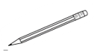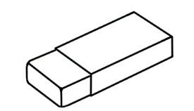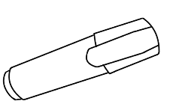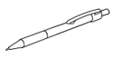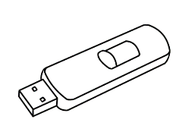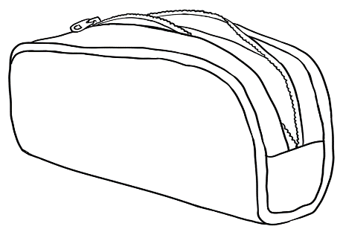

Pencil

**Get ready to learn**

***Date: February ________***

Highlighter

Notebook

Sharpener

USB

Ruler

Rubber

pen



Pencil case

Phone

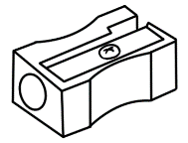

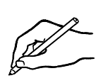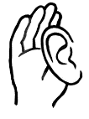**Listen** to the teacher.

**Write** the prices.



**Student A**

**Listen** to your partner.

**Say** the prices.

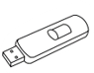

Pencil

$1.15

**Get ready for class**

***Date: January 13***

Highlighter

$1.20

Notebook

$2.50

Sharpener

$1.50

USB

$12

Ruler

80c

Rubber

$1

Pen

$2

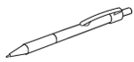

**The School Shop**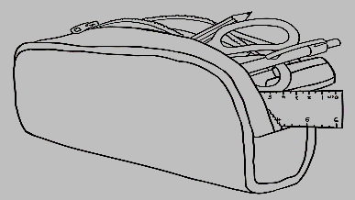

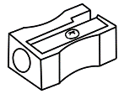

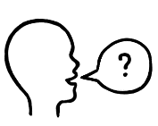

How much is the _____________?

 **Ask** your partner

**Write** the prices.



Pencil

**Get ready to learn**

***Date: January 13***

Highlighter

Notebook

Sharpener

USB

Ruler

Rubber

Pen



**The Office   
Shop**





How much is the _________?

**Student B**

 **Ask** your partner

**Write** the prices.

**The School Shop**



Pencil

**Get ready for class**

***Date: January 13***

Highlighter

Notebook

Sharpener

USB

Ruler

Rubber

Pen

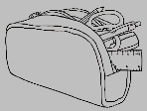



**Listen** to your partner. **Say** the prices.

**The Office Shop**



Pencil

90c

**Get ready to learn**

***Date: January 13***

Highlighter

$1.50

Notebook

$4.50

Sharpener

$2

USB

$15.00

Ruler

$1.20

Rubber

$1.30

Pen

$3



# How many?

**Activity 1 - Where are the items?**

Before handing out the worksheet, demonstrate the location of items:

* Put multiples of familiar classroom objects **on**, **under** and **next to** a table.
* Ask students questions about the location of items stressing the preposition. e.g.:
* Is the pen **on** the table?

Yes, it is.

* Are the rubbers **next to** the table?

No, they are **on** the table.

* Is the ruler **under** the table?

No, it’s **next to** the table.



**on**

**under**

**next to**



There are two hat**s next to** the box.

There is one hat **under** the box.

There is one hat **on** the box**.**

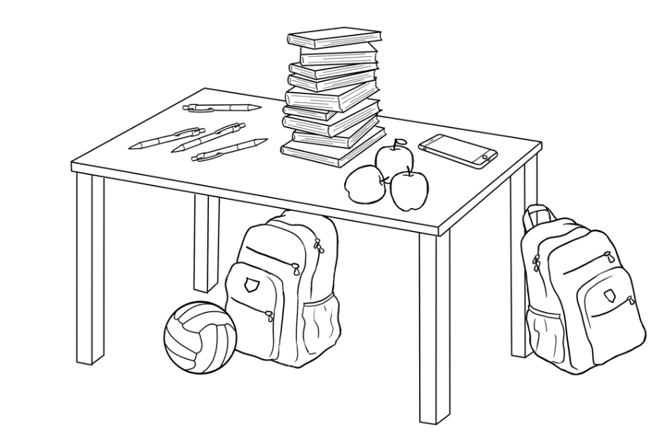

bag

book

phone

apple

pen

ball

**Write sentences.**

There is one phone on the table.

There are three apple**s** on the table.

______________________________________________________________________________________________________________________________________________________________________________________________________________________________________________________________________________________________________________________________________________________________________________________________________________________________________________________________________________________________________________________________

**Activity 2 - Plurals Memory game**

Put different quantities numbers of 6 familiar objects on a table. Give students a minute to count them and commit to memory. Then cover them.

What can the students recall?

The activity can be graded. Students can write the numbers of objects on any of the three worksheets:

* Level A - a list with 6 pictures and words
* Level B - a list with 8 words and pictures [It could include objects not on the table]
* Level C - a list with 12 words and pictures [It could include objects not on the table]

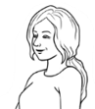

How many?

|  |  |  |
| --- | --- | --- |
| ______ phones | _______ mugs | _____ pencil cases |
| _____ pairs of glasses | _____workbooks | _____ highlighters |



How many?

|  |  |  |  |
| --- | --- | --- | --- |
| ______phones | _______mugs | _____pencil cases | _____highlighters |
| _____pairs  of glasses | _____pairs  of scissors | _______rulers | _____workbooks |



How many?

|  |  |  |  |
| --- | --- | --- | --- |
| ______phones | _______mugs | _____pencil cases | _____highlighters |
| _____ pairs   of glasses | _____ pairs   of scissors | ______ rulers | _____workbooks |
| A picture containing bottle, vessel  Description automatically generated_____ bottles   of water | _____ packets of chips | ______ apples | A picture containing text, sign  Description automatically generated_____ notebooks |

# Instructions in class

**Activity 1 – Classroom instructions**

Cut up the instructions on the following two pages. Introduce these gradually to the class. Keep in a box, and as they are introduced, students can take one and instruct a partner, a small group or the whole class. Repeat until students are familiar with all the instructions.

**Activity 2 – A polite version of the game ‘Simon says’**

Substitute ***Please*** for ***Simon says***, so that students only follow the instructions if it is prefaced with ***Please***. Vary some of the instructions to include familiar vocabulary. e.g. *stand up, turn right, walk around your chair, sit down, open your book, pick up your pen, look at the teacher, open your bag etc*

**Activity 3 - Pair Work - Give and follow instructions**

**Activity 1**

|  |  |
| --- | --- |
| Please stand up. | Please sit down. |
| Turn on the light. | Turn off the light. |
| Look at the board. | Look at me. |
| Look to your left. | Look to your right. |
| Open  your workbook. | Close your workbook. |
| Open the door. | Close the door. |

|  |  |
| --- | --- |
| Walk slowly to the door. | Walk quickly to the door. |
| Please stand in a circle. | Please stand  in a line. |
| Write your name  on the board. | Write number 9  on the board. |
| Smile. | Take a photo. |
| Walk slowly to the window. | Ask your teacher  to check. |

**Activity 3**

 **Give instructions** to your partner.

**Student A**

1. Circle the pen.
2. Colour the pencil case blue.
3. Underline the word students.
4. Colour the three books yellow.

**2.** Write your name **next to** the laptop.

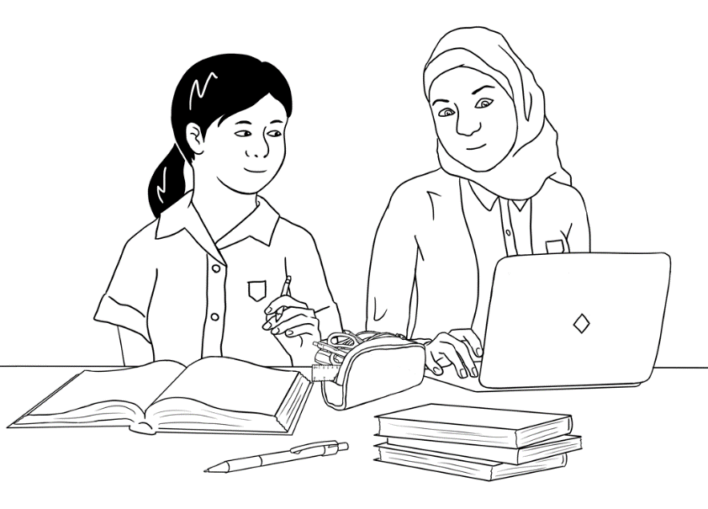

We are students.



*Fold*

 **Listen** to your partner.

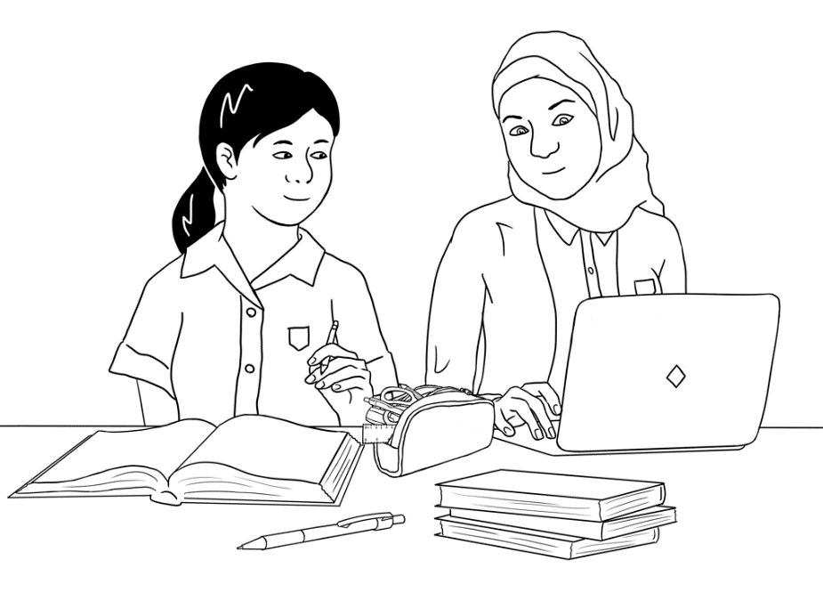

We are good friends.

 **Listen** to your partner.

**Student B**



We are students.

*Fold*



**Give instructions** to your partner.

1. Circle the three books.
2. Colour Mai’s book green.
3. Underline the word good.

**4.** Colour the pen red.

**2.** Write yourname **on** the laptop.



We are good friends.

# The community centre

**Activity 1 – Punctuation – capitals and full stops**

This worksheet is an introduction to reading a floor plan and a revision of work on basic punctuation. Before giving out the worksheet:

* Project the floor plan.
* Ask open and closed questions about what is represented on the plan. [Draw attention to the rising and falling intonation in the questions.]   
  e.g. How many rooms? Fire exits? Toilets?   
   What room is next to room2? etc  
   Is there a canteen? A reception? A library? etc
* Revise the use of capitals and full stops.
* On the worksheet, ask students to point to particular rooms and places on the plan.
* Students copy the sentences, adding capitals and full stops.

**Activity 2 – Information about my learning centre.**

***Preparation***

* Copy the ‘My learning centre’ page.
* Write the required information on the board.
* Say the relevant words and students repeat:   
  centre’s name, address, phone number, start and finish times, teacher’s name, class name, class days.
* Students copy the information from the board and read the completed information with a partner.



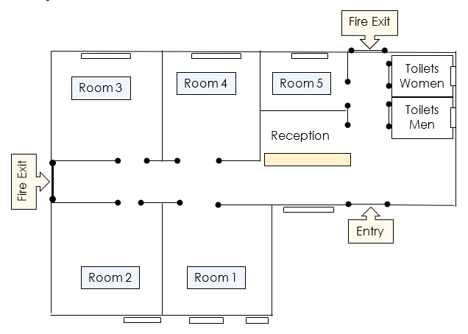 **Listen** to the teacher.

**Point** to places on the plan.



**Write** the sentences with capitals and full stops.

1. on tuesday morning ming is in room 4

On Tuesday morning Ming is in room 4. .

1. on wednesday afternoon ming is in room 4

_________________________________________________________

1. on friday morning ming is in room 3

_________________________________________________________

1. on thursday morning the centre is closed

_________________________________________________________

1. on thursday afternoon the centre is closed

_________________________________________________________

**Copy** from the board.

**Centre name ______________________________________________**

**Address ______________________________________________  
______________________________________________**

**Phone** ______________________________________________

**Centre Hours**

Monday ________________________________

Tuesday ________________________________

Wednesday ________________________________

Thursday ________________________________

Friday ________________________________

Saturday ________________________________

Sunday ________________________________

**My teacher’s name** ____________________________________________

**My class name** _____________________________________________



**Write** the times.

|  |  |  |  |  |  |
| --- | --- | --- | --- | --- | --- |
| **Mon** | **Tues** | **Wed** | **Thurs** | **Fri** | **Sat** |
|  |  |  |  |  |  |

# Signs in the community centre



Where are these signs in the community centre?



|  |  |  |  |  |
| --- | --- | --- | --- | --- |
|  |  |  |  |  |
|  |  |  |  |  |
|  |  |  |  |  |

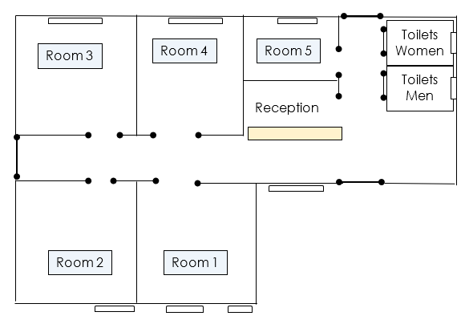

# A class timetable

**Activity - Reading Carim’s timetable.**

* Copy the worksheet on following page.
* Introduce new vocab - computers, room numbers e.g. A31.
* Project the timetable.
* Focus on a day and ask questions about start and finish times, room numbers etc.
* Give students a copy of the worksheet, read the introductory sentences and ask some additional questions about the days and times on the timetable.
* Students complete the yes/no exercise and copy the sentences into their notebooks.

*Confident students can be encouraged to use the model to construct sentences about their own timetable.

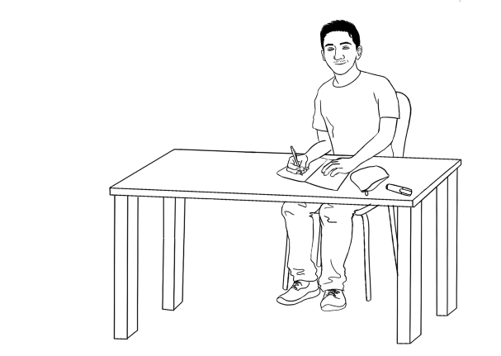



**Listen** to the teacher.

Carim learns English at TAFE.

This is his timetable.

|  |  |  |  |  |  |
| --- | --- | --- | --- | --- | --- |
|  | **Mon** | **Tues** | **Wed** | **Thurs** | **Fri** |
| **Morning**  Start  Finish | **Room A31**  9:00  12:00 | **Room B4**  9:30  12.30 | **Room H6**  9:00  12:00 | **Room A31**  8:30  12:00 | **Room H6** 9:00  1:00 |
| ***Lunch break*** | | | | | |
| **Afternoon**  Start  Finish | **Computers**  12:30  2:30 | **Room B4**  1:00  3:00 | **Room H6**  1:00  4:00 | **Room A31**  1:00  3:00 |  |

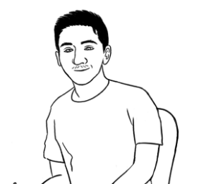

I start class at 9 o’clock on Monday.

|  |  |  |  |
| --- | --- | --- | --- |
|  | **Tick.** | **Yes** | **No** |
| **1** | I start class at 9:00 on Monday. | 🗸 |  |
| **2** | I start class at 9:00 on Tuesday. |  |  |
| **3** | I finish class at 4:30 on Wednesday. |  |  |
| **4** | I have lunch at 12:30 on Thursday. |  |  |
| **5** | I finish class at 4:00 on Thursday. |  |  |
| **6** | I finish class at 1:00 on Friday. |  |  |

**Copy** the sentences into your notebook.

# Talk about family and friends

**Activity - Description dictation**

There are two dictations at two levels. Dictate only one section at a time.

Remind students to use capital letters at the beginning of a sentence, and for the first letter in a country and the day of a week. Before the dictations, practise the initial blends included in the texts: fr, sh, bl, st, pl, th

* Dictation 1: Students can refer back to *soccer, they, play* and

the words are introduced in the student book.

* Dictation 2: *She* is spelt in the text once. After that, students need to refer back to the original *she* and copy.
* Encourage students to check their work.

1. Bao and Abdi **play** soccer.   
   **They** play **soccer** on the weekend.

They play at **the** park.

Bao and Abdi play soccer on sunny days.

1. Fatima is my friend.

**She** comes from **S**yria.

She is short.

She has blue eyes.

Fatima is a Year 9 student.

She plays netball on **F**riday.

She is hard-working and friendly.

At the end of each dictation, students could copy the sentences either under the original ones or in their notebooks.

**Dictation 1**- Level A

Bao and Abdi play _ occer.   
They _ _ _ _ _ occer on the _ eekend.

_ _ ­_ _ _ _ _ _ at the _ark.

|  |  |  |  |  |  |  |  |  |  |  |  |  |
| --- | --- | --- | --- | --- | --- | --- | --- | --- | --- | --- | --- | --- |
| A a | B b | C c | D d | E e | F f | G g | H h | I i | J j | K k | L l | M m |
| N n | O o | P p | Q q | R r | S s | T t | U u | V v | W w | X x | Y y | Z z |

Bao and Abdi _ _ _ _ _ occer on _ unny _ ays.

**pl th**

**Dictation 1 -** Level B

Bao and Abdi play _occer.   
They _ _ _ _ _ occ _ _ on the _ eekend.

_ _ ey _ _ _ _ at _ _e _ark.

Bao and Abdi _ _ ay _ occ_ _ _ _ _ unny _ ays.

|  |  |  |  |  |  |  |  |  |  |  |  |  |
| --- | --- | --- | --- | --- | --- | --- | --- | --- | --- | --- | --- | --- |
| A a | B b | C c | D d | E e | F f | G g | H h | I i | J j | K k | L l | M m |
| N n | O o | P p | Q q | R r | S s | T t | U u | V v | W w | X x | Y y | Z z |

**Dictation 2** - Level A

* 1. Fatima is _y _ riend.
  2. She _ omes _ rom _ yria.
  3. _____ is shor_.
  4. _____ has _ lue eyes.
  5. Fatima is a Year 9 __tudent.
  6. _____ _ lays _ etball on _ riday.

|  |  |  |  |  |  |  |  |  |  |  |  |  |
| --- | --- | --- | --- | --- | --- | --- | --- | --- | --- | --- | --- | --- |
| A a | B b | C c | D d | E e | F f | G g | H h | I i | J j | K k | L l | M m |
| N n | O o | P p | Q q | R r | S s | T t | U u | V v | W w | X x | Y y | Z z |

* 1. _____ is hard-working and _ riendly.

**Dictation** **2** - Level B

**fr sh bl st pl**

* 1. Fatima is _y _ _ ien_.
  2. She _ omes _ _ om _ yria.
  3. _ _ _ is _ _ or _.
  4. _ _ _ ha_ _ _ ue eye_.
  5. Fatima i_ a Year 9 _ _uden_.
  6. _ _ _ play_ _ etbal_ on _ _ iday.

|  |  |  |  |  |  |  |  |  |  |  |  |  |
| --- | --- | --- | --- | --- | --- | --- | --- | --- | --- | --- | --- | --- |
| A a | B b | C c | D d | E e | F f | G g | H h | I i | J j | K k | L l | M m |
| N n | O o | P p | Q q | R r | S s | T t | U u | V v | W w | X x | Y y | Z z |

* 1. _ _ _ is _ard-working and _ _ iendly.

**Copy** the sentences here and into your notebook.

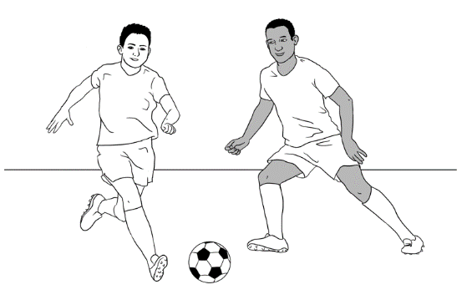

1. Bao and Abdi play soccer.

_________________________________________________

1. They play on the weekend.

_____________________________________________________________

1. They play at the park.

_____________________________________________________________

1. They play soccer on sunny days.

_____________________________________________________________

**Copy** the sentences here and into your notebook.

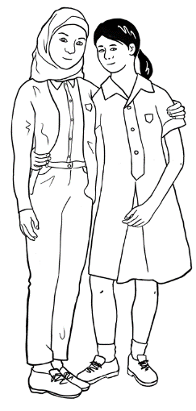

1. Fatima is my friend.

_________________________________________________

1. She comes from Syria.

_____________________________________________________________

1. She is short.

_____________________________________________________________

1. She has blue eyes.

_____________________________________________________________

# The weather

**Activity 1 - A weather chart** – Pair work

**What’s the weather like in Sydney?**

**Student A**

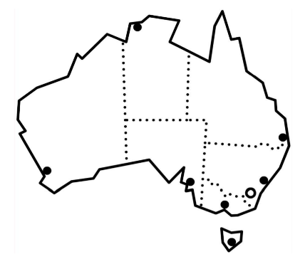

Sydney

|  |  |  |  |  |
| --- | --- | --- | --- | --- |
| sunny | cloudy | windy | rainy | stormy |



What’s the weather like on **Monday**?

**Ask** your partner

**Write** on the chart.

|  |  |  |  |
| --- | --- | --- | --- |
| **Sydney weather** | | | |
| Monday | Tuesday | Wednesday | Thursday |
| ______________ | rainy | ______________ | sunny |
| Friday | Saturday | Sunday |  |
| _____________ | windy | ____________ |  |

**What’s the weather like in Sydney?**

**Student B**



Sydney

|  |  |  |  |  |
| --- | --- | --- | --- | --- |
| sunny | cloudy | windy | rainy | stormy |



What’s the weather like on **Tuesday**?

**Ask** your partner

**Write** on the chart.

|  |  |  |  |
| --- | --- | --- | --- |
| **Sydney weather** | | | |
| Monday | Tuesday | Wednesday | Thursday |
| sunny | _____________ | rainy | ____________ |
| Friday | Saturday | Sunday |  |
| cloudy | ___________ | stormy |  |

**Activity 2 - A weather chart with temperatures** – Pair work

**Draw this table on the board.**

|  |  |  |  |  |  |
| --- | --- | --- | --- | --- | --- |
|  | windy | sunny | rainy | cloudy | stormy |
| Mon |  | 🗸 19 |  |  |  |
| Tues |  |  |  |  |  |
| Wed |  |  |  |  |  |
| Thur |  |  |  |  |  |
| Fri |  |  |  |  |  |
| Sat |  |  |  |  |  |

* Students need to listen, tick the box and write the temperature.
* Demonstrate the exercise by reading and asking students to come to the board, tick the appropriate box on the chart and write temperature.

**Read:** On Monday the weather is sunny. Tick under sunny.

It’s 19 degrees on Monday. Write 19.

On Tuesday it’s cloudy. Tick under cloudy.

It’s 9 degrees on Tuesday. Write 9.

On Wednesday it’s rainy. Tick under rainy.

It’s 12 degrees on Wednesday. Write 12.  
**Encourage students to show their understanding.**

|  |  |
| --- | --- |
| **Don’t understand**?  Can you say that again please?  Did you say sunny?  Did you say 19?  Did you say Monday?  Shake your head. | **Understand.**  Yes.  Ah ha.  Ok.  Good.  Nod your head. |

**Student A**



Are you ready?

**Ask** your partner



**Read slowly** to your partner.

On **Monday** it’s windy. Tick under windy.

It’s 11 degrees on Monday. Write 11.

On **Tuesday** it’s rainy. Tick under rainy.

It’s 9 degrees on Tuesday. Write 9.

On **Wednesday** it’s windy. Tick under windy.

It’s 10 degrees on Wednesday. Write 10.

|  |  |  |  |  |  |
| --- | --- | --- | --- | --- | --- |
|  | rainy | stormy | cloudy | windy | sunny |
| Mon |  |  |  | 🗸 11 |  |
| Tues | 🗸 9 |  |  |  |  |
| Wed |  |  |  | 🗸 10 |  |
| Thur |  |  |  |  |  |
| Fri |  |  |  |  |  |
| Sat |  |  |  |  |  |



**Listen** to your partner.

**Write** on the chart.



**Student B**



**Listen** to your partner.

**Write** on the chart.

|  |  |  |  |  |  |
| --- | --- | --- | --- | --- | --- |
|  | rainy | stormy | cloudy | windy | sunny |
| Mon |  |  |  |  |  |
| Tues |  |  |  |  |  |
| Wed |  |  |  |  |  |
| Thur |  | 🗸 8 |  |  |  |
| Fri |  |  | 🗸 12 |  |  |
| Sat |  |  |  |  | 🗸 15 |



**Read slowly** to your partner.

On **Thursday** the weather is stormy. Tick under stormy.

It’s 8 degrees on Thursday. Write 8.

On **Friday** it’s cloudy. Tick under cloudy.

It’s 12 degrees on Friday. Write 12.

On **Saturday** it’s sunny. Tick under sunny.

It’s 15 degrees on Saturday. Write 15.

**Check your work** with your partner.

**Activity 3 – Talking about the weather using connectives – and, but**

Project the two charts. Divide the class in two and read like a chant. Swap roles.

|  |  |
| --- | --- |
| **Student A** | **Student B** |
| What’s the weather like? | It’s cloudy **and** warm. |
| What’s the weather like? | It’s windy **and** cold. |
| What’s the weather like? | It’s rainy **and** very cold. |
| What’s the weather like? | It’s stormy **and** hot. |
| What’s the weather like? | It’s sunny **and** very hot. |

|  |  |
| --- | --- |
| **Student A** | **Student B** |
| What’s the weather like? | It’s cloudy **but** not rainy. |
| What’s the weather like? | It’s windy **but** not cold. |
| What’s the weather like? | It’s sunny **but** not hot. |
| What’s the weather like? | It’s stormy **but** not cold. |
| What’s the weather like? | It’s sunny **but** not warm. |

# The Medical Centre

**Dr Kim Tran**

35 North Road, Kellivale

Phone: 6527 8344

**Mr Tom Dean**

has an appointment

**at** 9:30 am

**on** Thursday 7 June



**Read** the appointment card.

**Match** questions and answers.

|  |  |  |
| --- | --- | --- |
| **Questions** |  | **Answers** |
| 1. What is this card? | Mr Tom Dean |
| 1. Who is the appointment for? | 35 North Road, Kellivale |
| 1. Who is the doctor? | an appointment card |
| 1. What is the doctor’s address? | Dr Kim Tran |
| 1. What is the telephone number? | 9:30 am |
| 1. What day is the appointment? | 7 June |
| 1. What time is the appointment? | 6527 8344 |
| 1. What date is the appointment? | Thursday |

**Read** the questions and answers with a partner.

Matching dates and times

|  |  |  |  |
| --- | --- | --- | --- |
|  | 1 February 2021 |  | 30. 9. 52 |
|  | 19 April 2015 |  | 8. 6. 98 |
|  | 30 September 1952 |  | 1. 2 . 21 |
|  | 5 October 1941 |  | 9. 11. 77 |
|  | 8 June 1998 |  | 15. 1. 65 |
|  | 21 May 1989 |  | 19. 4. 15 |
|  | 15 January 1965 |  | 21. 5. 89 |
|  | 9 November 1977 |  | 14. 12. 02 |
|  | 14 December 2002 |  | 16. 8. 49 |
|  | 16 August 1949 |  | 5 / 10 /41 |

**Match the dates.**

**Match the times.**

|  |  |  |  |
| --- | --- | --- | --- |
|  | One o’clock |  | 7:00 |
|  | Three thirty |  | 12:30 |
|  | Seven o’clock |  | 2:30 |
|  | Nine thirty |  | 1:00 |
|  | Twelve thirty |  | 5:30 |
|  | Six o’clock |  | 9:30 |
|  | Two thirty |  | 12:00 |
|  | Eleven thirty |  | 3:30 |
|  | Five thirty |  | 6:00 |
|  | Twelve o’clock |  | 11:30 |

**Read** the medical centre instructions.

1. Do **not** enter if you have COVID -19 symptoms .
2. Do **not** come late.
3. You must **check** **in.**
4. Have your Medicare **card** ready.
5. Sit down and waitfor the **doctor**.



**Tick** one.

These instructions are at the medical centre for the patient.

for the doctor.



**Write** the words.

**Number** the instructions.

**1**

Sit down and wait for the ________________.

You must ______________ ______________.

Do ______________ enter if you have COVID-19 symptoms.

Have your Medicare ______________ ready.

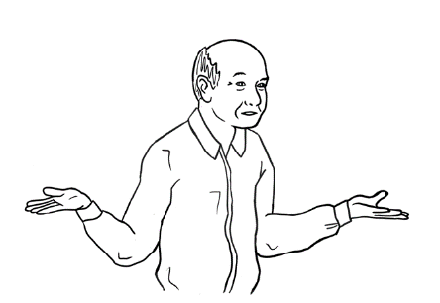Do not ______________ late.

Sorry. I don’t understand.

Can you check my work please?

**Ask** your partner

# Audio files and transcripts

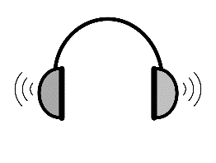

**1**

**Where is the Community Centre?**[Student Book Section 14, Pages 29-30]

 

**MP3 files**

**Transcript**

Student A Excuse me, where is the Community Centre?

Student B The Community Centre? Oh, it’s in Kemp Street.

It’s an old building. It has a red roof  
and a brown fence.   
There’s a small tree near the front door.

Student A Did you say a red roof?

Student B Yes, that’s right and a brown fence.

Student A Ok. thank you.



**2**

**Mai talks about Fatima** [Student Book Section 17, Page 43]

 

**MP3 files**

Fatima is my friend.

She comes from Syria.

She is short.

She has blue eyes.

Fatima is a Year 9 student.

She plays netball on Friday.

She is hard-working and friendly.

**Transcript**



**3**

**Lan talks about Nisha** [Student Book Section 17, Page 44]

 

**Transcript**

**MP3 files**

Nisha is my friend.  
She comes from India.

She works in a childcare centre.   
Nisha is tall.  
She has long, wavy hair.

She likes reading.   
Nisha is a good friend.



**4**

**Bao talks about Abdi** [Student Book Section 17, Page 45]

 

**MP3 files**

Abdi is my friend.  
He comes from Somalia.

He goes to uni.   
Abdi is tall.  
He has short, curly hair.

He likes playing soccer.   
Abdi is a good friend.

**Transcript**