

|  |
| --- |
| **English Ready**  22637VIC Course in EALVU23577 - Recognise and use numbers and money from 50 to 100  for highly familiar activities |

Numbers and money  
50 - 100

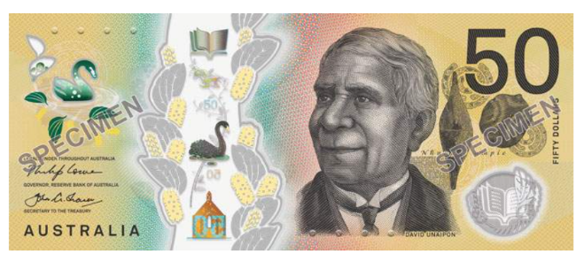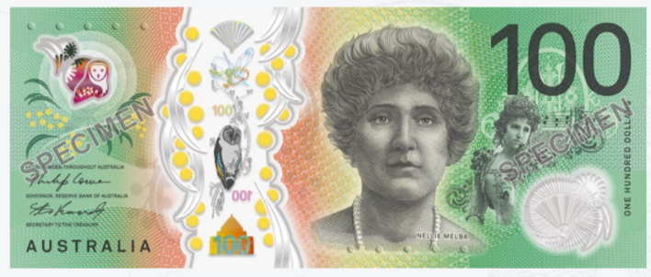

**Teacher** _______________________________________________________________

**Class** ___________________________________________________________________

**Date**____________________________________________________________________

**Name** __________________________________________________________________

*This workbook is designed to be used with the support of a teacher.*

**Design team:** Sue Paull, Vicki Hambling, Nikeh Shariatian, Bernie Milesand Mary Wallace

**Illustrations:** Madelena Scott

**Image acknowledgements:**  
Biscuits [This Photo](https://freepngimg.com/png/10847-biscuit-png-clipart) by Unknown Author is licensed under [CC BY-NC](https://creativecommons.org/licenses/by-nc/3.0/)  
Box with sticky tape - a href="https://www.freepik.com/free-vector/sticker-design-with-empty-box-closed-isolated_  
100th birthday cake - [This Photo](https://www.flickr.com/photos/gracefulcakecreations/3686072231/) by Unknown Author is licensed under [CC BY-NC-ND](https://creativecommons.org/licenses/by-nc-nd/3.0/)  
Cake box - **<**a href="https://www.freepik.com/icon/cake-box_6680318">Icon by small.smiles</a>

**Acknowledgements:** The design team would like to acknowledge the use of the EAL Framework which underpins the design of this book.

Copyright of the EAL Framework is reserved to the Crown in the right of the State of Victoria. © State of Victoria (Department of Education and Training) 2023.  
_________________________________________________________________________________________

This English Ready Resource is licensed under a Creative Commons Attribution-NoDerivs 3.0 Australia licence (More information is available [here](http://creativecommons.org/licenses/by-nd/3.0/au/)). You are free to use, copy and distribute to anyone in its original form as long as you attribute Department of Home Affairs as the author and you license any derivative work you make available under the same licence.  
  
 © Commonwealth of Australia 2024

With the exception of the Commonwealth Coat of Arms, the department’s logo, any material protected by a trade mark and where otherwise noted all material presented in this document is provided under a Creative Commons Attribution 4.0 International (<https://creativecommons.org/licenses/by/4.0/>) licence.

The details of the relevant licence conditions are available on the Creative Commons website (accessible using the links provided) as is the full legal code for the CC BY 4.0 licence (<https://creativecommons.org/licenses/by/4.0/legalcode>).

Use of all or part of this document must include the following attribution:   
© Commonwealth of Australia 2023

As far as practicable, material for which the copyright is owned by a third party will be clearly labelled.  The department has made all reasonable efforts to ensure that this material has been reproduced in this document with the full consent of the copyright owners.

Copyright requests and enquiries concerning usage not addressed by the CC BY 4.0 licence should be addressed to:

[*comms@homeaffairs.gov.au*](mailto:comms@homeaffairs.gov.au) *at the Department of Home Affairs.*

The terms of use for the Commonwealth Coat of Arms are available from the [It's an Honour](http://www.itsanhonour.gov.au/) website.

Where a copyright owner, other than the Commonwealth, is identified with respect to this material, please contact that third party copyright owner directly to seek permission.

**Contents**

1. Instructions 4

2. Meet the students and teachers. 5

3. Numbers 1 - 50 6

4. Numbers 50 - 100 8

5. Did you say 15 or 50? 14

6. Before and after 16

7. Add the numbers. 18

8. Money 20

9. Morning tea 26

10. At a café 30

11. At a men’s clothes shop 34

12. At an office shop 38

13. Let’s go out. 42

# Instructions

|  |
| --- |
|  |

|  |  |  |  |  |  |
| --- | --- | --- | --- | --- | --- |
|  |  | listen |  |  | say |
|  |  | read |  |  | write |
|  |  | ask |  |  | copy |
|  |  | match |  |  | circle |
|  |  | highlight |  |  | tick |
|  |  | work with  a partner |  |  | clap |

# Meet the students and teachers.



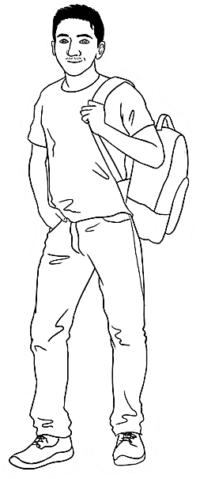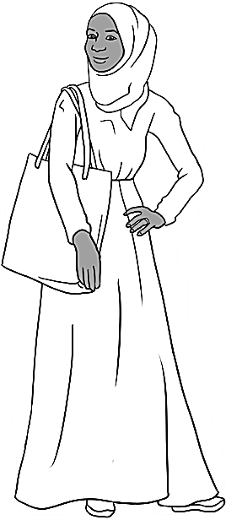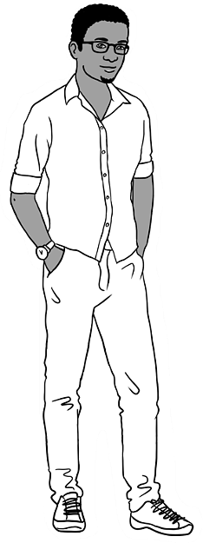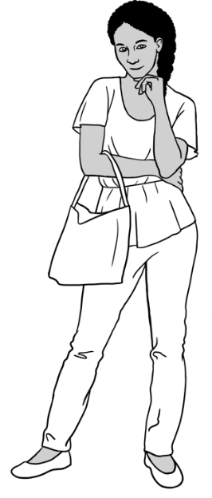

Carim Sahra Tahiil Anika Ming

**The students**

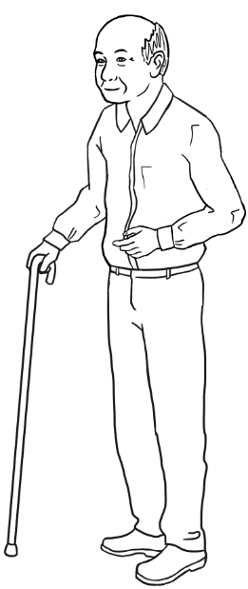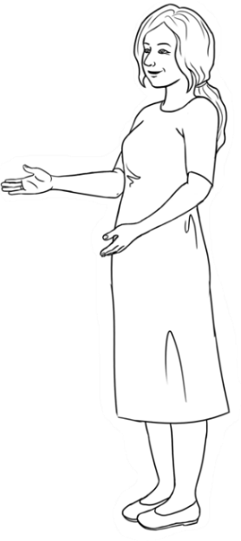

**The teachers**

Jenny Wendy

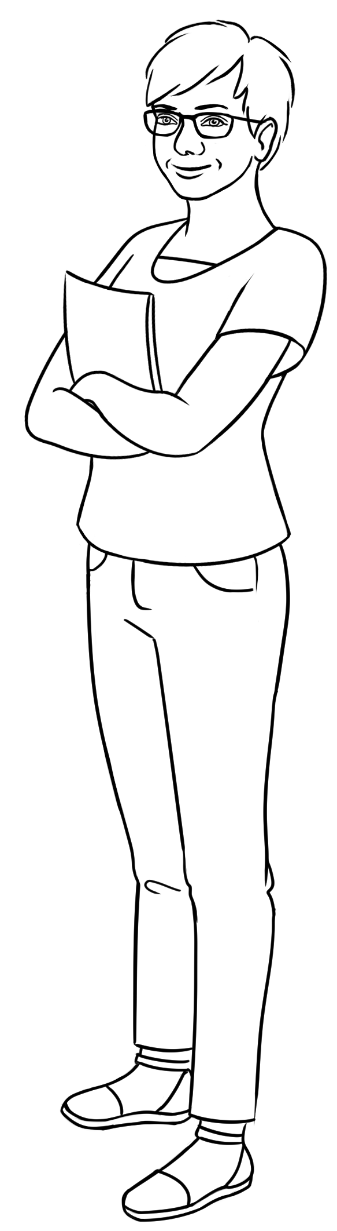

**The learning centres**

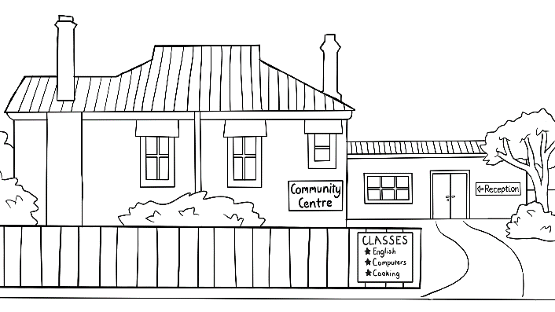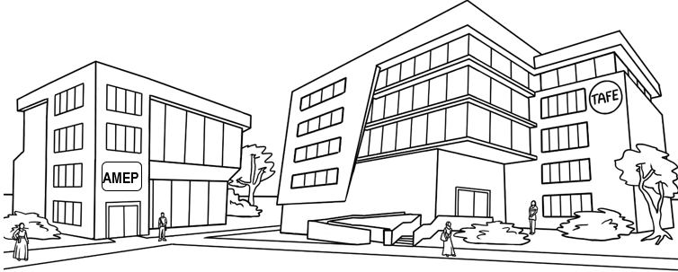

# Numbers 1 - 50

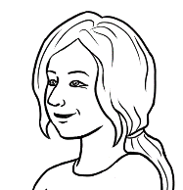

Circle 5.

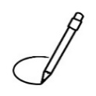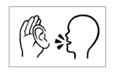

Row **a**.

Highlight 8 and 14.

|  |  |  |  |  |  |  |  |  |  |
| --- | --- | --- | --- | --- | --- | --- | --- | --- | --- |
| 0 | 1 | 2 | 3 | 4 | 5 | 6 | 7 | 8 | 9 |
| 10 | 11 | 12 | 13 | 14 | 15 | 16 | 17 | 18 | 19 |
| 20 | 21 | 22 | 23 | 24 | 25 | 26 | 27 | 28 | 29 |
| 30 | 31 | 32 | 33 | 34 | 35 | 36 | 37 | 38 | 39 |
| 40 | 41 | 42 | 43 | 44 | 45 | 46 | 47 | 48 | 49 |
| 50 |  |  |  |  |  |  |  |  |  |



**2.**

|  |  |  |  |  |  |  |  |  |  |  |
| --- | --- | --- | --- | --- | --- | --- | --- | --- | --- | --- |
| **a.** | 2 | 4 | 6 | 8 | 10 | 12 | 14 | 16 | 18 | 20 |
|  |  |  |  |  |  |  |  |  |  |  |
| **b.** | 3 | 6 | 9 | 12 | 15 | 18 | 21 | 24 | 27 | 30 |
|  |  |  |  |  |  |  |  |  |  |  |
| **c.** | 4 | 8 | 12 | 16 | 20 | 24 | 28 | 32 | 36 | 40 |
|  |  |  |  |  |  |  |  |  |  |  |
| **d.** | 5 | 10 | 15 | 20 | 25 | 30 | 35 | 40 | 45 | 50 |
|  |  |  |  |  |  |  |  |  |  |  |
| **e.** | 6 | 12 | 18 | 24 | 30 | 36 | 42 | 48 |  |  |



|  |  |  |  |  |  |  |  |  |  |
| --- | --- | --- | --- | --- | --- | --- | --- | --- | --- |
| 0 | 1 | 2 | 3 | 4 | 5 | 6 | 7 | 8 | 9 |
| 1 |  |  |  |  |  |  |  |  |  |
| 10 | 11 | 12 | 13 | 14 | 15 | 16 | 17 | 18 | 19 |
|  |  |  |  |  |  |  |  |  |  |
| 20 | 21 | 22 | 23 | 24 | 25 | 26 | 27 | 28 | 29 |
|  |  |  |  |  |  |  |  |  |  |
| 30 | 31 | 32 | 33 | 34 | 35 | 36 | 37 | 38 | 39 |
|  |  |  |  |  |  |  |  |  |  |
| 40 | 41 | 42 | 43 | 44 | 45 | 46 | 47 | 48 | 49 |
|  |  |  |  |  |  |  |  |  |  |
| 50 |  |  |  |  |  |  |  |  |  |
|  |  |  |  |  |  |  |  |  |  |

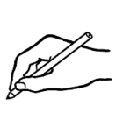

|  |  |  |  |  |  |  |  |  |  |
| --- | --- | --- | --- | --- | --- | --- | --- | --- | --- |
| 0 | 1 | 2 |  | 4 | 5 | 6 |  | 8 |  |
| 10 |  | 12 | 13 |  | 15 |  | 17 | 18 |  |
|  | 21 |  | 23 | 24 |  | 26 | 27 |  | 29 |
| 30 |  | 32 |  | 34 | 35 | 36 |  | 38 | 39 |
|  | 41 |  | 43 |  | 45 |  | 47 | 48 |  |
| 50 |  |  |  |  |  |  |  |  |  |



# Numbers 50 - 100



|  |  |  |  |  |  |  |  |  |  |
| --- | --- | --- | --- | --- | --- | --- | --- | --- | --- |
|  |  |  |  |  |  |  |  |  |  |
| 50 | 51 | 52 | 53 | 54 | 55 | 56 | 57 | 58 | 59 |
|  |  |  |  |  |  |  |  |  |  |
| 60 | 61 | 62 | 63 | 64 | 65 | 66 | 67 | 68 | 69 |



Circle 56.

|  |  |  |  |  |  |  |  |  |  |
| --- | --- | --- | --- | --- | --- | --- | --- | --- | --- |
|  |  |  |  |  |  |  |  |  |  |
| 70 | 71 | 72 | 73 | 74 | 75 | 76 | 77 | 78 | 79 |
|  |  |  |  |  |  |  |  |  |  |
| 80 | 81 | 82 | 83 | 84 | 85 | 86 | 87 | 88 | 89 |
|  |  |  |  |  |  |  |  |  |  |
| 90 | 91 | 92 | 93 | 94 | 95 | 96 | 97 | 98 | 99 |
|  |  |  |  |  |  |  |  |  |  |
| 100 |

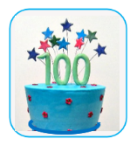



Circle 52.



|  |  |  |  |  |  |  |  |  |  |
| --- | --- | --- | --- | --- | --- | --- | --- | --- | --- |
| 50 | 51 | 52 | 53 | 54 | 55 | 56 | 57 | 58 | 59 |
| 60 | 61 | 62 | 63 | 64 | 65 | 66 | 67 | 68 | 69 |
| 70 | 71 | 72 | 73 | 74 | 75 | 76 | 77 | 78 | 79 |
| 80 | 81 | 82 | 83 | 84 | 85 | 86 | 87 | 88 | 89 |
| 90 | 91 | 92 | 93 | 94 | 95 | 96 | 97 | 98 | 99 |
| 100 |  |  |  |  |  |  |  |  |  |

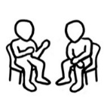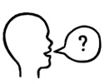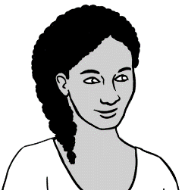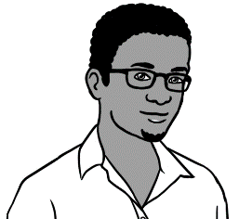

What’s **that** number?

76.

**What’s** = *What is*





1. **4.**

|  |  |  |  |  |  |  |  |  |  |
| --- | --- | --- | --- | --- | --- | --- | --- | --- | --- |
| 50 | 51 | 52 | 53 | 54 | 55 | 56 | 57 | 58 | 59 |
| 60 | 61 | 62 | 63 | 64 | 65 | 66 | 67 | 68 | 69 |
| 70 | 71 | 72 | 73 | 74 | 75 | 76 | 77 | 78 | 79 |



|  |  |  |  |  |  |  |  |  |  |
| --- | --- | --- | --- | --- | --- | --- | --- | --- | --- |
| 50  50 | 51 | 52 | 53 | 54 | 55 | 56 | 57 | 58 | 59 |
| 60 | 61 | 62 | 63 | 64 | 65 | 66 | 67 | 68 | 69 |
| 70 | 71 | 72 | 73 | 74 | 75 | 76 | 77 | 78 | 79 |
| 80 | 81 | 82 | 83 | 84 | 85 | 86 | 87 | 88 | 89 |
| 90 | 91 | 92 | 93 | 94 | 95 | 96 | 97 | 98 | 99 |
| 100 |  |  |  |  |  |  |  |  |  |
|  |  |  |  |  |  |  |  |  |  |
| 50 | 51 | 52 |  | 54 |  | 56 | 57 |  | 59 |
| 60 | 61 |  | 63 |  | 65 | 66 |  | 68 |  |
|  | 71 | 72 |  | 74 | 75 |  | 77 |  | 79 |
| 80 |  | 82 | 83 | 84 |  | 86 |  | 88 | 89 |
| 90 | 91 |  | 93 |  | 95 |  | 97 | 98 |  |
|  |  |  |  |  |  |  |  |  |  |

|  |  |  |  |  |  |  |  |  |
| --- | --- | --- | --- | --- | --- | --- | --- | --- |
| **a.** | 66 | 67 | 68 |  | **b.** | 71 | 72 | ______ |
|  |  |  |  |  |  |  |  |  |
| **c.** | ______ | 75 | 76 |  | **d.** | 69 | ______ | 71 |
|  |  |  |  |  |  |  |  |  |
| **e.** | ______ | 58 | 59 |  | **f.** | 79 | 80 | ______ |
|  |  |  |  |  |  |  |  |  |
| **g.** | 48 | ______ | 50 |  | **h.** | 88 | ______ | 90 |
|  |  |  |  |  |  |  |  |  |
| **i.** | 62 | ______ | 64 |  | **j.** | 50 | 51 | ______ |
|  |  |  |  |  |  |  |  |  |
| **k.** | 89 | ______ | 91 |  | **l.** | ______ | 56 | 57 |
|  |  |  |  |  |  |  |  |  |
| **m.** | 70 | ______ | 72 |  | **n.** | 40 | ______ | 42 |

1.  **2.**



|  |  |  |  |  |  |  |  |  |  |  |  |  |
| --- | --- | --- | --- | --- | --- | --- | --- | --- | --- | --- | --- | --- |
| 73 |  | 67 ✓ |  | 49 |  | 57 |  | 70 |  | 74 |  | 89 |
|  |  |  |  |  |  |  |  |  |  |  |  |  |
| 81 |  | 63 |  | 52 |  | 90 |  | 71 |  | 55 |  | 41 |

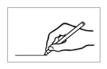



1. **2.**



|  |  |  |  |  |  |  |  |  |  |  |  |  |  |  |
| --- | --- | --- | --- | --- | --- | --- | --- | --- | --- | --- | --- | --- | --- | --- |
|  |  |  |  |  |  |  |  |  |  |  |  |  |  |  |
|  | **50** |  | 51 | 58 |  | 59 |  | 65 |  | 73 |  |  | 75 |  |
|  |  |  |  |  |  |  |  |  |  |  |  |  |  |  |
|  | 53 |  | 52 |  | 60 |  |  |  | 74 |  | 72 |  | 71 |  |
|  |  |  |  |  |  |  | 58 |  |  |  |  |  |  |  |
|  | 54 |  |  | 61 |  | 57 |  | 75 |  | 69 |  |  | 70 |  |
|  |  |  | 62 |  |  |  |  |  |  |  | 89 |  |  |  |
|  | 55 |  |  | 56 |  |  | 76 |  |  | 96 |  | 85 |  |  |
|  |  |  |  |  |  |  |  |  | 68 |  |  |  |  |  |
|  | 64 |  | 63 | 59 |  | 67 |  |  |  |  | 84 |  |  |  |
|  |  |  | 54 |  |  |  | 77 |  |  |  |  |  |  |  |
|  | 65 |  |  | 66 |  |  | 78 |  | 83 |  |  | 81 | 86 |  |
|  | 67 |  |  |  | 79 |  |  |  |  |  |  |  |  |  |
|  |  |  | 96 |  | 80 |  | 81 |  | 82 |  | 87 |  |  |  |
|  | 97 |  |  |  |  |  | 89 |  |  |  |  |  | 78 |  |
|  |  | 92 | 95 |  | 94 |  |  | 99 |  | 91 |  | 88 |  |  |
|  | 98 |  |  |  | 96 |  | 93 |  |  |  |  |  |  |  |
|  |  |  | 99 |  |  |  |  |  | 92 |  | 90 |  | 89 |  |
|  |  |  |  |  |  |  |  |  |  |  |  |  |  |  |

# Did you say 15 or 50?

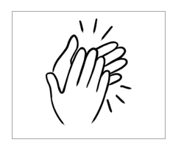

|  |  |  |  |  |  |
| --- | --- | --- | --- | --- | --- |
|  | 13 |  |  | 30 |  |
|  |  |  |  |  |  |
|  | 14 |  |  | 40 |  |
|  |  |  |  |  |  |
|  | 15 |  |  | 50 |  |
|  |  |  |  |  |  |
|  | 16 |  |  | 60 |  |
|  |  |  |  |  |  |
|  | 17 |  |  | 70 |  |
|  |  |  |  |  |  |
|  | 18 |  |  | 80 |  |
|  |  |  |  |  |  |
|  | 19 |  |  | 90 |  |



In **a**,

circle **13**.

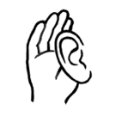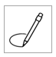

|  |  |  |  |  |  |  |
| --- | --- | --- | --- | --- | --- | --- |
| **a.** | 13 | 30 |  | **b.** | 14 | 40 |
|  |  |  |  |  |  |  |
| **c.** | 15 | 50 |  | **d.** | 16 | 60 |
|  |  |  |  |  |  |  |
| **e.** | 17 | 70 |  | **f.** | 18 | 80 |
|  |  |  |  |  |  |  |
| **g.** | 19 | 90 |  | **h.** | 15 | 50 |
|  |  |  |  |  |  |  |
| **i.** | 16 | 60 |  | **j.** | 17 | 70 |
|  |  |  |  |  |  |  |
| **k.** | 18 | 80 |  | **l.** | 19 | 90 |



Under **a**,

write **50**.

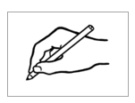

|  |  |  |  |  |  |
| --- | --- | --- | --- | --- | --- |
| **a.** | **b.** | **c.** | **d.** | **e.** | **f.** |
| 50 |  |  |  |  |  |
|  |  |  |  |  |  |
| **g.** | **h.** | **i.** | **j.** | **k.** | **l.** |
|  |  |  |  |  |  |

# Before and after





What’s the number **before 57**  
and the number **after** **57**?

|  |  |  |
| --- | --- | --- |
| **before** | **57** | **after** |
| **56** | **58** |

|  |  |  |
| --- | --- | --- |
| **before** | the number | **after** |
|  |  |  |
| 1. 49 | 50 | 51 |
|  |  |  |
|  | 65 |  |
|  |  |  |
|  | 74 |  |
|  |  |  |
|  | 88 |  |
|  |  |  |
|  | 91 |  |
|  |  |  |
|  | 69 |  |
|  |  |  |
|  | 70 |  |
|  |  |  |
|  | 99 |  |





Write the number **before 54**.



|  |  |  |  |  |  |  |
| --- | --- | --- | --- | --- | --- | --- |
| 1. 53 |  |  |  |  |  |  |
|  |  |  |  |  |  |  |
|  |  |  |  |  |  |  |
|  |  |  |  |  |  |  |
|  |  |  |  |  |  |  |



Write the number **after 67**.



|  |  |  |  |  |  |  |
| --- | --- | --- | --- | --- | --- | --- |
| 1. 68 |  |  |  |  |  |  |
|  |  |  |  |  |  |  |
|  |  |  |  |  |  |  |
|  |  |  |  |  |  |  |
|  |  |  |  |  |  |  |



|  |  |  |
| --- | --- | --- |
| **a.** 54 52 53 | **b.** 60 58 59 | **c.** 67 66 68 |
| . 52 . . 53 54 . | ___ ___ ___ | ___ ___ ___ |
|  |  |  |
| **d.** 71 73 72 | **e.** 86 85 84 | **f.** 100 98 99 |
| ___ ___ ___ | ___ ___ ___ | ____ ___ ___ |

# Add the numbers.





1. **2.**

|  |  |  |  |  |  |  |
| --- | --- | --- | --- | --- | --- | --- |
| **a.** | 5 people | + | | 5 people | | = 10 people |
| **b.** | 10 eggs | + | 10 eggs | | = 20 eggs | |
| **c.** | 20 chocolates | + | 20 chocolates | | = 40 chocolates | |
| **d.** | 30 days | + | 30 days | | = 60 days | |
| **e.** | 40 biscuits | + | 40 biscuits | | = 80 biscuits | |
| **f.** | 50 tea bags | + | 50 tea bags | | = 100 tea bags | |





How many is that?

|  |  |  |  |  |
| --- | --- | --- | --- | --- |
| **a.a.** | . 50 . teabags | + | ­. 3 . teabags | = . 53 . teabags |
| **b.** | _____ chocolates | + | _____ chocolates | = _____ chocolates |
| **c.** | _____ cakes | + | _____ cakes | = _____ cakes |
| **d.** | **_______** biscuits | + | _____ biscuits | = _____ biscuits |
| **e.** | _____ spoons | + | _____ spoons | = _____ spoons |
| **f.** | _____ mugs | + | _____ mugs | = ______ mugs |

1. **2.**

# Money



How many cents?

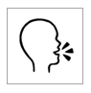

|  |  |  |  |
| --- | --- | --- | --- |
|  |  |  |  |
| 50 cents | ______ cents | ______ cents | ______ cents |
| **c** = *cents* | | | |

|  |  |  |
| --- | --- | --- |
| 1. 15 c |  | 1. _______c |
| 1. ______ c |  | 1. A collection of coins with images     Description automatically generated ______ c |
| 1. A collection of coins with images     Description automatically generated ______ c |  | 1. A collection of coins with images     Description automatically generated ______ c |





How many dollars?



1. **2.**

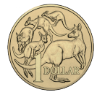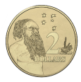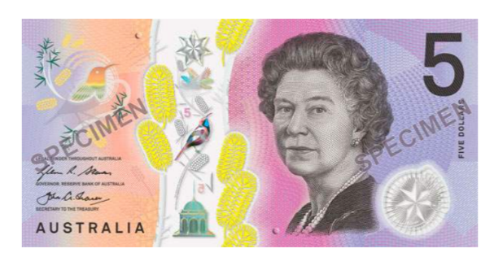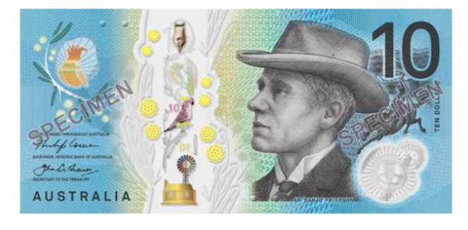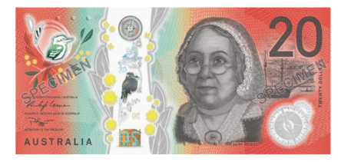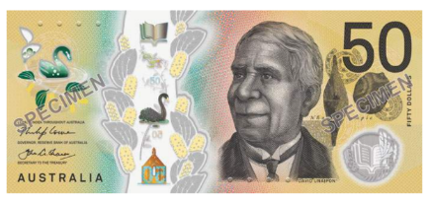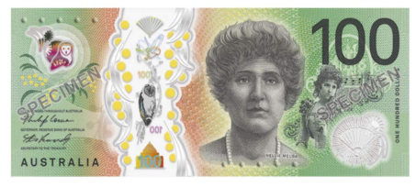

$= *dollar*

$2

$2

$10

_____

$50

_____

$1

_____

$100

_____

$20

_____

$5

_____



That’s $10.50



1. **2.**

|  |  |  |  |
| --- | --- | --- | --- |
|  |  | $10.50 | |
|  |  |  | |
|  |  | ___________ | |
|  |  |  | |
|  |  | _________ | |
|  |  |  | |
|  |  | _________ | |
|  |  |  | |
|  |  | _________ | |
|  |  |  | |
|  |  | _________ | |
|  |  |  | |
|  |  | _________ | |
|  |  |  | |
|  |  | _________ | |
|  |  | |  | |



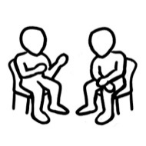

1. **2.**

|  |  |  |  |  |  |
| --- | --- | --- | --- | --- | --- |
|  |  |  |  |  | |
| $10 | + | 50c | = | $10.50 |
| ________ | ___ | ________ | ___ | __________ |
| **b.** |  |  |  |  |
| $20 | + | 50c | = | $20.50 |
| _______ | ___ | _______ | ___ | __________ |
| **c.** |  |  |  |  |
| $20 | + | $5 | = | $25 |
| _______ | ___ | _______ | ___ | __________ |
| **d.** |  |  |  |  |
| $50 | + | 50c | = | $50.50 |
| ______ | ___ | ______ | ___ | ________ |
|  |  |  |  |  |
| **e.** | | |  |  |
| $50 | + | $1 | = | $51 |
| ______ | ___ | ______ | ___ | ______ |



|  |  |  |  |  |
| --- | --- | --- | --- | --- |
|  |  |  |  | How much is that? |
| $50 | + | $2 | = | $52 |
|  |  |  |  |  |
| **b.** |  |  |  |  |
| $50 | + | $5 | = | _______ |
|  |  |  |  |  |
| **c.** |  |  |  |  |
| $50 | + | $10 | = | _______ |
|  |  |  |  |  |
|  |  |  |  |  |
| $50 | + | $20 | = | _______ |
|  |  |  |  |  |
|  |  |  |  |  |
| $50 | + | $50 | = | ________ |





|  |  |  |  |  |
| --- | --- | --- | --- | --- |
| **a.** |  |  |  |  |
| $20 | + | $50 | = | $70 |
|  |  |  |  |  |
| **b.** |  |  |  |  |
|  | + |  | = |  |
|  |  |  |  |  |
| **c.** |  |  |  |  |
|  | + |  | = |  |
|  |  |  |  |  |
| **d.** |  |  |  |  |
|  | + |  | = |  |
|  |  |  |  |  |
|  |  |  |  |  |
|  | + |  | = |  |



# Morning tea

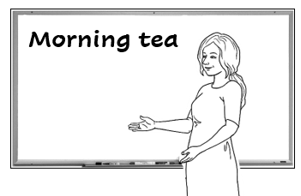







Let’s have morning tea  
with another class   
next Tuesday.

What do we need   
for morning tea?



**2.**

|  |  |  |  |
| --- | --- | --- | --- |
| tea bags | coffee | vegetables | milk |
| sugar | spoons | biscuits | cakes |
| juice | cereal | mugs | tissues |

**cereal** =  *breakfast food*



1. 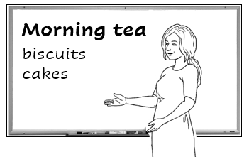

Who can make some biscuits and cakes? We need **enough**   
for 50 people.

**enough** =



What do we need to buy?

|  |  |  |  |
| --- | --- | --- | --- |
| **We have** | |  | **We need** |
| **Aa** | 30 mugs |  | _____ mugs |
| **bb** | 40 spoons |  | _____ spoons |
| **Cc** | No milk |  | _____ litres of milk |
| **Dd** | No tea bags |  | _____ box of tea bags |
| **ee** | No coffee |  | _____ jars of coffee |
| **d**  **f** | No sugar |  | _____ kilos of sugar |
| **Eg** | No juice |  | _____ litres of juice |
| **hh** | No tissues |  | _____ box of tissues |



There’s a sale at the supermarket.



***Supermarket***

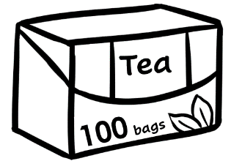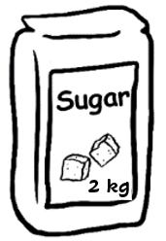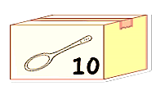

______

2 for

______

10 for ______

______

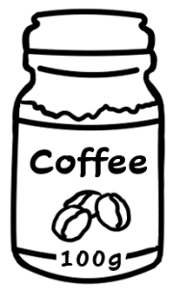

2 for

______

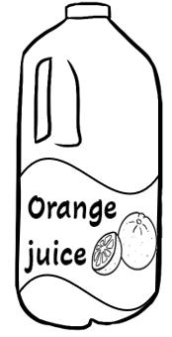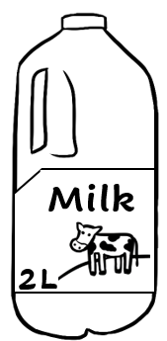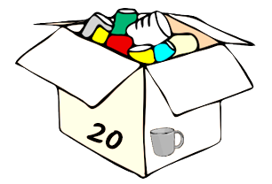

20 for ______

2 for

______

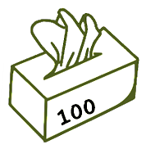

How much **are** the mugs?

How much **is** the coffee?



2 for $26

$12



|  |
| --- |
| coffee $ 26 .  sugar $ 3 .    **Total**  $29 . |
|  |
| juice $_____  tissues $ _____    **Total**  $ . |
|  |
| tea $_____  milk $ _____    **Total**  $ . |
|  |
| spoons $_____  mugs $ _____  **Total**  $ . |



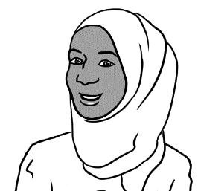

I’ll buy the coffee   
and sugar.



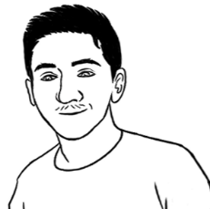

I’ll buy the juice   
and tissues.



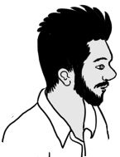

I’ll buy the tea  
and milk.



I’ll buy the spoons   
and mugs.



# At a café



1. 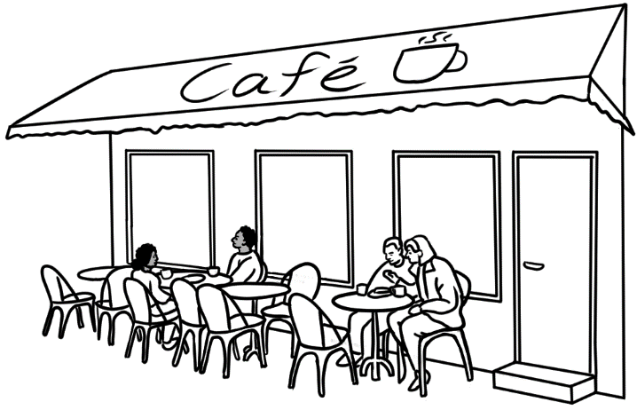

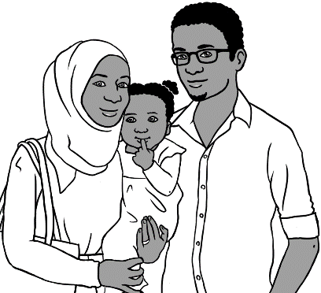

Let’s go to a café for lunch.

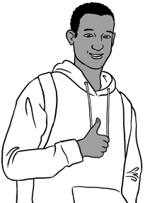

Good idea.

**Food Drinks**

Sandwich $12.00 Tea $4.00

Salad $10.50 Coffee $5.00

Pizza $22.00 Orange   
 juice $5.50

Eggs $11.00

Noodles $14.00 **Cakes**

Chips $6.00 Cake $7.00

**Café Menu**

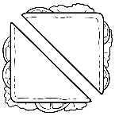

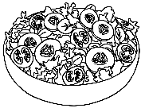

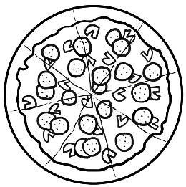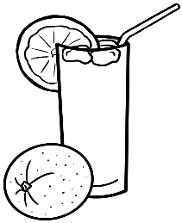

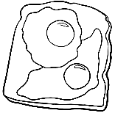

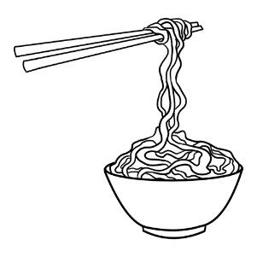

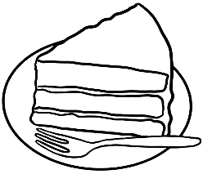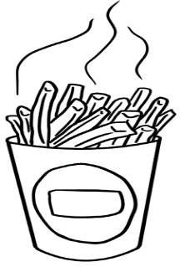



How much **is** the sandwich?

$12.00

$6.000

How much **are** the chip**s**?



|  |  |  |
| --- | --- | --- |
|  |  | _$4.00__ |
|  |  | _______ |
|  |  | _______ |
|  |  | _______ |
|  |  | _______ |
|  |  | _______ |
|  |  | _______ |
|  |  | _______ |
|  |  | _______ |
|  |  | _______ |

1. **2.**

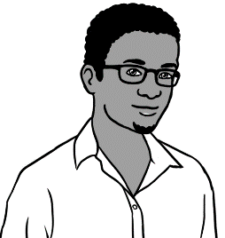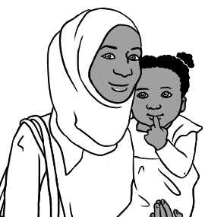

Let’s have a pizza and a salad.

Ok.



|  |  |  |
| --- | --- | --- |
|  | a pizza | $_______ |
|  | a salad  **Total** | + $_______    **__________** |
| Hani can have some noodles and an orange juice. | | |
| **b.** | noodles | $ _______ |
|  | an orange juice  **Total** | + $ _______  **_________** |
| I’ll have a sandwich and a coffee. | | |
| **c.**  a sandwich    a coffee  **Total** | | $_______ |
| + $_______  **_________** |



Do you have enough money?

|  |  |  |  |  |
| --- | --- | --- | --- | --- |
|  | | | **Yes** | **No** |
| 1. $11.00 | + $5.50 | = |  | ✓ |
| 1. ______ | + ______ | = |  |  |
| 1. ______ | + ______ | = |  |  |
| 1. ______ | + ______ | = |  |  |
| 1. ______ | + ______ | = |  |  |
| 1. **______** | + ______ | = |  |  |

# At a men’s clothes shop

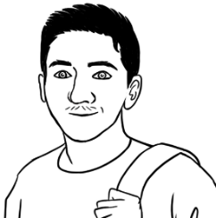

I need a jacket   
and a cap.

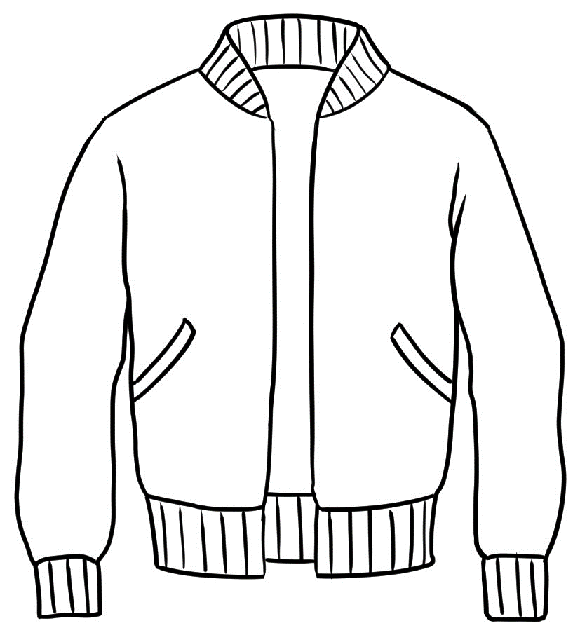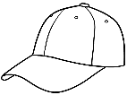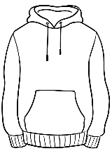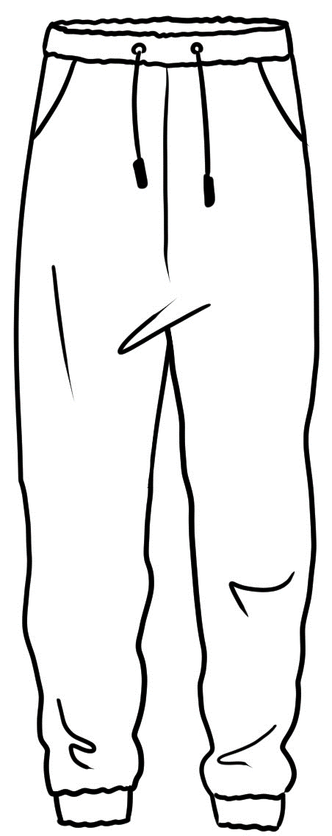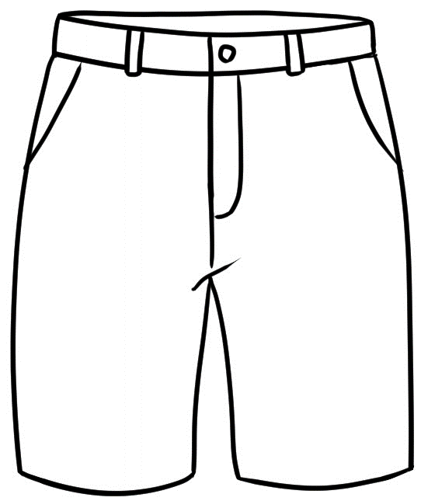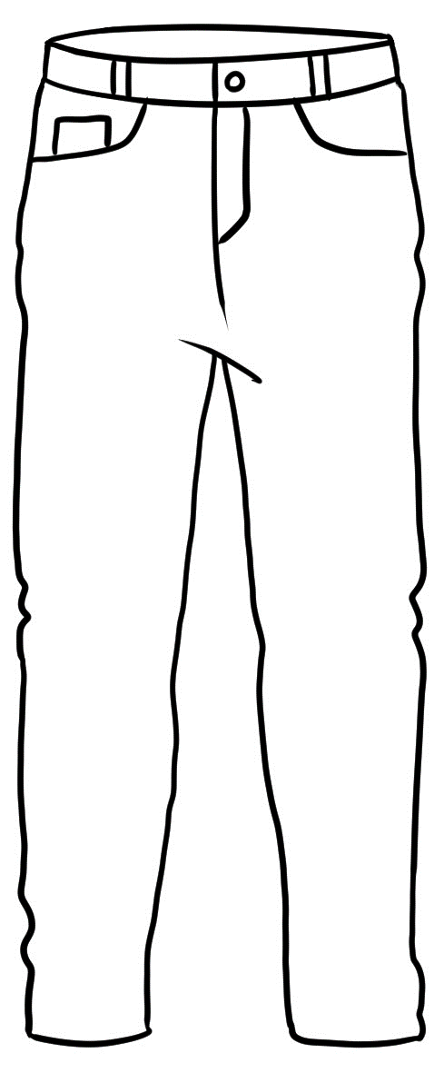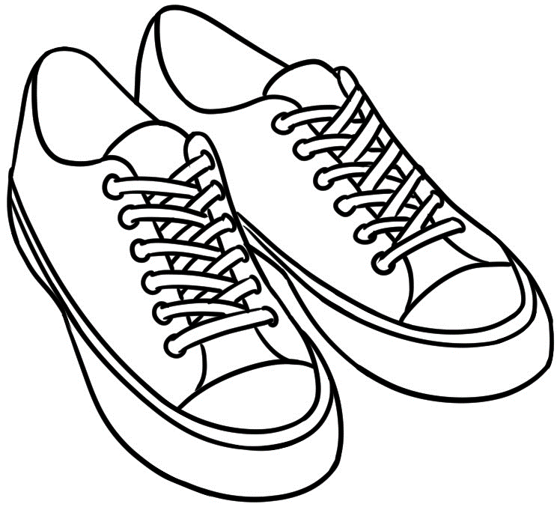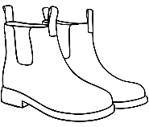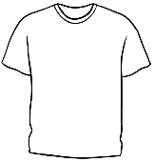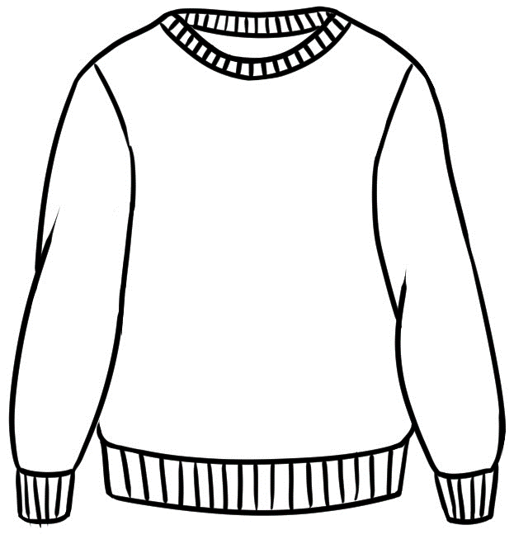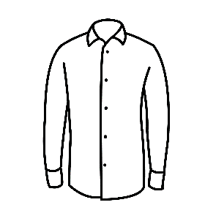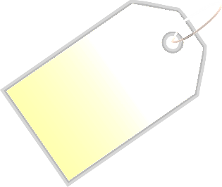

jacket

$70.50



jumper

$59



hoodie

$60

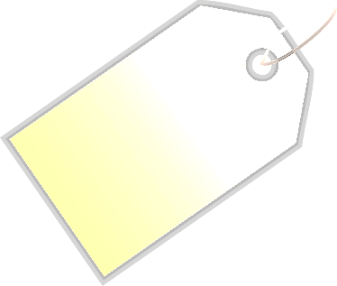

track pants

$35.50



jeans

$65

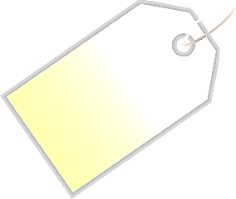

shirt

$50

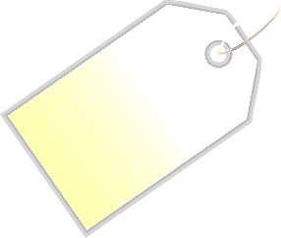

t-shirt

$30

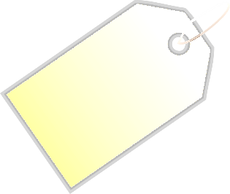

runners

$80

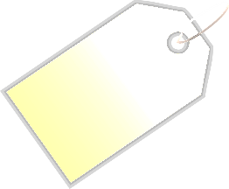

cap

$20



shorts

$40.50

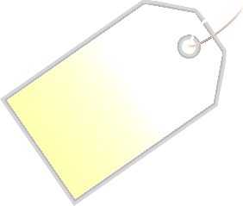

boots

$90

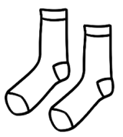

socks

$9



How much **is** the jacket?

$70.50

How much **are** the runner**s**?

$80







|  |
| --- |
| $9 |
| $20 |
| $30 |
| $35.50 |
| $40.50 |
| $50 |
| $59 |
| $60 |
| $65 |
| $70.50 |
| $80 |
| $90 |

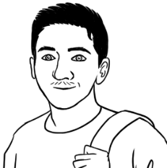

I need a jacket   
and a cap.



|  |  |  |
| --- | --- | --- |
|  | a jacket | $70.50 |
|  | a cap  **Total** | + $20.00  $90.50 . |
| I need a hoodie and some track pants. | | |
|  | a hoodie | $ _______ |
|  | track pants  **Total** | + $ _______  **_________** |
| My friend needs some shorts and  a shirt. | | |
|  | shorts | $_______ |
|  | a shirt  **Total** | + $_______  **_________** |

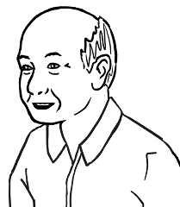

My grandson needs   
some jeans and a t-shirt.

|  |  |  |
| --- | --- | --- |
|  | a t-shirt | $_______ |
|  | jeans  **Total** | + $_______    **________** |
| I need some boots  and socks. | | |
| **b.** | boots | $ _______ |
|  | socks  **Total** | + $ _______  **__________** |
| My husband needs  a jumper and a cap. | | |
| **c.**  a jumper  a cap  **Total** | | $_______ |
| + $_______  **_________** |

# At an office shop



How much **is** the keyboard?

How much **are** the ear bud**s**?

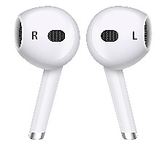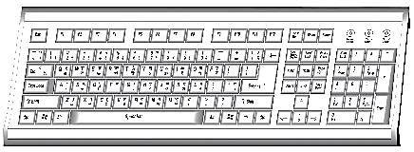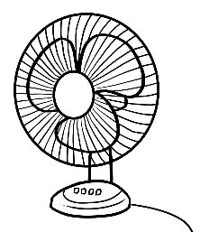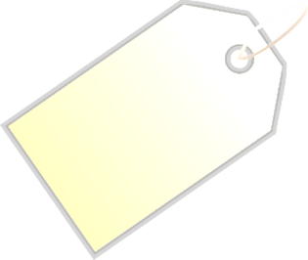

desk

_______

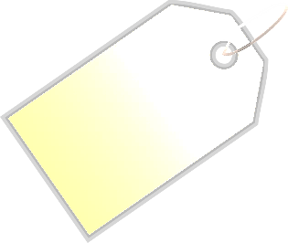

chair

_______



mouse

________



ear buds

_______



USB

_____



lamp  
_______



fan

_______

**The Office Warehouse**

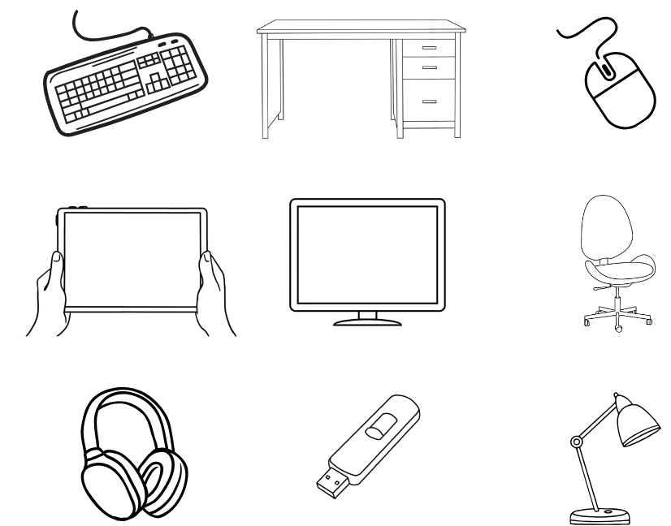

headphones

_________

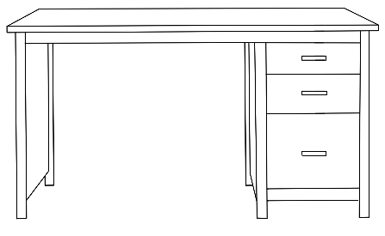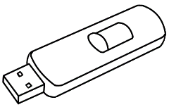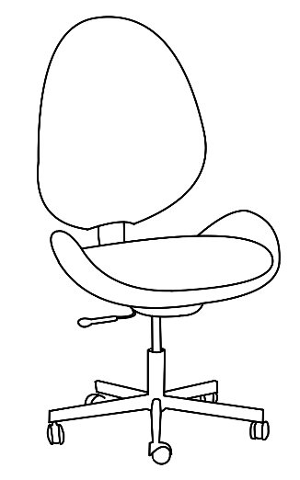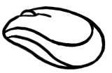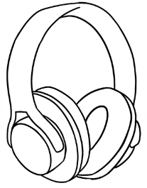

keyboard

_________

****_



|  |  |  |
| --- | --- | --- |
|  |  | __$15__ |
|  |  | _______ |
|  |  | _______ |
|  |  | _______ |
|  |  | _______ |
|  |  | _______ |
|  |  | _______ |
|  |  | _______ |
|  |  | _______ |

1. **2.**

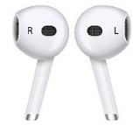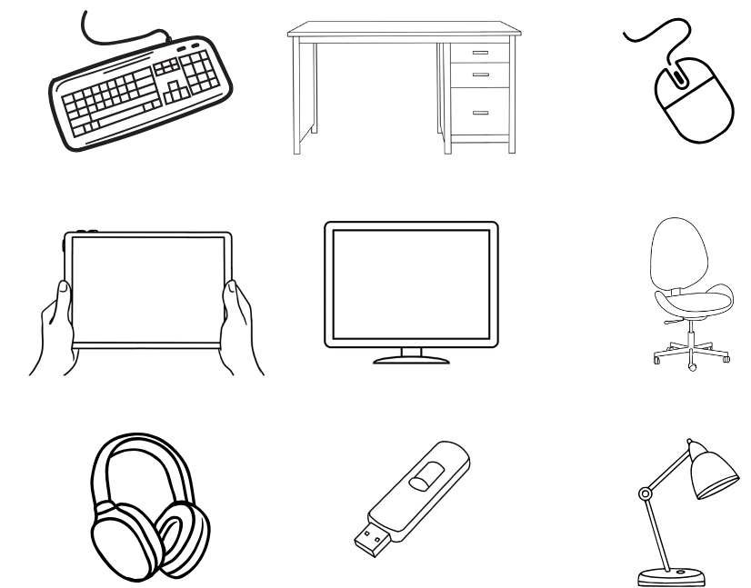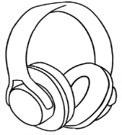

|  |  |  |
| --- | --- | --- |
|  | a desk | $_______ |
|  | a USB  **Total** | + $_______    **________** |
| I need a mouse and some headphones. | | |
| **b.** | a mouse | $ _______ |
|  | headphones  **Total** | + $ _______  **__________** |
| I need some ear buds and a fan. | | |
| **c.**  ear buds  a fan    **Total** | | $_______ |
| + $_______  **________** |

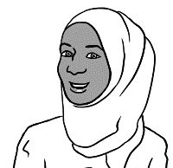

I need a desk   
and a USB.



Do you have enough money?



|  |  |  |  |  |
| --- | --- | --- | --- | --- |
|  | | | **Yes** | **No** |
| 1. $40 | + $55 | = |  | ✓ |
| 1. ______ | + ______ | = |  |  |
| 1. A computer keyboard and a usb drive     Description automatically generated______ | + ______ | = |  |  |
| 1. ______ | + ______ | = |  |  |
| 1. ______ | + ______ | = |  |  |
| 1. **______** | + ______ | = |  |  |

# Let’s go out.

**expensive** = not cheap





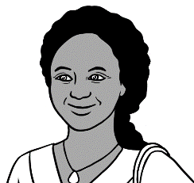

How much is   
a zoo ticket?

Is it **expensive**?

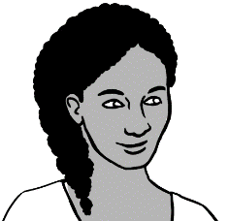

Let’s go to the zoo

on Saturday.

**WILDLIFE ZOO**

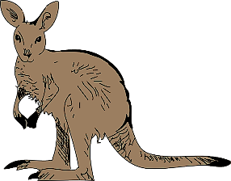

|  |  |  |
| --- | --- | --- |
| **Prices** | **A black and white drawing of an elephant  Description automatically generatedZoo  tickets** | **Bus  tickets** |
| Man with solid fill**Adult** | $41.00 | $6.00 |
| Man with solid fill**Concession** | $30.00 | $4.00 |
| **Child with balloon with solid fillChild** | $21.00 | $3.50 |
| **Family with two children with solid fillFamily** | $85.00 | $13.00 |

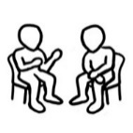

$30

How much is a **concession**   
**zoo** ticket?

$3.50

How much is a **child’s**   
**bus** ticket?

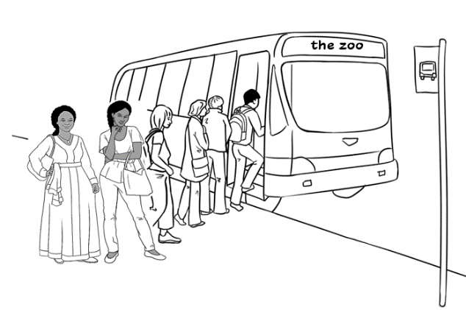

Anika and her mother   
catch the bus to the zoo on Saturday.

**3.**



**4.**

|  |  |  |  |  |
| --- | --- | --- | --- | --- |
| 1. How much are 2 concession **bus** tickets? | | | | |
| $6.00 | | $8.00 | $13.00 | |
| 1. What money do they need? | | | | |
|  | | | | |
| 1. A black and white drawing of an elephant     Description automatically generatedHow much are 2 concession **zoo** tickets? | | | | |
| $82.00 | | $50.00 | $60.00 | |
| 1. What money do they need? | | | | |
|  | | | | |
|  | bus tickets  A black and white drawing of an elephant  Description automatically generated  zoo tickets  **Total** | | | $____________  $____________  **$____________** |
|  | Close-up of a currency note  Description automatically generatedThey have $100.  Do they have enough? | | | _______ ______  yes no |

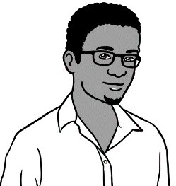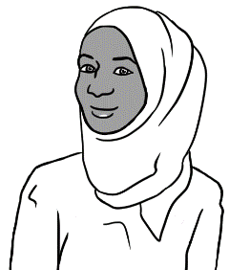

Let’s go to the zoo.  
The tickets are cheap this Sunday.

this Sunday.

How much are the tickets?

**WILDLIFE ZOO**

|  |  |  |
| --- | --- | --- |
| **Prices** | **Zoo  tickets** | **Bus  tickets** |
| **Adult** |  |  |
| **Concession** |  |  |
| **Child** |  |  |
| **Family** |  |  |

******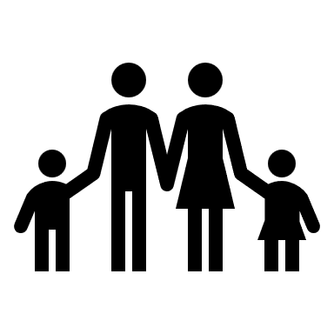****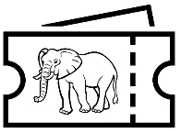**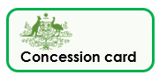

**Cheap prices this Sunday!!**

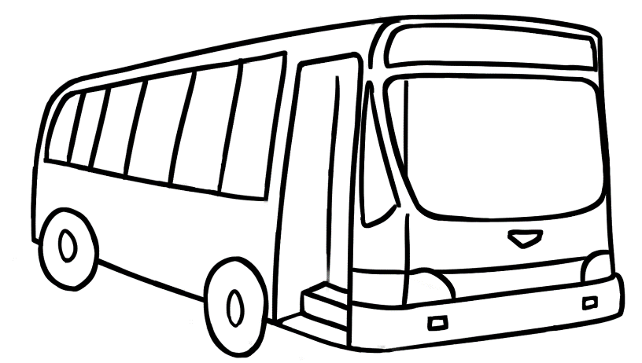



$70

How much is a **family**   
**zoo** ticket?

$4

How much is an **adult bus** ticket?

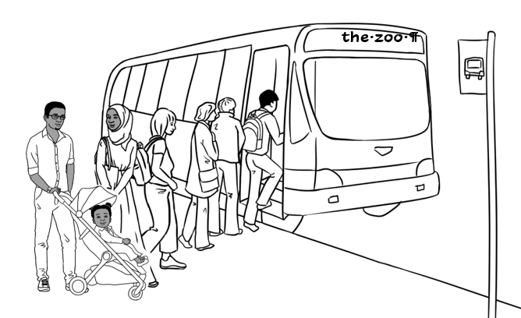

Sahra and her family   
catch the bus

to the zoo on Sunday.

**3.**



**4.**

|  |  |  |  |  |  |  |  |
| --- | --- | --- | --- | --- | --- | --- | --- |
| 1. How much is a family **bus** ticket? | | | | | | | |
| $9.00 | | $9.50 | | $10.00 | | | $10.50 |
| 1. What money do they need? | | | | | | | |
|  | | | | | | | |
| 1. A black and white drawing of an elephant     Description automatically generatedHow much is a family **zoo** ticket? | | | | | | | |
| $85.00 | | | $80.00 | | $70.00 | | |
| 1. What money do they need? | | | | | | | |
|  | | | | | | | |
|  | bus ticket  A black and white drawing of an elephant  Description automatically generated  zoo ticket  **Total** | | | | | $____________  $____________  **$____________** | |
|  | Close-up of a currency note  Description automatically generatedThey have $100.  Do they have enough? | | | | | _______ ______  yes no | |

**More places to go**



**Swimming Pool**

|  |  |
| --- | --- |
| **Prices** | **Tickets** |
| **Adult** |  |
| **Concession** |  |
| **Child** |  |
| **Family** |  |

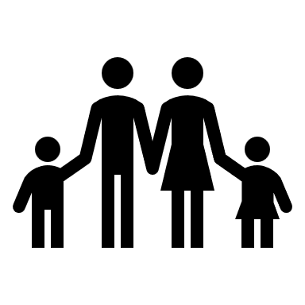

**Art Gallery**

|  |  |
| --- | --- |
| **Prices** | **Tickets** |
| **Adult** |  |
| **Concession** |  |
| **Child** |  |
| **Family** |  |

