

Student book with teacher notes

|  |
| --- |
| **English Ready**  22637VIC Course in EALVU23577 - Recognise and use numbers and money from 50 to 100  for highly familiar activities |

Numbers and money  
50 - 100

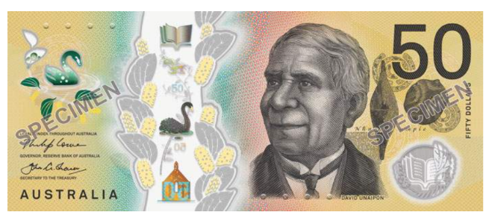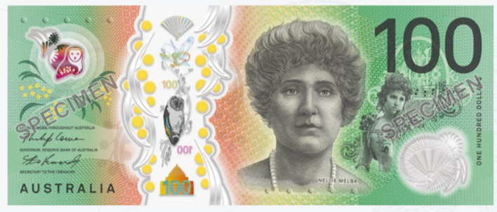

**Teacher** _______________________________________________________________

**Class** ___________________________________________________________________

**Date**____________________________________________________________________

**Name** __________________________________________________________________

*This workbook is designed to be used with the support of a teacher.*

**Design team:** Sue Paull, Vicki Hambling, Nikeh Shariatian, Bernie Milesand Mary Wallace

**Illustrations:** Madelena Scott

**Image acknowledgements:**  
Biscuits [This Photo](https://freepngimg.com/png/10847-biscuit-png-clipart) by Unknown Author is licensed under [CC BY-NC](https://creativecommons.org/licenses/by-nc/3.0/)  
Box with sticky tape - a href="https://www.freepik.com/free-vector/sticker-design-with-empty-box-closed-isolated_  
100th birthday cake - [This Photo](https://www.flickr.com/photos/gracefulcakecreations/3686072231/) by Unknown Author is licensed under [CC BY-NC-ND](https://creativecommons.org/licenses/by-nc-nd/3.0/)  
Cake box - **<**a href="https://www.freepik.com/icon/cake-box_6680318">Icon by small.smiles</a>

**Acknowledgements:** The design team would like to acknowledge the use of the EAL Framework which underpins the design of this book.

Copyright of the EAL Framework is reserved to the Crown in the right of the State of Victoria. © State of Victoria (Department of Education and Training) 2023.  
_________________________________________________________________________________________

This English Ready Resource is licensed under a Creative Commons Attribution-NoDerivs 3.0 Australia licence (More information is available [here](http://creativecommons.org/licenses/by-nd/3.0/au/)). You are free to use, copy and distribute to anyone in its original form as long as you attribute Department of Home Affairs as the author and you license any derivative work you make available under the same licence.  
  
 © Commonwealth of Australia 2024

With the exception of the Commonwealth Coat of Arms, the department’s logo, any material protected by a trade mark and where otherwise noted all material presented in this document is provided under a Creative Commons Attribution 4.0 International (<https://creativecommons.org/licenses/by/4.0/>) licence.

The details of the relevant licence conditions are available on the Creative Commons website (accessible using the links provided) as is the full legal code for the CC BY 4.0 licence (<https://creativecommons.org/licenses/by/4.0/legalcode>).

Use of all or part of this document must include the following attribution:   
© Commonwealth of Australia 2023

As far as practicable, material for which the copyright is owned by a third party will be clearly labelled.  The department has made all reasonable efforts to ensure that this material has been reproduced in this document with the full consent of the copyright owners.

Copyright requests and enquiries concerning usage not addressed by the CC BY 4.0 licence should be addressed to:

[*comms@homeaffairs.gov.au*](mailto:comms@homeaffairs.gov.au) *at the Department of Home Affairs.*

The terms of use for the Commonwealth Coat of Arms are available from the [It's an Honour](http://www.itsanhonour.gov.au/) website.

Where a copyright owner, other than the Commonwealth, is identified with respect to this material, please contact that third party copyright owner directly to seek permission.

**Contents**

1. Instructions 4

2. Meet the students and teachers. 5

3. Numbers 1 - 50 6

4. Numbers 50 - 100 8

5. Did you say 15 or 50? 14

6. Before and after 16

7. Add the numbers. 18

8. Money 20

9. Morning tea 26

10. At a café 30

11. At a men’s clothes shop 34

12. At an office shop 38

13. Let’s go out. 42

# Instructions

|  |
| --- |
| Project and mime each instruction. |

|  |  |  |  |  |  |
| --- | --- | --- | --- | --- | --- |
|  |  | listen |  |  | say |
|  |  | read |  |  | write |
|  |  | ask |  |  | copy |
|  |  | match |  |  | circle |
|  |  | highlight |  |  | tick |
|  |  | work with  a partner |  |  | clap |

# Meet the students and teachers.



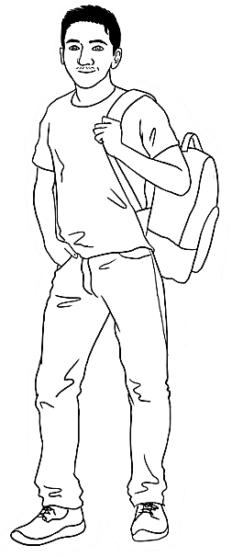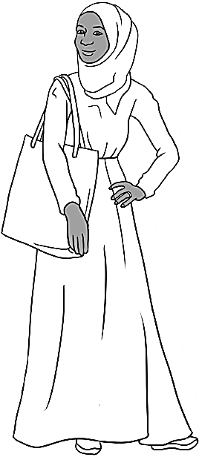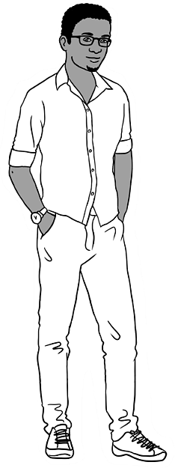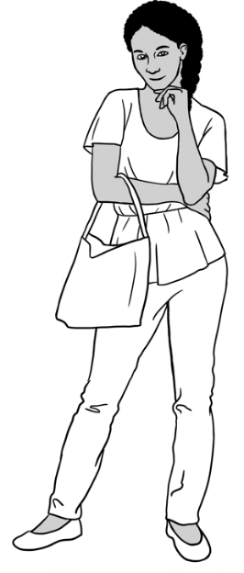

Carim Sahra Tahiil Anika Ming

**The students**

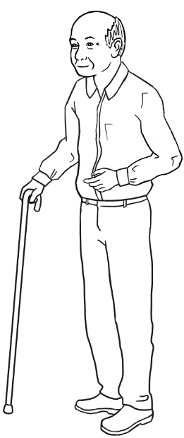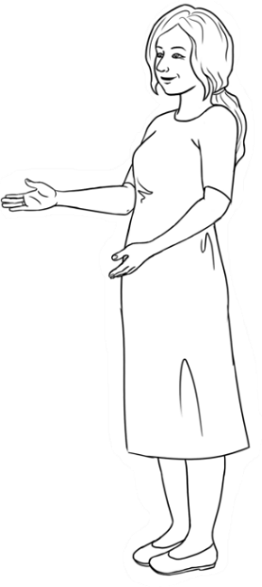

**The teachers**

Jenny Wendy

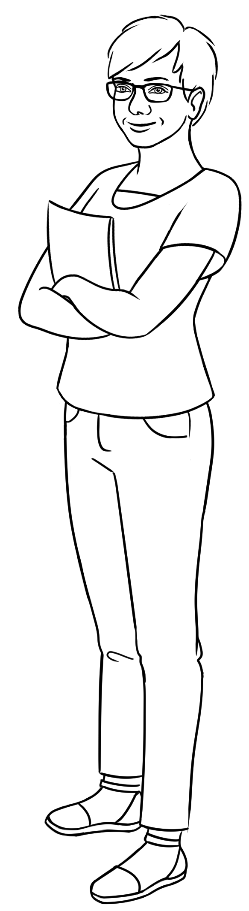

**The learning centres**

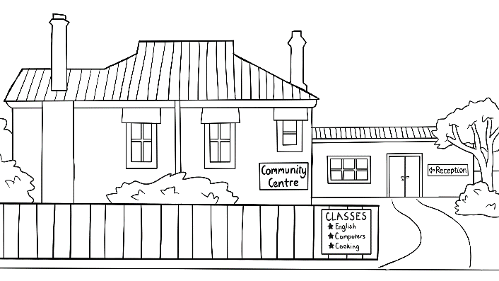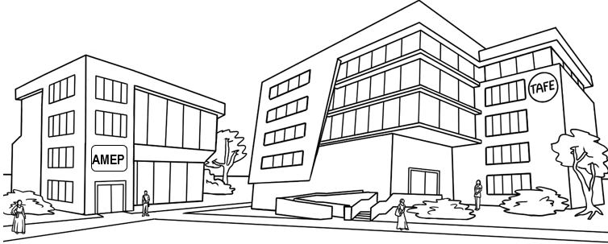

# Numbers 1 - 50

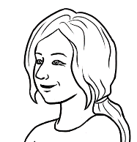

Circle 5.

Give instructions to circle  
some numbers.

See the Course in Initial Student Workbook, **VU23493 Numbers**   
for extended work on the numbers from 1 – 50. The exercises on these two pages are revision work only.

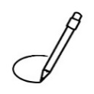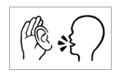

Row **a**.

Highlight 8 and 14.

|  |  |  |  |  |  |  |  |  |  |
| --- | --- | --- | --- | --- | --- | --- | --- | --- | --- |
| 0 | 1 | 2 | 3 | 4 | 5 | 6 | 7 | 8 | 9 |
| 10 | 11 | 12 | 13 | 14 | 15 | 16 | 17 | 18 | 19 |
| 20 | 21 | 22 | 23 | 24 | 25 | 26 | 27 | 28 | 29 |
| 30 | 31 | 32 | 33 | 34 | 35 | 36 | 37 | 38 | 39 |
| 40 | 41 | 42 | 43 | 44 | 45 | 46 | 47 | 48 | 49 |
| 50 |  |  |  |  |  |  |  |  |  |

Give instructions to highlight two or more numbers in each row.



**2.**

|  |  |  |  |  |  |  |  |  |  |  |
| --- | --- | --- | --- | --- | --- | --- | --- | --- | --- | --- |
| **a.** | 2 | 4 | 6 | 8 | 10 | 12 | 14 | 16 | 18 | 20 |
|  |  |  |  |  |  |  |  |  |  |  |
| **b.** | 3 | 6 | 9 | 12 | 15 | 18 | 21 | 24 | 27 | 30 |
|  |  |  |  |  |  |  |  |  |  |  |
| **c.** | 4 | 8 | 12 | 16 | 20 | 24 | 28 | 32 | 36 | 40 |
|  |  |  |  |  |  |  |  |  |  |  |
| **d.** | 5 | 10 | 15 | 20 | 25 | 30 | 35 | 40 | 45 | 50 |
|  |  |  |  |  |  |  |  |  |  |  |
| **e.** | 6 | 12 | 18 | 24 | 30 | 36 | 42 | 48 |  |  |



For guidance in the formation of numbers see the Course in   
Initial Student Workbook, **VU23493 Numbers** pages 3 – 6.   
**Note** the formation of the numbers 1, 7 and 9. Many printed numbers vary from font to font.

Copy the numbers.

|  |  |  |  |  |  |  |  |  |  |
| --- | --- | --- | --- | --- | --- | --- | --- | --- | --- |
| 0 | 1 | 2 | 3 | 4 | 5 | 6 | 7 | 8 | 9 |
| 1 |  |  |  |  |  |  |  |  |  |
| 10 | 11 | 12 | 13 | 14 | 15 | 16 | 17 | 18 | 19 |
|  |  |  |  |  |  |  |  |  |  |
| 20 | 21 | 22 | 23 | 24 | 25 | 26 | 27 | 28 | 29 |
|  |  |  |  |  |  |  |  |  |  |
| 30 | 31 | 32 | 33 | 34 | 35 | 36 | 37 | 38 | 39 |
|  |  |  |  |  |  |  |  |  |  |
| 40 | 41 | 42 | 43 | 44 | 45 | 46 | 47 | 48 | 49 |
|  |  |  |  |  |  |  |  |  |  |
| 50 |  |  |  |  |  |  |  |  |  |
|  |  |  |  |  |  |  |  |  |  |

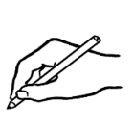

Write the missing numbers.

|  |  |  |  |  |  |  |  |  |  |
| --- | --- | --- | --- | --- | --- | --- | --- | --- | --- |
| 0 | 1 | 2 |  | 4 | 5 | 6 |  | 8 |  |
| 10 |  | 12 | 13 |  | 15 |  | 17 | 18 |  |
|  | 21 |  | 23 | 24 |  | 26 | 27 |  | 29 |
| 30 |  | 32 |  | 34 | 35 | 36 |  | 38 | 39 |
|  | 41 |  | 43 |  | 45 |  | 47 | 48 |  |
| 50 |  |  |  |  |  |  |  |  |  |



# Numbers 50 - 100



|  |  |  |  |  |  |  |  |  |  |
| --- | --- | --- | --- | --- | --- | --- | --- | --- | --- |
|  |  |  |  |  |  |  |  |  |  |
| 50 | 51 | 52 | 53 | 54 | 55 | 56 | 57 | 58 | 59 |
|  |  |  |  |  |  |  |  |  |  |
| 60 | 61 | 62 | 63 | 64 | 65 | 66 | 67 | 68 | 69 |



Circle 56.

See this section in the Teacher Resources for   
a range of activities to consolidate and extend the work on pages 8 – 9.

|  |  |  |  |  |  |  |  |  |  |
| --- | --- | --- | --- | --- | --- | --- | --- | --- | --- |
|  |  |  |  |  |  |  |  |  |  |
| 70 | 71 | 72 | 73 | 74 | 75 | 76 | 77 | 78 | 79 |
|  |  |  |  |  |  |  |  |  |  |
| 80 | 81 | 82 | 83 | 84 | 85 | 86 | 87 | 88 | 89 |
|  |  |  |  |  |  |  |  |  |  |
| 90 | 91 | 92 | 93 | 94 | 95 | 96 | 97 | 98 | 99 |
|  |  |  |  |  |  |  |  |  |  |
| 100 |

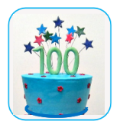



Circle 52.

A revision exercise - Read aloud together and then give instructions to circle some numbers.







|  |  |  |  |  |  |  |  |  |  |
| --- | --- | --- | --- | --- | --- | --- | --- | --- | --- |
| 50 | 51 | 52 | 53 | 54 | 55 | 56 | 57 | 58 | 59 |
| 60 | 61 | 62 | 63 | 64 | 65 | 66 | 67 | 68 | 69 |
| 70 | 71 | 72 | 73 | 74 | 75 | 76 | 77 | 78 | 79 |
| 80 | 81 | 82 | 83 | 84 | 85 | 86 | 87 | 88 | 89 |
| 90 | 91 | 92 | 93 | 94 | 95 | 96 | 97 | 98 | 99 |
| 100 |  |  |  |  |  |  |  |  | Project the table above, point to a number and ask students, *What’s* ***that*** *number?* [Stress ***that*.**] The whole class say the number. Students then work with a partner, and  take turns to point to a number and ask, *What’s* ***that*** *number?* e.g. Anika points to 76. |

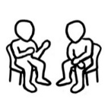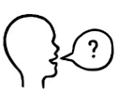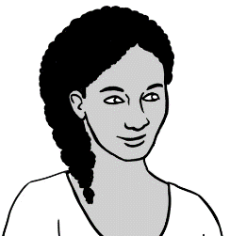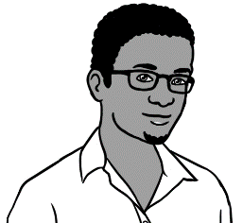

What’s **that** number?

76.

**What’s** = *What is*



**Play Bingo**. Students highlight any five numbers on the table below. Then read out numbers at random. Students circle their highlighted numbers as they hear them.   
Once their five numbers are called, they shout, ***Bingo!***



1. **4.**

|  |  |  |  |  |  |  |  |  |  |
| --- | --- | --- | --- | --- | --- | --- | --- | --- | --- |
| 50 | 51 | 52 | 53 | 54 | 55 | 56 | 57 | 58 | 59 |
| 60 | 61 | 62 | 63 | 64 | 65 | 66 | 67 | 68 | 69 |
| 70 | 71 | 72 | 73 | 74 | 75 | 76 | 77 | 78 | 79 |



Copy the numbers.

|  |  |  |  |  |  |  |  |  |  |
| --- | --- | --- | --- | --- | --- | --- | --- | --- | --- |
| 50  50 | 51 | 52 | 53 | 54 | 55 | 56 | 57 | 58 | 59 |
| 60 | 61 | 62 | 63 | 64 | 65 | 66 | 67 | 68 | 69 |
| 70 | 71 | 72 | 73 | 74 | 75 | 76 | 77 | 78 | 79 |
| 80 | 81 | 82 | 83 | 84 | 85 | 86 | 87 | 88 | 89 |
| 90 | 91 | 92 | 93 | 94 | 95 | 96 | 97 | 98 | 99 |
| 100 |  |  |  |  |  |  |  |  |  |
| Write the missing numbers.  For an extra challenge, students could cover the table above. |  |  |  |  |  |  |  |  |  |
| 50 | 51 | 52 |  | 54 |  | 56 | 57 |  | 59 |
| 60 | 61 |  | 63 |  | 65 | 66 |  | 68 |  |
|  | 71 | 72 |  | 74 | 75 |  | 77 |  | 79 |
| 80 |  | 82 | 83 | 84 |  | 86 |  | 88 | 89 |
| 90 | 91 |  | 93 |  | 95 |  | 97 | 98 |  |
|  |  |  |  |  |  |  |  |  |  |

Use the numbers from the grey boxes to complete the number sequences.

Read the number sequences aloud with a partner.



|  |  |  |  |  |  |  |  |  |
| --- | --- | --- | --- | --- | --- | --- | --- | --- |
| **a.** | 66 | 67 | 68 |  | **b.** | 71 | 72 | ______ |
|  |  |  |  |  |  |  |  |  |
| **c.** | ______ | 75 | 76 |  | **d.** | 69 | ______ | 71 |
|  |  |  |  |  |  |  |  |  |
| **e.** | ______ | 58 | 59 |  | **f.** | 79 | 80 | ______ |
|  |  |  |  |  |  |  |  |  |
| **g.** | 48 | ______ | 50 |  | **h.** | 88 | ______ | 90 |
|  |  |  |  |  |  |  |  |  |
| **i.** | 62 | ______ | 64 |  | **j.** | 50 | 51 | ______ |
|  |  |  |  |  |  |  |  |  |
| **k.** | 89 | ______ | 91 |  | **l.** | ______ | 56 | 57 |
|  |  |  |  |  |  |  |  |  |
| **m.** | 70 | ______ | 72 |  | **n.** | 40 | ______ | 42 |

1.  **2.**

|  |  |  |  |  |  |  |  |  |  |  |  |  |
| --- | --- | --- | --- | --- | --- | --- | --- | --- | --- | --- | --- | --- |
| 73 |  | 67 ✓ |  | 49 |  | 57 |  | 70 |  | 74 |  | 89 |
|  |  |  |  |  |  |  |  |  |  |  |  |  |
| 81 |  | 63 |  | 52 |  | 90 |  | 71 |  | 55 |  | 41 |

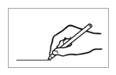

Take turns to read the numbers

aloud with a partner.



Draw a line joining   
the numbers 50 - 100.

1. **2.**



|  |  |  |  |  |  |  |  |  |  |  |  |  |  |  |
| --- | --- | --- | --- | --- | --- | --- | --- | --- | --- | --- | --- | --- | --- | --- |
|  |  |  |  |  |  |  |  |  |  |  |  |  |  |  |
|  | **50** |  | 51 | 58 |  | 59 |  | 65 |  | 73 |  |  | 75 |  |
|  |  |  |  |  |  |  |  |  |  |  |  |  |  |  |
|  | 53 |  | 52 |  | 60 |  |  |  | 74 |  | 72 |  | 71 |  |
|  |  |  |  |  |  |  | 58 |  |  |  |  |  |  |  |
|  | 54 |  |  | 61 |  | 57 |  | 75 |  | 69 |  |  | 70 |  |
|  |  |  | 62 |  |  |  |  |  |  |  | 89 |  |  |  |
|  | 55 |  |  | 56 |  |  | 76 |  |  | 96 |  | 85 |  |  |
|  |  |  |  |  |  |  |  |  | 68 |  |  |  |  |  |
|  | 64 |  | 63 | 59 |  | 67 |  |  |  |  | 84 |  |  |  |
|  |  |  | 54 |  |  |  | 77 |  |  |  |  |  |  |  |
|  | 65 |  |  | 66 |  |  | 78 |  | 83 |  |  | 81 | 86 |  |
|  | 67 |  |  |  | 79 |  |  |  |  |  |  |  |  |  |
|  |  |  | 96 |  | 80 |  | 81 |  | 82 |  | 87 |  |  |  |
|  | 97 |  |  |  |  |  | 89 |  |  |  |  |  | 78 |  |
|  |  | 92 | 95 |  | 94 |  |  | 99 |  | 91 |  | 88 |  |  |
|  | 98 |  |  |  | 96 |  | 93 |  |  |  |  |  |  |  |
|  |  |  | 99 |  |  |  |  |  | 92 |  | 90 |  | 89 |  |
|  |  |  |  |  |  |  |  |  |  |  |  |  |  |  |

See this section in the Teacher Resources on page 24 for a slightly harder maze.

# Did you say 15 or 50?

Listen, say and clap all the teens, then all the tens.   
Next, read each teen and ten, e.g. 13, 30 etc. Once complete, read and clap all numbers.

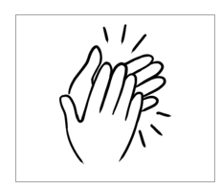

|  |  |  |  |  |  |
| --- | --- | --- | --- | --- | --- |
|  | 13 |  |  | 30 |  |
|  |  |  |  |  |  |
|  | 14 |  |  | 40 |  |
|  |  |  |  |  |  |
|  | 15 |  |  | 50 |  |
|  |  |  |  |  |  |
|  | 16 |  |  | 60 |  |
|  |  |  |  |  |  |
|  | 17 |  |  | 70 |  |
|  |  |  |  |  |  |
|  | 18 |  |  | 80 |  |
|  |  |  |  |  |  |
|  | 19 |  |  | 90 |  |

Dictate one number in each pair. Emphasise the stressed syllable. Students circle the number.



In **a**,

circle **13**.

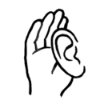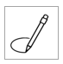

|  |  |  |  |  |  |  |
| --- | --- | --- | --- | --- | --- | --- |
| **a.** | 13 | 30 |  | **b.** | 14 | 40 |
|  |  |  |  |  |  |  |
| **c.** | 15 | 50 |  | **d.** | 16 | 60 |
|  |  |  |  |  |  |  |
| **e.** | 17 | 70 |  | **f.** | 18 | 80 |
|  |  |  |  |  |  |  |
| **g.** | 19 | 90 |  | **h.** | 15 | 50 |
|  |  |  |  |  |  |  |
| **i.** | 16 | 60 |  | **j.** | 17 | 70 |
|  |  |  |  |  |  |  |
| **k.** | 18 | 80 |  | **l.** | 19 | 90 |



Under **a**,

write **50**.

Dictate any of the numbers above. Students write the numbers under the letters.

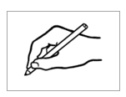

|  |  |  |  |  |  |
| --- | --- | --- | --- | --- | --- |
| **a.** | **b.** | **c.** | **d.** | **e.** | **f.** |
| 50 |  |  |  |  |  |
|  |  |  |  |  |  |
| **g.** | **h.** | **i.** | **j.** | **k.** | **l.** |
|  |  |  |  |  |  |

# Before and after





What’s the number **before 57**  
and the number **after** **57**?

|  |  |  |
| --- | --- | --- |
| **before** | **57** | **after** |
| **56** | **58** |

See this section in the Teacher Resources for a similar exercise to prepare students for this one, or to provide further practice.

|  |  |  |
| --- | --- | --- |
| **before** | the number | **after** |
|  |  |  |
| 1. 49 | 50 | 51 |
|  |  |  |
|  | 65 |  |
|  |  |  |
|  | 74 |  |
|  |  |  |
|  | 88 |  |
|  |  |  |
|  | 91 |  |
|  |  |  |
|  | 69 |  |
|  |  |  |
|  | 70 |  |
|  |  |  |
|  | 99 |  |





Read any number between 50 – 100 and   
students write the number   
**before** it.



Write the number **before 54**.



|  |  |  |  |  |  |  |
| --- | --- | --- | --- | --- | --- | --- |
| 1. 53 |  |  |  |  |  |  |
|  |  |  |  |  |  |  |
|  |  |  |  |  |  |  |
|  |  |  |  |  |  |  |
|  |  |  |  |  |  |  |

Read any number between 50 -100 and   
students write the number   
**after** it.



Write the number **after 67**.



|  |  |  |  |  |  |  |
| --- | --- | --- | --- | --- | --- | --- |
| 1. 68 |  |  |  |  |  |  |
|  |  |  |  |  |  |  |
|  |  |  |  |  |  |  |
|  |  |  |  |  |  |  |
|  |  |  |  |  |  |  |



Write the numbers in the correct sequence.

|  |  |  |
| --- | --- | --- |
| **a.** 54 52 53 | **b.** 60 58 59 | **c.** 67 66 68 |
| . 52 . . 53 54 . | ___ ___ ___ | ___ ___ ___ |
|  |  |  |
| **d.** 71 73 72 | **e.** 86 85 84 | **f.** 100 98 99 |
| ___ ___ ___ | ___ ___ ___ | ____ ___ ___ |

# Add the numbers.



Project the page. Read the additions aloud together. Ask students to highlight the **plus** and **equals** signs.   
For an extension activity, see this section in the Teacher Resources on pages 43-45.



1. **2.**

|  |  |  |  |  |  |  |
| --- | --- | --- | --- | --- | --- | --- |
| **a.** | 5 people | + | | 5 people | | = 10 people |
| **b.** | 10 eggs | + | 10 eggs | | = 20 eggs | |
| **c.** | 20 chocolates | + | 20 chocolates | | = 40 chocolates | |
| **d.** | 30 days | + | 30 days | | = 60 days | |
| **e.** | 40 biscuits | + | 40 biscuits | | = 80 biscuits | |
| **f.** | 50 tea bags | + | 50 tea bags | | = 100 tea bags | |





How many is that?

|  |  |  |  |  |
| --- | --- | --- | --- | --- |
| **a.a.** | . 50 . teabags | + | ­. 3 . teabags | = . 53 . teabags |
| **b.** | _____ chocolates | + | _____ chocolates | = _____ chocolates |
| **c.** | _____ cakes | + | _____ cakes | = _____ cakes |
| **d.** | **_______** biscuits | + | _____ biscuits | = _____ biscuits |
| **e.** | _____ spoons | + | _____ spoons | = _____ spoons |
| **f.** | _____ mugs | + | _____ mugs | = ______ mugs |

1. **2.**

Complete the additions as a class or individually. Read together once completed.

# Money



How many cents?

Say and copy the value of the coins. See this section in the Teacher Resources for further work on the recognition, values and addition of money.

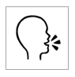

|  |  |  |  |
| --- | --- | --- | --- |
|  |  |  |  |
| 50 cents | ______ cents | ______ cents | ______ cents |
| Write the value of the two coins.  **c** = *cents* | | | |

|  |  |  |
| --- | --- | --- |
| 1. 15 c |  | 1. _______c |
| 1. ______ c |  | 1. A collection of coins with images     Description automatically generated ______ c |
| 1. A collection of coins with images     Description automatically generated ______ c |  | 1. A collection of coins with images     Description automatically generated ______ c |





How many dollars?



1. **2.**

Say and copy the dollar values.  
**Note**: singular - one dollar   
 plural - two dollar**s**

Match the dollar values.

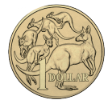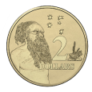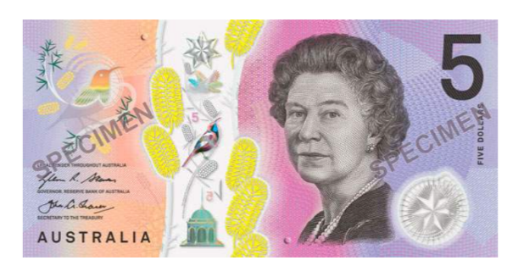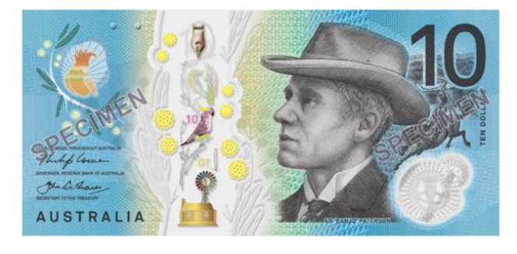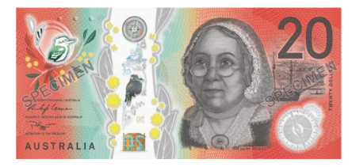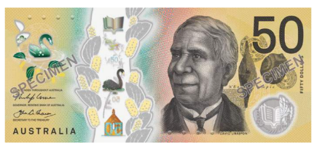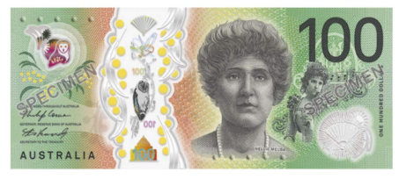

$= *dollar*

$2

$2

$10

_____

$50

_____

$1

_____

$100

_____

$20

_____

$5

_____



Students take turns to point to and read the amounts.   
e.g. *That’s $10.50*

That’s $10.50



1. **2.**

|  |  |  |  |
| --- | --- | --- | --- |
|  |  | $10.50 | |
|  |  |  | |
|  |  | ___________ | |
|  |  |  | |
|  |  | _________ | |
|  |  |  | |
|  |  | _________ | |
|  |  |  | |
|  |  | _________ | |
|  |  |  | |
|  |  | _________ | |
|  |  |  | |
|  |  | _________ | |
|  |  |  | |
|  |  | _________ | |
|  |  | |  | |



Point to the **+,** **=** and **$** signs. Copy the money amounts   
and the + and = signs on the lines below. Read the additions to a partner. e.g. *Ten dollars plus fifty cents equals ten dollars fifty cents.*

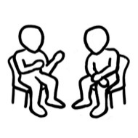

1. **2.**

|  |  |  |  |  |  |
| --- | --- | --- | --- | --- | --- |
|  |  |  |  |  | |
| $10 | + | 50c | = | $10.50 |
| ________ | ___ | ________ | ___ | __________ |
| **b.** |  |  |  |  |
| $20 | + | 50c | = | $20.50 |
| _______ | ___ | _______ | ___ | __________ |
| **c.** |  |  |  |  |
| $20 | + | $5 | = | $25 |
| _______ | ___ | _______ | ___ | __________ |
| **d.** |  |  |  |  |
| $50 | + | 50c | = | $50.50 |
| ______ | ___ | ______ | ___ | ________ |
|  |  |  |  |  |
| **e.** | | |  |  |
| $50 | + | $1 | = | $51 |
| ______ | ___ | ______ | ___ | ______ |



Write the money totals.

|  |  |  |  |  |
| --- | --- | --- | --- | --- |
|  |  |  |  | How much is that? |
| $50 | + | $2 | = | $52 |
|  |  |  |  |  |
| **b.** |  |  |  |  |
| $50 | + | $5 | = | _______ |
|  |  |  |  |  |
| **c.** |  |  |  |  |
| $50 | + | $10 | = | _______ |
|  |  |  |  |  |
|  |  |  |  |  |
| $50 | + | $20 | = | _______ |
|  |  |  |  |  |
|  |  |  |  |  |
| $50 | + | $50 | = | ________ |



Read the additions to a partner.



Write the money additions.

|  |  |  |  |  |
| --- | --- | --- | --- | --- |
| **a.** |  |  |  |  |
| $20 | + | $50 | = | $70 |
|  |  |  |  |  |
| **b.** |  |  |  |  |
|  | + |  | = |  |
|  |  |  |  |  |
| **c.** |  |  |  |  |
|  | + |  | = |  |
|  |  |  |  |  |
| **d.** |  |  |  |  |
|  | + |  | = |  |
|  |  |  |  |  |
|  |  |  |  |  |
|  | + |  | = |  |



Read the additions to a partner.

# Morning tea

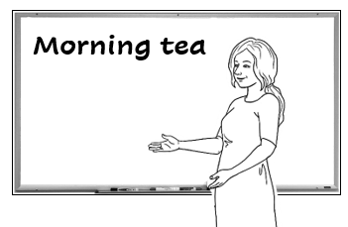







Let’s have morning tea  
with another class   
next Tuesday.

Read the list of things needed for a morning tea – ***tea, coffee, milk, sugar, biscuits, cakes, juice, spoons, mugs and tissues.*** Students tick each item.

What do we need   
for morning tea?



**2.**

|  |  |  |  |
| --- | --- | --- | --- |
| tea bags | coffee | vegetables | milk |
| sugar | spoons | biscuits | cakes |
| juice | cereal | mugs | tissues |

**cereal** =  *breakfast food*

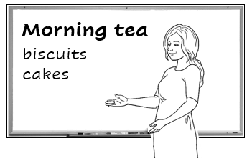

Who can make some biscuits and cakes? We need **enough**   
for 50 people.

1. 

Organise a morning tea with another class. Ask your class to help by making the biscuits and cakes. See this section in the Teacher Resources for an activity to buy ingredients for baking.

**enough** =

Students write ***enough*** in their language in the blue box.



The exercise below is a model for a morning tea. 1. Work out what you have and what you need. Ask, *Do we have enough mugs? spoons?* etc.   
2. Dictate the amounts in red below.   
*The answers are not in the student workbook.*

What do we need to buy?

|  |  |  |  |
| --- | --- | --- | --- |
| **We have** | |  | **We need** |
| **Aa** | 30 mugs |  | __20___ mugs |
| **bb** | 40 spoons |  | __10___ spoons |
| **Cc** | No milk |  | ___~~4~~__ litres of milk |
| **Dd** | No tea bags |  | ___1__ box of tea bags |
| **ee** | No coffee |  | ___2__ jars of coffee |
| **d**  **f** | No sugar |  | ___2__ kilos of sugar |
| **Eg** | No juice |  | ___2__ litres of juice |
| **hh** | No tissues |  | ___1__ box of tissues |

Ask students to guess the prices of the supermarket products. Then dictate the prices. Adjust these to more current prices if necessary. *The prices below are not in the student workbook.*



There’s a sale at the supermarket.



***Supermarket***

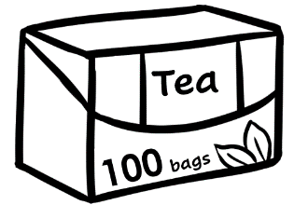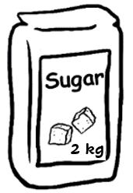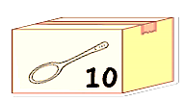

$12

$3

2 for   
$6

10 for $15

$4

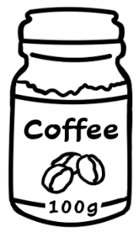

2 for

$26

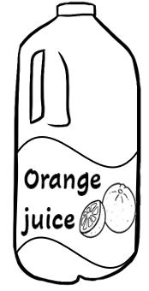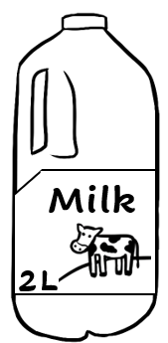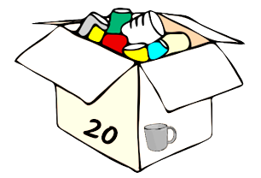

20 for $60

2 for $10

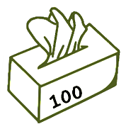

How much **are** the mugs?

How much **is** the coffee?



2 for $26

$12



|  |
| --- |
| coffee $ 26 .  sugar $ 3 .    **Total**  $29 . |
|  |
| juice $_____  tissues $ _____    **Total**  $ . |
|  |
| tea $_____  milk $ _____    **Total**  $ . |
|  |
| spoons $_____  mugs $ _____  **Total**  $ . |



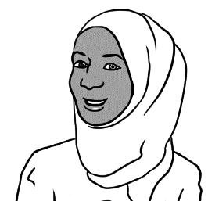

I’ll buy the coffee   
and sugar.



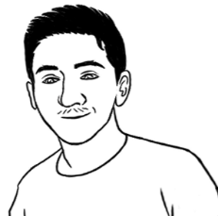

I’ll buy the juice   
and tissues.



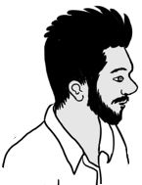

I’ll buy the tea  
and milk.

This is an unnamed student   
in the class. If necessary, students could choose   
a name for him.



I’ll buy the spoons   
and mugs.



# At a café

Project the page and introduce new vocabulary. See this section in the Teacher Resources for an information gap activity.



1. 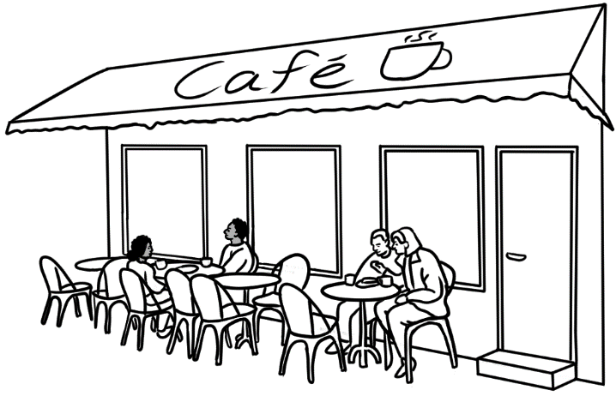

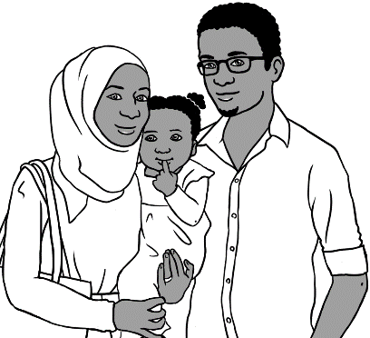

Let’s go to a café for lunch.

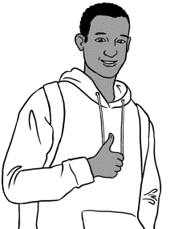

Good idea.

This is Sahra’s brother, **Abdi.** He features in other Course in EAL, English Ready books.

**Food Drinks**

Sandwich $12.00 Tea $4.00

Salad $10.50 Coffee $5.00

Pizza $22.00 Orange   
 juice $5.50

Eggs $11.00

Noodles $14.00 **Cakes**

Chips $6.00 Cake $7.00

**Café Menu**

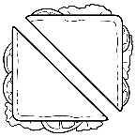

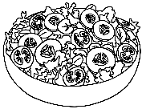

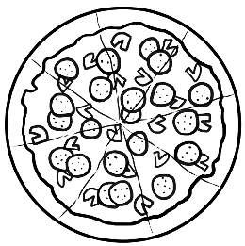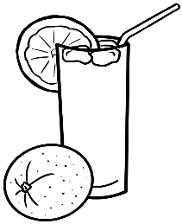

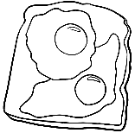

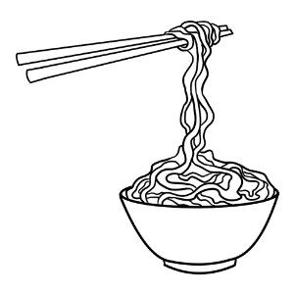

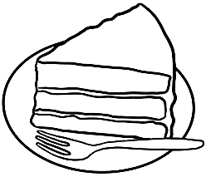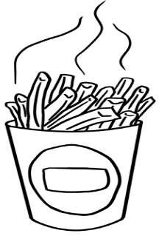



How much **is** the sandwich?

$12.00

$6.000

How much **are** the chip**s**?

Students take turns to ask their partner the price of food on the menu.  **Note** the use of ***is*** and ***are*** when talking about singular and plural items.



|  |  |  |
| --- | --- | --- |
|  |  | __$4.00__ |
|  |  | _______ |
|  |  | _______ |
|  |  | _______ |
|  |  | _______ |
|  |  | _______ |
|  |  | _______ |
|  |  | _______ |
|  |  | _______ |
|  |  | _______ |

1. **2.**

Match the prices and items.

Write the prices.

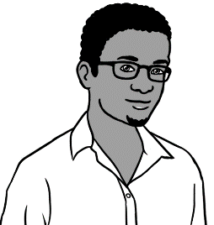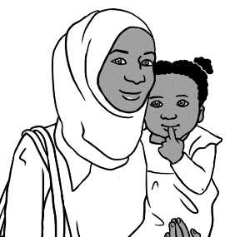

Let’s have a pizza and a salad.

Ok.



|  |  |  |
| --- | --- | --- |
|  | a pizza | $_______ |
|  | a salad  **Total** | + $_______    **__________** |
| Hani can have some noodles and an orange juice. | | |
| **b.** | noodles | $ _______ |
|  | an orange juice  **Total** | + $ _______  **_________** |
| I’ll have a sandwich and a coffee. | | |
| **c.**  a sandwich    a coffee  **Total** | | $_______ |
| + $_______  **_________** |

The red ticks are not in the student version of the workbook.



Do you have enough money?

|  |  |  |  |  |
| --- | --- | --- | --- | --- |
|  | | | **Yes** | **No** |
| 1. $11.00 | + $5.50 | = |  | ✓ |
| 1. ______ | + ______ | = | ✓ |  |
| 1. ______ | + ______ | = |  | ✓ |
| 1. ______ | + ______ | = | ✓ |  |
| 1. ______ | + ______ | = | ✓ |  |
| 1. **______** | + ______ | = |  | ✓ |

# At a men’s clothes shop

See this section in the Teacher Resources for an introduction to the vocabulary here including plural forms for *pairs of jeans* etc. There is also a parallel exercise with a women’s clothes shop.

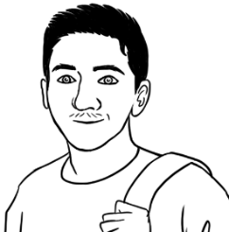

I need a jacket   
and a cap.

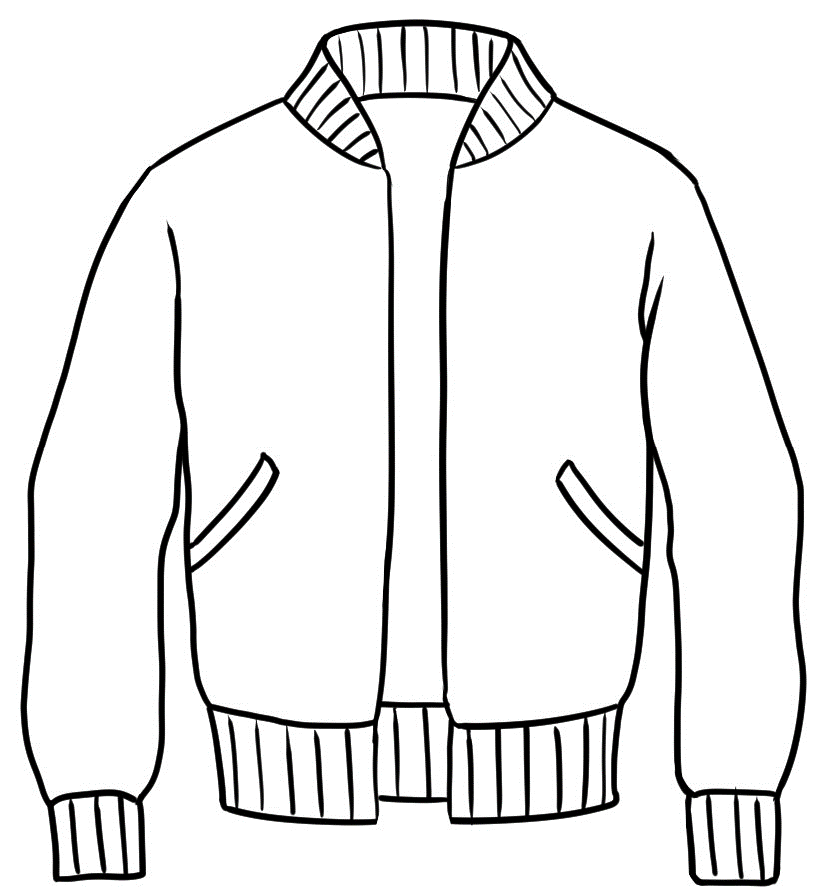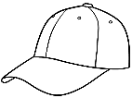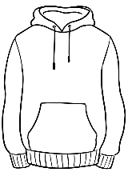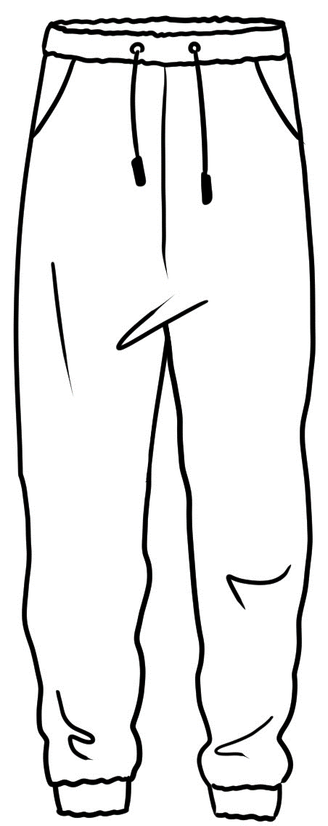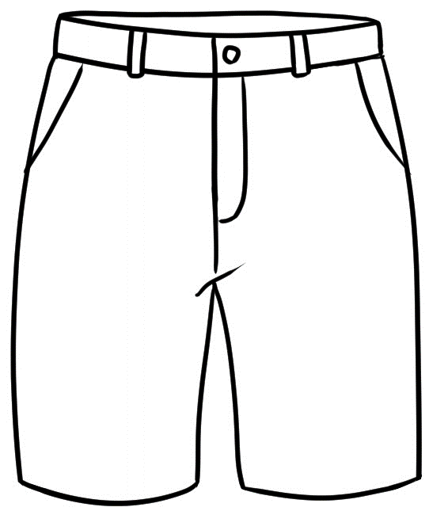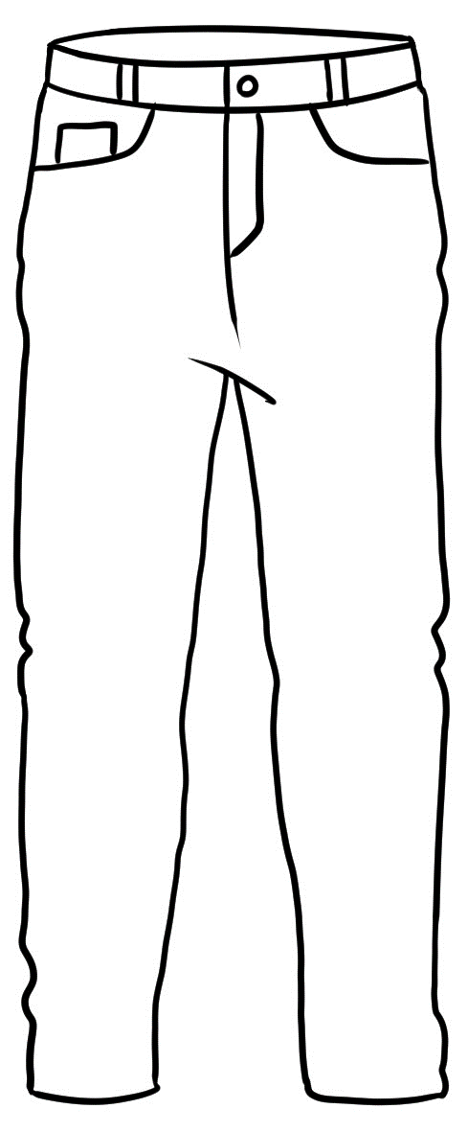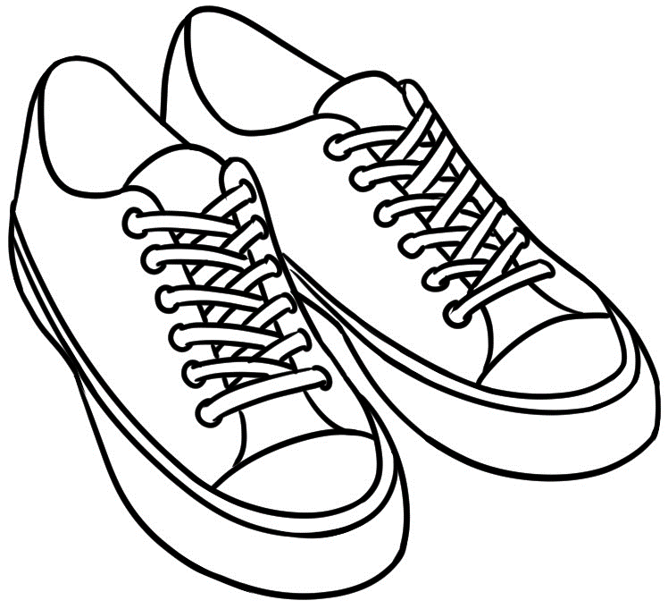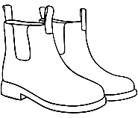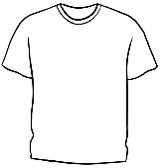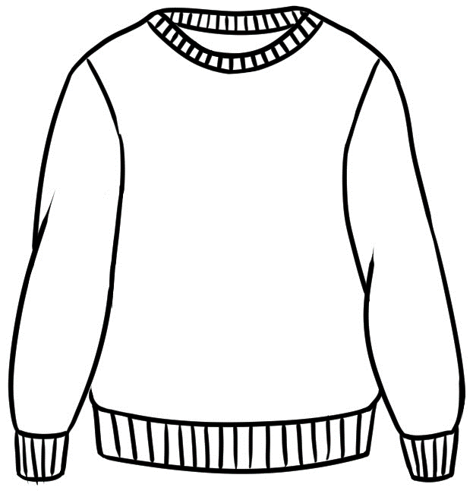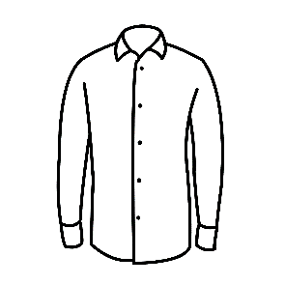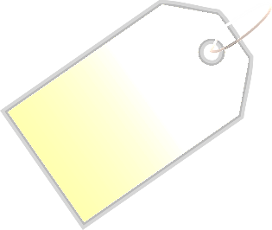

jacket

$70.50



jumper

$59



hoodie

$60

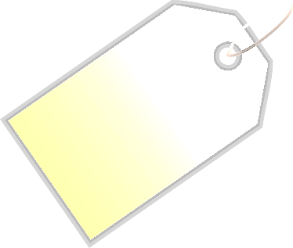

track pants

$35.50



jeans

$65

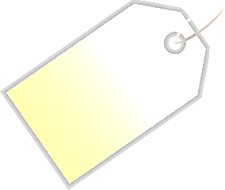

shirt

$50

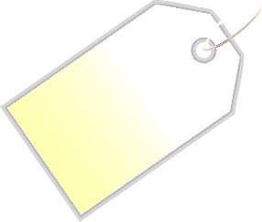

t-shirt

$30

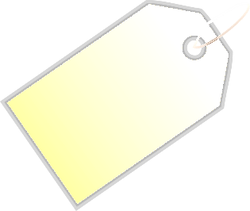

runners

$80

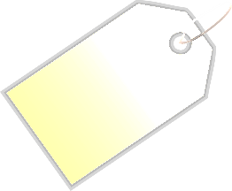

cap

$20



shorts

$40.50

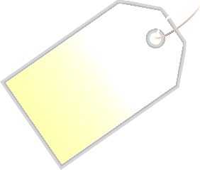

boots

$90

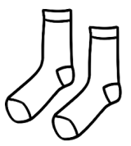

socks

$9



How much **is** the jacket?

Students take turns to ask their partner the price of the clothes.  **Note** the use of ***is*** and ***are*** when talking about singular and plural items.

$70.50

How much **are** the runner**s**?

$80



Draw a line to match the items to their prices.





|  |
| --- |
| $9 |
| $20 |
| $30 |
| $35.50 |
| $40.50 |
| $50 |
| $59 |
| $60 |
| $65 |
| $70.50 |
| $80 |
| $90 |

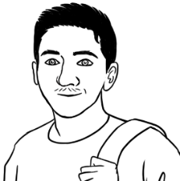

I need a jacket   
and a cap.



|  |  |  |
| --- | --- | --- |
|  | a jacket | $70.50 |
|  | a cap  **Total** | + $20.00  $90.50 . |
| I need a hoodie and some track pants. | | |
|  | a hoodie | $ _______ |
|  | track pants  **Total** | + $ _______  **_________** |
| Note the addition of ***s***  for Present Simple,  3rd person singular.  My friend needs some shorts and  a shirt. | | |
|  | shorts | $_______ |
|  | a shirt  **Total** | + $_______  **_________** |

Note the common use of ***some*** in speech as  
a substitute for ***a pair of***.

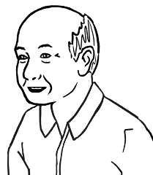

My grandson needs   
some jeans and a t-shirt.

|  |  |  |
| --- | --- | --- |
|  | a t-shirt | $_______ |
|  | jeans  **Total** | + $_______    **________** |
| I need some boots  and socks. | | |
| **b.** | boots | $ _______ |
|  | socks  **Total** | + $ _______  **__________** |
| My husband needs  a jumper and a cap. | | |
| **c.**  a jumper  a cap  **Total** | | $_______ |
| + $_______  **_________** |

# At an office shop

See this section in the Teacher Resources for an introduction to the vocabulary here.

Students take turns to ask the teacher the price of each item and then to write the price next to the items in the ad below. **Note** the use of the definite article when referring to specific objects.   
*The red prices are not in the student version of the workbook.*



How much **is** the keyboard?

How much **are** the ear bud**s**?

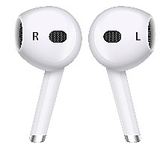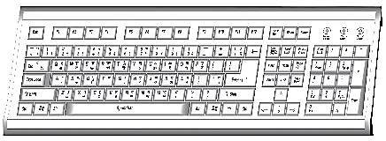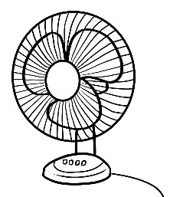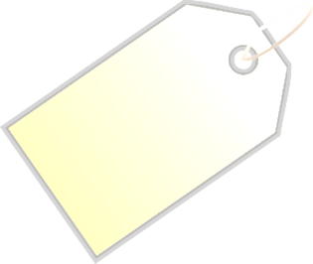

desk

$80

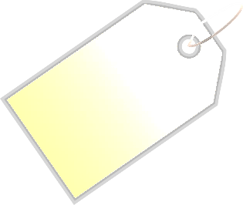

chair

$70



mouse

$25



ear buds  
$55



USB

$15



lamp

$50.50



fan  
$30

**The Office Warehouse**

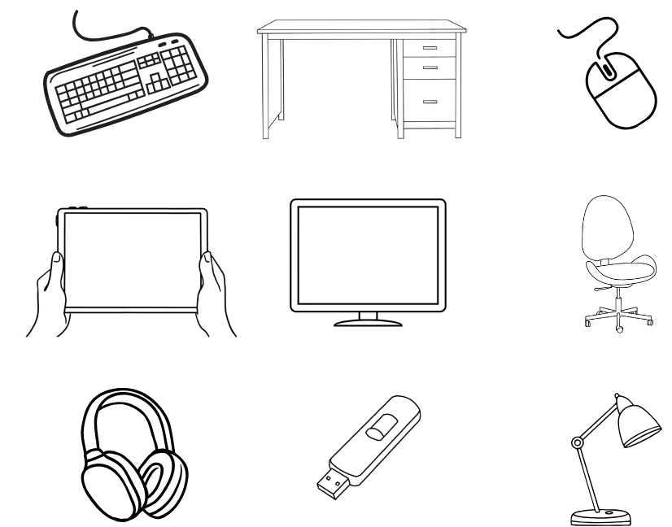

headphones

$60

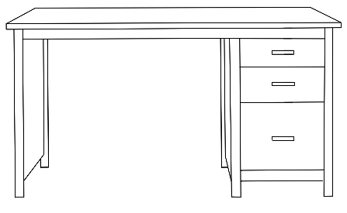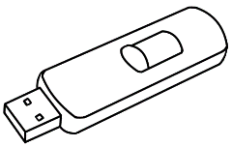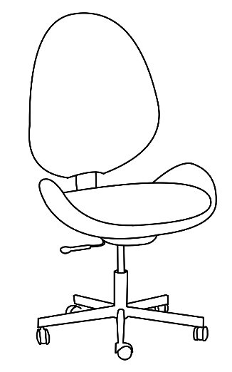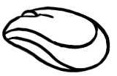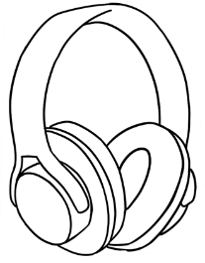

keyboard

$40

See this section in the Teacher resources for activities and exercises around a ***Kitchen Shop.***

_



|  |  |  |
| --- | --- | --- |
|  |  | __$15__ |
|  |  | _______ |
|  |  | _______ |
|  |  | _______ |
|  |  | _______ |
|  |  | _______ |
|  |  | _______ |
|  |  | _______ |
|  |  | _______ |

1. **2.**

Match the prices and items.

Write the prices.

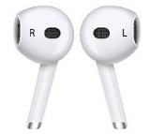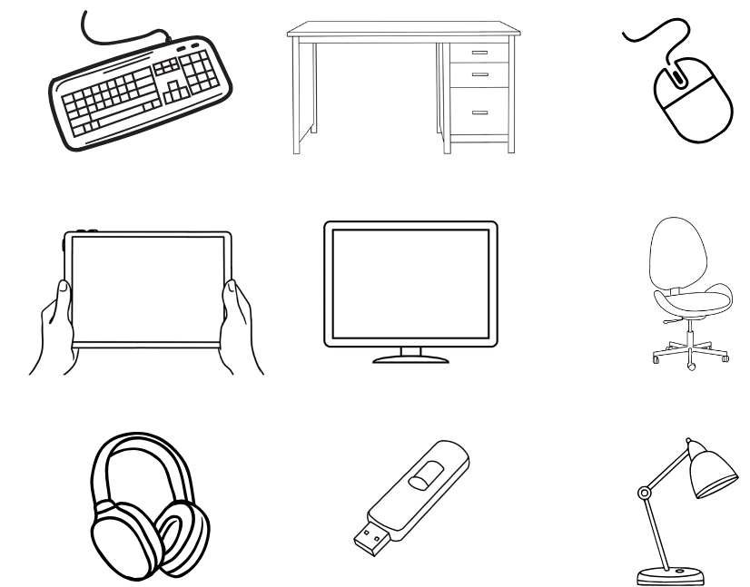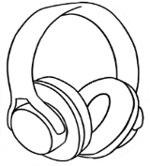

|  |  |  |
| --- | --- | --- |
|  | a desk | $_______ |
|  | a USB  **Total** | + $_______    **________** |
| I need a mouse and some headphones.  Note the use of ***some*** as a common substitute for ***a set of*** or ***a pair of***. | | |
| **b.** | a mouse | $ _______ |
|  | headphones  **Total** | + $ _______  **__________** |
| I need some ear buds and a fan. | | |
| **c.**  ear buds  a fan    **Total** | | $_______ |
| + $_______  **________** |

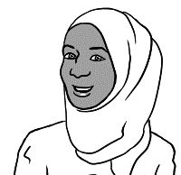

I need a desk   
and a USB.

The red ticks are not in the student version of the workbook.



Do you have enough money?



|  |  |  |  |  |
| --- | --- | --- | --- | --- |
|  | | | **Yes** | **No** |
| 1. $40 | + $55 | = |  | ✓ |
| 1. ______ | + ______ | = | ✓ |  |
| 1. A computer keyboard and a usb drive     Description automatically generated______ | + ______ | = |  | ✓ |
| 1. ______ | + ______ | = |  | ✓ |
| 1. ______ | + ______ | = | ✓ |  |
| 1. **______** | + ______ | = | ✓ |  |

# Let’s go out.

**expensive**= not cheap

Organise an excursion to a place of interest and use   
the prices of tickets, food etc as a numeracy exercise.   
A group student booking would reduce prices.





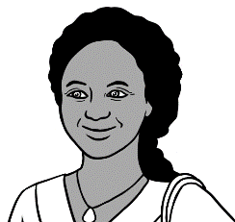

How much is   
a zoo ticket?

Is it **expensive**?

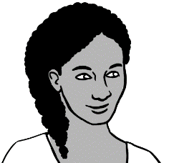

Let’s go to the zoo

on Saturday.

**WILDLIFE ZOO**

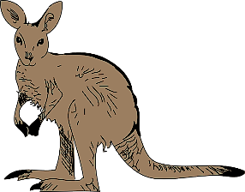

|  |  |  |
| --- | --- | --- |
| **Prices** | **A black and white drawing of an elephant  Description automatically generatedZoo  tickets** | **Bus  tickets** |
| Man with solid fill**Adult** | $41.00 | $6.00 |
| Man with solid fill**Concession** | $30.00 | $4.00 |
| **Child with balloon with solid fillChild** | $21.00 | $3.50 |
| **Family with two children with solid fillFamily** | $85.00 | $13.00 |

Students take turns to ask their partner the price of the zoo and bus tickets.

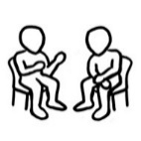

$30

How much is a **concession**   
**zoo** ticket?

$3.50

How much is a **child’s**   
**bus** ticket?

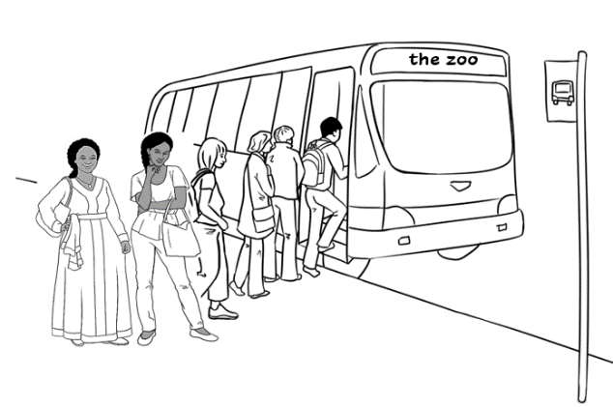

Anika and her mother   
catch the bus to the zoo on Saturday.

**3.**



Students circle   
the answers.

**4.**

|  |  |  |  |  |
| --- | --- | --- | --- | --- |
| 1. How much are 2 concession **bus** tickets? | | | | |
| $6.00 | | $8.00 | $13.00 | |
| 1. What money do they need? | | | | |
|  | | | | |
| 1. A black and white drawing of an elephant     Description automatically generatedHow much are 2 concession **zoo** tickets? | | | | |
| $82.00 | | $50.00 | $60.00 | |
| 1. What money do they need? | | | | |
|  | | | | |
|  | bus tickets  A black and white drawing of an elephant  Description automatically generated  Students write and add the sums.  zoo tickets  **Total** | | | $____________  $____________  **$____________** |
|  | Close-up of a currency note  Description automatically generatedThey have $100.  Do they have enough? | | | _______ ______  yes no |



Dictate the prices for students to write.   
*The prices are not in the student version of the* *workbook.*

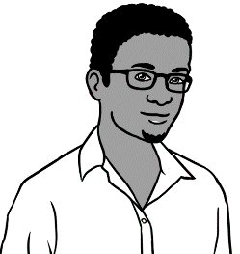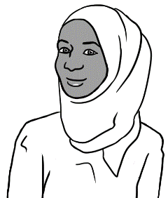

Let’s go to the zoo.  
The tickets are cheap this Sunday.

this Sunday.

How much are the tickets?

**WILDLIFE ZOO**

|  |  |  |
| --- | --- | --- |
| **Prices** | **Zoo  tickets** | **Bus  tickets** |
| **Adult** | $35.00 | $4.00 |
| **Concession** | $25.00 | $3.00 |
| **Child** | $15.00 | $2.50 |
| **Family** | $70.00 | $10.00 |

**********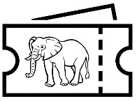**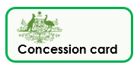

**Cheap prices this Sunday!!**

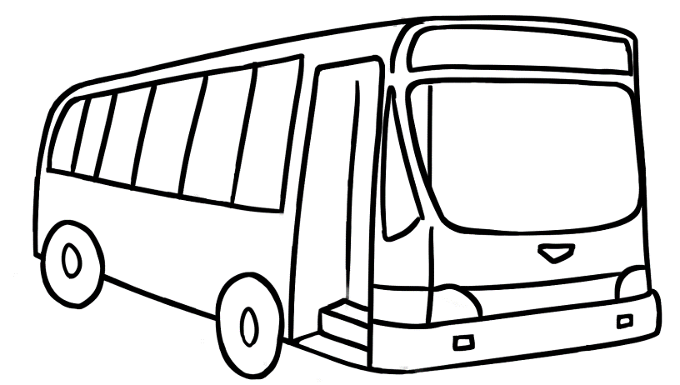

Students take turns to ask their partner the price of the zoo and bus tickets.



$70

How much is a **family**   
**zoo** ticket?

$4

How much is an **adult bus** ticket?

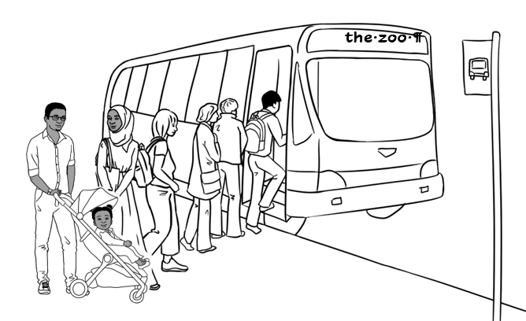

Sahra and her family   
catch the bus

to the zoo on Sunday.

**3.**



Students write and add the sums.

**4.**

|  |  |  |  |  |  |  |  |
| --- | --- | --- | --- | --- | --- | --- | --- |
| 1. How much is a family **bus** ticket? | | | | | | | |
| $9.00 | | $9.50 | | $10.00 | | | $10.50 |
| 1. What money do they need? | | | | | | | |
|  | | | | | | | |
| 1. A black and white drawing of an elephant     Description automatically generatedHow much is a family **zoo** ticket? | | | | | | | |
| $85.00 | | | $80.00 | | $70.00 | | |
| 1. What money do they need? | | | | | | | |
|  | | | | | | | |
|  | bus ticket  A black and white drawing of an elephant  Description automatically generated  Students write and add the sums.  zoo ticket  **Total** | | | | | $____________  $____________  **$____________** | |
|  | Close-up of a currency note  Description automatically generatedThey have $100.  Do they have enough? | | | | | _______ ______  yes no | |

**More places to go**



**Swimming Pool**

|  |  |
| --- | --- |
| **Prices** | **Tickets** |
| **Adult** | $9.50 |
| **Concession** | $7.00 |
| **Child** | $6.50 |
| **Family** | $25.00 |



Dictate the prices for students to write.

**Art Gallery**

|  |  |
| --- | --- |
| **Prices** | **Tickets** |
| **Adult** | $25.00 |
| **Concession** | $20.00 |
| **Child** | $13.00 |
| **Family** | $63.00 |

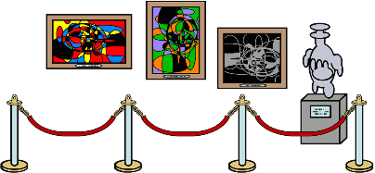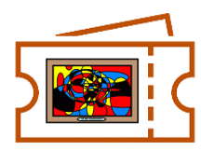

Explain that most art galleries are free, but people need to pay to see special exhibitions.