

|  |
| --- |
| **English Ready**  22637VIC Course in EALVU23578 - Recognise and use time in highly familiar situations |

Times and dates

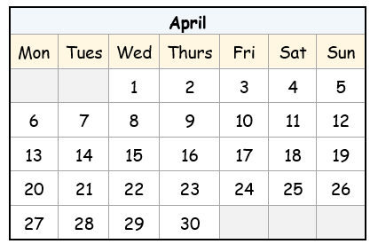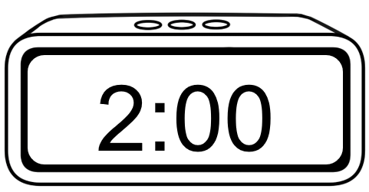

**Name** __________________________________________________________________

**Teacher** _______________________________________________________________

**Class** ___________________________________________________________________

**Date**____________________________________________________________________

*This workbook is designed to be used with the support of a teacher.*

**Design team:** Sue Paull, Vicki Hambling, Nikeh Shariatian, Bernie Miles,and Mary Wallace

**Illustrations:** Madelena Scott

**Image acknowledgements:**  
Student studying, shopping trolley, birthday banner, Christmas tree and lights - [These Photo](https://freepngimg.com/png/50184-exam-photos-png-image-high-quality)s by Unknown Author is licensed under [CC BY-NC](https://creativecommons.org/licenses/by-nc/3.0/)

**Acknowledgements:** The design team would like to acknowledge the use of the EAL Framework which underpins the design of this book.

Copyright of the EAL Framework is reserved to the Crown in the right of the State of Victoria. © State of Victoria (Department of Education and Training) 2023.  
_________________________________________________________________________________________

This English Ready Resource is licensed under a Creative Commons Attribution-NoDerivs 3.0 Australia licence (More information is available [here](http://creativecommons.org/licenses/by-nd/3.0/au/)). You are free to use, copy and distribute to anyone in its original form as long as you attribute Department of Home Affairs as the author and you license any derivative work you make available under the same licence.  
  
 © Commonwealth of Australia 2024

With the exception of the Commonwealth Coat of Arms, the department’s logo, any material protected by a trade mark and where otherwise noted all material presented in this document is provided under a Creative Commons Attribution 4.0 International (<https://creativecommons.org/licenses/by/4.0/>) licence.

The details of the relevant licence conditions are available on the Creative Commons website (accessible using the links provided) as is the full legal code for the CC BY 4.0 licence (<https://creativecommons.org/licenses/by/4.0/legalcode>).

Use of all or part of this document must include the following attribution:   
© Commonwealth of Australia 2023

As far as practicable, material for which the copyright is owned by a third party will be clearly labelled.  The department has made all reasonable efforts to ensure that this material has been reproduced in this document with the full consent of the copyright owners.

Copyright requests and enquiries concerning usage not addressed by the CC BY 4.0 licence should be addressed to:

[*comms@homeaffairs.gov.au*](mailto:comms@homeaffairs.gov.au) *at the Department of Home Affairs.*

The terms of use for the Commonwealth Coat of Arms are available from the [It's an Honour](http://www.itsanhonour.gov.au/) website.

Where a copyright owner, other than the Commonwealth, is identified with respect to this material, please contact that third party copyright owner directly to seek permission.

**Contents**

1. Instructions 4

2. Meet the students and teachers. 5

3. What day is it? 6

4. Sahra is busy this week. 10

5. What time is it? 12

6. What time do you get up? 16

7. Morning and afternoon 22

8. What month is it? 26

9. What’s the date? 30

10. Special dates 34

# Instructions

|  |
| --- |
|  |

|  |  |  |  |  |  |
| --- | --- | --- | --- | --- | --- |
|  |  | listen |  |  | say |
|  |  | read |  |  | write |
|  |  | ask |  |  | copy |
|  |  | match |  |  | circle |
|  |  | highlight |  |  | tick |
|  |  | work with  a partner |  |  | clap |

# Meet the students and teachers.



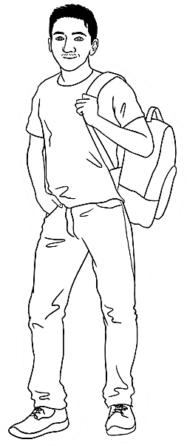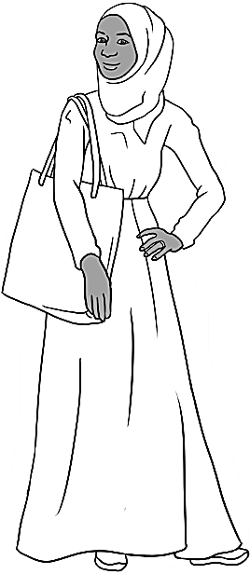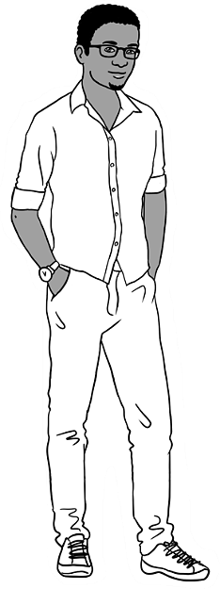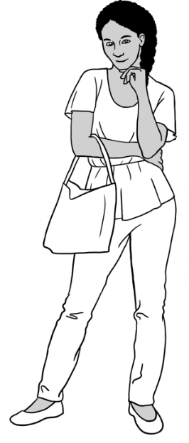

Carim Sahra Tahiil Anika Ming

**The students**

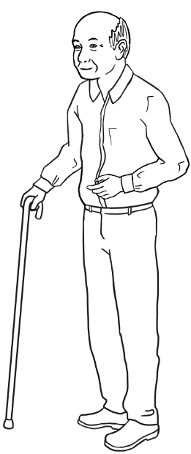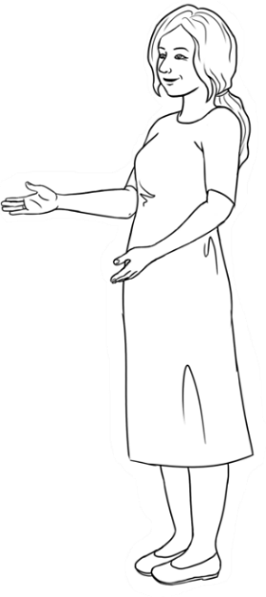

**The teachers**

Jenny Wendy

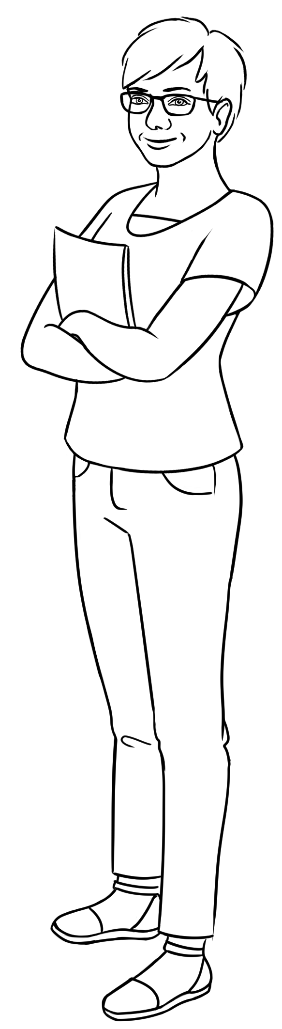

**The learning centres**

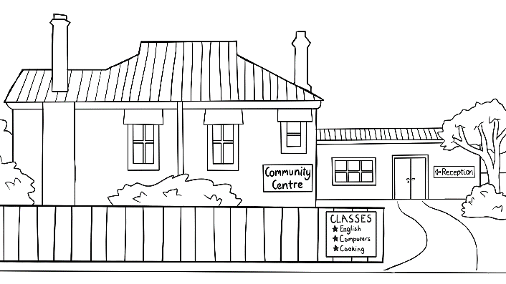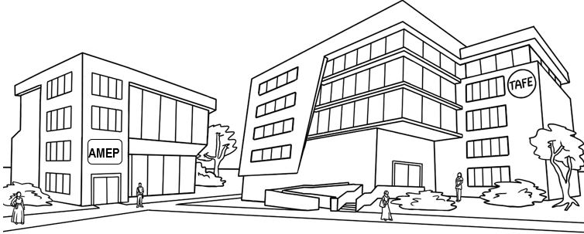

# What day is it?

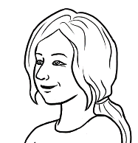

What day is it today?

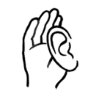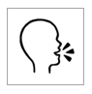

1. **2.**

|  |  |  |  |
| --- | --- | --- | --- |
|  | **1** | Monday |  |
|  | **2** | Tuesday |
|  | **3** | Wednesday |
|  | **4** | Thursday |
|  | **5** | Friday |
|  | **6** | Saturday |  |
|  | **7** | Sunday |



**3.**

|  |  |  |  |  |
| --- | --- | --- | --- | --- |
| weekdays | |  | the weekend | |
| **1** | Monday |  | **6** | Saturday |
| Monday |  |
| **2** | Tuesday |  | **7** | Sunday |
|  |  |
| **3** | Wednesday |  |  |  |
|  |
| **4** | Thursday |  |  | There are 7 days  in a week. |
|  |
| **5** | Friday |  |  |  |
|  |

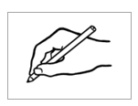

1. .

|  |  |  |
| --- | --- | --- |
| **Yesterday** | **Today** | **Tomorrow** |
| The day **before** today | ____________________ | The day **after** today |
| ____________________ | ___________________ |



What’s the day **before** Tuesday?



**4.**

|  |  |  |  |
| --- | --- | --- | --- |
| **a.** | Monday | Tuesday | Wednesday |
| **b.** | Thursday | Friday | Saturday |
| **c.** | Sunday | Monday | Tuesday |
| **d.** | Wednesday | Thursday | Friday |
| **e.** | Saturday | Sunday | Monday |
| **f.** | Tuesday | Wednesday | Thursday |
| **g.** | Friday | Saturday | Sunday |
| **h.** | Monday | Tuesday | Wednesday |
| **i.** | Thursday | Friday | Saturday |
| **j.** | Sunday | Monday | Tuesday |



|  |  |  |  |  |  |  |
| --- | --- | --- | --- | --- | --- | --- |
| Monday |  | Tuesday |  | Wednesday |  | Thursday✓ |
|  |  |  |  |  |  |  |
| Friday |  | Saturday |  | Sunday |  |  |

|  |  |  |
| --- | --- | --- |
| 1. Tuesday | Wednesday | Thursday . |
|  |  |  |
| **b.** ___________________ | Tuesday | Wednesday |
|  |  |  |
| **c.** ___________________ | Saturday | Sunday |
|  |  |  |
| **d.** Monday | Tuesday | ___________________ |
|  |  |  |
| **e.** Thursday | Friday | ___________________ |
|  |  |  |
| **f.** ___________________ | Monday | Tuesday |
|  |  |  |
| **g.** ___________________ | Wednesday | Thursday |



The days of the week are Monday , __________________________, _____________________________, _________________________, _________________________,

___________________________ and ___________________________**.**

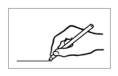

|  |  |  |
| --- | --- | --- |
| **Long** word |  | **Short word** |
| **Mon**day | Tues |
| **Tues**day | Wed |
| **Wed**nesday | Sun |
| **Thurs**day | Mon |
| **Fri**day | Sat |
| **Sat**urday | Thurs |
| **Sun**day | Fri |

**3.**



**4.**

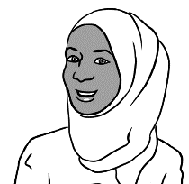

Is the market open on Monday?

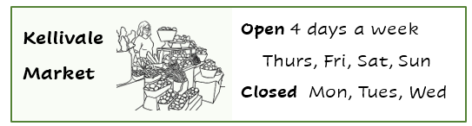

1. The market is open on ________, _________, __________ and _________.
2. The market is closed on ________, _________ and __________.

# Sahra is busy this week.



I’m busy this week.



|  |  |  |
| --- | --- | --- |
| 1. Monday |  | I go to class on Monday and Tuesday . |
| 1. Tuesday |  | My daughter Hani goes to childcare on ______________ and ________________. |
| 1. Wednesday |  | I clean and cook  on ___________________. |
| 1. Thursday |  | I go to the market  on _______________. |
| 1. Friday |  | We go to the park  on ________________. |
| 1. Saturday |  | Tahiil and I play sport  on ________________ and _________________. |
| 1. Sunday |

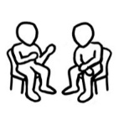



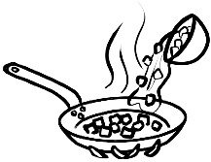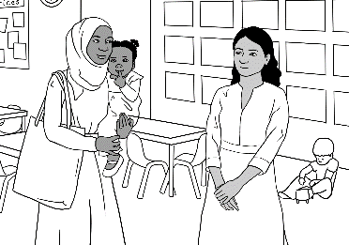

on Monday

on Tuesday

on Wednesday

on Thursday

on Friday

on Saturday

on Sunday

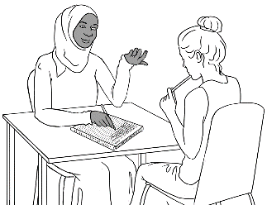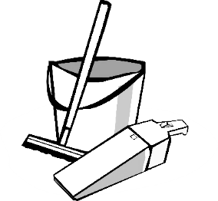

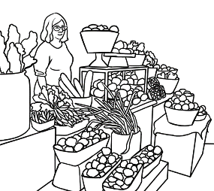

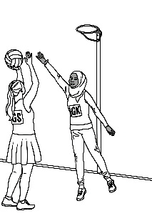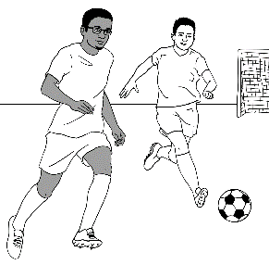

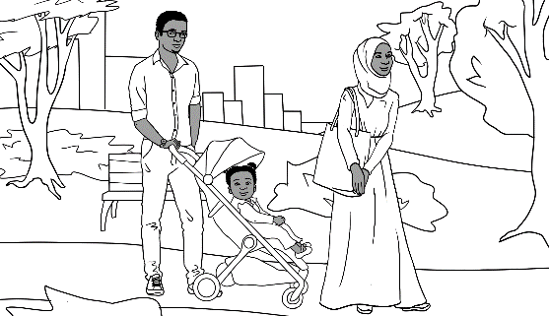

# What time is it?





What time is it?



|  |  |  |
| --- | --- | --- |
| **a.** It’s **1** o’clock. | **b.** It’s **2** o’clock. | **c.** It’s **3** o’clock. |
| 1:00 | **________** | **________** |
|  |  |  |
|  |  |  |
| **d.** It’s **4** o’clock. | **e.**  It’s **5** o’clock. | **f.**  It’s **6** o’clock. |
| **________** | **________** | **________** |
|  |  |  |
|  |  |  |
| **g.** It’s **7** o’clock. | **h.**  It’s **8** o’clock. | **i.**  It’s **9** o’clock. |
| **________** | **________** | **________** |
|  |  |  |
|  |  |  |
| **j.**  It’s **10** o’clock. | **k.**  It’s **11** o’clock. | **l.**  It’s **12** o’clock. |
| **________** | **________** | **________** |
|  |  |  |

1. **2.**

**It’s** = It is



|  |
| --- |
| 1. It’s 1 o’clock. |
| 1. It’s 2 o’clock. |
| 1. It’s 3 o’clock. |
| 1. It’s 4 o’clock. |
| 1. It’s 5 o’clock. |
| 1. It’s 6 o’clock. |
| 1. It’s 7 o’clock. |
| 1. It’s 8 o’clock. |
| 1. It’s 9 o’clock. |
| 1. It’s 10 o’clock. |
| 1. It’s 11 o’clock. |
| 1. It’s 12 o’clock. |

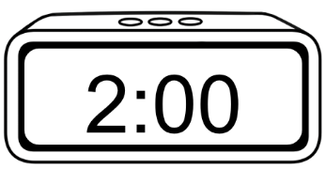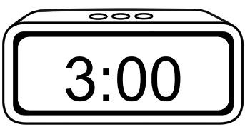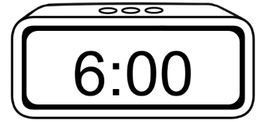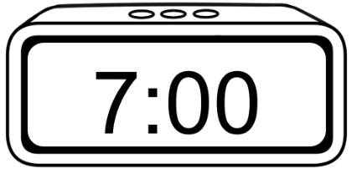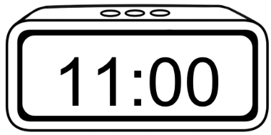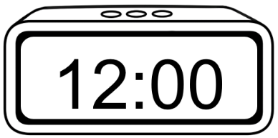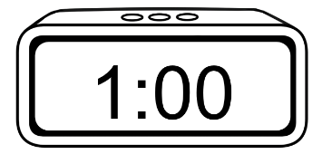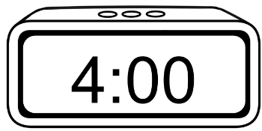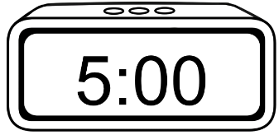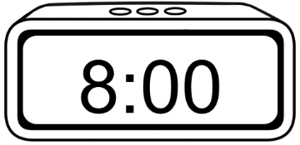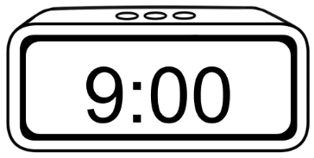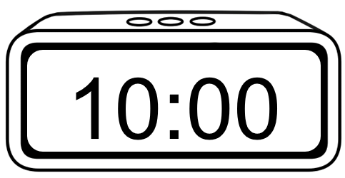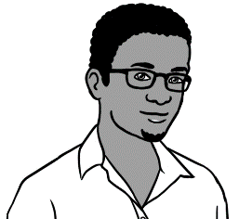

What time is it?

It’s **1** o’clock.



**2**.

|  |  |  |
| --- | --- | --- |
| **a.** | **b.** | **c.** |
| It’s 1:00.  It’s 1 o’clock. | It’s 2:00.  It’s ___ o’clock. | It’s 3:00.  It’s ___ o’clock. |
|  |  |  |
|  |  |  |
| **d.** | **e.** | **f.** |
| It’s 4:00.  It’s ___ o’clock. | It’s s 5:00.  It’s ___ o’clock. | It’s 6:00.  It’s __ o’clock. |
|  |  |  |
|  |  |  |
| **g.** | **h.** | **i.** |
| It’s 7:00.  It’s __ o’clock. | It’s 8:00.  It’s __ o’clock. | It’s 9:00.  It’s __ o’clock. |
|  |  |  |

|  |  |  |
| --- | --- | --- |
| **j.** | **k.** | **l.** |
| It’s 10:00.  It’s ___ o’clock. | It’s 11:00.  It’s ___ o’clock. | It’s 12:00.  It’s ___ o’clock. |
|  |  |  |

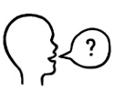

It’s 4 o’clock.







|  |  |  |
| --- | --- | --- |
| **a.** | **b.**  ✓ | **c.** |
| **d.** | **e.** | **f.** |
| **g.** | **h.** | **i.** |
| **j.** | **k.** | **l.** |

# What time do you get up?





1. **2. 3.**

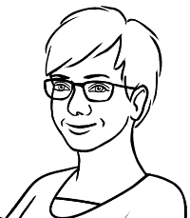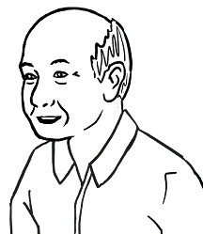

What time do you get up

on Tuesday Ming?

At 6 o’clock.

On Tuesday

|  |  |  |
| --- | --- | --- |
|  |  | I get up at 6 o’clock.  at 6 o’clock_ |
|  |  | I have breakfast  at 7 o’clock.  ____________ |
|  |  | I get to the Community Centre at 8 o’clock.  _____________ |
|  |  | I work in the community garden for an hour.  I start class at 9 o’clock.  _____________ |





1. **2.**

On Tuesday

|  |
| --- |
| **Ming’s family** |
| 1. Lan is his daughter.   I have lunch at 1:00.  _________  I get up at 6:00.  at_6:00__. |
|  |
| 1. Bao is his grandson.   I play soccer at 4:00.  ________  I get up at 8:00.  ________ |
|  |
| 1. Mai is his granddaughter.   I start school at 9:00.  __________  I finish at 3:00.  __________ |
|  |
| 1. The family has dinner together.     We have dinner at 6:00.  __________ |

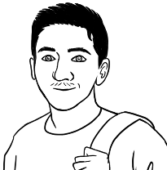

I get up at 7:00

on Monday.



1. **2.**

On Monday

|  |  |  |  |  |  |  |
| --- | --- | --- | --- | --- | --- | --- |
| **a.** |  | | **b.** | | | |
| I get up __at_7:00_. |  | | I have breakfast _____________. | | | |
|  |  | |  | | | |
| **c.** |  | | **d.**  **have a break** =stop work  for a short time | | | |
| I start class _____________. |  | | I **have a break** _____________. | | | |
|  |  | |  | | | |
| **e.** |  | | **f.** | | | |
| I have lunch _____________. |  | | I finish class _____________. | | | |
|  |  | |  | | | |
| **g.** |  | | **h.** | | | |
| I play soccer _____________. |  | | I eat dinner _____________. | | | |
|  |  | |  | | | |
| **i.** |  | | **j.** | | | |
| I study English _____________. |  | | I go to bed _____________. | |
|  | |  | |  | |



Is it true or false?

|  |  |  |
| --- | --- | --- |
|  | **True** | **False** |
| 1. I get up at 6:00. |  | ✓ |
| 1. I have breakfast at 8:00. |  |  |
| 1. I start class at 9:00. |  |  |
| 1. I have a break at 10:00. |  |  |
| 1. I have lunch at 12:00. |  |  |
| 1. I finish class at 3:00. |  |  |
| 1. I play soccer at 5:00. |  |  |
| 1. **A black and white screen with numbers     Description automatically generated**I have dinner at 6:00. |  |  |
| 1. I study English at 8:00. |  |  |
| 1. I watch TV at 9:00. | ? | ? |
| 1. I go to bed at 10:00. |  |  |

Carim’s Monday



What time do **you** get up   
on ___________________?



On ____________________

|  |  |  |  |  |  |  |
| --- | --- | --- | --- | --- | --- | --- |
| **a.** |  | | **b.** | | | |
| I get up at ________. |  | | I have breakfast at ________. | | | |
|  |  | |  | | | |
| **c.** |  | | **d.** | | | |
| I start class at ________. |  | | I have a break at ________. | | | |
|  |  | |  | | | |
| **e.** |  | | **f.** | | | |
| I have lunch at ________. |  | | I finish class at ________. | | | |
|  |  | |  | | | |
| **g.** |  | | **A black and white screen with numbers  Description automatically generatedImageh.** | | | |
| I study English at ________. |  | | I eat dinner at ________. | | | |
|  |  | |  | | | |
| **i.** |  | | **j.** | | | |
| I watch TV at ________. |  | | I go to bed at ________. | |
|  | |  | |  | |



What time do **you** get up   
on ____________________?

1. **2.**

On ___________________

|  |  |  |  |
| --- | --- | --- | --- |
| My partner is ___________________________ **Time** | | | |
|  | What time do you get up? |  | at _________ |
|  | What time do you have breakfast? |  | at _________ |
|  | What time do you start class? |  | at _________ |
|  | What time do you have a break? |  | at _________ |
|  | What time do you have lunch? |  | at _________ |
|  | What time do you finish class? |  | at _________ |
|  | What time do you have dinner? |  | at _________ |
|  | What time do you study English? |  | at _________ |
|  | What time do you watch TV? |  | at _________ |
|  | What time do you go to bed? |  | at _________ |

# Morning and afternoon



I start class in the morning.

I finish class in the afternoon.







|  |  |  |
| --- | --- | --- |
| morning = am |  | afternoon = pm |
|  |  |  |
|  |  |  |



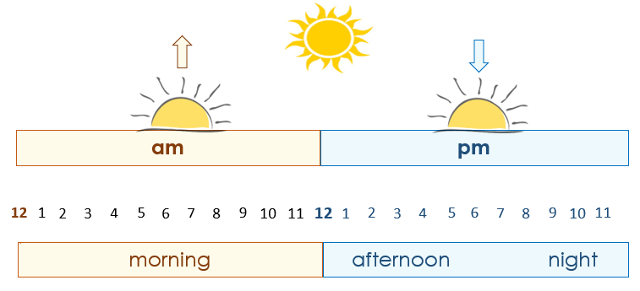



This is my class timetable.



**1.**

|  |  |  |  |  |  |
| --- | --- | --- | --- | --- | --- |
| **Day** | **Monday** | **Tuesday** | **Wednesday** | **Thursday** | **Friday** |
| **Start** |  | 9:00 am  **🗸** | 9:00 am  **🗸** |  | 10:00 am  **🗸** |
| **Finish** |  | 12:00 pm | 12:00 pm |  | 1:00 pm |
| **Room** |  | 4 | 4 |  | 3 |





**2. 3.**



I start class at 9:00 am on Tuesday and Wednesday.

I finish class at __________ .

I start class at __________ on Friday.

I finish class at __________ .



**4.**

afternoon

morning

Ming starts class in the ________________________.

He finishes class in the ________________________.



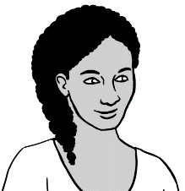

This is my class timetable.

**5.**

|  |  |  |  |  |  |
| --- | --- | --- | --- | --- | --- |
| **Day** | **Monday** | **Tuesday** | **Wednesday** | **Thursday** | **Friday** |
| **Start** | 9:00 am  **🗸** | 9:00 am  **🗸** | 12:00 pm  **🗸** | 12:00 pm  **🗸** |  |
| **Finish** | 1:00 pm | 1:00 pm | 3:00 pm | 3:00 pm |  |
| **Room** | 6 | 4 | 4 | 7 |  |





**6. 7.**



I start class at ___________ on Monday and Tuesday.

I finish class at ___________ .

I start class at __________ on Wednesday and Thursday.

I finish class at __________ .

|  |  |  |  |  |  |
| --- | --- | --- | --- | --- | --- |
| **Day** | **Monday** | **Tuesday** | **Wednesday** | **Thursday** | **Friday** |
| **Start** |  |  |  |  |  |
| **Finish** |  |  |  |  |  |
| **Room** |  |  |  |  |  |

**My** class timetable

**8.**



What time does

the supermarket   
open **today**?



|  |  |
| --- | --- |
| **Supermarket   Opening Hours** | |
| **Mon** - **Fri** | 7 am – 9 pm |
| **Sat** | 8 am – 9 pm |
| **Sun** | 8 am – 8 pm |

1. Today is ________________.
2. The supermarket opens

at ___________ today.

1. It closes at ____________.



**2.**

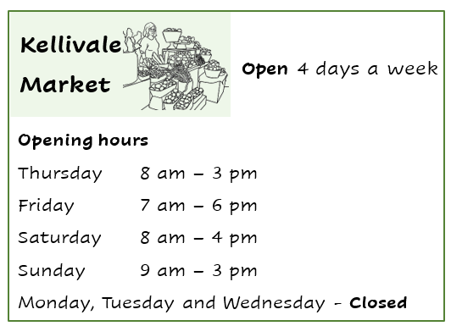

Is the market   
open **today**?



*Yes / No*



1. The market opens at ___________ on Thursday.
2. It closes at ___________ on Thursday.
3. The market opens at ___________ on Friday.
4. It closes at ___________ on Friday.
5. The market opens at ___________ on Saturday.
6. It closes at ___________ on Saturday.

# What month is it?

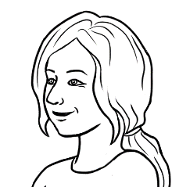

Circle the number   
for April.



1. **2.**

|  |  |  |  |  |
| --- | --- | --- | --- | --- |
| **Long words** | | |  | **Short words** |
| 1 |  | January |  | Jan |
| 2 |  | February |  | Feb |
| 3 |  | March |  | Mar |
| 4 |  | April |  | Apr |
| 5 |  | May |  | May |
| 6 |  | June |  | Jun |
| 7 |  | July |  | Jul |
| 8 |  | August |  | Aug |
| 9 |  | September |  | Sep |
| 10 |  | October |  | Oct |
| 11 |  | November |  | Nov |
| 12 |  | December |  | Dec |

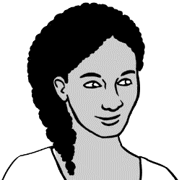

____ months

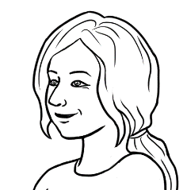

How many months   
are in a year?



**3.**

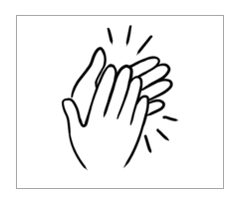





|  |  |  |  |
| --- | --- | --- | --- |
|  |  | |  |
| March  May  June | April  August | | July |
|  |  | |  |
|  | |  | |
| January  February | | September  October  November  December | |



|  |  |  |
| --- | --- | --- |
| **Jan**uary |  | **Feb**ruary |
| **March** |  | **Ap**ril |
| **May** |  | **June** |
| Ju**ly** |  | **Au**gust |
| Sep**tem**ber |  | Oc**to**ber |
| No**vem**ber |  | De**cem**ber |



**1. 2.**

|  |  |  |
| --- | --- | --- |
| January  1 |  | February |
| __January____ |  | _______________ |
|  |  |  |
| March |  | April |
| _______________ |  | _______________ |
|  |  |  |
| May |  | June |
| _______________ |  | _______________ |
|  |  |  |
| July |  | August |
| _______________ |  | _______________ |
|  |  |  |
| September |  | October |
| _________________ |  | ________________ |
|  |  |  |
| November |  | December |
| _________________ |  | __________________ |



**3.**



Circle July.



|  |  |  |
| --- | --- | --- |
| January | February | March |
| April | May | June |
| July | August | September |
| October | November | December |
|  | | |
| January | ___________________ | March |
| _________________ | May | _________________ |
| July | _________________ | September |
| _________________ | November | _________________ |
|  |  |  |
| _________________ | February | _________________ |
| April | _________________ | June |
| _________________ | August | _________________ |
| October | _________________ | December |

# What’s the date?





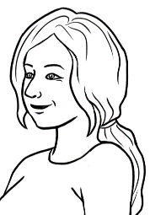

What’s the date today?



24 June

**Say**:   
*the* **24***th*

*of* **June**

|  |  |  |  |  |  |  |
| --- | --- | --- | --- | --- | --- | --- |
| **June 2025** | | | | | | |
| **Mon** | **Tues** | **Wed** | **Thurs** | **Fri** | **Sat** | **Sun** |
| 1 | 2 | 3 | 4 | 5 | 6 | 7 |
| 8 | 9 | 10 | 11 | 12 | 13 | 14 |
| 15 | 16 | 17 | 18 | 19 | 20 | 21 |
| 22 | 23 | **24** | 25 | 26 | 27 | 28 |
| 29 | 30 |  |  |  |  |  |

|  |  |  |  |
| --- | --- | --- | --- |
|  | **Day** | **Month** | **Year** |
| 1. The date today | 24 | June | 2025 |
| 1. The date today in numbers | 24 | 06 | 2025 |
|  | 24 / 06 / 2025 | | |

|  |  |  |  |  |  |  |
| --- | --- | --- | --- | --- | --- | --- |
| February |  | 01 |  | 07 |  | September |
| April |  | 02 |  | 08 |  | October |
| January |  | 03 |  | 09 |  | July |
| June |  | 04 |  | 10 |  | December |
| March |  | 05 |  | 11 |  | August |
| May |  | 06 |  | 12 |  | November |

1. 





Happy birthday

Hani.

It’s my daughter’s birthday

today. Her name is Hani.

|  |  |  |  |  |  |  |
| --- | --- | --- | --- | --- | --- | --- |
| **June 2025** | | | | | | |
| **Mon** | **Tues** | **Wed** | **Thurs** | **Fri** | **Sat** | **Sun** |
| 1 | 2 | 3 | 4 | 5 | 6 | 7 |
| 8 | 9 | 10 | 11 | 12 | 13 | 14 |
| 15 | 16 | 17 | 18 | 19 | 20 | 21 |
| 22 | 23 | **24** | 25 | 26 | 27 | 28 |
| 29 | 30  Birthdays |  |  |  |  |  |



|  |  |  |  |
| --- | --- | --- | --- |
| **a.** | Hani’s birthday | 24 June 2021 | 24 / 06 / 2021  24 / 06 / 2021 . |
|  |  |  |  |
| **b.** | Tahiil’s birthday | 27 June 1994 | 27 / 06 / 1994  __________________ |
|  |  |  |  |
| **c.** | Sahra’s birthday | 7 July 1996 | 07 / 07 / 1996  __________________ |



|  |  |  |  |
| --- | --- | --- | --- |
| **a.** | 24 June 2021 |  | 07 / 07 / 1996 |
|  |  |  |  |
| **b.** | 27 June 1994 |  | 24 / 06 / 2021 |
|  |  |  |  |
| **c.** | 7 July 1996 |  | 27 / 06 / 1994 |



|  |  |  |  |
| --- | --- | --- | --- |
|  | **The date before** | **Birthdays** | **The date after** |
| **a.** | 23 June 2021  23 / 06 / 2021  _________________ | **Hani’s birthday**  24 June 2021  24 / 06 / 2021 | 25 June 2021  25 / 06 / 2021  _________________ |
|  |  |  |  |
| **b.** | 26 June 1994  26 / 06 / 1994  __________________ | **Tahiil’s birthday**  27 June 1994  27 / 06 / 1994 | 28 June 1994  28 / 06 / 1994  __________________ |
|  |  |  |  |
| **c.** | 6 July 1996  06 / 07 / 1996  __________________ | **Sahra’s birthday**  7 July 1996  07 / 07 / 1996 | 8 July 1996  08 / 07 / 1996  __________________ |



|  |  |  |  |  |  |  |
| --- | --- | --- | --- | --- | --- | --- |
| **________________________ ____________** | | | | | | |
| **Mon** | **Tues** | **Wed** | **Thurs** | **Fri** | **Sat** | **Sun** |
|  |  |  |  |  |  |  |
|  |  |  |  |  |  |  |
|  |  |  |  |  |  |  |
|  |  |  |  |  |  |  |
|  |  |  |  |  |  |  |



Circle todays’ date.







|  |  |
| --- | --- |
| **a.** | Today ____________________ |
| **b.** | Tomorrow ____________________ |
| **c.** | Yesterday ____________________ |
| **d.** | Next Saturday ____________________ |
| **e.** | _________________________ ____________________ |
| **f.** | _________________________ ____________________ |
| **g.** | _________________________ ____________________ |

Dates

# Special dates





The start of   
the holidays.



What’s a special date  
for you Carim?

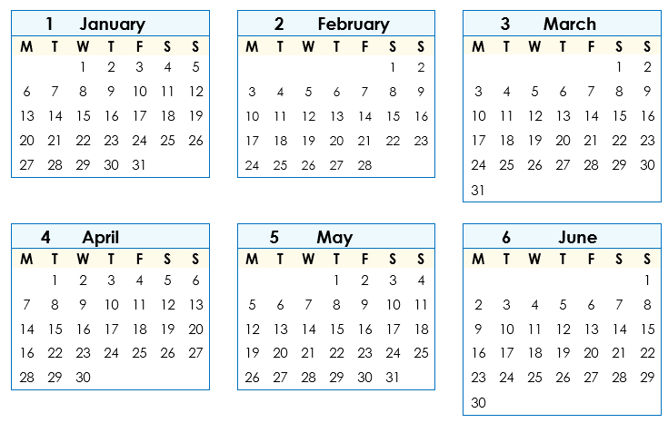



1. **3.**

|  |  |  |
| --- | --- | --- |
| **Class terms** | **Start** | **End** |
| **Term 1** | 3 February 2025  03 / 02 / 2025  03 / 02 / 2025 . | 11 April 2025  11 / 04 / 2025  _______________ |
| **Term 2** | 28 April 2025  28 / 04 / 2025  ________________ | 4 July 2025  05 / 07 / 2025  ______________ |





This is your **January** to **June** calendar. Circle some special dates.





|  |  |  |
| --- | --- | --- |
| **a. Class terms** | **Start** | **End** |
| **Term 1** | ________________________ | _______________________ |
| **Term 2** | ________________________ | _______________________ |



**b.** New Year’s Day **____________________**

**c.** ANZAC Day ____________________

**d. _________________________________ ____________________**

**e. _________________________________ ____________________**

**f. _________________________________ ____________________**





This is your **July** to **December** calendar. Circle some special dates.

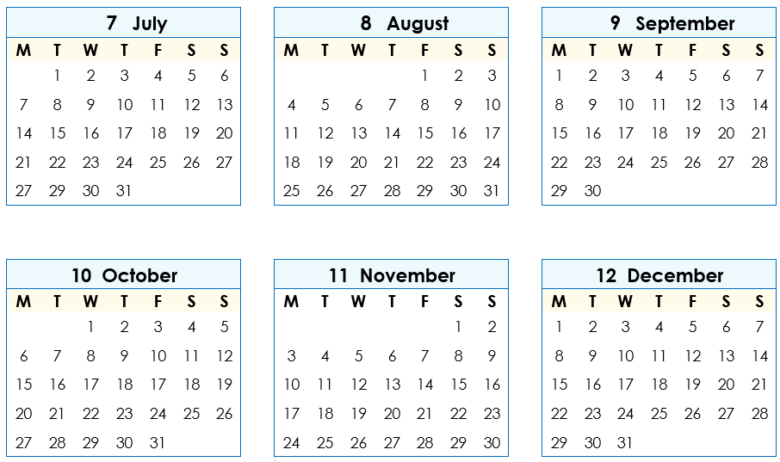



|  |  |  |
| --- | --- | --- |
| **a. Class terms** | **Start** | **End** |
| **Term 3** | ________________________ | _______________________ |
| **Term 4** | ________________________ | _______________________ |

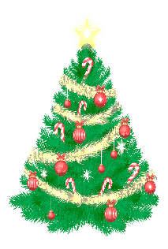**b.** Melbourne Cup Day **____________________**

**c.** Christmas Day **____________________**

**d.** Boxing day _____________________

**e. _________________________________ ____________________**

**f. _________________________________ ____________________**





Write your special dates.

|  |
| --- |
| **My special dates** |
| 1. **Birthdays** |
| ____ My birthday_____________ ________________________ |
| __________________________________ ________________________ |
| __________________________________ ________________________ |
| __________________________________ ________________________ |
|  |
| 1. **Arrival in Australia __________________________** |
|  |
| 1. **Special days** |
| __________________________________ ________________________ |
| __________________________________ ________________________ |
| __________________________________ ________________________ |
| __________________________________ ________________________ |
| __________________________________ ________________________ |