

Student book with teacher notes

|  |
| --- |
| **English Ready**  22637VIC Course in EALVU23578 - Recognise and use time in highly familiar situations |

Times and dates

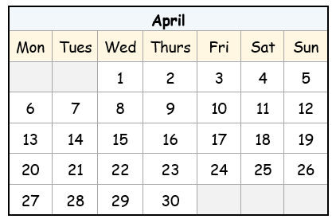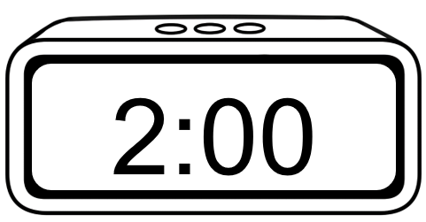

**Name** __________________________________________________________________

**Teacher** _______________________________________________________________

**Class** ___________________________________________________________________

**Date**____________________________________________________________________

*This workbook is designed to be used with the support of a teacher.*

**Design team:** Sue Paull, Vicki Hambling, Nikeh Shariatian, Bernie Miles,and Mary Wallace

**Illustrations:** Madelena Scott

**Image acknowledgements:**  
Student studying, shopping trolley, birthday banner, Christmas tree and lights - [These Photo](https://freepngimg.com/png/50184-exam-photos-png-image-high-quality)s by Unknown Author is licensed under [CC BY-NC](https://creativecommons.org/licenses/by-nc/3.0/)

**Acknowledgements:** The design team would like to acknowledge the use of the EAL Framework which underpins the design of this book.

Copyright of the EAL Framework is reserved to the Crown in the right of the State of Victoria. © State of Victoria (Department of Education and Training) 2023.  
_________________________________________________________________________________________

This English Ready Resource is licensed under a Creative Commons Attribution-NoDerivs 3.0 Australia licence (More information is available [here](http://creativecommons.org/licenses/by-nd/3.0/au/)). You are free to use, copy and distribute to anyone in its original form as long as you attribute Department of Home Affairs as the author and you license any derivative work you make available under the same licence.  
  
 © Commonwealth of Australia 2024

With the exception of the Commonwealth Coat of Arms, the department’s logo, any material protected by a trade mark and where otherwise noted all material presented in this document is provided under a Creative Commons Attribution 4.0 International (<https://creativecommons.org/licenses/by/4.0/>) licence.

The details of the relevant licence conditions are available on the Creative Commons website (accessible using the links provided) as is the full legal code for the CC BY 4.0 licence (<https://creativecommons.org/licenses/by/4.0/legalcode>).

Use of all or part of this document must include the following attribution:   
© Commonwealth of Australia 2023

As far as practicable, material for which the copyright is owned by a third party will be clearly labelled.  The department has made all reasonable efforts to ensure that this material has been reproduced in this document with the full consent of the copyright owners.

Copyright requests and enquiries concerning usage not addressed by the CC BY 4.0 licence should be addressed to:

[*comms@homeaffairs.gov.au*](mailto:comms@homeaffairs.gov.au) *at the Department of Home Affairs.*

The terms of use for the Commonwealth Coat of Arms are available from the [It's an Honour](http://www.itsanhonour.gov.au/) website.

Where a copyright owner, other than the Commonwealth, is identified with respect to this material, please contact that third party copyright owner directly to seek permission.

**Contents**

1. Instructions 4

2. Meet the students and teachers. 5

3. What day is it? 6

4. Sahra is busy this week. 10

5. What time is it? 12

6. What time do you get up? 16

7. Morning and afternoon 22

8. What month is it? 26

9. What’s the date? 30

10. Special dates 34

# Instructions

|  |
| --- |
| Project and mime each instruction. |

|  |  |  |  |  |  |
| --- | --- | --- | --- | --- | --- |
|  |  | listen |  |  | say |
|  |  | read |  |  | write |
|  |  | ask |  |  | copy |
|  |  | match |  |  | circle |
|  |  | highlight |  |  | tick |
|  |  | work with  a partner |  |  | clap |

# Meet the students and teachers.



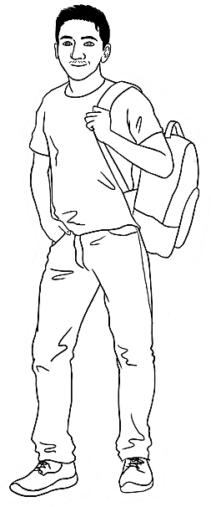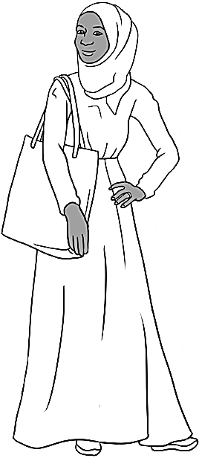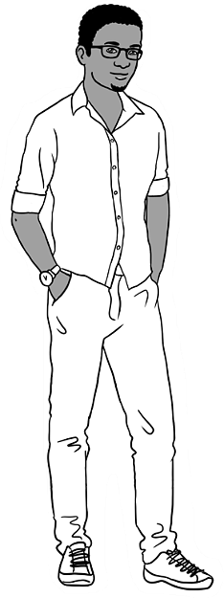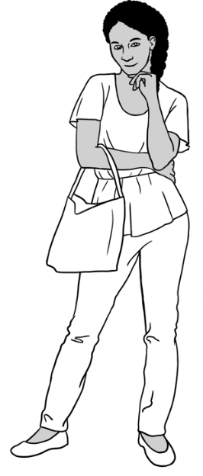

Carim Sahra Tahiil Anika Ming

**The students**

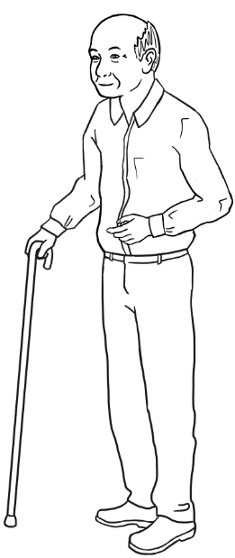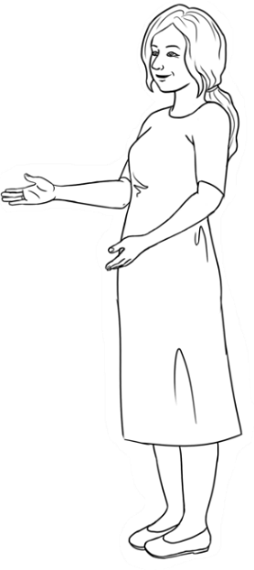

**The teachers**

Jenny Wendy

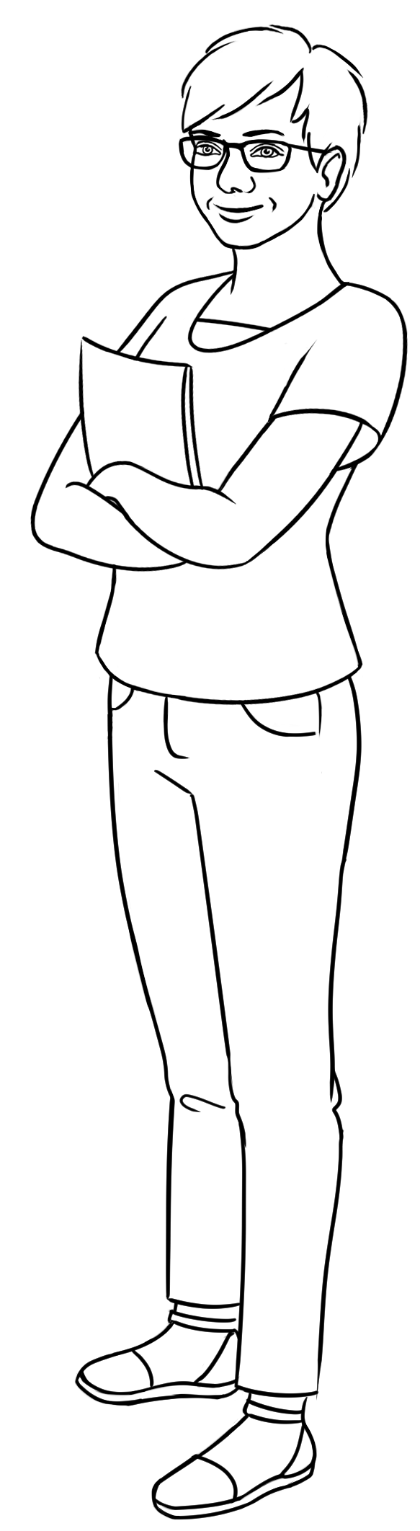

**The learning centres**

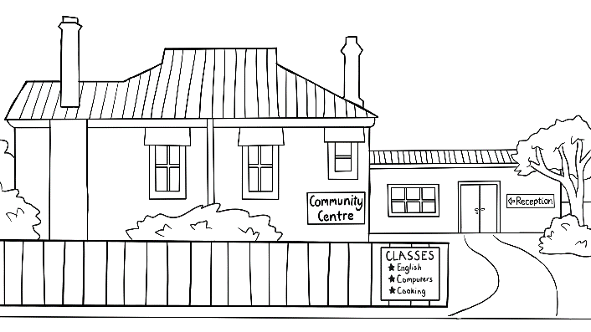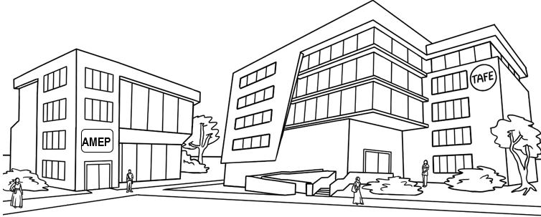

# What day is it?

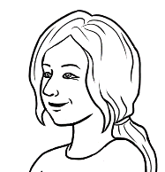

What day is it today?

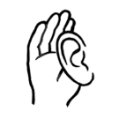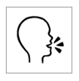

1. **2.**

|  |  |  |  |
| --- | --- | --- | --- |
|  | **1** | Monday |  |
|  | **2** | Tuesday |
|  | **3** | Wednesday |
|  | **4** | Thursday |
|  | **5** | Friday |
|  | **6** | Saturday |  |
|  | **7** | Sunday |

Listen and say the days. Students tick the current day.

**Note:** The stress  
falls on the first syllable in every day and every day has two syllables except Wednesday and Saturday. However, Wednesday when spoken has only two syllables - we say ***Wens****day.*



Copy the days.

**3.**

|  |  |  |  |  |
| --- | --- | --- | --- | --- |
| weekdays | |  | the weekend | |
| **1** | Monday |  | **6** | Saturday |
| Monday |  |
| **2** | Tuesday |  | **7** | Sunday |
|  |  |
| **3** | Wednesday |  |  |  |
|  |
| **4** | Thursday |  |  | There are 7 days  in a week. |
|  |
| **5** | Friday |  |  |  |
|  |

Write the current day, the day before and after today below.

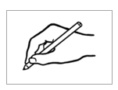

1. .

|  |  |  |
| --- | --- | --- |
| **Yesterday** | **Today** | **Tomorrow** |
| The day **before** today | ____________________ | The day **after** today |
| ____________________ | ___________________ |

Ask students to highlight a day in each row - either the day *before*   
or the day *after* the middle grey-shaded days.  
the middle



What’s the day **before** Tuesday?



**4.**

|  |  |  |  |
| --- | --- | --- | --- |
| **a.** | Monday | Tuesday | Wednesday |
| **b.** | Thursday | Friday | Saturday |
| **c.** | Sunday | Monday | Tuesday |
| **d.** | Wednesday | Thursday | Friday |
| **e.** | Saturday | Sunday | Monday |
| **f.** | Tuesday | Wednesday | Thursday |
| **g.** | Friday | Saturday | Sunday |
| **h.** | Monday | Tuesday | Wednesday |
| **i.** | Thursday | Friday | Saturday |
| **j.** | Sunday | Monday | Tuesday |



Write the missing days in the three-day sequences.

|  |  |  |  |  |  |  |
| --- | --- | --- | --- | --- | --- | --- |
| Monday |  | Tuesday |  | Wednesday |  | Thursday✓ |
|  |  |  |  |  |  |  |
| Friday |  | Saturday |  | Sunday |  |  |

|  |  |  |
| --- | --- | --- |
| 1. Tuesday | Wednesday | Thursday . |
|  |  |  |
| **b.** ___________________ | Tuesday | Wednesday |
|  |  |  |
| **c.** ___________________ | Saturday | Sunday |
|  |  |  |
| **d.** Monday | Tuesday | ___________________ |
|  |  |  |
| **e.** Thursday | Friday | ___________________ |
|  |  |  |
| **f.** ___________________ | Monday | Tuesday |
|  |  |  |
| **g.** ___________________ | Wednesday | Thursday |



Write the days in the correct order.

The days of the week are Monday , __________________________, _____________________________, _________________________, _________________________,

___________________________ and ___________________________**.**

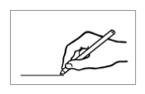

|  |  |  |
| --- | --- | --- |
| **Long** word |  | **Short word** |
| **Mon**day | Tues |
| **Tues**day | Wed |
| **Wed**nesday | Sun |
| **Thurs**day | Mon |
| **Fri**day | Sat |
| **Sat**urday | Thurs |
| **Sun**day | Fri |

**3.**

Match the long   
and short forms.

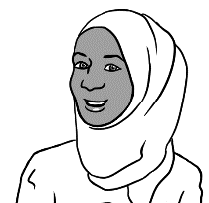

Is the market open on Monday?



**4.**

Write the short forms of the days.

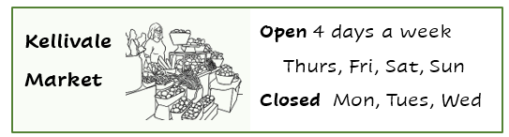

1. The market is open on ________, _________, __________ and _________.
2. The market is closed on ________, _________ and __________.

# Sahra is busy this week.



I’m busy this week.

See this section in the Teacher Resources for an activity to prepare for or to revise the work in this section.



|  |  |  |
| --- | --- | --- |
| 1. Monday |  | I go to class on Monday and Tuesday . |
| 1. Tuesday |  | My daughter Hani goes to childcare on ______________ and ________________. |
| 1. Wednesday |  | I clean and cook  on ___________________. |
| 1. Thursday |  | I go to the market  on _______________. |
| 1. Friday |  | We go to the park  on ________________. |
| 1. Saturday |  | Tahiil and I play sport  on ________________ and _________________. |
| 1. Sunday |



Students work with a partner and read aloud the sentences on the previous page about Sahra’s busy week.

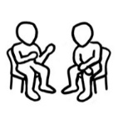



If students are confident, elicit what Sahra does on each day using the Present Simple 3rd person singular form of the verbs.   
e.g. *Sahra go****es*** *to class on Monday and Tuesday. She clean****s*** *and cook****s*** *on Wednesday.*

**Note**: The proposition ***on***before days.

Match the days and activities.

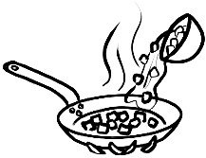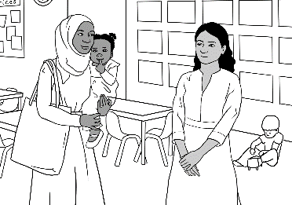

on Monday

on Tuesday

on Wednesday

on Thursday

on Friday

on Saturday

on Sunday

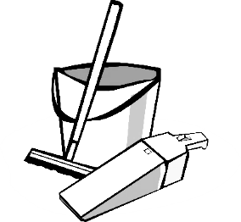

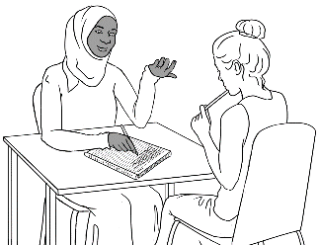

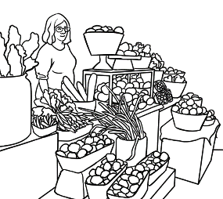

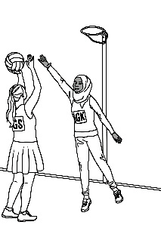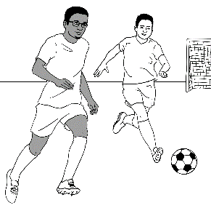

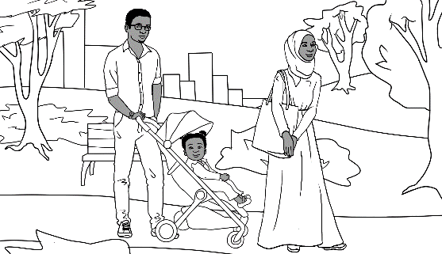

# What time is it?





What time is it?

Listen and say together. Copy the times with the colons and zeros.   
The hour is stressed.



|  |  |  |
| --- | --- | --- |
| **a.** It’s **1** o’clock. | **b.** It’s **2** o’clock. | **c.** It’s **3** o’clock. |
| 1:00 | **________** | **________** |
|  |  |  |
|  |  |  |
| **d.** It’s **4** o’clock. | **e.**  It’s **5** o’clock. | **f.**  It’s **6** o’clock. |
| **________** | **________** | **________** |
|  |  |  |
|  |  |  |
| **g.** It’s **7** o’clock. | **h.**  It’s **8** o’clock. | **i.**  It’s **9** o’clock. |
| **________** | **________** | **________** |
|  |  |  |
|  |  |  |
| **j.**  It’s **10** o’clock. | **k.**  It’s **11** o’clock. | **l.**  It’s **12** o’clock. |
| **________** | **________** | **________** |
|  |  |  |

1. **2.**

**It’s** = It is



|  |
| --- |
| 1. It’s 1 o’clock. |
| 1. It’s 2 o’clock. |
| 1. It’s 3 o’clock. |
| 1. It’s 4 o’clock. |
| 1. It’s 5 o’clock. |
| 1. It’s 6 o’clock. |
| 1. It’s 7 o’clock. |
| 1. It’s 8 o’clock. |
| 1. It’s 9 o’clock. |
| 1. It’s 10 o’clock. |
| 1. It’s 11 o’clock. |
| 1. It’s 12 o’clock. |

Match and say the times.

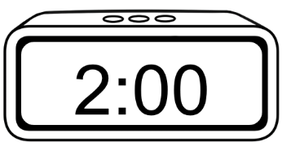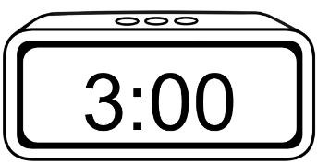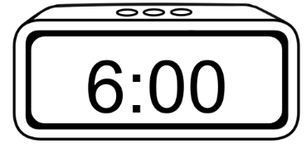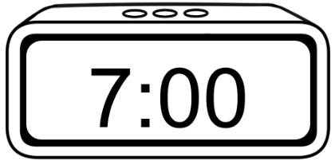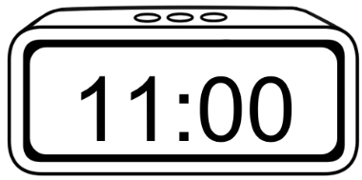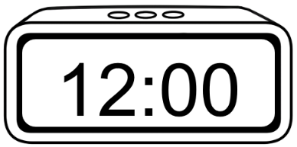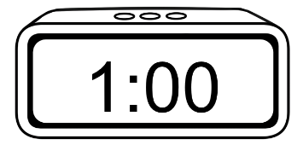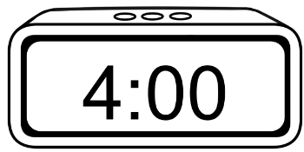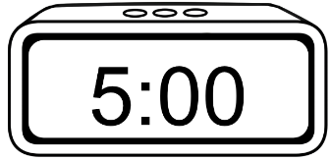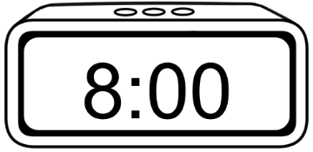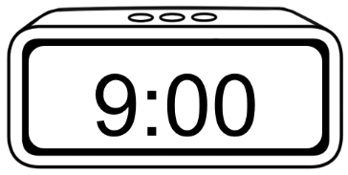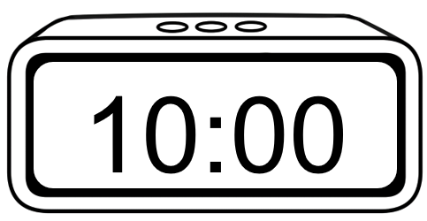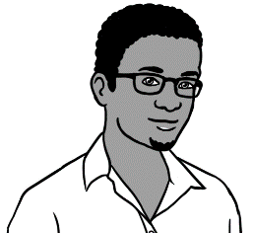

What time is it?

It’s **1** o’clock.





Read the times aloud together.  
Copy the hours without the zeros and colons.   
are omitted when writing the time with *o’clock*.

**2**.

|  |  |  |
| --- | --- | --- |
| **a.** | **b.** | **c.** |
| It’s 1:00.  It’s 1 o’clock. | It’s 2:00.  It’s ___ o’clock. | It’s 3:00.  It’s ___ o’clock. |
|  |  |  |
|  |  |  |
| **d.** | **e.** | **f.** |
| It’s 4:00.  It’s ___ o’clock. | It’s s 5:00.  It’s ___ o’clock. | It’s 6:00.  It’s __ o’clock. |
|  |  |  |
|  |  |  |
| **g.** | **h.** | **i.** |
| It’s 7:00.  It’s __ o’clock. | It’s 8:00.  It’s __ o’clock. | It’s 9:00.  It’s __ o’clock. |
|  |  |  |

|  |  |  |
| --- | --- | --- |
| **j.** | **k.** | **l.** |
| It’s 10:00.  It’s ___ o’clock. | It’s 11:00.  It’s ___ o’clock. | It’s 12:00.  It’s ___ o’clock. |

Project the table on page 14 and above, point to a time and ask students,   
*What time is it?* The whole class say the time. e.g. *It’s 1:00*. or *It’s 1 o’clock.* Students then work with a partner, and take turns to point to a time and ask, *What time is it?*  **Note.** The question can also be, *What’s the time?*

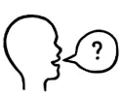

It’s 4 o’clock.



Give instructions to tick some times.  
e.g*. It’s 4 o’clock.*

|  |  |  |
| --- | --- | --- |
| **a.** | **b.**  ✓ | **c.** |
| **d.** | **e.** | **f.** |
| **g.** | **h.** | **i.** |
| **j.** | **k.** | **l.** |

# What time do you get up?



**Note** the use of the preposition ***at***when talking about the time of particular activities.



1. **2. 3.**

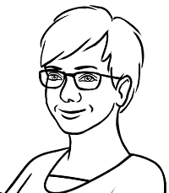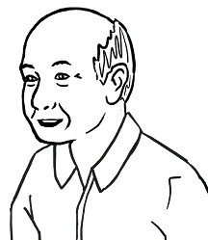

What time do you get up

on Tuesday Ming?

At 6 o’clock.

On Tuesday

|  |  |  |
| --- | --- | --- |
|  |  | I get up at 6 o’clock.  at 6 o’clock_ |
|  |  | I have breakfast  at 7 o’clock.  ____________ |
|  |  | I get to the Community Centre at 8 o’clock.  _____________ |
|  |  | I work in the community garden for an hour.  I start class at 9 o’clock.  _____________ |



Copy the times, and then students read about Ming’s family in pairs. **Note** The time can be spoken more simply without adding *o’clock.*



1. **2.**

On Tuesday

|  |
| --- |
| **Ming’s family** |
| 1. Lan is his daughter.   I have lunch at 1:00.  _________  I get up at 6:00.  at_6:00__. |
|  |
| 1. Bao is his grandson.   I play soccer at 4:00.  ________  I get up at 8:00.  ________ |
|  |
| 1. Mai is his granddaughter.   I start school at 9:00.  __________  I finish at 3:00.  __________ |
|  |
| 1. The family has dinner together.     We have dinner at 6:00.  __________ |

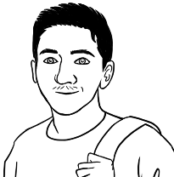

I get up at 7:00

on Monday.



1. **2.**

On Monday

|  |  |  |  |  |  |  |
| --- | --- | --- | --- | --- | --- | --- |
| **a.** |  | | **b.** | | | |
| I get up __at_7:00_. |  | | I have breakfast _____________. | | | |
|  |  | |  | | | |
| **c.** |  | | **d.**  **have a break** =stop work  for a short time | | | |
| I start class _____________. |  | | I **have a break** _____________. | | | |
|  |  | |  | | | |
| **e.** |  | | **f.** | | | |
| I have lunch _____________. |  | | I finish class _____________. | | | |
|  |  | |  | | | |
| **g.** |  | | **h.** | | | |
| I play soccer _____________. |  | | I eat dinner _____________. | | | |
|  |  | |  | | | |
| **i.** |  | | **j.** | | | |
| I study English _____________. |  | | I go to bed _____________. | |
|  | |  | |  | |

**Note** – Watch TV is not included in Carim’s activities, but added here to prepare for the exercise on the following page.



Is it true or false?

|  |  |  |
| --- | --- | --- |
| Carim’s Monday | **True** | **False** |
| 1. I get up at 6:00. |  | ✓ |
| 1. I have breakfast at 8:00. |  |  |
| 1. I start class at 9:00. |  |  |
| 1. I have a break at 10:00. |  |  |
| 1. I have lunch at 12:00. |  |  |
| 1. I finish class at 3:00. |  |  |
| 1. I play soccer at 5:00. |  |  |
| 1. **A black and white screen with numbers     Description automatically generated**I have dinner at 6:00. |  |  |
| 1. I study English at 8:00. |  |  |
| 1. I watch TV at 9:00. | ? | ? |
| 1. I go to bed at 10:00. |  |  |

Students write the current day in the speech bubble and the box. They need only write the times for activities they do on the current day as some activities may not be relevant. Use the *number, colon, double zero* format.   
Once complete, students may suggest additional activities and times.



What time do **you** get up   
on ___________________?

On ____________________

|  |  |  |  |  |  |  |
| --- | --- | --- | --- | --- | --- | --- |
| **a.** |  | | **b.** | | | |
| I get up at ________. |  | | I have breakfast at ________. | | | |
|  |  | |  | | | |
| **c.** |  | | **d.** | | | |
| I start class at ________. |  | | I have a break at ________. | | | |
|  |  | |  | | | |
| **e.** |  | | **f.** | | | |
| I have lunch at ________. |  | | I finish class at ________. | | | |
|  |  | |  | | | |
| **g.** |  | | **A black and white screen with numbers  Description automatically generatedImageh.** | | | |
| I study English at ________. |  | | I eat dinner at ________. | | | |
|  |  | |  | | | |
| **i.** |  | | **j.** | | | |
| I watch TV at ________. |  | | I go to bed at ________. | |
|  | |  | |  | |



What time do **you** get up   
on ____________________?

1. **2.**

Students write the current day in the yellow box and their partner’s name at the top of the table. Practise the questions for each statement before students work with their partner. When speaking about their partner’s activities, students need to use the 3rd person singular form. e.g. *He/she get****s*** *up at 7:00.*

On ___________________

|  |  |  |  |
| --- | --- | --- | --- |
| My partner is ___________________________ **Time** | | | |
|  | What time do you get up? |  | at _________ |
|  | What time do you have breakfast? |  | at _________ |
|  | What time do you start class? |  | at _________ |
|  | What time do you have a break? |  | at _________ |
|  | What time do you have lunch? |  | at _________ |
|  | What time do you finish class? |  | at _________ |
|  | What time do you have dinner? |  | at _________ |
|  | What time do you study English? |  | at _________ |
|  | What time do you watch TV? |  | at _________ |
|  | What time do you go to bed? |  | at _________ |

# Morning and afternoon



I start class in the morning.

I finish class in the afternoon.







|  |  |  |
| --- | --- | --- |
| morning = am |  | afternoon = pm |
|  |  |  |
|  |  |  |

Project the timeline or draw it on the board. Explain:

* the difference between *am* and *pm*
* the words *sunrise, sunset.*
* Add *midnight* and *midday* to the timeline if appropriate.
* *Night* is defined as when the sky is completely dark. This will vary depending on the time of year and location. Mark when night begins   
  for the current time of year.

Ask students to refer to page 16, and circle both when Ming gets up and when he starts class.



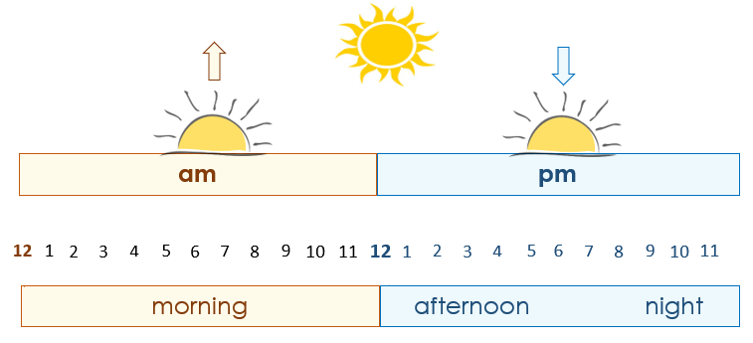



This is my class timetable.



**1.**

|  |  |  |  |  |  |
| --- | --- | --- | --- | --- | --- |
| **Day** | **Monday** | **Tuesday** | **Wednesday** | **Thursday** | **Friday** |
| **Start** |  | 9:00 am  **🗸** | 9:00 am  **🗸** |  | 10:00 am  **🗸** |
| **Finish** |  | 12:00 pm | 12:00 pm |  | 1:00 pm |
| **Room** |  | 4 | 4 |  | 3 |





**2. 3.**



I start class at 9:00 am on Tuesday and Wednesday.

I finish class at __________ .

I start class at __________ on Friday.

I finish class at __________ .



**4.**

afternoon

morning

Ming starts class in the ________________________.

Note the Present Simple,   
3rd person singular verbs   
– start**s**, finish**es**

He finishes class in the ________________________.



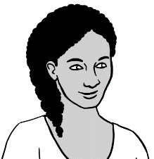

This is my class timetable.

**5.**

|  |  |  |  |  |  |
| --- | --- | --- | --- | --- | --- |
| **Day** | **Monday** | **Tuesday** | **Wednesday** | **Thursday** | **Friday** |
| **Start** | 9:00 am  **🗸** | 9:00 am  **🗸** | 12:00 pm  **🗸** | 12:00 pm  **🗸** |  |
| **Finish** | 1:00 pm | 1:00 pm | 3:00 pm | 3:00 pm |  |
| **Room** | 6 | 4 | 4 | 7 |  |





**6. 7.**



I start class at ___________ on Monday and Tuesday.

I finish class at ___________ .

I start class at __________ on Wednesday and Thursday.

I finish class at __________ .

|  |  |  |  |  |  |
| --- | --- | --- | --- | --- | --- |
| **Day** | **Monday** | **Tuesday** | **Wednesday** | **Thursday** | **Friday** |
| **Start** |  |  |  |  |  |
| **Finish** |  |  |  |  |  |
| **Room** |  |  |  |  |  |

Students need to tick the days they attend class and write their start, finish times and room numbers.

**My** class timetable

**8.**



What time does

the supermarket   
open **today**?

Ask the students about opening and closing hours on other days.



|  |  |
| --- | --- |
| **Supermarket   Opening Hours** | |
| **Mon** - **Fri** | 7 am – 9 pm |
| **Sat** | 8 am – 9 pm |
| **Sun** | 8 am – 8 pm |

1. Today is ________________.
2. The supermarket opens

at ___________ today.

1. It closes at ____________.

Ask students to circle *yes* or *no* to Anika’s question. Then ask them to circle the opening and closing times on different days.



**2.**

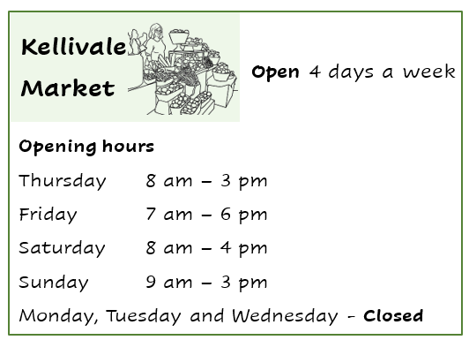

Is the market   
open **today**?



*Yes / No*



1. The market opens at ___________ on Thursday.
2. It closes at ___________ on Thursday.
3. The market opens at ___________ on Friday.
4. It closes at ___________ on Friday.
5. The market opens at ___________ on Saturday.
6. It closes at ___________ on Saturday.

# What month is it?

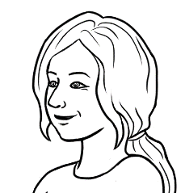

Circle the number   
for April.



1. **2.**

Students listen and repeat the months together. You then read aloud the months at random; students circle the number.

|  |  |  |  |  |
| --- | --- | --- | --- | --- |
| **Long words** | | |  | **Short words** |
| 1 |  | January |  | Jan |
| 2 |  | February |  | Feb |
| 3 |  | March |  | Mar |
| 4 |  | April |  | Apr |
| 5 |  | May |  | May |
| 6 |  | June |  | Jun |
| 7 |  | July |  | Jul |
| 8 |  | August |  | Aug |
| 9 |  | September |  | Sep |
| 10 |  | October |  | Oct |
| 11 |  | November |  | Nov |
| 12 |  | December |  | Dec |

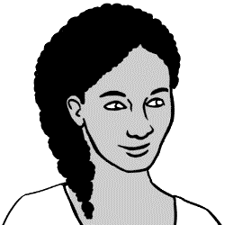

____ months

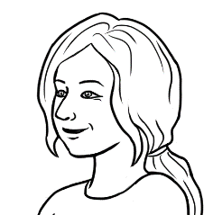

How many months   
are in a year?



**3.**

Listen, say and clap the stressed syllables longer and stronger.

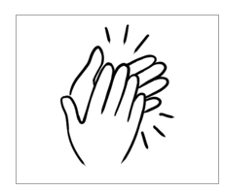





|  |  |  |  |
| --- | --- | --- | --- |
|  |  | |  |
| March  May  June | April  August | | July |
|  |  | |  |
|  | |  | |
| January  February | | September  October  November  December | |

Listen, say and clap the months in order. The stressed syllables are in bold.



|  |  |  |
| --- | --- | --- |
| **Jan**uary |  | **Feb**ruary |
| **March** |  | **Ap**ril |
| **May** |  | **June** |
| Ju**ly** |  | **Au**gust |
| Sep**tem**ber |  | Oc**to**ber |
| No**vem**ber |  | De**cem**ber |



Students copy the months and write the number of each month in the boxes.

**1. 2.**

|  |  |  |
| --- | --- | --- |
| January  1 |  | February |
| __January____ |  | _______________ |
|  |  |  |
| March |  | April |
| _______________ |  | _______________ |
|  |  |  |
| May |  | June |
| _______________ |  | _______________ |
|  |  |  |
| July |  | August |
| _______________ |  | _______________ |
|  |  |  |
| September |  | October |
| _________________ |  | ________________ |
|  |  |  |
| November |  | December |
| _________________ |  | __________________ |



**3.**

Students read the months aloud with a partner.



Circle July.

Give instructions to circle different months. As you do, ask questions about the order of the months. e.g. *What’s the month before/after July?*



|  |  |  |
| --- | --- | --- |
| January | February | March |
| April | May | June |
| July | August | September |
| October | November | December |
| Write the missing months. | | |
| January | ___________________ | March |
| _________________ | May | _________________ |
| July | _________________ | September |
| _________________ | November | _________________ |
|  | Write the missing months. |  |
| _________________ | February | _________________ |
| April | _________________ | June |
| _________________ | August | _________________ |
| October | _________________ | December |

# What’s the date?

This unit requires students to read and write the date only, so teaching the ordinals is unnecessary. However, it’s practical for students to be able to **say**   
a number of dates. e.g. the day’s date, birthdate, dateof arrival in Australia. This would require teaching the ordinals. See this section in the Teacher Resources.







**Say**:   
*the* **24***th*

*of* **June**

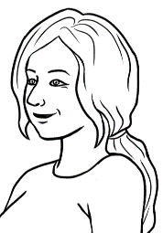

What’s the date today?



24 June

|  |  |  |  |  |  |  |
| --- | --- | --- | --- | --- | --- | --- |
| **June 2025** | | | | | | |
| **Mon** | **Tues** | **Wed** | **Thurs** | **Fri** | **Sat** | **Sun** |
| 1 | 2 | 3 | 4 | 5 | 6 | 7 |
| 8 | 9 | 10 | 11 | 12 | 13 | 14 |
| 15 | 16 | 17 | 18 | 19 | 20 | 21 |
| 22 | 23 | **24** | 25 | 26 | 27 | 28 |
| 29 | 30 |  |  |  |  |  |

|  |  |  |  |
| --- | --- | --- | --- |
|  | **Day** | **Month** | **Year** |
| 1. The date today | 24 | June | 2025 |
| 1. The date today in numbers | 24 | 06 | 2025 |
| Explain that a zero is added before months and days with a single digit, when writing the date in numbers. | 24 / 06 / 2025 | | |

Check, copy and say the dates on everyday items.   
e.g. ATM and Medicare cards, driver licences, use-by dates on food.

|  |  |  |  |  |  |  |
| --- | --- | --- | --- | --- | --- | --- |
| February |  | 01 |  | 07 |  | September |
| April |  | 02 |  | 08 |  | October |
| January |  | 03 |  | 09 |  | July |
| June |  | 04 |  | 10 |  | December |
| March |  | 05 |  | 11 |  | August |
| May |  | 06 |  | 12 |  | November |

1. 





Happy birthday

Hani.

It’s my daughter’s birthday

today. Her name is Hani.

|  |  |  |  |  |  |  |
| --- | --- | --- | --- | --- | --- | --- |
| **June 2025** | | | | | | |
| **Mon** | **Tues** | **Wed** | **Thurs** | **Fri** | **Sat** | **Sun** |
| 1 | 2 | 3 | 4 | 5 | 6 | 7 |
| 8 | 9 | 10 | 11 | 12 | 13 | 14 |
| 15 | 16 | 17 | 18 | 19 | 20 | 21 |
| 22 | 23 | **24** | 25 | 26 | 27 | 28 |
| 29 | 30  Birthdays |  |  |  |  |  |

Students need only copy the digital date format. Remind students that zeros must be added before months and days with a single digit.



|  |  |  |  |
| --- | --- | --- | --- |
| **a.** | Hani’s birthday | 24 June 2021 | 24 / 06 / 2021  24 / 06 / 2021 . |
|  |  |  |  |
| **b.** | Tahiil’s birthday | 27 June 1994 | 27 / 06 / 1994  __________________ |
|  |  |  |  |
| **c.** | Sahra’s birthday | 7 July 1996 | 07 / 07 / 1996  __________________ |



Match the dates.

|  |  |  |  |
| --- | --- | --- | --- |
| **a.** | 24 June 2021 |  | 07 / 07 / 1996 |
|  |  |  |  |
| **b.** | 27 June 1994 |  | 24 / 06 / 2021 |
|  |  |  |  |
| **c.** | 7 July 1996 |  | 27 / 06 / 1994 |



Copy the digital dates before and after the birthdays.



|  |  |  |  |
| --- | --- | --- | --- |
|  | **The date before** | **Birthdays** | **The date after** |
| **a.** | 23 June 2021  23 / 06 / 2021  _________________ | **Hani’s birthday**  24 June 2021  24 / 06 / 2021 | 25 June 2021  25 / 06 / 2021  _________________ |
|  |  |  |  |
| **b.** | 26 June 1994  26 / 06 / 1994  __________________ | **Tahiil’s birthday**  27 June 1994  27 / 06 / 1994 | 28 June 1994  28 / 06 / 1994  __________________ |
|  |  |  |  |
| **c.** | 6 July 1996  06 / 07 / 1996  __________________ | **Sahra’s birthday**  7 July 1996  07 / 07 / 1996 | 8 July 1996  08 / 07 / 1996  __________________ |



Project the grid. Add the current month’s details for the students to copy on the empty grid below. Include the month, year and dates.

|  |  |  |  |  |  |  |
| --- | --- | --- | --- | --- | --- | --- |
| **________________________ ____________** | | | | | | |
| **Mon** | **Tues** | **Wed** | **Thurs** | **Fri** | **Sat** | **Sun** |
|  |  |  |  |  |  |  |
|  |  |  |  |  |  |  |
|  |  |  |  |  |  |  |
|  |  |  |  |  |  |  |
|  |  |  |  |  |  |  |



Circle todays’ date.

As well as circling the current day’s date on the grid above, ask students to circle other dates.   
e.g the day after today/ tomorrow, the day before today/ yesterday, next Saturday, next Monday, special days





On the board, write in digital format all or some of the dates students have circled. Students copy the dates on the lines below, adding the names of other days circled.

Students copy them below.



|  |  |
| --- | --- |
| **a.** | Today ____________________ |
| **b.** | Tomorrow ____________________ |
| **c.** | Yesterday ____________________ |
| **d.** | Next Saturday ____________________ |
| **e.** | _________________________ ____________________ |
| **f.** | _________________________ ____________________ |
| **g.** | _________________________ ____________________ |

Dates

# Special dates

This is the 2025 calendar. See the Teacher Resources for a blank template to complete for the current year.





The start of   
the holidays.



What’s a special date  
for you Carim?

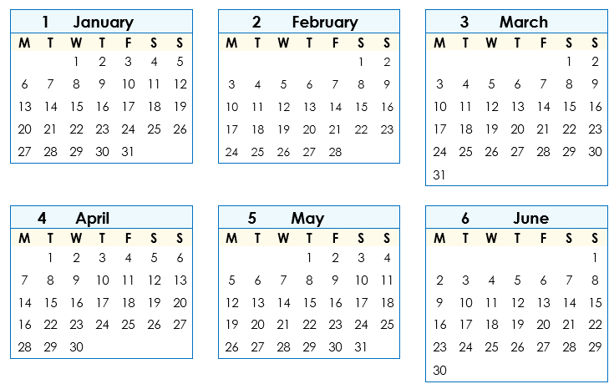

Circle the class terms 1 & 2   
start and end dates on the calendar. These are the 2025 NSW dates.



Copy the digital dates. Ask, *When do the April holidays start?* *When do the holidays end?*

1. **3.**

|  |  |  |
| --- | --- | --- |
| **Class terms** | **Start** | **End** |
| **Term 1** | 3 February 2025  03 / 02 / 2025  03 / 02 / 2025 . | 11 April 2025  11 / 04 / 2025  _______________ |
| **Term 2** | 28 April 2025  28 / 04 / 2025  ________________ | 4 July 2025  05 / 07 / 2025  ______________ |



Talk about and circle special dates such as public holidays, excursions, local events, celebrations etc



This is your **January** to **June** calendar. Circle some   
special dates.





Write the start and end dates for each term on the board in digital form for students to copy. Circle the dates on the calendar.

|  |  |  |
| --- | --- | --- |
| **a. Class terms** | **Start** | **End** |
| **Term 1** | ________________________ | _______________________ |
| **Term 2** | ________________________ | _______________________ |



**b.** New Year’s Day **____________________**

On the board, write the dates of public holidays, excursions, local events and celebrations such as Easter, Chinese New Year, Ramadan. Students copy the events and dates.

**c.** ANZAC Day ____________________

**d. _________________________________ ____________________**

**e. _________________________________ ____________________**

**f. _________________________________ ____________________**





This is your **July** to **December** calendar. Circle some special dates.

Talk about and circle special   
dates.

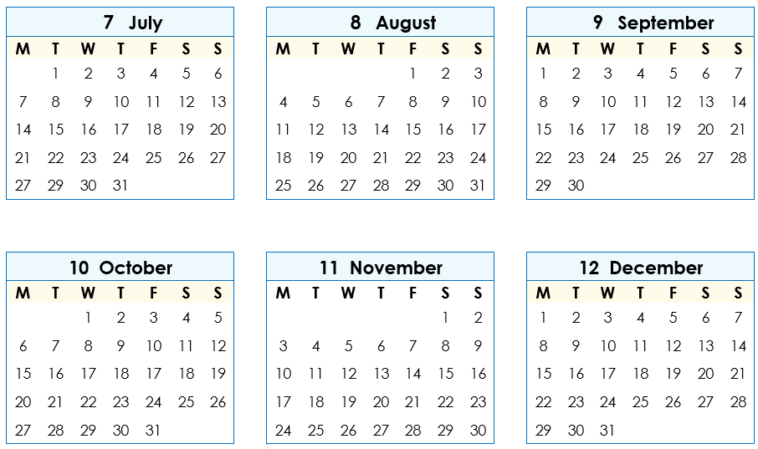



Write the start and end dates for each term on the board in digital form for students to copy. Circle the dates on the calendar..

|  |  |  |
| --- | --- | --- |
| **a. Class terms** | **Start** | **End** |
| **Term 3** | ________________________ | _______________________ |
| **Term 4** | ________________________ | _______________________ |

On the board, write the dates of public holidays, excursions, local events and celebrations.. Students copy the events and dates.

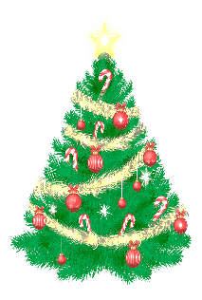**b.** Melbourne Cup Day **____________________**

**c.** Christmas Day **____________________**

**d.** Boxing day _____________________

**e. _________________________________ ____________________**

**f. _________________________________ ____________________**





Write your

special dates.

Students will need support completing   
this page and their work checked on completion. The dates of some special days can be copied from previous pages.

|  |
| --- |
| **My special dates** |
| 1. **Birthdays**   Students write the birthdates of children, other family and/or friends. |
| ____ My birthday_____________ ________________________ |
| __________________________________ ________________________ |
| __________________________________ ________________________ |
| __________________________________ ________________________ |
|  |
| 1. **Arrival in Australia __________________________** |
|  |
| 1. **Special days** |
| __________________________________ ________________________ |
| __________________________________ ________________________ |
| __________________________________ ________________________ |
| __________________________________ ________________________ |
| __________________________________ ________________________ |