Student book with teacher notes

**English Ready**

22636VIC Course in Initial EAL  
VU23491 Recognise and copy extremely familiar words

Words

**Name** _______________________________________________

**Teacher**____________________________________________   
**Class**________________________________________________

**Date**________________________________________________

This book is supported by additional writing exercises

in the **Writing** book.

*This workbook is designed to be used with the support of a teacher.*

**Design team:** Vicki Hambling, Sue Paull, Frida Dean, Glenise Kleehammer and Mary Wallace

**Illustrations:** Madelena Scott  
**Image Acknowledgements:**

Peg [This Photo](https://commons.wikimedia.org/wiki/File:Clothespin-2459e.jpg) by Unknown Author is licensed under [CC BY-SA](https://creativecommons.org/licenses/by-sa/3.0/)  
Pig - [This Photo](https://www.biologycorner.com/worksheets/fetal_pig_dissection.html) by Unknown Author is licensed under [CC BY-SA-NC](https://creativecommons.org/licenses/by-nc-sa/3.0/)  
Tag [This Photo](https://freepngimg.com/png/25048-blank-tag-transparent-background) by Unknown Author is licensed under [CC BY-NC](https://creativecommons.org/licenses/by-nc/3.0/)

**Acknowledgements:** The design team would like to thank the AMEP service providers and practitioners who participated in the trial and gave valuable feedback. The team would also like to acknowledge the use of the EAL Framework which underpins the design of this book.

opyright of the EAL Framework is reserved to the Crown in the right of the State of Victoria. © State of Victoria (Department of Education and Training) 2023.  
__________________________________________________________________________________

This English Ready Resource is licensed under a Creative Commons Attribution-NoDerivs 3.0 Australia licence (More information is available [here](http://creativecommons.org/licenses/by-nd/3.0/au/)). You are free to use, copy and distribute to anyone in its original form as long as you attribute Department of Home Affairs as the author and you license any derivative work you make available under the same licence.

© Commonwealth of Australia 2023



With the exception of the Commonwealth Coat of Arms, the department’s logo, any material protected by a trade mark and where otherwise noted all material presented in this document is provided under a Creative Commons Attribution 4.0 International (<https://creativecommons.org/licenses/by/4.0/>) licence.

The details of the relevant licence conditions are available on the Creative Commons website (accessible using the links provided) as is the full legal code for the CC BY 4.0 licence. (<https://creativecommons.org/licenses/by/4.0/legalcode>).

Use of all or part of this document must include the following attribution:   
© Commonwealth of Australia 2023

As far as practicable, material for which the copyright is owned by a third party will be clearly labelled.  The department has made all reasonable efforts to ensure that this material has been reproduced in this document with the full consent of the copyright owners.

Copyright requests and enquiries concerning usage not addressed by the CC BY 4.0 licence should be addressed to: [*comms@homeaffairs.gov.au*](mailto:comms@homeaffairs.gov.au) *at the Department of Home Affairs.*

The terms of use for the Commonwealth Coat of Arms are available from the [It's an Honour](http://www.itsanhonour.gov.au/) website.

Where a copyright owner, other than the Commonwealth, is identified with respect to this material, please contact that third party copyright owner directly to seek permission.



**Table of contents**

1 Instructions 1

2 The alphabet letters 2

3 Match the letters 4

4 Trace and copy. 7

5 Short vowel words 13

6 Consonant blends 21

7 Two consonants make one sound. 31

8 Numbers 40

9 Name 42

10 Address 44

11 Today is Monday. 46

# Instructions

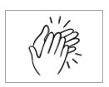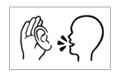  
The arrow is a reminder to read from left to right.

|  |  |
| --- | --- |
| 1.  🗸  listen | 2.  say |
| 3.  copy | 4.  match |
| 5.  colour | 6.  circle |
| 7.  trace | 8.  tick |
| 9.  point | 10.  clap |

# The alphabet letters

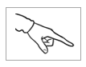

1. Capital Letters

A B C D E F

G H I J K L

M N O P Q R

S T U V W X

Y Z

1. Small letters

a b c d e f

g h i j k l

m n o p q r

s t u v w x

y z



****1.

**A B C D E F**

**G H I J K L**

**M N O P Q R**

**S T U V W X**

**Y Z**



2.

**a b c d e f**

**g h i j k l**

**m n o p q r**

**s t u v w x**

**y z**

# Match the letters







Aa Bb Cc Dd Ee Ff

Gg Hh Ii Jj Kk Ll

Mm Nn Oo Pp Qq Rr

Ss Tt Uu Vv Ww Xx

Yy Zz

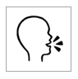

|  |  |  |  |  |
| --- | --- | --- | --- | --- |
| A |  | b | a | c |
| B |  | d | a | b |
| C |  | e | c | f |
| D |  | d | a | g |



|  |  |  |  |  |
| --- | --- | --- | --- | --- |
| H |  | e | g | h |
| I |  | a | i | l |
| J |  | h | b | j |
| K |  | k | c | h |

|  |  |  |  |  |
| --- | --- | --- | --- | --- |
| E |  | f | c | e |
| F |  | e | f | h |
| G |  | g | p | f |

|  |  |  |  |  |
| --- | --- | --- | --- | --- |
| L |  | i | k | l |
| M |  | j | a | m |
| N |  | n | m | h |
| O |  | k | o | p |
| P |  | p | l | n |

1. 

|  |  |  |  |  |
| --- | --- | --- | --- | --- |
| Q |  | o | p | q |
| R |  | b | r | s |
| S |  | s | t | u |

|  |  |  |  |  |
| --- | --- | --- | --- | --- |
| T |  | r | f | t |
| U |  | o | u | i |
| V |  | w | t | v |

|  |  |  |  |  |
| --- | --- | --- | --- | --- |
| W |  | x | w | y |
| X |  | v | z | x |

|  |  |  |  |  |
| --- | --- | --- | --- | --- |
| Y |  | y | w | m |
| Z |  | v | z | x |

# Trace and copy.

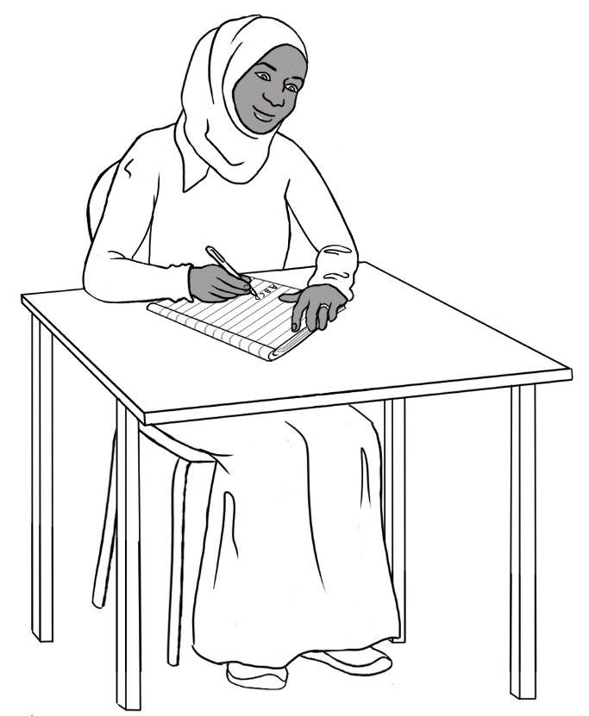

Explain the correct writing posture, pencil grip and letter formation. The colour of the arrows is a guide:   
green = 1st stroke, orange = 2nd stroke, purple = 3rd stroke.

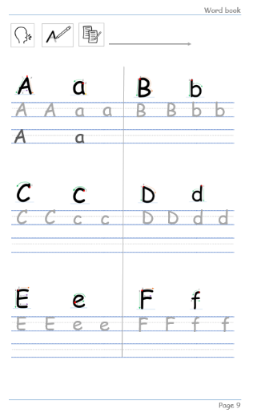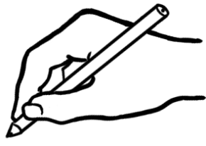

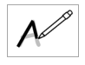

|  |  |
| --- | --- |
|  |  |
|  |  |



A

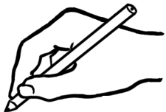

A

a

A

A

a

a



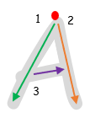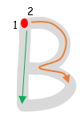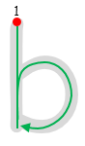

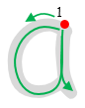

B

b

b

B

a

A

a

A

A

a

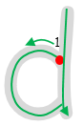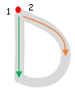

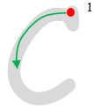

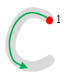

D

D

d

d

c

c

C

C

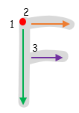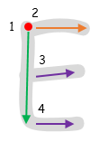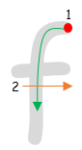

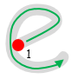

F

E

f

f

F

e

e

E

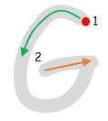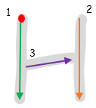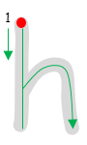

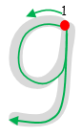

g

g

h

H

h

H

G

G

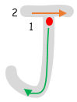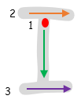

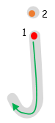

I

j

j

J

J

I

i

i

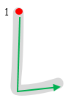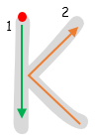

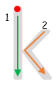

L

l

l

L

k

k

K

K

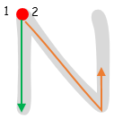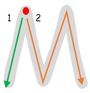

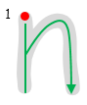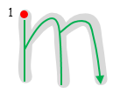

m

n

n

N

N

m

M

M

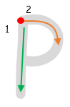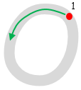

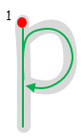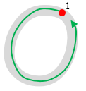

o

P

pk

pk

P

o

O

O

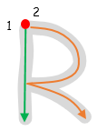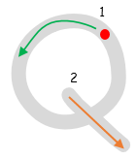

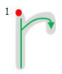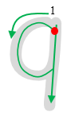

r

r

R

R

q

q

Q

Q

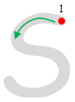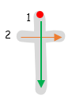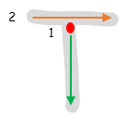



t

t

T

T

s

s

S

S

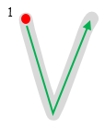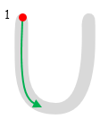

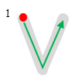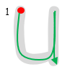

V

V

v

v

u

u

U

U

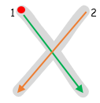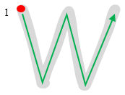

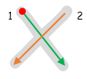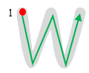

x

x

X

X

w

w

W

W

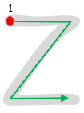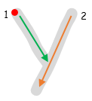

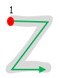

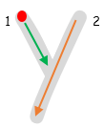

Y

z

z

Z

Z

y

y

Y



More practise in number formation in the writing book.

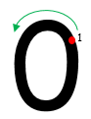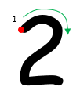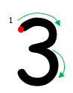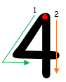

0

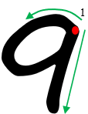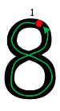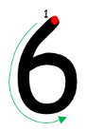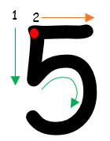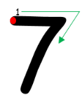

 Vowels are in gold boxes, the consonants blue.

a

_

g_

b_

c_

d_

e

_

f_

_

a_

_

_

_

_

_

n_

m_

l_

k_

j_

i

_

h_

_

_

_

_

_

_

_

u

_

p_

o

_

t_

s_

r_

q_

_

_

_

_

_

_

_

z_

y_

x_

w_

v_

_

_

_

_

_

# Short vowel words

Explain that the short vowel sound can come  
 at the beginning or in the middle of a word.



|  |  |  |
| --- | --- | --- |
| a |  | apple |
| e |  | egg |
| i |  | ink |
| o |  | orange |
| u |  | umbrella |



|  |  |  |  |  |
| --- | --- | --- | --- | --- |
| a | e | i | o | u |
| a |  |  |  |  |



a

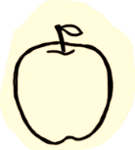

1. hat cat

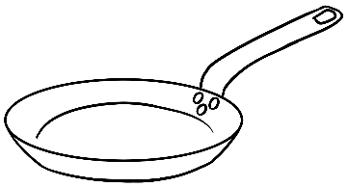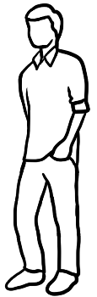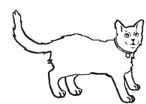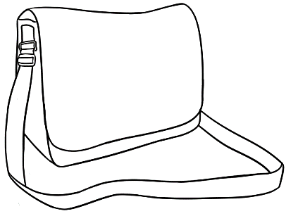

hat __________

1. man pan

__________ __________

3. bag tag

__________ __________



e

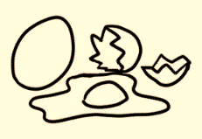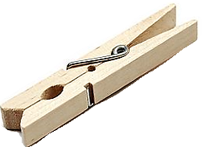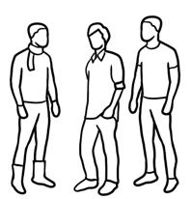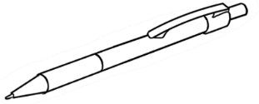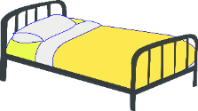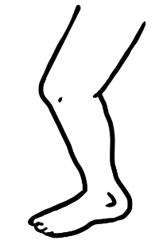

1. bed red  
   bed __________
2. pen men

__________ __________

1. peg leg

__________ __________

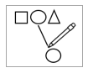

|  |  |  |
| --- | --- | --- |
|  | hat |  |
|  | pan |  |
|  | man |  |
|  | men |  |
|  | pen |  |
|  | leg |  |
|  | bed |  |



i

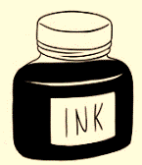

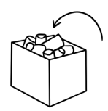

1. in bin

in __________

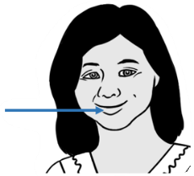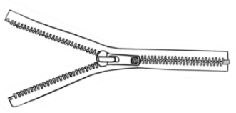

1. lip zip  
   __________ __________

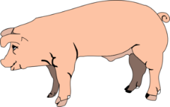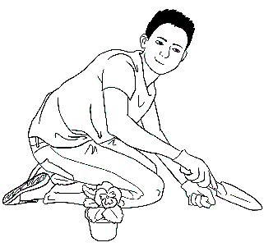

1. pig dig  
   __________ __________

****Colour the stop sign red.

o

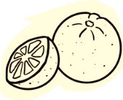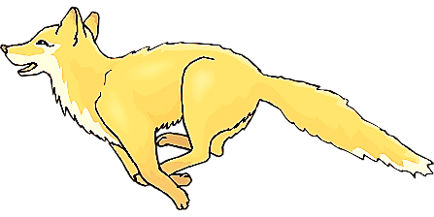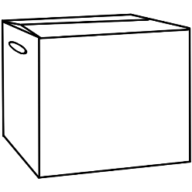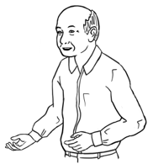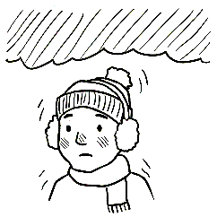

1. old cold

old __________

2. mop stop

__________ __________

3. box fox

__________ __________



u

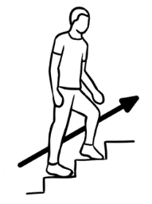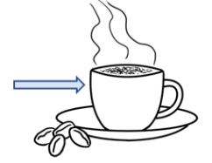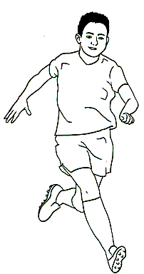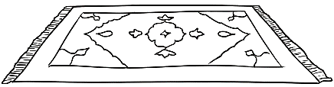

1. up cup

up __________

1. run sun

__________ __________

1. mug rug

__________ __________



|  |  |  |
| --- | --- | --- |
|  | bin |  |
|  | zip |  |
|  | pig |  |
|  | mop |  |
|  | box |  |
|  | sun |  |
|  | mug |  |

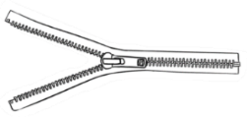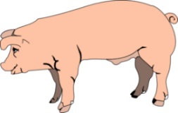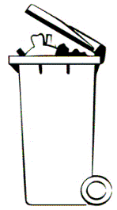

# Consonant blends







Say the consonants separately.   
Then blend, colour and copy them.

**br**

**b r**

|  |  |  |  |  |
| --- | --- | --- | --- | --- |
| br | br | br | br | br |
| br |  |  |  |  |



|  |  |  |
| --- | --- | --- |
| br |  |  |
| bread  __ __ ead  __ __ ead  __ __ ead | brush  __ __ ush  __ __ ush  __ __ ush |



1. 

**tr**

**t r**

|  |  |  |  |  |
| --- | --- | --- | --- | --- |
| tr | tr | tr | tr | tr |
| tr |  |  |  |  |



|  |  |  |
| --- | --- | --- |
| tr |  |  |
| train  __ __ ain  __ __ ain  __ __ ain | tree  __ __ ee  __ __ ee  __ __ ee |



|  |
| --- |
| A picture containing linedrawing  Description automatically generatedtree |
| brush |
| train |
| A close-up of a book  Description automatically generated with medium confidencebread |

br

tr

Pages 23, 26 & 29 - Say a word stressing the blend.   
Students tick the blend.

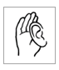

**🗸**

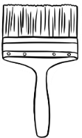

bread brush train tree

Say the consonants separately.   
Then blend, colour and copy them.



**fr**

**f r**

|  |  |  |  |  |
| --- | --- | --- | --- | --- |
| fr | fr | fr | fr | fr |
| fr |  |  |  |  |



|  |  |  |
| --- | --- | --- |
| fr |  |  |
| fruit  __ __ uit  __ __ uit  __ __ uit | friend  __ __ iend  __ __ iend  __ __ iend |



1. Colour all stop signs red.

**st**

**s t**

|  |  |  |  |  |
| --- | --- | --- | --- | --- |
| st | st | st | st | st |
| st |  |  |  |  |



|  |  |  |
| --- | --- | --- |
| st |  |  |
| stop  __ __ op  __ __ op  __ __ op | stand  __ __ and  __ __ and  __ __ and |



|  |
| --- |
| A picture containing text  Description automatically generatedfruit |
| Shape, rectangle  Description automatically generatedstop |
| friend |
| A picture containing linedrawing  Description automatically generatedstand |

fr

st



**🗸**

1. A picture containing linedrawing

   Description automatically generated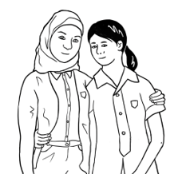

**fr**uit **fr**iend **st**op **st**and

Say the consonants separately.   
Then blend, colour and copy them.  
Colour the shapes black or blue.  
Identify objects that are black or blue.



**bl**

**b l**



|  |  |  |  |  |
| --- | --- | --- | --- | --- |
| bl | bl | bl | bl | bl |
| bl |  |  |  |  |



|  |  |  |
| --- | --- | --- |
| bl |  |  |
| black  __ __ ack  __ __ ack  __ __ ack | blue  __ __ ue  __ __ ue  __ __ ue |



1. 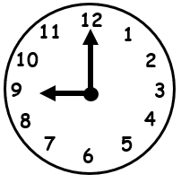

**cl**

**c l**

|  |  |  |  |  |
| --- | --- | --- | --- | --- |
| cl | cl | cl | cl | cl |
| cl |  |  |  |  |



|  |  |  |
| --- | --- | --- |
| cl |  |  |
| clock  __ __ ock  __ __ ock  __ __ ock | clap  __ __ ap  __ __ ap  __ __ ap |



|  |
| --- |
| blue |
| clap |
| clock |
| black |

bl

cl



**🗸**



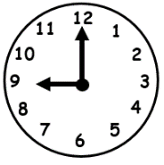



**bl**ack **bl**ue **cl**ock **cl**ap

******Listening exercise - Say the blended sound in the box and then the two words. Students circle the word with the blended sound. The first word is *brush*.

|  |  |  |
| --- | --- | --- |
| br | A picture containing text, appliance  Description automatically generatedbrush | A picture containing linedrawing  Description automatically generatedtree |
| tr | A picture containing linedrawing  Description automatically generatedfriend | train |
| fr | blue | A picture containing clipart  Description automatically generatedfruit |
| st | stand | clock |
| bl | Shape, rectangle  Description automatically generatedstop | black |
| cl | clap | A close-up of a book  Description automatically generated with medium confidencebread |

# Two consonants make one sound.



**ch**

**ch**

**ch**

|  |  |  |  |  |
| --- | --- | --- | --- | --- |
| ch | ch | ch | ch | ch |
| ch |  |  |  |  |



|  |  |  |
| --- | --- | --- |
| ch |  |  |
| chips  __ __ ips  __ __ ips  __ __ ips | chicken  __ __ icken  __ __ icken  __ __ icken |

1. A picture containing clipart

   Description automatically generated



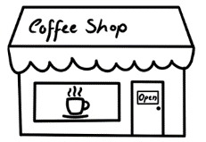

**sh**

**sh**

**sh**

|  |  |  |  |  |
| --- | --- | --- | --- | --- |
| sh | sh | sh | sh | sh |
| sh |  |  |  |  |



|  |  |  |
| --- | --- | --- |
| sh |  |  |
| shop  __ __ op  __ __ op  __ __ op | shoe  __ __ oe  __ __ oe __ __ oe |



|  |
| --- |
| shoe |
| A picture containing clipart  Description automatically generatedchips |
| shop |
| chicken |

ch

sh

Say a word stressing the bolded sound.   
Students tick the sound.



**🗸**

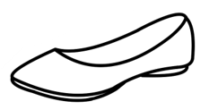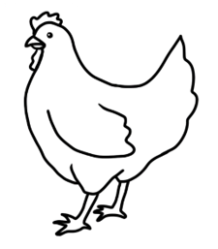

**ch**ips **ch**icken **sh**op **sh**oe



1. 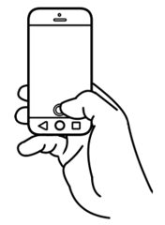

**ph**

**ph**

**ph**

|  |  |  |  |  |
| --- | --- | --- | --- | --- |
| ph | ph | ph | ph | ph |
| ph |  |  |  |  |



|  |  |  |
| --- | --- | --- |
| ph |  |  |
| phone  __ __ one  __ __ one  __ __ one | photo  __ __ oto  __ __ oto __ __ oto |

See the Teacher Resources for notes about   
the pronunciation of the voiced and unvoiced *th*.   
The *th* in *thirty* and *Thursday* is unvoiced*.* Additional words are *thirteen, thirty* and *thanks*.







3

**th**

**th**

**th**

|  |  |  |  |  |
| --- | --- | --- | --- | --- |
| th | th | th | th | th |
| th |  |  |  |  |



|  |  |  |
| --- | --- | --- |
| th | 3 |  |
| three  __ __ ree  __ __ ree  __ __ ree | Thursday  __ __ ursday __ __ ursday __ __ ursday |



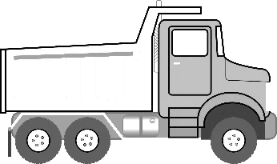

**ck**

**ck**

**ck**

|  |  |  |  |  |
| --- | --- | --- | --- | --- |
| ck | ck | ck | ck | ck |
| ck |  |  |  |  |



|  |  |  |
| --- | --- | --- |
| ck |  |  |
| truck  tru__ __  tru__ __  tru__ __ | clock  clo__ __   clo __ __   clo __ __ |

Say the double-letter sound and the two words.   
Students circle the word with the double-letter sound.****

|  |  |  |  |
| --- | --- | --- | --- |
| ch  sh  ph  th  ck | chicken | | Diagram  Description automatically generatedshop |
|  | shoe | phone | |
|  | photo | clock | |
|  | A picture containing clipart  Description automatically generatedchips | Thursday | |
|  | truck | three  3 | |

|  |  |  |  |
| --- | --- | --- | --- |
| ch  sh  ph  th  ck |  | chips |  |
| chicken |  |
|  | shop |  |
| shoe |  |
|  | phone |  |
| photo |  |
|  | three | 3 |
| Thursday |  |
|  | clock |  |
| truck |  |



 Say the word, sound the word, say the word.



|  |  |  |
| --- | --- | --- |
| cl | a | p |

1. clap clap

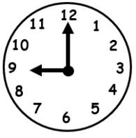

|  |  |  |
| --- | --- | --- |
| cl | o | ck |

1. clock clock

|  |  |  |
| --- | --- | --- |
| tr | u | ck |

1. truck truck

|  |  |  |
| --- | --- | --- |
| sh | o | p |

1. shop shop



|  |  |  |
| --- | --- | --- |
| br | u | sh |

1. brush brush

|  |  |  |  |
| --- | --- | --- | --- |
| ch | i | p | s |

1. chips chips



clap clock truck

clap _________ _________

shop brush chips  
 _________ __________ _________

# Numbers



|  |  |
| --- | --- |
| 0 |  |
| 1 |  |
| 2 |  |
| 3 |  |
| 4 |  |
| 5 |  |
| 6 |  |
| 7 |  |
| 8 |  |
| 9 |  |

|  |  |  |  |  |
| --- | --- | --- | --- | --- |
| 0 | 1 | 2 | 3 | 4 |
| 0 |  |  |  |  |
|  |  |  |  |  |
| 5 | 6 | 7 | 8 | 9 |
|  |  |  |  |  |



Students *dial* their number on the phone keyboard.



1. 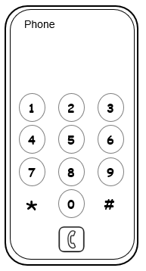

What is your phone number?

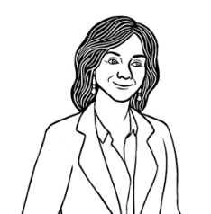

|  |  |  |  |  |  |  |  |  |  |  |  |
| --- | --- | --- | --- | --- | --- | --- | --- | --- | --- | --- | --- |
|  |  |  |  |  |  |  |  |  |  |  |  |

1. 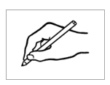



# Name

1. 

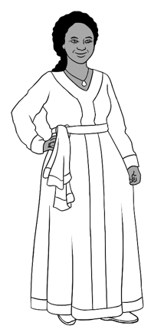

My first name is Jamila.

My family name is Desta.



My first name is Jamila.

My family name is Desta.

|  |  |
| --- | --- |
| First name | Jamila |
| Family name | Desta |

1. 

You

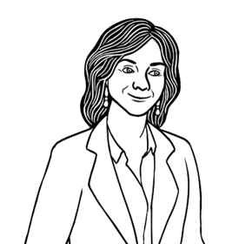

What is your first name?

What is your family name?



Students can copy their names from a card   
with their personal details.

My first name is _____________________.

My family name is _____________________.



|  |  |
| --- | --- |
| First name | ________________________________ |
| Family name | ________________________________ |

# Address

1. 

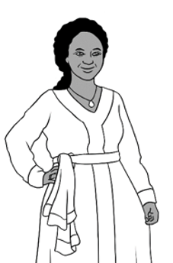

I live in Kellivale.

I live at 56 North Street.

My phone number is   
0408 629 531.



|  |  |  |  |  |  |  |  |  |  |  |  |  |
| --- | --- | --- | --- | --- | --- | --- | --- | --- | --- | --- | --- | --- |
| Address | | | | | | | | | | | | |
| Street | 56 North Street | | | | | | | | | | | |
| Suburb | Kellivale | | | | | | | | | | | |
| Postcode | 2421 | | | | | | | | | | | |
| Phone | 0 | 4 | 0 | 8 |  | 6 | 2 | 9 |  | 5 | 3 | 1 |

Students can copy their address and phone number from a card with their personal details.



You



Where do **you** live?

What is **your** phone number?

|  |  |  |  |  |  |  |  |  |  |  |  |  |
| --- | --- | --- | --- | --- | --- | --- | --- | --- | --- | --- | --- | --- |
| Address | | | | | | | | | | | | |
| Street | _______________________________________________ | | | | | | | | | | | |
| Suburb | ___________________________________________ | | | | | | | | | | | |
| Postcode | _____________________ | | | | | | | | | | | |
| Phone |  |  |  |  |  |  |  |  |  |  |  |  |

# Today is Monday.

****

|  |  |
| --- | --- |
| Monday |  |
| Tuesday |
| Wednesday |
| Thursday |
| Friday |
| Saturday |  |
| Sunday |  |



1. Today is Monday.  
    Monday
2. Today is Tuesday.  
    Tues________
3. Today is Wednesday.  
    Wednes________
4. Today is Thursday.  
    Thurs________
5. Today is Friday.  
    Fri________
6. Today is Saturday.  
    Satur_______
7. Today is Sunday.

______________

1. 

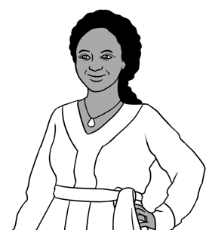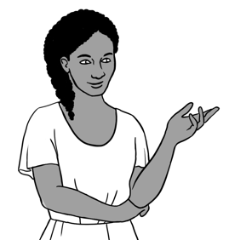

When is your class?

Monday, Tuesday   
and Thursday.



**🗸**

|  |  |  |
| --- | --- | --- |
|  | Jamila | You |
| Monday | ✓ |  |
| Tuesday |  |  |
| Wednesday |  |  |
| Thursday |  |  |
| Friday |  |  |
| Saturday |  |  |
| Sunday |  |  |

1. Students tick Jamila’s days and their class days.