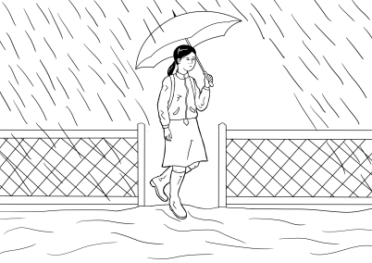

Section 4

Rain, rain, rain

**Table of contents**

The text for this section 4

Build vocabulary for the story 5

A short version of the story - a class cloze 12

Listen and order the sentences - 3 levels 16

Level A - Order the Sentences 18

Level B - Order the Sentences 21

Level C - Order the Sentences 22

Spell the words – 3 levels 23

Level A - Spelling 24

Level B - Spelling 25

Level C - Spelling 26

A Word Find - 3 levels 27

Level A - Word Find 28

Level B - Word Find 29

Level C - Word Find 30

An individual cloze – 3 levels 31

Level A - Write 32

Level B - Write the words 34

Level C - Write the words 35

PPT - Revise the short version of the story 36

Build the complete story 37

Listen and order the pictures and the text 47

The animated story – Rain, rain, rain 52

Label a picture of Mai 53

Question inflection - *What do we need to pack?* activity 55

Sentence stress – A jazz chant 57

Using the past simple - regular verbs 58

Change the story into the past – 3 levels 60

Level A - Past Tense 61

Level B – Past Tense 62

Level C - Past Tense 63

A phone conversation using the past simple 64

Appendix - Vocabulary list for Section 4 65

Appendix – Large size story pictures and text 66

Appendix - Photos for ‘What do we pack?’ activity 76

Appendix – The story at Level A 89

Level A - Rain, rain, rain 90

Acknowledgements 93

# The text for this section

**Rain, rain, rain**

It rains on Monday. Mai walks to school in the rain.

It rains on Tuesday. Mai walks to school in the rain again.

It rains on Wednesday. Water covers the road. Mai walks to school in the rain. A car splashes water on her clothes.

It rains on Thursday. Water covers the footpath. Mai walks to school in the rain. She wears her boots.

It rains on Friday. Water covers the garden. Mai stays at home.

It rains on Saturday. Water fills the river.

It rains on Sunday. Water floods the town.

Mai and her family watch the news on Sunday morning.

The SES man knocks on the door on Sunday afternoon.

The man says, “Pack a small bag. Leave now.”

# Build vocabulary for the story

In preparation for the story, project the pictures from the story and build the vocabulary   
as suggested. The words need to be introduced over a number of days and revised. Revision activities could include the students recording the vocabulary in their books, highlighting the new words and translating into their own language, word lists on the wall, vocab flashcards and a variety of games.

Some words in the story have been introduced already in ***Section 3***, but may need to be revised: **fills, floods, covers, footpath, road, garden, river, town**

| **VOCABULARY** | **Board Work** |
| --- | --- |
| **Mai**  Revise the names of students in the class, noting the stress and the number of ‘beats’ in each name. Write **Mai** on the board and under this, write the names of students with the same single syllable stress pattern. | Mai |
| **walk**  Mime the word **walk** and ask some students or the whole class to demonstrate the word **walk**. After learning the spelling, students could walk and spell the letters of the word **walk**, out loud on each step. Use 2 fingers on the desk to imitate walking. Point to Mai’s legs and move your 2 fingers. | _ a l _  Say **walk.** Ask the students what letters they can hear. Say the word slowly out loud. Do this several times and write in the letters the students get right. Add any missing letters and explain the way each letter is formed.  Point to the word. Ask students to repeat the word **walk** after you. Spell the word together, pointing to each letter as you spell. Ask how many letters in the word, count the letters together. |
| **school**  Take a picture of your school or the local school and project it on the board. | _ c h o o _  Repeat the process used to teach the word **walk**. |
| **again**  Get the students to do an action again and again and again. e.g. stand up, sit down, hands up, hands down, look left, look right, clap, stamp feet etc | _ _ _ i _  Repeat the process used to teach the word **walk**. |
| **splash**  C:\Users\v i c k y\Downloads\Wednesday.pngPut some water in a bowl or a mug and splash some on the table. | _ _ _ ash  Repeat the process used to teach the word **walk**. |
| **clothes**  Show a photo of some clothes, point to your own clothes and the students’ clothes. To explain that this general word includes different pieces of clothing, make a small pile of clothes on the table. | _ _ _ thes  Repeat the process used to teach the word **walk**. |
| C:\Users\v i c k y\Downloads\thursday.png**boots**  Draw a picture of boots and point to the boots in the picture of Mai. Check if anyone is wearing boots. | _ o o _ _  Repeat the process used to teach the word **walk**. |
| **family** Draw a picture of a family or put a large photo of a family on the board. If appropriate, get the students to show a photo of their family to their partner on their phone. | _ _ _ i _ y  Repeat the process used to teach the word **walk**. |
| C:\Users\v i c k y\Downloads\8.png**watch**  Mime the word **watch**.Point to the picture of Mai and her family in front of the TV.The time factor is important to distinguish **watch** from **look**. | _ a t _ _  Repeat the process used to teach the word ***walk***. |
| **news**  Hold up a newspaper or click on a TV news service. | _ew_  Repeat the process used to teach the word ***walk***. |
| **SES**  Project **SES** logo onto the board or draw it.  Show photos of people being assisted by the SES. Write **State Emergency Service** on the board and bold the first letters.  Perhaps show part of ***7 News*** video to show SES workers during the NSW floods. | **S**tate **E**mergency **S**ervice |
| **door**  Point to the **door** in the picture. Say ‘Door?’ to the class, look around and encourage them to point to the classroom door. Walk to the door and open and close it. | _ oo _  Repeat the process used to teach the word **walk**. |
| **knock**  Mime the word **knock** using a closed fist**.** Go out and knock on the door. Knock on the table - knock once, twice, three times and get students to copy the number of knocks each time. Also revise **again** here. | k _ _ c _  Repeat the process used to teach the word **walk**. |
| a **small bag**  Point to several different **bag**s belonging to students.  Compare a large and a **small** bag. Draw a large and a small cup, tree, ball, box etc. Point to the small object and say *small.* | _ _ all _ _ _  Repeat the process used to teach the word **walk**. |
| **Pack** Mime the word ***pack*** using a bag similar to the one used by Mai and her family. Point to the picture. | _ _ c _  Repeat the process used to teach the word **walk**. |
| **leave**  Demonstrate the word **leave** by taking the packed bag, waving goodbye and walking out of the classroom - remain outside the room for a minute to give the sense of having left.Revise the last three words – **bag, pack** and **leave** at the end of the class by telling students, **‘*Pack*** *your* ***bags*** *and* ***leave.’*** | _ _ a _ e  Repeat the process used to teach the word **walk**. |
| **stay**  Teach this as an opposite of *leave*. | _ _ ay _  Repeat the process used to teach the word **walk**. |
| **home**  Draw a picture of a house with no one in it. Write ***house*** under it. Draw another picture of a house and this time draw some people inside. Write **home** under it. | _ _ _ e  Repeat the process used to teach the word **walk**. |
| **now**  Use a clock to show the current time and say **now**. Wait a minute and point to the time and say **now** and so on. | _ ow  Repeat the process used to teach the word **walk**. |
| **morning**  Use a clock face to demonstratethe word **morning –** midnight to midday. When the clock hand gets to around 7am, mime sleeping, waking up, getting up etc. If possible, elicit the times in the morning that students get up. The morning could be drawn on the board as a linear timeline with students’ names written under the time they usually get-up. | _ o r _ i n g  Repeat the process used to teach the word **walk**. |
| **afternoon**  Use a clock face to demonstrate **afternoon** – midday to 6pm. Continue the timeline from above and note times when class ends, lunch, children’s school ends etc. | _ _ _ er _ oo _  Repeat the process used to teach the word **walk**. |
| **says**  Draw a face on the board with a speech bubble and insert previous spoken words or ones that follow.  **Hurry up.**  up.  e.g. | _ a y s  Repeat the process used to teach the word **walk**. |

# A short version of the story - a class cloze

This shorter version of the story focuses on Mai and uses the vocabulary just learned. Project the cloze below and elicit the missing letters and words to fill in the blank spaces.

|  |  |
| --- | --- |
| 1.  Mai w_ _ _ _ to sch _ _ _  in the _ _ _ _ . |  |
| 2.  Mai walks t_ s _ _ _ _ _  in the rain a_ _ _ _. | C:\Users\v i c k y\Downloads\tuesday.png |
| 3.  Mai walks to school  in the rain. A c_ _  splashes w _ _ _ _  on her clothes. | C:\Users\v i c k y\Downloads\Wednesday.png |
| 4.  Mai walks to school  in the r _ _ _. She  wears her b _ _ _ _. | C:\Users\v i c k y\Downloads\thursday.png |
| 5.  Mai stays at h _ _ _. | C:\Users\v i c k y\Downloads\Friday (1).png |
| 6.  W_ _ _ _ fills the river. | C:\Users\v i c k y\Downloads\Saturday.png |
| 7.  Water floods the t_ _ _. | C:\Users\v i c k y\Downloads\Sunday.png |
| 8.  Mai and her f_ _ _ _ _ watch the n_ _ _ . | C:\Users\v i c k y\Downloads\8.png |
| 9.  The SES man knocks on  the door . The man  says, “P_ _ _ a small   b_ _. Leave now.” |  |

# Listen and order the sentences - 3 levels

**Preparation**

* Copy the sentences and pictures on the following pages, enough so that students can work in pairs and at their ability level.
* Provide scissors and glue, a page of light card for each pair, and an envelope for later storage of the cut-up sentences.

**Activity**

1. Hand out copies of the sentences with the card, glue, scissors and envelopes.
2. Demonstrate the process of pasting the page of words onto the card, then cutting along   
   the dotted lines to make word cards.
3. Students work together to paste the paper onto the card and then cut out the strips.

As they work, encourage students to say what they are doing like a chant.

*We are gluing paper onto the card, onto the card, onto the card.   
We are gluing paper onto the card, onto the card, onto the card.*

*We are cutting sentence strips, sentence strips, sentence strips,*

*We are cutting sentence strips, cut, cut, cut.*

This makes for a noisy class, but gives students time to practice speaking. It doesn’t matter that a new tense is being introduced here. It’s a way of practising the form of a new tense so that it is familiar before its use is explained at a later time.

1. When the cutting and pasting has been completed, slowly read the text of the shortened story to the class and ask students to put the sentences in order as they listen.

Mai walks to school in the rain.

Mai walks to school in the rain again.

Mai walks to school in the rain. A car splashes water on her clothes.

Mai walks to school in the rain. She wears her boots.

Mai stays at home.

Water fills the river.

Water floods the town.

Mai and her family watch the news.

The SES man knocks on the door. The man says, “Pack a small bag. Leave now.”

1. To make it more difficult cut the sentences in half and mix them up. However, with Level A, keep sentences and pictures together until the students are more confident.
2. Encourage students to use clues such as the full stops and capital letters. This activity can be repeated over several days. Each time the students find the activity easy, they can cut up the strips into smaller pieces.

*After these ordering activities, ask each pair to insert their pictures and text in an envelope. Collect the envelopes for later classes.*

## Level A - Order the Sentences

|  |  |
| --- | --- |
| Mai walks to school in the rain. |  |
| Mai walks to school in the rain again. | C:\Users\v i c k y\Downloads\tuesday.png |
| Mai walks to school in the rain. A car splashes water on her clothes. | C:\Users\v i c k y\Downloads\Wednesday.png |
| Mai walks to school in the rain. She wears her boots. | C:\Users\v i c k y\Downloads\thursday.png |
| Mai stays at home. | C:\Users\v i c k y\Downloads\Friday (1).png |
| Water fills the river. | C:\Users\v i c k y\Downloads\Saturday.png |
| Water floods the town. | C:\Users\v i c k y\Downloads\Sunday.png |
| Mai and her family watch the news. | C:\Users\v i c k y\Downloads\8.png |
| The SES man knocks on the door. The man says,  “Pack a small bag.  Leave now.” |  |

## Level B - Order the Sentences

|  |
| --- |
| Mai walks to school in the rain. |
| Mai walks to school in the rain again. |
| Mai walks to school in the rain. A car splashes water on her clothes. |
| Mai walks to school in the rain. She wears her boots. |
| Mai stays at home. |
| Water fills the river. |
| Water floods the town. |
| Mai and her family watch the news. |
| The SES man knocks on the door. The man says, “Pack a small bag. Leave now.” |

## Level C - Order the Sentences

|  |  |
| --- | --- |
| Mai walks to school | in the rain. |
| Mai walks | to school in the rain again. |
| Mai walks to school in the rain. | A car splashes water on her clothes. |
| Mai walks to school in the rain. | She wears her boots. |
| Mai stays | at home. |
| Water fills | the river. |
| Water floods | The town. |
| Mai and her family | watch the news. |
| The SES man knocks on the door. | The man says, “Pack a small bag. Leave now.” |

# Spell the words – 3 levels

1. For **lower levels** use a modified version of ‘Look, say, cover, write, check’.

Teach: ***Look, say the word out loud, spell the word out loud as you copy****.*

For **higher levels** teach **‘Look, say, cover, write, check’**.

1. It is important that the students:

* Finish one word before writing the next word
* Work down the page rather than across.
* Check their spelling with the typed word.
* Try to chunk the letters rather than copy letter by letter
* The words are printed twice at each level so that students practise once in class,   
  and then again at home or in a following class. In this way, students are shown   
  a way to improve their writing through brief and regular practice.

## Level A - Spelling

|  |  |
| --- | --- |
|  | C:\Users\v i c k y\Downloads\Wednesday.png |
| walk | car |
|  |  |
| walk | car |
|  |  |

|  |  |
| --- | --- |
| C:\Users\v i c k y\Downloads\thursday.png |  |
| boots | rain |
|  |  |
| boots | rain |
|  |  |

## Level B - Spelling

|  |  |  |  |
| --- | --- | --- | --- |
| walk | car | rain | boots |
|  |  |  |  |
|  |  |  |  |
|  |  |  |  |
| walk | car | rain | boots |
|  |  |  |  |
|  |  |  |  |
|  |  |  |  |

|  |  |  |  |
| --- | --- | --- | --- |
| pack | bag | now | family |
|  |  |  |  |
|  |  |  |  |
|  |  |  |  |
| pack | bag | now | family |
|  |  |  |  |
|  |  |  |  |
|  |  |  |  |

## Level C - Spelling

|  |  |  |  |
| --- | --- | --- | --- |
| walk | splash | water | boots |
|  |  |  |  |
|  |  |  |  |
| walk | splash | water | boots |
|  |  |  |  |
|  |  |  |  |

|  |  |  |  |
| --- | --- | --- | --- |
| family | watch | news | now |
|  |  |  |  |
|  |  |  |  |
| family | watch | news | now |
|  |  |  |  |
|  |  |  |  |

|  |  |  |  |
| --- | --- | --- | --- |
| rain | school | knocks | small |
|  |  |  |  |
|  |  |  |  |
| rain | school | knocks | small |
|  |  |  |  |
|  |  |  |  |

# A Word Find - 3 levels

Word finds are a helpful way to develop students’ visual word recognition and spelling.

It is also a good time to introduce highlighters. Yellow highlighters are best as they allow the word to be seen clearly and don’t bleed through the page. Yellow is also a stimulating colour and is believed to enhance memory retention.

Project each *Word Find* and demonstrate the technique for each.

## Level A - Word Find

|  |  |  |  |  |  |  |  |  |  |
| --- | --- | --- | --- | --- | --- | --- | --- | --- | --- |
| **Highlight the words** | | | | | | | | | |
| **Mai** |  | w | a | l | k |  |  |  |
| **boots** |  |  |  |  | c | a | r |
| **school** | M | a | i |  |  |  |  |
| **walk** |  | w | a | t | e | r |  |
|  |  |  | b | o | o | t | s |
| **in** |  |  |  |  |  |  |  |
| **car** | r | a | i | n |  |  |  |
| **water** |  |  |  |  |  | i | n |
| **rain** |  |  | h | o | m | e |  |
| **home** |  | s | c | h | o | o | l |

## Level B - Word Find

|  |  |  |  |  |  |  |  |  |
| --- | --- | --- | --- | --- | --- | --- | --- | --- |
| **Highlight the words** | | | | | | | | |
| **Mai** |  | a | s | p | l | a | s | h |
| **pack** |  | b | c | d | e | c | a | r |
| **boots** | p | a | c | k | f | g | h |
| **school** | i | j | k | h | o | m | e |
| **walk** | r | a | i | n | l | m | n |
| **splash** | o | s | c | h | o | o | l |
| **car** | b | o | o | t | s | p | q |
| **family** | r | w | a | t | e | r | s |
| **water** | w | a | l | k | t | u | v |
| **rain** | w | x | y | z | M | a | i |
| **home** | n | o | w | a | b | c | d |
| **now** |  | e | f | a | m | i | l | y |

## Level C - Word Find

|  |  |  |  |  |  |  |  |  |  |  |
| --- | --- | --- | --- | --- | --- | --- | --- | --- | --- | --- |
| **Highlight the words** | | | | | | | | | | |
| **walk** |  | p | a | c | k | r | a | b | c | d |
| **road** |  | e | s | p | l | a | s | h | f | g |
| **boots** | h | c | i | j | i | k | l | m | n |
| **school** | o | h | p | q | n | g | r | s | t |
| **pack** | u | o | v | w | x | a | y | z | a |
| **splash** | n | o | w | b | c | r | o | a | d |
| **garden** | d | l | a | e | f | d | g | h | i |
| **family** | j | k | l | l | n | e | w | s | m |
| **water** | n | o | k | p | q | n | r | s | t |
| **rain** | u | w | a | t | c | h | v | w | x |
| **home** | y | a | z | a | b | h | c | d | e |
| **now** |  | f | t | g | h | b | o | o | t | s |
| **watch** |  | i | e | j | f | a | m | i | l | y |
| **news** |  | k | r | l | m | n | e | o | p | q |

# An individual cloze – 3 levels

* **At level A**, students are provided with the pictures, the word and the first letter.
* **At Level B**, there are no pictures, but some difficult sounds are given and the words are provided at the bottom of the page. This bottom section can be folded over and used to copy or check spelling.
* **At Level C**, there are no pictures or letters, but the words are provided at the bottom of   
  the page. This bottom section can be folded over and used to copy or check spelling.

## Level A - Write

|  |  |
| --- | --- |
| **1.**  Mai **w**_ _ _ _ to school in the rain. | **walks** |
| **2.**  Mai walks to school in the **r _** _ _ again. | **C:\Users\v i c k y\Downloads\tuesday.pngrain** |
| **3.**  Mai walks to school in the rain.  A **c** _ _ splashes water on her clothes. | **C:\Users\v i c k y\Downloads\Wednesday.pngcar** |
| **4.**  Mai walks to school in the rain.  She wears her **b** _ _ _ _. | **C:\Users\v i c k y\Downloads\thursday.pngboots** |

|  |  |
| --- | --- |
| **5.**  Mai stays at **h** _ _ _. | **C:\Users\v i c k y\Downloads\Friday (1).pnghome** |
| **6.**  **W**_ _ _ _ fills the river. | **C:\Users\v i c k y\Downloads\Saturday.pngwater** |
| **7.**  Water floods the **t**_ _ _. | **C:\Users\v i c k y\Downloads\Sunday.pngtown** |
| **8.**  Mai and her family watch the **n**_ _ _ . | **C:\Users\v i c k y\Downloads\8.pngnews** |
| **9.**  The SES man knocks on the  door. The man says, “Pack a   small **b** _ _. Leave now.” | **bag** |

## Level B - Write the words

|  |
| --- |
| 1. Mai _ a l _ _ to school in the _ ai _ . |
| 1. Mai walks to _ ch_ _ _ in the rain a _ _ i_. |
| 1. Mai walks to school in the rain. A _ ar splashes water on her _ _ _the_. |
| 1. Mai walks to school in the rain. She _ears  her _ oo_ _. |
| 1. Mai _ _ays at _ _ _ e. |
| 1. _ a _ er fills the _ i _er. |
| 1. Water _ _ood_ the _ ow _. |
| 1. Mai and her _a_ily watch the _ ew _ . |
| 1. The SES man knocks on the door. The man says,  “_ac _ a small bag. Leave _ow.” |
| **walks rain school again car clothes**  **wears boots stays home water river**  **floods town family news pack now** |

## Level C - Write the words

|  |
| --- |
| 1. Mai _ _ _ _ _ to school in the _ _ _ _ . |
| 1. Mai walks to _ _ _ _ _ _ in the rain _ _ _ _ _. |
| 1. Mai walks to school in the rain. A _ _ _ splashes water  on her _ _ _ _ _ _ _. |
| 1. Mai walks to school in the rain. She _ _ _ _ _ her   _ _ _ _ _. |
| 1. Mai _ _ _ _ _ at _ _ _ _. |
| 1. _ _ _ _ _ fills the _ _ _ _ _. |
| 1. Water _ _ _ _ _ _ the _ _ _ _. |
| 1. Mai and her _ _ _ _ _ _ watch the _ _ _ _ . |
| 1. The SES man knocks on the door. The man says,  “_ _ _ _ a small bag. Leave _ _ _.” |
| **walks rain school again car clothes**  **wears boots stays home water river**  **floods town family news pack now** |

# PPT - Revise the short version of the story

Before introducing the complete story, revise the short version with a PPT. The great advantage of the PPT is that you can show it many times, and at varying speeds.

**Download the PPT from the hub.**

* Project the PPT in *slide show mode*. The animation feature will reveal the words slowly   
  to build each sentence.
* The forward arrow on your keyboard will make the pictures and words appear in order. The back arrow will remove the words and pictures.
* Click *Escape* anytime to close.
* Encourage students to guess the words before they appear.

**PPT**

Rain, rain, rain

short version



# Build the complete story

The story can be built in a number of ways. You could use just one method or different ones over several days

1. **Project the pictures and the sentences with missing words.**

Project the following pages on the board and build the whole story together as a class. The words will need to be rubbed off after each slide.

1. **Project the pictures and build the story on the board**

Project only the pictures, and draw lines on the board for each word, working on one sentence at a time. You can give some letters if you like or leave them all blank. Elicit the words and write them on the board and/or ask students to spell each word. If you’re lucky, the board may be large enough to contain the whole story. This would allow you to reverse the process, by rubbing out some of the words and students reading the story recalling the rubbed-out words.

**1.**

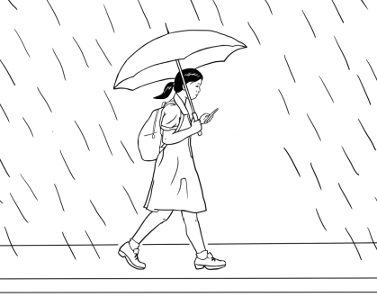

It r _ _ _ _ _ _ M_ _ _ _ _. Mai w_ _ _ _ _ to school in _ _ _ _ _ _ _.

**2.**

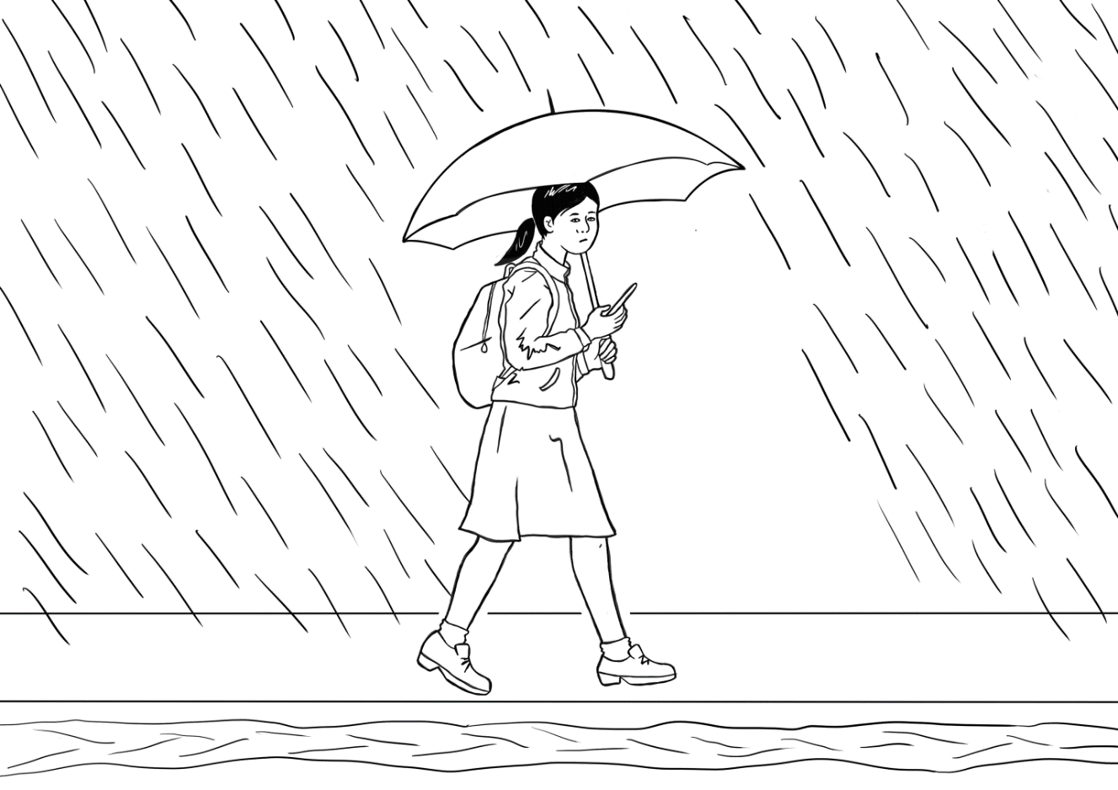

It rains on T_ _ _ _ _ _. M_ _ walks to s_ _ _ _ _ in the r_ _ _ ag_ _ _.

**3.**

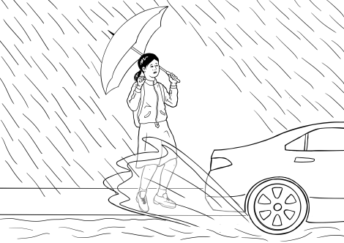

It rains on W_ _ _ _ _day. W_ _ _ _ covers the r_ _ _. Mai w_ _ _ _ to school _ _ the rain. A c_ _ _ _ _ashes water on h_ _ cl_ _ _ _ _.

**4.**



It r_ _ _ _ on Th_ _ _ _ _ _. Water c_ _ _ _ _   
the f _ _ _ path. Mai walks to s_ _ _ _ _   
in the rain. She w_ _ _ _ her b_ _ _ _.

**5.**

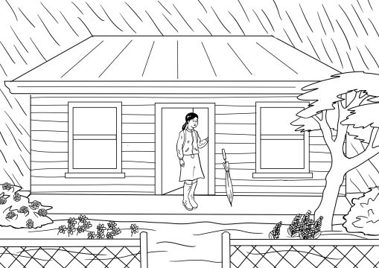

It rains _ _ Friday. W_ _ _ _ covers the g_ _ _ _ _. Mai st_ _ _ at h_ _ _.

**6.**

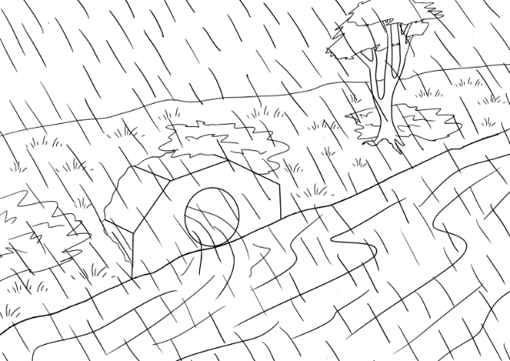

_ _ rains on S _ _ _ _ _ _ _. Water fills

the r _ _ _ _.

**7.**

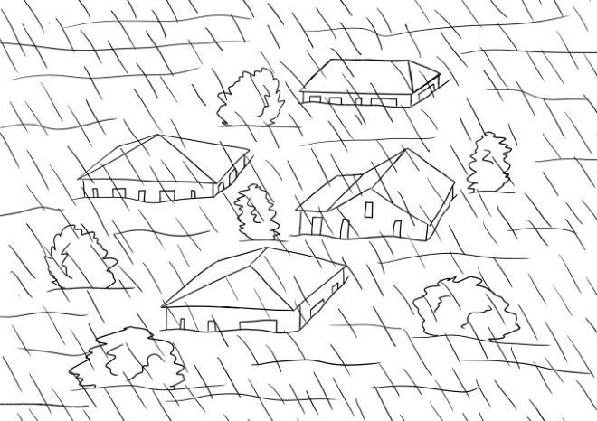

It rains on S_ _ _ _ _. Water fl_ _ _ _

the t_ _ _.

**8.**

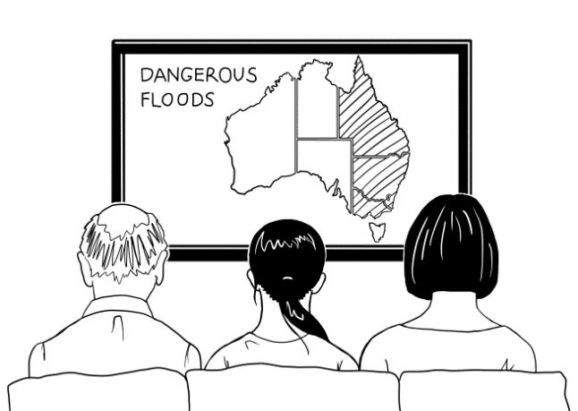

Mai and her f_ _ _ _ _ w_ _ _ _ the n_ _ _ on Sunday morning.

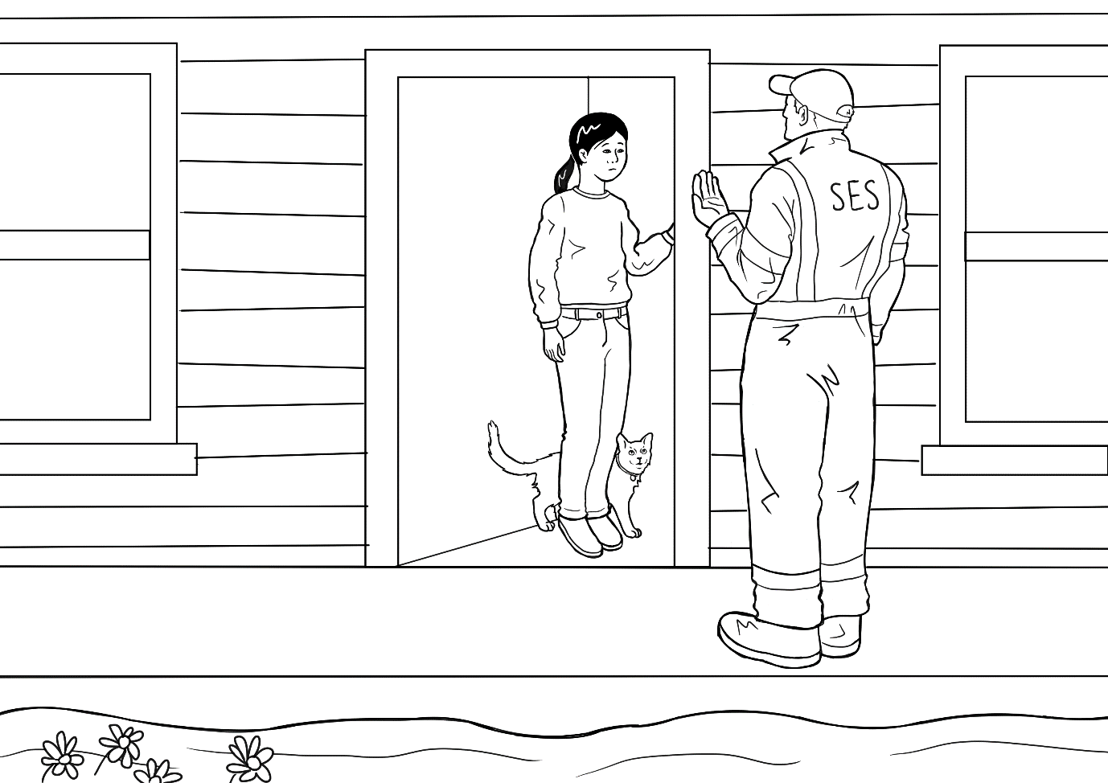

**9.**

The SES man kn_ _ _ _ on the d_ _ _ on Sunday afternoon. The m_ _ says,   
“P_ _ _ a small b_ _. Leave n_ _.”

# Listen and order the pictures and the text

**Step 1: Order the pictures**

Copy the following pages, enough for students to work in pairs. Students cut up the pictures.   
As the teacher reads the story, students order the pictures.

It is important to pair higher-level students with lower-level students to provide support when needed.

*A class set of scissors is essential. Cutting up is a good preparation for writing as the open and close motion of cutting strengthens the same muscles in the hand that are used in holding a pen or pencil.*

**Step 2: Order the text next to the pictures**

Copy the pages of text enough for students to work in pairs. Students cut up each box of text. As the teacher reads the story, students match the text with the ordered pictures.

*It is important to pair higher-level students with lower-level students to provide support when needed.*

**Step 3: Read the story as a class**

* The teacher reads the story, and the students repeat and point to the words as they read.
* Once the students have practised in pairs, ask some higher-level students to read a page aloud to the class. This gives the teacher the opportunity to do some individual correction of pronunciation and stress and also note common issues to address either at the time or in a later class.

*After these ordering activities, ask each pair to insert their pictures and text in an envelope. Collect the envelopes for later classes.*

|  |  |
| --- | --- |
| C:\Users\v i c k y\Downloads\Wednesday.png |  |
| C:\Users\v i c k y\Downloads\8.png | C:\Users\v i c k y\Downloads\Friday (1).png |
| C:\Users\v i c k y\Downloads\thursday.png | C:\Users\v i c k y\Downloads\Saturday.png |
|  | C:\Users\v i c k y\Downloads\Sunday.png |
| C:\Users\v i c k y\Downloads\tuesday.png |  |

|  |  |
| --- | --- |
| It rains on Wednesday. Water covers the road. Mai walks to school in the rain. A car splashes water on her clothes. | It rains on Thursday. Water covers the footpath. Mai walks to school in the rain. She wears her boots. |
| It rains on Friday. Water covers the garden. Mai stays at home. | It rains on Tuesday. Mai walks to school in the rain again. |
| It rains on Monday. Mai walks to school in the rain. | It rains on Saturday. Water fills the river. |
| The SES man knocks on the door on Sunday afternoon. The man says, “Pack a small bag. Leave now.” | It rains on Sunday. Water floods the town. |
| Mai and her family watch the news on Sunday morning. |  |

# The animated story – Rain, rain, rain

Open the animated version of the story on the hub and listen to the story together.

# Label a picture of Mai

Labelling is a useful way to revise vocabulary and add some new ones within a familiar context. Copy the drawing on the next page for each student.

1. Project the image of Mai on the board and ask some simple questions:

* Who is this?
* What is this? [Point to different things]

1. Label each part of the drawing on the board. Add more words in the grey boxes if students are familiar with other vocabulary in the drawing. e.g. dress, uniform, shoes, socks, hair etc
2. Colour different parts of the drawing.

* At level A direct the colouring
* At level B students select their colours and later describe their colouring to a partner. e.g a red umbrella
* At level C students select their colours and describe their picture to another student using simple sentences. E.g. Mai has a red umbrella.

*Colouring-in is an excellent pre-writing exercise – it provides an opportunity to learn correct pencil grip and strengthen muscles for writing. It is also a calming non-threatening activity and a good way to learn colours.*

**This is Mai.**

rain



# Question inflection - *What do we need to pack?* activity

This activity aims to make students aware of what is important to take in the event of a flood evacuation. It also paves the way for Story 2 ‘Leave now’, in which Mai and her family must pack a bag and find a safe place.

**Preparation**

* **Teach the vocab** of possible things to put in the bag. Don’t be limited by the pictures of objects in the appendix. It’s possible to increase the fun by suggesting ridiculous things. Where possible, use realia.
* **Print enough pictures** for the group activity with the words attached, so each group has a set. **Enlarge one set** of pictures to use on the board later.

**Activity 1:** **Question Inflection - *wh*** and **simple *yes/no* questions**

This is best done over a couple of days.

1. Write the question, ‘What do we need to pack?” on the board.

Demonstrate the **downward** inflection on the word **pack** with a downward arrow.

1. The students practise asking the question using the downward inflection.
2. The teacher holds up an object and responds by asking a simple yes/no question.   
   e.g. A torch? The TV? with an upward inflection.
3. Write the simple yes/no questions on the board showing the   
   **upward** inflection with an arrow.

**Teach body language:**

***Yes.*** - nod your head  
***No.*** - shake your head  
***I don’t know*.** - Lift your hands with palms up, raise your shoulders and show uncertainty on your face.

1. Give each student a large picture. Students will respond to the ‘What do we need to pack?” question, with a yes/no question. Students take turns to hold up their picture, and ask a simple question using the upward inflection. The class responds using body language or with a **yes** or **no answer**.

**Activity 2: ‘What do we need to pack? ‘ - Group activity**

1. **Organise students into groups of three with a set of pictures.** Each student will be a character: Grandfather, mother or Mai.
2. **Each ‘family’ group then sort the objects** into two columns: things to pack and not to pack. Make it very simple, a **Yes** and a **No** column.
3. **Use the enlarged pictures to arrange a final list** of the groups’ choiceson the board.

**Question Inflection - *wh* and *simple* *yes/no* questions**

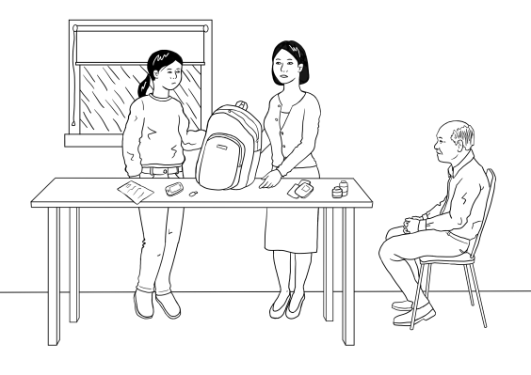

**Scenario**   
The family need to pack a small bag and leave the house. They must decide what to pack in the bag.

|  |  |  |
| --- | --- | --- |
| **wh questions** [Open questions]*Inflection* ***falls*** *with* ***wh*** *questions.* | | |
|  | *Say slowly. This is what we read.* | *Say quickly. This is what we hear.* |
| **Grandfather** | **Wh**at do we need to pack? | Whadda we need tapack? |
| **Simple yes/no questions** [Closed questions]*Inflection* ***goes up*** *at the end of a question requiring a* ***yes*** *or* ***no*** *answer.* | | |
| **Mother** | A close-up of a book  Description automatically generated with medium confidence The passports? | |
| **Grandfather** | A picture containing light  Description automatically generated A torch? | |
| **Mai** | A picture containing text, monitor, electronics, indoor  Description automatically generated The TV?  **No.** | |
| **Short Answers**  **Yes.** | | |

# Sentence stress – A jazz chant

**Jazz Chant** – Project the chant. Chant and clap, stressing information words marked with a large dot over the vowel. If a word has more than one syllable,   
the correct word stress must be followed: passports, certificates

Come on!

Pack the passports.

Pack the phone.

Pack the pills.

Pack the torch.

Pack the charger.

Pack the water.

Pack the certificates.

Leave now! Hurry, hurry, hurry!

# Using the past simple - regular verbs

The story offers an opportunity to introduce **past simple regular verbs**. Begin by comparing the verbs in a simple table on the board. Some common time markers could also be introduced and sentences created. e.g. It rains *every day*. It rained *last night*.

**Activity 1 – Verbs, use and common time markers**

|  |  |  |
| --- | --- | --- |
| **The verb [infinitive]** | **The present [simple] tense**  **Use:** *\* Regular habits, activities & events * Facts*  **Time markers:** *every day/morning/week/year etc* | **The past [simple] tense**  **Use:** *Completed activities and events*  **Time markers:** *yesterday, last night/week/Sunday etc* |
|  |  | add **ed** |
| to rain | it rains | it rain**ed** |
| to cover | it covers | it cover**ed** |
| to fill | it fills | it fill**ed** |
| to flood | it floods | it flood**ed** |

**Activity 2: Change the present to the past**

1. Project or write the following table on the board.
2. The teacher calls out a sentence in the present and the students reply using the past.
3. Divide the class in half, half read the present the other half read the past.

|  |  |
| --- | --- |
| **Present Tense** | **Past Tense** |
| It **rains** on Monday. | It **rained** on Monday. |
| It **rains** on Tuesday. | It **rained** on Tuesday. |
| It **rains** on Wednesday. | It **rained** on Wednesday. |
| It **rains** on Thursday. | It **rained** on Thursday. |
| It **rains** on Friday. | It **rained** on Friday. |
| It **rains** on Saturday. | It **rained** on Saturday. |
| It **rains** on Sunday. | It **rained** on Sunday. |
| The water **covers** the roads. | The water **covered** the road. |
| The water **covers** the footpath. | The water **covered** the footpath. |
| The water **covers** the garden. | The water **covered** the garden. |
| The water **fills** the river. | The water **filled** the river. |
| The water **floods** the town. | The water **flooded** the town. |

# Change the story into the past – 3 levels

The following activity provides additional work on regular verbs. The **irregular verbs** have been provided for the students and written in **bold**.

**Activity**

1. Project the following pages on the board and demonstrate what needs to be done   
   at each level.
2. Give students a copy of the activity at their level.
3. Check and correct it together on the board.

## Level A - Past Tense

|  |
| --- |
| **Past Tense** |
| It **rained** on Monday.  It **_ ain _ d** on Monday. |
| It **rained** on Tuesday. It **rain _ _** on Tuesday. |
| It **rained** on Wednesday.  It **ra_n_d** on Wednesday. |
| It **rained** on Thursday. It **_ai_ed** on Thursday. |
| It **rained** on Friday.  It **r_in_d** on Friday. |
| It **rained** on Saturday.  It **r_ _ned** on Saturday. |
| It **rained** on Sunday.  It **rain_ _** on Sunday. |

|  |  |
| --- | --- |
| **Verbs** | **Story** |
| to rain  to walk | It _________ on Monday. Mai ________ to school in the rain. |
| to rain  to walk | It _________on Tuesday. Mai _____________to school in the rain again. |
| to rain  to cover  to walk  to splash | It___________ on Wednesday. Water __________ the road. Mai _________ to school in the rain. A car _____________ water on her clothes. |
| to rain  to cover  to walk  **to wear** | It__________ on Thursday. Water__________ the footpath. Mai __________ to school in the rain. She **wore** her boots. |
| to rain  to cover  to stay | It __________on Friday. Water ___________ the garden.  Mai __________at home. |
| to rain  to fill | It __________ on Saturday. Water ____________ the river. |
| to rain  to flood | It __________ on Sunday. Water ___________ the town. |
| to watch | Mai and her family ________ the news on Sunday morning. |
| to knock  **to say** | The SES man __________ on the door on Sunday afternoon. The man **said**, “Pack a small bag. Leave now.” |

## Level B – Past Tense

## Level C - Past Tense

|  |  |
| --- | --- |
| **Verbs** | **Story** |
| to rain  to walk  to cover  to splash  **to wear**  to stay  to fill  to flood  to watch  to knock  **to say** | It _________ on Monday. Mai ________ to school in the rain. |
| It _________on Tuesday. Mai ___________to school in the rain again. |
| It___________ on Wednesday. Water ________ the road. Mai _________ to school in the rain. A car ___________ water on her clothes. |
| It________ on Thursday. Water___________ the footpath. Mai __________ to school in the rain. She **wore** her boots. |
| It __________on Friday. Water __________ the garden.  Mai _________at home. |
| It ___________ on Saturday. Water ____________ the river. |
| It ___________ on Sunday. Water ____________ the town. |
| Mai and her family ________ the news on Sunday morning. |
| The SES man __________ on the door on Sunday afternoon. The man **said**, “Pack a small bag. Leave now.” |

# A phone conversation using the past simple

This exercise includes a variety of interjections and expressions of surprise that can be used to show attention during a conversation. It is important that students understand that these are not ‘real’ words, but simply show that the listener is listening. Project or write the table on the board. You could also give each student a copy.

|  |  |
| --- | --- |
| **Student A** | **Student B** |
| Hi, how was your week? | **Ohhh** |
| Ohhh? | It rained and rained |
| Oh no! | and rained and rained. |
| Ohhh? | The water covered the roads. |
| Ahhh | The water covered the footpaths. |
| Ohhh! | The water covered the gardens. |
| Oh no! | The water filled the rivers. |
| Really? | The water flooded the town. |
| Oh dear! That’s bad! | **Yes**. Very, very, **very** bad. |

# Appendix - Vocabulary list for Section 4

Words introduced in this section are in **bold.**

|  |  |  |  |  |
| --- | --- | --- | --- | --- |
| **A** | **a, afternoon**, **again, at** |  | **N** | **news, now** |
| **B** | **bag, boots** | **O** | on |
| **C** | **car, clothes,** covers | **P** | **pack** |
| **D** | **door** | **Q** |  |
| **E** |  | **R** | **rain**, rains, river, road |
| **F** | **family,** fills, floods, footpath, Friday | **S** | Saturday, **says**, **school, SES**, **small, splashes**, **stays,** Sunday |
| **G** | garden | **T** | the, Thursday, **to**, town, Tuesday |
| **H** | **her, home** | **U** |  |
| **I** | it, **in** | **V** |  |
| **J** |  | **W** | **walks, watch,** water, **wears,** Wednesday |
| **K** | **knock** | **X** |  |
| **L** | **leave** | **Y** |  |
| **M** | **Mai**, **man**, Monday, **morning** | **Z** |  |

# Appendix – Large size story pictures and text

**The following activities recycle the language and should be completed over several days.**

**Activity 1 : Matching exercise as a class #1**

1. Enlarge the large size pictures and text to A3 size. [Appendix 6b]
2. Print, cut up and laminate the pictures if possible.
3. Distribute the 9 pictures and ask students to arrange themselves in the story order in front of the class.
4. Distribute the text to 9 students and ask them to match with the corresponding picture.

**Activity 2 : Matching exercise as a class #2**

1. Distribute all the pictures and text. The students then move round the class looking for a match.   
   If there are more than 18 students, make duplicate copies so everyone has something   
   to match.
2. Pictures can be arranged on the wall later.

|  |
| --- |
|  |
| C:\Users\v i c k y\Downloads\tuesday.png |
| C:\Users\v i c k y\Downloads\Wednesday.png |
| C:\Users\v i c k y\Downloads\thursday.png |

|  |
| --- |
| C:\Users\v i c k y\Downloads\Friday (1).png |
| C:\Users\v i c k y\Downloads\Saturday.png |
| C:\Users\v i c k y\Downloads\Sunday.png |
| C:\Users\v i c k y\Downloads\8.png |

|  |  |
| --- | --- |
|  | |
| It rains on Monday. Mai walks  to school in the rain. |

|  |
| --- |
| It rains on Tuesday. Mai walks  to school in the rain again. |
| It rains on Wednesday. Water covers the road. Mai walks to school in the rain. A car splashes water on her clothes. |
| It rains on Thursday. Water covers the footpath. Mai walks to school  in the rain. She wears her boots. |
| It rains on Friday. Water covers  the garden. Mai stays at home.  It rains on Saturday. Water fills  the river. |
| Mai and her family watch the news on Saturday morning. |
| It rains on Sunday. Water floods  the town. |
| The SES man knocks on the door on Sunday afternoon. The man says, “Pack a small bag. Leave now.” |

# Appendix - Photos for ‘What do we pack?’ activity

**Cut-up the objects, and leave the words attached.**

|  |  |
| --- | --- |
|  | **the passports** |
|  | **a USB with photos** |
|  | **a phone** |
|  | **grandfather’s pills** |
|  | **a torch** |
|  | **a phone charger** |
|  | **water** |
|  | **certificates** |
|  | **jewellery** |
|  | **money** |
|  | **the TV** |
|  | **driving licence** |
|  | **hand sanitiser** |
|  | **books** |
|  | **the laptop** |
|  | **clothes** |
|  | **an umbrella** |
|  | **bananas** |
|  | **chocolate** |
|  | **towels** |
|  | **toothbrushes** |
|  | **a backpack** |
|  | **a shopping bag** |
|  | **the cat** |
|  | **the radio and batteries** |
|  | **the First Aid kit** |

# Appendix – The story at Level A

Some teachers with mixed classes like to make small books for the students at different levels. The following pages have been included to support this activity. To make the word meanings clearer the students could colour the part of the picture the word applies to.  
 e.g. for the word *rain,* colour the rain.

Levels B and C can be copied from pictures and text earlier in the section.

## Level A - Rain, rain, rain

|  |  |
| --- | --- |
| rains |  |
| C:\Users\v i c k y\Downloads\tuesday.png2 | walks |
| water | C:\Users\v i c k y\Downloads\Wednesday.png3 |

|  |  |
| --- | --- |
| C:\Users\v i c k y\Downloads\thursday.png4 | footpath |
| garden | C:\Users\v i c k y\Downloads\Friday (1).png5 |
| C:\Users\v i c k y\Downloads\Saturday.png6 | river |

|  |  |
| --- | --- |
| town | C:\Users\v i c k y\Downloads\Sunday.png7 |
| C:\Users\v i c k y\Downloads\8.png8 | news |
| SES | C:\Users\v i c k y\Downloads\9.2 (1).png9 |

# Acknowledgements

**Images**

|  |  |
| --- | --- |
| Passports | https://www.freepik.com/free-photo/passport-fabric-bag_1155960.htm#page=1&query=passport&position=40 by Suksao |
| Water | [This Photo](http://ell.stackexchange.com/questions/88651/if-it-has-a-common-name-whats-a-big-water-bottle-called) by Unknown Author is licensed under [CC BY-SA](https://creativecommons.org/licenses/by-sa/3.0/) |
| USB | [This Photo](https://freepngimg.com/png/52752-usb-pen-drive-download-free-transparent-image-hq) by Unknown Author is licensed under [CC BY-NC](https://creativecommons.org/licenses/by-nc/3.0/) |
| Phone | [This Photo](http://www.prepaidphonenews.com/2017/01/prepaid-phones-on-sale-this-week-jan-1.html) by Unknown Author is licensed under [CC BY-SA](https://creativecommons.org/licenses/by-sa/3.0/) |
| Phone Charger | [This Photo](https://askleo.com/why-does-my-phone-charge-more-quickly-on-some-chargers/) by Unknown Author is licensed under [CC BY-NC-ND](https://creativecommons.org/licenses/by-nc-nd/3.0/) |
| Torch | [This Photo](http://www.pngall.com/torch-png) by Unknown Author is licensed under [CC BY-NC](https://creativecommons.org/licenses/by-nc/3.0/) |
| Pills | [This Photo](https://www.flickr.com/photos/mpcaphotos/38392167481/) by Unknown Author is licensed under [CC BY-NC](https://creativecommons.org/licenses/by-nc/3.0/) |
| Toothbrushes | [This Photo](https://en.wikipedia.org/wiki/Toothbrush) by Unknown Author is licensed under [CC BY-SA](https://creativecommons.org/licenses/by-sa/3.0/) |
| Chocolate | [This Photo](http://www.pngall.com/dark-chocolate-png) by Unknown Author is licensed under [CC BY-NC](https://creativecommons.org/licenses/by-nc/3.0/) |
| Towels | [This Photo](https://pngimg.com/download/53225) by Unknown Author is licensed under [CC BY-NC](https://creativecommons.org/licenses/by-nc/3.0/) |
| Bananas | [This Photo](https://legendaryfacts.com/uncategorized/20-fascinating-banana-fun-facts/) by Unknown Author is licensed under [CC BY-NC-ND](https://creativecommons.org/licenses/by-nc-nd/3.0/) |
| Clothes | [This Photo](http://www.flickr.com/photos/horiavarlan/4307774862/) by Unknown Author is licensed under [CC BY](https://creativecommons.org/licenses/by/3.0/) |
| SES logo | [This Photo](https://en.wikipedia.org/wiki/Victoria_State_Emergency_Service) by Unknown Author is licensed under [CC BY-SA](https://creativecommons.org/licenses/by-sa/3.0/) |
| Umbrella | [This Photo](https://pngimg.com/download/69220) by Unknown Author is licensed under [CC BY-NC](https://creativecommons.org/licenses/by-nc/3.0/) |
| Backpack | [This Photo](http://www.pngall.com/backpack-png) by Unknown Author is licensed under [CC BY-NC](https://creativecommons.org/licenses/by-nc/3.0/) |
| Laptop | [This Photo](https://pngimg.com/download/5940) by Unknown Author is licensed under [CC BY-NC](https://creativecommons.org/licenses/by-nc/3.0/) |
| Books | [This Photo](http://scherlund.blogspot.com/2015/08/top-100-books-to-read-before-leaving.html) by Unknown Author is licensed under [CC BY](https://creativecommons.org/licenses/by/3.0/) |
| Hand sanitiser | [This Photo](https://www.flickr.com/photos/pennstatelive/12348121395/) by Unknown Author is licensed under [CC BY-NC-ND](https://creativecommons.org/licenses/by-nc-nd/3.0/) |
| Driving licence | [This Photo](http://travel.stackexchange.com/questions/16968/can-i-use-my-probationary-australian-drivers-license-to-rent-a-car-in-the-unite) by Unknown Author is licensed under [CC BY-SA](https://creativecommons.org/licenses/by-sa/3.0/) |
| TV | [This Photo](http://pngimg.com/download/39275) by Unknown Author is licensed under [CC BY-NC](https://creativecommons.org/licenses/by-nc/3.0/) |
| Money | [This Photo](http://capitocome.blogspot.com/2012/02/australian-online-shopping.html) by Unknown Author is licensed under [CC BY-NC-ND](https://creativecommons.org/licenses/by-nc-nd/3.0/) |
| Jewellery | [This Photo](http://www.pngall.com/dark-chocolate-png) by Unknown Author is licensed under [CC BY-NC](https://creativecommons.org/licenses/by-nc/3.0/) |
| Certificate of birth | [This Photo](http://turning-of-generations.blogspot.com/2010/10/98th-edition-of-cog-document-analysis.html) by Unknown Author is licensed under [CC BY-NC-ND](https://creativecommons.org/licenses/by-nc-nd/3.0/) |
| On-line certificate | [This Photo](https://saranmicro.wordpress.com/nptel/) by Unknown Author is licensed under [CC BY-SA-NC](https://creativecommons.org/licenses/by-nc-sa/3.0/) |
| Shopping bag | [This Photo](https://www.flickr.com/photos/keykalou/25942366757/) by Unknown Author is licensed under [CC BY](https://creativecommons.org/licenses/by/3.0/)-SA |
| A cat | [This Photo](https://pngimg.com/download/50514) by Unknown Author is licensed under [CC BY-NC](https://creativecommons.org/licenses/by-nc/3.0/) |
| Radio and batteries | [This Photo](http://www.volkside.com/2009/05/workshop-name-plate-template/) was taken by Sue Paull and is copyright free |
| First Aid kit | [This Photo](http://www.pngall.com/first-aid-kit-png) by Unknown Author is licensed under [CC BY-NC](https://creativecommons.org/licenses/by-nc/3.0/) |
| Flooded town | [This Photo](http://www.pngall.com/flood-png) by Unknown Author is licensed under [CC BY-NC](https://creativecommons.org/licenses/by-nc/3.0/) |

**Project team**

Vicki Hambling, Lorraine Hatcher-Friel, Sue Paull, Madelena Scott, Mary Wallace, Visual Domain

**Acknowledgements**

The Project Team would like to thank the AMEP Service Providers and practitioners who participated in the trial and gave valuable feedback.

This Floods Teaching Material is licensed under a Creative Commons Attribution-NoDerivs 3.0 Australia licence (More information is available [here](http://creativecommons.org/licenses/by-nd/3.0/au/)). You are free to use, copy and distribute to anyone in its original form as long as you attribute Department of Home Affairs as the author and you license any derivative work you make available under the same licence.

© Commonwealth of Australia 2021

With the exception of the Commonwealth Coat of Arms, the department’s logo, any material protected by a trade mark and where otherwise noted all material presented in this document is provided under a Creative Commons Attribution 4.0 International (<https://creativecommons.org/licenses/by/4.0/>) licence.

The details of the relevant licence conditions are available on the Creative Commons website (accessible using the links provided) as is the full legal code for the CC BY 4.0 licence (<https://creativecommons.org/licenses/by/4.0/legalcode>).

Use of all or part of this document must include the following attribution:-   
© Commonwealth of Australia 2021

As far as practicable, material for which the copyright is owned by a third party will be clearly labelled. The department has made all reasonable efforts to ensure that this material has been reproduced in this document with the full consent of the copyright owners.

Copyright requests and enquiries concerning usage not addressed by the CC BY 4.0 licence should be addressed to:

[*comms@homeaffairs.gov.au*](mailto:comms@homeaffairs.gov.au) *at the Department of Home Affairs.*

The terms of use for the Commonwealth Coat of Arms are available from the [It's an Honour](http://www.itsanhonour.gov.au/) website.

Where a copyright owner, other than the Commonwealth, is identified with respect to this material, please contact that third party copyright owner directly to seek permission.

