

**English Ready**

22482VIC Course in Initial EAL

VU22579 Use strategies to participate in learning

Learn English

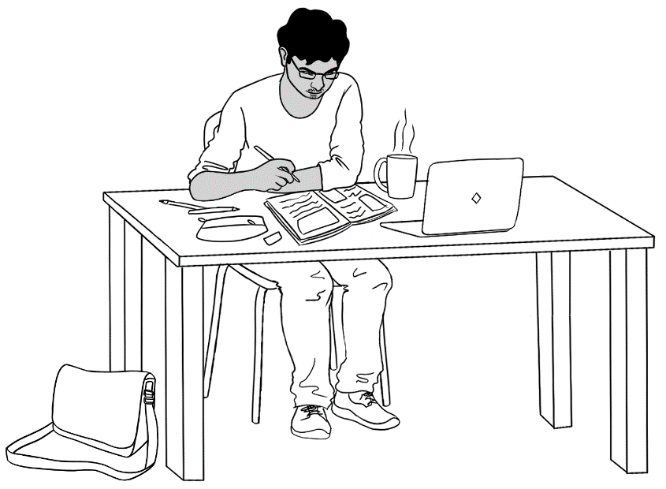

**Name** _________________________________________________

**Teacher** _____________________________________________ **Class** _________________________________________________

**Date**__________________________________________________

**Design team:** Vicki Hambling, Sue Paull, Frida Dean and Mary Wallace

**Illustrations:** Madelena Scott

**Acknowledgements:** The design team would like to thank the AMEP service providers and practitioners who participated in the trial and gave valuable feedback. The team would also like to acknowledge the use of the EAL Framework which underpins the design of this book.

Copyright of the EAL Framework is reserved to the Crown in the right of the State of Victoria. © State of Victoria (Department of Education and Training) 2018.  
_________________________________________________________________________________________

This English Ready Resource is licensed under a Creative Commons Attribution-NoDerivs 3.0 Australia licence (More information is available [here](http://creativecommons.org/licenses/by-nd/3.0/au/)). You are free to use, copy and distribute to anyone in its original form as long as you attribute Department of Home Affairs as the author and you license any derivative work you make available under the same licence.  
  
© Commonwealth of Australia 2023



With the exception of the Commonwealth Coat of Arms, the department’s logo, any material protected by a trade mark and where otherwise noted all material presented in this document is provided under a Creative Commons Attribution 4.0 International (<https://creativecommons.org/licenses/by/4.0/>) licence.

The details of the relevant licence conditions are available on the Creative Commons website (accessible using the links provided) as is the full legal code for the CC BY 4.0 licence. (<https://creativecommons.org/licenses/by/4.0/legalcode>).

Use of all or part of this document must include the following attribution:   
© Commonwealth of Australia 2023

As far as practicable, material for which the copyright is owned by a third party will be clearly labelled.  The department has made all reasonable efforts to ensure that this material has been reproduced in this document with the full consent of the copyright owners.

Copyright requests and enquiries concerning usage not addressed by the CC BY 4.0 licence should be addressed to: [*comms@homeaffairs.gov.au*](mailto:comms@homeaffairs.gov.au) *at the Department of Home Affairs.*

The terms of use for the Commonwealth Coat of Arms are available from the [It's an Honour](http://www.itsanhonour.gov.au/) website.

Where a copyright owner, other than the Commonwealth, is identified with respect to this material, please contact that third party copyright owner directly to seek permission.



**Table of contents**

1 Instructions 2

2 Do you understand? 3

3 Meet the students and teachers. 4

4 What is your name? 5

5 Where do you learn English? 6

6 Who is your teacher? 7

7 I go to class today. 8

8 When do you start class? 14

9 I am sorry. I am late. 16

10 Do you have a pencil? 20

11 I want to learn English. 28

12 Follow instructions. 38

13 I am sick. 44

# Instructions

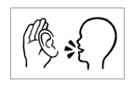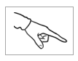

|  |  |
| --- | --- |
| listen | say |
| copy | match |
| colour | circle |
| trace | 🗸  tick |
| point | clap |

# Do you understand?



Yes

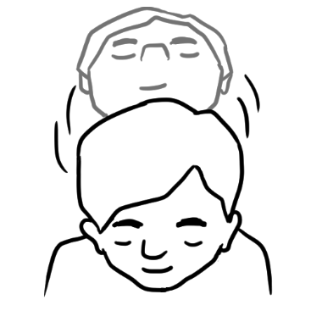

No

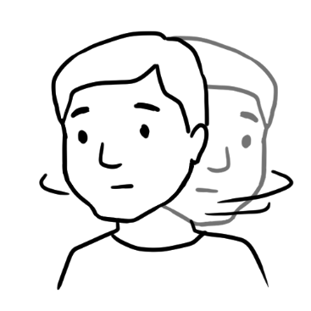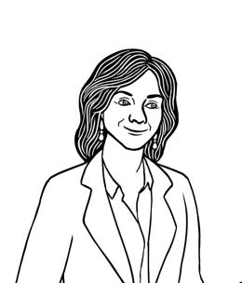

Do you understand?



Do you understand?

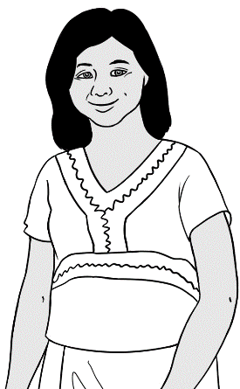

Yes, I understand.

No, I **don’t** understand.

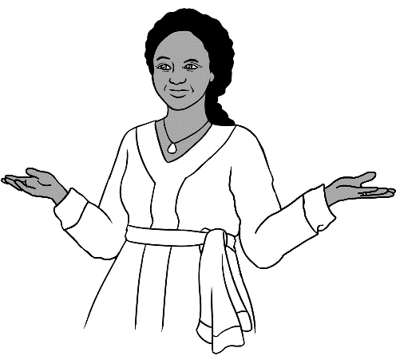

Say it again please?

don’t = do not

# Meet the students and teachers.

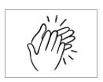

Students

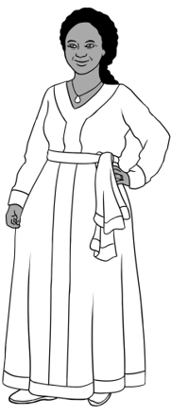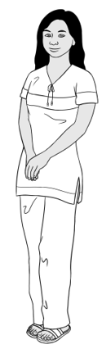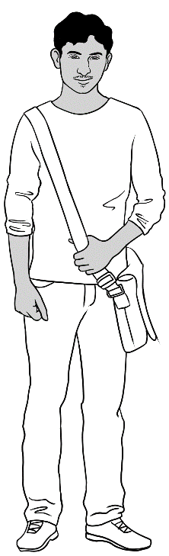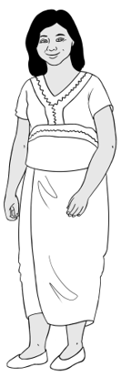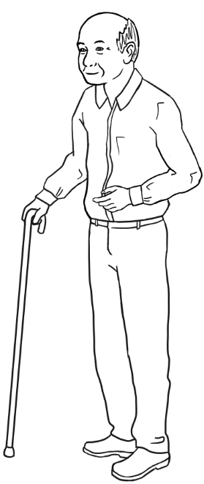

3. Jamila

2. San

4. Rahim

1. Zarni

5. Ming

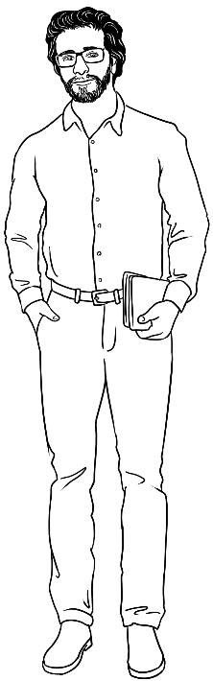

Teachers

6. Rosie

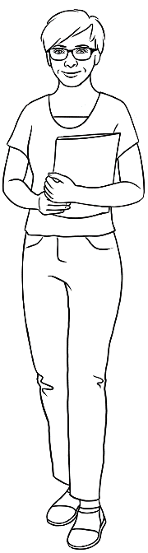

8. Peter

7. Wendy

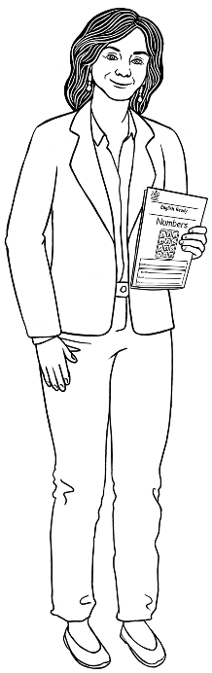

# What is your name?



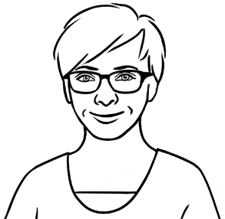

What is your name?

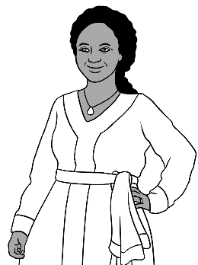

My name is Jamila.

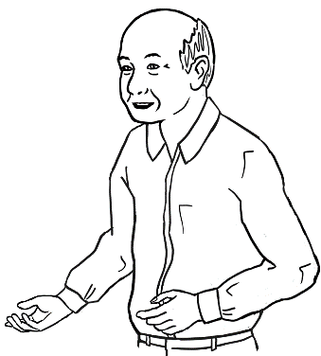

My name is Ming.

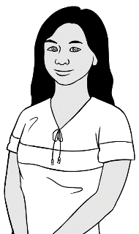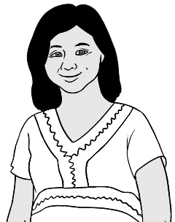

My name is Zarni.

My name is San.

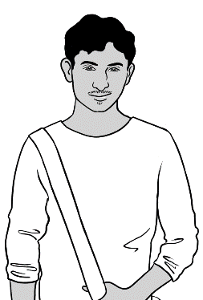

My name is Rahim.

What is your name?

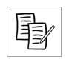

My name is ______________________________________ .

# Where do you learn English?

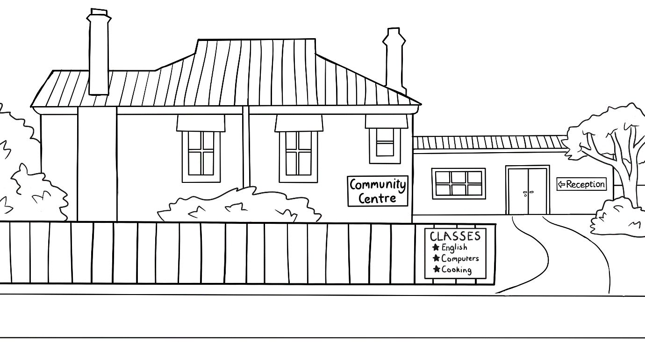****

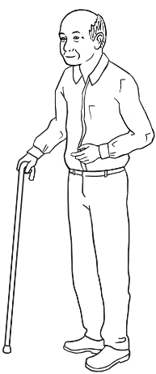

I learn at a community centre.

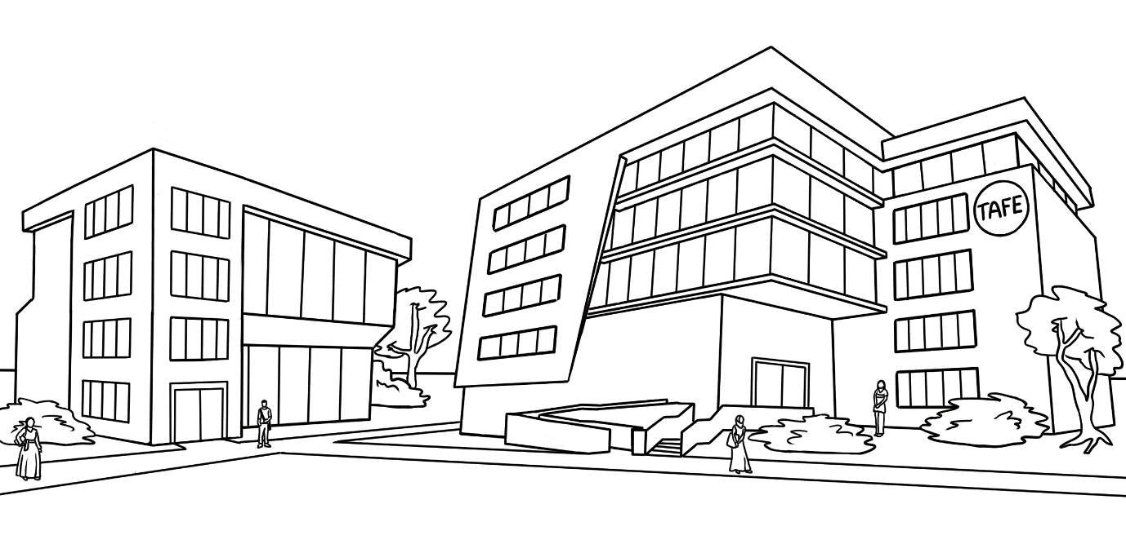

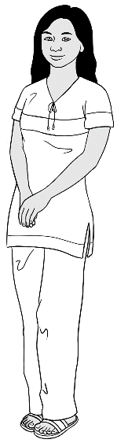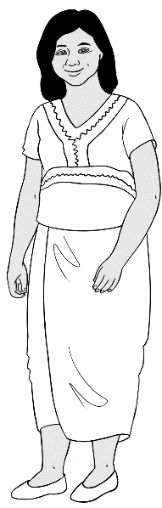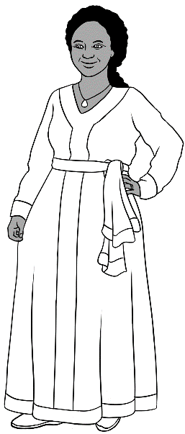

We learn at TAFE.

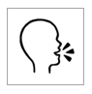

Where do you learn?

I learn at ____________________________________.

# Who is your teacher?



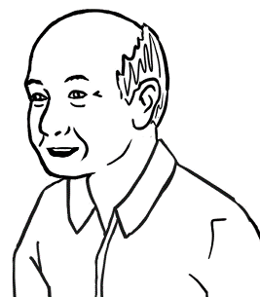

My teacher is **Wendy**.

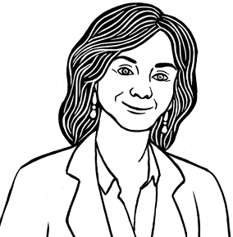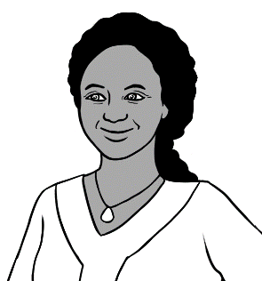

My teacher is **Rosie**.

1. 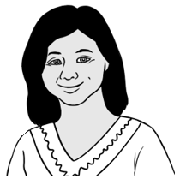

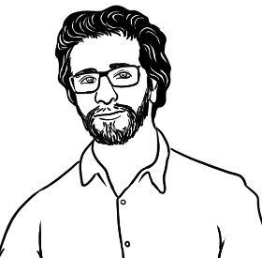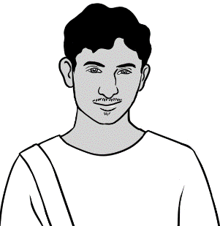

My teacher is **Peter**.

1. 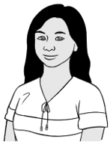



Who is your teacher?

My teacher is _______________________________.

# I go to class today.



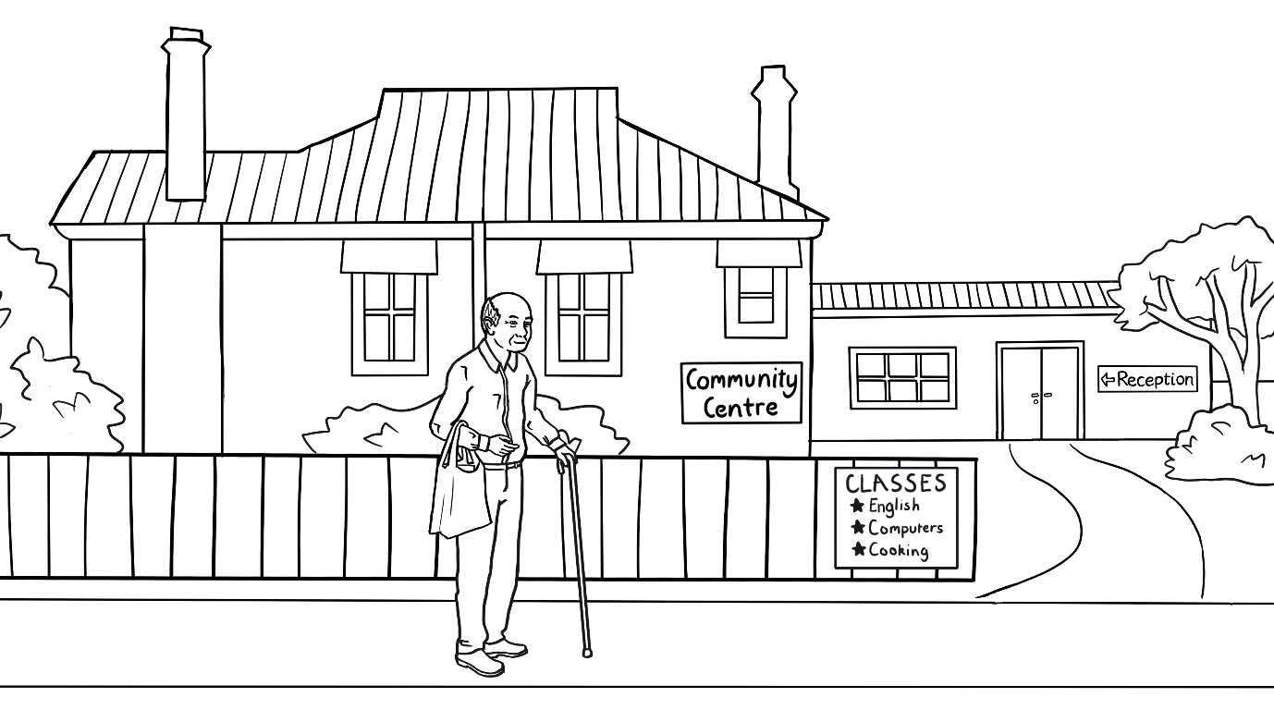

I go to class today.



|  |  |  |  |  |
| --- | --- | --- | --- | --- |
|  |  |  |  |  |
| Monday | Tuesday | Wednesday | Thursday | Friday |
|  | 9:00 -1:00  Room 4 | 9:00 -1:00  Room 4 |  | 9:00 -1:00  Room 4 |

This is Ming’s timetable.

**🗸**





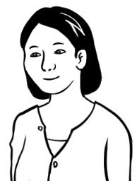

When do you go to class?

I go to class on Tuesday,   
Wednesday and Friday.



|  |  |
| --- | --- |
| Day | 🗸 |
| Monday |  |
| Tuesday | 🗸 |
| Wednesday |  |
| Thursday |  |
| Friday |  |

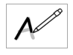

|  |  |  |
| --- | --- | --- |
| Tuesday | Wednesday | Friday |
| Tuesday | Wednesday | Friday |



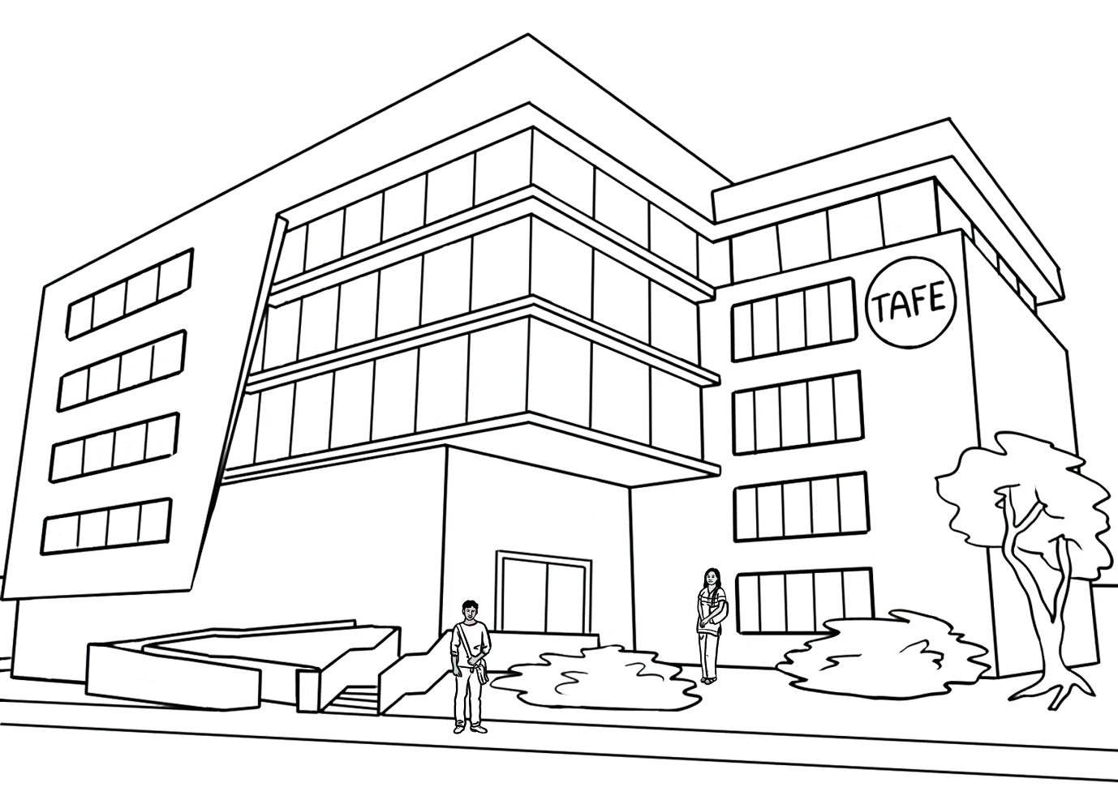

We go to class today.

|  |  |  |  |  |
| --- | --- | --- | --- | --- |
| Monday | Tuesday | Wednesday | Thursday | Friday |
| 9 - 1  Room 40 | 9 - 1  Room 40 | 9 - 1  Room 40 | 9 - 1  Room 40 | 9 - 1  Room 14 |

This is Rahim and San’s timetable.

**🗸**



When do you go to class San?

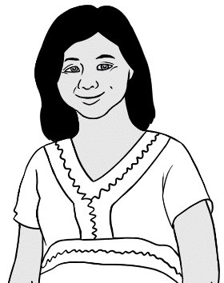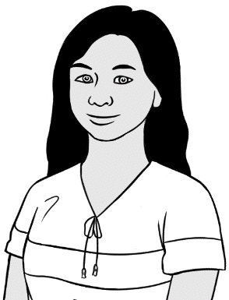

I go to class on Monday, Tuesday, Wednesday, Thursday and Friday.

|  |  |
| --- | --- |
| Day | 🗸 |
| Monday | 🗸 |
| Tuesday |  |
| Wednesday |  |
| Thursday |  |
| Friday |  |

|  |  |
| --- | --- |
| **M**onday | **T**uesday |
| Monday | ___uesday |



|  |  |  |
| --- | --- | --- |
| **W**ednesday | **Th**ursday | **Fr**iday |
| ___ednesday | __ __ursday | __ __iday |





**🗸**

When do **you** go to class?

|  |  |
| --- | --- |
| Day | 🗸 |
| Monday |  |
| Tuesday |  |
| Wednesday |  |
| Thursday |  |
| Friday |  |



|  |  |  |
| --- | --- | --- |
| Monday | Tuesday | Wednesday |
| Monday | _______day | ______nesday |

|  |  |  |
| --- | --- | --- |
| Thursday | Friday | Saturday |
| _________day | _____day | ______urday |

|  |  |  |  |  |  |  |  |  |
| --- | --- | --- | --- | --- | --- | --- | --- | --- |
| M | o | n | d | a | y |  |  |  |
| M | o | n | d | a | y |  |  |  |
|  |  |  |  |  |  |  |  |  |
| T | u | e | s | d | a | y |  |  |
|  |  |  |  |  |  |  |  |  |
|  |  |  |  |  |  |  |  |  |
| W | e | d | n | e | s | d | a | y |
|  |  |  |  |  |  |  |  |  |
|  |  |  |  |  |  |  |  |  |
| T | h | u | r | s | d | a | y |  |
|  |  |  |  |  |  |  |  |  |
|  |  |  |  |  |  |  |  |  |
| F | r | i | d | a | y |  |  |  |
|  |  |  |  |  |  |  |  |  |
|  |  |  |  |  |  |  |  |  |
| S | a | t | u | r | d | a | y |  |
|  |  |  |  |  |  |  |  |  |
|  |  |  |  |  |  |  |  |  |
| S | u | n | d | a | y |  |  |  |
|  |  |  |  |  |  |  |  |  |



# When do you start class?



1.

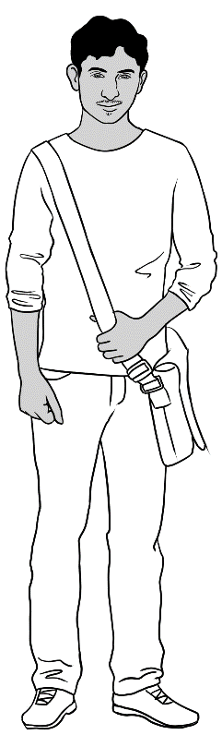

I start class at 9 o’clock.

I finish at 1 o’clock.

|  |
| --- |
| Monday |
| 9:00 - 1:00  Room 40 |

****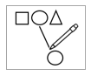**

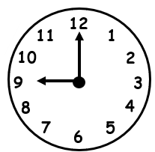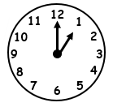2.

|  |
| --- |
| 9 o’clock |
| 1 o’clock |







I start class at 9 o’clock.

I finish at 1 o’clock.

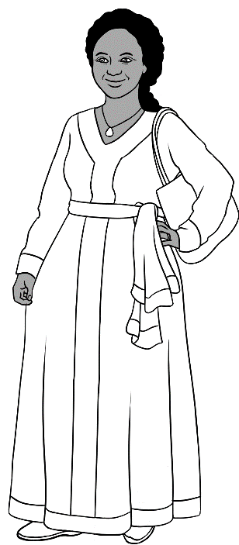

|  |
| --- |
| **Monday** |
| 9:00 - 1:00  Room 16 |





When do **you** start class? .

When do **you** finish? .

I start class at _____ o’clock.

I finish at _____o’clock.

# I am sorry. I am late.

Class starts at 9 o’clock.

.

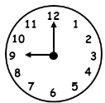

I am ready for class.

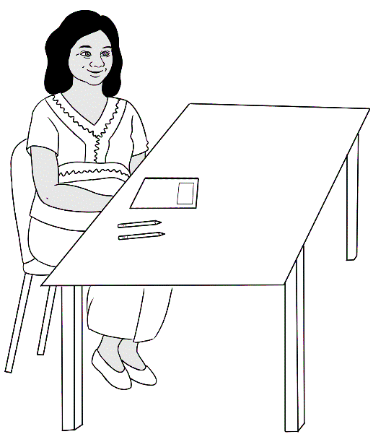

Where is Jamila?

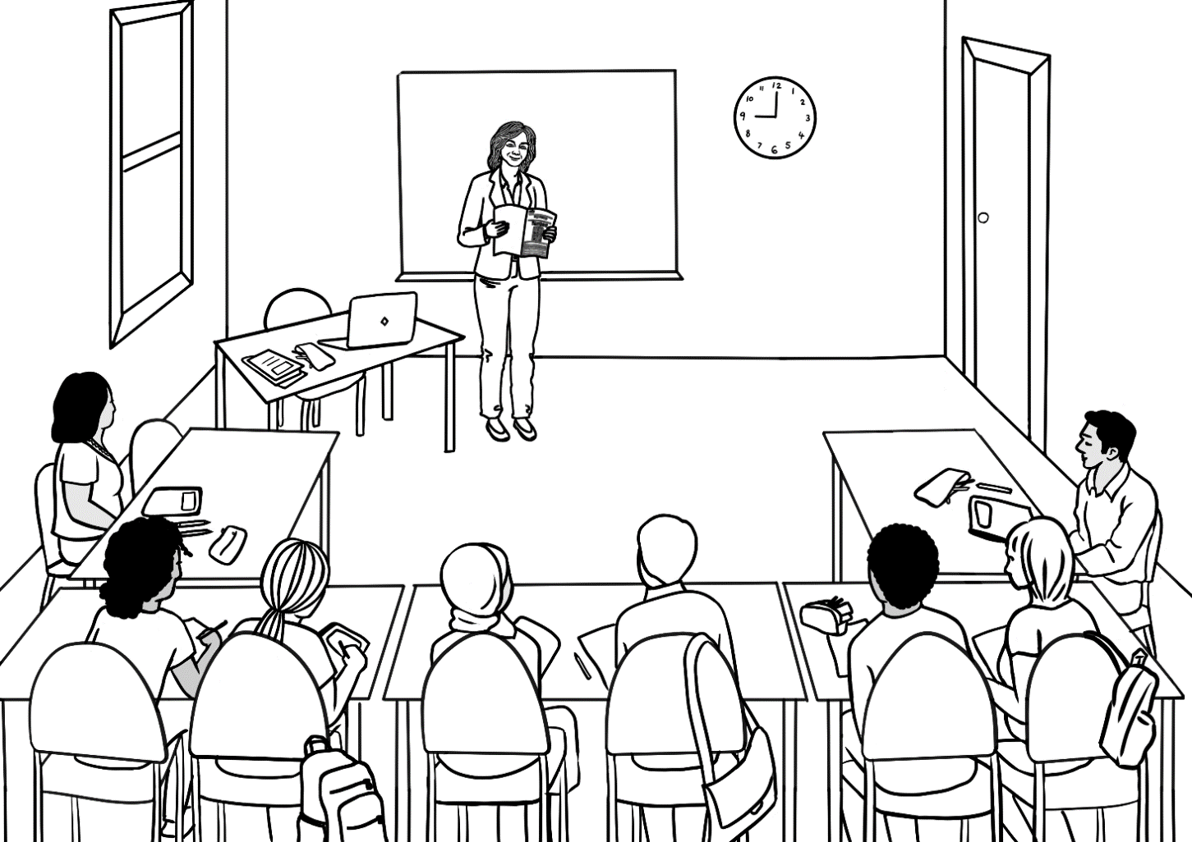

Good morning everyone.

Good morning Rosie.

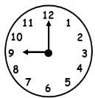

Good morning Rosie.



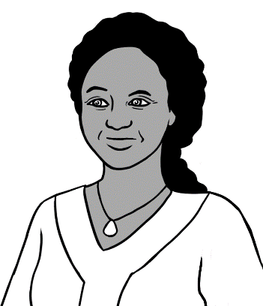

It is **10** o’clock.

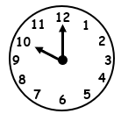

I am late.

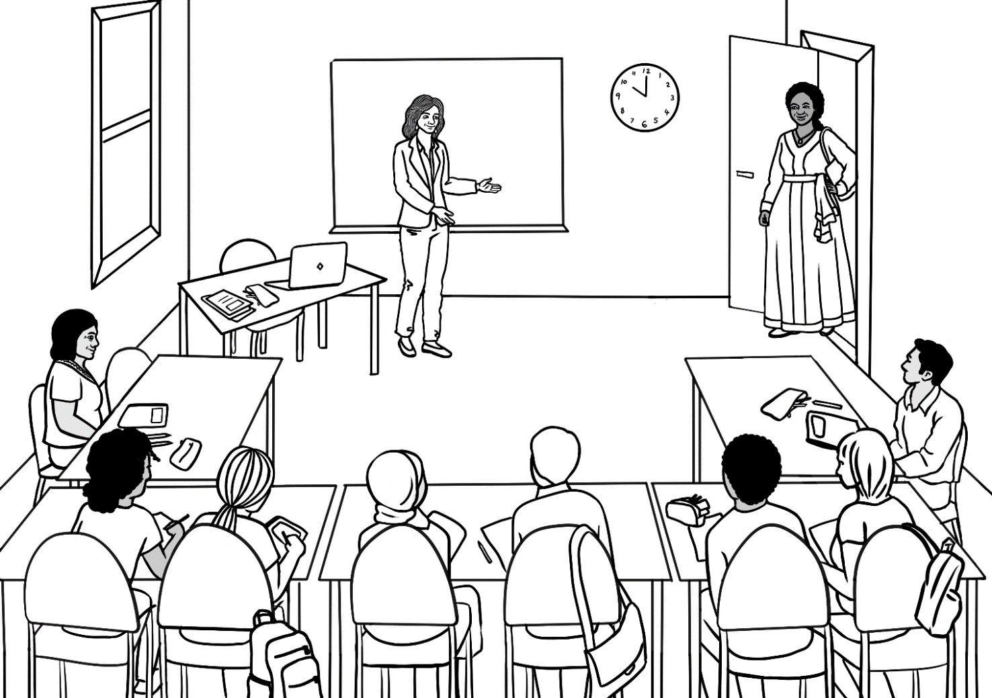

Good morning Rosie.

I am sorry. I am late.

Good morning Jamila.

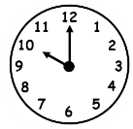



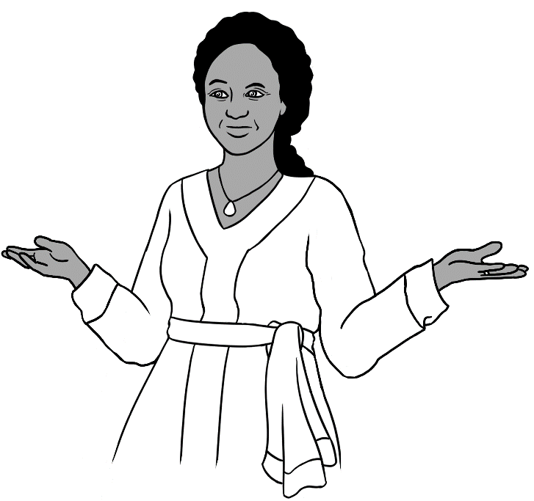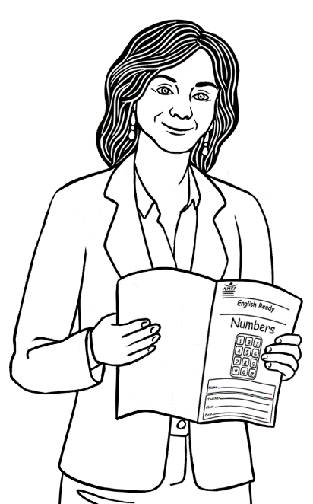

Page 13.

What page Rosie?







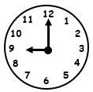

Come on time.

Come on time.

Our class

starts at 9.

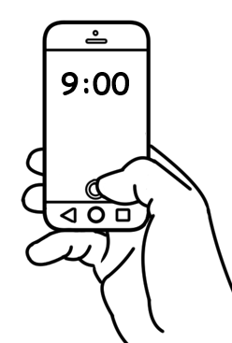



The next day

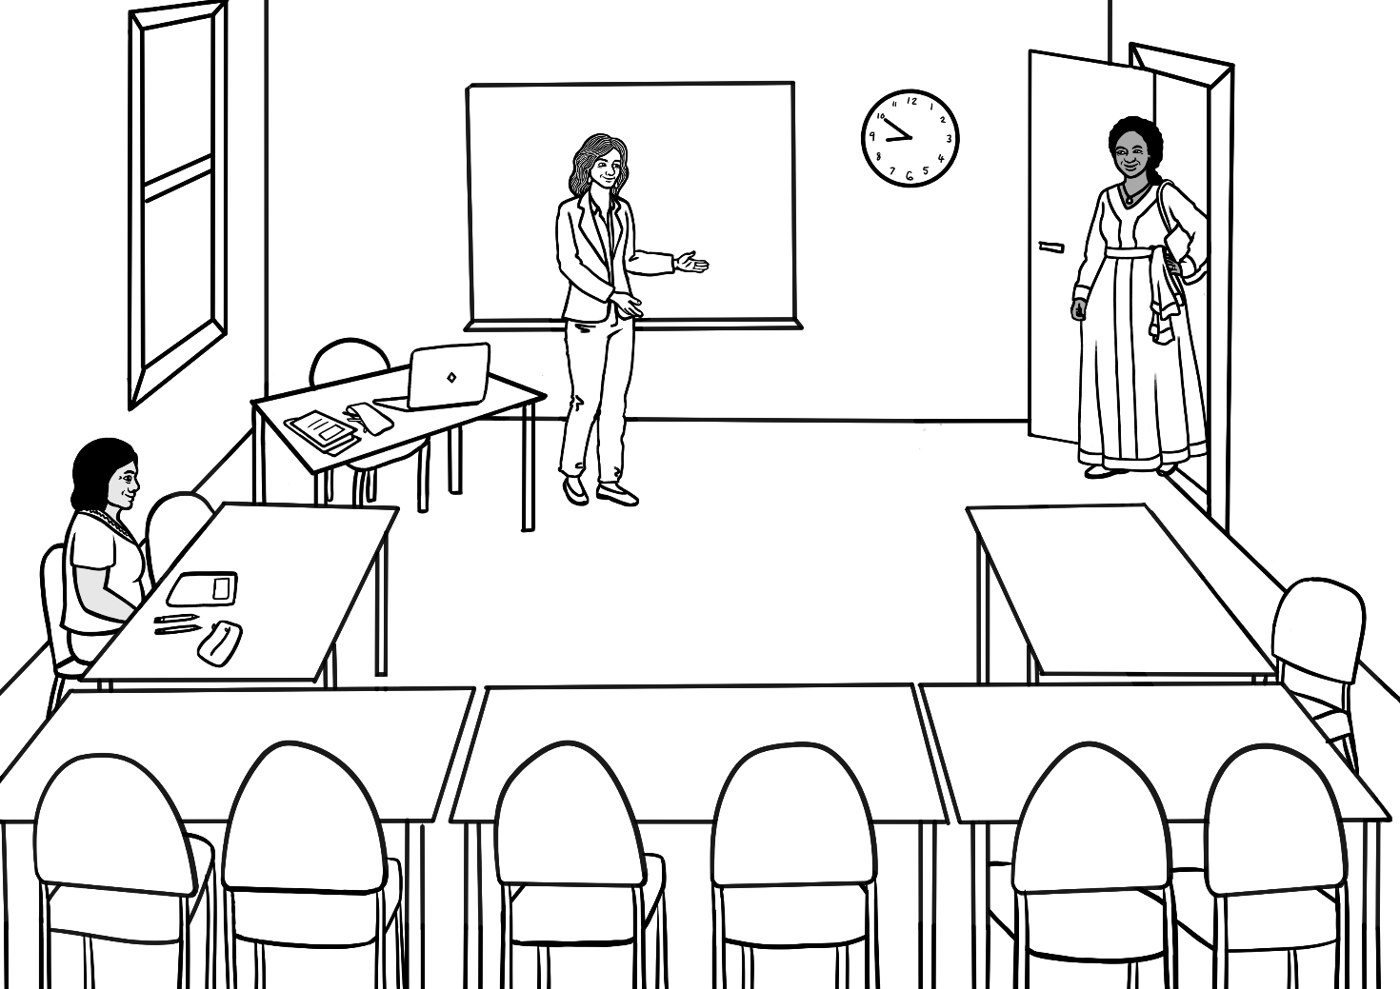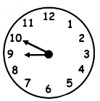

Good morning Jamila.

Good morning Rosie.

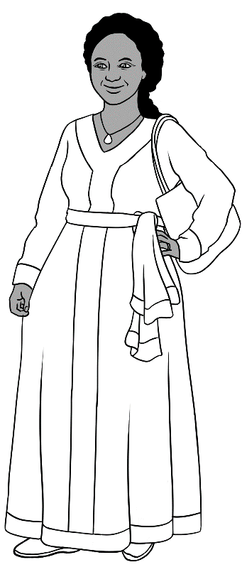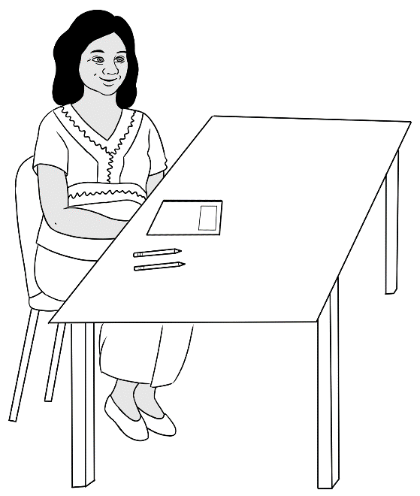

Hi Jamila.

Hello Zarni.

How are you?

Good thanks.



# Do you have a pencil?



|  |  |  |
| --- | --- | --- |
| 1. | 2. | 3. |
| pencil | pen | rubber |
|  |  |  |
| 4. | 5. | 6. |
| sharpener | notebook | ruler |
|  |  |  |
| 7. | 8. | 9. |
| pencil case | water bottle | glasses |



|  |
| --- |
| 1. pencil |
| 1. pen |
| 1. rubber |
| 1. sharpener |
| 1. notebook |
| 1. ruler |
| 1. pencil case |
| 1. water bottle |
| 1. glasses |

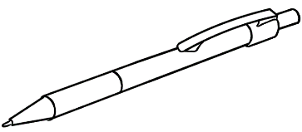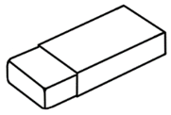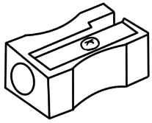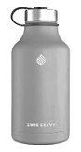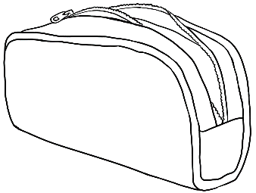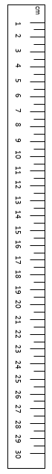



Do you have a pencil?

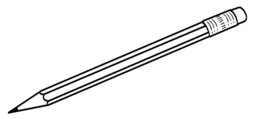

1. 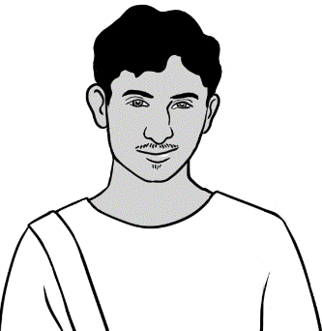

Yes.

Do you have a rubber?



1. 



No.



**🗸**



What do **you** have?

|  |  |
| --- | --- |
|  | ✓ |
| I have a pencil. |  |
| I have a rubber. |  |



**🗸**



What do **you** have?

|  |  |
| --- | --- |
|  | ✓ |
| 1. I have a pen. |  |
| 1. I have a sharpener. |  |
| 1. I have a notebook. |  |
| 1. I have a ruler. |  |
| 1. I have a pencil case |  |
| 1. I have a water bottle. |  |
| 1. I have glasses. |  |

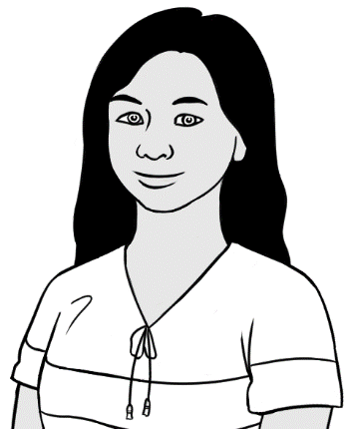



San’s pencil case

1. pencil



2. pen



3. rubber

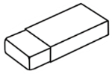

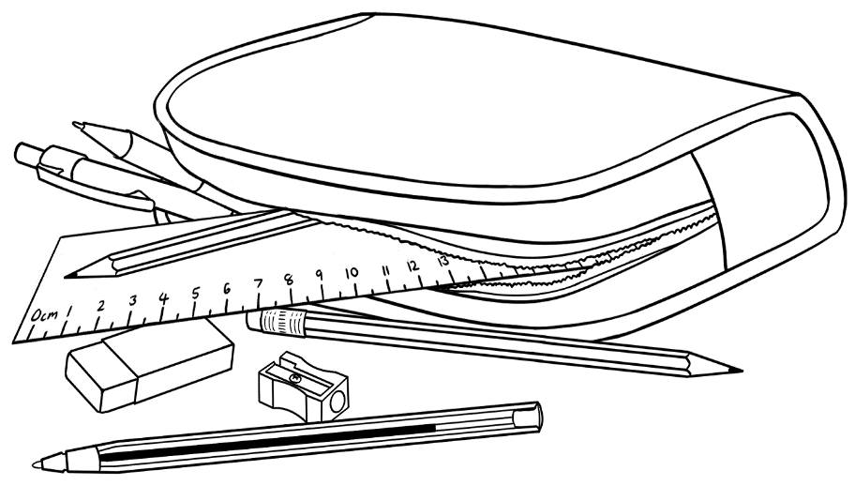

5. sharpener



4. ruler







|  |  |
| --- | --- |
| **p**encil | **p**en |
| __ encil | __ en |
| **r**ubber | **r**uler |
| __ ubber | __ uler |

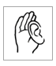

**🗸**

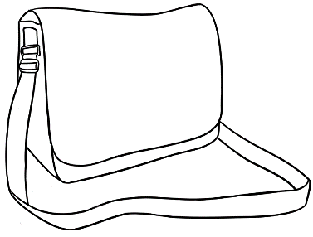

Rahim’s bag

|  |  |
| --- | --- |
|  | ✓ |
| 1. a pencil case |  |
| 1. a notebook |  |
| 1. a water bottle |  |
| 1. a phone |  |
| 1. glasses |  |
| 1. an apple |  |
| 1. an umbrella |  |



**🗸**

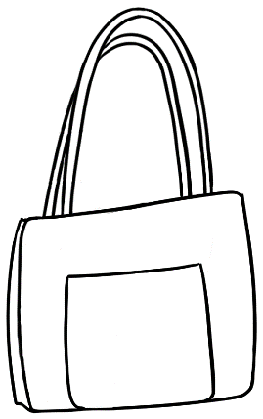

|  |  |
| --- | --- |
|  | ✓ |
| 1. a pencil case |  |
| 1. a notebook |  |
| 1. a water bottle |  |
| 1. a phone |  |
| 1. glasses |  |
| 1. an apple |  |
| 1. an umbrella |  |

San’s bag

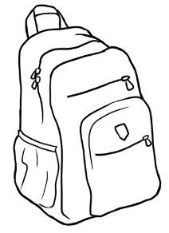



**🗸**



What is in **your** bag?

|  |  |
| --- | --- |
|  | ✓ |
| 1. a pencil case |  |
| 1. a notebook |  |
| 1. a water bottle |  |
| 1. a phone |  |
| 1. glasses |  |
| 1. an apple |  |
| 1. an umbrella |  |

# I want to learn English.



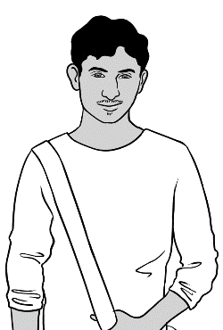

I want to be   
a painter.

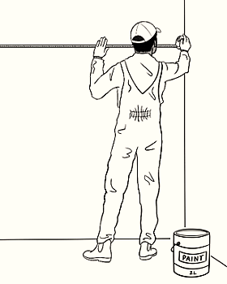

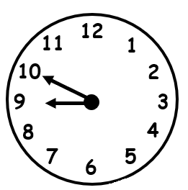

I come to class **before** 9 o’clock.

I have

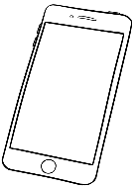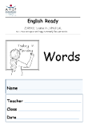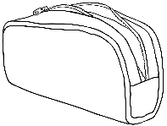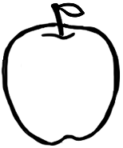


2. 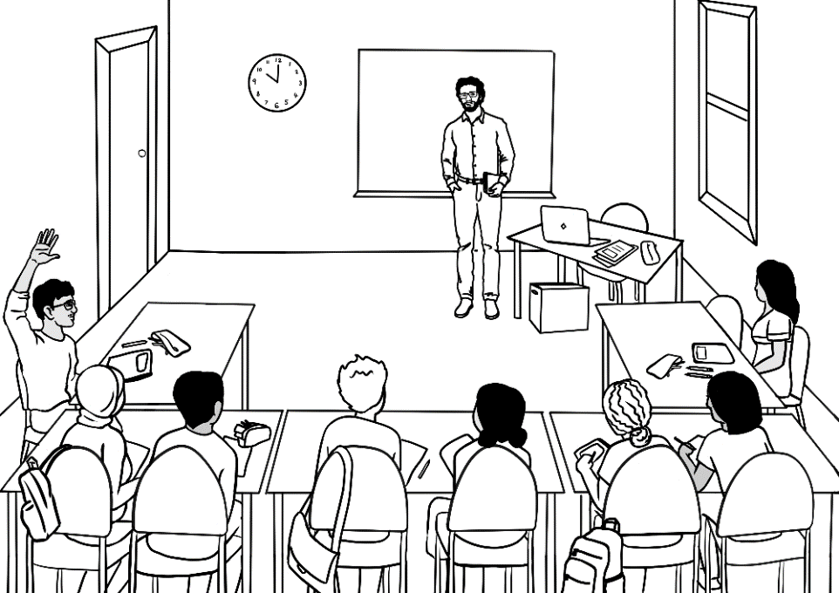

I ask questions.

Say it again please?



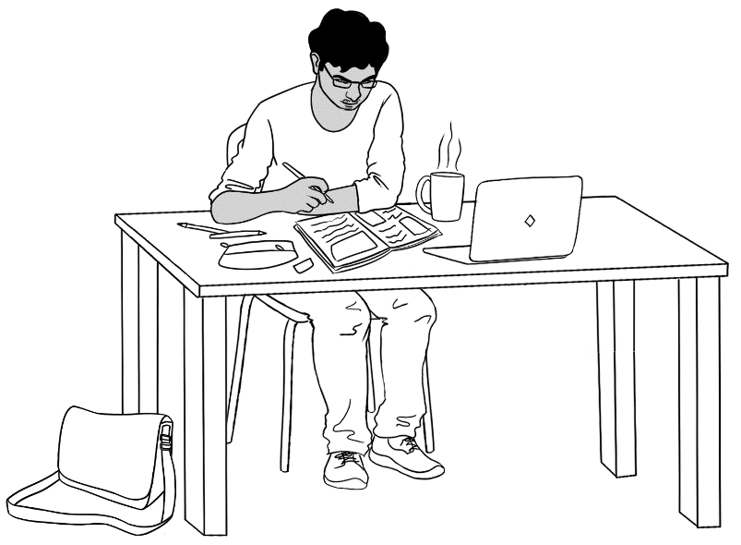

I do my homework.

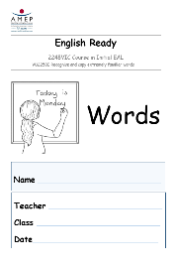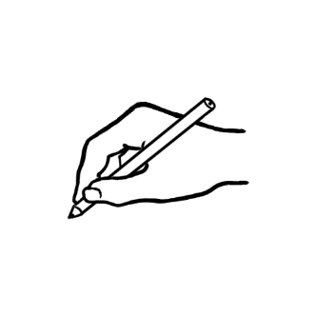

I copy words

into my notebook.

I talk to my friend in English.

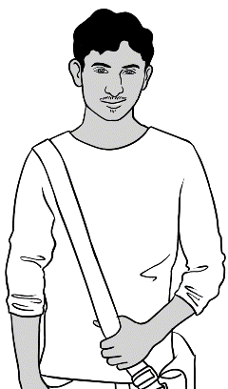

Hi Carim

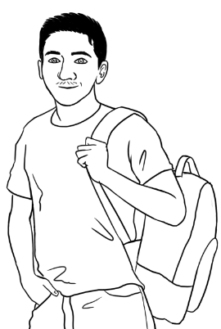

Hi Rahim. How was   
your weekend?

Good thanks.



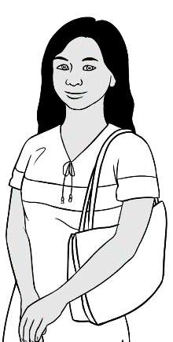

I want to work  
with children.

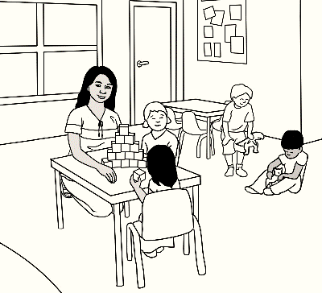

I ask for help.

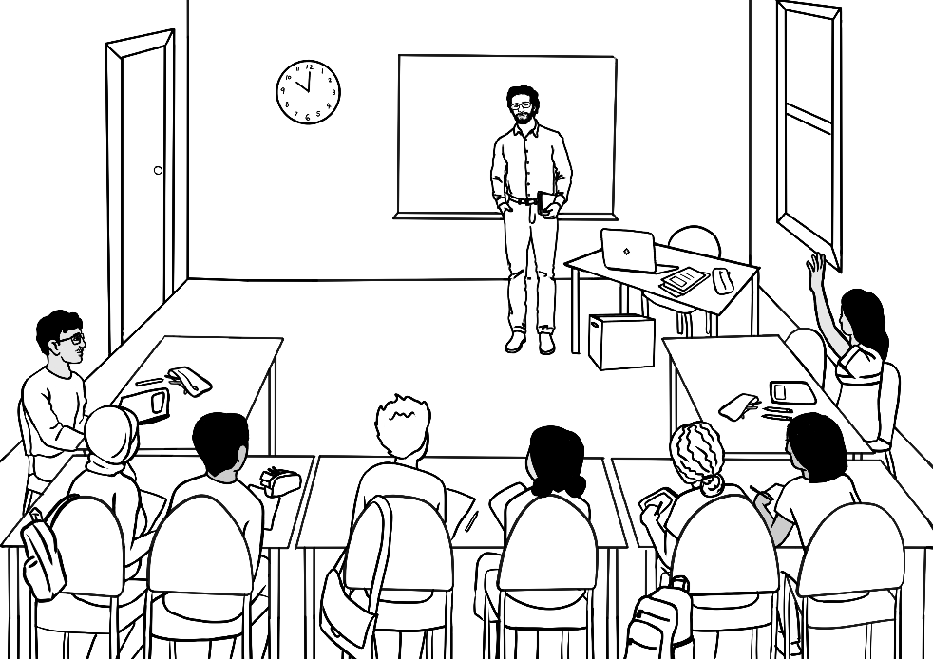

Can you help me   
please?

I record the teacher.

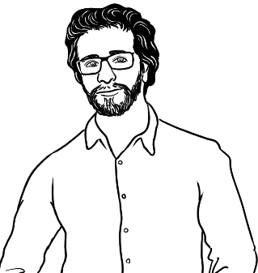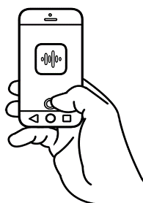

I have a pencil.





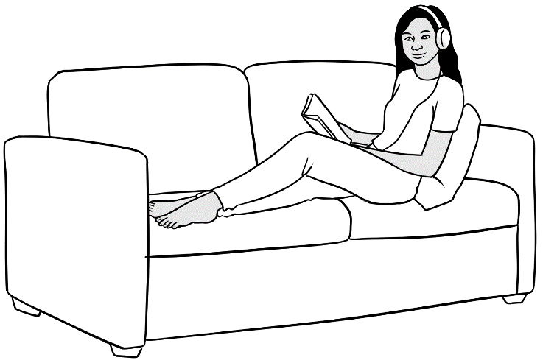

I listen to the teacher.

I repeat the words.

I have a pencil.



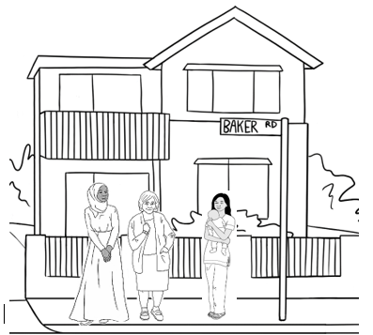

I talk to my neighbours.

I learn new words. day.



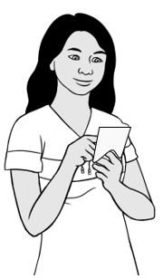

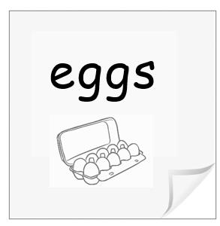

**e**ggs



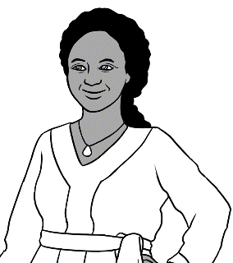

I want to be

a cook.

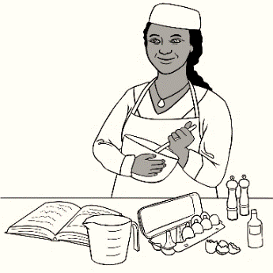

I say the sounds. I copy the sounds.

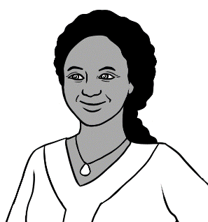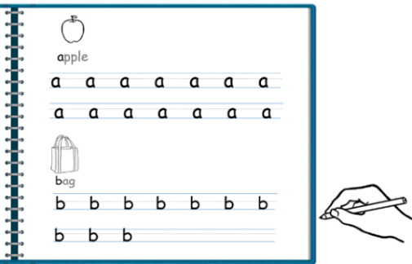

**a**pple **a**

**b**ag **b**.

I match the words. I say the words.

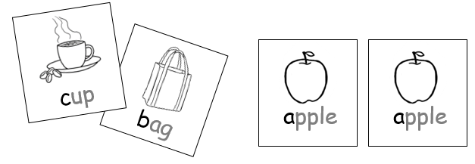

apple

I talk to my friend in English.

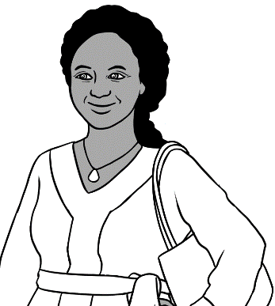

Hi Zarni.

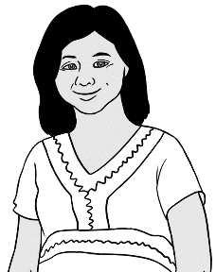

Hi Jamila.

She is sick today.

How is San?



I learn with a volunteer. I learn the sounds.

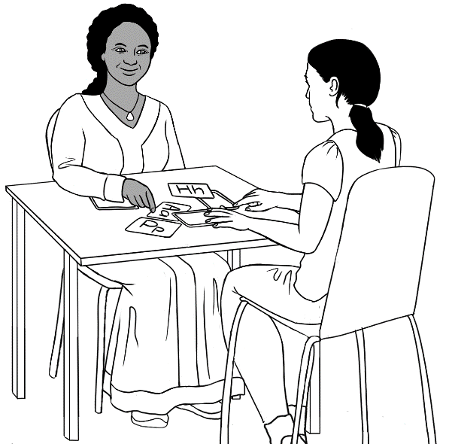

a

I use a laptop in the library.

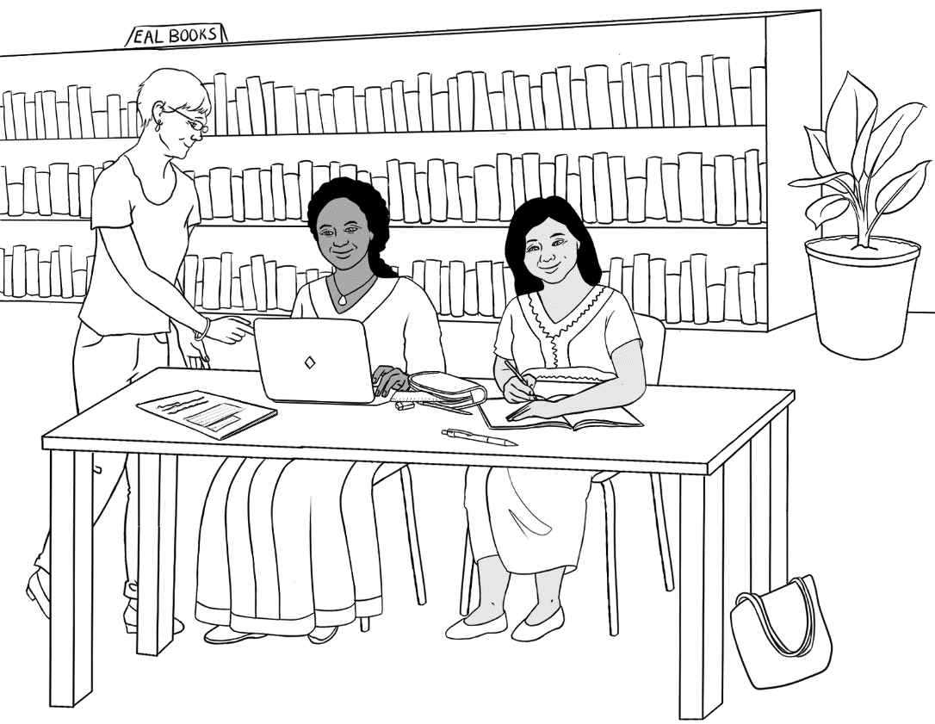

Can you help me please?



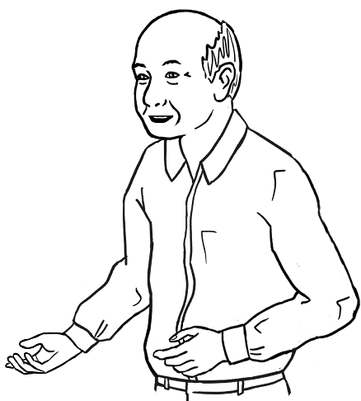

I want to talk to  
my grandchildren.

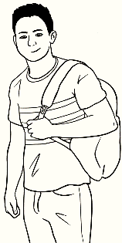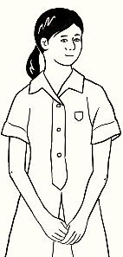

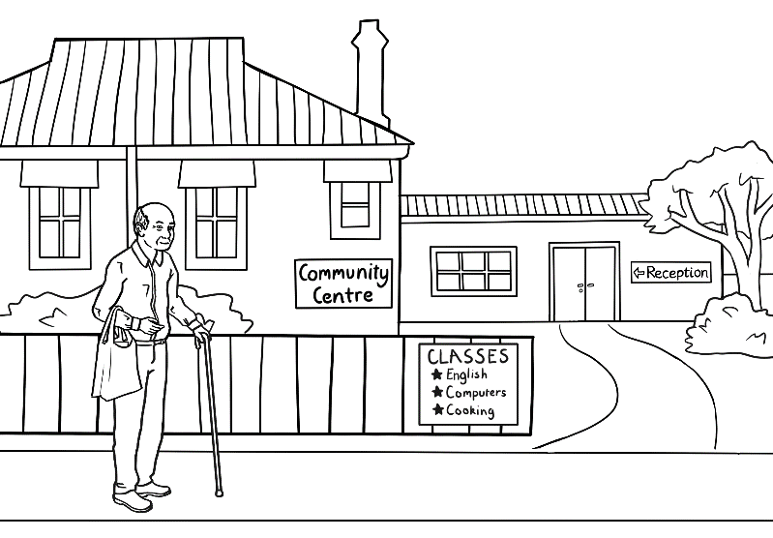

I go to class.

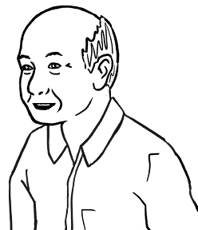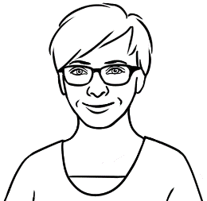

Monday

Monday

I listen and repeat.

I ask for help.

1. 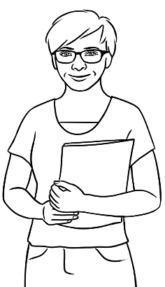

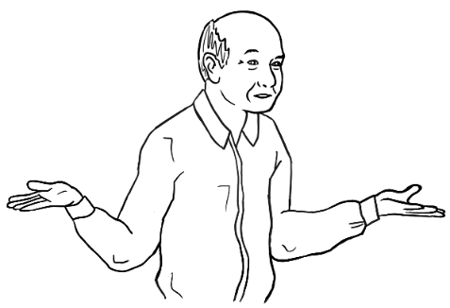

Can you help me   
please Wendy?



I go to the library.

1. 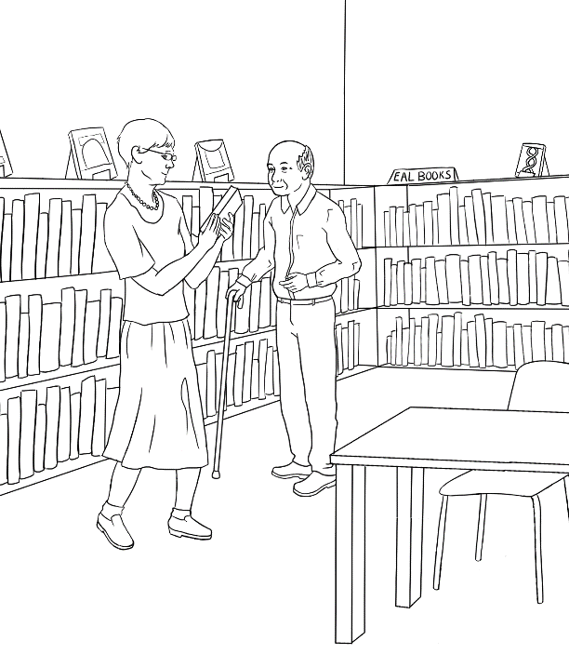

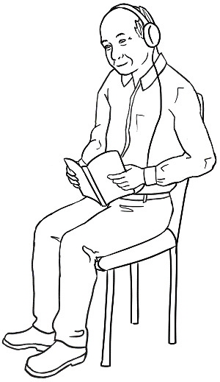

I read   
and listen.

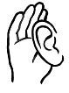

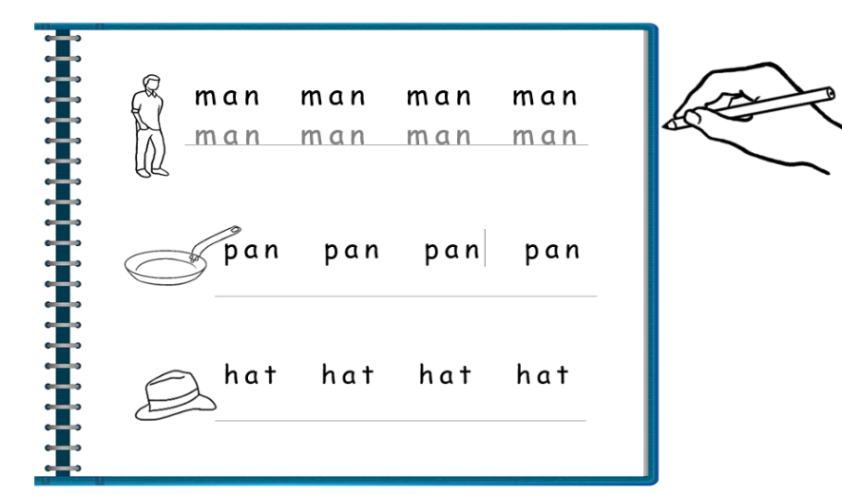

I do my homework.

I talk to my grandchildren.

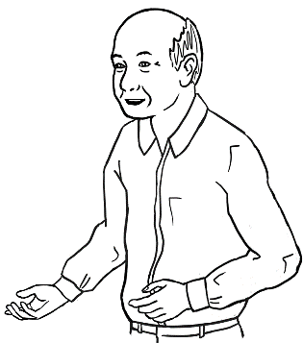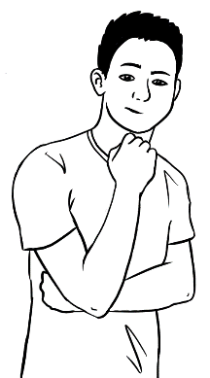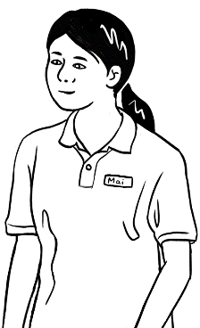

What do you do in class?

I use the computer.



**🗸**

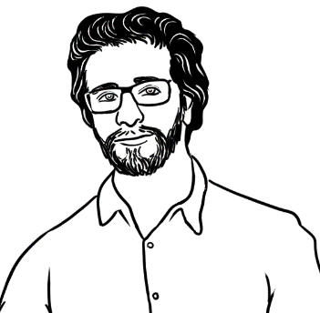

What do **you** do?

|  |  |
| --- | --- |
| 1 | 2 |
| 3 | 4 |
| 5 | 6 |





**🗸**

What do **you** do?

|  |  |
| --- | --- |
| 1 | 2 |
| 3 | 4 |
| 5 | 6 |

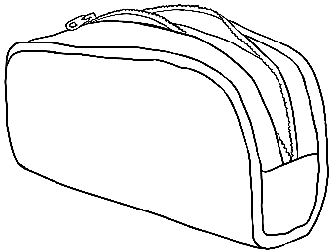

# Follow instructions.

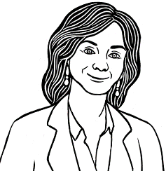

Circle **b**.



|  |  |  |  |  |  |  |
| --- | --- | --- | --- | --- | --- | --- |
| a | b | c | d | e | f | g |
| h | i | j | k | l | m |  |

|  |  |  |  |  |  |  |
| --- | --- | --- | --- | --- | --- | --- |
| n | o | p | q | r | s | t |
| u | v | w | x | y | z |  |



**🗸**



Tick **d**.

|  |  |  |  |  |  |  |  |  |  |  |  |  |
| --- | --- | --- | --- | --- | --- | --- | --- | --- | --- | --- | --- | --- |
| a | b | c | d | e | f | g | h | i | j | k | l | m |
|  |  |  | ✓ |  |  |  |  |  |  |  |  |  |



**🗸**



Tick **r**.

|  |  |  |  |  |  |  |  |  |  |  |  |  |
| --- | --- | --- | --- | --- | --- | --- | --- | --- | --- | --- | --- | --- |
| n | o | p | q | r | s | t | u | v | w | x | y | z |
|  |  |  |  | ✓ |  |  |  |  |  |  |  |  |







Colour **F** .

|  |  |  |  |  |  |  |  |  |  |  |  |  |
| --- | --- | --- | --- | --- | --- | --- | --- | --- | --- | --- | --- | --- |
| A | B | C | D | E | F | G | H | I | J | K | L | M |
|  |  |  |  |  |  |  |  |  |  |  |  |  |

|  |  |  |  |  |  |  |  |  |  |  |  |  |
| --- | --- | --- | --- | --- | --- | --- | --- | --- | --- | --- | --- | --- |
| N | O | P | Q | R | S | T | U | V | W | X | Y | Z |
|  |  |  |  |  |  |  |  |  |  |  |  |  |



|  |
| --- |
| 1. **a**pple **a** |
| 1. **b**ag **b** |
| 1. **c**up **c** |
| 1. **d**oor **d** |
| 1. **e**ggs **e** |
| 1. **f**amily **f** |
| 1. **g**lasses **g** |
| 1. **h**ome **h** |

c

e

a

b

h

f

g

d



|  |  |
| --- | --- |
| **i**nk  **i**nk | 10.  **j**acket ___acket |
| 11.  **k**ids  ___ids | 12.    **l**emon  ___emon |
| 13.  **m**an  ___ an | 14.  **n**o  ___o |
| 15.  **o**range  _­­__range | 16.  **p**encil  ___encil |
| 17.  **q**ueen  _­__ueen | 18.  **r**ubber  ___ubber |



|  |
| --- |
| 1. **s**tudent **s** |
| 1. **t**eacher **t** |
| 1. **u**mbrella **u** |
| 1. **v**an **v** |
| 1. **w**oman **w** |
| 1. bo**x** **x** |
| 1. **y**es **y** |
| 1. **z**ero **z** |











10.

|  |  |  |  |  |
| --- | --- | --- | --- | --- |
| 1 | 2 | 3 | 4 | 5 |
| 6 | 7 | 8 | 9 | 10 |
| 11 | 12 | 13 | 14 | 15 |
| 16 | 17 | 18 | 19 | 20 |
| 21 | 22 | 23 | 24 | 25 |
| 26 | 27 | 28 | 29 | 30 |
| 31 | 32 | 33 | 34 | 35 |
| 36 | 37 | 38 | 39 | 40 |
| 41 | 42 | 43 | 44 | 45 |
| 46 | 47 | 48 | 49 | 50 |

# I am sick.



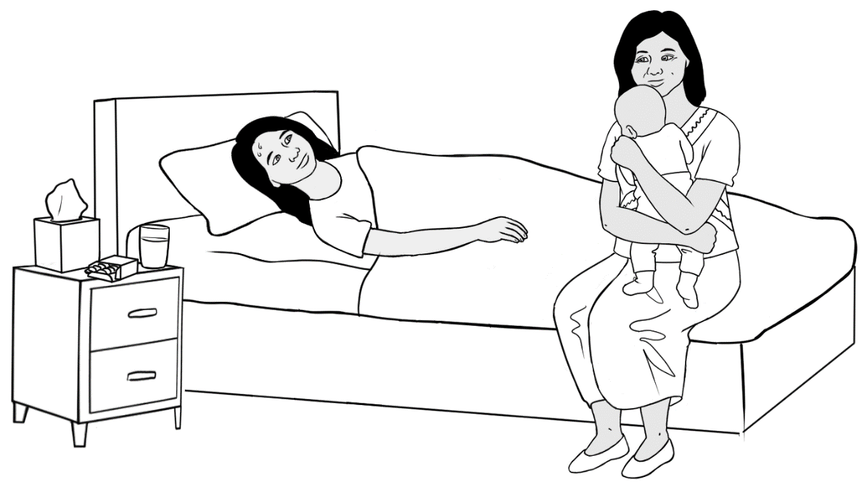

I am sick.

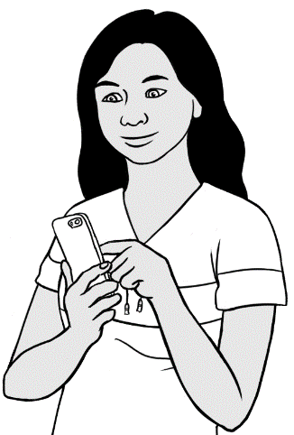

I text my teacher.

Hi Peter

I am sick.

San



Hi Peter

H i __ eter

I am sick.

__ __ m ___ ick.

San

__ an



I am sick.

__ ______ _________ .

I am sick.

__ ______ _________ .



Text the teacher.



|  |  |  |  |  |  |  |  |  |  |
| --- | --- | --- | --- | --- | --- | --- | --- | --- | --- |
| 0 | 1 | 2 | 3 | 4 | 5 | 6 | 7 | 8 | 9 |



My teacher’s phone number is

|  |  |  |  |  |  |  |  |  |  |  |  |
| --- | --- | --- | --- | --- | --- | --- | --- | --- | --- | --- | --- |
|  |  |  |  |  |  |  |  |  |  |  |  |







Hi ________________

I am sick.

__________________



Bye.

See you soon.

Bye.

See you later.

Bye.

See you tomorrow.

