

**English Ready**

22482VIC Course in Initial EAL  
VU22578 Recognise letters of the alphabet and their sounds

Letter sounds

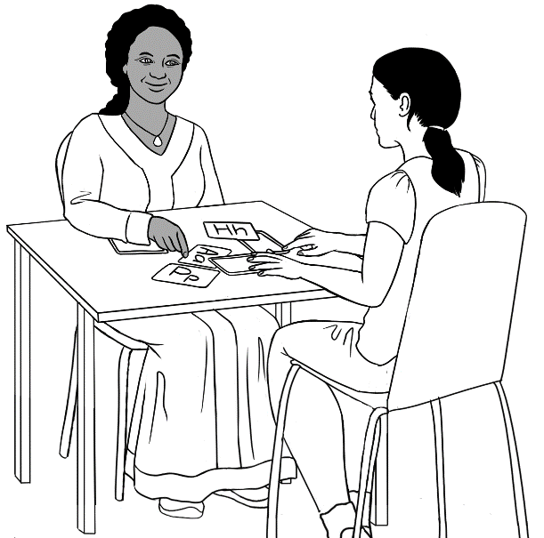

apple a

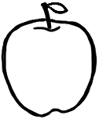

**Name** _____________________________________________

**Teacher** _________________________________________   
**Class** ______________________________________________

**Date**________________________________________________

This book provides additional work on sounds   
to support the **Letter Names** book.

**Design team:** Vicki Hambling, Sue Paull, Frida Dean, Glenise Kleehammer and Mary Wallace

**Illustrations:** Madelena Scott  
 **Acknowledgements:** The design team would like to thank the AMEP service providers and practitioners who participated in the trial and gave valuable feedback. The team would also like to acknowledge the use of the EAL Framework which underpins the design of this book.

Copyright of the EAL Framework is reserved to the Crown in the right of the State of Victoria. © State of Victoria (Department of Education and Training) 2018.  
__________________________________________________________________________________

This English Ready Resource is licensed under a Creative Commons Attribution-NoDerivs 3.0 Australia licence (More information is available [here](http://creativecommons.org/licenses/by-nd/3.0/au/)). You are free to use, copy and distribute to anyone in its original form as long as you attribute Department of Home Affairs as the author and you license any derivative work you make available under the same licence.

© Commonwealth of Australia 2023



With the exception of the Commonwealth Coat of Arms, the department’s logo, any material protected by a trade mark and where otherwise noted all material presented in this document is provided under a Creative Commons Attribution 4.0 International (<https://creativecommons.org/licenses/by/4.0/>) licence.

The details of the relevant licence conditions are available on the Creative Commons website (accessible using the links provided) as is the full legal code for the CC BY 4.0 licence. (<https://creativecommons.org/licenses/by/4.0/legalcode>).

Use of all or part of this document must include the following attribution:   
© Commonwealth of Australia 2023

As far as practicable, material for which the copyright is owned by a third party will be clearly labelled.  The department has made all reasonable efforts to ensure that this material has been reproduced in this document with the full consent of the copyright owners.

Copyright requests and enquiries concerning usage not addressed by the CC BY 4.0 licence should be addressed to: [*comms@homeaffairs.gov.au*](mailto:comms@homeaffairs.gov.au) *at the Department of Home Affairs.*

The terms of use for the Commonwealth Coat of Arms are available from the [It's an Honour](http://www.itsanhonour.gov.au/) website.

Where a copyright owner, other than the Commonwealth, is identified with respect to this material, please contact that third party copyright owner directly to seek permission.





**Table of contents**

1 Instructions 2

2 The first sounds 3

3 Practise the first sounds. 9

4 Consonant sounds 22

5 Vowel sounds 36

6 Listen to the sounds. 46

7 Consonant blends 48

8 Two consonants make one sound. 57

# Instructions

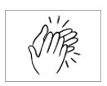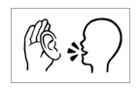

|  |  |
| --- | --- |
| 1.  listen | 2.  say |
| 3.  copy | 4.  match |
| 5.  colour | 6.  circle |
| 7.  trace | 8.  tick  🗸 |
| 9.  point | 10.  clap |

# The first sounds

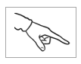

|  |  |  |
| --- | --- | --- |
| a | **a**pple | a |
| b | **b**ag | b |
| c | **c**up | c |
| d | **d**oor | d |



|  |  |  |
| --- | --- | --- |
| e | **e**gg | e |
| f | **f**amily | f |
| g | **g**lasses | g |
| h | **h**ome | h |

|  |  |  |
| --- | --- | --- |
| i | **i**nk | i |
| j | **j**acket | j |
| k | **k**ids | k |
| l | **l**emon | l |
| m | **m**an | m |



|  |  |  |
| --- | --- | --- |
| n | **n**o | n |
| o | **o**range | o |
| p | **p**encil | p |
| q | **q**ueen | q |

|  |  |  |
| --- | --- | --- |
| r | **r**ubber | r |
| s | **s**tudent | s |
| t | **t**eacher | t |
| u | **u**mbrella | u |
| v | **v**an | v |



|  |  |  |
| --- | --- | --- |
| w | **w**oman | w |
| x | bo**x** | x |
| y | **y**es  **0** | y |
| z | **z**ero | z |

# Practise the first sounds.

`



|  |  |  |  |
| --- | --- | --- | --- |
| a |  | apple | a |
| b |  | bag | b |
| c |  | cup | c |

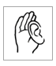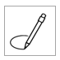

|  |  |  |
| --- | --- | --- |
| a | b | c |



|  |  |  |  |
| --- | --- | --- | --- |
| d |  | door | d |
| e |  | egg | e |
| f |  | family | f |
| g |  | glasses | g |



|  |  |  |  |
| --- | --- | --- | --- |
| d | e | f | g |

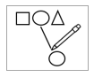

|  |
| --- |
| cup |
| door |
| apple |
| bag |
| family |
| glasses |
| egg |



|  |  |  |  |
| --- | --- | --- | --- |
| h |  | home | h |
| i |  | ink | i |
| j |  | jacket | j |
| k |  | kids | k |



|  |  |  |  |
| --- | --- | --- | --- |
| h | i | j | k |



|  |  |  |  |
| --- | --- | --- | --- |
| l |  | lemon | l |
| m |  | man | m |
| n |  | no | n |



|  |  |  |
| --- | --- | --- |
| l | m | n |



|  |
| --- |
| jacket |
| lemon |
| home |
| man |
| ink |
| no |
| kids |



|  |  |  |  |
| --- | --- | --- | --- |
| o |  | orange | o |
| p |  | pencil | p |
| q |  | queen | q |



|  |  |  |
| --- | --- | --- |
| o | p | q |



|  |  |  |  |
| --- | --- | --- | --- |
| r |  | rubber | r |
| s |  | student | s |
| t |  | teacher | t |



|  |  |  |
| --- | --- | --- |
| r | s | t |



|  |
| --- |
| pencil |
| rubber |
| teacher |
| orange |
| queen |
| student |



|  |  |  |  |
| --- | --- | --- | --- |
| u |  | umbrella | u |
| v |  | van | v |
| w |  | woman | w |



|  |  |  |
| --- | --- | --- |
| u | v | w |



|  |  |  |  |
| --- | --- | --- | --- |
| x |  | box | x |
| y |  | yes | y |
| z | **0** | zero | z |



|  |  |  |
| --- | --- | --- |
| x | y | z |



|  |
| --- |
| woman |
| umbrella |
| box  **0** |
| zero |
| van |
| yes |

|  |  |  |  |  |  |  |
| --- | --- | --- | --- | --- | --- | --- |
| a |  | m | n | o |  | Finish |
| b |  | l |  | p |  | z |
| c |  | k |  | q |  | y |
| d |  | j |  | r |  | x |
| e |  | i |  | s |  | w |
| f | g | h |  | t | u | v |

Start

# Consonant sounds



|  |  |  |
| --- | --- | --- |
| b | bag | bed |
|  |  |  |
| c | cup | cat |
|  |  |  |
| d | door | dog |

|  |  |  |
| --- | --- | --- |
|  |  |  |
| bed | cat | dog |
| ___ed | ___at | ___ og |
| ___ed | ___at | ___og |
| ___ed | ___at | ___og |

4.



5.

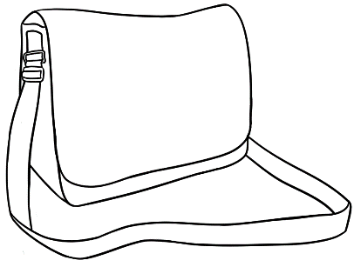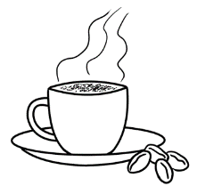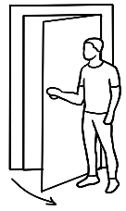

b

c

d

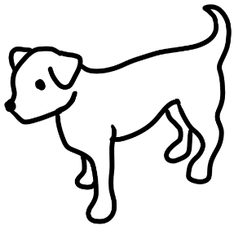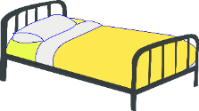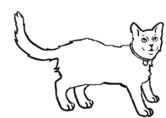

|  |  |  |
| --- | --- | --- |
|  | family | fan |
|  |  |  |
| g | glasses  f | gate |
|  |  |  |
| h | home | Shape  Description automatically generated with low confidencehat |
|  |  |  |



4.



|  |  |  |
| --- | --- | --- |
|  |  |  |
| fan | gate | Shape  Description automatically generated with low confidencehat |
| ___an | ___ate | ___at |
| ___an | ___ate | ___at |
| ___an | ___ate | ___at |

5.

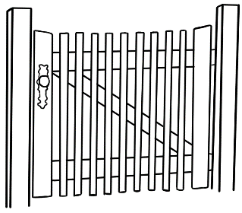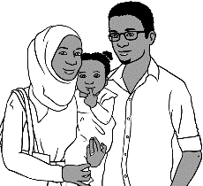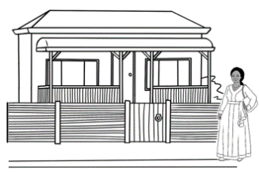

f

g

h

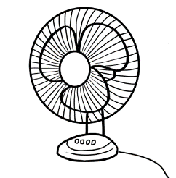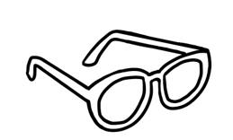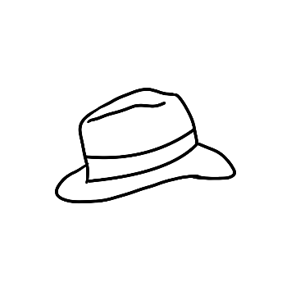

|  |  |  |  |
| --- | --- | --- | --- |
| j | jacket | jug | |
|  |  |  | |
| k | kids | key | |
|  |  |  | |
| l | lemon | | lips | |
|  |  | |  |

4.



|  |  |  |
| --- | --- | --- |
|  |  |  |
| jug | key | lips |
| ___ug | ___ey | ___ips |
| ___ug | ___ey | ___ips |
| ___ug | ___ey | ___ips |

5.

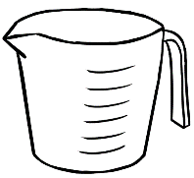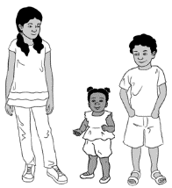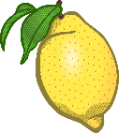

j

k

l

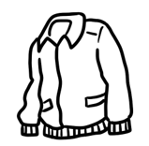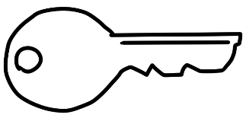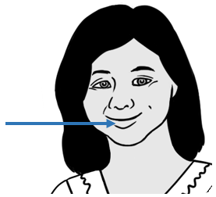

|  |  |  |  |
| --- | --- | --- | --- |
| m | man | mop | |
|  |  |  | |
| n | no | net | |
|  |  |  | |
| p | pencil | | pizza | |
|  |  | |  |

|  |  |  |
| --- | --- | --- |
|  |  |  |
| mop | net | pizza |
| ___op | ___et | ___izza |
| ___op | ___et | ___izza |
| ___op | ___et | ___izza |

4.



5.



m

n

p

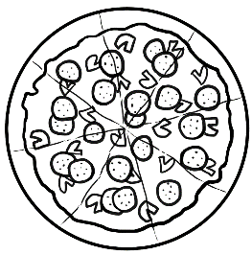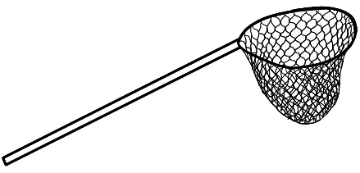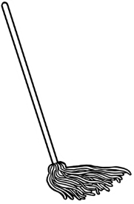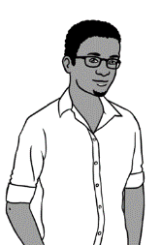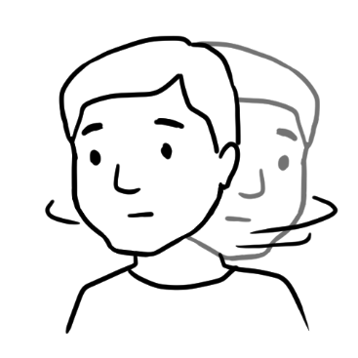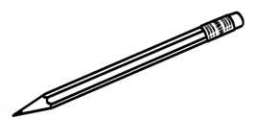

|  |  |  |  |
| --- | --- | --- | --- |
| q | queen | question | |
|  |  |  | |
| r | rubber | run | |
|  |  |  | |
| s | student | | sun | |
|  |  | |  |



4.



|  |  |  |
| --- | --- | --- |
|  |  |  |
| question | run | sun |
| ___uestion | ___un | ___un |
| ___uestion | ___un | ___un |
| ___uestion | ___un | ___un |

5.



q

r

s

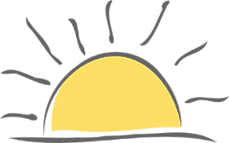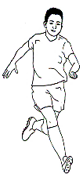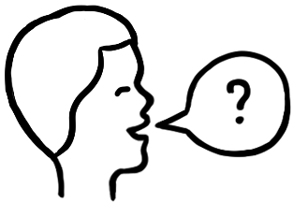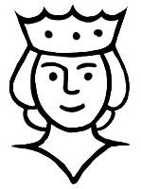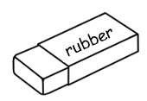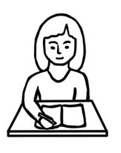

|  |  |  |  |
| --- | --- | --- | --- |
| t | teacher | time | |
|  |  |  | |
| v | van | |  |  |  |  |  | | --- | --- | --- | --- | --- | | a | e | i | o | u |   vowels | |
|  |  |  | |
| w | woman | | window |
|  |  | |  |

4.



|  |  |  |
| --- | --- | --- |
|  |  |  |
| time | van | window |
| ___ime | ___an | ___indow |
| ___ime | ___an | ___indow |
| ___ime | ___an | ___indow |

5.



t

v

w

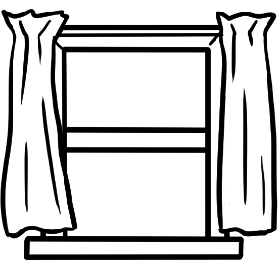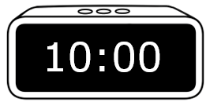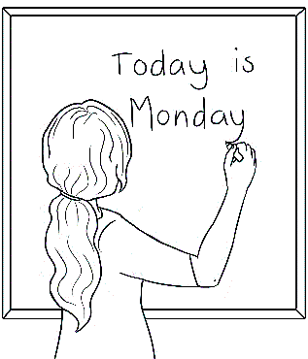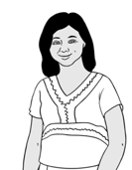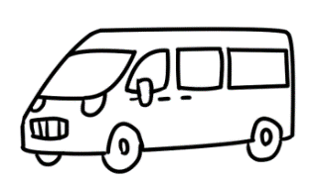

|  |  |  |  |  |
| --- | --- | --- | --- | --- |
| a | e | i | o | u |



|  |  |  |  |
| --- | --- | --- | --- |
| x | box | fox | |
|  |  |  | |
| y | yes | yam | |
|  | **0** |  | |
| z | zero | | zip |
|  |  | |  |

|  |  |  |
| --- | --- | --- |
|  |  |  |
| fox | yam | zip |
| fo___ | ___am | ___ip |
| fo___ | ___am | ___ip |
| fo___ | ___am | ___ip |

5.



4.



x

y

z

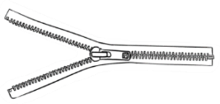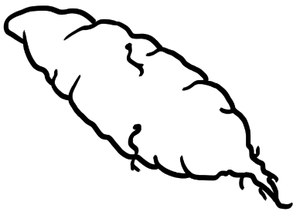

**0**

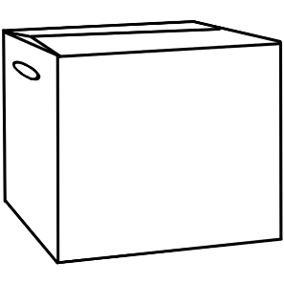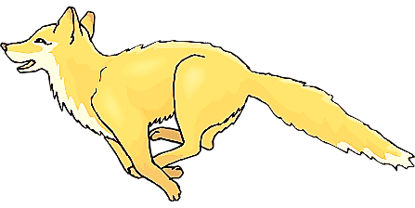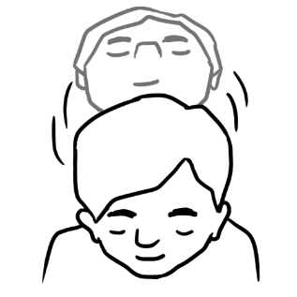

# Vowel sounds

1. 

**a**pple **a**

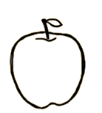

|  |  |  |  |  |  |  |  |  |  |
| --- | --- | --- | --- | --- | --- | --- | --- | --- | --- |
|  | hat | h | | a | | t | | hat | |
|  |  |  |  | |  | |  | |
|  | cat | c | | a | | t | | cat | |
|  |  |  |  | |  | |  | |
|  | fan | f | | a | | n | | fan | |
|  |  |  |  | |  | |  | |
|  | man | m | | a | | n | | man | |



hat cat  
 h_t c_t

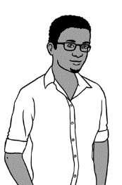

 fan man  
 f_n m_n





hat cat

________ ________



fan man

________ _ _________



|  |  |  |  |  |  |
| --- | --- | --- | --- | --- | --- |
| hat | h | u | a | p | t |
| cat | e | c | a | d | t |
| fan | l | r | f | a | n |
| man | m | a | w | o | n |



**e**gg **e**

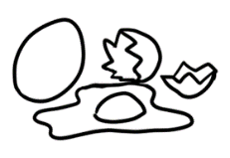

|  |  |  |  |  |  |  |  |  |  |
| --- | --- | --- | --- | --- | --- | --- | --- | --- | --- |
|  | bed | b | | e | | d | | bed | |
|  |  |  |  | |  | |  | |
|  | red | r | | e | | d | | red | |
|  |  |  |  | |  | |  | |
|  | pen | p | | e | | n | | pen | |
|  | **10** |  |  | |  | |  | |
|  | ten | t | | e | | n | | ten | |



2.



bed red  
 b_d r_d

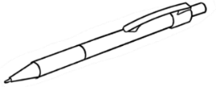 pen ten  
 p_n t_n

**10**





bed red

________ ________

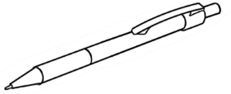pen ten

_________ ________



|  |  |  |  |  |  |
| --- | --- | --- | --- | --- | --- |
| bed | l | b | e | r | d |
| red | r | e | a | d | b |
| pen | l | p | o | e | n |
| ten  **10** | m | t | e | a | n |

1. 

**i**nk **i**

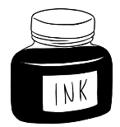

|  |  |  |  |  |  |  |  |  |
| --- | --- | --- | --- | --- | --- | --- | --- | --- |
|  | in |  | i | | n | | in | |
|  |  |  |  |  | |  | |
|  | bin | b | i | | n | | bin | |
|  |  |  |  |  | |  | |
|  | lip | l | i | | p | | lip | |
|  |  |  |  |  | |  | |
|  | zip | z | i | | p | | zip | |



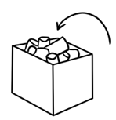

in bin  
_n b_n



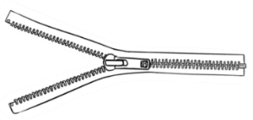lip zip

l_p z_p





inbin

_________ _________

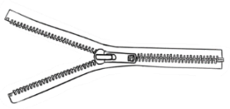lip zip

_________ __________

|  |  |  |  |  |  |
| --- | --- | --- | --- | --- | --- |
| in | l | i | a | k | n |
| bin | b | c | i | n | d |
| lip | p | f | l | i | p |
| zip | z | i | w | p | n |



.

**o**range **o**

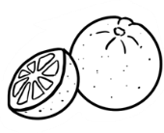

|  |  |  |  |  |  |  |  |  |  |  |  |  |  |
| --- | --- | --- | --- | --- | --- | --- | --- | --- | --- | --- | --- | --- | --- |
|  | old |  | | o | | l | | d | | old | | | |
|  |  |  |  | |  | |  | |  | | |
|  | cold | c | | o | | l | | d | | | cold | | | |
|  |  |  |  | |  | |  | |  | | |
|  | mop |  | | m | | o | | p | | mop | | |
|  |  |  |  | |  | |  | |  | | |
|  | stop | s | | t | | o | | p | | stop | | | |



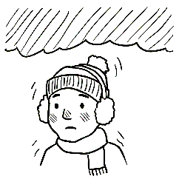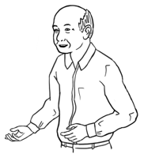old cold

_ld c_ld

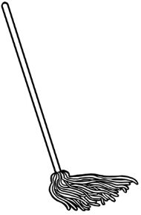

mop stop

m_p st_p





old cold

___________ ___________

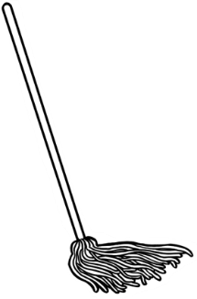

mop stop

___________ _____________



|  |  |  |  |  |  |
| --- | --- | --- | --- | --- | --- |
| old | a | o | l | p | d |
| cold | c | m | o | l | d |
| mop | l | m | o | a | p |
| Shape, rectangle  Description automatically generatedstop | s | t | w | o | p |

**u**mbrella **u**



1. 

|  |  |  |  |  |  |  |  |  |
| --- | --- | --- | --- | --- | --- | --- | --- | --- |
|  | up |  | u | | p | | up | |
|  |  |  |  |  | |  | |
|  | cup | c | u | | p | | cup | |
|  |  |  |  |  | |  | |
|  | run | r | u | | n | | run | |
|  |  |  |  |  | |  | |
|  | sun | s | u | | n | | sun | |



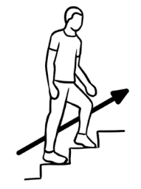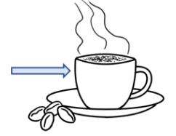up cup

_p c_p

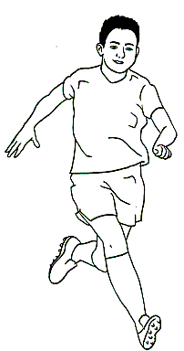run sun

r_n s_n



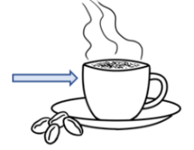

 up cup

__________ __________



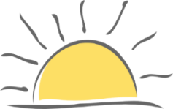run sun

___________ __________



|  |  |  |  |  |  |
| --- | --- | --- | --- | --- | --- |
| up | a | u | v | p | c |
| cup | c | i | u | d | p |
| run | s | r | b | u | n |
| sun | s | u | m | o | n |

# Listen to the sounds.



|  |  |  |
| --- | --- | --- |
|  | **b**ag  **b** | **c**up  **c** |
|  | **d**og  **d** | **f**amily  **f** |
|  | **g**ate  **g** | **l**emon  **l** |
|  | **m**op  **m** | **d**oor  **d** |
|  | **b**in  **b** | **r**ubber  **r** |
|  | **v**an  **v** | **c**old  **c** |



|  |  |  |
| --- | --- | --- |
|  | **b**ed  **b** | **Shape  Description automatically generated with low confidence h**at  **h** |
|  | **c**at  **c** | **r**ed  **r** |
|  | **r**un  **r** | **f**an  **f** |
|  | **n**o  **n** | **s**un  **s** |
|  | **y**am  **y** | **w**indow  **w** |
|  | **z**ip  **z** | **m**an  **m** |

# Consonant blends



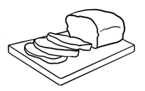

**b r**

**br**

|  |  |  |
| --- | --- | --- |
|  |  |  |
| bread | brush | broom |
| __ __ead | __ __ush | __ __oom |
| __ __ead | __ __ ush | __ __oom |
| __ __ead | __ __ ush | __ __ oom |

|  |  |  |  |  |
| --- | --- | --- | --- | --- |
| br | br | br | br | br |
| br |  |  |  |  |



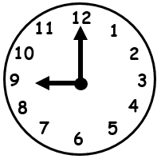

**c l**

**cl**

|  |  |  |  |  |
| --- | --- | --- | --- | --- |
| cl | cl | cl | cl | cl |
| cl |  |  |  |  |



|  |  |  |
| --- | --- | --- |
|  |  |  |
| clock | clap | close |
| __ __ock | __ __ap | __ __ose |
| __ __ock | __ __ ap | __ __ose |
| __ __ock | __ __ ap | __ __ose |



|  |  |
| --- | --- |
| 1. A picture containing text, appliance     Description automatically generatedbrush | clock |
| 1. broom | clap |
| 1. bread | close |
| 1. broom | clock |
| 1. bread | clap |



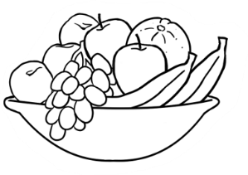

**f r**

**fr**

|  |  |  |  |  |
| --- | --- | --- | --- | --- |
| fr | fr | fr | fr | fr |
| fr |  |  |  |  |



|  |  |  |
| --- | --- | --- |
|  |  |  |
| fruit | friend | Friday |
| __ __uit | __ __iend | __ __iday |
| __ __uit | __ __ iend | __ __iday |
| __ __uit | __ __ iend | __ __iday |



**s t**

**st**

|  |  |  |  |  |
| --- | --- | --- | --- | --- |
| st | st | st | st | st |
| st |  |  |  |  |

|  |  |  |
| --- | --- | --- |
|  |  |  |
| stop | stand | study |
| __ __op | __ __and | __ __udy |
| __ __op | __ __ and | __ __udy |
| __ __op | __ __ and | __ __udy |



1. 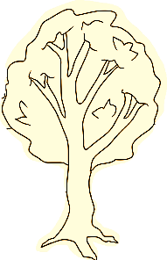



**t r**

**tr**

|  |  |  |  |  |
| --- | --- | --- | --- | --- |
| tr | tr | tr | tr | tr |
| tr |  |  |  |  |



|  |  |  |
| --- | --- | --- |
|  |  |  |
| tree | train | truck |
| __ __ee | __ __ain | __ __uck |
| __ __ee | __ __ ain | __ __uck |
| __ __ee | __ __ ain | __ __uck |



|  |  |
| --- | --- |
| 1. friend | stand |
| 1. train | fruit |
| 1. Shape, rectangle     Description automatically generatedstop | truck |
| 1. friend | study |
| 1. tree | Friday |



|  |  |
| --- | --- |
| clock  __ock |  |
| tree  __ee |  |
| bread  __ead |  |
| fruit  __uit |  |
| stand  __and |  |

br

cl

st

tr

fr



|  |  |
| --- | --- |
| stop  __op |  |
| brush  __ush |  |
| train  __ain |  |
| friend  __iend |  |
| clap  __ap |  |

br

cl

st

tr

fr

# Two consonants make one sound.



1. A picture containing clipart

   Description automatically generated

**ch**

**ch**

**ch**

|  |  |  |  |  |
| --- | --- | --- | --- | --- |
| ch | ch | ch | ch | ch |
| ch |  |  |  |  |



|  |  |  |
| --- | --- | --- |
|  |  |  |
| chips | chicken | chair |
| __ __ips | __ __icken | __ __air |
| __ __ips | __ __ icken | __ __air |
| __ __ips | __ __ icken | __ __air |



1. 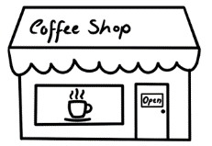

**sh**

**sh**

**sh**

|  |  |  |  |  |
| --- | --- | --- | --- | --- |
| sh | sh | sh | sh | sh |
| sh |  |  |  |  |



|  |  |  |
| --- | --- | --- |
|  |  |  |
| shop | shoe | fish |
| __ __op | __ __oe | fi __ __ |
| __ __op | __ __ oe | fi __ __ |
| __ __op | __ __ oe | fi __ __ |



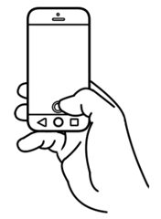

**ph**

**ph**

**ph**

|  |  |  |  |  |
| --- | --- | --- | --- | --- |
| ph | ph | ph | ph | ph |
| ph |  |  |  |  |



|  |  |
| --- | --- |
|  |  |
| phone | photo |
| __ __one | __ __oto |
| __ __one | __ __ oto |
| __ __one | __ __ oto |



|  |  |
| --- | --- |
| 1. shop | chicken |
| 1. chips | phone |
| 1. fish | chair |
| 1. shoe | chicken |
| 1. photo | shop |



3

**th**

**th**

**th**

|  |  |  |  |  |
| --- | --- | --- | --- | --- |
| th | th | th | th | th |
| th |  |  |  |  |



|  |  |  |
| --- | --- | --- |
| th | 3 |  |
| three  __ __ ree  __ __ ree  __ __ ree | Thursday  __ __ ursday __ __ ursday __ __ ursday |



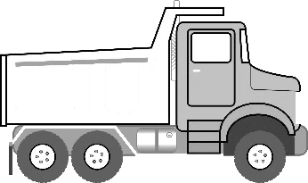

**ck**

**ck**

**ck**

|  |  |  |  |  |
| --- | --- | --- | --- | --- |
| ck | ck | ck | ck | ck |
| ck |  |  |  |  |



|  |  |  |
| --- | --- | --- |
|  |  |  |
| truck | clock | bucket |
| tru __ __ | clo__ __ | bu__ __et |
| tru __ __ | clo __ __ | bu__ __et |
| tru __ __ | clo __ __ | bu__ __et |



|  |  |
| --- | --- |
| chips  __ips |  |
| phone  __one |  |
| shop  __op |  |
| clock  clo__ |  |
| three  __ree | 3 |

sh

ch

th

ck

ph



|  |  |
| --- | --- |
| photo  __oto |  |
| bucket  bu__et |  |
| Thursday  __ursday |  |
| shoe  __oe |  |
| chair  __air |  |

sh

ch

th

ck

ph