# My Dictionary

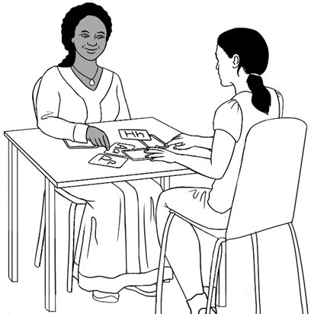

Name:

Class:

## Project team

Vicki Hambling, Sue Paull, Frida Dean, Glenise Kleehammer and Mary Wallace

## Illustrations

Madelena Scott

This English Ready Resource is licensed under a Creative Commons Attribution-NoDerivs 3.0 Australia licence (More information is available [here](http://creativecommons.org/licenses/by-nd/3.0/au/)). You are free to use, copy and distribute to anyone in its original form as long as you attribute Department of Home Affairs as the author and you license any derivative work you make available under the same licence.

© Commonwealth of Australia 2023



With the exception of the Commonwealth Coat of Arms, the department’s logo, any material protected by a trade mark and where otherwise noted all material presented in this document is provided under a Creative Commons Attribution 4.0 International (<https://creativecommons.org/licenses/by/4.0/>) licence.

The details of the relevant licence conditions are available on the Creative Commons website (accessible using the links provided) as is the full legal code for the CC BY 4.0 licence.(<https://creativecommons.org/licenses/by/4.0/legalcode>).

Use of all or part of this document must include the following attribution:   
© Commonwealth of Australia 2023

As far as practicable, material for which the copyright is owned by a third party will be clearly labelled.  The department has made all reasonable efforts to ensure that this material has been reproduced in this document with the full consent of the copyright owners.

Copyright requests and enquiries concerning usage not addressed by the CC BY 4.0 licence should be addressed to: [*comms@homeaffairs.gov.au*](mailto:comms@homeaffairs.gov.au) *at the Department of Home Affairs.*

The terms of use for the Commonwealth Coat of Arms are available from the [It's an Honour](http://www.itsanhonour.gov.au/) website.

Where a copyright owner, other than the Commonwealth, is identified with respect to this material, please contact that third party copyright owner directly to seek permission.

st stop

 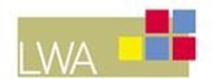

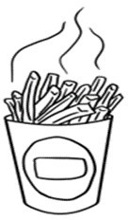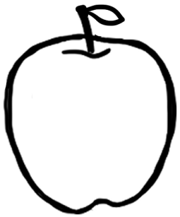ch chips

Aa apple

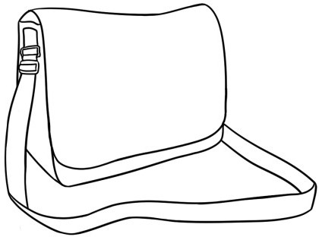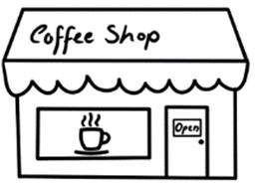Bb bag

sh shop

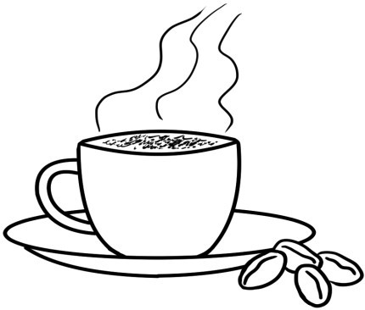Zz 0

# zero

Cc cup

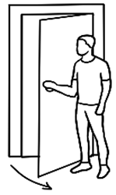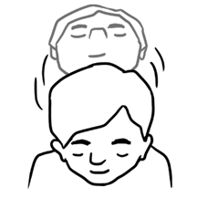Dd door

Yy yes

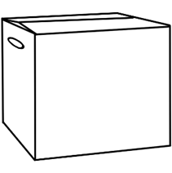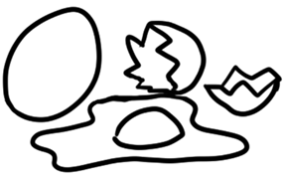Xx bo**x** Ee .eggs

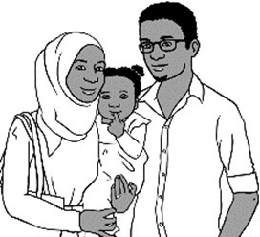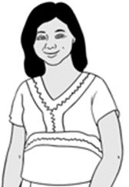Ff family

Ww woman

Vv 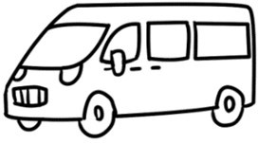 van

Gg  glasses

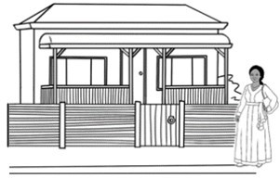Hh house

Uu umbrella

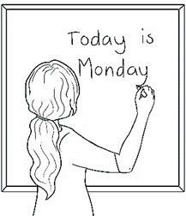Tt teacher

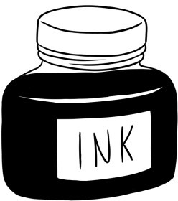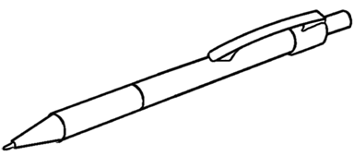

Ii ink

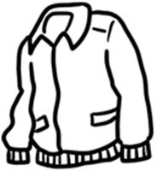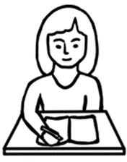Jj jacket

Ss student

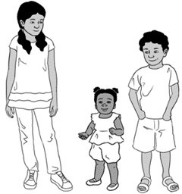Rr 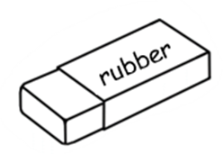 rubber

Kk kids

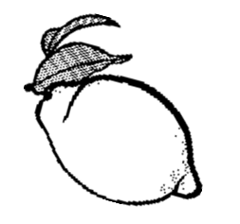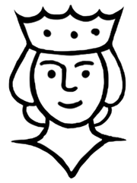Ll lemon

Qq queen

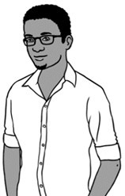Pp pencil

Mm man

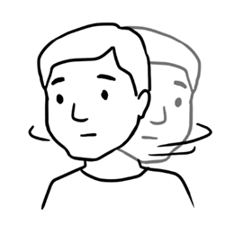Nn no

Oo 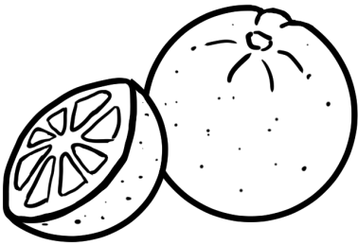 orange