|  |
| --- |
| **English Ready**  **Course in EAL  VU22353 Recognise, give and follow simple and familiar directions** |

**Student Workbook**

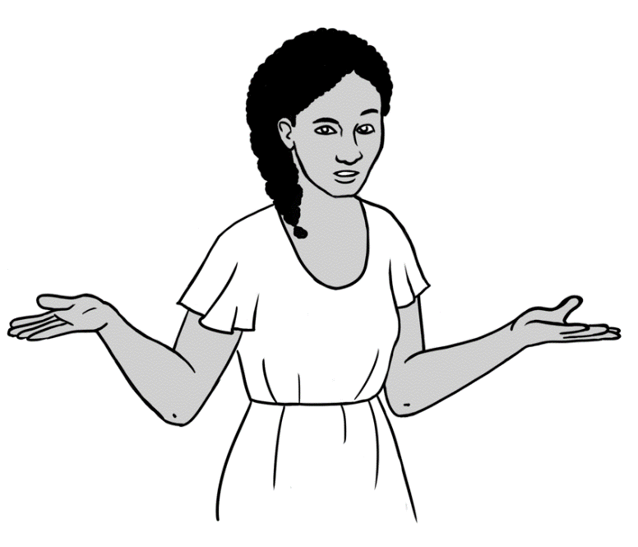

Where’s   
my phone?

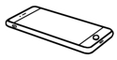

Where’s   
the cafe?



Where are   
the eggs?

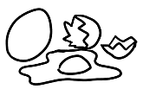

**Student ___________________________________________________**

**___________________________________________________________**

**Teacher ___________________________________________________**

**Class ______________________________________________________**

**Date ______________________________________________________**

**Design team:** Vicki Hambling, Sue Paull, Frida Dean, Janice Langley, Dhammika Fernando, Glenise Kleehammer and Mary Wallace

**Illustrations:** Madelena Scott

**Acknowledgements:** The design team would like to thank the AMEP service providers and practitioners who participated in the trial and gave valuable feedback. The team would also like to acknowledge the use of the EAL Framework which underpins the design of this book.

Copyright of the EAL Framework is reserved to the Crown in the right of the State of Victoria. © State of Victoria (Department of Education and Training) 2018.  
_________________________________________________________________________________________

This English Ready Resource is licensed under a Creative Commons Attribution-NoDerivs 3.0 Australia licence (More information is available [here](http://creativecommons.org/licenses/by-nd/3.0/au/)). You are free to use, copy and distribute to anyone in its original form as long as you attribute Department of Home Affairs as the author and you license any derivative work you make available under the same licence.  
  
© Commonwealth of Australia 2023

With the exception of the Commonwealth Coat of Arms, the department’s logo, any material protected by a trade mark and where otherwise noted all material presented in this document is provided under a Creative Commons Attribution 4.0 International (<https://creativecommons.org/licenses/by/4.0/>) licence.

The details of the relevant licence conditions are available on the Creative Commons website (accessible using the links provided) as is the full legal code for the CC BY 4.0 licence (<https://creativecommons.org/licenses/by/4.0/legalcode>).

Use of all or part of this document must include the following attribution:   
© Commonwealth of Australia 2023

As far as practicable, material for which the copyright is owned by a third party will be clearly labelled.  The department has made all reasonable efforts to ensure that this material has been reproduced in this document with the full consent of the copyright owners.

Copyright requests and enquiries concerning usage not addressed by the CC BY 4.0 licence should be addressed to:

[*comms@homeaffairs.gov.au*](mailto:comms@homeaffairs.gov.au) *at the Department of Home Affairs.*

The terms of use for the Commonwealth Coat of Arms are available from the [It's an Honour](http://www.itsanhonour.gov.au/) website.

Where a copyright owner, other than the Commonwealth, is identified with respect to this material, please contact that third party copyright owner directly to seek permission.

*This workbook is designed to be used with the support of a teacher.*

**Table of Contents**

1. Where’s the ball? 4

2. Where’s my phone? 7

3. Where is it? 9

4. Where is it in the cupboard? 11

5. Where is it in the supermarket? 15

6. Where’s my classroom? 19

7. Where’s the number? 20

8. Where’s the cafe? 21

9. Where are you? 25

10. Where are the maps on my phone? 27

# Where’s the ball?

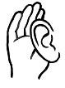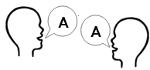

 **Listen** and **repeat.**

**Copy.**



**on** the box **in** the box **next to** the box

on the box  **____________________ ____________________**



**behind** the box **in front of** the box **between the boxes**

**____________________ ____________________ ____________________**



**on the left** of the box **on the right** of the box

_____________________________ ______________________________



**on the corner** of the box **under** the box

_____________________________ ______________________________

 **Match.**

|  |  |  |
| --- | --- | --- |
|  |  | **in front of** the box |
|  |  | **next to** the box |
|  |  | **behind** the box |
|  |  | **on** the box |
|  |  | **on the left** of the box |
|  |  | **under** the box |
|  |  | **on the corner** of the box |
|  |  | **in** the box |
|  |  | **on the right** of the box |
|  |  | **between** the boxes |

# Where’s my phone?

**Listen** and **repeat**.



Where’s my phone?





**Match**.

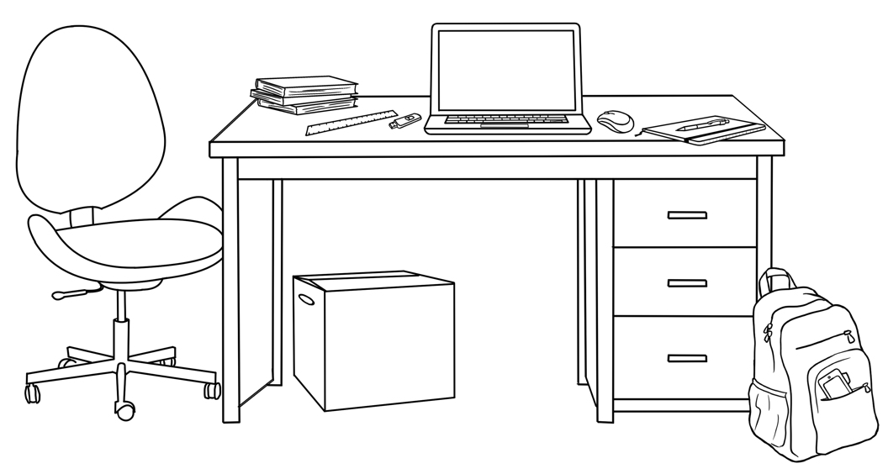

**backpack**



**pen**

**notebook**

**phone**

**box**

**chair**

**books**

**laptop**

**ruler**

**USB**

**desk**

**mouse**

|  |  |  |  |
| --- | --- | --- | --- |
| chair  _ chair _ | desk  ________________ | books  ________________ | ruler  ________________ |
| USB  ________________ | laptop  ________________ | mouse  ________________ | notebook  ________________ |
| pen  ________________ | box  ________________ | backpack  ________________ | phone  ________________ |

**Copy.**

|  |  |  |  |  |
| --- | --- | --- | --- | --- |
| on | between | in | behind | in front of |
| on | between | under | next to **🗸** | on the corner of |

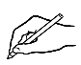**Write.**

|  |
| --- |
| 1. The chair is next to .the desk. |
| 1. The laptop is ________ the desk. |
| 1. The mouse is __________________ the laptop and the notebook. |
| 1. The pen is _______ the notebook. |
| 1. The backpack is ____________________________________ the desk. |
| 1. The USB is __________________ the ruler and the laptop. |
| 1. The box is _______________ the desk. |
| 1. The books are ___________________________________________ the desk. |
| 1. The ball is ______________ the desk. |
| 1. The phone is __________ the backpack. |

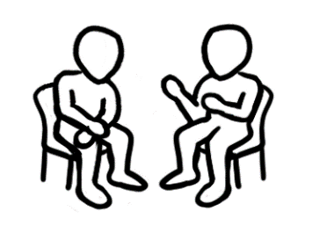**Read**.

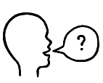

What’s **on** the desk?

What’s **on the left** and **on the right** of the laptop?

|  |  |  |
| --- | --- | --- |
| **on the left** |  | **on the right** |
| the books |  |
|  |  |
|  |  |

# Where is it?

**Listen** and **repeat. Copy**.

**opposite**

_______________________

**through** the box

_______________________

**over** the box

_______________________

**up**

**________**

**down**

**________**



**Read**.



**Match**.

|  |  |
| --- | --- |
|  | **opposite** |
|  | **over** the box |
|  | **up** |
|  | **down** |
|  | **through** the box |

# Where is it in the cupboard?

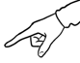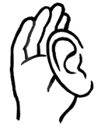**Listen** and **point**.

**Copy.**

|  |  |  |  |
| --- | --- | --- | --- |
|  | biscuits  biscuits . |  | milk  **________________** |
|  | potatoes  **________________** |  | flour  **________________** |
|  | coffee  **________________** |  | noodles  **________________** |
|  | rice  **________________** |  | Weet-Bix  **________________** |
|  | sugar  **________________** |  | eggs  **________________** |
|  | oranges  **________________** |  | jam  **________________** |

**Listen** and **repeat**.



Where’s the milk?

Where are the eggs?

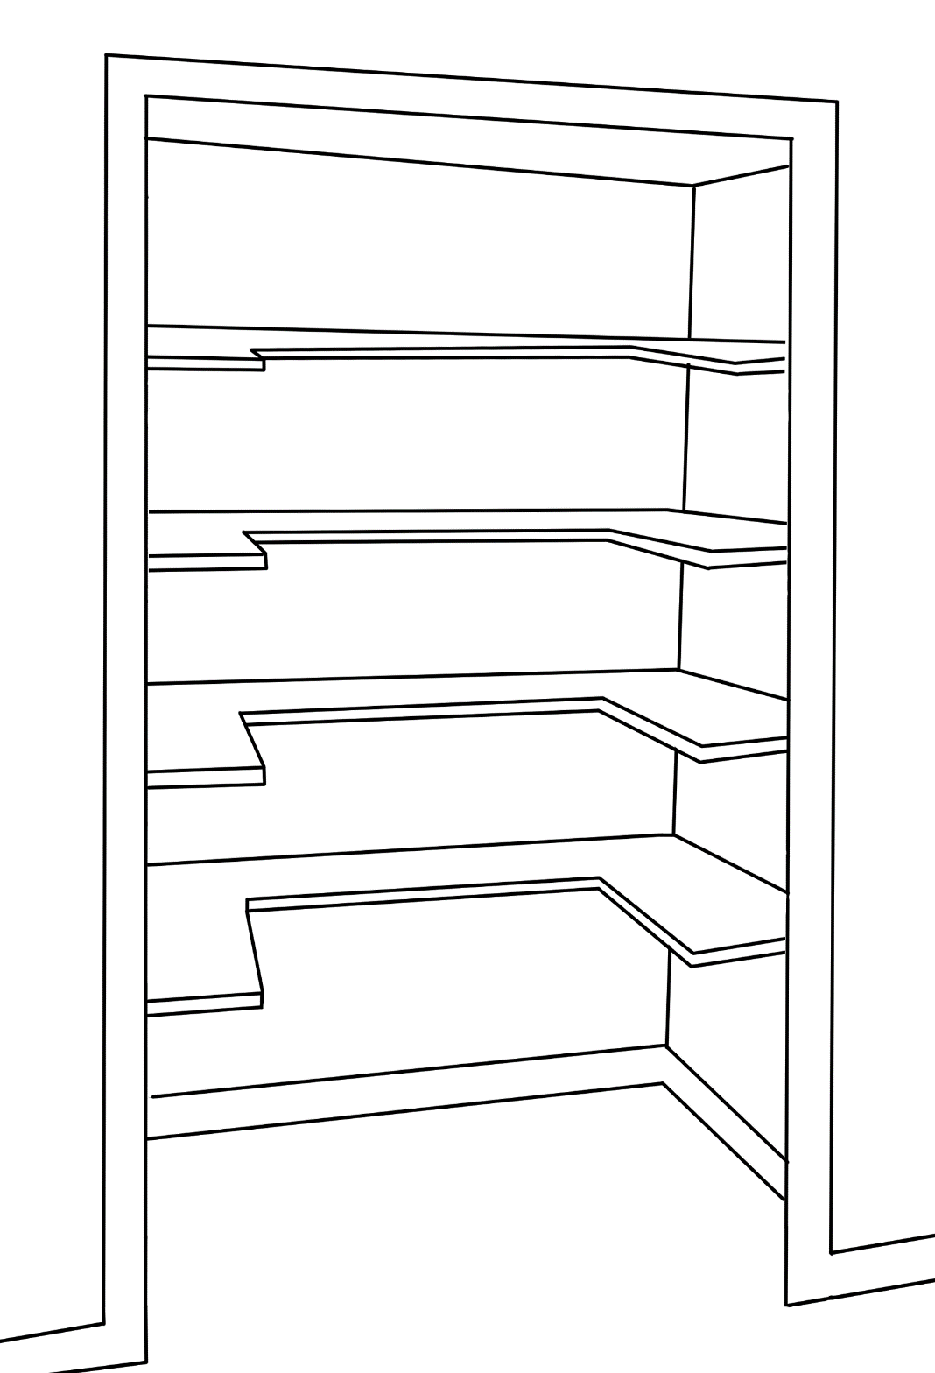

**the top shelf**

**the second shelf**

**the third shelf**

**the floor**

**the first shelf**

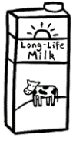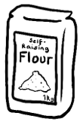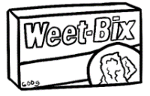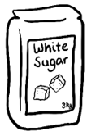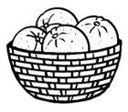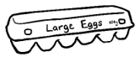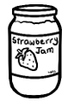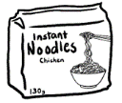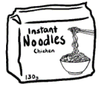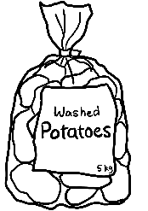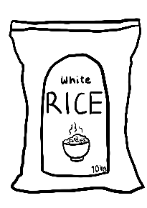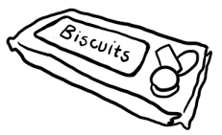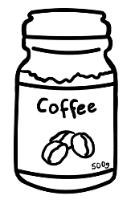

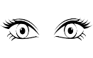**Look** in the cupboard.

** Write**.

1. Where’s the milk? It’s **on** the third shelf.
2. Where’s the sugar? It’s **on** ______________________________________.
3. Where’s the rice? It’s **on** ________________________________________.
4. Where’s the coffee? It’s **on** _____________________________________.
5. Where are the eggs? They are **on** ______________________________.
6. Where are the oranges? They are **on** ____________________________.

**Read**.

|  |  |  |
| --- | --- | --- |
| **Tick** yes or no.  **🗸** | **Yes** | **No** |
| 1. The jam is **on** the second shelf. | **🗸** |  |
| 1. The jam is **between** the coffee and the biscuits. |  |  |
| 1. The Weet-Bix is **on** the top shelf. |  |  |
| 1. The milk is **next to** the Weet-Bix. |  |  |
| 1. The noodles are **on** the third shelf. |  |  |
| 1. The potatoes are **on** the floor. |  |  |

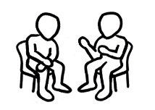

**Work** with a partner.

Where’s the milk?

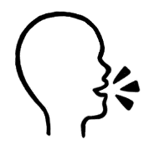**Ask** your partner

It’s **on** the third shelf **next to** the Weet-Bix.

**.**

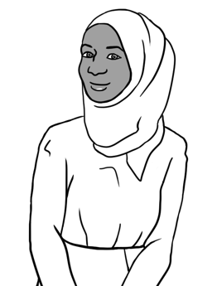

**the top shelf**

**the second shelf**

**the third shelf**

**the floor**

**the first shelf**

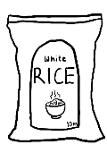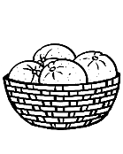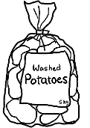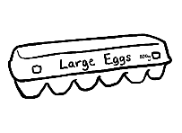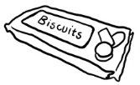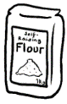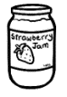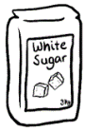



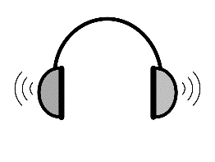

**1**

|  |  |  |
| --- | --- | --- |
| **Tick** yes or no.  **🗸** | **Yes** | **No** |
| 1. The milk is on the top shelf. | **🗸** |  |
| 1. The eggs are on the first shelf. |  |  |
| 1. The oranges are on the first shelf. |  |  |
| 1. The coffee is next to the oranges. |  |  |
| 1. The jam is between the noodles and the biscuits. |  |  |
| 1. The rice is behind the potatoes. |  |  |
| 1. The sugar is on the third shelf. |  |  |
| 1. The noodles are on the top shelf. |  |  |

**Listen**.

# Where is it in the supermarket?



**Listen** and **repeat.**

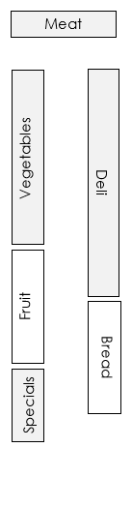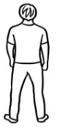

straight ahead

the end of the aisle

third on the left

first on the left

second on the right

** Write**.

|  |  |  |  |
| --- | --- | --- | --- |
| vegetables | meat | deli | specials🗸 |

1. The ______specials ________ are **first on the left**.
2. The ________________________ is **second on the right**.
3. The ________________________ are **third on the left**.
4. The ________________________ is **straight ahead.**

It’s at the **end of the aisle.**



**Read**.

Excuse me.   
Where’s the bread?

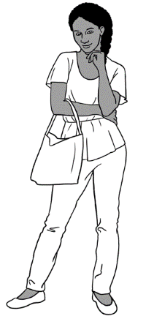

The bread’s in **aisle 1**. It’s the **first on the right**.

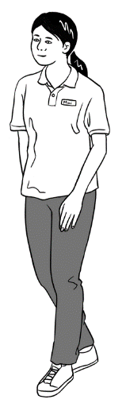

**2**

**Listen**.

**Circle** the food and the aisle.

|  |  |  |  |  |
| --- | --- | --- | --- | --- |
| biscuits | meat | fruit | eggs | rice |

|  |  |
| --- | --- |
| aisle 1 | aisle 2 |

|  |  |  |  |  |
| --- | --- | --- | --- | --- |
| biscuits | meat | fruit | eggs | rice |

|  |  |
| --- | --- |
| aisle 1 | aisle 2 |

|  |  |  |  |  |
| --- | --- | --- | --- | --- |
| biscuits | meat | fruit | eggs | rice |

|  |  |
| --- | --- |
| aisle 1 | aisle 2 |

|  |  |  |  |  |
| --- | --- | --- | --- | --- |
| biscuits | meat | fruit | eggs | rice |

|  |  |
| --- | --- |
| aisle 1 | aisle 2 |

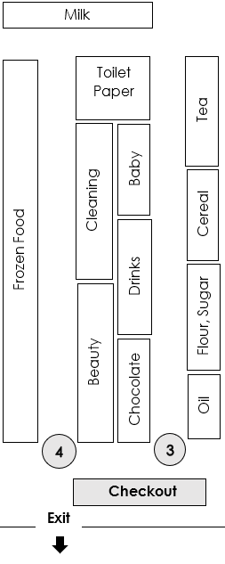

**Work** with a partner.

Excuse me.   
Where’s the **cereal**?



It’s in **aisle 3** next to the flour and sugar.

**Ask** four questions.

**Student A questions**

1. Excuse me, where’s the sugar?
2. Excuse me, where are the drinks?
3. Excuse me, where’s the tea?
4. Excuse me, where’s the toilet paper?

**Student B questions**

1. Excuse me, where’s the oil?
2. Excuse me, where’s the milk?
3. Excuse me, where’s the baby food?
4. Excuse me, where’s the frozen food?



**Listen** to your partner.

# Where’s my classroom?

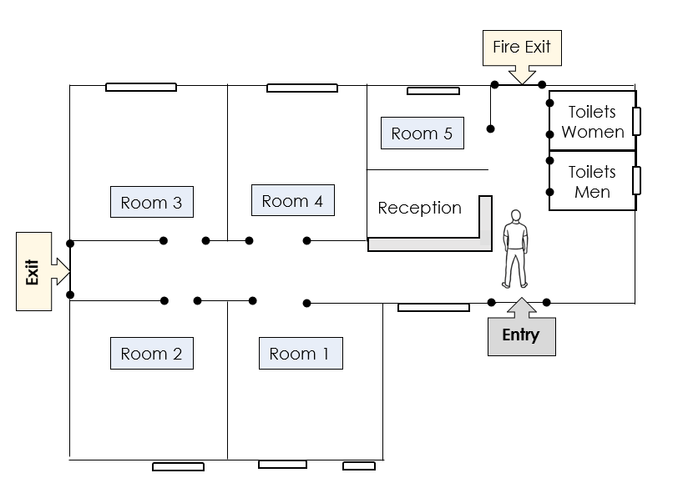

**3**

**Listen**.

**Circle** the room.

Room 1

Room 2

Room 3

Room 4

Room 2

Room 3

Room 4

Room 5

Room 1

Room 2

Room 3

Room 4

Room 2

Room 3

Room 4

Room 5

# Where’s the number?



**Listen** and **repeat.**

|  |  |  |  |
| --- | --- | --- | --- |
| **first** | **second** | **third** | **last** |
| **on the left** | **on the right** | **next to** | **between** |

|  |  |  |  |  |  |  |  |  |  |
| --- | --- | --- | --- | --- | --- | --- | --- | --- | --- |
| **5** | **4** | **1** | **8** | **6** | **9** | **7** | **0** | **2** | **3** |



**Read** the numbers aloud.

** Write**.

1. The **first** number is___5___.
2. The **second** number is______.
3. The **third** number is ______.
4. The number **on the left** of **6** is______.
5. The number **on the right** of **6** is ______.
6. The numbers **next to** **0** are ______ and _____.
7. The numbers **between** **5** and **8** are _____, _____ and _____.
8. The **last** number is ________.



What’s the number on the right of _____?

What’s the number of the left of _____?

What numbers are next to ____?

What’s the number between ____ and ____?

**Work** with a partner.

# Where’s the cafe?



**Listen** and **repeat.**

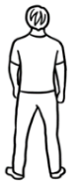

second   
on the left

third on the left

first   
on the right

straight ahead

High School

High School

Hot Bread Shop

Chemist

Fruit Shop

Fruit Shop

Bank

Cafe

Post Office

Cafe



Stop at the shop **second on the left**. Where are you?



I’m at the Fruit Shop.



**Write** two directions.

third on the left

third on the right

second on the left

second on the right

first on the left

first on the right

1. Stop at the shop ____________________________.

Where are you?

1. Stop at the shop ____________________________.

Where are you?



**Give** the directionsto your partner.



**Listen** and **repeat.**

|  |  |  |
| --- | --- | --- |
| toilets | parking | swimming pool |
| supermarket | tree | park |
| bus stop | hospital | medical centre |
| post office | cafe | petrol station |



**Write.**

|  |  |  |  |  |
| --- | --- | --- | --- | --- |
|  | cafe |  |  |  |
|  |  |  |  |
|  |  |  |  |
|  |  |  |  |
|  |  |  |  |
|  |  |  |  |

**Work** with a partner.  **Point** to a symbol.

**Ask**

What is this?





**4**

**Listen**.

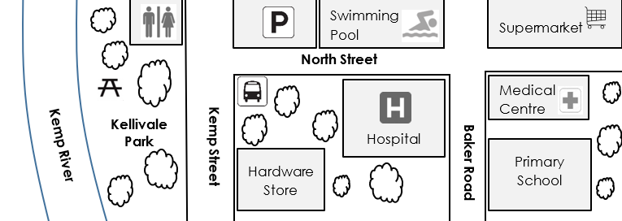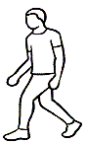

 **Circle**.

1. Supermarket Hardware Store Cafe
2. Primary School Medical Centre Parking
3. Toilets Hospital Swimming Pool
4. Hardware Store Swimming pool Kellivale Park
5. ****Hardware store Primary school Parking

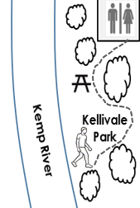**Copy.**

The man is **in** the park.

___________________________________________________.

The park is **next to** the river.

___________________________________________________.

The man walks **through** the park to the toilets.   
_______________________________________________________________________.



**5**

**Listen**.

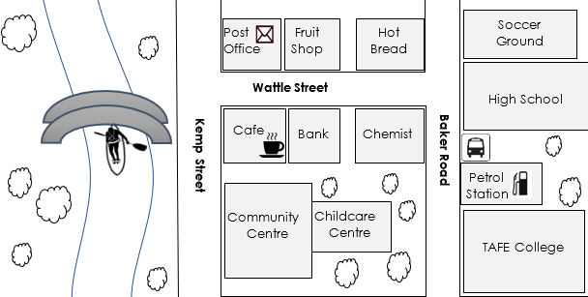



**Circle** the answers.

1. Chemist Hot bread Café
2. Petrol Station Bank Fruit Shop
3. Fruit Shop Post Office Chemist
4. TAFE College Community Centre High School
5. Childcare Centre Soccer Ground Fruit Shop
6. Soccer ground Petrol Station High School

**Circle**.

1. Chemist Hot bread Café
2. Petrol Station Bank Fruit Shop
3. Fruit Shop Post Office Chemist
4. TAFE College Community Centre High School
5. Childcare Centre Soccer Ground Fruit Shop
6. Soccer ground Petrol Station High School

# Where are you?

** Listen** and **repeat.**

**Match.**

|  |  |
| --- | --- |
| 1. I’m **in** the garden. |  |
| 1. I’m **in** the toilets. |  |
| 1. I’m **in** **the next** room. |  |
| 1. I’m **in** **the next** building. |  |
| 1. I’m **next to** the window. |  |
| 1. I’m **next to** the light switch. |  |
| 1. I’m **next to** the door. |  |
| 1. I’m **in the front** of the room. |  |



**Read**.

**Write**.

|  |  |  |  |
| --- | --- | --- | --- |
| in🗸 | behind | behind | next to |
| in front of | in front of | on |  |



|  |  |  |
| --- | --- | --- |
| 1. I’m in the car. |  | |
| 1. I’m **______________** the car. | |  |
| 1. I’m **_________________** the cupboard. | |  |
| 1. I’m **________________________________** the whiteboard. | |  |
| 1. I’m **________________________** the desk. | |  |
| 1. I’m **________________________________** the desk. | |  |
| 1. I’m **______________** the chair. | |  |

**Read**.

# Where are the maps on my phone?

**Listen**.

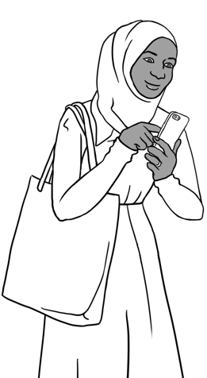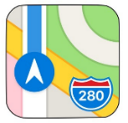

**Maps**



**Maps**

* + 1. See the source imageSahra is in her English class.
    2. She clicks **Google maps** on her phone.

210 West Street, Kellivale



* + 1. She types her address in the box.

**Directions**

* + 1. She clicks
    2. There is a blue line from her school to home.
    3. 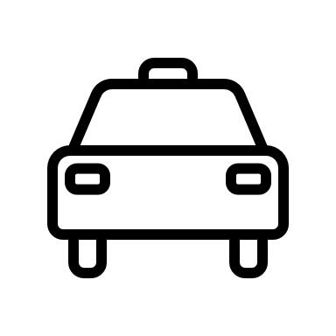Sahra’s home is 7 km from school.

**km** = kilometre

**hr** = hour

**min** = minute

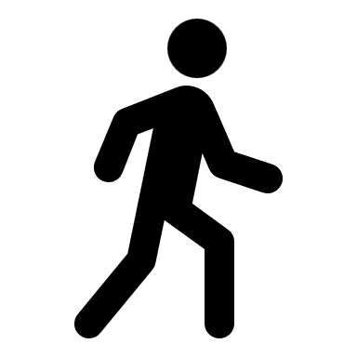It takes 10 min to drive home.

It takes 1hr 21 min to walk home.

It takes 35 min by bus.

**Write**.

35

21

7

blue **🗸**

10

* 1. There is a blue_ line from her school to home.
  2. Sahra’s home is _______km from her school.
  3. It takes _________min to drive home.
  4. It takes 1 hr ____min to walk home.
  5. It takes _______min by bus.



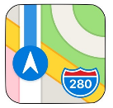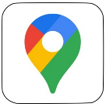**Use your phone.**

1. Click on the **Maps** symbol on your phone.



1. Type your address.

**Directions**

1. Click on



**Write about you**.

1. 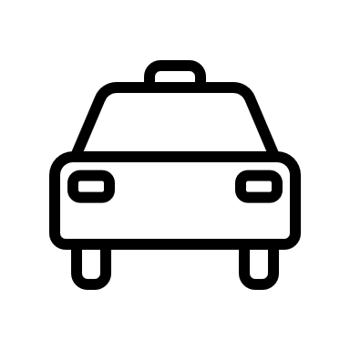My home is ________________km away from here.
2. It takes ______________ min to drive home.
3. It takes______________ min to walk home.
4. It takes ____________ min by bus.



 **Work** with a partner.

How far away is your home?

**Ask**

How long does it take to drive home?



**Write about your partner.**

1. My partner’s home is ________________km from here.



1. It takes ______________ min to drive home.



1. It takes______________ min to walk home.



1. It takes ____________ min by bus.



Who lives closer to school?

**🗸**

**Tick** one. I live closer to school.

My partner lives closer to school.