

|  |
| --- |
| **English Ready**  **Course in EAL  VU22352 Recognise numbers and money in simple, highly familiar situations** |

**Student Workbook**

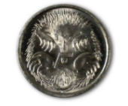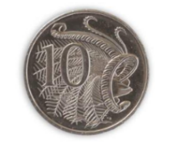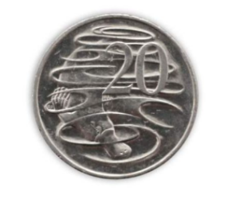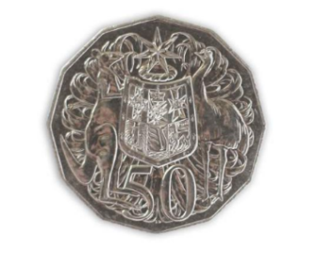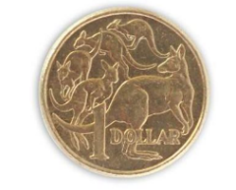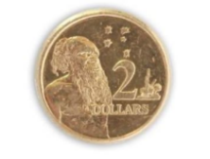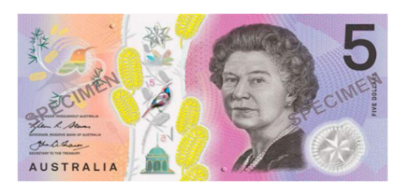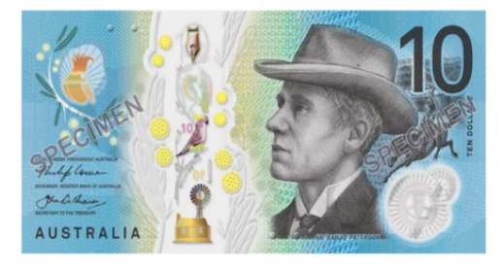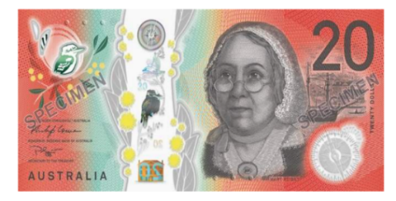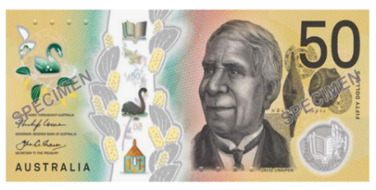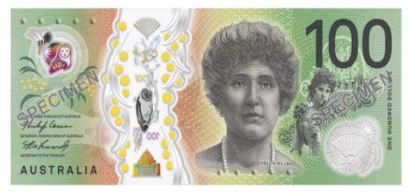

**Student ___________________________________________________**

**___________________________________________________________**

**Teacher ___________________________________________________**

**Class ______________________________________________________**

**Date ______________________________________________________**

**Design team:** Vicki Hambling, Sue Paull, Frida Dean, Janice Langley, Dhammika Fernando, Glenise Kleehammer and Mary Wallace

**Illustrations:** Madelena Scott

**Image acknowledgements:**  
Australian Currency designs – Permission granted by the Royal Australian Mint, Approval # 9/45/432

IGA & Bunnings Warehouse logos, Toaster #A, Kettle #B - [These Photo](https://en.wikipedia.org/wiki/IGA_(supermarkets))s by Unknown Author is licensed under [CC BY-SA](https://creativecommons.org/licenses/by-sa/3.0/)

Tape, Toaster #B, Sydney Swans & North Melbourne Football Club logos- [These Photo](https://z1battleroyale.gamepedia.com/Duct_Tape)s by Unknown Author is licensed under [CC BY-SA-NC](https://creativecommons.org/licenses/by-nc-sa/3.0/)  
Fridge #B, Stove #B [These Photo](https://www.pngall.com/fridge-png)s by Unknown Author is licensed under [CC BY-NC](https://creativecommons.org/licenses/by-nc/3.0/)  
Stove #A, Kettle #A [This Photo](http://fabioskol.deviantart.com/art/3D-Model-Home-Appliances-Electrolux-Stove-566347775) by Unknown Author is licensed under [CC BY](https://creativecommons.org/licenses/by/3.0/)

**Acknowledgements:** The design team would like to thank the AMEP service providers and practitioners who participated in the trial and gave valuable feedback. The team would also like to acknowledge the use of the EAL Framework which underpins the design of this book.

Copyright of the EAL Framework is reserved to the Crown in the right of the State of Victoria. © State of Victoria (Department of Education and Training) 2018.  
_________________________________________________________________________________________

This English Ready Resource is licensed under a Creative Commons Attribution-NoDerivs 3.0 Australia licence (More information is available [here](http://creativecommons.org/licenses/by-nd/3.0/au/)). You are free to use, copy and distribute to anyone in its original form as long as you attribute Department of Home Affairs as the author and you license any derivative work you make available under the same licence.  
  
© Commonwealth of Australia 2023

With the exception of the Commonwealth Coat of Arms, the department’s logo, any material protected by a trade mark and where otherwise noted all material presented in this document is provided under a Creative Commons Attribution 4.0 International (<https://creativecommons.org/licenses/by/4.0/>) licence.

The details of the relevant licence conditions are available on the Creative Commons website (accessible using the links provided) as is the full legal code for the CC BY 4.0 licence (<https://creativecommons.org/licenses/by/4.0/legalcode>).

Use of all or part of this document must include the following attribution:   
© Commonwealth of Australia 2023

As far as practicable, material for which the copyright is owned by a third party will be clearly labelled.  The department has made all reasonable efforts to ensure that this material has been reproduced in this document with the full consent of the copyright owners.

Copyright requests and enquiries concerning usage not addressed by the CC BY 4.0 licence should be addressed to:

[*comms@homeaffairs.gov.au*](mailto:comms@homeaffairs.gov.au) *at the Department of Home Affairs.*

The terms of use for the Commonwealth Coat of Arms are available from the [It's an Honour](http://www.itsanhonour.gov.au/) website.

Where a copyright owner, other than the Commonwealth, is identified with respect to this material, please contact that third party copyright owner directly to seek permission.

*This workbook is designed to be used with the support of a teacher.*

**Table of Contents**

1. Numbers 4

2. Higher or lower? 8

3. How much? 10

4. More or less? 13

5. School 14

6. The supermarket 18

7. Half 22

8. The garden shop 24

9. Bills 28

10. The paint shop 30

11. The kitchen shop 33

# Numbers

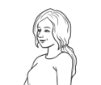

**5**

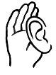

**Listen**.

**Circle**.

|  |  |  |  |  |  |  |  |  |  |
| --- | --- | --- | --- | --- | --- | --- | --- | --- | --- |
|  | | | | | | | | | 0 |
| 1 | 2 | 3 | 4 | 5 | 6 | 7 | 8 | 9 | 10 |
| 11 | 12 | 13 | 14 | 15 | 16 | 17 | 18 | 19 | 20 |
| 21 | 22 | 23 | 24 | 25 | 26 | 27 | 28 | 29 | 30 |
| 31 | 32 | 33 | 34 | 35 | 36 | 37 | 38 | 39 | 40 |
| 41 | 42 | 43 | 44 | 45 | 46 | 47 | 48 | 49 | 50 |
| 51 | 52 | 53 | 54 | 55 | 56 | 57 | 58 | 59 | 60 |
| 61 | 62 | 63 | 64 | 65 | 66 | 67 | 68 | 69 | 70 |
| 71 | 72 | 73 | 74 | 75 | 76 | 77 | 78 | 79 | 80 |
| 81 | 82 | 83 | 84 | 85 | 86 | 87 | 88 | 89 | 90 |
| 91 | 91 | 93 | 94 | 95 | 96 | 97 | 98 | 99 | 100 |

**Read** the circled numbers to your partner.

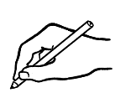 **Write** the missing numbers.

|  |  |  |  |  |  |  |  |  |  |
| --- | --- | --- | --- | --- | --- | --- | --- | --- | --- |
|  | | | | | | | | | 0 |
| 1 |  | 3 | 4 |  | 6 | 7 |  | 9 | 10 |
| 11 | 12 |  |  | 15 |  | 17 | 18 |  | 20 |
|  |  | 23 | 24 |  | 26 |  | 28 | 29 |  |
| 31 | 32 |  | 34 | 35 |  | 37 | 38 |  | 40 |
| 41 |  | 43 |  |  | 46 |  | 48 | 49 | 50 |
|  | 52 |  | 54 |  | 56 | 57 |  |  | 60 |
| 61 |  | 63 |  | 65 |  | 67 |  | 69 |  |
|  | 72 | 73 |  |  | 76 |  |  | 79 | 80 |
| 81 |  |  | 84 | 85 |  | 87 | 88 |  | 90 |
| 91 |  | 93 | 94 | 95 |  | 97 |  | 99 | 100 |

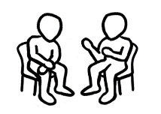

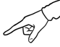 **Work** with a partner.

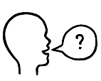 **Point** to a number.

What number is that?

**Ask**



**Read** the numbers.

|  |  |  |  |  |
| --- | --- | --- | --- | --- |
| 1. one | 1. two | 1. three | 1. four | 1. five |
| 1. six | 1. seven | 1. eight | 1. nine | 1. ten |
| 1. eleven | 1. twelve | 1. thirteen | 1. fourteen | 1. fifteen |
| 1. sixteen | 1. seventeen | 1. eighteen | 1. nineteen | 1. twenty |



**Match**.

|  |  |  |  |  |
| --- | --- | --- | --- | --- |
| **1** | two |  | **11** | thirteen |
| **2** | four | **12** | fifteen |
| **3** | five | **13** | eleven |
| **4** | one | **14** | twelve |
| **5** | three | **15** | fourteen |
| **6** | eight | **16** | seventeen |
| **7** | nine | **17** | nineteen |
| **8** | six | **18** | twenty |
| **9** | ten | **19** | sixteen |
| **10** | seven | **20** | eighteen |

**Listen**.



**two**

**Circle**.

|  |  |  |  |
| --- | --- | --- | --- |
| one |  | three | four |
| five | six | seven | eight |
| nine | ten | eleven | twelve |
| thirteen | fourteen | fifteen | sixteen |
| seventeen | eighteen | nineteen | twenty |

**Copy**.

|  |  |  |  |
| --- | --- | --- | --- |
| one | two | three | four |
| _ one ___ . | ______________ | ______________ | ______________ |
| five | six | seven | eight |
| ______________ | ______________ | ______________ | ______________ |
| nine | ten | eleven | twelve |
| ______________ | ______________ | ______________ | ______________ |
| thirteen | fourteen | fifteen | sixteen |
| ______________ | ______________ | ______________ | ______________ |
| seventeen | eighteen | nineteen | twenty |
| ______________ | ______________ | ______________ | ______________ |

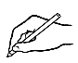**Write** the missing letters.

|  |  |  |  |
| --- | --- | --- | --- |
| one | tw__ | thre__ | fou__ |
| __ive | __ix | __even | __ight |
| n__ne | t__n | e__even | t__elve |

# Higher or lower?

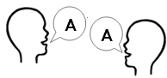

**Listen** and **repeat.**



This speed is **higher than** this speed.

This speed is **lower than** both speeds.

|  |  |  |  |  |
| --- | --- | --- | --- | --- |
| Circle   the **higher** number. | |  | Circle  the **lower** number. | |
| 7 | 11 | 17 | 2 |
| 16 | 6 | 11 | 19 |
| 5 | 50 | 21 | 89 |
| 15 | 5 | 77 | 170 |
| 7 | 70 | 46 | 64 |
| 70 | 17 | 19 | 91 |
| 87 | 78 | 87 | 367 |
| 65 | 650 | 510 | 51 |
| 888 | 887 | 879 | 798 |
| 547 | 546 | 543 | 345 |
| 401 | 107 | 999 | 879 |



**Read** the **higher numbers** to a partner.

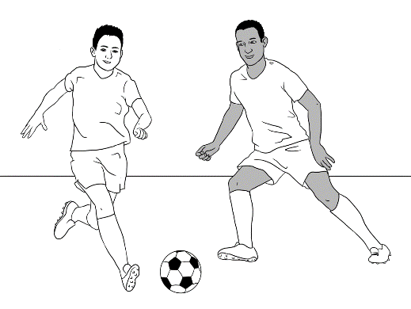



**Listen** and **repeat.**

Bao and Abdi play soccer every week.

They play in the River Dragons team.

They play different teams every week.

|  |  |  |
| --- | --- | --- |
| Week | River Dragons | the other team |
| 1 | 4 | 2 |
| 2 | 3 | 5 |
| 3 | 0 | 2 |
| 4 | 5 | 1 |

**Circle** the **higher** score.



**Listen** and **repeat**.

Bao and Abdi watch Aussie Rules football.

They like the Sydney Swans.

The Sydney Swans play different teams every week.

 **Circle** the **higher** score.

|  |  |  |
| --- | --- | --- |
| Week | Sydney Swans | the other team |
| 1 | 60 | 79 |
| 2 | 109 | 102 |
| 3 | 64 | 93 |
| 4 | 136 | 49 |
| 5 | 91 | 77 |



What’s the **higher** score in week 1?

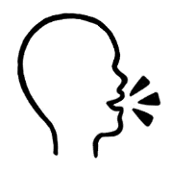 **Ask** a partner

60

79

What’s the **lower** score?

# How much?

  
 **Match**.

|  |  |  |  |  |
| --- | --- | --- | --- | --- |
|  | 10c |  |  | $2 |
|  | 20c |  |  | 50c |
|  | 5c |  |  | $1 |



|  |  |  |
| --- | --- | --- |
| __ten cents____ | __________________ | **__________________** |
| __________________ | __________________ | __________________ |

|  |  |  |
| --- | --- | --- |
| five cents | ten cents ✓ | twenty cents |
| fifty cents | one dollar | two dollars |

**Write**.

 **Match**.

|  |  |  |
| --- | --- | --- |
|  |  | $10 |
| $100 |
| $5 |
| $20 |
| $50 |



**Write**.

|  |  |  |
| --- | --- | --- |
|  | five dollars . | twenty dollars  one hundred dollars  ten dollars  five dollars ✓  fifty dollars |
|  | ________________________ |
|  | ________________________ |
|  | ________________________ |
|  | ________________________ |

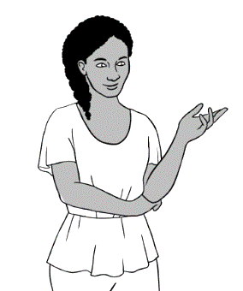

How much money do I have?

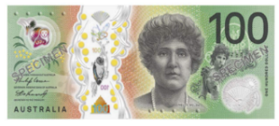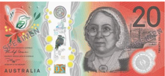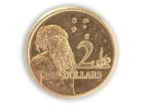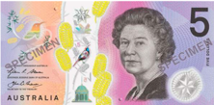

I have **$129**.

|  |  |
| --- | --- |
| **Count** themoney. |   **Write** how much. |
|  | 70c |
| 1. **A picture containing turtle, coin     Description automatically generated**A picture containing coin     Description automatically generated |  |
|  |  |
| 1. A picture containing text     Description automatically generatedA picture containing text, coin     Description automatically generated |  |
| 1. A coin with a person's face on it     Description automatically generated with low confidenceA coin with a person's face on it     Description automatically generated with low confidence |  |
|  |  |

# More or less?



**Listen** and **repeat**.

Is it more?

Is it less?

Is it the same?

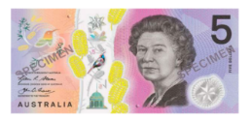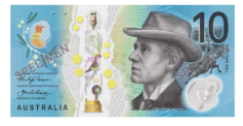

1. is **more than**



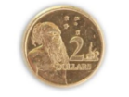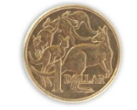

1. is **less than**





|  |  |  |
| --- | --- | --- |
| **Tick** yes or no.  **🗸** | **Yes** | **No** |
| **1.** is more than | **🗸** |  |
| **2.** is less than |  |  |
| **3.** is the same as |  |  |
| **4.** is more than |  |  |
| **5.** is less than |  |  |
| **6.** is the same as |  |  |

1. is **the same as**

 **Read** to a partner.

# School

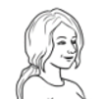****

How much is a __________?

**Listen.**

**SALE**

Notebook

$6



Pen

$2

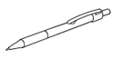

**Pen and Pencil Shop**



Ruler

$3



Rubber

$1

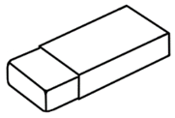

Highlighter

$2



Pencil

50c



Pencil case

$5

USB

$8



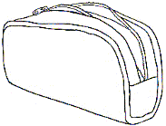



|  |  |
| --- | --- |
| 1. pencil | $1 |
| 1. rubber | $5 |
| 1. highlighter | 50c |
| 1. notebook | $2 |
| 1. pencil case | $8 |
| 1. pen | $3 |
| 1. USB | $6 |
| 1. ruler | $2 |

**Match**.



 **Work** with a partner.

It’s 50 cents.

How much is the pencil?

**Ask**

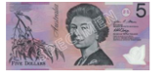

The pencil costs 50 cents. You have



**Yes**, I do.

Do you have **enough** money?

|  |  |  |  |  |
| --- | --- | --- | --- | --- |
|  **Write** the prices. | | Do you have **enough** money? | **Yes**, I do. | **No**,  I don’t. |
| **1.**  $3 | A picture containing text, paper clip  Description automatically generated  $8 |  |  | **🗸** |
| **A picture containing text, sign  Description automatically generated2.**  ________ | ________ |  |  |  |
| **A picture containing text, paper clip  Description automatically generated3.**  ________ | ________ |  |  |  |
| **Diagram, engineering drawing  Description automatically generated4.**  A picture containing text, paper clip  Description automatically generated _______ | Diagram, engineering drawing  Description automatically generated  _______ |  |  |  |
| **5.**  ________ |   ________ |  |  |  |
| **6.**    ________ | ________ |  |  |  |
| **7.**    ________ ________ | |  |  |  |



**Listen** and **repeat**.

Mai and Fatima are in high school.

They need some things for school.

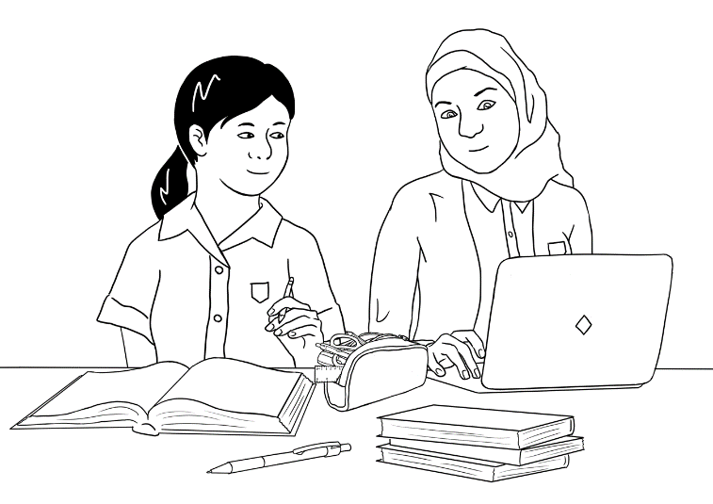

I need a backpack and a notebook.

I need a laptop and a mouse.

They **read** the advertisement.

**The School Shop**



Laptop

$780

Laptop

$667

Notebook

$7

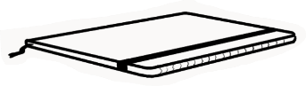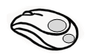

Mouse

$30

Mouse

$15

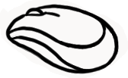

Notebook

$4

Backpack

$29

Backpack

$69

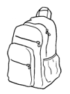

Pencil case

$12

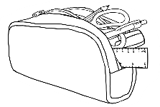

Pencil case

$25

**Great  
Prices**

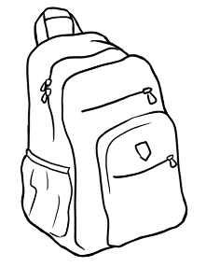



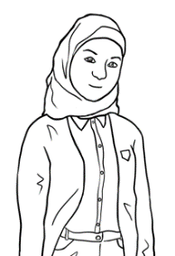

What is **cheaper**?

What is **more expensive**?

This is **cheaper.**

This is **more expensive.**

|  |  |  |
| --- | --- | --- |
| **Circle** the **cheaper** price. | | **Write** the **more expensive** price. |
| Pencil cases | $12 $25 | $25 |
| Notebooks | $7 $4 |  |
| Backpacks | $69 $29 |  |
| Mouse | $15 $30 |  |
| Laptops | $667 $780 |  |

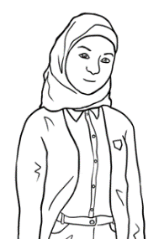**Write**.

Fatima buys the cheaper backpack. $29 .

She buys the more expensive notebook. _________

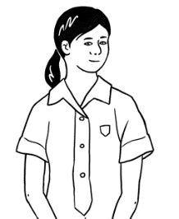 Fatima pays_________

Mai buys the more expensive laptop. _________

She buys the cheaper mouse. _________

Mai pays_________

|  |  |  |
| --- | --- | --- |
| **Circle** the answer. | She pays | Her change is |
| Fatima has **$50**. | $32 $36 $35 | $14 $15 $16 |
| Mai has **$800**. | $795 $796 $797 | $3 $4 $5 |



# The supermarket

**Listen**.

**Write** the prices.

|  |  |  |  |
| --- | --- | --- | --- |
| 1. $5 .     Weet Bix | 1. _______   eggs | 1. ______     cocoa | 1. _________     milk |
| 1. _______   bicarb soda | 1. ________     dates | 1. ________   flour | 1. ________     soy sauce |
| 1. ________   oil | 1. _______     honey | 1. _______ kg     oranges | 1. _______   sugar |
| 1. ________     nuts | 1. ________     rice | 1. ________     coffee | 1. ________     noodles |

**Ask**

**?**

$5

How much does the Weet-Bix cost?

How much do the noodles cost?

  **Listen** and **repeat.**

Nisha does the shopping on Monday.

This is her shopping list.

|  |  |
| --- | --- |
| **Shopping list** | **Price** |
| dates | $4 |
| sugar |  |
| milk |  |
| eggs |  |
| rice |  |
| flour |  |
| oranges |  |
| cocoa |  |

**Write** the prices.

What’s **cheaper**?

What’s **more expensive**?

What’s **the same** price?

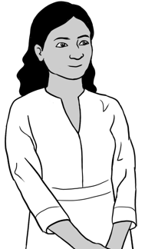

|  |  |  |
| --- | --- | --- |
| **Tick** yes or no.  **🗸** | **Yes** | **No** |
| 1. The flour is **cheaper than** the milk. |  | ✓ |
| 1. The eggs are cheaper than   the cocoa. |  |  |
| 1. The rice is **more expensive than**   the dates. |  |  |
| 1. The oranges are more expensive   than the eggs. |  |  |
| 1. The sugar is **the same** **price** **as** the flour. |  |  |

 **Read** to your partner.

How much

is it?

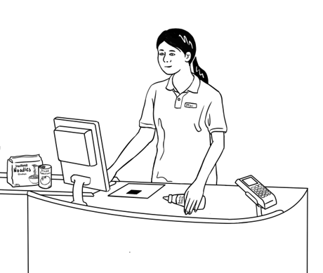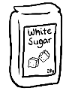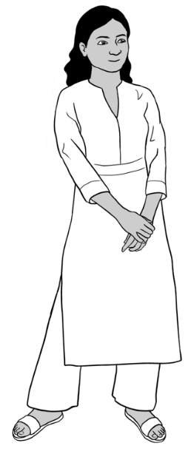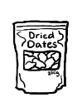

Maybe

$6?

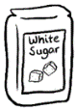



|  |  |
| --- | --- |
| **How much is it?** | **How much does Nisha pay?** |
| $4  $3  and | *Work it out here.*  $3  + $4  $7 |
| $1    $7 + | *Work it out here.*    $ 7  + $____  $ ____ |
| $_____  $6  + | $____  *Work it out here.*    + $ ____  $____ |

 **Listen** and **repeat.**

Nisha doesn’t shop for two weeks.

Now she needs **two** of everything.

|  |  |  |  |
| --- | --- | --- | --- |
| **$5**  Weet Bix |   eggs | **$5 kg**    oranges | **$1**  A picture containing whiteboard  Description automatically generated  milk |
| **$3**  A picture containing text  Description automatically generated  sugar | **$4**    dates | **Diagram  Description automatically generated$2**  flour | **$6**    oil |

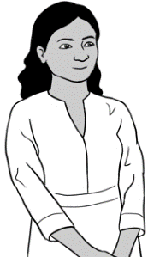 **Write** the price for one.

What’s **double** the price?

|  |  |  |  |
| --- | --- | --- | --- |
| **Shopping list** | **Price for one** |  | **Double the price** |
| sugar | $3 | $2 |
| milk |  | $4 |
| dates |  | $6 |
| eggs |  | $8 |
| flour |  | $10 |
| oil |  | $10 |
| oranges |  | $12 |
| Weet Bix |  | $12 |

**Match** the **double** price.

# Half

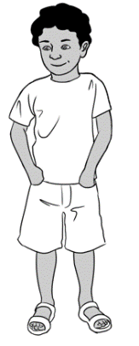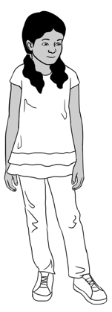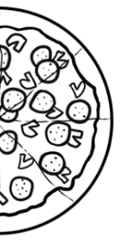

Nisha cuts the pizza in half.

Pari eats half the pizza.

Dev eats half the pizza.

|  |  |
| --- | --- |
| **This is one pizza.** | **This is half a pizza.** |
|   **1** **pizza** | **½ pizza** |

|  |  |
| --- | --- |
| **Match.** | **½** |
| one jug of milk | half an orange  **½** |
| one sandwich | half a dozen eggs  **½**  **½** |
| one orange | half a jug of milk |
| one dozen eggs | half one hundred dollars |
| eight students | half a sandwich  **½**  **½** |
| one hundred dollars | half the students  **½** |

**Work** with a partner.

This is one orange.

This is half an orange.

**Say**

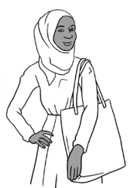

**Listen** and **repeat.**

Sahra does the shopping on Tuesday.

It’s half price on Tuesday.

$16

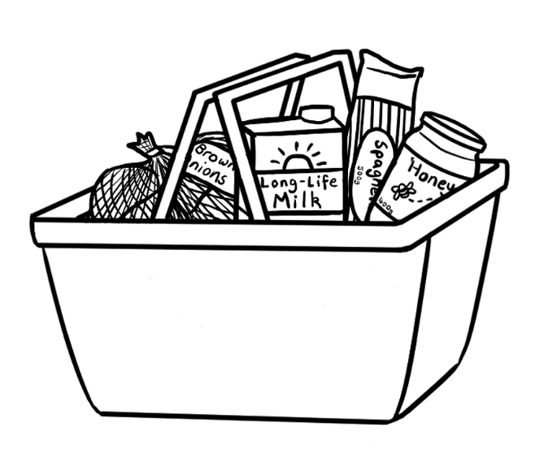

$2

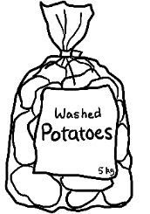

$4

$6

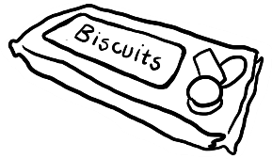

$2

$8

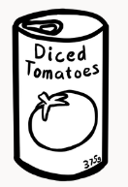

$1

$4

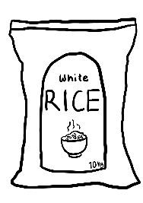

**Tuesday**

**½**

**Write** the price. **Circle** the half price.

|  |  |  |
| --- | --- | --- |
| **Sahra’s shopping list** | **Price** | **½ price** |
| tin of tomatoes | $1 | $1 50c 60c |
| potatoes |  | $3 $4 $5 |
| onions |  | $1 $2 $3 |
| rice |  | $8 $7 $6 |
| honey |  | $2 $3 $4 |
| biscuits |  | $1 $2 $3 |

# The garden shop

**Listen** and **repeat.**

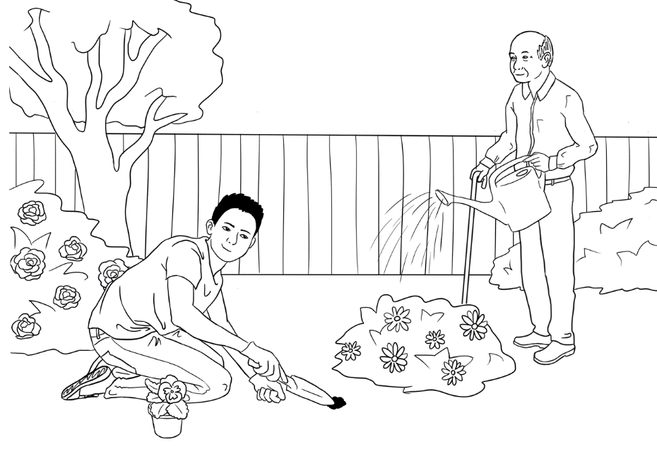

I need   
a small plant.

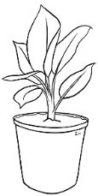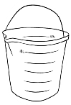

I need   
a garden hose.

Bao and Ming need some things for the garden.

They read the advertisement.



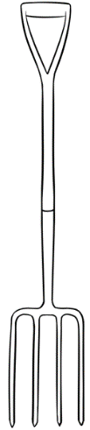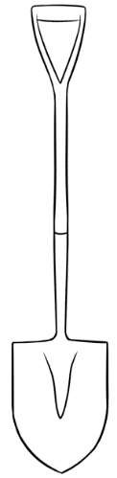

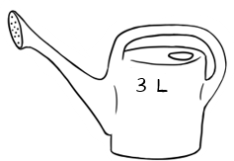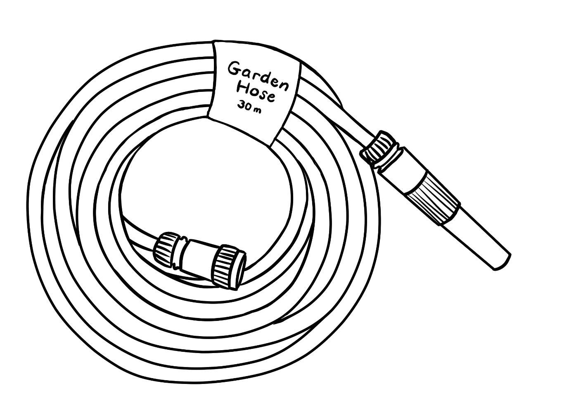

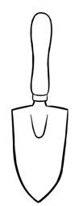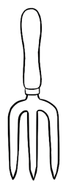

watering can  
**$30**

garden hose  
**$28**

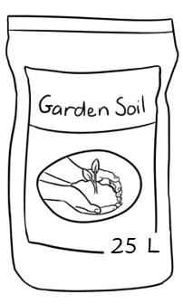

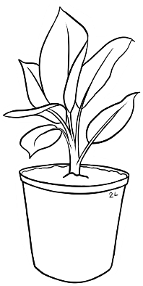

small spade and fork  
**$15** each

big spade and fork **$50** each

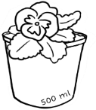

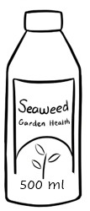

bottle of seaweed

**$16**

small plant

**$13**

big plant

**$40**

bag of soil   
**$14**

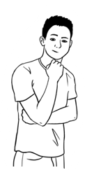

**How much is it?**

Maybe

$50?

 **Listen** and **repeat.**

Bao buys a garden hose and a small plant.

He has $100.

|  |  |
| --- | --- |
| **How much is it?** | **How much change?** |
| Diagram  Description automatically generated  A picture containing text, clipart  Description automatically generated  a garden hose and a small plant  *Work it out here.*  $28  + $13  $41 | Bao has $100.  *Work it out here.*  $100  - $ 41  $ 59 |

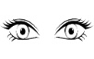 **Look at** the *Bunnings* prices.

**Write** how much.

|  |  |
| --- | --- |
| **How much is it?** | **How much change?** |
| a watering can and a big spade  *Work it out here.* | Bao has $100.  *Work it out here.* |

 **Check** with your partner.

|  |  |
| --- | --- |
| **How much is it?** | **How much change?** |
| A picture containing text, clipart  Description automatically generated    a big plant and a small plant  *Work it out here.* | Bao has $70.  *Work it out here.* |
|  | |
| a small spade and a bag of soil    *Work it out here.* | Bao has $50.  *Work it out here.* |
|  | |
| a bottle of seaweed and a big fork  *Work it out here.* | Bao has $100.  *Work it out here.* |



How much is a small fork and a big fork?

**Ask** your partner.



Maybe $60?

I have one hundred **and** thirty dollars.

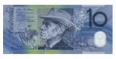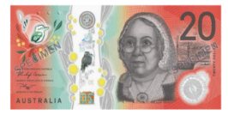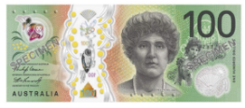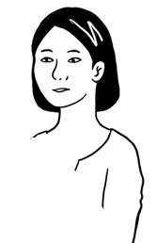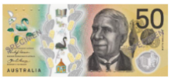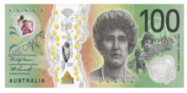

I have two hundred **and** fifty dollars.

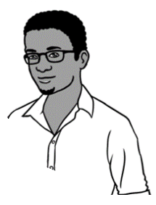



 **Work** with a partner.

**Say** how much you have.

|  |  |
| --- | --- |
| **Numbers** | **Words** |
| **1.**  $130 | I have one hundred **and** thirty dollars. |
| **2.**  $213 | I have two hundred **and** thirteen dollars. |
| **3.**  $260 | I have two hundred **and** sixty dollars. |
| **4.**  $316 | I have three hundred **and** sixteen dollars. |
| **5.**  $470 | I have four hundred **and** seventy dollars |
| **6.**  $517 | I have five hundred **and** seventeen dollars. |

# Bills

How much   
is the bill?



When do I have to pay?

**bill** = account

**Electricity Account**

**Customer Number 682-3651**

**Due Date**

**Amount Due**

**Mrs L Wu**

**70 Wattle Street**

**Kellivale NSW**



The bill is $258.

Lan has to pay by 18 September 2022.

Lan’s bill is more than $200.



How much   
is the bill?

When do I have to pay?

**Electricity Account**

**Customer Number 687-4189**

**Due Date 24 Sept 2022**

**Amount Due $125.00**

**Mr T Dihoud**

**6/50 Baker Road**

**Kellivale NSW**





**Write.**

The bill is $______________.

Tahill has to pay by _________________________.

Tahill’s bill is _________________________ $200.

less than / more than

I have $150.

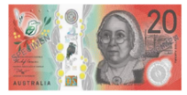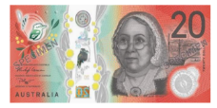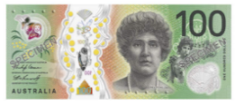



How much change do I get?

**Gas Account**

**Customer Number 674-6598**

**Due Date 12 June 2022**

**Mrs L Wu**

**70 Wattle Street**

**Kellivale NSW**



**Amount Due $128.00**

*Work it out here.*

**Write.**

Lan’s gas bill is $ _________.

Lan has $________.

Lan gets $_______ change.



I have $250.

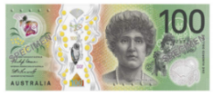

How much change do I get?

**Gas Account Account**

**Customer Number 676-3077**

**Due Date 14 June 2022**

**Mr T Dihoud**

**6/50 Baker Road**

**Kellivale NSW**

**Amount Due $226.00**



**Write.**

*Work it out here.*

Tahill’s gas bill is $ _________.

Tahiil has $________

Tahill gets $_______ change.

# The paint shop

****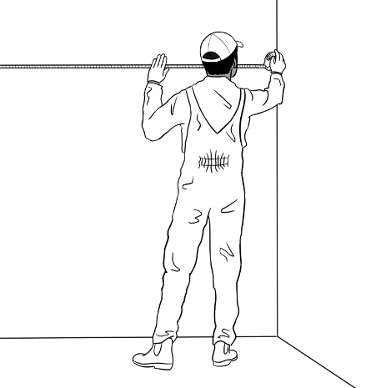**Listen** and **repeat.**

Tahiil is a house painter.

First, he measures the walls.

Then he goes to the paint shop.

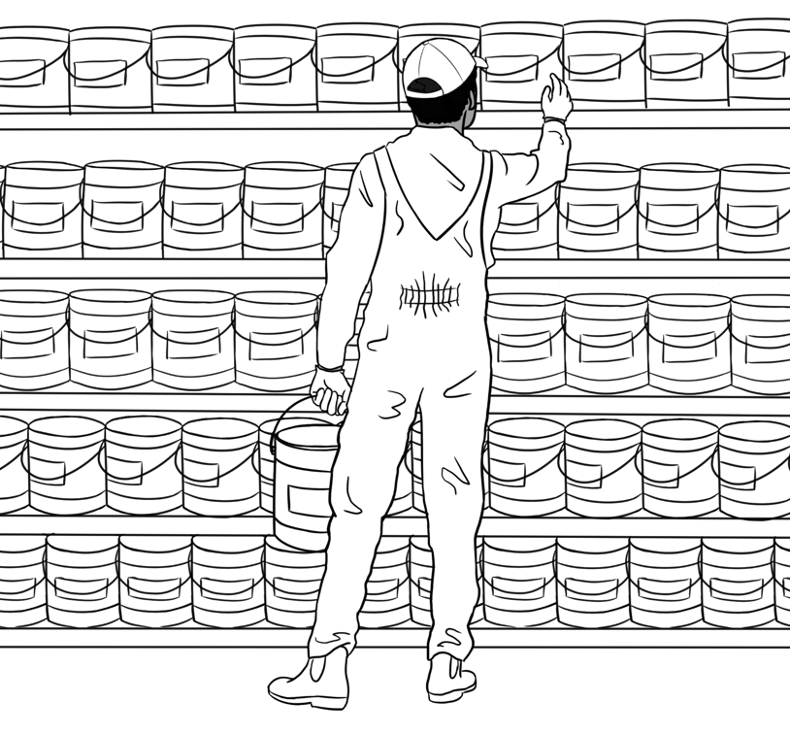

I need a **big** tin of paint.



 **Listen to** your teacher.

**Write** the prices.

|  |  |  |  |
| --- | --- | --- | --- |
|  |  |  |  |
| small tin of paint  $ 60 | big tin of paint  $______ | tape  $______ | ladder  $______ |
|  |  |  |  |
| short roller  $______ | long roller  $______ | small brush  $______ | big brush  $______ |

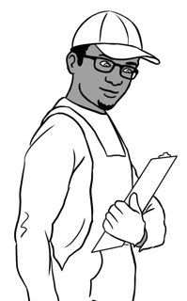

What’s cheaper?

What’s more expensive?

|  |  |  |
| --- | --- | --- |
| **Tick** yes or no.  **🗸** | **Yes** | **No** |
| 1. The small tin of paint is **cheaper than**   the big tin. |  |  |
| 1. The long roller is cheaper than the short roller. |  |  |
| 1. The ladder is **more expensive than**   the big tin of paint. |  |  |
| 1. The big brush is more expensive than   the small brush. |  |  |



**Work** with a partner.



The tape

**?**

What’s more expensive?   
 The small tin of paint   
 or the short roller?

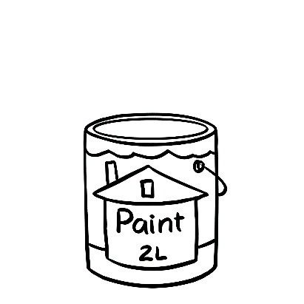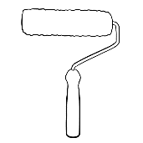

What’s cheaper?   
 The tape or   
 the big brush?

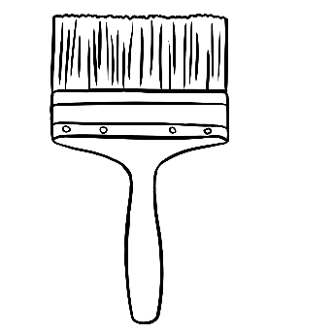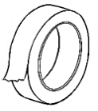



**Ask**

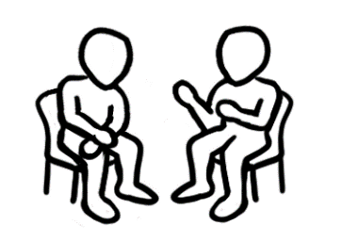

**Listen** and **repeat.**

|  |  |
| --- | --- |
| **How much is it?** | **How much change?** |
| a big tin of paint and a long roller  *Work it out here.*  $225  + $ 56   $281 | Tahill has $300.  *Work it out here.*  $300   - $281   $19 |

Tahiil buys a big tin of paint and a long roller.

**Write** how much.

|  |  |
| --- | --- |
| **How much is it?** | **How much change?** |
| tape and a small brush  *Work it out here.* | Tahiil has $30.  *Work it out here.* |
| a ladder and a small tin of paint  *Work it out here.* | Tahiil has $250.  *Work it out here.* |

# The kitchen shop



**Listen** and **repeat**.

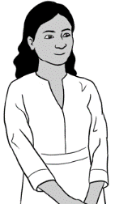

I need a fridge and a kettle.

I need a stove and a toaster.

**Sale**

Fridge**A**

$780

Fridge  
**B**

$990

Stove  
**A**

$775

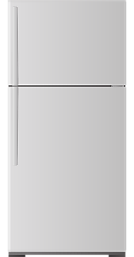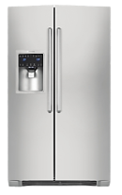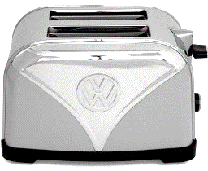

Toaster  
**A**

$225

Stove **B**

$555

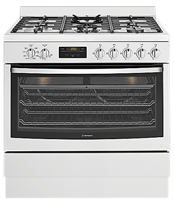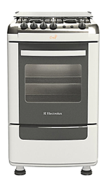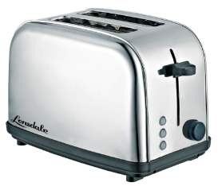

Toaster  
**B**

$195

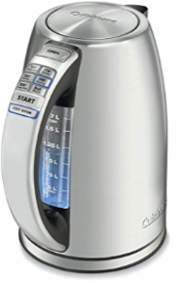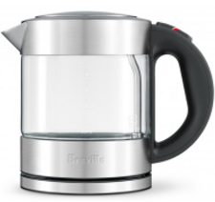

Kettle  
**A**

$125

Kettle  
**B**

$145

**The Kitchen Shop**



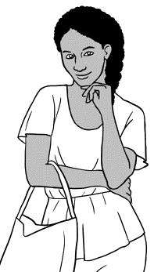

Which one is **cheaper**?

Which one is **more expensive**?

|  |  |  |
| --- | --- | --- |
| **Circle** the **cheaper** price. | | **Write** the **more expensive** price. |
| Fridges | $780 $990 | $990 |
| Kettles | $145 $125 |  |
| Stoves | $555 $775 |  |
| Toasters | $225 $195 |  |



**Write**.

Anika buys the cheaper fridge. $780

She buys the more expensive kettle. $______

*Work it out here.*

Anika has $1000.

She gets $______ change.



Nisha buys the more expensive stove. $________

She buys the cheaper toaster. $________

*Work it out here.*

Nisha has $1000.

She gets $_______ change.

**Read** to a partner.