

|  |
| --- |
| **English Ready**  **Course in EAL  VU22585 Use beginning language learning strategies with support** |

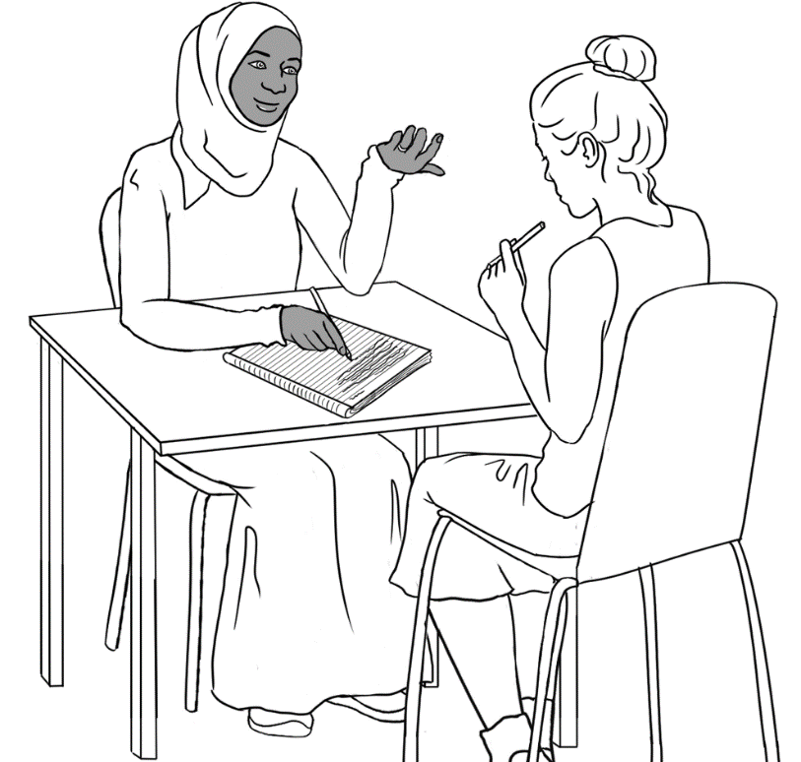**Student Workbook**

**Student ___________________________________________________**

**___________________________________________________________**

**Teacher ___________________________________________________**

**Class ______________________________________________________**

**Date ______________________________________________________**

**Design team:** Vicki Hambling, Sue Paull, Frida Dean, Janice Langley, Glenise Kleehammer and Mary Wallace

**Illustrations:** Madelena Scott

**Image acknowledgements:**

Police logo - Standards Australia, CC BY 3.0 AU <https://creativecommons.org/licenses/by/3.0/au/deed.en>, via Wikimedia Commons   
Toilet sign - [This Photo](http://nvda.in.th/s449400-skpnwybqyijoeewsap/) by Unknown Author is licensed under [CC BY](https://creativecommons.org/licenses/by/3.0/)

**Acknowledgements:** The design team would like to thank the AMEP service providers and practitioners who participated in the trial and gave valuable feedback. The team would also like to acknowledge the use of the EAL Framework which underpins the design of this book.

Copyright of the EAL Framework is reserved to the Crown in the right of the State of Victoria. © State of Victoria (Department of Education and Training) 2018.  
_________________________________________________________________________________________

This English Ready Resource is licensed under a Creative Commons Attribution-NoDerivs 3.0 Australia licence (More information is available [here](http://creativecommons.org/licenses/by-nd/3.0/au/)). You are free to use, copy and distribute to anyone in its original form as long as you attribute Department of Home Affairs as the author and you license any derivative work you make available under the same licence.  
  
© Commonwealth of Australia 2023

With the exception of the Commonwealth Coat of Arms, the department’s logo, any material protected by a trade mark and where otherwise noted all material presented in this document is provided under a Creative Commons Attribution 4.0 International (<https://creativecommons.org/licenses/by/4.0/>) licence.

The details of the relevant licence conditions are available on the Creative Commons website (accessible using the links provided) as is the full legal code for the CC BY 4.0 licence (<https://creativecommons.org/licenses/by/4.0/legalcode>).

Use of all or part of this document must include the following attribution:   
© Commonwealth of Australia 2023

As far as practicable, material for which the copyright is owned by a third party will be clearly labelled.  The department has made all reasonable efforts to ensure that this material has been reproduced in this document with the full consent of the copyright owners.

Copyright requests and enquiries concerning usage not addressed by the CC BY 4.0 licence should be addressed to:

[*comms@homeaffairs.gov.au*](mailto:comms@homeaffairs.gov.au) *at the Department of Home Affairs.*

The terms of use for the Commonwealth Coat of Arms are available from the [It's an Honour](http://www.itsanhonour.gov.au/) website.

Where a copyright owner, other than the Commonwealth, is identified with respect to this material, please contact that third party copyright owner directly to seek permission.

*This workbook is designed to be used with the support of a teacher.*

**Table of Contents**

1. Meet the people. 4

2. Instructions 6

3. The alphabet 8

4. The sounds of the alphabet 14

5. English class 18

6. Who helps you learn English? 20

7. Sahra can’t come to class today. 21

8. Important words 22

9. Learning in Australia 25

10. My word list 28

# Meet the people.

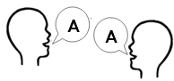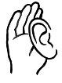

**Listen** and **repeat**.

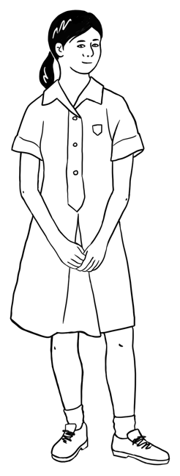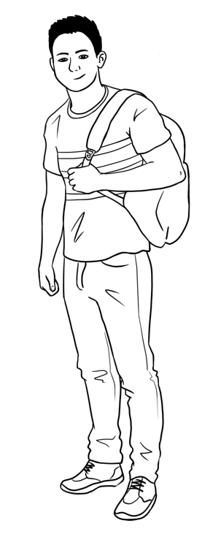

This is **Ming**.This is **Lan**.This is **Mai**.This is **Bao**.

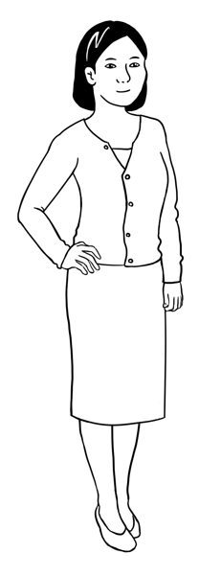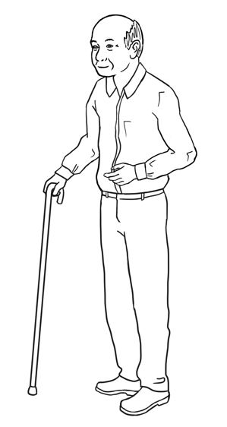

Ming’s family comes from China.

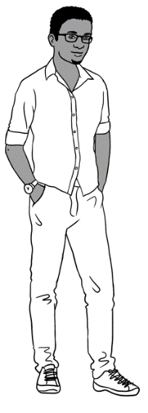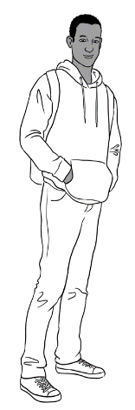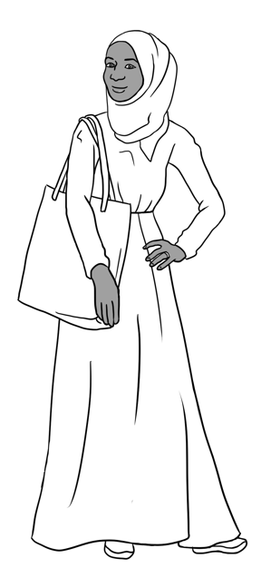

Sahra’s family comes from Somalia.

This is **Sahra**.

This is **Hani**.

This is **Tahiil**.

This is **Abdi**.

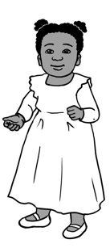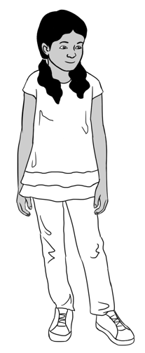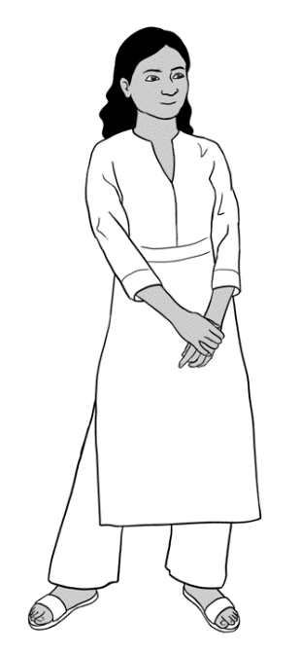

Nisha’s family comes from India.

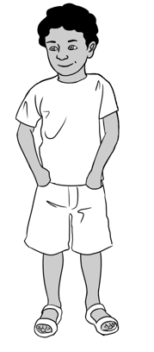

This is **Nisha.** This is **Pari.** This is **Dev**.

Anika comes from Ethiopia.

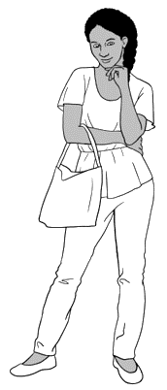

This is **Anika**.

Jenny is a teacher.   
She is from Australia. neighboureighbourneigh

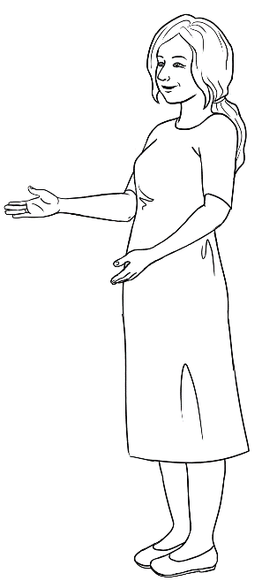

This is **Jenny**.

Carim’s family comes from Syria.

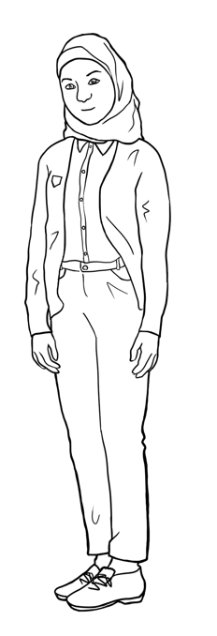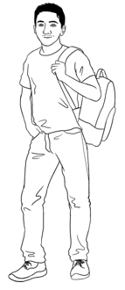

This is **Fatima**.

This is **Carim**.

This is **Carim**. This is **Fatima**.

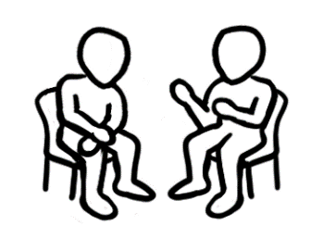

**Read** with a partner.

# Instructions

**Match.**

|  |  |  |
| --- | --- | --- |
|  |  | 1. Copy. |
|  | 1. Repeat. |
|  | 1. Write. |
|  | 1. Read. |
|  | 1. Listen. |
|  | 1. Spell. |
| **🗸** | 1. Circle. |
|  | 1. Say. |
|  | 1. Work with a partner. |
|  | 1. Tick. |
|  | 1. Record. |
|  | 1. Ask. |



**Check** with your partner.

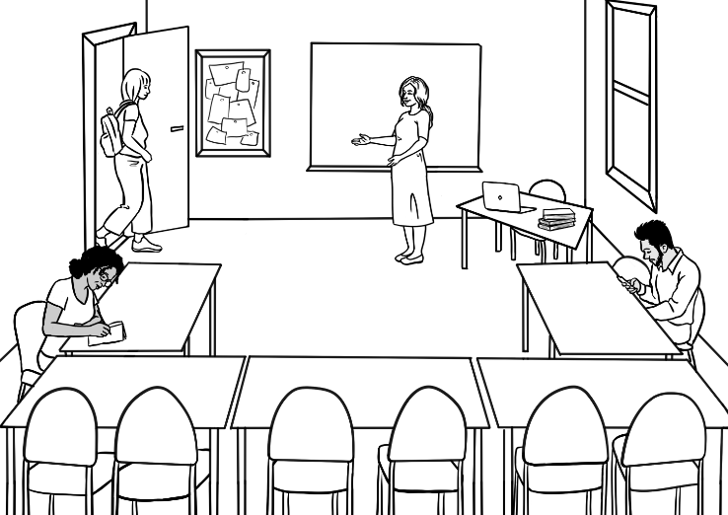

Come in.

**Listen** and **repeat**.

**Listen** and follow the instructions.

|  |  |
| --- | --- |
| Stand up.  **1** | Sit down.  **2** |
| Open your workbook.  **3** | Close your workbook.  **4** |
| Look at the board.  **5** | Listen to  the teacher.  Listen.  **6** |
| Stand in a line.  **7** | Stand in a circle.  **8** |

# The alphabet



 **Listen** and **repeat**.

**Listen** and **circle**.

|  |  |  |  |  |  |  |  |  |  |  |  |  |
| --- | --- | --- | --- | --- | --- | --- | --- | --- | --- | --- | --- | --- |
| **A** | B | C | D | **E** | F | G | H | **I** | J | K | L | M |
| N | **O** | P | Q | R | S | T | **U** | V | W | X | Y | Z |

**Capital letters**

**Copy** the capital letters.

|  |  |  |  |  |  |  |  |  |  |  |  |  |  |
| --- | --- | --- | --- | --- | --- | --- | --- | --- | --- | --- | --- | --- | --- |
|  | **A** | **B** | **C** | **D** | **E** | **F** | **G** | **H** | **I** | **J** | **K** | **L** | **M** |
| **1** | A | B |  | D | E |  | G | H |  | J | K |  | M |
| **2** | A |  | C |  |  | F |  |  | I |  |  | L |  |
| **3** |  |  |  |  |  |  |  |  |  |  |  |  |  |

|  |  |  |  |  |  |  |  |  |  |  |  |  |  |  |
| --- | --- | --- | --- | --- | --- | --- | --- | --- | --- | --- | --- | --- | --- | --- |
|  | **N** | **O** |  | **P** | **Q** | **R** | **S** | **T** | **U** | **V** | **W** | **X** | **Y** | **Z** |
| **4** | N |  |  | P | Q | R |  | T | U |  | W |  | Y | Z |
| **5** |  | O |  |  |  |  | S |  |  | V |  | X |  |  |
| **6** |  |  |  |  |  |  |  |  |  |  |  |  |  |  |

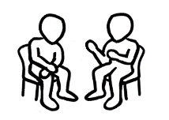

**Read** with a partner.



**Listen** and **repeat**.

**Listen** and **circle**.

**Small letters**

|  |  |  |  |  |  |  |  |  |  |  |  |  |
| --- | --- | --- | --- | --- | --- | --- | --- | --- | --- | --- | --- | --- |
| **a** | b | c | d | **e** | f | g | h | **i** | j | k | l | m |
| n | **o** | p | q | r | s | t | **u** | v | w | x | y | z |

**Copy** the small letters.

|  |  |  |  |  |  |  |  |  |  |  |  |  |  |
| --- | --- | --- | --- | --- | --- | --- | --- | --- | --- | --- | --- | --- | --- |
|  | **a** | **b** | **c** | **d** | **e** | **f** | **g** | **h** | **i** | **j** | **k** | **l** | **m** |
| **1** | a | b |  | d | e |  | g | h |  | j | k |  | m |
| **2** |  |  | c |  |  | f |  |  | i |  |  | l |  |
| **3** |  |  |  |  |  |  |  |  |  |  |  |  |  |

|  |  |  |  |  |  |  |  |  |  |  |  |  |  |
| --- | --- | --- | --- | --- | --- | --- | --- | --- | --- | --- | --- | --- | --- |
|  | **n** | **o** | **p** | **q** | **r** | **s** | **t** | **u** | **v** | **w** | **x** | **y** | **z** |
| **4** | n |  | p | q | r |  | t | u |  | w |  | y | z |
| **5** |  | o |  |  |  | s |  |  | v |  | x |  |  |
| **6** |  |  |  |  |  |  |  |  |  |  |  |  |  |



**Read** with a partner.

**Capital and small letters**

|  |  |  |  |  |  |  |
| --- | --- | --- | --- | --- | --- | --- |
| A a | B b | C c | D d | E e | F f | G g |
| H h | I i | J j | K k | L l | M m | N n |
| O o | P p | Q q | R r | S s | T t | U u |
| V v | W w | X x | Y y | Z z |  |  |

**Match** the capital and small letters.

|  |  |  |  |  |
| --- | --- | --- | --- | --- |
| A | b |  | N | p |
| B | d | O | n |
| C | a | P | t |
| D | c | Q | o |
| E | g | R | s |
| F | e | S | q |
| G | f | T | w |
| H | k | U | r |
| I | m | V | x |
| J | l | W | u |
| K | h | X | z |
| L | i | Y | v |
| M | j | Z | y |

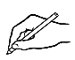**Write** the small letter.

|  |  |  |  |  |  |  |
| --- | --- | --- | --- | --- | --- | --- |
| A a | B | C | D | E | F | G |
| H | I | J | K | L | M | N |
| O | P | Q | R | S | T | U |
| V | W | X | Y | Z |  |  |

**Write** the capital letter.

|  |  |  |  |  |  |  |
| --- | --- | --- | --- | --- | --- | --- |
| a A | b | c | d | e | f | g |
| h | i | j | k | l | m | n |
| o | p | q | r | s | t | u |
| v | w | x | y | z |  |  |



|  |  |  |  |  |
| --- | --- | --- | --- | --- |
| b | d | b | p | q |
| f | h | k | f | l |
| m | n | w | m | u |
| y | u | v | w | y |
| x | s | c | x | z |
| p | t | b | p | r |
| k | c | v | k | t |
| a | o | u | v | a |
| g | y | g | j | q |

**Circle** the same letter.

**The computer keyboard**

**Listen** and **repeat.**

**Listen**. **Circle** the capital letters.

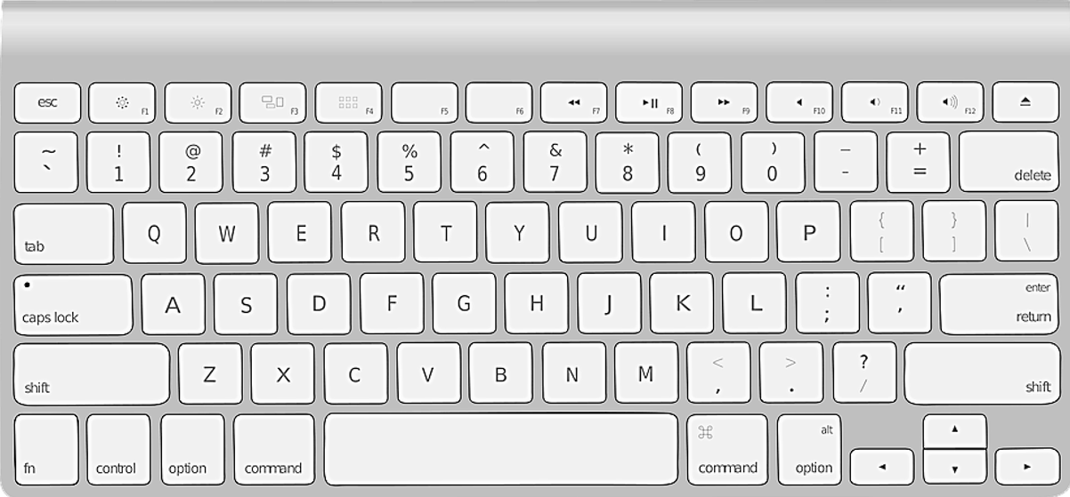

**G**

**W**

**E**

**R**

**T**

**Y**

**U**

**I**

**O**

**P**

**D**

**A**

**S**

**Q**

**F**

**H**

**R**

**Q**

**X**

**C**

**B**

**N**

**M**

**V**

**Z**

**K**

**J**

**L**



**Write** the capital letters.



**G**

**W**

E

**R**

**Y**

**I**

**P**

**D**

**A**

**Q**

**R**

**Q**

**C**

**B**

**M**

**Z**

**J**

**L**

**Read** to a partner.

|  |  |  |  |  |  |  |  |  |  |  |  |  |
| --- | --- | --- | --- | --- | --- | --- | --- | --- | --- | --- | --- | --- |
| A | B | C | D | E | F | G | H | I | J | K | L | M |
| N | O | P | Q | R | S | T | U | V | W | X | Y | Z |



**Listen**. **Write** the capital letters.

|  |  |  |  |  |  |
| --- | --- | --- | --- | --- | --- |
|  |  | **3.** | **4.** | **5.** | **6.** |
|  |  |  |  |  |  |

|  |  |  |  |  |  |
| --- | --- | --- | --- | --- | --- |
| **7.** | **8.** | **9.** | **10.** | **11.** | **12.** |
|  |  |  |  |  |  |

|  |  |  |  |  |  |  |  |  |  |  |  |  |
| --- | --- | --- | --- | --- | --- | --- | --- | --- | --- | --- | --- | --- |
| a | b | c | d | e | f | g | h | i | j | k | l | m |
| n | o | p | q | r | s | t | u | v | w | x | y | z |

**Listen**. **Write** the small letters.

|  |  |  |  |  |  |
| --- | --- | --- | --- | --- | --- |
| **1.** | **2.** | **3.** | **4.** | **5.** | **6.** |
|  |  |  |  |  |  |

|  |  |  |  |  |  |
| --- | --- | --- | --- | --- | --- |
| **7.** | **8.** | **9.** | **10.** | **11.** | **12.** |
|  |  |  |  |  |  |

# The sounds of the alphabet



|  |  |  |
| --- | --- | --- |
| **A a**  **a**pple | **B b**  **b**ackpack | **C c**  **c**omputer |
| **D d**  **d**oor | **E e**  **e**ggs | **F f**  **f**ive |
| **G g**  **g**lasses | **H h**  **h**ighlighter | **I i**  **i**nsect |
| **J j**  **j**acket | **K k**  **k**ey | **L l**  **l**amp |

**Listen** and **repeat**.

**Match**.

|  |  |  |  |  |
| --- | --- | --- | --- | --- |
|  | **a**pple |  | **b**ackpack |  |
|  | **e**ggs | **d**oor |  |
|  | **i**nsect | **g**lasses |  |
|  | **h**ighlighter | **c**omputer |  |

******Listen** and **repeat**.

|  |  |  |
| --- | --- | --- |
| **M m**  **m**oney | **N n**  **n**otebook | **O o**  **o**range |
| **P p**  **p**encil | **Q q**  **q**uestion | **R r**  Rubber  **r**ubber |
| **S s**  **s**tudent | **T t**  **t**able | **U u**  **u**mbrella |
| **V v**  **v**an | **W w**  **w**ater | **X x**  **x**-ray |
| **Y y**  **y**am | **Z z**  **z**ero |  |

**Match**.

|  |  |  |  |  |
| --- | --- | --- | --- | --- |
|  | **o**range |  | **p**encil |  |
|  | **u**mbrella | **r**ubber | Rubber |
|  | **s**tudent | **t**able |  |

** Listen**. **Circle** the sound.

|  |  |  |  |
| --- | --- | --- | --- |
| **1** | **c** computer | **A picture containing text  Description automatically generateds** student | **Icon  Description automatically generated with medium confidencez** zero |
| **2** | **A picture containing knife  Description automatically generatedp** pencil | **A drawing of a child  Description automatically generated with low confidenceb**  backpack | **A picture containing clipart  Description automatically generatedd**  door |
| **3** | **Diagram  Description automatically generatedk**  key | **Icon  Description automatically generatedg**  glasses | **A picture containing text  Description automatically generatedj**  jacket |
| **4** | **A picture containing text, sign  Description automatically generatedn** notebook | **A picture containing text, metalware, gear  Description automatically generatedm** money | **Diagram, engineering drawing  Description automatically generatedh** highlighter |
| **5** | **i**  insect | **A picture containing shape  Description automatically generateda** apple | **A picture containing shape  Description automatically generatede** eggs |
| **6** | **u** umbrella | **w** water | **A picture containing text  Description automatically generatedv** van |

******Listen** and **repeat**.  **Underline** the sound.

|  |  |  |  |
| --- | --- | --- | --- |
| **sh** | sharpener | shoe | shop |
| shirt | fish | Nisha |
| **ch** | child | children | teacher |
| chicken | chair | chips |
| **th** | three  3 | thirteen  13 | thirty  30 |
| Thursday  Wednesday  **Thursday**  Friday  Saturday | fourth | thank |

# English class



**Listen**.

I go to class four days a week.

My class starts at 9:00 on Monday.

My class finishes at 2:30.

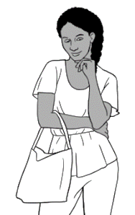

When do **you** go to class?

**This is your timetable.**

 **Tick** the days of your classes.

**Write** the times and room numbers.

|  |  |  |  |  |  |
| --- | --- | --- | --- | --- | --- |
| **Day** | **Monday** | **Tuesday** | **Wednesday** | **Thursday** | **Friday** |
| **Start** |  |  |  |  |  |
| **Finish** |  |  |  |  |  |
| **Room** |  |  |  |  |  |

**Listen**. **Write** the days and dates.

The last day of term is _____________________________________.

The public holidays are ___________________________________

__________________________________________________________.

The special days are ______________________________________.

Our excursion day is _______________________________________.

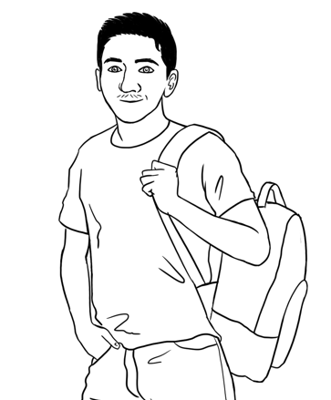

It’s Monday.

I’m ready for class.

I have 12 things in my backpack.

|  |  |  |  |
| --- | --- | --- | --- |
| a pencil | a rubber  Rubber | a sharpener | a pencil case |
| a highlighter | a pen | a workbook | A picture containing text, sign  Description automatically generateda notebook |
| a ruler | a phone | glasses | water |

 **Listen** and **repeat**.

**Tick** what **you** have today.

**🗸**

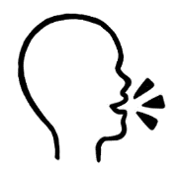 **Work** with a partner.

I have a pencil, a rubber,   
a pencil case, a workbook,   
a notebook and a phone.

**Say** what **you** have.

**Listen** to your partner.

# Who helps you learn English?

Who helps **me** learn?

Who helps **me** learn?

Who helps **you** learn?

 **Listen** to the teacher. **Tick.**

|  |  |  |  |
| --- | --- | --- | --- |
| **Who helps?** | **Sahra** | **Tahiil** | **You** |
| the teacher | **🗸** | **🗸** |  |
| a volunteer tutor |  | **🗸** |  |
| the librarian | **🗸** |  |  |
| family | **🗸** | **🗸** |  |
| a neighbour | **🗸** |  |  |

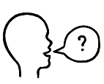 **Ask** your partner.

Who helps you learn English?

# Sahra can’t come to class today.



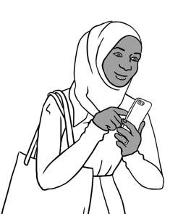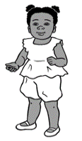

**Listen**.

**Why can’t Sahra come to class?**

Hani is sick today.

Sahra sends a message   
to the childcare centre and her teacher.

Hi Nisha,

Hani is sick today.

Sahra Elmi

Hi Teacher,

I can’t come to class today.

Sahra Elmi

________________________________________________________________________________________________________________________________________________________________________________________________________________________________________________________

Hi Teacher,

I can’t come to class today.

_____________



**Write** your name.

**Copy**.

 **Read** the messages with a partner.

Hi Nisha,

Hani is sick today.

Sahra Elmi

# Important words

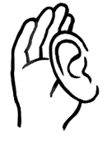

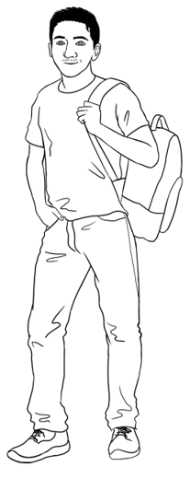**Listen** and **repeat**.

 Carim’s important words

|  |  |
| --- | --- |
| **First name** | Carim |
| **Family name** | Hamed |
| **Street** | North Street |
| **Town / Suburb** | Kellivale |



**Write** your important words.

|  |  |
| --- | --- |
| **First name** |  |
| **Family name** |  |
| **Street** |  |
| **Town / Suburb** |  |

**Ask** your teacher.

Can you check my spelling please?

Can you say the name of my street and suburb please?



**Record** your teacher.



**Listen** and **repeat** at home.

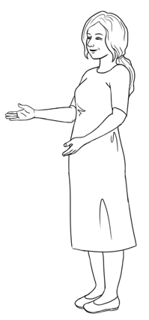

Can you spell your name please Carim?

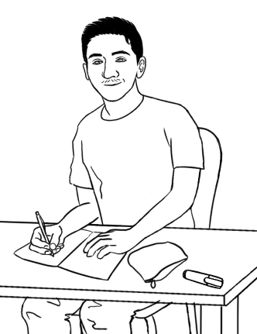

Carim **C** - **a** - **r** - **i** - **m**

**Learn your important words**.

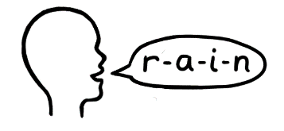****

**Say** the word. **Copy** the word. **Spell** aloud.

|  |  |
| --- | --- |
| **First Name** | **Family Name** |
|  |  |
|  |  |
|  |  |
|  |  |
|  |  |

|  |  |
| --- | --- |
| **Street** | **Town / suburb** |
|  |  |
|  |  |
|  |  |
|  |  |
|  |  |

******Listen** and **repeat**.

**Listen**. **Tick** the sign.

|  |  |  |  |  |  |
| --- | --- | --- | --- | --- | --- |
| **1** | | **2** | | **3** | |
| **4** | **5** | | **6** | | **7** |

Aa Bb Cc Dd Ee Ff Gg Hh Ii Jj Kk Ll Mm

Nn Oo Pp Qq Rr Ss Tt Uu Vv Ww Xx Yy Zz

**Write** in small letters.

|  |  |  |
| --- | --- | --- |
| TOILETS | RECEPTION | FIRE EXIT |
| toilets. | __________________ | __________________ |
| DANGER | STOP | HOSPITAL |
| __________________ | __________________ | __________________ |

# Learning in Australia

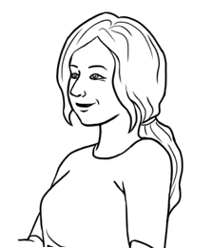

Is learning in Australia the same as   
learning in your country?



**Listen**. **🗸 Tick** yes or no.

|  |  |  |  |  |
| --- | --- | --- | --- | --- |
| **Learning in Australia** | | | **In your country** | |
| **Yes** | **No** |
|  | Students come  to class on time. | |  |  |
| Good morning Alina.  Good morning Jenny.  Teachers and  students use  their first names. | | |  |  |
| Do you understand? | | The teacher says,  Do you understand? |  |  |
| Sorry. I don’t  understand.  Students say,  Sorry. I don’t understand. | | |  |  |

|  |  |  |  |  |  |
| --- | --- | --- | --- | --- | --- |
| **Learning in Australia** | | | | **In your**  **country** | |
| **Yes** | **No** |
| **Thank you**.  Can you  help me **please**? | | | Teachers and students say please and thank you. |  |  |
| Students ask questions. | | Excuse me.  What is this word? | |  |  |
|  | Students work  with a partner. | | |  |  |
| Men and women  work together. | | | |  |  |

|  |  |  |  |  |  |
| --- | --- | --- | --- | --- | --- |
| **Learning in Australia** | | | | **In your**  **country** | |
| **Yes** | **No** |
| Students work  in groups. |  | | |  |  |
|  | | | Students and  teachers work together. |  |  |
| Students go on excursions. | | | |  |  |
|  | | Students study  at home. | |  |  |

|  |  |  |
| --- | --- | --- |
|  |  |  |
|  |  |  |
|  |  |  |
|  |  |  |
|  |  |  |
|  |  |  |
|  |  |  |
|  |  |  |
|  |  |  |
|  |  |  |
|  |  |  |
|  |  |  |
|  |  |  |

# My word list