

|  |
| --- |
| **English Ready**  **Course in EAL  VU22354 Recognise measurements in simple, highly familiar situations** |

**Student Workbook**

**Student** _______________________________________________________

_________________________________________________________________

**Teacher** _______________________________________________________

**Class** __________________________________________________________

**Date**___________________________________________________________

**Design team:** Vicki Hambling, Sue Paull, Frida Dean, Janice Langley, Dhammika Fernando, Glenise Kleehammer and Mary Wallace

**Illustrations:** Madelena Scott

**Image acknowledgements:**IGA & Bunnings Warehouse logos - [These Photo](https://en.wikipedia.org/wiki/IGA_(supermarkets))s by Unknown Author is licensed under [CC BY-SA](https://creativecommons.org/licenses/by-sa/3.0/)

**Acknowledgements:** The design team would like to thank the AMEP service providers and practitioners who participated in the trial and gave valuable feedback. The team would also like to acknowledge the use of the EAL Framework which underpins the design of this book.

Copyright of the EAL Framework is reserved to the Crown in the right of the State of Victoria. © State of Victoria (Department of Education and Training) 2018.  
_________________________________________________________________________________________

This English Ready Resource is licensed under a Creative Commons Attribution-NoDerivs 3.0 Australia licence (More information is available [here](http://creativecommons.org/licenses/by-nd/3.0/au/)). You are free to use, copy and distribute to anyone in its original form as long as you attribute Department of Home Affairs as the author and you license any derivative work you make available under the same licence.  
  
© Commonwealth of Australia 2023

With the exception of the Commonwealth Coat of Arms, the department’s logo, any material protected by a trade mark and where otherwise noted all material presented in this document is provided under a Creative Commons Attribution 4.0 International (<https://creativecommons.org/licenses/by/4.0/>) licence.

The details of the relevant licence conditions are available on the Creative Commons website (accessible using the links provided) as is the full legal code for the CC BY 4.0 licence (<https://creativecommons.org/licenses/by/4.0/legalcode>).

Use of all or part of this document must include the following attribution:   
© Commonwealth of Australia 2023

As far as practicable, material for which the copyright is owned by a third party will be clearly labelled.  The department has made all reasonable efforts to ensure that this material has been reproduced in this document with the full consent of the copyright owners.

Copyright requests and enquiries concerning usage not addressed by the CC BY 4.0 licence should be addressed to:

[*comms@homeaffairs.gov.au*](mailto:comms@homeaffairs.gov.au) *at the Department of Home Affairs.*

The terms of use for the Commonwealth Coat of Arms are available from the [It's an Honour](http://www.itsanhonour.gov.au/) website.

Where a copyright owner, other than the Commonwealth, is identified with respect to this material, please contact that third party copyright owner directly to seek permission.

*This workbook is designed to be used with the support of a teacher.*

**Table of Contents**

1. What’s the time? 4

2. What’s the date? 8

3. Is it hot or cold today? 13

4. Is Hani sick? 16

5. How tall are you? 18

6. How high and wide is it? 21

7. How long and wide is it? 22

8. How far is it? 24

9. How heavy is it? 26

10. How many litres? 27

11. How much flour? 28

12. How much milk? 31

# What’s the time?

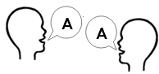

**Listen** and **repeat.**

**am** = morning

|  |  |  |
| --- | --- | --- |
|  | | |
| 12  1  11  6  3  2  10  9  8  5  7  4 | It’s 7:30 am. | **8:00 am**  Mon 7 Aug  18**°**C |
| It’s 7:00 am.  It’s 7 o’clock. | It’s seven thirty.  It’s half past seven. | It’s 8 am.  It’s 8 o’clock. |

There are **60 minutes** in an hour.

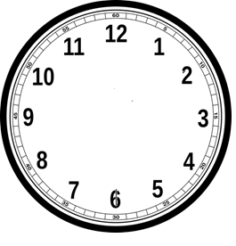

There are **30 minutes** in half an hour.

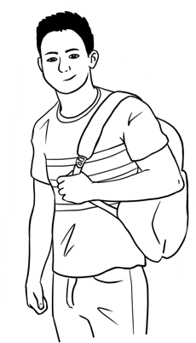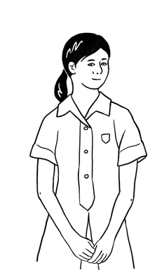

It’s eight thirty.

St eight.

It’s half past eight.

St eight.

What’s the time?

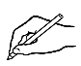**Write** the times.

|  |  |  |  |  |
| --- | --- | --- | --- | --- |
| **am = morning** | |  | **pm = afternoon** | |
| 12  1  11  6  3  2  10  9  8  5  7  4 | 9:00 am  nine o’clock |  | **4**.  12  1  11  6  3  2  10  9  8  5  7  4 | 1:30 pm  one thirty *or*  half past one |
| 12  1  11  6  3  2  10  9  8  5  7  4 | ______am  nine thirty *or*  half past nine |  | **5**.  12  1  11  6  3  2  10  9  8  5  7  4 | _______pm  three thirty *or*  half past three |
| 12  1  11  6  3  2  10  9  8  5  7  4 | _______am  ten thirty *or*  half past ten |  | **6**.  12  1  11  6  3  2  10  9  8  5  7  4 | _______pm  five o’clock |

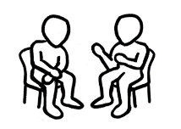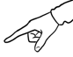

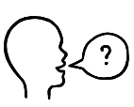**Work** with a partner. **Point to** a clock.

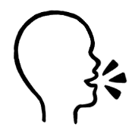**Ask**

It’s nine.

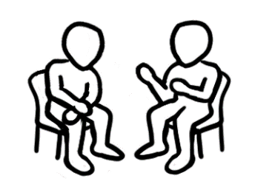

What’s the time?

It’s 9 o’clock.

**Swap roles**.

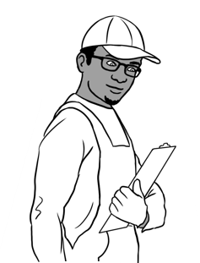**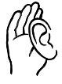 Listen** and **repeat.**

Tahiil is a painter.   
He works five days a week.   
Today is Monday.

**Write** the times.

|  |  |
| --- | --- |
| **7:30 am**  Mon 7 Aug  18**°**C | He gets up at 6:30 am. |
|  | He drives to work at ______am. |
|  | He starts work at _______am. |
|  | He works for 8 hours.  He finishes work at ______pm. |
|  | He takes Hani to the park  at ___________pm. |

**Read** to a partner.

**½ P** = 30 minutes

**1P** = 1 hour

**2P** = 2 hours



22222p

**2 P**

9 am – 5 pm

Mon - Fri

**Listen** to the teacher.

He can park for **2** hours.

He can park between **9 am** and **5 pm**.

He can park from **Monday to Friday**.

**½ P**

9 am – 5 pm

Mon –Fri

**🗸**

**Tick** yes or no.

I can park for 1 hour . □yes □no

I can park between 9 am and 5 pm. □yes □no

I can park on Saturday. □yes □no

**3 P**

11 am – 6 pm

Mon – Fri

9 am – 12 pm

Sat

I can park for 3 hours. □yes □no

I can park at 10 am on Monday. □yes □no

I can park at 9 am on Saturday. □yes □no

I can park all day on Saturday. □yes □no

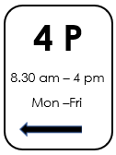

**Talk** with your partner.

**  
 Ask**

What time can you park?

What days can you park?

# What’s the date?



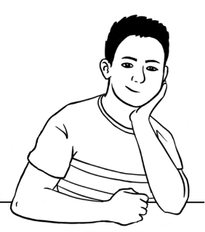**Listen** and **repeat.**

There are **seven** days in **a week**.

|  |  |  |  |
| --- | --- | --- | --- |
| **a week** | Monday | Tuesday | Wednesday |
| Thursday | Friday | Saturday | Sunday |

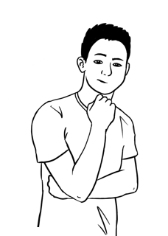

How many days are in **a month**?

**Open the Calendar** on your phone.

This month is _________________________. It has ______ days.



|  |
| --- |
| January |
| February**🗸** |
| March |
| April |
| May |
| June |
| July |
| August |
| September |
| October |
| November |
| December |

**Write** the months.

|  |  |
| --- | --- |
| **28** or **29 days** | February |
| **30 days** | __________________________  __________________________  __________________________  __________________________ |
| **31 days** | __________________________  __________________________  __________________________  __________________________  __________________________  __________________________  __________________________ |

|  |  |
| --- | --- |
| [**Hours**](https://www.google.com/search?sxsrf=APq-WBu3R_ioOBbOBMnT7fK7F6Y5GEHSUw:1650088741505&q=bunnings+mill+park+hours&ludocid=6634445409430538691&sa=X&ved=2ahUKEwjKgYHK85f3AhUS4nMBHWHPCU0Q6BN6BAgFEAI) | |
| **Saturday** | 6am – 7pm |
| **Sunday** | 7am – 7pm |
| **Monday** | 7am – 7pm |
| **Tuesday** - **Friday** | 6:30am – 9pm |

**Long and short words**

|  |  |
| --- | --- |
| **Hours** | |
| **Mon** - **Sat** | 7am - 9pm |
| **Sun** | 7am - 8pm |



**Match**.

|  |  |  |
| --- | --- | --- |
| **Long** word |  | **Short word** |
| Sunday | Tues |
| Monday | Wed |
| Tuesday | Sun |
| Wednesday | Mon |
| Thursday | Sat |
| Friday | Thurs |
| Saturday | Fri |

|  |  |  |  |
| --- | --- | --- | --- |
| **Long word** | |  | **Short** word |
| **1** | January | Feb |
| **2** | February | Apr |
| **3** | March | Jan |
| **4** | April | Mar |
| **5** | May | Jun |
| **6** | June | May |
| **7** | July | Aug |
| **8** | August | Jul |
| **9** | September | Dec |
| **10** | October | Nov |
| **11** | November | Oct |
| **12** | December | Sept |

**Circle** the dates.

|  |  |  |
| --- | --- | --- |
| **Electricity**  Ms Nisha Kumar  56 North St Kellivale NSW | Customer | 69452301 |
| Due date | 09 Aug 23 |
| Pay | $115.45 |

1. **An electricity bill**

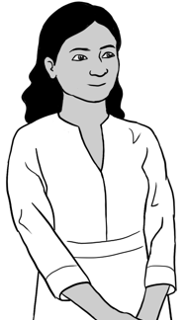

1. **A party invitation**

**3.** **A doctor’s appointment**

Come to

**Dev’s birthday party**

**Saturday 26 August**1 pm – 3 pm56 North St, Kellivale

Dr Myra Kidman

Medical Centre, Kellivale

Phone: 0495 626 469

Pari Kumar

*has an appointment*

on Tues 15 Aug

at 9:30 am

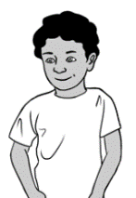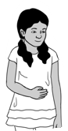

**Circle** the dates on the calendar.

|  |  |  |  |  |  |  |
| --- | --- | --- | --- | --- | --- | --- |
| **August** | | | | | | |
| **Sun** | **Mon** | **Tues** | **Wed** | **Thurs** | **Fri** | **Sat** |
|  |  | 1 | 2 | 3 | 4 | 5 |
| 6 | 7 | 8 | 9 | 10 | 11 | 12 |
| 13 | 14 | 15 | 16 | 17 | 18 | 19 |
| 20 | 21 | 22 | 23 | 24 | 25 | 26 |
| 27 | 28 | 29 | 30 | 31 |  |  |

**Listen**.

**Circle** the dates.

**Listen** to the teacher.



**Write** the date. Tues 15 Aug

Tuesday the fifteenth of August

**Say** the date.

|  |  |  |  |  |  |  |
| --- | --- | --- | --- | --- | --- | --- |
| **August** | | | | | | |
| **Sun** | **Mon** | **Tues** | **Wed** | **Thurs** | **Fri** | **Sat** |
|  |  | **1st**  first | **2nd**  second | **3rd**  third | **4th**  fourth | **5th**  fifth |
| **6th**  sixth | **7th**  seventh | **8th**  eighth | **9th**  ninth | **10th**  tenth | **11th**  eleventh | **12th**  twelfth |
| **13th**  thirteenth | **14th**  fourteenth | **15th**  fifteenth | **16th**  sixteenth | **17th**  seventeenth | **18th**  eighteenth | **19th**  nineteenth |
| **20th**  twentieth | **21st**  twenty-first | **22nd**  twenty-second | **23rd**  twenty-third | **24th**  twenty-fourth | **25th**  twenty-fifth | **26th**  twenty-sixth |
| **27th**  twenty-seventh | **28th**  twenty-eighth | **29th**  twenty-ninth | **30th**  thirtieth | **31st**  thirty-first |  |  |



**Work** with a partner. **Point** to a date on the calendar.



What’s the date?



Thursday the tenth of August

**Listen**.

|  |  |  |  |  |  |  |
| --- | --- | --- | --- | --- | --- | --- |
| **This month is ________________________.** | | | | | | |
| **Sun** | **Mon** | **Tues** | **Wed** | **Thurs** | **Fri** | **Sat** |
|  |  |  |  |  |  |  |
|  |  |  |  |  |  |  |
|  |  |  |  |  |  |  |
|  |  |  |  |  |  |  |
|  |  |  |  |  |  |  |

**Write** the month and date numbers on the calendar.

|  |  |  |  |  |
| --- | --- | --- | --- | --- |
| **A picture containing insect  Description automatically generatedWrite** the days. | | Sunday | Monday | Tuesday |
|  | Wednesday | Thursday | Friday | Saturday |

1. The first day of the month is ______________________________.
2. The tenth day of the month is ____________________________.
3. The fourteenth day of the month is _______________________.
4. The twenty-second day of the month is ___________________.



**Circle** the dates on the calendar.

1. Today’s date ___________________________________



**Write**

the dates.

1. Yesterday’s date________________________________
2. ****Tomorrow’s date________________________________

**Work** with a partner. **Point to** a date on the calendar.

**Ask**

What’s the date?

# Is it hot or cold today?



**Listen** and **repeat.**

This thermometer measures **air** temperature.

**OC**

**-10**

**-5**

**0**

**10**

**15**

**20**

**25**

**30**

**35**

**40**

**45**

**50**

**55**

**5**

**°C** = *degrees Celsius*

The temperature is **20°C**.



**Write** the temperature.

O**C**

**-10**

**-5**

**0**

**10**

**15**

**20**

**25**

**30**

**35**

**40**

**45**

**50**

**55**

**5**

1. The temperature is ______ **°**C.

**Tick.** It’s hot. It’s cold.

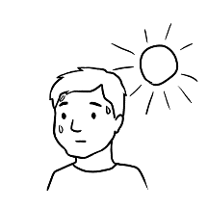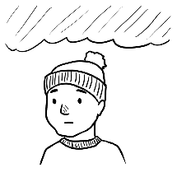

O**C**

**-10**

**-5**

**0**

**10**

**15**

**20**

**25**

**30**

**35**

**40**

**45**

**50**

**55**

**5**

1. The temperature is ______ **°**C.

**Tick.** It’s hot. It’s cold.



  
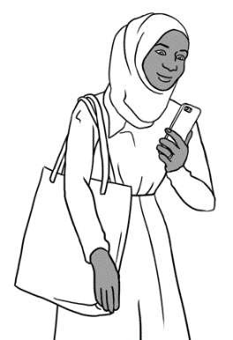**Listen** and **repeat.**

It’s 14 degrees.

**10:00 am**

Wed, 16 Feb

**14°C**



Sahra checks the temperature  
in the **morning**. It is 14**°**C.

She checks the temperature

in the **afternoon.**

**Colour** the temperatures on the thermometers.

|  |  |  |  |
| --- | --- | --- | --- |
| 12 pm | 2 pm | 3 pm | 4 pm |
|  |  |  |  |
| 20**°**C | 30**°**C | 35**°**C | 30**°**C |
|  |  |  |  |

|  |  |  |
| --- | --- | --- |
| **🗸 Tick** yes or no. | **Yes** | **No** |
| 1. It’s **colder** at 10 am than at 12 pm. | **🗸** |  |
| 1. It’s colder at 12 pm than at 4 pm. |  |  |
| 1. It **hotter** at 2 pm than at 3 pm. |  |  |
| 1. It’s hotter at 3 pm than at 4 pm. |  |  |

 **Read** to your partner.

Put a thermometer somewhere **inside** the classroom.

**Put a thermometer** somewhere **outside.**

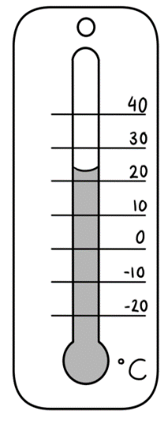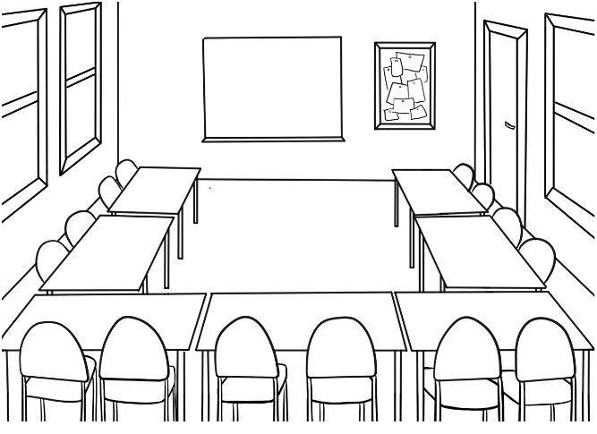

inside

outside

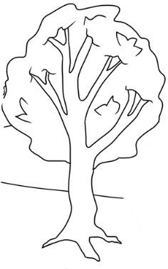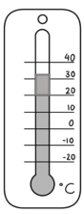

**Work** with a partner.   
**Write** the temperatures for four days.

Temp = temperature

|  |  |  |
| --- | --- | --- |
| Day and date | Temp inside the room | Temp outside the room |
|  |  |  |
|  |  |  |
|  |  |  |
|  |  |  |



**Write** the dates.

1. 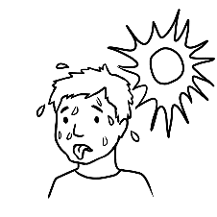It is hotter inside the room on _____________________.
2. It is hotter outside the room on ____________________.
3. It is colder inside the room on _____________________.
4. It is colder outside the room on____________________.

# Is Hani sick?

**Listen** to the teacher.

It is Monday morning.

Nisha checks Hani’s temperature.

**Tick** what Nisha can use.

**🗸**

|  |  |  |  |
| --- | --- | --- | --- |
|  |  |  |  |

**Listen**.

Nisha writes Hani’s temperature in the book.

|  |  |  |
| --- | --- | --- |
| **Hani**  Mon 7 Aug | | |
| **Time** | **Temperature** | **Why?** |
| 9:30 am | 37**°**C | Hani arrives. |
| 12:30 pm | 38**°**C | Hani looks sick. |
| 12:45 pm | 38**°**C | Hani leaves. |

At 12:30, Hani looks sick.

She has a high temperature.

Her temperature is 38 degrees.

Sahra takes Hani home.

**Read** with a partner.

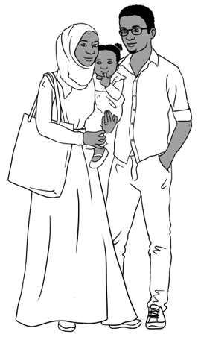

**Listen** and **repeat**.

On Monday Hani is sick.

On Tuesday Sahra is sick.

On Wednesday Tahiil is sick.

On Thursday Tahiil is **very** sick.



**Read** to a partner.

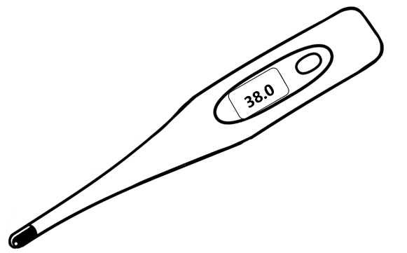

**_______________________________________________________________________**

**Listen**.

**Write** the temperatures.

|  |  |  |  |  |
| --- | --- | --- | --- | --- |
|  | **Mon** | **Tues** | **Wed** | **Thurs** |
| **Hani** | 38**°**C | **°**C | **°**C | **°**C |
| **Sahra** | **°**C | **°**C | **°**C | **°**C |
| **Tahiil** | **°**C | **°**C | **°**C | **°**C |



**Write** the temperatures.

On Monday, Hani’s temperature is _____ degrees.

On Tuesday, her temperature is _____ degrees.

On Wednesday, her temperature is ____ degrees.

**Read** to a partner.

# How tall are you?

**Listen** and **repeat**.

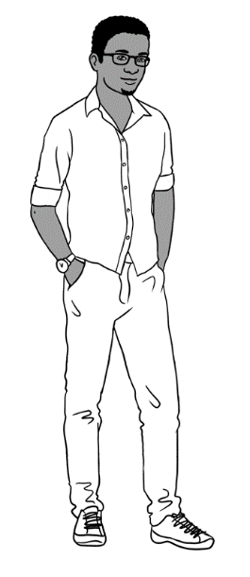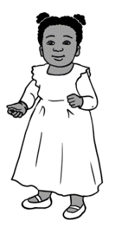

I am tall.

Hani is short.

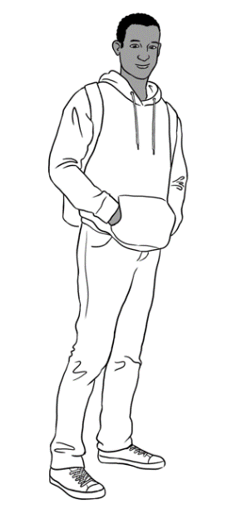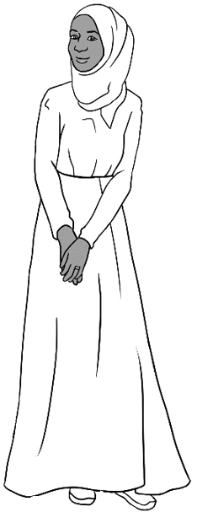

Abdi is **taller than** Sahra.  
 Sahra is **shorter than** Abdi.  
 They are not **the same height.**

**Tick** the **best** tool to measure height.

**🗸**

|  |  |  |
| --- | --- | --- |
| a tape measure | string | kitchen scales |
| a ruler | | |

|  |  |  |
| --- | --- | --- |
| We measure height in **centimetres**. | 200 | **2m** |
|  | 190 |  |
|  | 180 |  |
|  | 170 |  |
|  | 160 |  |
|  | 150 |  |
|  | 140 |  |
|  | 130 |  |
|  | 120 |  |
|  | 110 |  |
|  | 100 | **1m** |
|  | 90 |  |
|  | 80 |  |
| 70 |  |
| 60 |  |
| 50 |  |
| 40 |  |
| 30 |  |
| 20 |  |
| 10 |  |
| **cm** 0 |  |
| Abdi Tahiil Sahra Hani | |  |

**Match** the people to their height.

|  |  |
| --- | --- |
| Abdi | 169cm |
| Tahiil | 87cm |
| Sahra | 184cm |
| Hani | 180cm |

**Write** the names.

1. Abdi is taller than Tahiil .
2. Sahra is taller than ____________________.
3. Tahiil is shorter than __________________.

Are Sahra and Abdi **the same** height?

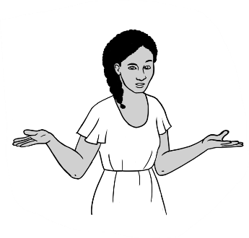

How tall are you?

How tall is your partner?

 **Work** with a partner.

**🗸**

|  |  |  |
| --- | --- | --- |
|  |  |  |

**Tick** the **best** toolto measure your height.



**Write** the height in centimetres.

**cm** = centimetres

1. My height is __________cm.
2. My partner’s height is _________cm.
3. I am __________________ than my partner.

taller / shorter

**_______________________________________________________________________**

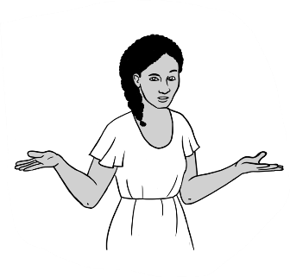

Are you taller than your teacher?

How tall is your teacher?

Are you shorter than your teacher?



**Write.**

1. My teacher is _____ cm.
2. I am _______ cm.
3. I am ____________________ than my teacher.

taller / shorter

# How high and wide is it?

How wide is it?



How high is it?



height

width

**Tick** the **best** tool to measure.

|  |  |  |
| --- | --- | --- |
| **cm** = centimetres  **m** = metres | 30 cm ruler | A drawing of a person  Description automatically generated with low confidence  10 m tape |
| door |  | **🗸** |
| window |  |  |
| whiteboard |  |  |

|  |  |  |
| --- | --- | --- |
| **Measure** | **height** cm / m | **width** cm / m |
| door |  |  |
| window |  |  |
| whiteboard |  |  |

**Write.**

**Talk** with your partner.

1. The door is **higher than** the window.
2. The whiteboard is **wider than** the window.

# How long and wide is it?

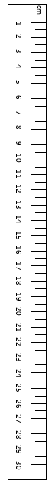

How long is the pen and pencil?

**Measure** the pen and pencil.



pencil

pen

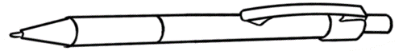

**Write** the length in centimetres.

**cm** = centimetres

1. The pen is ______ cm long.
2. The pencil is ______cm long.
3. The pencil is **longer** than the pen.
4. The pen is **shorter** than the pencil.



|  |  |
| --- | --- |
| arm _____ cm | foot _____cm |

**Work** with a partner. **Measure** the length of your arm and foot.



**Write** about you and your partner.

1. My arm is _____________________ than my partner’s arm.

longer / shorter

1. My foot is ____________________ than my partner’s foot.

longer / shorter

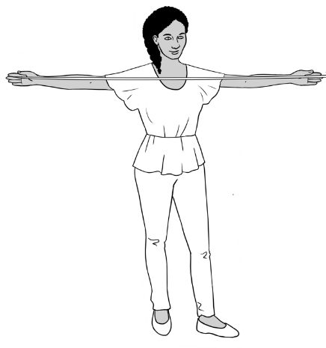

How wide is it?

**Measure** the width of your hands and arms.



**cm** = centimetres

|  |  |
| --- | --- |
| my hand ______ cm  my partner’s hand _______ cm | my arms ______ cm  my partner’s arms ______ cm |

**Work** with a partner.



**Write** about you and your partner.

1. My hand is ____________________ than my partner’s hand.

wider / not wider

1. My arms are____________________ than my partner’s arms.

wider / not wider

**_______________________________________________________________________**

**Measure your phone and your partner’s phone.  
  
Write** the length and width.

1. My phone is ______cm long.  
   It is _______cm wide.



length

width

1. My partner’s phone is _____cm long.   
   It is _______cm wide.

# How far is it?

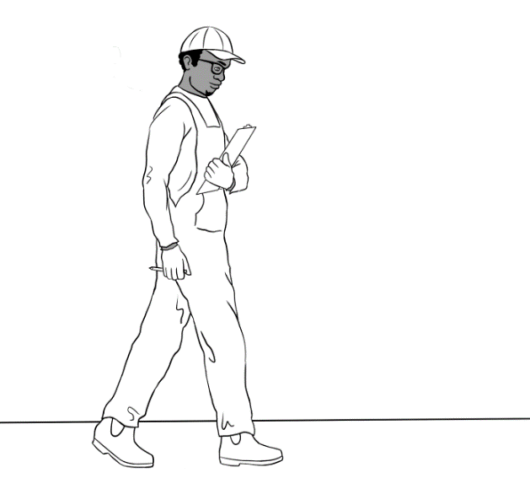

**Listen** and **repeat.**

Tahiil is at work.

He measures a room to paint.

He counts his steps from the wall

to the door.

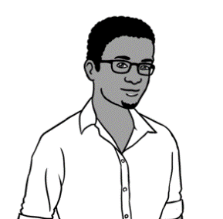

This is **one** step.

My step is 95 cm.

It’s **shorter than** a metre.

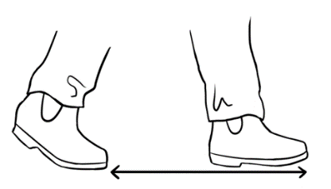



**Work** with a partner.

|  |  |
| --- | --- |
| **My step** | **My partner’s step** |
| My step is ______ cm. | My partner’s step is _______ cm. |

**Measure** your step and your partner’s step.

 **Write.**

1. My step is ____________________ than a metre.

shorter / longer

1. My step is ____________________ than my partner’s step.

shorter / longer

1. My step is ____________________ than Tahiil’s step.

shorter / longer

**Read** to your partner.



**Listen** and **repeat.**

Tahiil takes 10 steps

from the wall to the door.

Ten steps is **about** 10 metres.



|  |  |  |
| --- | --- | --- |
| **Count** the steps.  **Write** the steps. | You | _____________ partner’s name |
| 1. Walk from the door  to the toilets. | _____ steps | _____ steps |
| 1. Walk from the toilets  to reception. | _____ steps | _____ steps |
| 1. Walk from reception  to the classroom. | _____ steps | _____ steps |

**Work** with a partner. **Write** your partner’s name.



**Write.**

1. I take _______ steps from the door to the toilets.

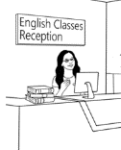It is **about** _______ metres.

1. I take _______ steps from the toilets to reception.

****It is **about** _______ metres.

**Read** to your partner.

# How heavy is it?

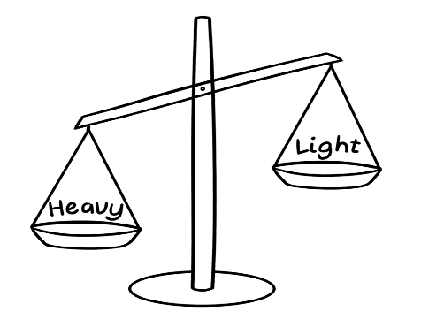

How **heavy** is it?

**Tick** the tools to measure weight.

**🗸**

|  |  |  |
| --- | --- | --- |
| bathroom scales |   tape measure | Shape  Description automatically generated  kitchen scales |

|  |  |  |  |  |
| --- | --- | --- | --- | --- |
| Water Bottle outline |  | Closed book outline | Smart Phone outline | Shopping bag outline |
| water bottle | mug | book | phone | bag |
| _________ | _________ | _______ | _______ | ________ |

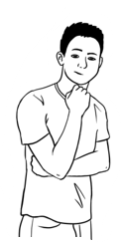**Work** with a partner.  
**Measure** the weight of things in the classroom.  
**Write** in grams or kilograms.

**g** = grams

**kg** = kilograms

What’s heavier?

The bag is **heavier** than the book.

The phone is **lighter**than the bag.

What’s lighter?

**Write.**

My book is ___________ g / kg.

My partner’s book is ________ g/kg. It is _________________.

lighter / heavier

My bag is __________ kg. My partner’s bag is ___________kg.

My partner’s bag is ________________________.

lighter / heavier

# How many litres?



**Listen** and **repeat.**

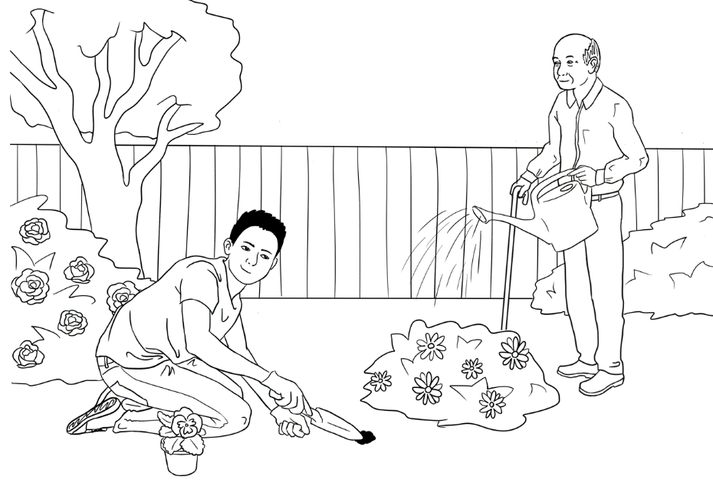

The bucket holds   
10 litres of water.

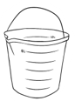

Bao and Ming   
work in the garden   
on the weekend.

**ml** = millilitre **L** = litre

**Write** the millilitres and litres.

|  |  |  |  |  |
| --- | --- | --- | --- | --- |
|  |  |  |  |  |
|  |  |  |  |  |
| **bucket** | **watering can** | **small pot** | **big pot** | **bag of soil** |
| 10 L | ______ L | _____ ml | _______L | ______L |

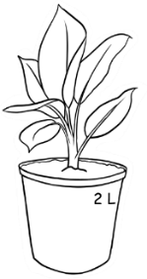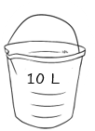 **Write** the numbers.

1. The bucket holds 10 litres.
2. 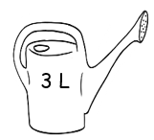The big pot holds _______ litres.
3. 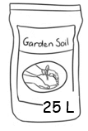The watering can holds ______ litres.
4. The bag of soil holds _______litres.

**Read** to a partner.

# How much flour?

Nisha’s children love to cook.

Every Saturday they make pikelets.

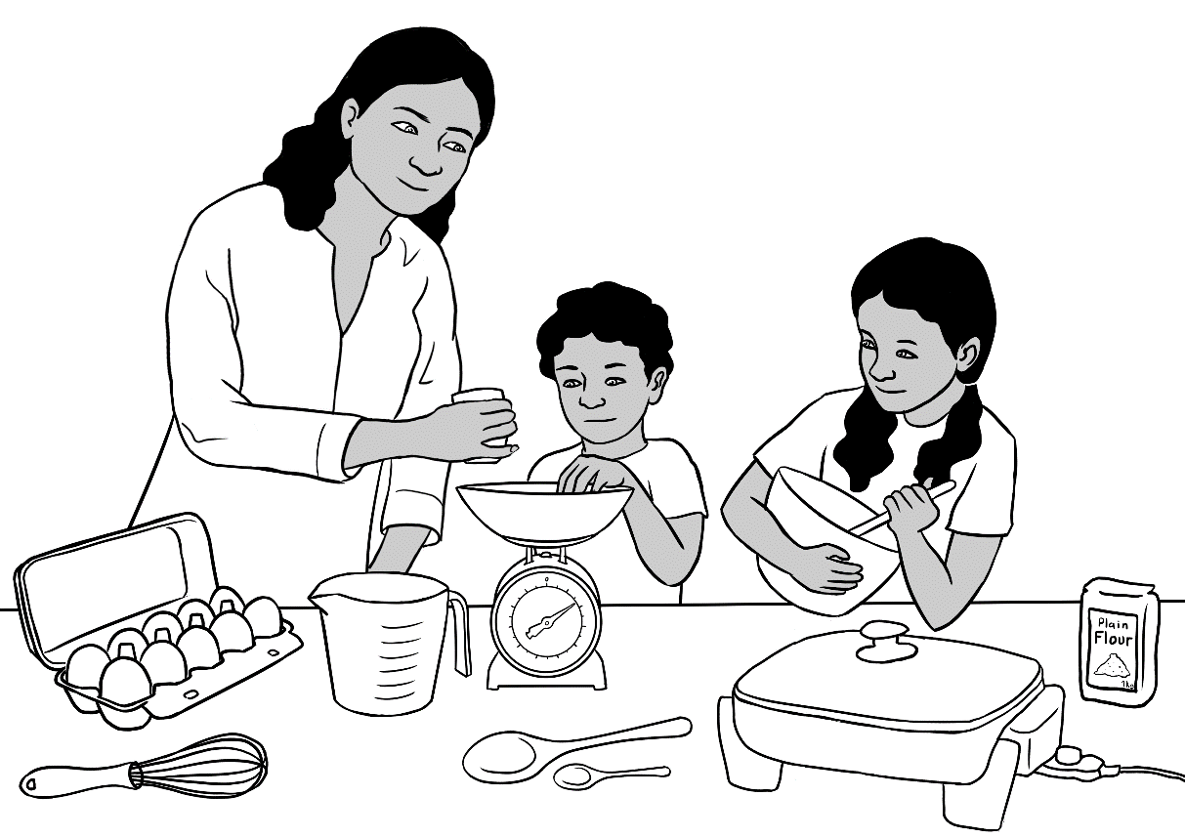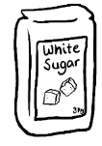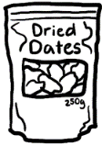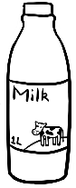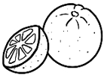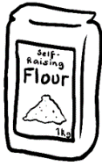



**Listen to** your teacher.

**🗸**

|  |  |  |  |  |
| --- | --- | --- | --- | --- |
| **🗸** | self-raising flour |  |  | coffee |
|  | nuts |  | eggs |
|  | sugar |  | dates |
|  | bi-carb soda |  | rice |
|  | milk |  | oranges |
|  | bananas |  | cocoa |

**Tick** what is in the pikelets.

**g** = gram

**kg** = kilogram

**ml** = millilitres

**L** = litre

**Orange and date pikelets**

150 g self-raising flour

70 g sugar

½ tsp bicarb soda

2 eggs

125 ml milk

80 g dates

60 ml orange juice

1 tbsp orange rind

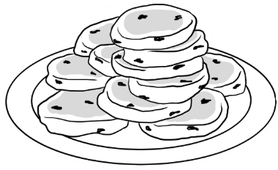

|  |  |  |  |  |
| --- | --- | --- | --- | --- |
| **🗸**  **Tick** the measuring tools. | **tsp**  teaspoon | **tbsp**  tablespoon | **ml**  measuring jug | **g**  kitchen scales |
| flour |  |  |  | **🗸** |
| sugar |  |  |  |  |
| bicarb soda |  |  |  |  |
| milk |  |  |  |  |
| dates |  |  |  |  |
| orange juice |  |  |  |  |
| orange rind |  |  |  |  |

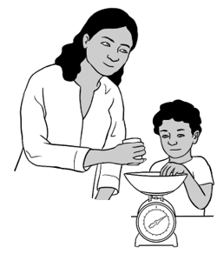

Is the flour **heavier than** the sugar?

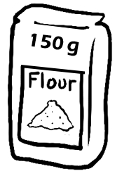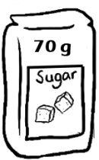



**Read** with a partner.

150 g flour is **heavier than** 70 g sugar.

70 g sugar is **lighter than** 150 g flour.

**More or less?**

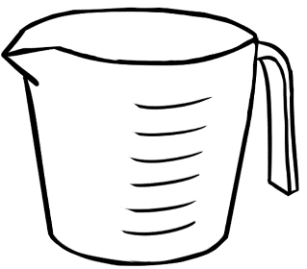

**juice**



**milk**

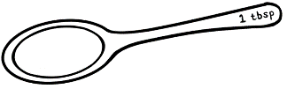

**orange rind**

**bicarb soda**



**Read** with a partner.

125 ml milk is **more** **than** 60 ml juice.

60 ml juice is **less** **than** 125 ml milk.

|  |  |  |
| --- | --- | --- |
| **🗸 Tick** yes or no. | **Yes** | **No** |
| 1. 70 g sugar is **heavier than** 80 g dates. |  | **🗸** |
| 1. 80 g dates are lighter than 150 g flour. |  |  |
| 1. 125ml milk is more than 60 ml juice. |  |  |
| 1. 1 tbsp orange rind is **less than**   ½ tsp bicarb soda. |  |  |

# How much milk?



What’s in chocolate milk?

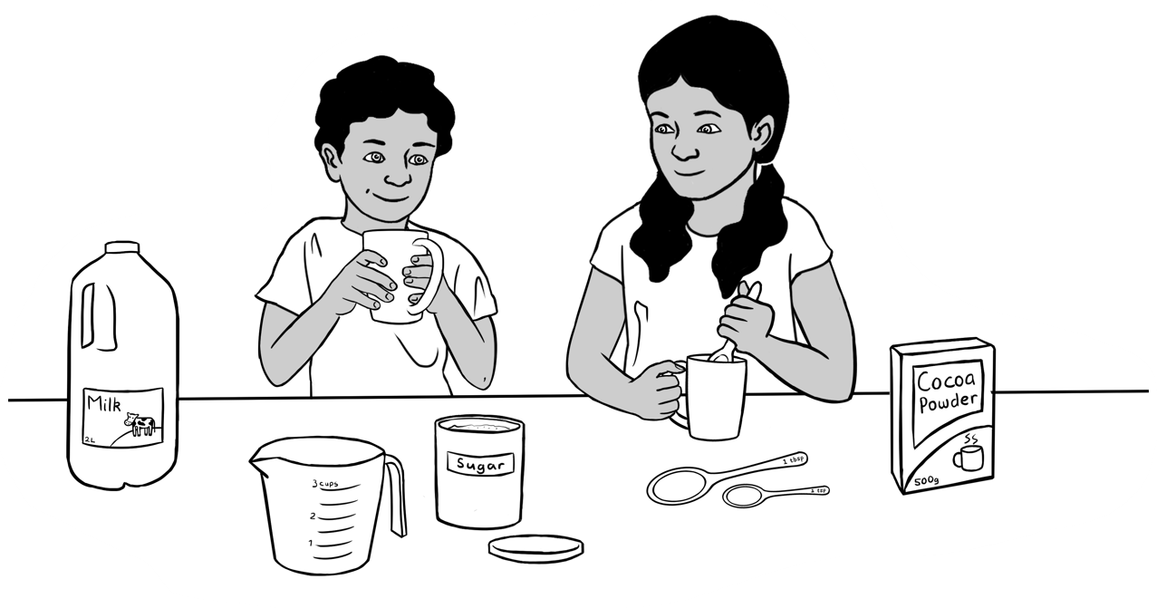

**🗸**

**Listen**.

**Tick.**

|  |  |  |  |  |
| --- | --- | --- | --- | --- |
| **🗸** | milk |  |  | eggs |
|  | flour |  | sugar |
|  | cocoa |  | bananas |

**Match** the measuring tool.

|  |  |  |
| --- | --- | --- |
| 1 cup milk |  | teaspoon |
| 1 tbsp cocoa | measuring cup |
| 1 tsp sugar | tablespoon |

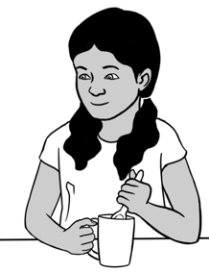

How much milk, cocoa and sugar for **two** people?

**Double** everything.

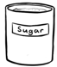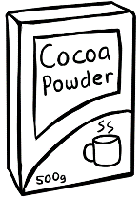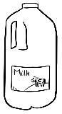

|  |  |
| --- | --- |
| Chocolate milk for  **one** person | Coffee outlineCoffee outline**Double** for **two** people. |
| 1 cup milk  1 tbsp cocoa  1 tsp sugar | **2** cups milk  **2** tbsp cocoa  **2** tsp sugar |

|  |  |
| --- | --- |
| This makes **20 pikelets**. | **Double** to make **40 pikelets.** |
| 150 g self-raising flour  70 g sugar  ½ tsp bicarb soda  2 eggs  125 ml milk  80 g dates  60 ml orange juice  1 tbsp orange rind | 300 g self-raising flour  ______ g sugar  ______ tsp bicarb soda  _______ eggs  _______ ml milk  _______ g dates  _______ ml orange juice  _______ tbsp orange rind |



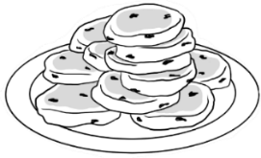**Double** the pikelet recipe.   
 **Listen to** the teacher.

**Write** the numbers to double the recipe.