

|  |
| --- |
| **English Ready**  **Course in EAL  VU22587 Give and respond to basic information and instructions**  **VU22589 Read and write short, basic factual texts** |

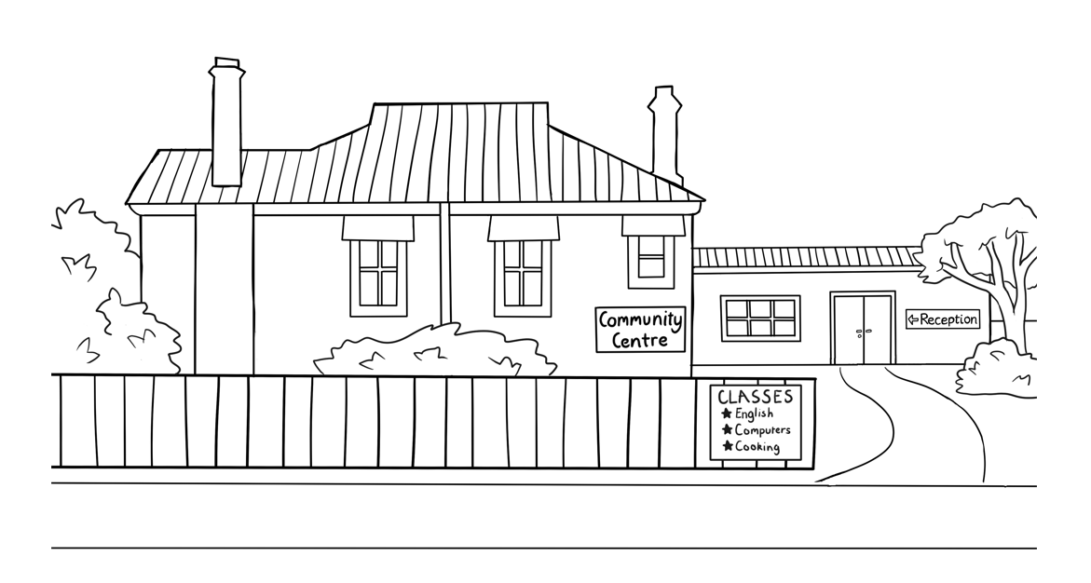**Student Workbook**

**Student ___________________________________________________**

**___________________________________________________________**

**Teacher ___________________________________________________**

**Class ______________________________________________________**

**Date ______________________________________________________**

**Design team:** Vicki Hambling, Sue Paull, Frida Dean, Janice Langley, Glenise Kleehammer   
and Mary Wallace

**Illustrations:** Madelena Scott

**Acknowledgements:** The design team would like to thank the AMEP service providers and practitioners who participated in the trial and gave valuable feedback. The team would also like to acknowledge the use of the EAL Framework which underpins the design of this book.

Copyright of the EAL Framework is reserved to the Crown in the right of the State of Victoria. © State of Victoria (Department of Education and Training) 2018.  
_________________________________________________________________________________________

This English Ready Resource is licensed under a Creative Commons Attribution-NoDerivs 3.0 Australia licence (More information is available [here](http://creativecommons.org/licenses/by-nd/3.0/au/)). You are free to use, copy and distribute to anyone in its original form as long as you attribute Department of Home Affairs as the author and you license any derivative work you make available under the same licence.  
  
© Commonwealth of Australia 2023

With the exception of the Commonwealth Coat of Arms, the department’s logo, any material protected by a trade mark and where otherwise noted all material presented in this document is provided under a Creative Commons Attribution 4.0 International (<https://creativecommons.org/licenses/by/4.0/>) licence.

The details of the relevant licence conditions are available on the Creative Commons website (accessible using the links provided) as is the full legal code for the CC BY 4.0 licence (<https://creativecommons.org/licenses/by/4.0/legalcode>).

Use of all or part of this document must include the following attribution:   
© Commonwealth of Australia 2023

As far as practicable, material for which the copyright is owned by a third party will be clearly labelled.  The department has made all reasonable efforts to ensure that this material has been reproduced in this document with the full consent of the copyright owners.

Copyright requests and enquiries concerning usage not addressed by the CC BY 4.0 licence should be addressed to:

[*comms@homeaffairs.gov.au*](mailto:comms@homeaffairs.gov.au) *at the Department of Home Affairs.*

The terms of use for the Commonwealth Coat of Arms are available from the [It's an Honour](http://www.itsanhonour.gov.au/) website.

Where a copyright owner, other than the Commonwealth, is identified with respect to this material, please contact that third party copyright owner directly to seek permission.

**Table of Contents**

1. Meet the people 4

2. Instructions in the workbook 6

3. Do you understand? 7

4. Introductions 8

5. The alphabet 10

6. Numbers 14

7. The days 16

8. The time 17

9. The months 18

10. English class 20

11. Get ready for class. 22

12. How many? 26

13. Instructions in class 28

14. The community centre 32

15. Signs at the community centre 34

16. A class timetable 36

17. Talk about family and friends. 38

18. The weather 50

19. The medical centre 56

20. What’s this? 61

21. Word List 63

*This workbook is designed to be used with the support of a teacher.*

# Meet the people

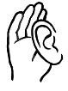**Listen** and **repeat.**

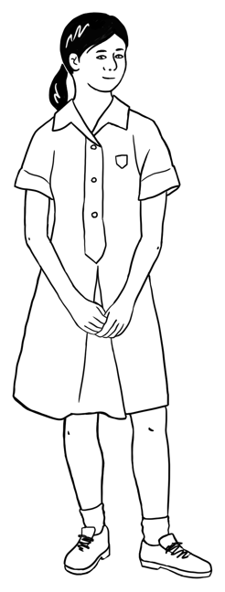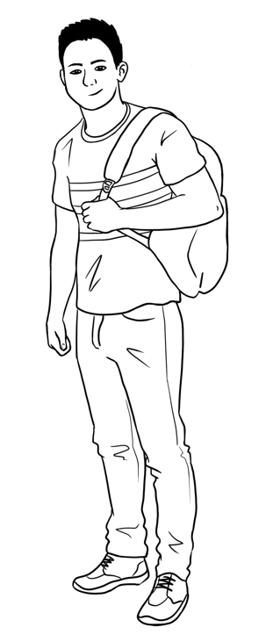

This is **Ming**.This is **Lan**.This is **Mai**.This is **Bao**.

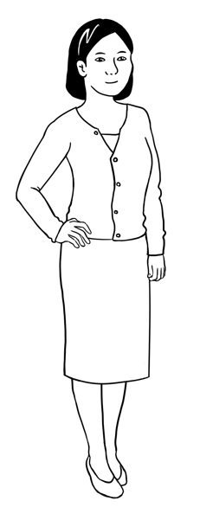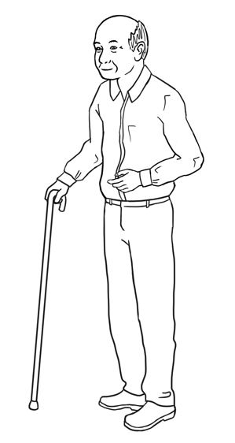

Ming’s family comes from China.

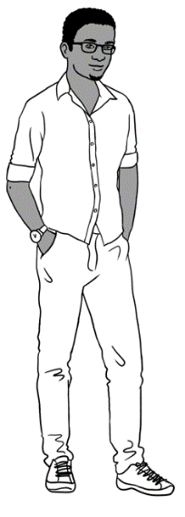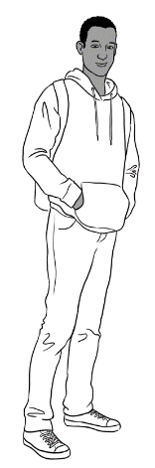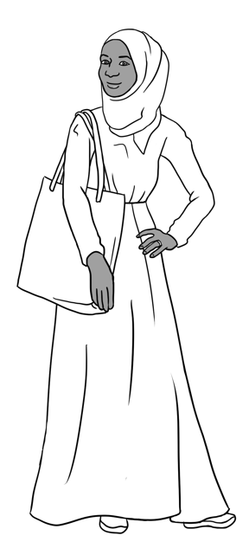

Sahra’s family comes from Somalia.

This is **Sahra**.

This is **Hani**.

This is **Tahiil**.

This is **Abdi**.

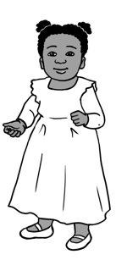

Anika comes from Ethiopia.

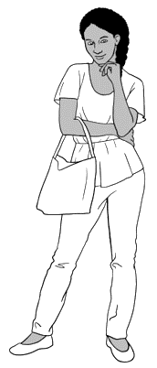

This is **Anika**.

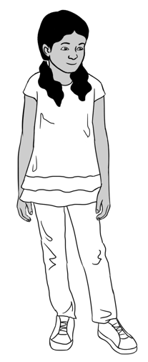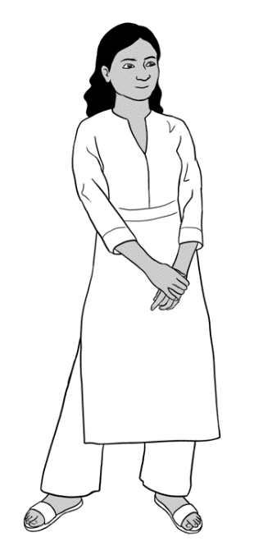

Nisha’s family comes from India.

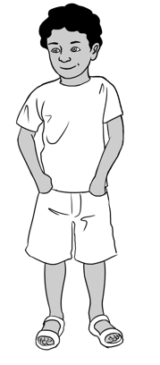

This is **Nisha.** This is **Pari.** This is **Dev**.

Carim’s family comes from Syria.

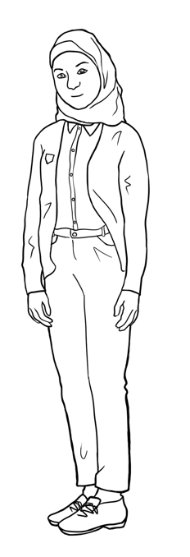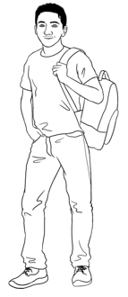

This is **Carim**.

This is **Fatima**.

Jenny is a teacher.   
She is from Australia.

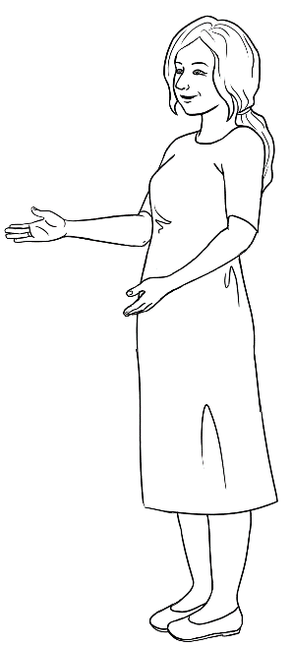

This is **Jenny**.

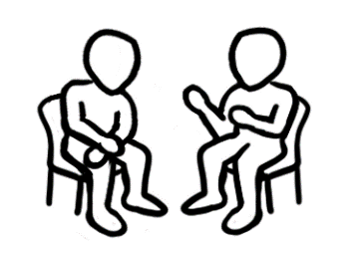

**Read** to a partner.

# Instructions in the workbook

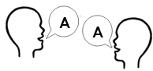**Listen** and **repeat**.

**Copy** the letters.

|  |  |
| --- | --- |
| 1. read   . rea___ . | 1. write   wri___e |
| 1. copy   co___y | 1. listen   liste___ |
| 1. say   ___ay | 1. repeat   re___eat |
| 1. Ask questions.   As___ questions. | 1. spell   sp___ll |
| 1. tick   **🗸**  t___ck | 1. circle   cir___le |
| 1. **A picture containing text, cosmetic     Description automatically generated**colour   co___our | 1. point   poin___ |
| 1. Work with a partner.   Wor___ with  a partner | 1. record   re___ord |

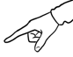**Listen**. **Point** to the instructions.

# Do you understand?

*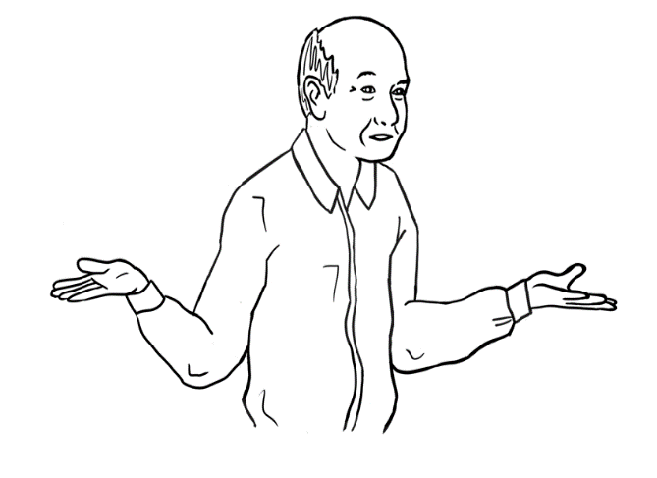***Listen** and **repeat.**

Sorry, I **don’t** understand.

Can you speak **slowly** please?

Can you say that **again** please? please?

Can you **help me** please?

|  |
| --- |
| 1. Can you say that again please? |
| 1. Can you speak **_________________** please? |
| 1. Sorry, I **________________**understand. |
| 1. Can you **____________ _______** please? |

**Write**.

|  |
| --- |
| **help me** |
| **don’t** |
| **slowly** |
| **again** **🗸** |

|  |
| --- |
| Nod your head. |
| **No**.  Shake your head. |

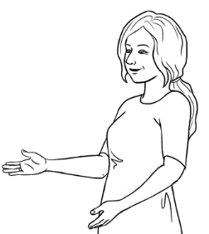

**Yes**.

Do you understand?

# Introductions



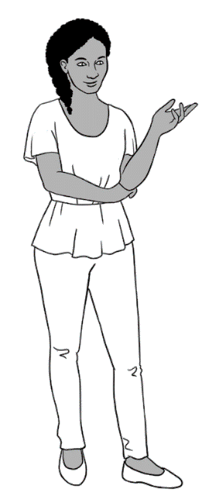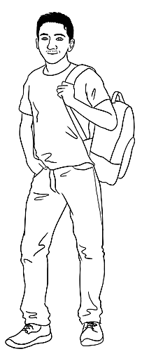**Listen** and **repeat.**

Hi. My name is Anika.

What’s your name?

Hi. My name is Carim.

Nice to meet you.

Nice to meet you too.

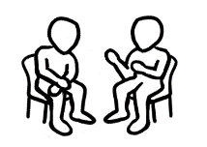

**Work** with a partner.

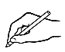

**Write** your name and your partner’s name.

Hi. My name is _______________________.  
 your name

What’s your name?

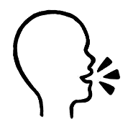

You

Hi. My name is _______________________.  
 your partner’s name

What’s your name?

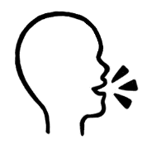

Your  
partner

Nice to meet you.

Nice to meet you too.



**Read** with your partner.

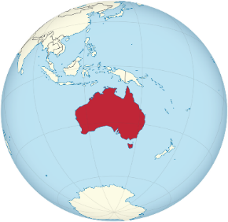

**?**



**Listen** and **repeat.**

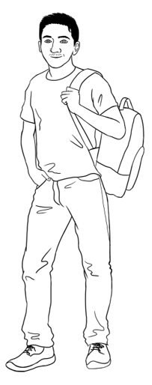

Where are you from Carim?

I am from Syria.

Can you spell that please?

Syria S y r i a

|  |  |  |  |  |  |  |  |  |  |  |  |  |
| --- | --- | --- | --- | --- | --- | --- | --- | --- | --- | --- | --- | --- |
| A a | B b | C c | D d | E e | F f | G g | H h | I i | J j | K k | L l | M m |
| N n | O o | P p | Q q | R r | S s | T t | U u | V v | W w | X x | Y y | Z z |



**Write** about you.   
My name is__________________________.

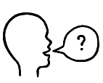I am from ____________________________.

Where are you from?

**Ask** 2 students in your class.

Can you spell that please?

|  |  |
| --- | --- |
| **Write** the student’s name. | **Write** the country. |
|  |  |
|  |  |

# The alphabet

**Listen** and **repeat.**

|  |  |  |  |  |  |  |  |  |  |  |  |  |
| --- | --- | --- | --- | --- | --- | --- | --- | --- | --- | --- | --- | --- |
| **A** | B | C | D | **E** | F | G | H | **I** | J | K | L | M |
| N | **O** | P | Q | R | S | T | **U** | V | W | X | Y | Z |

 **Capital letters**

**Small letters**

|  |  |  |  |  |  |  |  |  |  |  |  |  |
| --- | --- | --- | --- | --- | --- | --- | --- | --- | --- | --- | --- | --- |
| **a** | b | c | d | **e** | f | g | h | **i** | j | k | l | m |
| n | **o** | p | q | r | s | t | **u** | v | w | x | y | z |

|  |  |  |  |  |  |  |  |  |  |  |  |  |
| --- | --- | --- | --- | --- | --- | --- | --- | --- | --- | --- | --- | --- |
| A | B | C | D | E | F | G | H | I | J | K | L | M |
| N | O | P | Q | R | S | T | U | V | W | X | Y | Z |

**Listen**. **Circle** the capital letters.

|  |  |  |  |  |  |  |  |  |  |  |  |  |
| --- | --- | --- | --- | --- | --- | --- | --- | --- | --- | --- | --- | --- |
| a | b | c | d | e | f | g | h | i | j | k | l | m |
| n | o | p | q | r | s | t | u | v | w | x | y | z |

**Listen**. **Circle** the small letters.

 **Listen** to the teacher. **Circle** the letters.

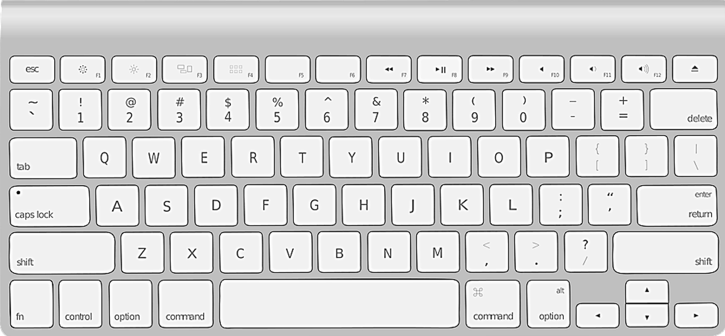

**G**

**W**

**E**

**R**

**T**

**Y**

**U**

**I**

**O**

**P**

**D**

**A**

**S**

**Q**

**F**

**H**

**R**

**Q**

**X**

**C**

**B**

**N**

**M**

**V**

**Z**

**K**

**J**

**L**



**Write** the small letters.

**Q**

**R**

**O**

**I**

**U**

**Y**

**T**

**E**

**W**

**P**

q

w



**G**

**W**

**E**

**R**

**T**

**Y**

**U**

**I**

**O**

**P**

**D**

**A**

**S**

**Q**

**F**

**H**

**R**

**Q**

**X**

**C**

**B**

**N**

**M**

**V**

**Z**

**K**

**J**

**L**

**S**

**D**

**G**

**H**

**K**

**L**

**F**

**A**

**Z**

**V**

**M**

**N**

**B**

**C**

**X**

 **Read** the keyboard letterswith a partner.

**Listen. Record** your teacher**. Listen** at home.

| **The sounds of the alphabet** | | | **Write** a word with  the same first sound. |
| --- | --- | --- | --- |
| **a** |  | **a**pple | ambulance |
| **b** |  | **b**anana |  |
| **c** |  | **c**ar |  |
| **d** |  | **d**og |  |
| **e** |  | **e**xit |  |
| **f** |  | **f**ish |  |
| **g** |  | **g**lasses |  |
| **h** |  | **h**at |  |
| **i** |  | **i**nsect |  |
| **j** |  | **j**acket |  |
| **k** |  | **k**ite |  |
| **l** |  | **l**emon |  |

|  |  |  |  |
| --- | --- | --- | --- |
| **m** |  | **m**oney |  |
| **n** |  | **n**ose |  |
| **o** |  | **o**range |  |
| **p** |  | **p**encil |  |
| **q** |  | **q**ueen |  |
| **r** |  | **r**ain |  |
| **s** |  | **s**tar |  |
| **t** |  | **t**able |  |
| **u** |  | **u**mbrella |  |
| **v** |  | **v**an |  |
| **w** |  | **w**indow |  |
| **x** |  | **x**-ray |  |
| **y** |  | **y**am |  |
| **z** |  | **z**ip |  |

# Numbers

**Listen**.

|  |  |  |  |  |  |  |  |  |  |
| --- | --- | --- | --- | --- | --- | --- | --- | --- | --- |
| **Write** the missing numbers. | | | | | | | | | 0 |
| 1 | 2 | 3 | 4 | 5 |  | 7 | 8 |  | 10 |
| 11 |  | 13 | 14 |  | 16 |  | 18 | 19 | 20 |
| 21 | 22 |  | 24 | 25 |  | 27 |  |  | 30 |
| 31 |  | 33 | 34 |  | 36 |  | 38 | 39 | 40 |
|  | 42 | 43 |  | 45 | 46 | 47 |  |  | 50 |
| 51 |  |  | 54 | 55 |  | 57 | 58 | 59 |  |
|  | 62 | 63 | 64 |  | 66 |  |  | 69 | 70 |
| 71 | 72 |  | 74 |  |  | 77 | 78 | 79 | 80 |
|  |  | 83 |  | 85 | 86 | 87 |  |  | 90 |
| 91 | 92 |  | 94 |  | 96 |  | 98 |  | 100 |

******Listen**.

**Circle** the numbers.



**Listen** and **repeat.**

|  |  |  |  |  |
| --- | --- | --- | --- | --- |
| 1. one | 1. two | 1. three | 1. four | 1. five |
| 1. six | 1. seven | 1. eight | 1. nine | 1. ten |

**Circle** the words. **Write** the words.

|  |  |  |  |  |  |  |  |  |  |  |
| --- | --- | --- | --- | --- | --- | --- | --- | --- | --- | --- |
| t | w | o | a | b | o | n | e | c | d | e |
| f | g | h | s | i | x | i | j | t | e | n |
| t | h | r | e | e | c | d | n | i | n | e |
| k | l | m | n | f | i | v | e | q | r | s |
| e | i | g | h | t | u | v | f | o | u | r |
| w | s | e | v | e | n | x | y | z | a | b |

1. __________
2. two .
3. ___________
4. ___________
5. ___________
6. ___________
7. ___________
8. ___________
9. ___________
10. ___________

|  |  |  |  |  |
| --- | --- | --- | --- | --- |
| **1**  o n e | **2** ___wo | **3**  thre ___ | **4**  ___our | **5** fi___e |
| **6** ___i x | **7** ___even | **8**  eigh___ | **9** ni___e | **10** t___n |

**Write** the letters.

# The days

**Listen** and **repeat.**

 **Copy**.

|  |  |  |
| --- | --- | --- |
| **Full word** | | **Short word** |
| Monday | Monday | Mon |
| Monday . | _______________ | ___________ |
| Tuesday | Tuesday | Tues |
| _______________ | _______________ | ___________ |
| Wednesday | Wednesday | Wed |
| _______________ | _______________ | ___________ |
| Thursday | Thursday | Thurs |
| _______________ | _______________ | ___________ |
| Friday | Friday | Fri |
| _______________ | _______________ | ___________ |
| Saturday | Saturday | Sat |
| _______________ | _______________ | ___________ |
| Sunday | Sunday | Sun |
| _______________ | _______________ | ___________ |

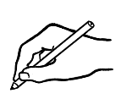**Write** the days.

Today is _______________________________.

Tomorrow is ____________________________.

The **weekend** is Saturday and ____________________.

# The time

**Listen** and **repeat.**

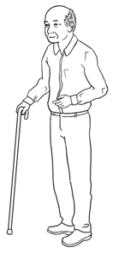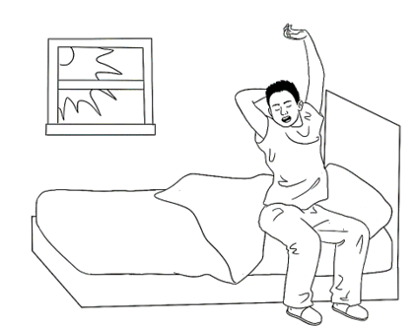

What’s the time?

It’s 8 o’clock.

St eight.

|  |  |  |
| --- | --- | --- |
| 12  1  11  6  3  2  10  9  8  5  7  4 | **am** = morning  **8:30** | **9:00 am**  Mon 8 Feb  25**°**C |
| It’s 8 o’clock. It’s 8:00 am. | It’s eight thirty.  It’s half past eight. It’s 8:30 am. | It’s 9 o’clock.  It’s 9:00 am. |

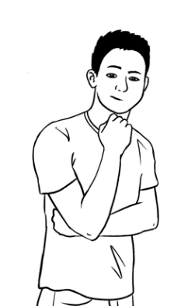

I get up at 8 o’clock on Monday.

What time do **you** get up?



**Write** about you.

I get up at ___________________ on Monday.   
**Ask** your partner

What time do you get up?

St eight.

# The months

****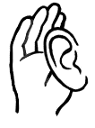

**Listen** and **repeat.**

**Write** the missing letters.

|  |  |  |
| --- | --- | --- |
| **Long words**. | | **Short words** |
|  | January Ja___uary . | Jan |
|  | February Fe___ruary | Feb |
|  | March ___arch | Mar |
|  | April A____ril | Apr |
|  | May M____y | May |
|  | June Ju____e | June |
|  | July Ju___y | July |
|  | August Au____ust | Aug |
|  | September Septem____er | Sept |
|  | October Oct____ber | Oct |
|  | November Nove____ber | Nov |
|  | December De____ember | Dec |

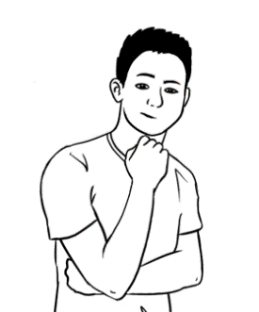

What is this month?

What is next month?



**Write.**

This month is __________________________.

Next month is _________________________.



**Listen** and **repeat.**

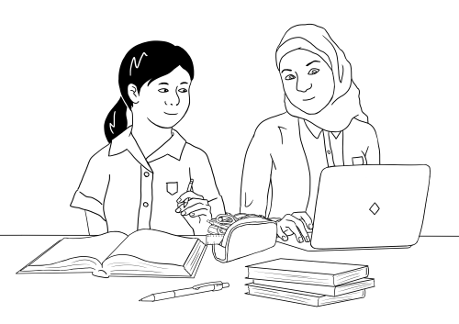

When is your birthday Fatima?

My birthday is in **April.**

My birthday is in **July**.

When is your birthday Mai?



**Write.**

Mai’s birthday is in April .

Fatima’s birthday is in ________________.

My birthday is in _________________________.

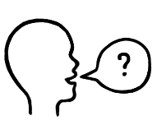

When is your birthday?

**Ask** your teacher and partner

**Write.**

My teacher’s birthday is in _______________________.

My partner’s birthday is in **________________________**.

# English class



**Listen** and **repeat**.

Ming wants to learn English.

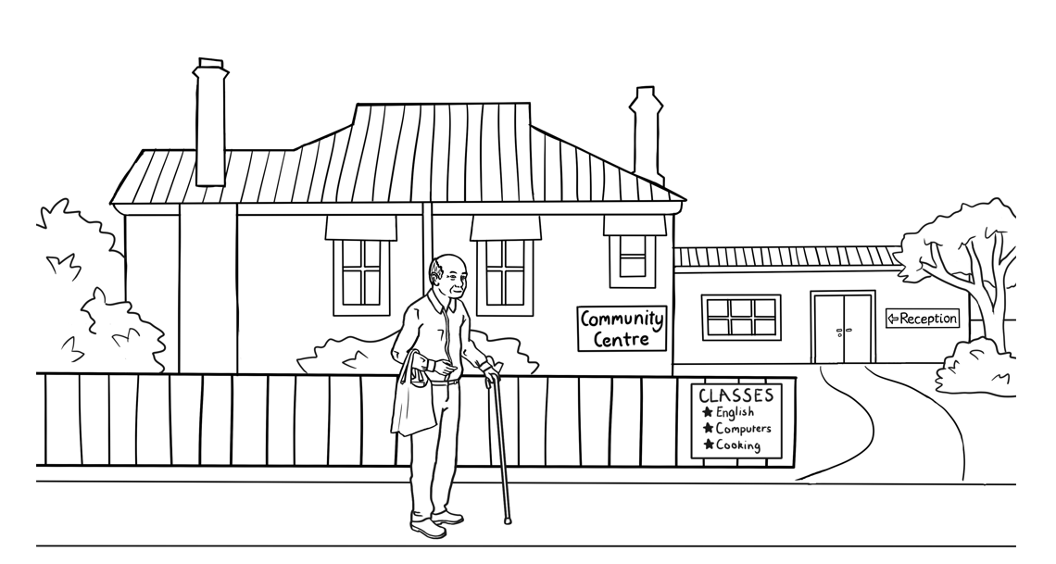He goes to the community centre.



**Read** with your teacher.

**Kellivale Community Centre**

**Address** 50 Kemp St, Kellivale

**Phone** 6562 8261

**Hours** Monday 9am – 4pm

Tuesday 9am – 4pm

Wednesday 9am – 4pm

Thursday Closed

Friday 9am – 4pm

Saturday Closed

Sunday Closed



**Write.**

The phone number is **____________________________**.

The centre is open on **___________________**, **____________________,**

**______________________** and _______________________.

**Listen** and **repeat.**

Carim wants to learn English.

He has an interview at TAFE.

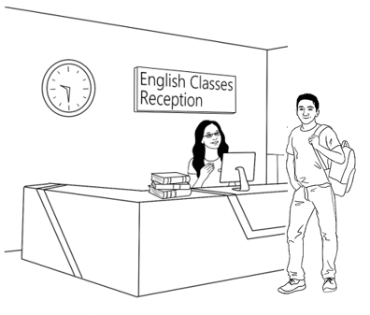

Hi Carim

Your interview   
is on Thursday   
20 January   
at 9:30 am.

Go to reception.

Kellivale TAFE

.



**Copy**.

|  |  |  |
| --- | --- | --- |
| interview | Thursday | January |
| interview |  |  |
|  |  |  |
|  |  |  |



**Write.**

1. When is the interview?

Day ___________________________

Date ___________________________

Time ___________________________

1. Where does Carim go to? _________________________.

**Read** the message with a partner.

# Get ready for class.

**Listen** and **repeat**.

Carim gets ready for class.

He reads the School Shop catalogue.

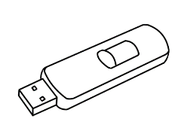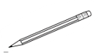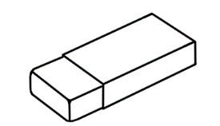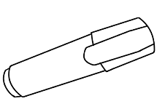

Pencil

50c

**Get ready for school**

Notebook

$5

USB

$8

Ruler

80c

Rubber

$1.50

pen

$2



Highlighter

$1

**The School Shop**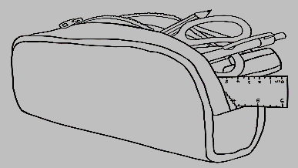

sharpener

$3

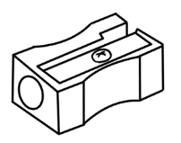

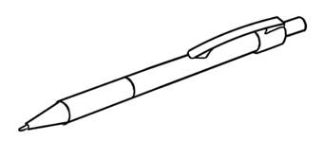

**Match the prices.**

|  |  |  |  |  |  |  |
| --- | --- | --- | --- | --- | --- | --- |
| 1. pencil |  | $1 |  | **5**. notebook |  | $3 |
| 1. rubber | $2 | **6**. sharpener | 80c |
| 1. highlighter | 50c | **7**. USB | $5 |
| 1. pen | $1.50 | **8**. ruler | $8 |



 **Listen** and repeat.

**Copy** the missing letters.

|  |  |
| --- | --- |
|  |  |
| pencil | rubber |
| p__ncil | r__bber |
|  |  |
| sharpener | pen |
| shar__ener | pe__ |
|  |  |
| highlighter | notebook |
| highligh__er | note__ook |
|  |  |
| ruler | USB |
| ru__er | US__ |

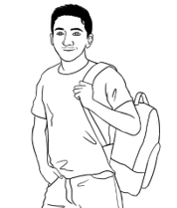

What do **you** buy?

**Write.**

I buy a __________________, a _________________

and a _______________________.

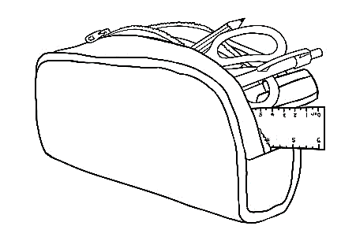**Listen** and **repeat.**

Carim buys 8 things at the shop.

He puts 6 things in his pencil case.

**Match**.

|  |  |  |
| --- | --- | --- |
|  |  | pen |
|  | pencil |
|  | rubber |
|  | sharpener |
|  | notebook |
| 1. **A picture containing text, sign     Description automatically generated** | highlighter |
|  | USB |
|  | ruler |



**Listen** and **repeat**.

I have 6 things in my pencil case.

What’s in your pencil case?



**Write 5** things in your pencil case.

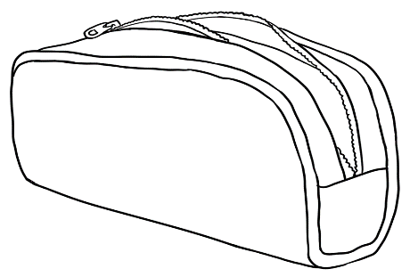



**Write.**

I have a ________________________, a _________________________, a ___________________________, a ________________________ and   
a ___________________________ in my pencil case.

What’s in your pencil case?

 **Ask** your partner

**Write** about your partner.

My partner has a ____________________, a ____________________, a ___________________________, a ________________________ and   
a ___________________________ .

**Read** with your partner.

**Copy** the sentences into your notebook.

# How many?

**Listen** and **repeat**.

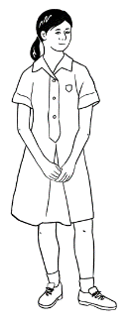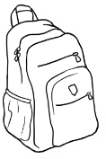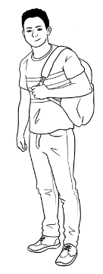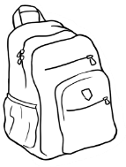

Mai has **one** bag. Bao has **two** bag**s**.

**________________________________________________________________**

|  |
| --- |
| one ruler |
| two rubber**s** |
| three pen**s** |
| four pencil**s** |
| nine book**s** |

**Match.**

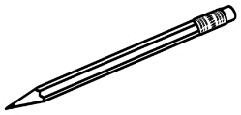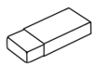

**_________________________________________________________________**

**Write** how many.

_______ student**s**

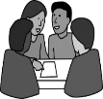

1. How many **students** are in your class?

______ table**s**

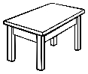

**2.** How many **tables** arein your room?

**3.** How many **chairs**?

______chair**s**

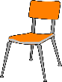



**Listen** and **repeat.**

|  |  |  |
| --- | --- | --- |
|  |  |  |
| **on** the table | **under** the table | **next to** the table |
| on the table . | _________________ | ________________ |

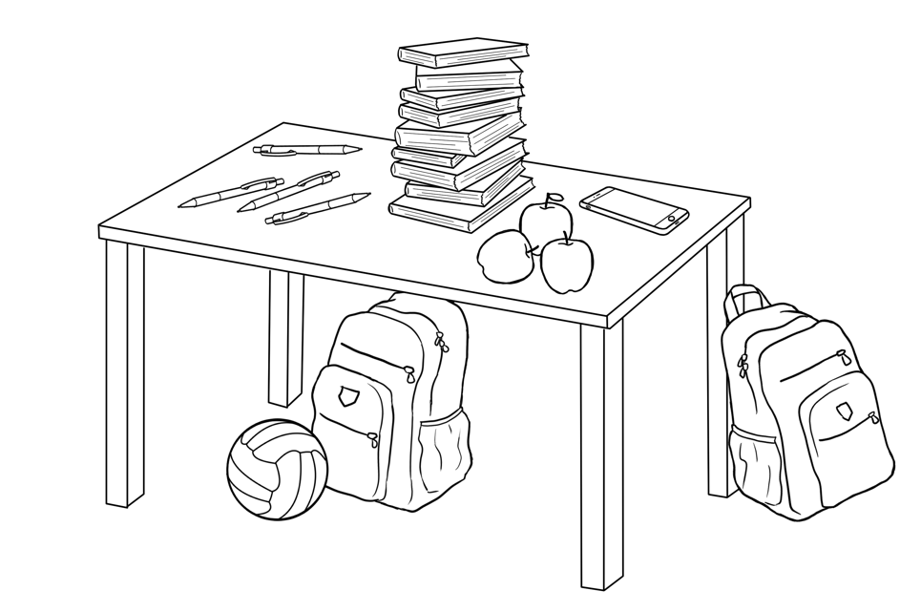**Copy**.

**Listen**.

How many **pens** are on the table?

**Match**.

|  |  |  |
| --- | --- | --- |
| 1. There is **one** ball |  | **on** the table. |
| 1. There is **one** phone |
| 1. There is **one** bag | **under** the table. |
| 1. There are **three** apple**s** |
| 1. There are **fou**r pen**s** | **next to** the table. |
| 1. There are **nine** book**s** |

 **Read** with a partner.

# Instructions in class

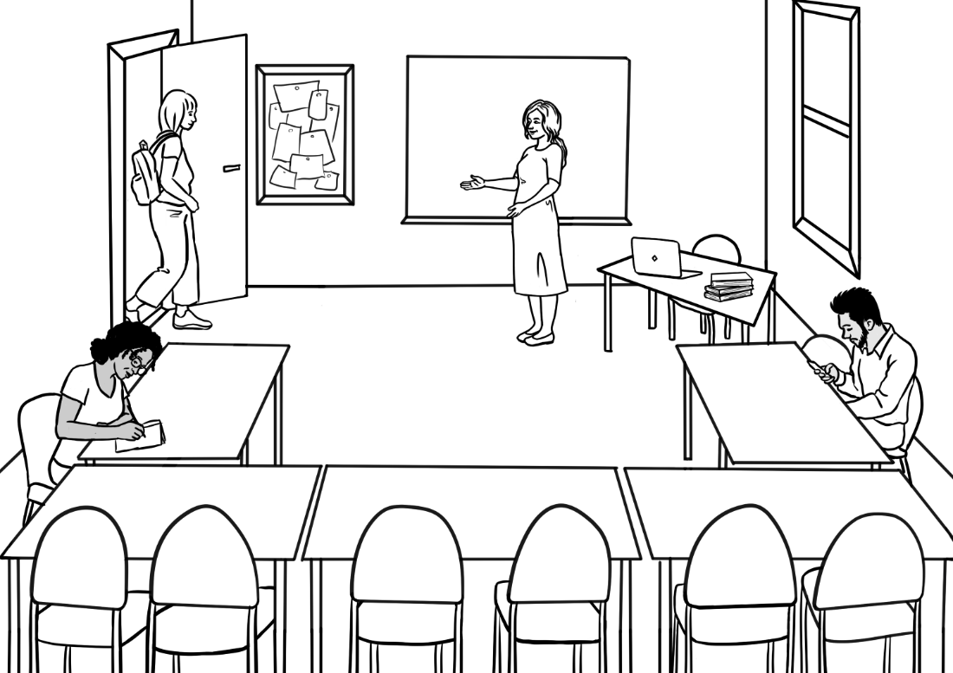

Come in Alina.

Please sit down.

**Listen** and **repeat.**

**Follow** the instructions.

|  |  |  |
| --- | --- | --- |
| **1** | **2** | **3** |
| Come in. | Sit down. | Stand up. |
| **4** | **5** | **6** |
| Open  your workbook. | Close  your workbook. | Look at  the board. |

**Match.** **Copy**.

|  |  |  |
| --- | --- | --- |
| **1** |  | Stand up.  Stand up. . |
| **2** | Come in.  ______________ |
| **3** | Open your workbook.  ____________________________ |
| **4** | Sit down.  _______________________ |
| **5** | Look at the board.  ___________________________ |
| **6** | Close your workbook.  ______________________________ |



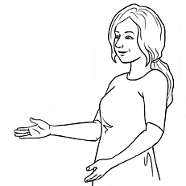**Listen**.

**Please** sit down.

Look at the board **please.**

Open your workbook **please.**

**Read** with a partner.



**Listen** and **repeat**.

**Follow** the instructions.

|  |  |  |  |
| --- | --- | --- | --- |
| **1** | | **2** | **3** |
| Write on the board. | | Take a photo. | Record the teacher. |
| **4** | | **5** | **6** |
| Stand next to  the table. | | Stand in a line. | Stand in a circle. |
| **7** | | **8** | **9** |
| Go left. | | Go right. | Go straight ahead. |
| **10**  **11** | Turn the light on.  Turn the light off. | **12** | **13** |
| Walk slowly  to the door. | Walk quickly  to the door. |

**Match**. **Copy**.

|  |  |  |
| --- | --- | --- |
| **1** |  | Take a photo.  Take a photo. . |
| **2** | Stand in a line.  __________________________________ |
| **3** | Write on the board.  ____________________________ |
| **4** | Go right.  _________________________ |
| **5** | Stand next to the table.  _____________________________ |
| **6** | Turn the light off.  ____________________________ |
| **7** | Go left.  ______________________________ |
| **8** | Go straight ahead.  _____________________________ |



**Listen**.

**Can you** stand in a line **please**?

**Can you** turn on the light **please**?

# The community centre

****

**Listen**. **Colour** the boxes.

|  |  |  |  |  |  |  |  |
| --- | --- | --- | --- | --- | --- | --- | --- |
| **red** |  |  | **green** |  |  | **brown** |  |
| **blue** |  | **yellow** |  | **black** |  |
| **orange** |  | **white** |  | **grey** |  |

**Colour** the community centre.



a red roof

a brown fence

a tree

a green door

a bush

a path

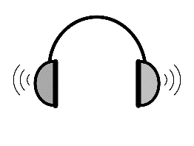

**1**

**Listen**.

**Circle.**

|  |  |  |  |  |
| --- | --- | --- | --- | --- |
| 1. The community centre is | in Kemp Road. | in Kemp Street. | | in Kemp Lane. |
| 1. The building is | old. | | new. | |
| 1. Near the door, there is | an old tree. | a big  tree. | | a small tree. |

**Listen**.



**1**

**Write.**

|  |
| --- |
| Street |
| red |
| centre 🗸 |
| old |
| fence |
| brown |
| small |
| roof |

Woman Excuse me.   
 Where is the community centre ?

Man The community centre?

Oh, it’s in Kemp ______________.

It’s an __________ building.

It has a ____________roof and   
a _____________ fence.   
There’s a ____________ tree   
near the front door.

Woman Did you say a red ______________?

Man Yes, that’s right and   
a brown ________________.

Woman Okay, thank you.

**Read** with partner. **Copy** the sentences here and into your notebook.



building.

an

old

It’s

It’s an old building. .

a

It

red

roof.

has

______________________________________________________________________

a

brown

has

fence.

It

________________________________________________________________

# Signs at the community centre



**Listen** and **repeat**.

|  |  |  |  |
| --- | --- | --- | --- |
| **1** | No smoking | **2** | Exit |
| **3** | Men’s toilet | **4** | Women’s toilet |
| **5** | No rubbish  in the toilet | **6** | Wash your hands. |
| **7** | Wet floor | **8** | Wear a face mask. |
| **9** | Turn off  the sound  on your phone. | **10** | Put rubbish  in the bin. |

**🗸**

**Tick** the signs in your English centre.

**Match**.

|  |  |  |
| --- | --- | --- |
|  |  | Exit |
|  | Men’s toilet |
|  | No smoking |
|  | Women’s toilet |
|  | Wash your hands. |
|  | No rubbish in the toilet |
|  | Wear a face mask. |
|  |  | Wet floor |
|  |  | Put rubbish in the bin. |
|  |  | Turn off the sound  on your phone. |

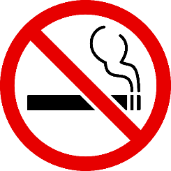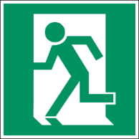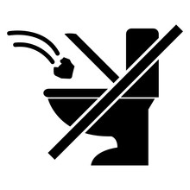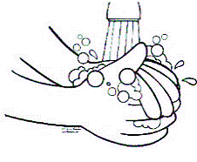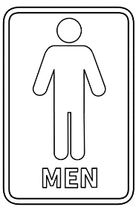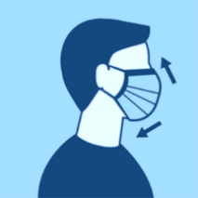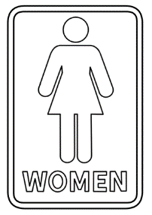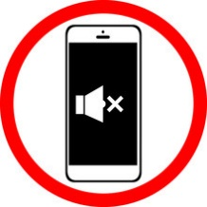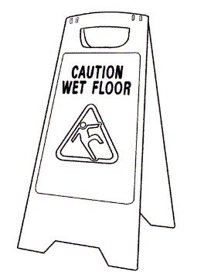

# A class timetable

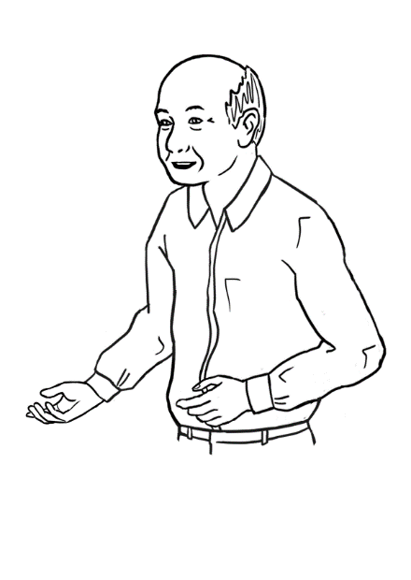**Listen** and **repeat.**

This is my timetable.

I go to class on Tuesday,

Wednesday and Friday.

|  |  |  |  |  |  |
| --- | --- | --- | --- | --- | --- |
|  | **Monday** | **Tuesday** | **Wednesday** | **Thursday** | **Friday** |
| **Morning**  *am* |  | 9:00 -12:00  Room 4 |  | Closed | 9:30 -12:30  Room 3 |
| **Afternoon**  *pm* |  |  | 1:00 - 3:30  Room 4 | Closed |  |

 **Tick.**

1. When does Ming go to class?

Monday Tuesday Wednesday Friday

1. 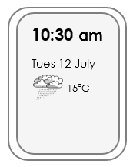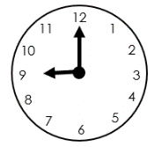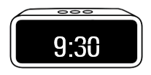What time does Ming start on Tuesday?
2. 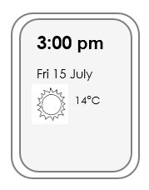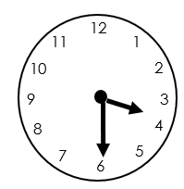What time does Ming finish on Wednesday?

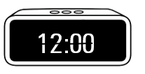

** Listen**.

**Match** the times on Ming’s timetable.

|  |  |  |
| --- | --- | --- |
|  | Tuesday  **12:00**  9:00  12:00  Wednesday  1:00  3:30  Friday  9:30  12:30 |  |
|  |  |
|  |  |

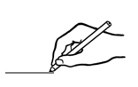

**Draw** the times.

12

1

11

2

10

3

9

8

4

5

7

6

|  |  |  |
| --- | --- | --- |
| 12  1  11  2  10  3  9  8  4  5  7  6 | 12  1  11  2  10  3  9  8  4  5  7  6 |  |
| 9:00 am | 9:30 am | 1:00 pm |

**Write** about your class times.

1. Today I start class at ____________.
2. Today I finish class at ___________.

# Talk about family and friends.

****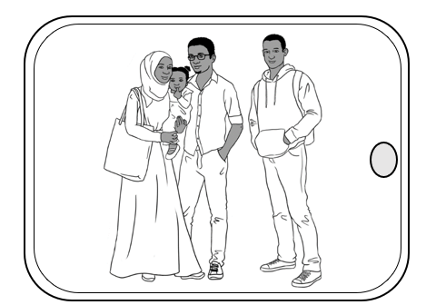**Listen** and **repeat.**

My name is Sahra.

This is my **family**.

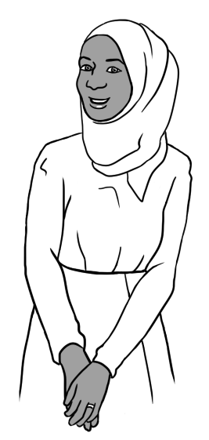

I am married.

This is my **husband** Tahiil.

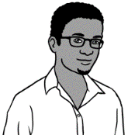

This is my **daughter** Hani.

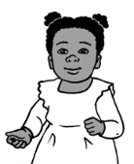

This is my **brother** Abdi.

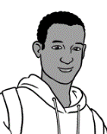

**___________________________________________________________________________**

Sahra is my **sister.**

Hani is my **niece.**

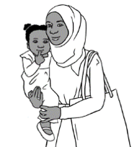

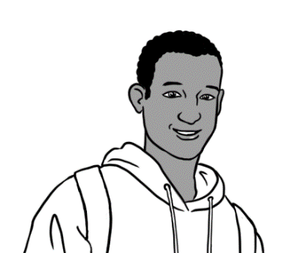

Tahiil is my **brother-in-law**.



****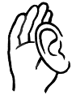

**Listen** and **repeat.**

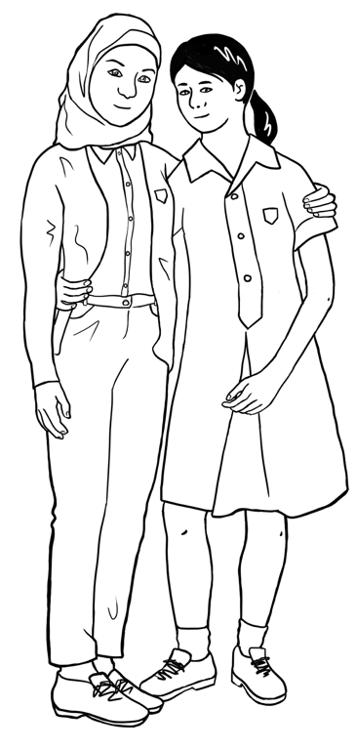

Fatima **is** my friend.   
She **comes** from Syria.

She **has** a brother.

His name **is** Carim.

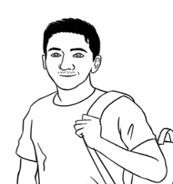

I **have** a brother too.

His name **is** Bao.

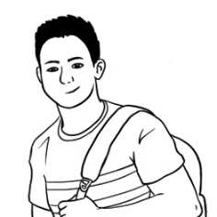

|  |  |  |
| --- | --- | --- |
| Fatima **is** |  | from Syria. |
| She **comes** | Carim. |
| She **has** | my friend. |
| His name **is** | a brother. |
| I **have** |  | Bao. |
| His name **is** | a brother too. |

**Match**.

 **Write** about Fatima.

Fatima _______ Mai’s friend.

She ________________ from Syria.

She _______________ a brother.

His name ________ Carim.



**Read** with a partner.

**Listen** and **repeat.**

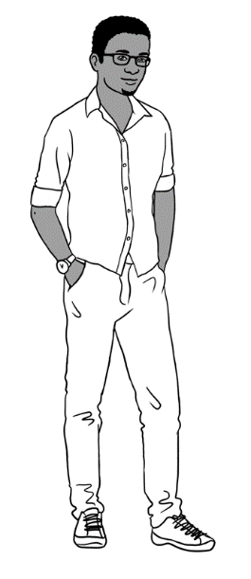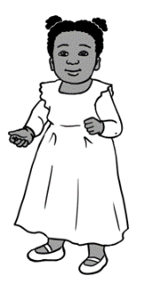

I am **tall**.

Hani is **short**.

**Tick** who is **tall.**

|  |  |  |  |  |  |
| --- | --- | --- | --- | --- | --- |
| **1**  **🗸** | | **2** | | **3** | |
| Abdi | Hani | Carim | Fatima | Nisha | Dev |
| 🗸 |  |  |  |  |  |



tall

short

**Write.**

1. Abdi is tall . Hani is _________________.
2. Carim is ________________. Fatima is _______________.
3. 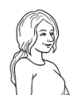Nisha is __________________. Dev is __________________.

Who is **tall** in your class?



**Write** two names.

**___________________** and **____________________** are tall.



**Listen** and **repeat.**

|  |  |  |
| --- | --- | --- |
| **old** | **middle-aged** | **young** |
|  |  |  |
| MIng | Lan | Mai |

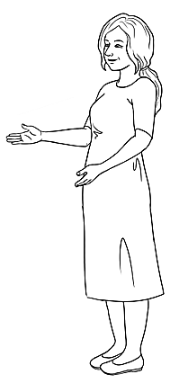

Ming is **old**.

Lan is **middle-aged**.

Mai is **young**.

I am **young.**

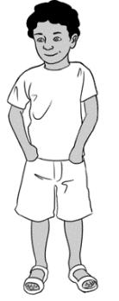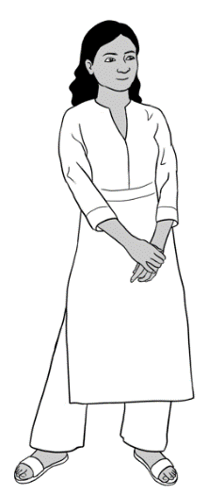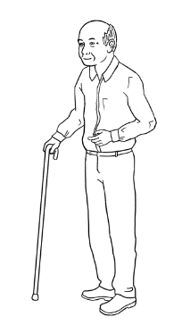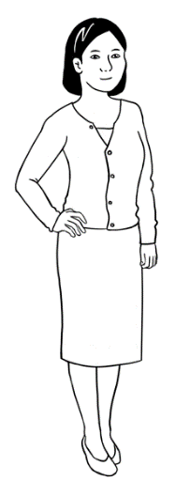

**Match.**

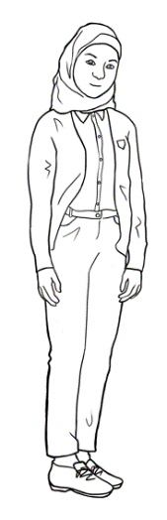

**Write** the sentences in your notebook.

**Listen** and **repeat.**

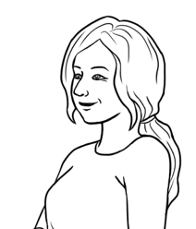

I have **long** hair.

Mai has **long** hair.

Carim has **short** hair.

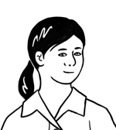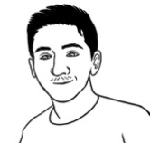

|  |  |
| --- | --- |
|  | 1. Nisha has long hair.  Nisha has long hair. . |
|  | 1. Anika has long hair.  _______________________________. |
|  | 1. Bao has short hair.  ________________________________. |



**Copy**.

**Listen**.

|  |  |  |
| --- | --- | --- |
| **1** | **2** | **3** |
| **straight** | **wavy** | **curly** |
| Lan has **straight** hair. | Nisha has **wavy** hair. | Dev has **curly** hair. |

**Write**.   
**1**. Lan has straight hair.

**2.** Nisha has ______________ hair.

**3.** Dev has ________________ hair.

**Read** with a partner. **Copy** into your notebook.



**Listen** and **repeat.**

I have **blonde** hair.

Anika has **black** hair.

I have **blue** eyes.

Anika has **brown** eyes.

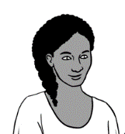

|  |  |
| --- | --- |
| **Hair colours** | |
| blonde |  |
| light brown |  |
| dark brown |  |
| black |  |
| grey |  |
| red |  |

**Colour.**

|  |
| --- |
| **Eye colours** |
|   green eyes** |

  
**Write** about you and your teacher.

I have _____________________________ hair.

I have _____________________________ eyes.

My teacher has _______________________ hair.

He / She has ________________________ eyes.

**Read** with a partner.

**Copy** the sentences into your notebook.

****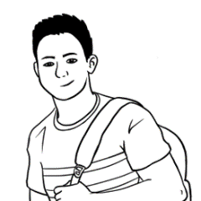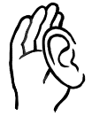 **Listen** and **repeat**.

Bao is my son.

He is tall.

He has short hair and brown eyes.

Bao is **kind** and **helpful**.

He is **strong** and **healthy**.

|  |  |
| --- | --- |
|  |  |
| Bao is **kind** and **helpful**. | He is **strong** and **healthy**. |



**Read** with a partner.

**Write** the sentences here and into your notebook.

my

is

son.

Bao



Bao is my son. .

and

kind

He

is

helpful.



_________________________________________________________

healthy..

and

He

strong

is

___________________________________________________________________

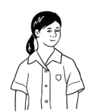



**Listen** and **repeat**.

Mai is my granddaughter.

She is short.

She has long hair and brown eyes.

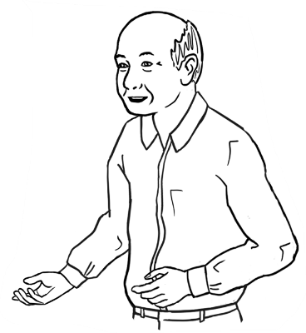

Mai is **hard-working.**

She is **friendly**.

He is **strong** and **healthy**.

|  |  |
| --- | --- |
|  |  |
| Mai is **hard-working**. | She is **friendly**. |



**Read** with a partner.

**Write** the sentences here and into your notebook.

is

my

granddaughter.

Mai

Mai is my granddaughter. .

She

is

hard-working.

_______________________________________________

friendly.

She

is

________________________________________________

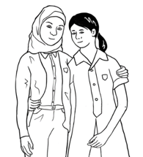



**2**

**Listen.**

**Tick.**

**🗸**

1. Fatima comes from Somalia. China. Syria.
2. She is tall short.
3. She has brown eyes. blue eyes. green eyes.
4. She is a Year 9 student. Year 10 student.

1. She plays netball on Monday. Thursday. Friday.



|  |
| --- |
| comes |
| Friday |
| student |
| short |
| friendly |
| is🗸 |
| blue |

**Write**.

Fatima is my friend.

She ______________ from Syria.

She is ______________.

She has _______________eyes.

Fatima is a Year 9 __________________.

She plays netball on _______________.

She is hard-working and _________________.

**Read** with a partner.

**Copy** into your notebook.

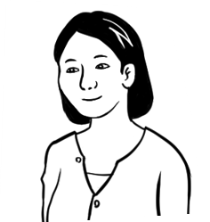



**3**

**Listen**.

**🗸**

**Tick**.

1. Nisha comes from China. Syria. India.
2. She works in

a medical centre.

a childcare centre.

a community centre.

1. Nisha is tall. short.
2. She has long hair. short hair.
3. She has curly hair. wavy hair. straight hair.
4. She likes playing soccer. reading.

|  |
| --- |
| centre |
| tall |
| friend 🗸 |
| reading |
| India |
| long |
| wavy |



**Write.**

* 1. Nisha is Lan’s friend. .
  2. She comes from __________________.
  3. She works in a childcare _______________.
  4. Nisha is ______________.
  5. She has _______________ , ________________ hair.
  6. She likes ______________________.

**Read** with your partner. **Copy** into your notebook.

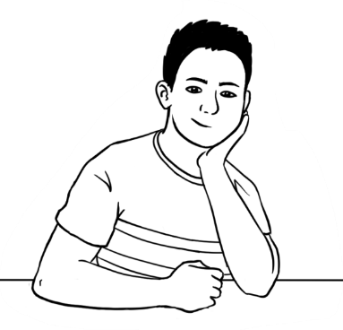



**4**

**Listen.**

**Tick.**

**🗸**

1. Abdi comes from China. Somalia. Syria.

**uni** = university

1. He goes to school. work. uni.
2. Abdi is short. tall.
3. He has long hair. short hair.
4. He has curly hair. wavy hair. straight hair.
5. He likes playing soccer. reading.

|  |
| --- |
| uni |
| tall |
| friend 🗸 |
| soccer |
| Somalia |
| good |
| short |
| curly |

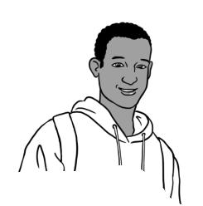

**Write.**

* 1. Abdi is Bao’s friend .
  2. He comes from __________________.
  3. He goes to _______________.
  4. Abdi is ______________.
  5. He has _______________ , ________________ hair.
  6. He likes playing ___________________.
  7. Abdi is a ______________ friend.



**Read** with your partner.

**Copy** into your notebook.



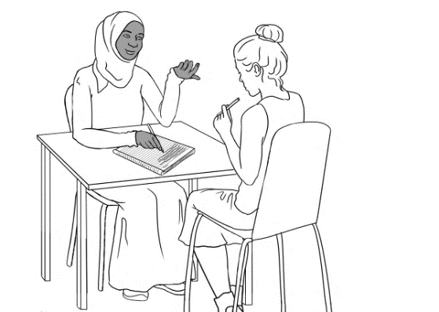**Listen** and **repeat**.

What is your name?

Where are you from?

Can you spell that please?



**Write** about your partner.

1. My partner’s name is ____________________________.
2. He / She comes from ____________________________.

**Circle.**

|  |  |  |  |  |  |
| --- | --- | --- | --- | --- | --- |
| 1. My partner is | old. | middle-aged. | | | young. |
| 1. He / She is | tall. | | short. | | |
| 1. He / She has | long hair. | | short hair. | | |
| 1. He / She has | straight hair. | wavy hair. | | | curly hair. |
| 1. He / She has | brown eyes. | blue eyes. | | | green eyes. |
| 1. My partner is | kind and helpful. | | | strong and healthy. | |
| hard-working. | | | friendly. | |

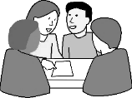 **Read** about your partner in a group.

**Copy** the sentences into your notebook**.**

# The weather



**Listen** and **repeat.**

|  |  |  |  |  |
| --- | --- | --- | --- | --- |
|  |  |  |  |  |
| **sunny** | **cloudy** | **windy** | **rainy** | **stormy** |

**Copy.**

|  |  |
| --- | --- |
| **Shape, circle  Description automatically generated1** | It is sunny.  It is sunny. . |
| **2** | It is cloudy.  ________________________ |
| **Diagram  Description automatically generated3** | It is windy.  ________________________ |
| **4** | It is rainy.  ________________________ |
| **Text  Description automatically generated with low confidence5** | It is stormy.  ________________________ |



**Tick**.

Today the weather is

sunny. cloudy. windy. rainy. stormy.

**Read** with a partner.



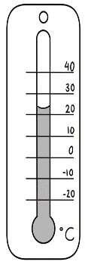**Listen** and **repeat.**

|  |  |  |  |  |
| --- | --- | --- | --- | --- |
|  |  |  |  |  |
| **warm** | **hot** | **very hot** | **cold** | **very cold** |

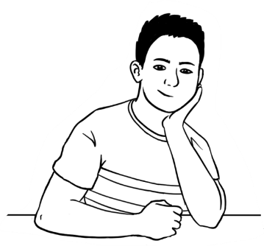

What do you think?

Is it a **nice** day?



|  |  |  |  |
| --- | --- | --- | --- |
| **Copy. Tick** | | **Yes.**  It is. | **No.**  It isn’t. |
| **1** | It is a warm day.  **🗸**  It is a warm day. . |  |  |
| **2** | It is a hot day.  _______________________________ |  |  |
| **3** | It is a very hot day.  _______________________________ |  |  |
| **4** | It is a cold day.  _______________________________ |  |  |
| **5** | It is a very cold day.  _______________________________ |  |  |



**Read** with a partner.

**Copy** the sentences into your workbook.



**Listen** and **repeat.**

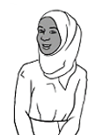

Is it hot or cold today?

How many degrees?

**°**C= degrees

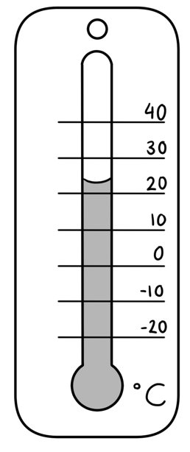

It is very hot.

It is ______°C.

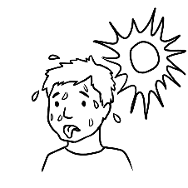

It ishot.

It is ______°C.

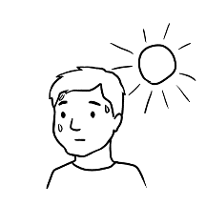

It iscold.

It is ______°C.

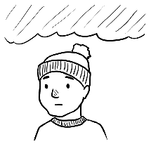

It isvery cold.

It is ______°C.

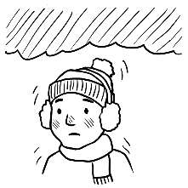

It iswarm.

It is ______°C.

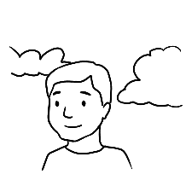

**Write** the degrees.

**Write** about today.

|  |  |  |
| --- | --- | --- |
| **Student A** | | **Student B** |
| **1** | What day is it today? | It is _______________________. |
| **2** | What is the date? | It is _____ ______________ ________.  day month year |
| **3** | Is it hot or cold today? | It is __________________. It is ______°C. |

**Read** with a partner.

**Copy** the sentences into your notebook.



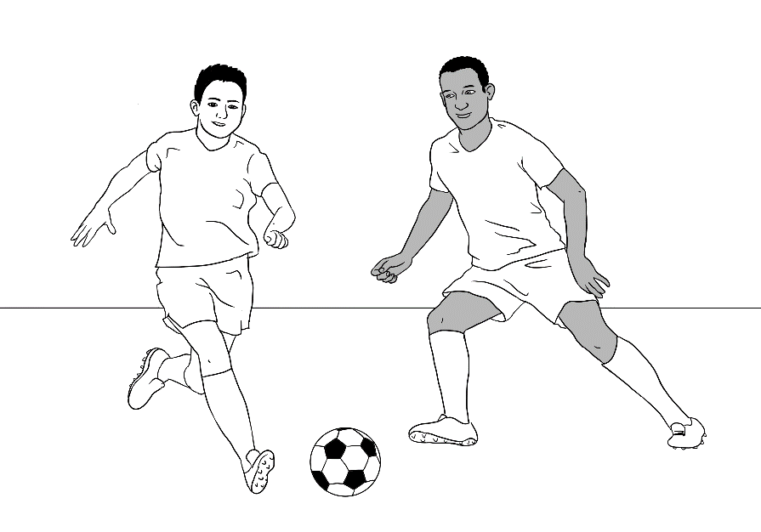**Listen** and **repeat.**

Bao and Abdi play soccer on the weekend.

They play at the park on sunny days.

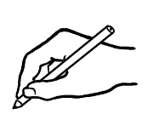

**Write.**

1. Who plays soccer? __________________________________
2. When do they play? ________________________________
3. Where do they play? _______________________________

**Saturday**

Warm and sunny  
 20°C

___________

**Sunday**

Cold and stormy

13°C

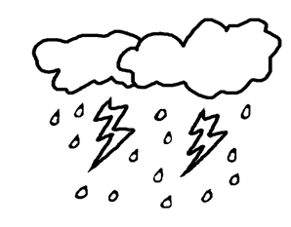

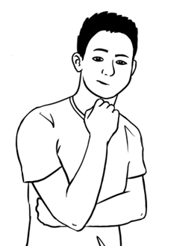



What is **a nice day**   
for soccer?

**Write** the day.

________________________ is a nice day for soccer.

**Read** with a partner.



**Listen** and **repeat.**



**Tick.**



It is **cloudy** today.

It is **18°C**.

Is it a **nice** day?



|  |  |  |
| --- | --- | --- |
|  |  |  |
| **Yes, it is.** | **It’s OK.** | **No, it isn’t.** |

|  |  |  |  |
| --- | --- | --- | --- |
| **Student A** | **Student B 🗸** | | |
| A picture containing text, weapon  Description automatically generatedIt is cloudy today.  It is 11 °C.  Is it a nice day? | Yes,  it is. | It’s OK. | No,  it isn’t. |
| A black and white logo  Description automatically generated with low confidenceIt is rainy tomorrow.  It is 17 °C.  Is it a nice day? | Yes, it is. | It’s OK. | No,  it isn’t. |
| Shape  Description automatically generated with medium confidenceIt is sunny on Saturday.  It is 21°C.  Is it a nice day? | Yes, it is. | It’s OK. | No,  it isn’t. |

**Read** with a partner.



**Listen** and **repeat.**

**°**C= degrees

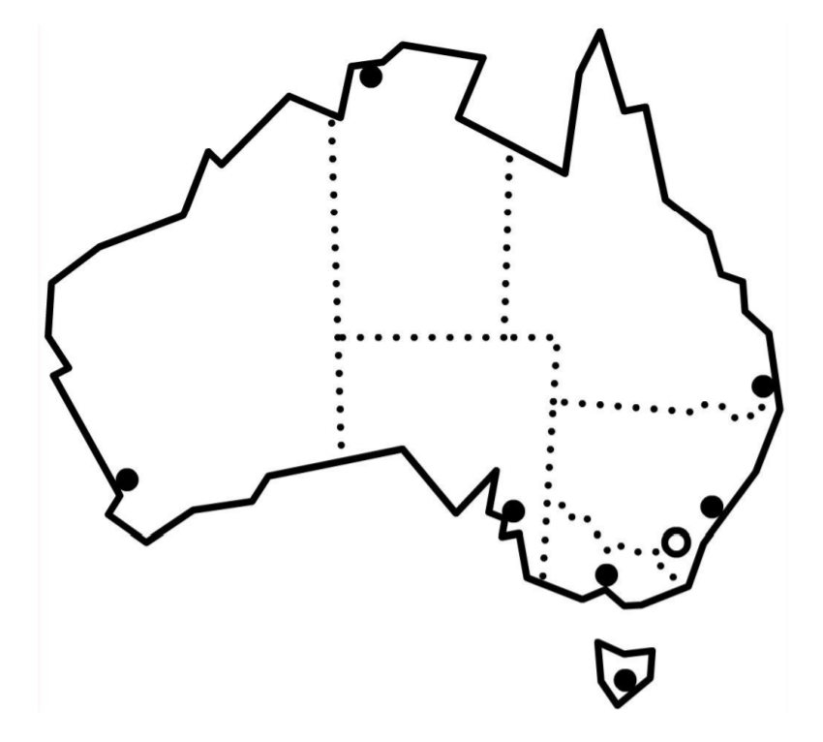

Darwin  
 stormy 32°C



Perth  
 rainy 21°C

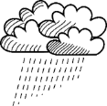

Adelaide cloudy 19°C



Brisbane   
 sunny 28°C



Sydney  
 rainy 23°C



Canberra  
 sunny 19°C



Melbourne  
 windy18°C

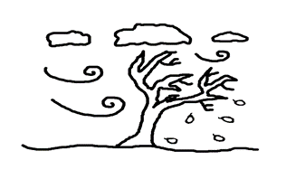

Hobart windy 16°C





**Write** about the weather.

1. In Brisbane, it is sunny and 28 °C.
2. In Sydney, it is ________________ and _______°C.
3. In Canberra, it is ________________and _______°C.
4. In Melbourne, it is ________________and _______°C.
5. In Hobart, it is ________________and _______°C.
6. In Adelaide, it is ________________and _______°C.
7. In Perth, it is ________________and _______°C.
8. In Darwin, it is ________________and _______°C.

**Read** with a partner.

# The medical centre

**Listen** and **repeat**.

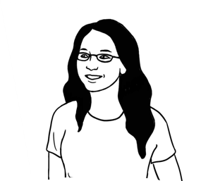

Excuse me.

Where’s the medical centre?

__________________________________________________________________________

Lan Excuse me.

Where’s the medical centre?

Woman The medical centre?

Go straight ahead.

Turn right.

It’s on your left.

LanThanks for your help.

WomanYou’re welcome.  
_____________________________________________________________________________________________

**Read** with a partner.



Which map shows me the way   
to the medical centre?

**Tick.**

**X**

**Lan is here**.

**X**

**Lan is here.**

Map A

Map B

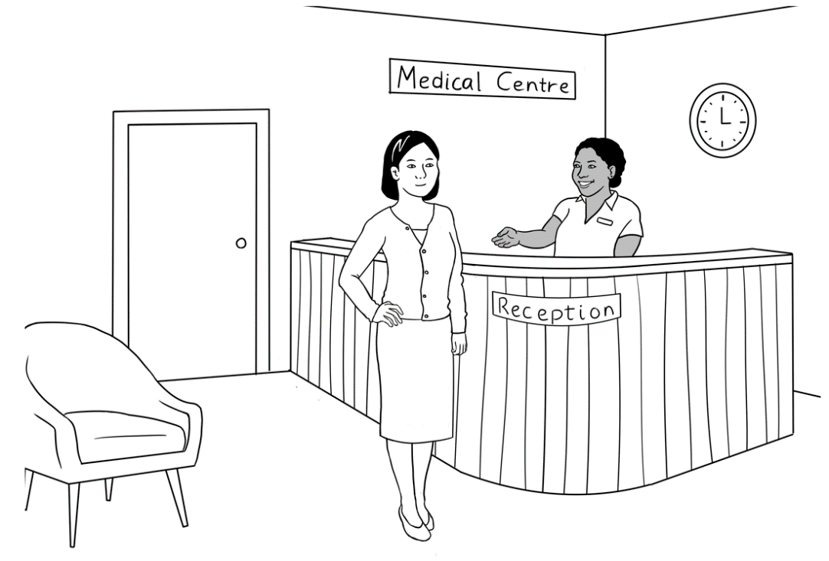



**Listen** and **repeat**.



Please sit down.

Hello. My name is Lan Wu.

I have an appointment   
at 3 o’clock.

|  |  |  |
| --- | --- | --- |
| **Kellivale Medical Centre** | | |
| **Address** | 35 North Road, Kellivale | |
| **Phone** | 6527 8344 | |
| **Hours** | Monday | 8:00am – 6:00pm |
|  | Tuesday Wednesday | 8:30am – 5:30pm |
|  | Thursday Friday | 8:30am – 7:00pm |
|  | Saturday Sunday | Closed |



**Write.**

1. When is the centre open on Monday?

From 8:00am to 6:00pm .

1. When is the centre open on Thursday?

From _____________to ______________

1. What days is the centre closed?

______________________ and ______________________



**Listen** and **repeat**.

Do you have   
a Medicare card?

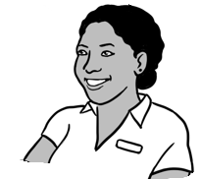

Yes. Here it is. .

What’s your number on the card? card?

My number is **one**.

valid = legal

***medicare***

3056 53521 3

1. LAN WU
2. BAO WU
3. MAI WU

VALID to **03/2026**

Medicare number

expiry date

names



**Write.**

1. This is a Medicare card.
2. The names on the card are ______________________ ____________________and ________________________.
3. The Medicare number is _________________________.
4. The expiry date is ________________________.
5. Lan’s number is _________.
6. Bao’s number is _________.
7. Mai’s number is _________.



**Copy** from your medical card.

Card number _____________________________

Expiry date________________________________  
Your number on the card _______________



**Listen**.

This is my appointment card.

doctor’s address

**Dr James Brown**

35 North Road, Kellivale

Phone 6527 8344

Mrs Lan Wu

has an appointment

**at** 3:00 pm

**on** Thursday 14 April

doctor’s phone number

doctor

patient

time

day

date



**Write** about your doctor.

Doctor’s name ____________________________________

Address ___________________________________________  
___________________________________________________

Phone number _____________________________________



**Read** the appointment card.

**Match.**

|  |  |
| --- | --- |
| **Question** | **Answer** |
| 1. What is this card? | 35 North Road, Kellivale |
| 1. Who is the patient? | an appointment card |
| 1. Who is the doctor? | Mrs Lan Wu |
| 1. What is the doctor’s address? | Dr J. Brown |
| 1. What is the phone number? | 3:00 pm |
| 1. What time is the appointment? | 14 April |
| 1. What day is the appointment? | 6527 8344 |
| 1. What date is the appointment? | Thursday |

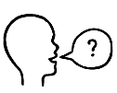**Ask** your partner the questions.

|  |
| --- |
| name |
| card🗸 |
| date |
| time |
| phone |

**Write**.

1. It is an appointment card .
2. The doctor’s _______________ is Dr J. Brown.
3. The doctor’s _______________ number is 6527 8344.
4. The ___________ of the appointment is 3:00pm.
5. The ___________ of the appointment is 14 April.

**Read** with a partner.

# What’s this?

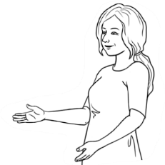**Listen** and **repeat.**

What’s this?

|  |
| --- |
| 1. It is an appointment card. |
| 1. It is a Medicare card. |
| 1. It is a weather chart. |
| 1. It is a timetable. |
| 1. It is a sign. |



What’s this?

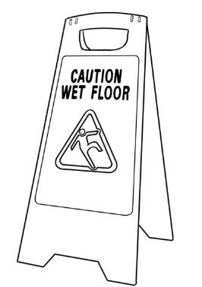

**Match.**

It is a Medicare Care card.

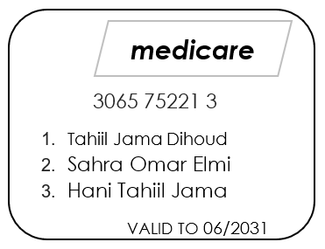

It is a sign.

It is a weather chart.

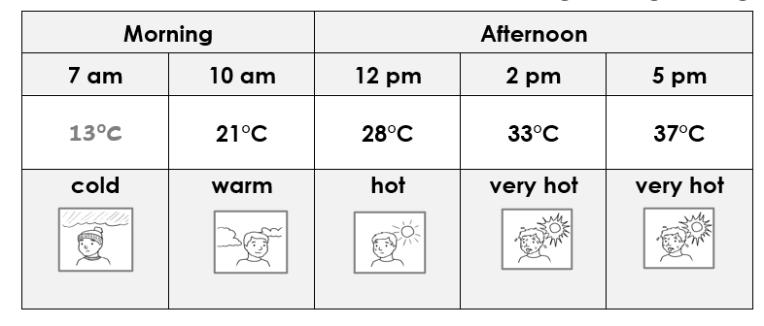

It is an appointment card.

It is a timetable.

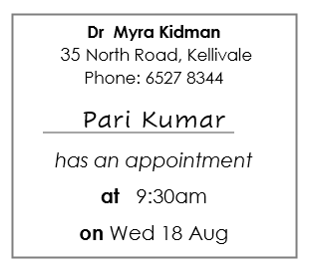

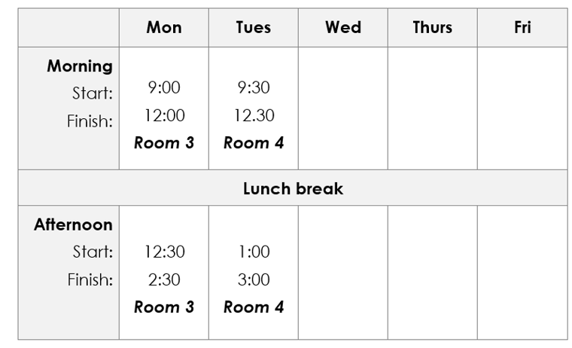



What’s this?

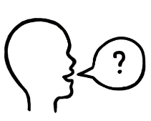**Point.**

**Ask** your partner

It is a timetable.

# Word List

|  |  |  |
| --- | --- | --- |
| **When** | **Days** | **Months** |
| time  year  month  week  day  morning  afternoon  today  tomorrow  next week  weekend | Monday  Tuesday  Wednesday  Thursday  Friday  Saturday  Sunday    birthday | January  February  March  April  May  June  July  August  September  October  November  December |

|  |  |  |
| --- | --- | --- |
| **Timetable** | **Appointment card** | **Weather** |
| day  morning  afternoon  evening  start  finish  room | doctor  patient  time  day  date  address  phone number | hot  warm  Shape  Description automatically generated with medium confidencecold  sunny  cloudy  windy  rainy  stormy  nice |

|  |  |  |
| --- | --- | --- |
| **Verbs** | **Workbook instructions** | **Classroom instructions** |
| to be  to have  to understand  to go  to come  to want  to buy  to put  to start  to finish  to talk  to play | read  write  copy  listen  say  repeat  ask  spell  ______________  tick  circle  underline  point  record  match  work  colour | Come in.  Sit down.  Stand up.  Open your book.  Close your book.  Look at the board.  Write on the board.  Take a photo.  Record the teacher. ______________________  Stand next to the table.  Stand in a line.  Stand in a circle.  Walk slowly.  Walk quickly.  Turn the light on.  Turn the light off.  Go left.  Go right.  Go straight ahead. |

|  |  |  |
| --- | --- | --- |
| **Colour** | **Talk about people** | **Family and friends** |
| A picture containing text, cosmetic  Description automatically generatedyellow  orange  white  blonde  light brown  dark brown  black  grey  red  green  blue | tall  short  old  middle aged  young  long hair  short hair  straight hair  curly hair  wavy hair  blonde hair  blue eyes  green eyes  brown eyes | husband  wife  father  mother  daughter  son  brother  sister  niece  nephew  brother-in-law  friend |
| **What do you think?** |
| kind  helpful  strong  healthy  friendly  hard working |

|  |  |
| --- | --- |
| **Useful Sentences** | |
| Sorry, I **don’t** understand.  Can you speak **slowly** please?  Can you say that **again** please?  Can you **help me** please?  Can you **spell** that please? | What’s your name?  Where are you from?  When is your birthday?  What’s the weather like? |



