

|  |
| --- |
| **English Ready**  **Course in EAL  VU22352 Recognise numbers and money in simple, highly familiar situations** |

**Teacher Resources**

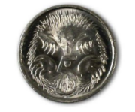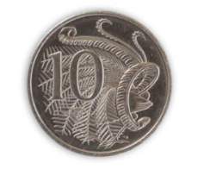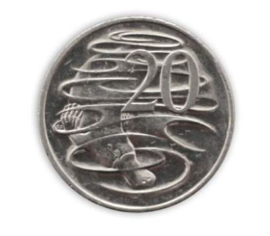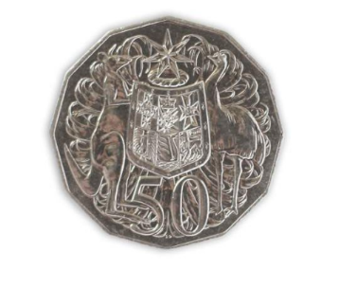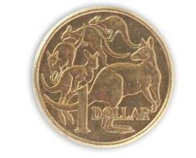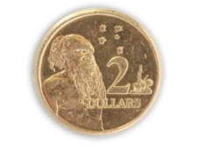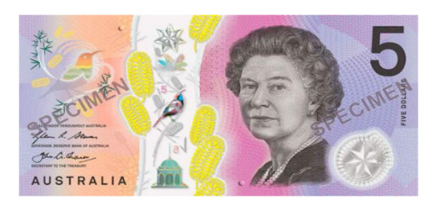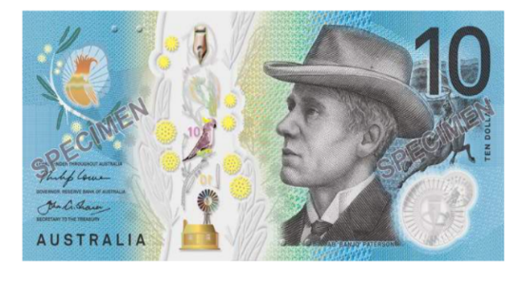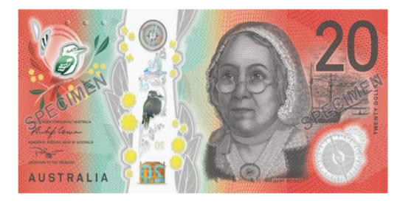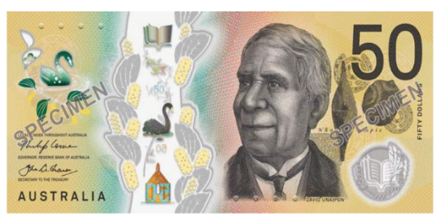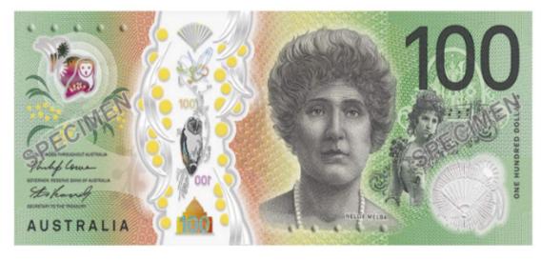

**Design team:** Vicki Hambling, Sue Paull, Frida Dean, Janice Langley, Dhammika Fernando, Glenise Kleehammer and Mary Wallace

**Illustrations:** Madelena Scott

**Image acknowledgements:**  
Australian Currency designs – Permission granted by the Royal Australian Mint, Approval # 9/45/432

IGA & Bunnings Warehouse logos, Toaster #A, Kettle #B - [These Photo](https://en.wikipedia.org/wiki/IGA_(supermarkets))s by Unknown Author is licensed under [CC BY-SA](https://creativecommons.org/licenses/by-sa/3.0/)

Tape, Toaster #B, Sydney Swans & North Melbourne Football Club logos- [These Photo](https://z1battleroyale.gamepedia.com/Duct_Tape)s by Unknown Author is licensed under [CC BY-SA-NC](https://creativecommons.org/licenses/by-nc-sa/3.0/)  
Fridge #B, Stove #B [These Photo](https://www.pngall.com/fridge-png)s by Unknown Author is licensed under [CC BY-NC](https://creativecommons.org/licenses/by-nc/3.0/)  
Stove #A, Kettle #A [This Photo](http://fabioskol.deviantart.com/art/3D-Model-Home-Appliances-Electrolux-Stove-566347775) by Unknown Author is licensed under [CC BY](https://creativecommons.org/licenses/by/3.0/)

**Acknowledgements:** The design team would like to thank the AMEP service providers and practitioners who participated in the trial and gave valuable feedback. The team would also like to acknowledge the use of the EAL Framework which underpins the design of this book.

Copyright of the EAL Framework is reserved to the Crown in the right of the State of Victoria. © State of Victoria (Department of Education and Training) 2018.  
_________________________________________________________________________________________

This English Ready Resource is licensed under a Creative Commons Attribution-NoDerivs 3.0 Australia licence (More information is available [here](http://creativecommons.org/licenses/by-nd/3.0/au/)). You are free to use, copy and distribute to anyone in its original form as long as you attribute Department of Home Affairs as the author and you license any derivative work you make available under the same licence.  
  
© Commonwealth of Australia 2023

With the exception of the Commonwealth Coat of Arms, the department’s logo, any material protected by a trade mark and where otherwise noted all material presented in this document is provided under a Creative Commons Attribution 4.0 International (<https://creativecommons.org/licenses/by/4.0/>) licence.

The details of the relevant licence conditions are available on the Creative Commons website (accessible using the links provided) as is the full legal code for the CC BY 4.0 licence (<https://creativecommons.org/licenses/by/4.0/legalcode>).

Use of all or part of this document must include the following attribution:   
© Commonwealth of Australia 2023

As far as practicable, material for which the copyright is owned by a third party will be clearly labelled.  The department has made all reasonable efforts to ensure that this material has been reproduced in this document with the full consent of the copyright owners.

Copyright requests and enquiries concerning usage not addressed by the CC BY 4.0 licence should be addressed to:

[*comms@homeaffairs.gov.au*](mailto:comms@homeaffairs.gov.au) *at the Department of Home Affairs.*

The terms of use for the Commonwealth Coat of Arms are available from the [It's an Honour](http://www.itsanhonour.gov.au/) website.

Where a copyright owner, other than the Commonwealth, is identified with respect to this material, please contact that third party copyright owner directly to seek permission.



**Introduction**

**The Teacher Book**

This book is an electronic reference. Print pages as only needed. It includes materials and activities for:

* pair work and class work
* revision and homework
* pronunciation
* extension.

**The Student Workbook**

This book requires teacher direction and is **not** intendedfor independent learning. It is also not intended to be the only material used to teach these units. The activities included are not suitable to be used for assessment.   
The book is available as a Word document so that teachers can:

* localise and update the content
* adjust the material to suit the requirements of particular classes
* delete or add materials as required

**Table of Contents**

1. Numbers 5

2. Higher or lower? 21

3. How much? 23

4. More or less? 25

5. School 26

6. The supermarket 27

7. Half 31

8. The garden shop 33

9. Bills 42

10. The paint shop 43

11. The kitchen shop 47

# Numbers

**Activity 1**

Select numbers at random to read to the class. Students circle the numbers in their workbooks. The number 5 is circled as an example for students.

After circling the numbers, students read these in pairs.

|  |  |  |  |  |  |  |  |  |  |
| --- | --- | --- | --- | --- | --- | --- | --- | --- | --- |
|  | | | | | | | | | 0 |
| 1 | 2 | 3 | 4 | 5 | 6 | 7 | 8 | 9 | 10 |
| 11 | 12 | 13 | 14 | 15 | 16 | 17 | 18 | 19 | 20 |
| 21 | 22 | 23 | 24 | 25 | 26 | 27 | 28 | 29 | 30 |
| 31 | 32 | 33 | 34 | 35 | 36 | 37 | 38 | 39 | 40 |
| 41 | 42 | 43 | 44 | 45 | 46 | 47 | 48 | 49 | 50 |
| 51 | 52 | 53 | 54 | 55 | 56 | 57 | 58 | 59 | 60 |
| 61 | 62 | 63 | 64 | 65 | 66 | 67 | 68 | 69 | 70 |
| 71 | 72 | 73 | 74 | 75 | 76 | 77 | 78 | 79 | 80 |
| 81 | 82 | 83 | 84 | 85 | 86 | 87 | 88 | 89 | 90 |
| 91 | 91 | 93 | 94 | 95 | 96 | 97 | 98 | 99 | 100 |

**Activity 2**

**Matching numbers and words**

The following numbers can be printed as whole pages for students to cut up for matching activities. Alternatively, students can work in pairs, point to a number while their partner points to the word. They are useful also for turn-taking.

|  |  |  |  |
| --- | --- | --- | --- |
| **1** | **2** | **3** | **4** |
| **5** | **6** | **7** | **8** |
| **9** | **10** | **11** | **12** |
| **13** | **14** | **15** | **16** |
| **17** | **18** | **19** | **20** |

|  |  |
| --- | --- |
| **one** | **two** |
| **three** | **four** |
| **five** | **six** |
| **seven** | **eight** |
| **nine** | **ten** |

|  |  |
| --- | --- |
| **eleven** | **twelve** |
| **thirteen** | **fourteen** |
| **fifteen** | **sixteen** |
| **seventeen** | **eighteen** |
| **nineteen** | **twenty** |

**Activity 3**

**Pronunciation – Word stress patterns –** thir**teen** and **thir**ty

The changing stress pattern between pairs of numbers such as *thirteen* and *thirty* can confuse new learners. Large rubber bands are useful to demonstrate and help students remember the stressed syllable. Give each student a rubber band, hold with the fingers, stretch the band out on the stressed syllable and bring the fingers together on the unstressed one. The stressed syllable is said a little louder and longer.

Show the stress pattern on the board. Write the pairs of numbers with a larger dot above the vowel in the stressed syllable.   
e.g.

Students read the numbers aloud, stretching the rubber band on the stressed syllable.

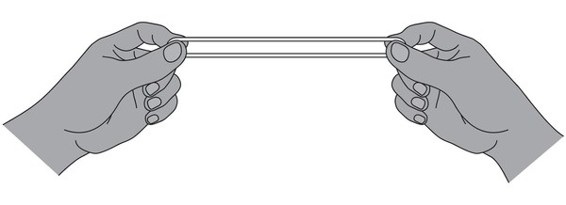

thirteen thirty

fourteen forty

fifteen fifty

sixteen sixty

seventeen seventy

eighteen eighty

nineteen ninety

**Activity 4 - Counting**

* Practise saying the numbers by counting in a variety of ways. Count forwards, backwards, by fives, by tens, by twos.
* Play the ‘Bananas’ game. Count forwards round the class and whenever a student comes to a number with **5** in it, the student must say ‘Banana’ rather than the five. The next student continues to the following number.

**Activity 5**

**Bingo – Practising numbers into the hundreds**

Game 1: Give students cards with the numbers between 1-50filled in and explain the game. As you call the numbers, students cross them off until someone has all their numbers crossed and shouts ***Bingo***.

Game 2: Give students cards with the numbers between 50 - 100filled in.

Game 3: Give students cards with the numbers between 101 - 150filled in. Games with numbers over one hundred offer an opportunity to model the addition of ***and*** when saying numbers in the hundreds.

Game 4: Using the blank cards, students put a different number in every square on their card in the range of 50 numbers to be practised such as:

1 – 50

51 – 100

101 – 150

higher numbers in groups of 50 up to 999.

**Teacher call chart 1 - 50**

|  |  |  |  |  |  |  |  |  |  |
| --- | --- | --- | --- | --- | --- | --- | --- | --- | --- |
| 1 | 2 | 3 | 4 | 5 | 6 | 7 | 8 | 9 | 10 |
| 11 | 12 | 13 | 14 | 15 | 16 | 17 | 18 | 19 | 20 |
| 21 | 22 | 23 | 24 | 25 | 26 | 27 | 28 | 29 | 30 |
| 31 | 32 | 33 | 34 | 35 | 36 | 37 | 38 | 39 | 40 |
| 41 | 42 | 43 | 44 | 45 | 46 | 47 | 48 | 49 | 50 |

**Student Bingo cards 1 – 50**

|  |  |  |  |  |  |  |
| --- | --- | --- | --- | --- | --- | --- |
| 21 | 32 | 50 |  | 38 | 13 | 44 |
| 30 | 20 | 19 |  | 3 | 27 | 40 |
| 2 | 43 | 25 |  | 17 | 33 | 34 |

|  |  |  |  |  |  |  |
| --- | --- | --- | --- | --- | --- | --- |
| 50 | 5 | 38 |  | 38 | 13 | 44 |
| 28 | 14 | 3 |  | 3 | 27 | 40 |
| 12 | 22 | 17 |  | 17 | 33 | 34 |

|  |  |  |  |  |  |  |
| --- | --- | --- | --- | --- | --- | --- |
| 40 | 46 | 16 |  | 16 | 6 | 17 |
| 15 | 5 | 4 |  | 4 | 28 | 45 |
| 39 | 23 | 18 |  | 18 | 50 | 34 |

|  |  |  |  |  |  |  |
| --- | --- | --- | --- | --- | --- | --- |
| 9 | 13 | 21 |  | 50 | 5 | 38 |
| 42 | 26 | 30 |  | 48 | 14 | 3 |
| 49 | 11 | 2 |  | 10 | 22 | 17 |

|  |  |  |  |  |  |  |
| --- | --- | --- | --- | --- | --- | --- |
| 30 | 12 | 2 |  | 2 | 15 | 7 |
| 41 | 47 | 40 |  | 40 | 24 | 28 |
| 16 | 8 | 19 |  | 19 | 29 | 35 |

|  |  |  |  |  |  |  |
| --- | --- | --- | --- | --- | --- | --- |
| 9 | 25 | 50 |  | 50 | 16 | 7 |
| 42 | 30 | 48 |  | 48 | 31 | 22 |
| 49 | 20 | 10 |  | 10 | 36 | 40 |

|  |  |  |  |  |  |  |
| --- | --- | --- | --- | --- | --- | --- |
| 21 | 16 | 32 |  | 30 | 12 | 44 |
| 30 | 13 | 20 |  | 41 | 47 | 40 |
| 2 | 29 | 43 |  | 16 | 8 | 34 |

|  |  |  |  |  |  |  |
| --- | --- | --- | --- | --- | --- | --- |
| 50 | 15 | 9 |  | 38 | 6 | 17 |
| 28 | 13 | 43 |  | 3 | 28 | 45 |
| 12 | 40 | 29 |  | 17 | 50 | 34 |

|  |  |  |  |  |  |  |
| --- | --- | --- | --- | --- | --- | --- |
| 40 | 38 | 13 |  | 16 | 2 | 15 |
| 15 | 3 | 27 |  | 4 | 40 | 24 |
| 39 | 17 | 33 |  | 18 | 19 | 29 |

|  |  |  |  |  |  |  |
| --- | --- | --- | --- | --- | --- | --- |
| 30 | 46 | 16 |  | 2 | 25 | 50 |
| 41 | 5 | 4 |  | 40 | 30 | 48 |
| 16 | 23 | 18 |  | 19 | 20 | 10 |

**Teacher call chart 51 - 100**

|  |  |  |  |  |  |  |  |  |  |
| --- | --- | --- | --- | --- | --- | --- | --- | --- | --- |
| 51 | 52 | 53 | 54 | 55 | 56 | 57 | 58 | 59 | 60 |
| 61 | 62 | 63 | 64 | 65 | 66 | 67 | 68 | 69 | 70 |
| 71 | 72 | 73 | 74 | 75 | 76 | 77 | 78 | 79 | 80 |
| 81 | 82 | 83 | 84 | 85 | 86 | 87 | 88 | 89 | 90 |
| 91 | 92 | 93 | 94 | 95 | 96 | 97 | 98 | 99 | 100 |

**Student Bingo cards 51 – 100**

|  |  |  |  |  |  |  |
| --- | --- | --- | --- | --- | --- | --- |
| 64 | 71 | 53 |  | 100 | 56 | 57 |
| 88 | 81 | 59 |  | 83 | 66 | 94 |
| 95 | 91 | 98 |  | 71 | 76 | 52 |

|  |  |  |  |  |  |  |
| --- | --- | --- | --- | --- | --- | --- |
| 72 | 88 | 54 |  | 96 | 81 | 80 |
| 82 | 76 | 61 |  | 69 | 77 | 90 |
| 92 | 95 | 99 |  | 55 | 83 | 100 |

|  |  |  |  |  |  |  |
| --- | --- | --- | --- | --- | --- | --- |
| 54 | 72 | 67 |  | 63 | 74 | 71 |
| 76 | 82 | 96 |  | 89 | 57 | 81 |
| 88 | 92 | 65 |  | 92 | 60 | 91 |

|  |  |  |  |  |  |  |
| --- | --- | --- | --- | --- | --- | --- |
| 94 | 72 | 55 |  | 73 | 58 | 62 |
| 86 | 82 | 98 |  | 86 | 68 | 93 |
| 61 | 92 | 87 |  | 99 | 78 | 91 |

|  |  |  |  |  |  |  |
| --- | --- | --- | --- | --- | --- | --- |
| 57 | 62 | 58 |  | 57 | 85 | 72 |
| 79 | 84 | 68 |  | 63 | 91 | 82 |
| 96 | 93 | 78 |  | 77 | 64 | 92 |

|  |  |  |  |  |  |  |
| --- | --- | --- | --- | --- | --- | --- |
| 89 | 56 | 79 |  | 71 | 66 | 94 |
| 75 | 66 | 84 |  | 81 | 78 | 98 |
| 61 | 76 | 69 |  | 91 | 85 | 52 |

|  |  |  |  |  |  |  |
| --- | --- | --- | --- | --- | --- | --- |
| 58 | 76 | 85 |  | 81 | 80 | 85 |
| 61 | 86 | 63 |  | 74 | 90 | 69 |
| 72 | 96 | 89 |  | 67 | 100 | 72 |

|  |  |  |  |  |  |  |
| --- | --- | --- | --- | --- | --- | --- |
| 80 | 81 | 67 |  | 56 | 55 | 69 |
| 90 | 84 | 96 |  | 66 | 97 | 98 |
| 100 | 77 | 87 |  | 76 | 89 | 54 |

**Teacher call chart 101 – 150**

|  |  |  |  |  |  |  |  |  |  |
| --- | --- | --- | --- | --- | --- | --- | --- | --- | --- |
| 101 | 102 | 103 | 104 | 105 | 106 | 107 | 108 | 109 | 110 |
| 111 | 112 | 113 | 114 | 115 | 116 | 117 | 118 | 119 | 120 |
| 121 | 122 | 123 | 124 | 125 | 126 | 127 | 128 | 129 | 130 |
| 131 | 132 | 133 | 134 | 135 | 136 | 137 | 138 | 139 | 140 |
| 141 | 142 | 143 | 144 | 145 | 146 | 147 | 148 | 149 | 150 |

**Student Bingo cards 101 – 150**

|  |  |  |  |  |  |  |
| --- | --- | --- | --- | --- | --- | --- |
| 113 | 102 | 121 |  | 139 | 130 | 126 |
| 101 | 112 | 130 |  | 113 | 102 | 136 |
| 148 | 122 | 136 |  | 141 | 114 | 146 |

|  |  |  |  |  |  |  |
| --- | --- | --- | --- | --- | --- | --- |
| 128 | 105 | 130 |  | 105 | 103 | 113 |
| 138 | 113 | 126 |  | 115 | 146 | 128 |
| 148 | 131 | 114 |  | 125 | 130 | 150 |

|  |  |  |  |  |  |  |
| --- | --- | --- | --- | --- | --- | --- |
| 130 | 129 | 141 |  | 109 | 114 | 111 |
| 103 | 139 | 113 |  | 113 | 124 | 121 |
| 114 | 149 | 136 |  | 141 | 130 | 131 |

|  |  |  |  |  |  |  |
| --- | --- | --- | --- | --- | --- | --- |
| 101 | 110 | 113 |  | 130 | 146 | 103 |
| 114 | 120 | 149 |  | 129 | 102 | 113 |
| 143 | 130 | 136 |  | 114 | 138 | 123 |

|  |  |  |  |  |  |  |
| --- | --- | --- | --- | --- | --- | --- |
| 109 | 130 | 105 |  | 103 | 150 | 130 |
| 119 | 115 | 113 |  | 113 | 148 | 126 |
| 129 | 124 | 150 |  | 122 | 105 | 131 |

|  |  |  |  |  |  |  |
| --- | --- | --- | --- | --- | --- | --- |
| 130 | 104 | 124 |  | 114 | 104 | 133 |
| 136 | 142 | 109 |  | 122 | 113 | 129 |
| 114 | 129 | 113 |  | 108 | 146 | 130 |

|  |  |  |  |  |  |  |
| --- | --- | --- | --- | --- | --- | --- |
| 141 | 132 | 127 |  | 130 | 122 | 113 |
| 122 | 130 | 114 |  | 141 | 150 | 133 |
| 113 | 111 | 108 |  | 109 | 114 | 112 |

|  |  |  |  |  |  |  |
| --- | --- | --- | --- | --- | --- | --- |
| 140 | 113 | 103 |  | 113 | 104 | 117 |
| 133 | 150 | 130 |  | 140 | 111 | 130 |
| 127 | 111 | 139 |  | 149 | 146 | 144 |

**Student Bingo cards Blank**

|  |  |  |  |  |  |  |
| --- | --- | --- | --- | --- | --- | --- |
|  |  |  |  |  |  |  |
|  |  |  |  |  |  |  |
|  |  |  |  |  |  |  |

|  |  |  |  |  |  |  |
| --- | --- | --- | --- | --- | --- | --- |
|  |  |  |  |  |  |  |
|  |  |  |  |  |  |  |
|  |  |  |  |  |  |  |

|  |  |  |  |  |  |  |
| --- | --- | --- | --- | --- | --- | --- |
|  |  |  |  |  |  |  |
|  |  |  |  |  |  |  |
|  |  |  |  |  |  |  |

|  |  |  |  |  |  |  |
| --- | --- | --- | --- | --- | --- | --- |
|  |  |  |  |  |  |  |
|  |  |  |  |  |  |  |
|  |  |  |  |  |  |  |

|  |  |  |  |  |  |  |
| --- | --- | --- | --- | --- | --- | --- |
|  |  |  |  |  |  |  |
|  |  |  |  |  |  |  |
|  |  |  |  |  |  |  |

|  |  |  |  |  |  |  |
| --- | --- | --- | --- | --- | --- | --- |
|  |  |  |  |  |  |  |
|  |  |  |  |  |  |  |
|  |  |  |  |  |  |  |

**Activity 6**

**Back-to-back numbers**

This pair activity develops skills in reading, writing, speaking and listening to numbers.

* Students sit back-to-back in pairs.
* Each student has small worksheet with:
* one column of numbers to read
* one column for writing the numbers read to them.
* Students take turns to read their numbers and write their partner’s numbers.
* They must not show their numbers to their partner.
* Finally, students check the accuracy of their numbers together.

Before students begin:

* Demonstrate the process with a student so that everyone understands what to do.
* Practise the insertion of ***and*** after hundreds  
   e.g. two hundred and fifty-two.

On the following pages are:

* an example of the worksheets
* blank templates which allow the activity to be tailored to the ability of class.

*[This activity has been adapted from an activity in Beth Marr’s resources, ‘Building strength with numeracy’, VALBEC 2013. ]*

|  |  |
| --- | --- |
| **Read** the numbers  to your partner. | **Write** your partner’s  numbers here. |
| 13 |  |
| 26 |  |
| 78 |  |
| 145 |  |
| 369 |  |
| 724 |  |

Student A

✂

Student B

|  |  |
| --- | --- |
| **Read** the numbers  to your partner. | **Write** your partner’s  numbers here. |
| 18 |  |
| 44 |  |
| 83 |  |
| 137 |  |
| 468 |  |
| 925 |  |

Student A

|  |  |
| --- | --- |
| **Read** the numbers  to your partner. | **Write** your partner’s  numbers here. |
|  |  |
|  |  |
|  |  |
|  |  |
|  |  |
|  |  |

✂

Student B

|  |  |
| --- | --- |
| **Read** the numbers  to your partner. | **Write** your partner’s  numbers here. |
|  |  |
|  |  |
|  |  |
|  |  |
|  |  |
|  |  |

# Higher or lower?

**Introduction to the vocabulary - higher or lower**

Project the following pictures on the board and ask the questions.   
Delete or obscure the questions before projecting.

|  |  |
| --- | --- |
|  | What is  the higher speed?  What is  the lower speed? |
| **Monday**  **Tuesday** | When is the temperature higher?  When is the temperature lower? |
| **$899**  **$898** | What is  the higher price?  What is  the lower price? |
| **Sahra**  **Hani** | Whose picture  is higher on  the wall?  Whose picture  is lower? |
| **112**  **98** | Which team has the  higher score?  Which team has the  lower score? |
|  | Which chair  is higher?  Which chair  is lower? |
| 62 59  756 784  944 949 | What is  the higher number?  What is  the lower  number? |

# How much?

**What’s for lunch?**

**Pair work**

* Ask students what they have for lunch.
* Project the pictures below on the whiteboard and pre teach the vocabulary of the food if it’s unfamiliar.
* Ask students to guess how much each item costs.
* Divide the class into pairs – Student A and Student B.
* Give each student a copy of their worksheet.
* Demonstrate how to do the exercise with a confident student.
* Encourage students to use polite forms to ask for repetition when they don’t understand. E.g. *Can you say that again please*? *Sorry, I don’t understand. Please speak slowly.* etc

|  |  |  |  |
| --- | --- | --- | --- |
|  |  |  |  |
| **orange juice** | **pizza** | **sandwich** | **banana** |
|  |  |  |  |
| **coffee** | **tea** | **cake** | **ice cream** |

**How much is the_____________**?

**Student A**

|  |  |  |  |
| --- | --- | --- | --- |
|  |  |  |  |
| orange juice | pizza | sandwich | banana |
| ____________ | **$3** | ___________ | **50c** |
|  |  |  |  |
| coffee | tea | cake | ice cream |
| **$4** | _____________ | **$6** | ____________ |

✂

**How much is the_____________**?

**Student B**

|  |  |  |  |
| --- | --- | --- | --- |
|  |  |  |  |
| orange juice | pizza | sandwich | banana |
| **$6** | _____________ | **$7** | ____________ |
|  |  |  |  |
| coffee | tea | cake | ice cream |
| ____________ | **$3** | ____________ | **$5** |

# More or less?

**Introduction - Is it more, less or the same**?

Introduce the activity in the student book on page 13 by projecting the table below and comparing the examples. Compare 1 & 2, 3 & 4 etc and ask the questions, ‘Is it more? Is it less? Is it the same?’ for each pair of amounts.

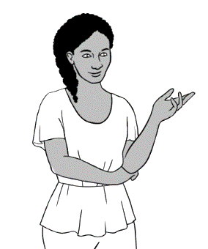

Is it **more**?

Is it **less**?

Is it **the same**?

|  |  |
| --- | --- |
| **1.** | **2.** |
| **3.** | **4.** |
| **5.** | **6.** |
| **7.** | **8.** |
| **9.** | **10.** |

# School

**Relate this section to your local area**

* Before doing any work in the student book, brainstorm what your students need for school.
* On the whiteboard, make a list of the items suggested. *[See table below.]*
* Select two local stationery suppliers and add their names to the table.
* Use a catalogue or Google two suppliers to find out the cost of each item. Round the numbers to the nearest dollar to avoid decimals.

Alternatively, to avoid this issue, create two simple charts following the pattern on the next page.

* Compare the cost of the items using the comparative language to be practised in this section - ***cheaper*** and ***more expensive***
* Write and read sentences e.g. *The pencil is more expensive at ____________. The rubber is cheaper at ______________.* etc  
   name of the shop name of the shop

|  |  |  |
| --- | --- | --- |
| **What you need for school:** | Shop 1_____**____________ Cost** | Shop 2**______________ Cost** |
| pencil |  |  |
| rubber |  |  |
|  |  |  |
|  |  |  |
|  |  |  |
|  |  |  |
|  |  |  |

# The supermarket

**Activity 1 – Write the prices. [In the student book]**

**Read** the prices below to the students. *[The price of Weet-Bix is written in the student book.]*

|  |  |  |  |
| --- | --- | --- | --- |
| 1. **$5**   Weet Bix | 1. **$6**     eggs | 1. **$10**     cocoa | 1. **$1**     milk |
| 1. **$3**     bicarb soda | 1. **$4**     dates | 1. **$2**   flour | 1. **$6**   soy sauce |
| 1. $**6**   oil | 1. **$8**     honey | 1. **$5 kg**     oranges | 1. **$3**     sugar |
| 1. **$5**     nuts | 1. **$16**   rice | 1. **$11**   coffee | 1. **$3**     noodles |

**Activity 2 - Game ‘I buy some…’**

This game can be played as a class and in small groups. Project a photo of the local supermarket. Point to the photo and begin the game.

* The teacher says what he/she buys. e.g. *I buy some milk.*Writethis on the board.
* The first student repeats the teacher’s sentence and adds an item.   
  e.g. *I buy some milk* [Teacher holds up a card with ***and*** ] *eggs.*   
  Add *eggs* under milk on the board.
* Continue in this way, with students adding items to the sentence and the teacher holding up the card with ***and*** before the final item.
* When students become more familiar with the game and the food items, omit writing the items on the board to develop memory skills.

*The game can be extended to cover a wide range of vocabulary. It can be used as a warmer to revise vocab from a previous class and as a light activity at the end of class.

**Supermarket catalogues**   
Collect a class set of catalogues from Aldi, Coles etc

Advertising catalogues are a great resource for EAL learners. However, as many prices include decimals, they are not suitable at Course level.   
Activity 3 has been adapted for Course students, while the remaining activities are appropriate for more advanced and confident students.

**Activity 3:**

* Write a shopping list on the whiteboard.
* Students cut out pictures of items on the list.
* Students paste the pictures in their notebooks.
* The teacher reads out the prices for students to write next to each item.

***The following activities involve decimals.***

**Activity 4:**

* Write a shopping list on the whiteboard. If possible, include some or all of the items pictured on the previous page.
* Students copy and read the list together in class.
* They then look through the catalogue to find and write the prices.

**Activity 5:**

* Students write their own shopping list selecting from the catalogue.
* They write the prices next to each item.
* Students work in pairs and take turns to ask each other the prices of different items. e.g. How much is the ….? How much are the…?

**Activity 6 – Have a guess**

The worksheet on the following page is aimed to develop skills in estimation.

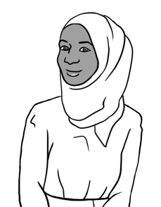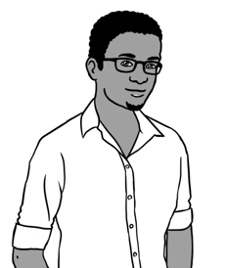

How much is   
a washing machine??

Maybe $600??

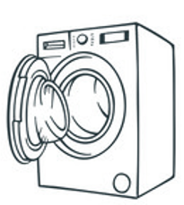



|  |  |
| --- | --- |
| 1. How much is  a washing machine? | Maybe $4? |
| 1. A picture containing text, clipart     Description automatically generatedHow much is  a cup of coffee? | Maybe $600 or $700? |
| 1. A picture containing clipart     Description automatically generatedHow much is  a backpack? | Maybe 50 cents? |
| 1. How much is  a laptop? | Maybe $600? |
| 1. A picture containing whip, adapter     Description automatically generatedHow much is  a banana? | Maybe $25? |
| 1. How much is  a bag of potatoes? | Maybe $30 or $40? |
| 1. A black and white drawing of a person's face     Description automatically generated with medium confidenceHow much is  a kilo of lamb chops? | Maybe $7? |

**Match.**

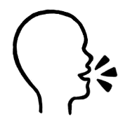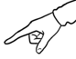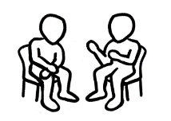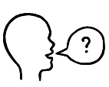 **Work** with your partner. **Point to** something.

**Ask**

Maybe $30 or $40?

How much is this?

# Half

**Introduce half.**

The pictures below may be projected to introduce the concept and numeral of half. Alternatively, the two pages could be printed and students asked to colour half of each item.

|  |  |
| --- | --- |
|  |  |
|  |  |
|  |  |
|  |  |
|  |  |
|  |  |
|  |  |
|  |  |
|  |  |

# The garden shop

**Revision - an interactive oral activity**

In this activity, students move round the room with a question strip held in front of them. They need to ask different students to give an answer to the question.

The activity gives student practice in:

* one-step calculations
* the concepts of half and double
* vocabulary - more/less, cheaper/more expensive
* spelling numbers to 20
* naming the bank notes and coins.

**Preparation**

* Print and cut-up the strips on the following pages.
* Write the answer to each question on the back of the strip.

**Activity**

* Demonstrate the activity with a confident student:
* Stand in front of the student and show them the question.  
  Make sure the answer is not shown.
* Tell the student the answer if they’re incorrect.
* Answer the question on the student’s question strip.
* Then, move onto another student.
* Give each student a question strip.
* Students move from partner to partner. The partner reads the question aloud before answering. Then they swap roles.
* Stop the activity when you can see that students have worked with several different students.

|  |
| --- |
| How much change?  $100 - $30 = ____ |
| How much is it?  $40 + $15 = ___ |
| How much change?  $50 - $30 = ___ |
| How much is it?  $50 + $28 = ___ |
| How much change?  $75 - $30 = ____ |

|  |
| --- |
| What is more?  $100 or $90? |
| How much is  $150 + $16 = ___ |
| What is cheaper?  $150 or $180? |
| What is ½ of $50? |
| What is ½ of $100? |

|  |
| --- |
| What is double 10? |
| What is double $100? |
| Name the bank notes.  $5, $10 _____, ______, ______ |
| Name the coins.  5 cents,10 cents, _______, ______,  ________, ______ |

|  |
| --- |
| Spell the word for 10. |
| Spell the word for 5. |
| +  $20 + $30 = _____ |
| +  $28 + $25 = _____ |

|  |
| --- |
| +  $6 + $40 = _______ |
| +  $18 + $5 = _______ |
| +  $20 + $40 = ________ |
| +  $25 + $40 = ________ |

|  |
| --- |
| +  $30 + $25 = ________ |
| +  $18 + $5 = ________ |
| +  $28 + $30 = ________ |
| +  $25 + $5 = _______ |

**Answers**

**Bunnings Game**

In this game students are practising simple calculations such as adding amounts together and calculating how much change they should get.

Encourage students to calculate the amounts. If they are unsure, they can guess and check the answer sheet below.

Print the game on the next page on A3 paper.

**FINISH**

**$42**

**$25**

**$29**

**$78**

**$20**

**$26**

**$70**

**START**

**$54**

**$100**

**$166**

**$150**



**$5**

**$5, $10, $20, $50, $100**

**5c,10c, 20c,50c, $1, $2,**

**$45**

**What is cheaper**?

**$150 or $180 =_______**

**How much is it**?

**$150 + $16**

**What is more**?

**$100 or $90**

**How much is it**?

**$40 +$14**

**START**

**Can you say all the notes**? ***$5, $10* ____**

**Can you say all the coins**? **5c, 10c_____**

**

**What is ½ of $10**?

**How much change**?

**$100 - $30**

**FINISH**

**How much change**?

**$75- $50**

**How much is it**?

**$50 + $28**

**How much change**?

**$50 - $30**

**How much is it**?

**+**

**How much**?

**How much**?

**+ **

# Bills

**Reading bills**

Before students read the bills on Pages 28 & 29, project the sample electricity and gas invoices below. Highlight and explain the key vocab and information and compare the costs.

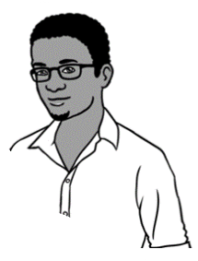

**bill**

**When to pay**

**Electricity Account**

**Customer Number 687-4189**

**Due Date 16 Nov 2022**

**Amount Due $218.00**

**Mr T Dihoud**

**Unit 6  
50 Baker Road**

**Kellivale NSW**



**Tahiil’s address**

**How much to pay**

**Gas Account**

**Customer Number** **676-3077**

**Due Date 14 Aug 2022**

**Mr T Dihoud**

**Unit 6  
50 Baker Road**

**Kellivale NSW**

**Amount Due $240.00**



1. Is the gas bill more than the electricity bill?
2. Tahiil has $250 for his gas bill.

How much change does he get?

# The paint shop

**Preparation for work in the student book**

**Activity - What do we need to paint the classroom**?

**Preparation**

Collect a wide range of different colour swatches from a paint supplier such as Bunnings. [At least 6 colours for each pair of students.]

**Pair work**

* Distribute at least six colour swatches to each pair of students.
* In pairs, students choose a colour to paint the classroom or another room or area in need of painting.
* Students blutack their chosen paint colour to the whiteboard.
* Circle the most popular colour.
* Through mime, elicit the equipment needed to paint the room.
* Project the pictures of painting equipment on the next page and pre teach unfamiliar vocabulary.
* Ask students to guess how much each item costs.
* Divide the class into pairs – Student A and Student B.
* Give students a copy of the worksheet, either Student A or B.
* Demonstrate how to do the exercise with a confident student.
* Encourage students to use polite forms to ask for repetition when they don’t understand. E.g. *Can you say that again please*? *Sorry, I don’t understand. Please speak slowly.* etc

|  |  |  |  |
| --- | --- | --- | --- |
|  |  |  |  |
| **small tin  of paint** | **big tin  of paint** | **tape** | **ladder** |
|  |  |  |  |
| **short  roller** | **long  roller** | **small brush** | **big  brush** |

**How much is the ________________?**

**Student A**

|  |  |  |  |
| --- | --- | --- | --- |
|  |  |  |  |
| small tin of paint  **$50** | big tin of paint  **$______** | tape  **$2** | ladder  **$______** |
|  |  |  |  |
| short roller  **$44** | long roller  **$______** | small brush  **$17** | big brush  **$_____** |

✂

**Student B**

**How much is the ________________?**

|  |  |  |  |
| --- | --- | --- | --- |
|  |  |  |  |
| small tin of paint  **$______** | big tin of paint  **$195** | tape  **$_____** | ladder  **$256** |
|  |  |  |  |
| short roller  **$_____** | long roller  **$63** | small brush  **$______** | big brush  **$38** |

**What does Tahiil need in the paint shop?** [Student Book, pages 30]

**Read** the prices below to the students.   
*[The price of the small tin of paint is written in the student book.]*

|  |  |  |  |
| --- | --- | --- | --- |
|  | 1. A picture containing icon     Description automatically generated | 1. A picture containing shape     Description automatically generated | 1. A picture containing crane     Description automatically generated |
| small tin of paint  **$60** | big tin of paint  **$225** | tape  **$4** | ladder  **$190** |
| 1. A picture containing hanger, paper clip, masher     Description automatically generated |  |  |  |
| short roller  **$31** | long roller  **$56** | small brush  **$20** | big brush  **$40** |

# The kitchen shop

**Introduction**

***\**** *Students need to keep their workbooks closed.*

Project or print the brochure on the next page to introduce the kitchen vocabulary.

* Ask questions such as: *Which fridge is cheaper*? *Which stove is more expensive*?etc
* Encourage students to guess the cost of each appliance and write each guess next to the name of the appliance in their notebook.
* Revise simple calculations with the prices student suggest – adding and subtracting, estimating change etc
* Students later check the accuracy of their guesses in their workbooks.

Fridge **A**

Fridge **B**

**Sale**

Stove **A**

Toaster

**B**

Toaster

**A**

Kettle

**A**

Kettle

**B**

Stove

**B**

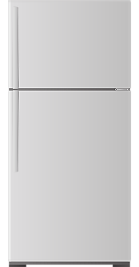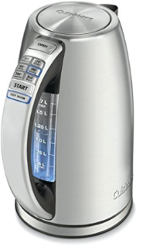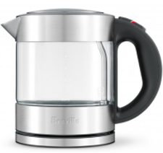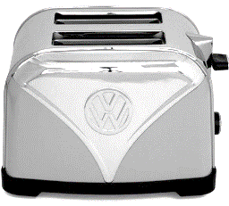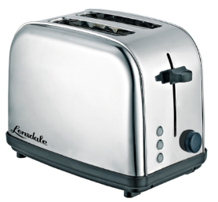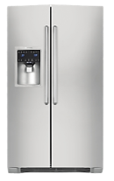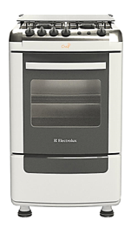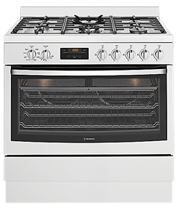

**The Kitchen Shop**

