

|  |
| --- |
| **English Ready**  **Course in EAL  VU22353 Recognise, give and follow simple and familiar directions** |

**Teacher Resources**

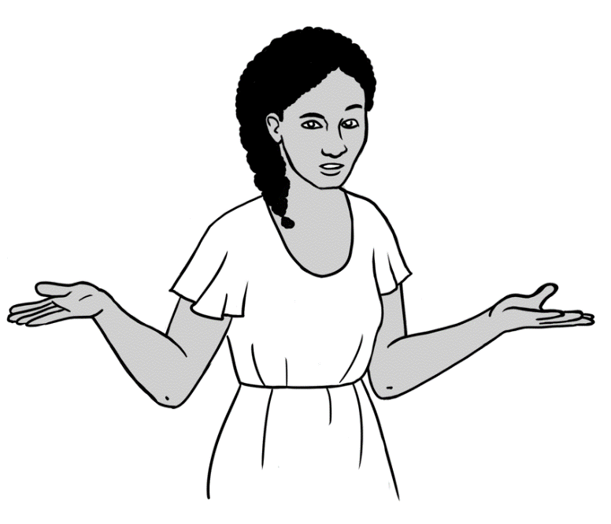

Where’s   
my phone?

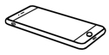

Where’s   
the cafe?



Where are   
the eggs?

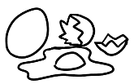

**Design team:** Vicki Hambling, Sue Paull, Frida Dean, Janice Langley, Dhammika Fernando, Glenise Kleehammer and Mary Wallace

**Illustrations:** Madelena Scott

**Acknowledgements:** The design team would like to thank the AMEP service providers and practitioners who participated in the trial and gave valuable feedback. The team would also like to acknowledge the use of the EAL Framework which underpins the design of this book.

Copyright of the EAL Framework is reserved to the Crown in the right of the State of Victoria. © State of Victoria (Department of Education and Training) 2018.  
_________________________________________________________________________________________

This English Ready Resource is licensed under a Creative Commons Attribution-NoDerivs 3.0 Australia licence (More information is available [here](http://creativecommons.org/licenses/by-nd/3.0/au/)). You are free to use, copy and distribute to anyone in its original form as long as you attribute Department of Home Affairs as the author and you license any derivative work you make available under the same licence.  
  
© Commonwealth of Australia 2023

With the exception of the Commonwealth Coat of Arms, the department’s logo, any material protected by a trade mark and where otherwise noted all material presented in this document is provided under a Creative Commons Attribution 4.0 International (<https://creativecommons.org/licenses/by/4.0/>) licence.

The details of the relevant licence conditions are available on the Creative Commons website (accessible using the links provided) as is the full legal code for the CC BY 4.0 licence (<https://creativecommons.org/licenses/by/4.0/legalcode>).

Use of all or part of this document must include the following attribution:   
© Commonwealth of Australia 2023

As far as practicable, material for which the copyright is owned by a third party will be clearly labelled.  The department has made all reasonable efforts to ensure that this material has been reproduced in this document with the full consent of the copyright owners.

Copyright requests and enquiries concerning usage not addressed by the CC BY 4.0 licence should be addressed to:

[*comms@homeaffairs.gov.au*](mailto:comms@homeaffairs.gov.au) *at the Department of Home Affairs.*

The terms of use for the Commonwealth Coat of Arms are available from the [It's an Honour](http://www.itsanhonour.gov.au/) website.

Where a copyright owner, other than the Commonwealth, is identified with respect to this material, please contact that third party copyright owner directly to seek permission.

**Introduction**

**The Teacher Book**

This book is an electronic reference. Print pages as only needed. It includes materials and activities for:

* pair work and class work
* revision and homework
* pronunciation
* extension

The book also contains audio transcripts and links to the audio MP3 files.

**The Student Workbook**

This book requires teacher direction and is **not** intendedfor independent learning. It is also not intended to be the only material used to teach these units. The activities included are not suitable to be used for assessment.   
The book is available as a Word document so that teachers can:

* localise and update the content
* adjust the material to suit the requirements of particular classes
* delete or add materials as required

**Table of Contents**

1. Where’s the ball? 5

2. Where’s my phone? 6

3. Where is it? 8

4. Where is it in the cupboard? 9

5. Where is it in the supermarket? 16

6. Where’s my classroom? 17

7. Where’s the number? 18

8. Where’s the cafe? 21

9. Where are you? 30

10. Where are the maps on my phone? 33

11. Audio files and transcripts 36

# Where’s the ball?

**Activity - Pairs**

* Give each pair of students one set of cards.
* Student A has the cards and using gesture alone must convey   
  the meaning on the card.
* Student B must repeat the gesture and guess the direction word.
* Students then swap roles.

Alternatively, the words could be projected on the board.

|  |  |
| --- | --- |
| up | down |
| right | left |
| under | above |
| in front | behind |
| next to | between |
| opposite | on the corner |

# Where’s my phone?

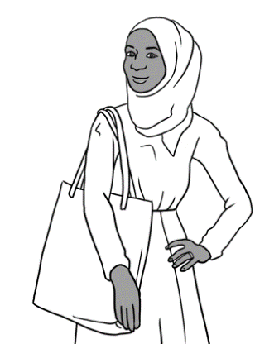

Where’s my phone?

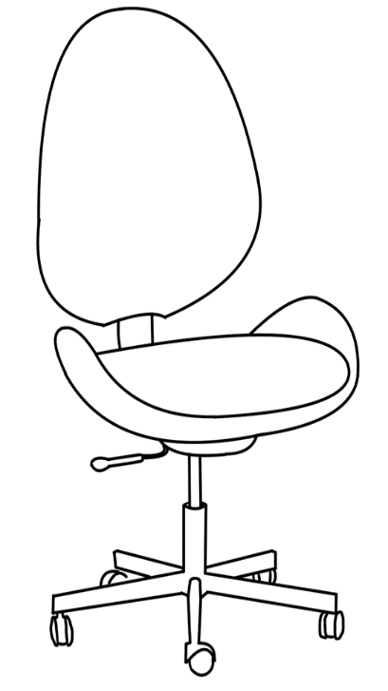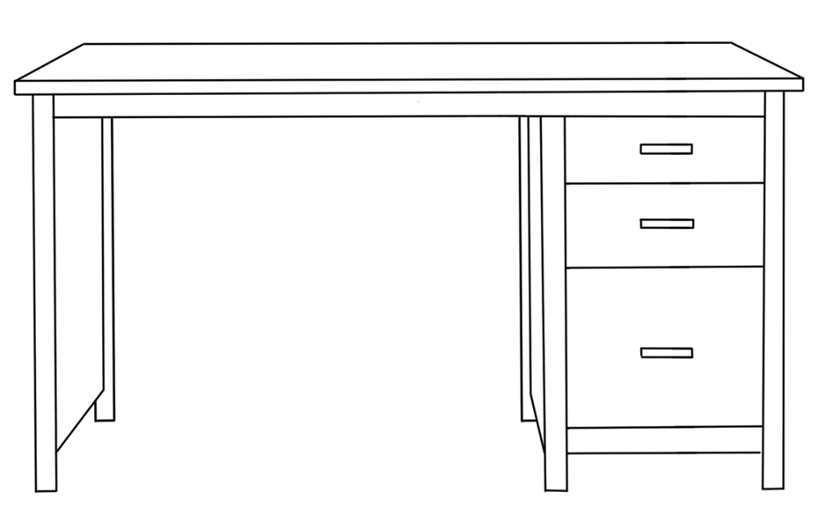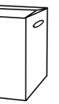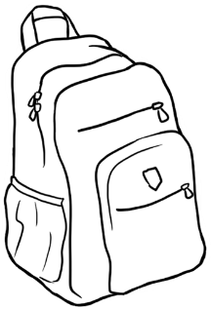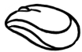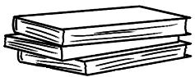

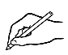

**Write**.

|  |  |  |  |  |
| --- | --- | --- | --- | --- |
| on **🗸** | in front of | in | behind |  |
| on | between | next to | next to | under |

1. The laptop is ___ on ___ the desk.
2. The books are ________________ the laptop.
3. The box is ______________ the desk.
4. The notebook is ____________ the desk.
5. The chair is ________________ the desk.
6. The backpack is __________________ the chair.
7. The ruler is _____ the backpack.
8. The USB is ____________ the mouse and the pen.
9. The phone is ______ the chair.

What’s **on** the desk?   
What is **on the left** and **on the right** of the laptop?

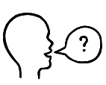

|  |  |  |
| --- | --- | --- |
| **on the left** |  | **on the right** |
| the mouse |  |
|  |  |
|  |



|  |  |  |
| --- | --- | --- |
| **Tick** yes or no.  **🗸** | **Yes** | **No** |
| 1. The books are **on** the chair. |  | **🗸** |
| 1. The mouse is **next to** the laptop. |  |  |
| 1. The mouse is **between** the USB and the laptop. |  |  |
| 1. The box is **in front of** the desk. |  |  |
| 1. The phone is **in** the backpack. |  |  |
| 1. The pen is **on the corner of** the desk. |  |  |
| 1. The books are **on the left of** the laptop. |  |  |
| 1. The mouse is **on the left of** the laptop. |  |  |

**Read**.

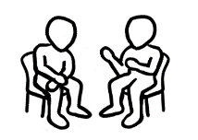**Work** with a partner.

It’s **next to** the desk **on the right**.

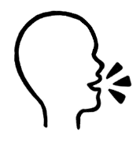**Ask**

Where’s the chair?

# Where is it?

The drawings from previous books can be used to revise and recycle the language for directions. Below are some examples.

|  |  |  |
| --- | --- | --- |
| C:\Users\v i c k y\Downloads\8.png |  |  |
| The family sit **on**  the couch **in front of** the TV. | The family walk **through** the park. | The receptionist sits **behind** the desk. |

|  |  |  |
| --- | --- | --- |
| C:\Users\v i c k y\Downloads\Book 2 Pic 5.png |  |  |
| Mai sits **in** the car **behind** Ming and Lan. | Fatima sits **next to** Mai. | Mai is **on the right**.  Fatima is **on the left**. |

|  |  |  |
| --- | --- | --- |
|  |  |  |
| He swims **through** the water. | Sahra is **on the left**. Nisha is **on the right**. | Baby Hani is **between** Sahra and Tahiil. |

# Where is it in the cupboard?

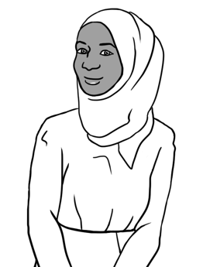

**This is Sahra’s cupboard.**

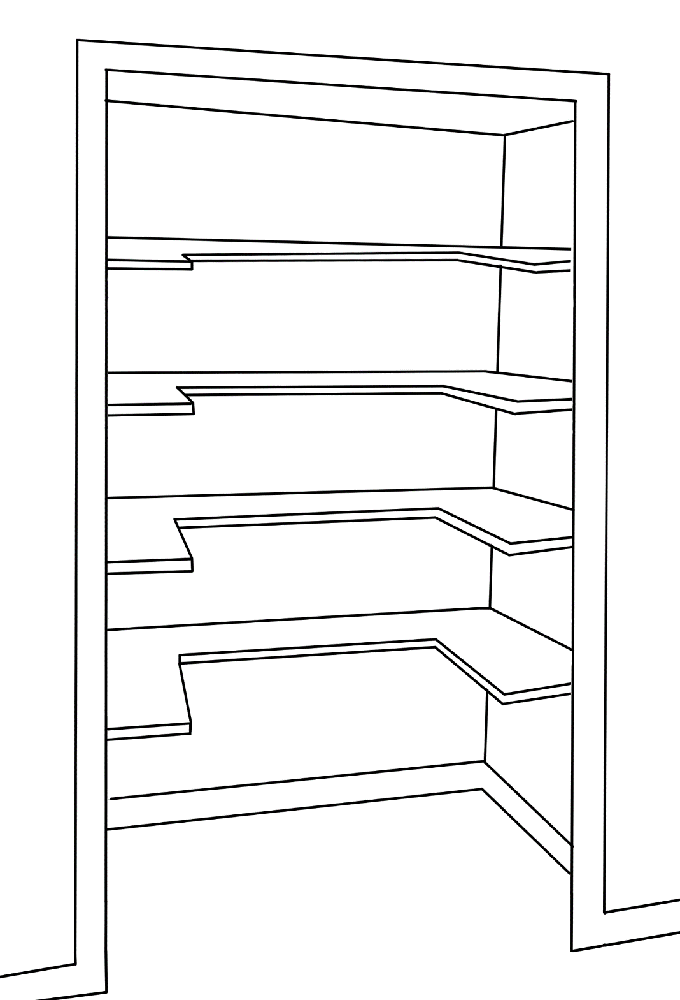

**the top shelf**

**the second shelf**

**the third shelf**

**the floor**

**the first shelf**

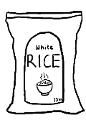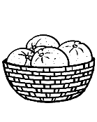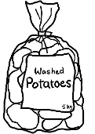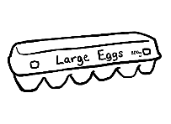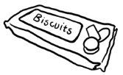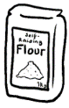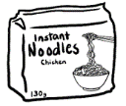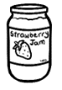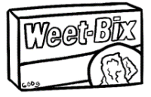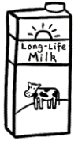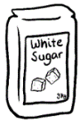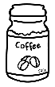

|  |  |  |
| --- | --- | --- |
| **Answers**  **1** | Yes | No |
| 1. The milk is on the top shelf. | **🗸** |  |
| 1. The eggs are on the first shelf. |  | **🗸** |
| 1. The oranges are on the first shelf. |  |  |
| 1. The coffee is next to the oranges. | **🗸**  **🗸** |  |
| 1. The jam is between the noodles and the biscuits. |  | **🗸** |
| 1. The rice is behind the potatoes. | **🗸**  **🗸** |  |
| 1. The sugar is on the third shelf. |  |  |
| 1. The noodles are on the top shelf. |  | **🗸** |

**Activity - Pair Work**

In this activity, students ask their partner to draw food in the pantry.   
Each student will need two worksheets:

* Give directions
* Follow directions

To avoid confusion, give only one worksheet at a time to each student:

**Worksheet 1**: Student A - Give directions  
 Student B – Follow directions

**Worksheet 2**: Student B - Give directions  
Student A – Follow directions

If this type of activity is new for the students, project Student A & B’s cupboards onto the whiteboard and explain what students need to do.



**the top shelf**

**the second shelf**

**the third shelf**

**the floor**

**the first shelf**



**Worksheet 1 Student A - Give directions.**

.

 **Give directions** to your partner.

1. The oranges are on the first shelf on the right.
2. The potatoes are on the floor under the oranges.
3. The noodles on the top shelf next to the sugar.
4. The jam is on the second shelf between the Weet-Bix   
   and the flour.
5. The milk is on the third shelf on the left.
6. The eggs are on first shelf next to the coffee.



**Check** your drawing with your partner.

Ask your teacher for Worksheet 2.

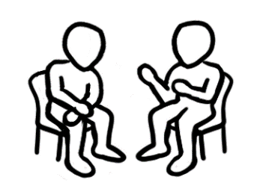

**Swap roles.**

**Worksheet 1 Student B -Follow directions.**



**the top shelf**

**the second shelf**

**the third shelf**

**the floor**

**the first shelf**

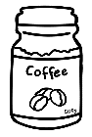

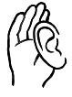

**Listen** to your partner. Follow the directions.

**Draw** this food in the cupboard.





**Check** your drawing with your partner.



***Swap roles****.*

Ask your teacher for Worksheet 2.

**Worksheet 2 Student B - Give directions.**



**the top shelf**

**the second shelf**

**the third shelf**

**the floor**

**the first shelf**

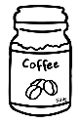

**Give directions** to your partner.

1. The rice is on the floor in the corner.
2. The oranges are on the second shelf on the right.
3. The flour is on the top shelf between the sugar and   
   the coffee.
4. The jam is on the third shelf on the left.
5. The Weet-Bix is on the first shelf next to the biscuits.
6. The milk is on the second shelf between the eggs and   
   the oranges.



**Check** your drawing with your partner.

**Worksheet 2 Student A - Follow directions.**



**the top shelf**

**the second shelf**

**the third shelf**

**the floor**

**the first shelf**

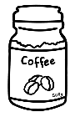



**Listen to** your partner.

**Draw** this food in the pantry.



 **Check** your drawing with your partner.

**Homework** - **My food cupboard**

**Look** in your food cupboard at home.

**Circle** the number of shelves in your cupboard.  
I have 1 2 3 4 5 6 shelves.

Where’s the food in your cupboard?



**Write.**



on the top shelf, on the second shelf, on the third shelf, on the bottom shelf, on the left, on the right, next to, between _________ and ____________

1. The flour is on the ___________ shelf.

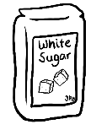

1. The sugar is __________________________________________.

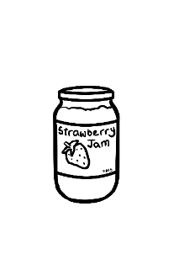

1. The jam is ___________________________________________.

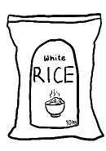

1. The rice is __________________________________________.

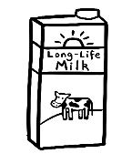

1. The milk is __________________________________________.

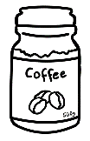

1. The coffee is ________________________________________.

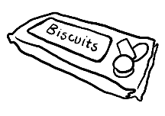

1. The biscuits are _____________________________________.

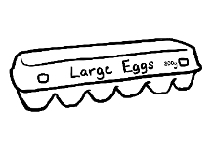

1. The eggs are ________________________________________.

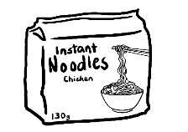

1. The noodles are ________________________________________.

# Where is it in the supermarket?

Pre - teach new vocabulary before students begin the worksheets in the student workbook. Words not previously covered are in greyed boxes on the plan below. An additional key word is ***aisle.***

**Complete plan of the supermarket**

**Checkout**

Beauty

Flour, Sugar

Sauces

Oil

Chocolate

Fruit

Vegetables

Specials

**Entry**

**Exit**

Cleaning

Milk

Frozen Food

Rice

Cereal

Tea

Drinks

Biscuits

Dried Fruit

Tinned Food

Meat

Toilet Paper

Deli

Health food

Eggs

Bread

Baby

**Checkout**

# Where’s my classroom?

Pre - teach new vocabulary by projecting the floor plan before students listen to the audio and complete the listening exercises in the student workbook.

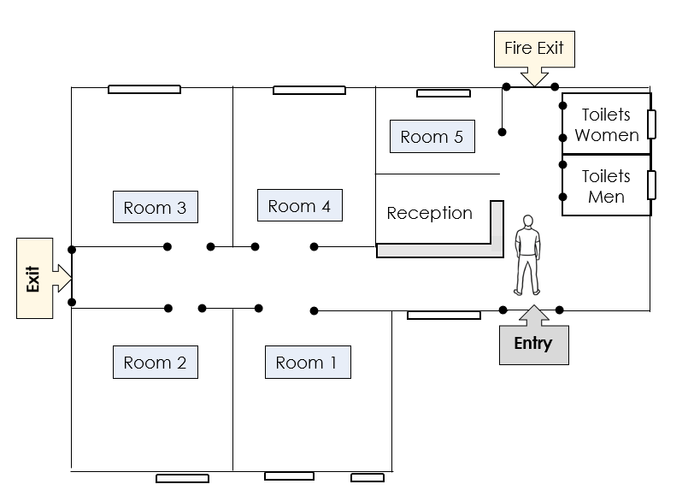

.

# Where’s the number?

|  |  |  |  |
| --- | --- | --- | --- |
| **first** | **second** | **third** | **last** |
| **on the left** | **on the right** | **next to** | **between** |

|  |  |  |  |  |  |  |  |  |  |
| --- | --- | --- | --- | --- | --- | --- | --- | --- | --- |
| **0** | **4** | **5** | **8** | **6** | **3** | **9** | **1** | **7** | **2** |



**Read** the numbers aloud.

**Write**.

1. The **third** number is ___5_____.
2. The **second** number is ________.
3. The **first** number is _________.
4. The number **on the left** of **8** is ________.
5. The number **on the right** of **8** is ________.
6. The numbers **next to** **9** are ________ and _________.
7. The numbers **between** 4 and 3 are _____, ____ and _____.
8. The **last** number is _______.

What’s the number on the right of _____?

What’s the number of the left of _____?

What numbers are next to ____?

What’s the number between ____ and ____?

**Work** with a partner.

**Directions game**

**Instructions**

1. Arrange the following objects around the room in positions which will help revise the vocabulary of location – in, on, under, in front of, behind, opposite, on the corner, next to, between.

* a stapler
* a laptop
* a mouse
* a ruler
* a box
* a ball
* a mirror
* scissors
* whiteboard markers
* a water bottle
* a coffee mug

1. Write the language of location on the board and revise if necessary.
2. Play the game in groups of 2 – 4 players. Each group will need counters and a dice.
3. Demonstrate how to play with one group of students.

**Where’s the laptop?**

**Where’s the stapler?**

**Where’s your bag?**

**Where’s your teacher?**

**Where’s your workbook?**

**Where’s the mouse?**

**Where’s the ruler?**

**Where are the scissors?**

**Where are the whiteboard markers?**

**Where’s the mirror?**

**Where’s the water bottle?**

**Where’s your phone?**

**Where’s the coffee mug?**

**Where’s your pen?**

## **Directions Game**

**Finish**

**Where’s the box?**

**Where’s the ball?**

**Start**

# Where’s the cafe?

**Listening activity**

Pre - teach new vocabulary before students begin the listening activity in the student workbook.

**Complete Map of Kellivale**

Petrol

Station



**North Street**

**Baker Road**

**Wattle Street**

**Kellivale**

**Park**

Swimming   
Pool

High School

Medical Centre

Soccer Ground

Childcare Centre

Supermarket

Cafe

**Kemp River**

Post Office

Fruit Shop

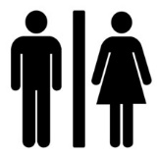

Primary School

Hardware Store

Hot Bread

Bank

Chemist



**Kemp Street**



Hospital

TAFE College

Community Centre

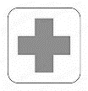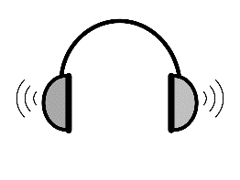

**4**

**Listen*.***

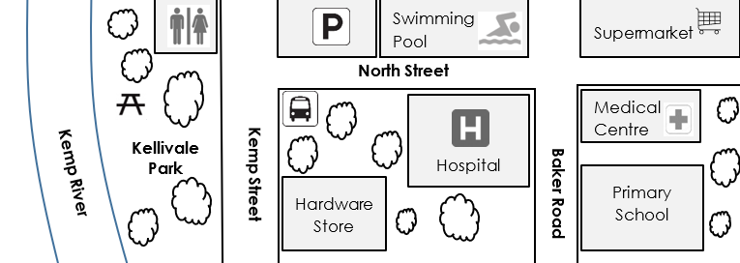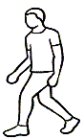

*Listen to the recording. Pause after each direction to give students time to circle the locations in their workbook*.



**5**

**Listen.**

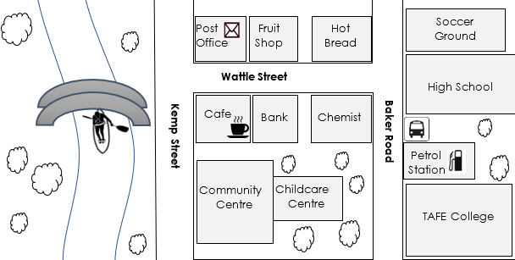

*Listen to the recording. Pause after each direction to give students time to circle the locations in their workbook.*

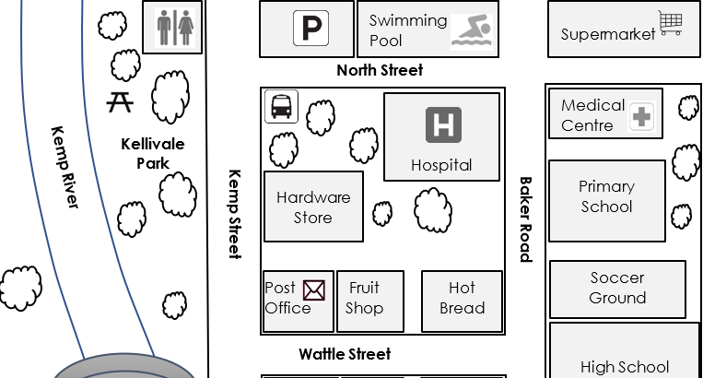

**Reading and understanding maps**

Some students are unfamiliar with reading and understanding the concept of maps. The following activity turns the classroom into a map, and in this way, may help such students.

**Instructions**

1. Turn the classroom into the map by organizing the desks and

chairs to form roads.

1. Use the labels on the following pages to label the tables with the names of the shops etc.
2. Label the roads. The layout is below.
3. Students work in pairs. They give and follow directions.

Remind students to keep to the left when moving around.

|  |
| --- |
| Post Office |
| Fruit Shop |
| Hot Bread |
| Hospital |
| Hardware |
| Bus Stop |
| Parking |
| Toilets |
| Parking |
| Swimming Pool |
| Supermarket |
| Medical Centre |
| Primary School |
| Soccer Ground |
| High School |

|  |
| --- |
| North Street |
| Baker Road |
| Wattle Street |
| Kemp Street |
| Kellivale Park |

**Role Play**

**Student A**



**Work with a partner**.



**Start**

**.**

Begin here



**Read** the directions to your partner.

1. Stand near the corner of Wattle Street and Kemp Street.  
   What shop is on the right? *Answer: The Post Office*

Go back to the start.

1. Walk straight ahead down Kemp Street.   
   Turn right into North Street.   
   What is next to the car park on the left?   
   *Answer: The Swimming Pool*

Go back to the start.

1. Turn right into Wattle Street.   
   Walk to Baker Road.

Turn left into Baker Road.

What is between the High School and the Primary School?   
*Answer: The Soccer Ground*

**Student B**



**Work with a partner**.



**Start**

**.**

Begin here



**Read** the directions to your partner.

1. Stand near the corner of Wattle Street and Baker Road.  
   What shop is on the left? *Answer: The Hot Bread*

Go back to the start.

1. Walk straight ahead down Baker Road.   
   Turn left into North Street.   
   What is the large building on the left?   
   *Answer: The Hospital*

Go back to the start.

1. Turn left into Wattle Street.  
   Walk straight ahead to Kemp Street.

Turn right into Kemp Street.   
What shop is opposite the park?   
*Answer: The Hardware Store*

# Where are you?

**Activity 1 – Giving directions in pairs**

1. Revise the places introduced in the student book and the language of location.
2. Students work in pairs with the worksheet on the next page.
3. Student A selects a location, but keeps this secret from Student B.
4. Student A gives directions to Student B using the language of location.
5. Student B guesses the location from the direction given.

**Activity 2 – Where are you in Australia?**

This is a class activity. Project the map and introduce the compass points. The worksheet can be later given to the students to complete. The activity can be extended to locations in your own town or city.

**Activity 1**



**Work** with a partner.

**Student A : Choose a place below**.

the teacher’s chair

the  
toilets

the  
 door

the teacher’s desk

the  
light switch

the  
whiteboard

the  
cupboard

the   
window

the next room

the next building

the reception desk

the back   
of the   
room

the   
garden

a tree

the car park



**Give directions** to your partner.

Walk **straight ahead** to the door.   
Turn **left**.

Go in the **next door on the left**. Where are you?





I’m **in** **the next room**.



**Swap roles.**

**Activity 2 Where do you live in Australia?**

**Write** the states and territories on the map.

|  |  |  |  |
| --- | --- | --- | --- |
| **WA** Western Australia **🗸** | **SA** South Australia | | **TAS** Tasmania |
| **VIC** Victoria | **NSW** New South Wales | | **QLD** Queensland |
| **NT** The Northern Territory | | **ACT**  The Australian Capital Territory | |

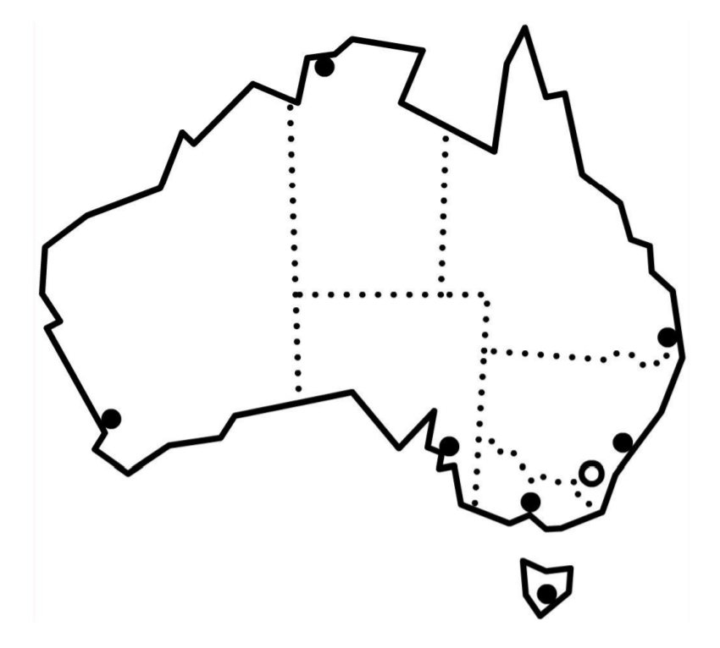

WA



**Colour** your state red.



**Read** with a partner.

1. Queensland is **north** of New South Wales.
2. Victoria is **south** of New South Wales.
3. Queensland is **east** of the Northern Territory.
4. New South Wales is **east** of South Australia.
5. Western Australia is **west** of the Northern Territory.

# Where are the maps on my phone?

**Phone maps**

The following activity has been included for more confident students and builds on the model in the student workbook. It will require modelling by projecting the steps in the activity on the whiteboard. The differences between Android and iPhones could be addressed by modelling both types of phones.

**Maps**

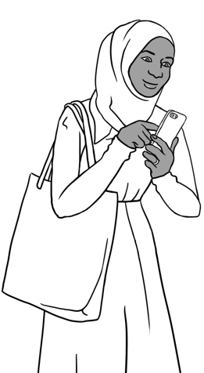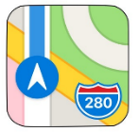

**Maps**

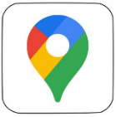

 Click on the **Maps** symbol on your phone.

**Work with a partner**.

**Ask**

What is the closest supermarket?



1. Type Woolworths, Coles or Aldi.
2. Click on the closest supermarket.



**Write**.   
The supermarket is ________________km away from here.

The supermarket is ________________min to drive there.

**Directions**

1. Click on
2. Click on or

**Go**

**Steps**



**Write** the first direction.

____________________________________________________________________________________________________________________________________

1. Click or X to go back.

|  |  |  |  |
| --- | --- | --- | --- |
| **Search for the closest:** | **How many km?** | Taxi outline**How many min to drive?** | Walk with solid fill**How many min to walk?** |
| 1. Petrol station |  |  |  |
| 1. Hospital |  |  |  |
| 1. Park |  |  |  |
| 1. Police station |  |  |  |
| 1. Train station |  |  |  |
| 1. Library |  |  |  |

**Work with a partner.**



The closest park is _____kilometres away.   
It’s about ____ minutes to drive.   
It’s about ____ minutes to walk.



The closest petrol station is _____kilometres away.   
It’s about ____ minutes to drive.   
It’s about ____ minutes to walk.

# Audio files and transcripts



**1**

**Sahra’s cupboard** [Student book - Section 4, Page 12]

 

**MP3 files**

|  |
| --- |
| **Transcript** |
| **1.** The milk is on the top shelf. |
| 1. The eggs are on the first shelf. |
| 1. The oranges are on the first shelf. |
| 1. The coffee is next to the oranges. |
| 1. The jam is between the noodles and the biscuits. |
| 1. The rice is behind the potatoes. |
| 1. The sugar is on the third shelf. |
| 1. The noodles are on the top shelf. |



**2**

**In the supermarket** [Student Book - Section 5, Page 14]

 

**MP3 files**

**Transcript**

**Conversation 1**

Shopper Excuse me. Where’s the meat?

Worker It’s straight ahead, at the end of Aisle 1.

**Conversation 2**

Shopper Hello. Where’s the rice?

Worker The rice is in Aisle 2. It’s on the left.

**Conversation 3**

Shopper Excuse me please. Where are the biscuits?

Worker The biscuits are in aisle 2 opposite the tinned food.

**Conversation 4**

Shopper Excuse me. Where are the eggs?

Worker The eggs are at the end of Aisle 2.



**3**

**The community centre** [Student Book - Section 6, Page 16]

 

**MP3 files**

**Transcript**

**Conversation 1**

|  |  |
| --- | --- |
| Student | Excuse me. Where’s my English class today? |
| Receptionist | Go left.  The English class is in the second room on the right. |
| Student | The second room? |
| Receptionist | Yes, the second room. |
| Student | Thank you. |

**Conversation 2**

|  |  |
| --- | --- |
| Student | Hello.  I have an appointment with the manager. |
| Receptionist | Go straight ahead.   The manager is in the room on the left.  The room is opposite the toilets. |
| Student | Thank you. |

**Conversation 3**

|  |  |
| --- | --- |
| Student | Excuse me please  Where’s my English class? |
| Receptionist | Go left.  It’s in the first room on the left. |
| Student | Oh yes. Thank you. |

**Conversation 4**

|  |  |
| --- | --- |
| Student | Excuse me.  Where’s the computer class? |
| Receptionist | Go left.  The computer class is the second room on the left. |
| Student | Thank you. |



**4**

**Where’s the café?** [Student Book - Section 8, Page 20]

 

**MP3 files**

**Transcript**

1. Walk through the park to Kemp Street.

What shop is opposite the park?

1. Walk to the bus stop.   
   What’s opposite the bus stop in North Street?
2. Walk down North Street.   
   What’s the big building on the right?
3. Walk down North Street.

What’s second on the left?

1. Walk straight ahead to the medical centre.

What’s next to the medical centre in Baker Road?



**5**

**Where’s the café?** – **second exercise**[Student Book - Section 8, Page 21]

**MP3 files**

 

**Transcript**

1. You are in the park. Walk over the bridge.

What shop is straight ahead?

1. Stand next to the café in Wattle Street.

What is next to the cafe?

1. What is on the corner opposite the cafe?
2. Walk down Kemp Street.

What is the large building next to the café?

1. Walk between the café and the Community Centre.

What is behind the Community Centre?

1. Walk to Baker Road.

What’s between the bus stop and the TAFE College?