

|  |
| --- |
| **English Ready**  **Course in EAL  VU22354 Recognise measurements in simple, highly familiar situations** |

**Teacher Resources**

**Design team:** Vicki Hambling, Sue Paull, Frida Dean, Janice Langley, Dhammika Fernando, Glenise Kleehammer and Mary Wallace

**Illustrations:** Madelena Scott

**Image acknowledgements:**Paper plane design, Microwave - [These Photo](https://tuxamito.com/wiki/index.php/Paper_Airplane)s by Unknown Author is licensed under [CC BY-SA](https://creativecommons.org/licenses/by-sa/3.0/)  
Paper plane flying - [This Photo](https://freepngimg.com/png/94059-angle-plane-paper-art-airplane-line) by Unknown Author is licensed under [CC BY-NC](https://creativecommons.org/licenses/by-nc/3.0/)  
Glass - [This Photo](http://livinganyway.blogspot.com/) by Unknown Author is licensed under [CC BY-SA-NC](https://creativecommons.org/licenses/by-nc-sa/3.0/)  
Tennis ball - [This Photo](http://www.undercoverwaitress.com/2011/08/please-bring-water.html) by Unknown Author is licensed under [CC BY-NC-ND](https://creativecommons.org/licenses/by-nc-nd/3.0/)

**Acknowledgements:** The design team would like to thank the AMEP service providers and practitioners who participated in the trial and gave valuable feedback. The team would also like to acknowledge the use of the EAL Framework which underpins the design of this book.

Copyright of the EAL Framework is reserved to the Crown in the right of the State of Victoria. © State of Victoria (Department of Education and Training) 2018.  
_________________________________________________________________________________________

This English Ready Resource is licensed under a Creative Commons Attribution-NoDerivs 3.0 Australia licence (More information is available [here](http://creativecommons.org/licenses/by-nd/3.0/au/)). You are free to use, copy and distribute to anyone in its original form as long as you attribute Department of Home Affairs as the author and you license any derivative work you make available under the same licence.  
  
© Commonwealth of Australia 2023

With the exception of the Commonwealth Coat of Arms, the department’s logo, any material protected by a trade mark and where otherwise noted all material presented in this document is provided under a Creative Commons Attribution 4.0 International (<https://creativecommons.org/licenses/by/4.0/>) licence.

The details of the relevant licence conditions are available on the Creative Commons website (accessible using the links provided) as is the full legal code for the CC BY 4.0 licence (<https://creativecommons.org/licenses/by/4.0/legalcode>).

Use of all or part of this document must include the following attribution:   
© Commonwealth of Australia 2023

As far as practicable, material for which the copyright is owned by a third party will be clearly labelled.  The department has made all reasonable efforts to ensure that this material has been reproduced in this document with the full consent of the copyright owners.

Copyright requests and enquiries concerning usage not addressed by the CC BY 4.0 licence should be addressed to:

[*comms@homeaffairs.gov.au*](mailto:comms@homeaffairs.gov.au) *at the Department of Home Affairs.*

The terms of use for the Commonwealth Coat of Arms are available from the [It's an Honour](http://www.itsanhonour.gov.au/) website.

Where a copyright owner, other than the Commonwealth, is identified with respect to this material, please contact that third party copyright owner directly to seek permission.

**Introduction**

**The Teacher Book**

This book is an electronic reference. Print pages as only needed. It includes materials and activities for:

* pair work and class work
* revision and homework
* pronunciation
* extension.

**The Student Workbook**

This book requires teacher direction and is **not** intendedfor independent learning. It is also not intended to be the only material used to teach these units. The activities included are not suitable to be used for assessment.   
The book is available as a Word document so that teachers can:

* localise and update the content
* adjust the material to suit the requirements of particular classes
* delete or add materials as required

**Table of Contents**

1. What’s the time? 5

2. What’s the date? 8

3. Is it hot or cold today? 11

4. Is Hani sick? 17

5. How tall are you? 20

6. How high and wide is it? 21

7. How long and wide is it? 23

8. How far is it? 24

9. How heavy is it? 29

10. How many litres? 31

11. How much flour? 32

12. Revision 36

# What’s the time?

Clock face

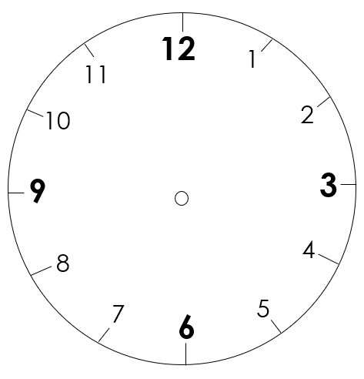

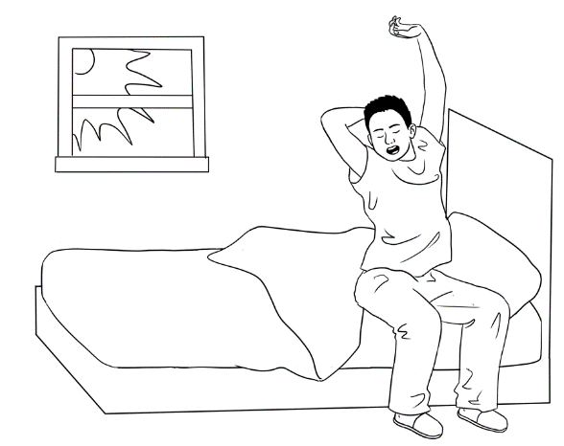**What time do you get up?**

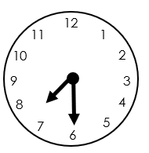

It’s Monday morning.

Bao gets up at **7:30.**

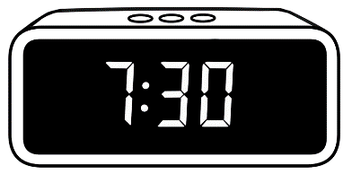

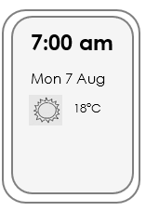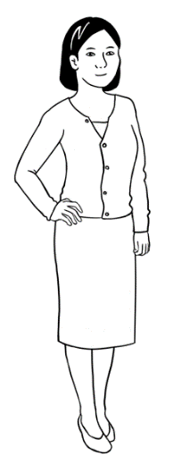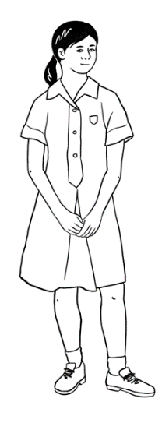

Mai and Lan get up at **7:00 am**.

**am** = morning



|  |  |  |  |  |  |  |  |  |
| --- | --- | --- | --- | --- | --- | --- | --- | --- |
| 5:00 | 5:30 | 6:00 | 6:30 | 7:00 | 7:30 | 8:00 | 8:30 | 9:00 |

**Circle** the times Bao, Mai and Lan get up.

**Circle** the time **you** get up.

**Read.**

Mai gets up **at the same time as** Lan.

They get up **before** Bao.

Bao gets up **after** Mai and Lan.

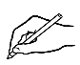

**Write.**

I get up at _________________ on Monday.

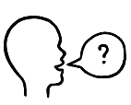I get up ________________________________________ Bao.

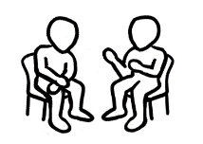before / after / at the same time as

What time do you get up on Monday?

**Ask** your partner.

My partner gets up at ______________on Monday.

My partner gets up ______________________________ me.  
before / after / at the same time as

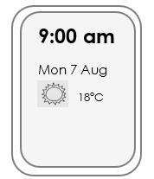**Class times**

**Write** the times**.**

I leave home at ___________am.

I start class at _____________ am.

I finish class at _____________ pm.

**pm** = afternoon

I get home at _____________ pm.

I am in class for __________ hours.

**hr** = hours

**min** = minutes

My lunchbreak is _______ minutes.

**Talk** to three classmates.

What time do you **leave** **home**?

**Ask**

What time do you **get** **home**?

|  |  |  |
| --- | --- | --- |
| Name | What time do you **leave home**? | What time do you **get home?** |
| Ahmed | 8 am | 3:30 pm |
|  |  |  |
|  |  |  |
|  |  |  |

  
**Read** with a partner.

Ahmed leaves home at 8 am.

Ahmed gets home at 3:30 pm.

**Write.**

My partner leaves home at ____________.

My partner gets home at ______________.

# What’s the date?

**Create a calendar.**

The template below is in the student workbook on page 12. Once students have added the name of the month and written the dates, mark in important events in that month. e.g.:

* Public holidays
* Special days - Harmony Day, International Women’s Day etc.
* Beginning of term, end of term
* Excursion dates
* Visitors – speakers, volunteers etc.
* Birthdays
* Work with other classes
* Important sporting events – AFL Grand Final, Olympics etc
* Using a different colour, students can mark their own important dates e.g. appointments

Use this calendar for different activities e.g.:

Ask questions: *What activities are planned for this month?*

*What day is the excursion? When is ________ birthday?* *What’s the first important date? The second?* etc.

Print a new calendar for the next month to paste in the back of student’s workbooks . Repeat the activity above for the new month.

|  |  |  |  |  |  |  |
| --- | --- | --- | --- | --- | --- | --- |
| **This month is ________________________.** | | | | | | |
| **Sun** | **Mon** | **Tues** | **Wed** | **Thurs** | **Fri** | **Sat** |
|  |  |  |  |  |  |  |
|  |  |  |  |  |  |  |
|  |  |  |  |  |  |  |
|  |  |  |  |  |  |  |
|  |  |  |  |  |  |  |

* …

**Ordinals Bingo**

* Give each student a calendar strip
* Ask students to circle **five** dates each.
* Randomly call out the days and dates, marking them on the master sheet. e.g. *Wednesday the fourth, Friday the thirteenth* etc.
* The first student to get all their circled dates called, shouts out **bingo.**

**Teacher Master Sheet**

|  |  |  |  |  |  |  |
| --- | --- | --- | --- | --- | --- | --- |
| **Sun** | **Mon** | **Tues** | **Wed** | **Thurs** | **Fri** | **Sat** |
| **1** | **2** | **3** | **4** | **5** | **6** | **7** |
| **8** | **9** | **10** | **11** | **12** | **13** | **14** |
| **15** | **16** | **17** | **18** | **19** | **20** | **21** |
| **22** | **23** | **24** | **25** | **26** | **27** | **28** |
| **29** | **30** | **31** |  |  |  |  |

|  |  |  |  |  |  |  |
| --- | --- | --- | --- | --- | --- | --- |
| **Sun** | **Mon** | **Tues** | **Wed** | **Thurs** | **Fri** | **Sat** |
| 1 | 2 | 3 | 4 | 5 | 6 | 7 |
| 8 | 9 | 10 | 11 | 12 | 13 | 14 |
| 15 | 16 | 17 | 18 | 19 | 20 | 21 |
| 22 | 23 | 24 | 25 | 26 | 27 | 28 |
| 29 | 30 | 31 |  |  |  |  |

**Student calendar strips** *[To cut up]*

|  |  |  |  |  |  |  |
| --- | --- | --- | --- | --- | --- | --- |
| **Sun** | **Mon** | **Tues** | **Wed** | **Thurs** | **Fri** | **Sat** |
| 1 | 2 | 3 | 4 | 5 | 6 | 7 |
| 8 | 9 | 10 | 11 | 12 | 13 | 14 |
| 15 | 16 | 17 | 18 | 19 | 20 | 21 |
| 22 | 23 | 24 | 25 | 26 | 27 | 28 |
| 29 | 30 | 31 |  |  |  |  |

- - - - - - - - - - - - - - - - - - - - - - - - - - - - - - - - - - - - - - - - - - - - - - - - - - - - - - - - - - -

|  |  |  |  |  |  |  |
| --- | --- | --- | --- | --- | --- | --- |
| **Sun** | **Mon** | **Tues** | **Wed** | **Thurs** | **Fri** | **Sat** |
| 1 | 2 | 3 | 4 | 5 | 6 | 7 |
| 8 | 9 | 10 | 11 | 12 | 13 | 14 |
| 15 | 16 | 17 | 18 | 19 | 20 | 21 |
| 22 | 23 | 24 | 25 | 26 | 27 | 28 |
| 29 | 30 | 31 |  |  |  |  |

- - - - - - - - - - - - - - - - - - - - - - - - - - - - - - - - - - - - - - - - - - - - - - - - - - - - - - - - - - -

|  |  |  |  |  |  |  |
| --- | --- | --- | --- | --- | --- | --- |
| **Sun** | **Mon** | **Tues** | **Wed** | **Thurs** | **Fri** | **Sat** |
| 1 | 2 | 3 | 4 | 5 | 6 | 7 |
| 8 | 9 | 10 | 11 | 12 | 13 | 14 |
| 15 | 16 | 17 | 18 | 19 | 20 | 21 |
| 22 | 23 | 24 | 25 | 26 | 27 | 28 |
| 29 | 30 | 31 |  |  |  |  |

- - - - - - - - - - - - - - - - - - - - - - - - - - - - - - - - -- - - - - - - - - - - - - - - - - - - - - - - - - - -

# Is it hot or cold today?

**Pair work – temperatures today and tomorrow**

This pair work activity gives students practice in:

* reading the temperature and times aloud
* listening to the temperature and times read aloud
* recording temperatures on a table.

Preparation:

Write up some temperatures and times on the whiteboard such as   
the ones below and practise reading them together, placing stress on the numbers:

*At* ***6*** *o’clock it’s* ***14*** *degrees.*

*At* ***9*** *o’clock it’s* ***19*** *degrees.*

*At* ***2*** *o’clock it’s* ***30*** *degrees.*

|  |  |  |
| --- | --- | --- |
| **6 am** | **9 am** | **2 pm** |
| **14°C** | **19°C** | **30°C** |
|  |  |  |

Activity

* Divide the class into pairs – Student A and Student B. Student A has today’s temperatures; Student B has tomorrow’s temperatures.
* Give each student a copy of their worksheet.
* Demonstrate how to do the exercise with a confident student.
* Encourage students to use polite forms to ask for repetition when they don’t understand. e.g. *Can you say that again please?* etc

**The temperature today**

**Student A**

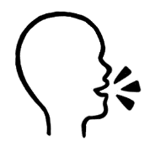

**Tell** your partner today’s temperatures.

At **7** o’clock it’s **13** degrees.

**Today’s temperatures**

**°**C= *degrees*

|  |  |  |  |  |
| --- | --- | --- | --- | --- |
| **Morning** | | **Afternoon** | | |
| **7 am** | **10 am** | **12 pm** | **2 pm** | **5 pm** |
| **13°C** | **21°C** | **28°C** | **33°C** | **37°C** |
| **cool** | **warm** | **hot** | **very hot** | **very hot** |

- - - - - - - - - - - - - - - - - - - - - - - - - - - - - - - - - - - - - - - - - - - - - - - - - - - - - - - - - - -

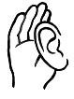**Listen** to your partner.

**Write** tomorrow’s temperatures.

**Tomorrow’s temperatures**

|  |  |  |  |  |
| --- | --- | --- | --- | --- |
| **Morning** | | **Afternoon** | | |
| **7am** | **10 am** | **12pm** | **2pm** | **5pm** |
|  |  |  |  |  |
| **cool** | **warm** | **hot** | **very hot** | **very hot** |

**Check** your work with your partner.

**The temperature tomorrow**

**Student B**



**Listen** to your partner.

**Write** today’s temperatures.

**°**C= *degrees*

**Today’s Temperatures**

|  |  |  |  |  |
| --- | --- | --- | --- | --- |
| **Morning** | | **Afternoon** | | |
| **7am** | **10 am** | **12pm** | **2pm** | **5pm** |
|  |  |  |  |  |
| **cool** | **warm** | **hot** | **very hot** | **very hot** |

- - - - - - - - - - - - - - - - - - - - - - - - - - - - - - - - - - - - - - - - - - - - - - - - - - - - - - - - - - -

 **Tell** your partner tomorrow’s temperatures.

At **7** o’clock it’s **16** degrees.

**Tomorrow’s temperatures**

|  |  |  |  |  |
| --- | --- | --- | --- | --- |
| **Morning** | | **Afternoon** | | |
| **7 am** | **10 am** | **12 pm** | **2 pm** | **5 pm** |
| **16°C** | **23°C** | **27°C** | **31°C** | **34°C** |
| **cool** | **warm** | **hot** | **very hot** | **very hot** |



**Check** your work with your partner.

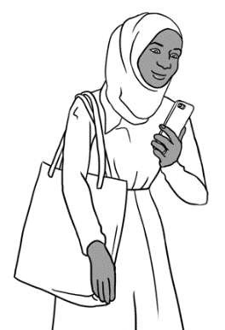

**Temperatures around Australia.**

Sahra checks the temperatures around Australia.

These are the temperatures.

|  |  |  |  |
| --- | --- | --- | --- |
| Adelaide  33**°**C **🗸** | Brisbane  29**°**C | Canberra  26**°**C | Darwin  37**°**C |
| Hobart  30**°**C | Melbourne  32**°**C | Perth  36**°**C | Sydney  26**°**C |

**Write** the temperatures on the map.

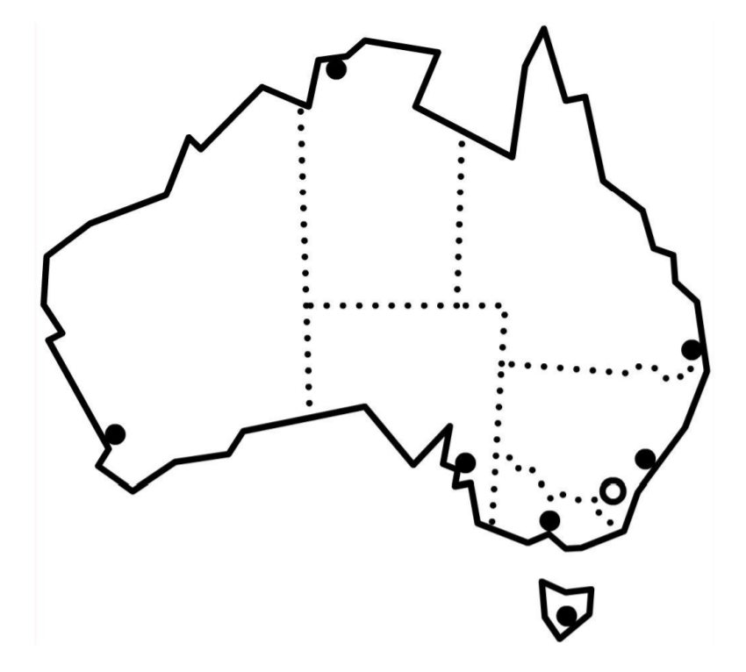

Sydney

Perth

Canberra

Adelaide

33**°**C

Melbourne

Hobart

Darwin

Brisbane

|  |  |  |
| --- | --- | --- |
| **🗸 Tick** yes or no. | **Yes** | **No** |
| 1. Sydney is hotter than Adelaide. |  | **🗸** |
| 1. Melbourne is hotter than Canberra. |  |  |
| 1. Brisbane is hotter than Hobart. |  |  |
| 1. Perth is hotter than Darwin. |  |  |

**Temperature Quiz**

**Work** with a partner.

**Circle** the temperature.

|  |  |
| --- | --- |
| **1**  Boiling water temperature is | 50**°**C 100**°**C 95**°**C |
| **2**  Ice temperature is | 10**°**C 5**°**C 0**°**C |
| **3**  A hot day temperature is | 10**°**C 20**°**C 30**°**C |
| **4**  Body temperature is | 30**°**C 37**°**C 45**°**C |
| **5**  Fridge temperature is | 14**°**C 9**°**C 4**°**C |
| **6**  A hot oven temperature is | 230**°**C 170**°**C 130**°**C |
| **7**  A cold classroom is | 20**°**C 10**°**C 30**°**C |



**Check** your answers with the teacher.

**Answer Sheet**

|  |  |
| --- | --- |
| **1**  Boiling water temperature is | 50**°**C 100**°**C 95**°**C |
| **2**  Ice temperature is | 10**°**C 5**°**C 0**°**C |
| **3**  A hot day temperature is | 10**°**C 20**°**C 30**°**C |
| **4**  Body temperature is | 30**°**C 37**°**C 45**°**C |
| **5**  Fridge temperature is | 14**°**C 9**°**C 4**°**C |
| **6**  A hot oven temperature is | 230**°**C 170**°**C 130**°**C |
| **7**  A cold classroom is | 20**°**C 10**°**C 30**°**C |

# 4. Is Hani sick?

**Activity 1 – Temperatures in Sahra’s family** [Student Workbook - P17]

Read the temperatures for the four days in Sahra’s family. Students record the temperatures on the table in their workbooks.

e.g: On **Monday**, Hani is sick.   
Hani has a temperature of **38** degrees.

Sahra has a temperature **37** degrees.

Tahiil has a temperature of **37** degrees.

On **Tuesday**,Sahra is sick.

Hani has a temperature of **37** degrees.

Sahra has a temperature **38** degrees.

Tahiil has a temperature of **37** degrees.

On **Wednesday**, Tahiil is sick.

Hani has a temperature of **37** degrees.

Sahra has a temperature **37** degrees.

Tahiil has a temperature of **38** degrees.

On **Thursday**, Tahiil is sick.

Hani has a temperature of **37** degrees.

Sahra has a temperature **37** degrees.

Tahiil has a temperature of **39** degrees.

|  |  |  |  |  |
| --- | --- | --- | --- | --- |
|  | **Mon** | **Tues** | **Wed** | **Thurs** |
| **Hani** | 38**°**C | 37**°**C | 37**°**C | 37**°**C |
| **Sahra** | 37**°**C | 38**°**C | 37**°**C | 37**°**C |
| **Tahiil** | 37**°**C | 37**°**C | 38**°**C | 39**°**C |

**Activity 2 - Body temperature**

If you have access to a modern thermometer, ask students to take each other’s temperatures.

* Take a reading on the forehead and then on the neck.   
  Are the readings the same or different?
* Make a record of the temperatures and the date taken.
* This exercise could be repeated the following day and   
  the two days’ results compared.

**Note**: The reading could vary if students have been outside on a cold day or   
in the sun.

**Activity 3 - Temperatures inside cars**

The worksheet on the following page is designed to warn students about how quickly the temperature inside cars can increase and endanger the lives of the people inside, even on days when the outside temperature is relatively mild. Especially at risk are children and the elderly. Adapt the worksheet to suit the times and temperatures of your locality.

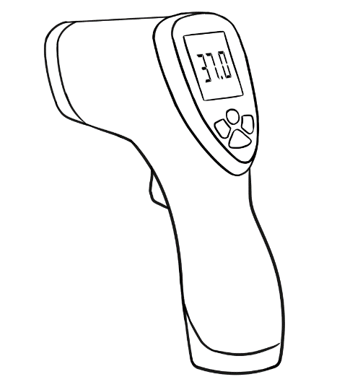

**Temperatures inside cars.**

|  |  |  |
| --- | --- | --- |
|  |  |  |
| **Time** | Temp **outside** the car | Temp **inside** the car |
| 1:00 pm | 21**°**C | 21**°**C |
| 1:30 pm | 21**°**C | 38**°**C |
| 2:00 pm | 21**°**C | 45**°**C |

**Colour** the thermometers to show the **car temperatures**.

O**C**

**-10**

**-5**

**0**

**10**

**15**

**20**

**25**

**30**

**35**

**40**

**45**

**50**

**55**

**5**

1:00 pm **21°**C

O**C**

**-10**

**-5**

**0**

**10**

**15**

**20**

**25**

**30**

**35**

**40**

**45**

**50**

**55**

**5**

1:30 pm **38°**C

O**C**

**-10**

**-5**

**0**

**10**

**15**

**20**

**25**

**30**

**35**

**40**

**45**

**50**

**55**

**5**

2:00 pm **45°**C

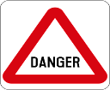 **Read.**

Cars get **very hot** inside.

It’s very dangerous to leave children inside cars.

# How tall are you?

**An introduction to measuring people’s height** [Workbook Pages 18 - 20]

1. **Introduce the vocabulary**

* Mime the meaning of the words *tall* and *short.* Invite two students to stand in front of the class. Write sentences with the students’ names on the board - *_______ is tall. _______ is short.*
* Introduce comparatives by using the students’ names –

_________ is taller than ___________.

_________ is shorter than _________.

* Ask students to arrange themselves in order of height.
* As they do this, use the language *taller than* and *shorter than* as much as possible to model the comparative.
* On the board write:

___________ is taller than ________________.

___________ is shorter than _______________.

* While standing in line ask each student to make up a sentence using taller than or shorter than and about the students around them.
* Write some of the students’ comparative sentences on the board.

1. **Introduce centimetres and metres**

Centimetres

* Each student will need a ruler. Ask students to:
* count the centimetres
* draw 3 lines - 5cm, 10cm and 15cm long
* mark in each centimetre on the 15 cm line.

Metres

* Ask a confident student to draw a 100 cm line on the board. Explain that 100 cm = 1 metre.
* Give each student a piece of string over a metre long. Students guess and mark a metre length on the string.
* In pairs, students check their guess with a tape measure and cut the string into a metre length.   
  [The string can be kept and used for other measuring activities.]

1. **Measuring tools**

Display a range of measuring tools – ruler, string, 2m tape, 10 metre tape, scales, thermometer etc and ask which tools students might use to measure height.

# How high and wide is it?

**An introduction to measuring vertical surfaces** [Workbook Page 21]

**Height inside the classroom**

1. **Introduce the vocabulary**

* Demonstrate by miming the meaning of the words *high*, *height* by referring to the whiteboard.e.g*.* *How* ***high*** *is the whiteboard?*   
  Measure how high, write it on the board, and say *This is the* ***height***.
* Invite students to guess the height and width of the door, window, whiteboard, wall etc. Write some of these estimates

on the board.

* Make some comparisons e.g. *The door is higher than the window*.

etc

1. **Introduce the measuring tools.**

* Display a range of measuring tools – ruler, string, 2m tape, 10 metre tape, scales, thermometer etc and ask which tool students might use to measure each of the objects.
* Increase the number of measuring tools by using string cut into metre or 5 metre lengths.

**Extension activity - Height outside the classroom**

Measure the height of objects outside the classroom.

* Customise the worksheet on the following page to include a number of things to measure that are relevant to your area.
* Organise students into pairs, and ask them to choose some measuring tools e.g. ruler, tape, string.
* When students have completed the task, write comparative sentences on the board. e.g. *The fence is higher than the gate. .* etc

**Measure height outside the classroom.**

**Work** with a partner.

|  |  |  |  |  |
| --- | --- | --- | --- | --- |
| **Measure** | **height**  cm / m | **🗸 Tick** the tool. | | |
|  |  |  |
| fence |  |  |  |  |
| gate |  |  |  |  |
| front door |  |  |  |  |
| step |  |  |  |  |
| garden bed |  |  |  |  |
| bench |  |  |  |  |
| table |  |  |  |  |
| bicycle |  |  |  |  |
| car |  |  |  |  |
|  |  |  |  |  |
|  |  |  |  |  |

# How long and wide is it?

**Measuring horizontal surfaces** [Workbook Page 22 - 23]

**An extension activity**

This activity involves measuring horizontal surfaces both inside and outside the class. The worksheet below needs to be customised to suit your classroom and surrounding area.



length

width

**Measure length and width**

 **Work** with a partner.

|  |  |  |  |  |  |
| --- | --- | --- | --- | --- | --- |
| **Measure** | **length**  cm / m | **width**  cm / m | **🗸 Tick** the tool. | | |
|  |  |  |
| workbook |  |  |  |  |  |
| notebook |  |  |  |  |  |
| table |  |  |  |  |  |
| floor |  |  |  |  |  |
| parking space |  |  |  |  |  |
| disabled parking space |  |  |  |  |  |
| garden bed |  |  |  |  |  |
|  |  |  |  |  |  |
|  |  |  |  |  |  |

# How far is it?

**Measure distance**

**Activity 1** - **Paper planes**

This activity follows up the work in the student workbook.

Making paper planes appeals to all ages and is an enjoyable way to practise measurement.

* Use the highly recommended paper plane design on the following page, one of your own or one suggested by a student.
* Using an A4 piece of paper, students make their paper planes and write their names on them. You may need to demonstrate this.
* Students work in groups of three.
* Go outside or to a place where the planes can be thrown.
* Students throw their planes, step out the distance of each plane’s flight and record it on their worksheet.
* Using a tape or 5m string, measure the flight more accurately and record the measurement in metres.

*NOTE:* *Increase the number of measuring tools, by creating 5 metre string measures, using sticky tape to mark each metre.*

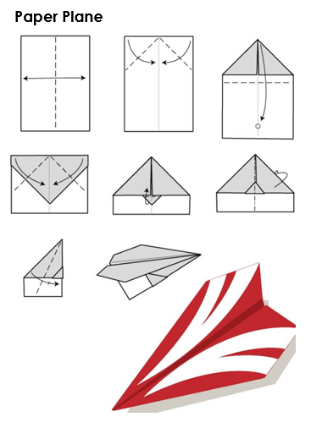

**Make a paper plane.**

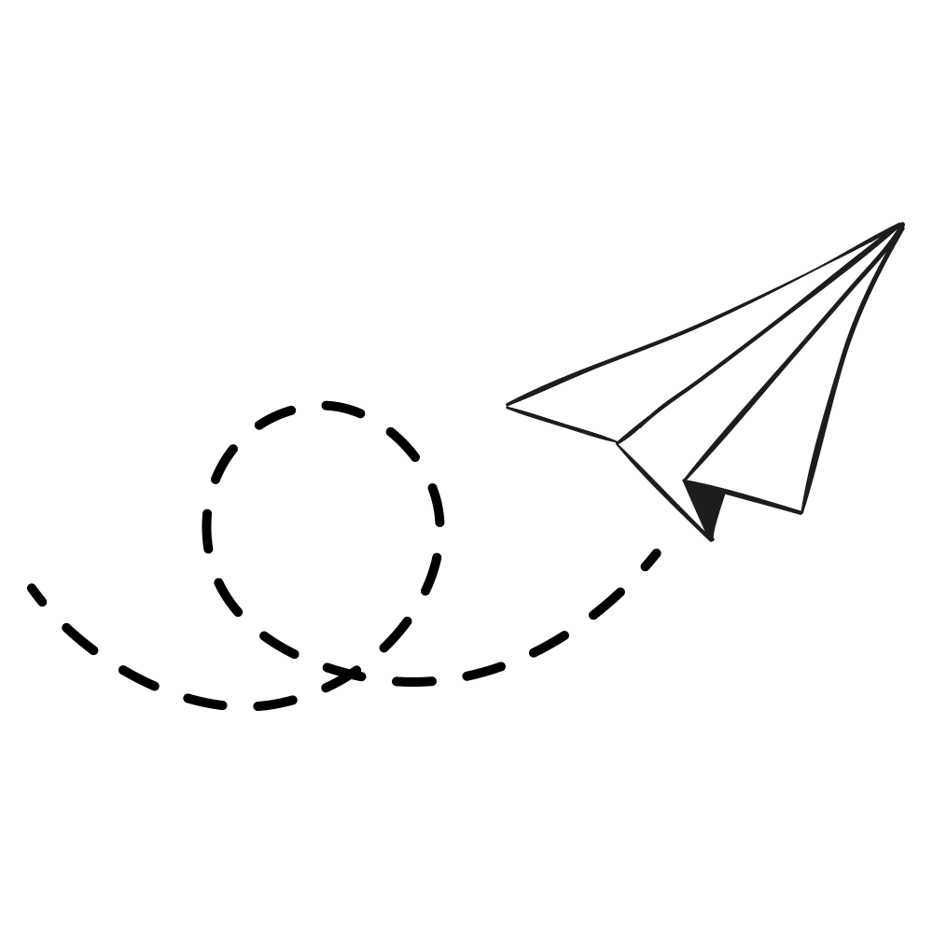****

**Work** with two students.

1. Throw your paper planes.
2. Measure how far in steps.

|  |  |  |
| --- | --- | --- |
| **Student names** | **Count the steps** | **Metres** |
|  |  |  |
|  |  |  |
|  |  |  |

1. Use a tape or string to measure in metres.

**Measure distance**

**Activity 2** - **Using Google Maps to estimate distance.***This activity could be completed independently by students who are digitally confident. The following activity is teacher directed.*

1. Project the map of Australia and ask students how far their city/town is from the nearest capital city. [Add your town to the map if it isn’t marked.] Discuss other distances in kilometres.
2. Open Google Maps and follow the steps Sahra takes to find the distance between:

* Taree and Sydney.
* Your town/ city and a nearby town/city.

1. Complete the activity about Nisha and her family on page 24.



Sydney

Brisbane

Canberra

Hobart

Melbourne

Adelaide

Perth

Darwin

 Taree

**How far is it?**



Sydney

Brisbane

Canberra

Hobart

Melbourne

Adelaide

Perth

Darwin

 Taree

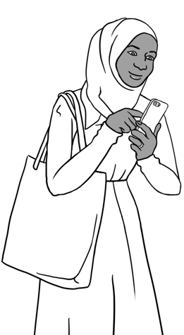

**Google  
Maps**



How **far** is Sydney from Taree?

Sahra checks on her phone. She has to:

1. Click on the **Google** **Maps** symbol

Sydney



1. Type **Sydney** in the search box.
2. Press the **search** icon.

**Directions**

1. Click on directions.

Choose start location

1. Type **Taree** in this box.
2. Press the **search** icon.
3. Click on the **car** icon.

Sydney is **313 km** from Taree.

Nisha lives near Taree in New South Wales.   
She wants to go to Brisbane with her children.

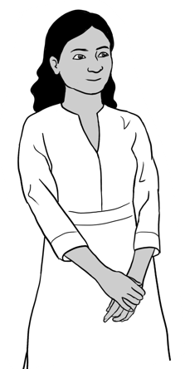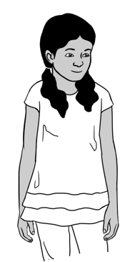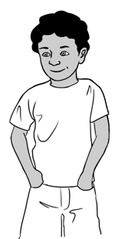

How **far** is Brisbane from Taree?

1. Click on the **Google Maps** symbol on your phone.

Brisbane



1. Type **Brisbane** in the search box.
2. Press

**Directions**

1. Click on directions.

Choose start location

1. Type **Taree** in this box.



1.  Press
2. Click on the **car** icon.

**Write** the number of kilometres.

Brisbane is ___________**km** from Taree.

_____________________ is **closer to** Taree.

Brisbane / Sydney

 **Work** with a partner.

|  |  |
| --- | --- |
| In the search box, **type**: | How many km  from Taree? |
| 1. Newcastle | __________ km |
| 1. Canberra | __________ km |

What is   
closer   
 to Taree?

**Tick** yes or no.

**🗸**

1. Newcastle is closer to Taree than Canberra. Yes No
2. Canberra is closer than Brisbane. Yes No
3. Newcastle is closer than Brisbane. Yes No

# How heavy is it?

**Weighing fruit and vegetables**

This could be a teacher demonstrated activity with help from students or a group activity depending on the number of scales available and objects to be weighed. Customize this worksheet and extend to suit the students and fruit and vegetables available.

Teach the vocabulary required.

**Preparation**

You will need:

* Kitchen scales
* Fruit and vegetables –more kilos than the number predicted on the worksheet.
* A worksheet for each student. [See the next page]

**Activity**

* Display the fruit and vegetables in the order on the worksheet.
* Ask students to guess how many of each item is needed to make the specified number of kilos.
* Students record their guess on the worksheet.
* Students can either come to the front to weigh the fruit and vegetables **or** work in small groups to weigh it.
* Students record the correct number on their worksheet.
* Create sentences using the data and write them on the board.

e.g. *There are 6 small bananas in a kilo.*

*There are 3 large potatoes in a kilo.*

* Read the sentences with the students

|  |  |  |  |  |
| --- | --- | --- | --- | --- |
|  | | **Question** | **Guess** | **Check** |
| **1** | onions | How many onions in 3 kilos? |  |  |
| **2** | potatoes | How many potatoes in 2 kilos? |  |  |
| **3** | lemons | How many lemons in 2 kilos? |  |  |
| **4** | apples | How many apples in 1 kilo? |  |  |
| **5** | bananas | How many bananas in 1 kilo? |  |  |
|  |  |  |  |  |
|  |  |  |  |  |

**Student worksheet**

# How many litres?

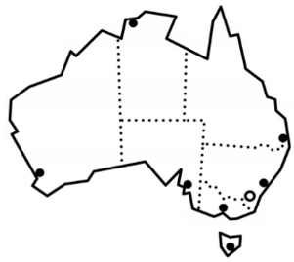

**How much** **water do you drink?**

**Read.**

Australia is a hot country.

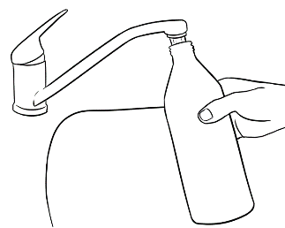On hot days, we need to   
drink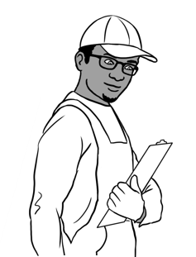 more water.

I get thirsty at work.

Tahiil fills his water bottle at home.

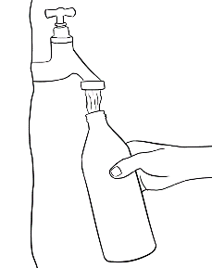He fills his water bottle at work.

He drinks more water on a hot day.

**Measure the water.**

|  |  |  |
| --- | --- | --- |
|  |  | [This Photo](http://narmo.milne-library.org/Sports-Water-Bottles-15224/for-Hot-&-Cold-Drinks-with-Coffee-Lid-&-Carrying-Sleeve-Pouch-32oz-Light-Green-SWIG-SAVVY-Stainless-Steel/) by Unknown Author is licensed under [CC BY](https://creativecommons.org/licenses/by/3.0/) |
| a glass | a mug | a water bottle |

 **Work** with a partner to measure the water.

**Write.**

1. There are ______ glasses of water in 2 litres.
2. There are ______ mugs of water in 2 litres.
3. There are ______ water bottles in 2 litres.

How much water do you drink on a hot day?

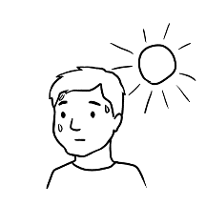

I drink _____ litres of water on a hot day.

I drink _________________ water than my partner.

more / less

# How much flour?

**Introduction to cooking**

Class cooking activities are very popular with EAL students. They give them an opportunity to:

* demonstrate and share their skills
* relax and communicate with each other on familiar ground
* develop measurement and other language skills in a pleasant and natural way.

Although cooking activities can present challenges for the teacher if there are no kitchen facilities available, the following activities can be completed very successfully in a classroom with minimum stress.

**Activity 1** - **Pikelets**

**Exercise on page 28 in the student workbook**

1. Slowly read the ingredients for the pikelets while students tick off each ingredient in their books.
2. Make the pikelets in class using an electric frypan, before completing the exercises in the student workbook. If you are unable to cook them in the class, make the pikelets at home and bring them to class. Ask students to taste them and guess the ingredients. You could then mime how you made them.

self-raising flour

sugar

bicarb soda

eggs

milk

dates

oranges

|  |  |  |  |  |
| --- | --- | --- | --- | --- |
| **Pikelets** | |  |  | |
| **Cooking tools** | | scales | electric frypan | |
|  | **tsp** | **tbsp** |  |  |
| bowl | teaspoon | tablespoon | grater | whisk |

|  |  |
| --- | --- |
| **Orange and date pikelets** *Makes 20 pikelets* | |
| **Ingredients** | **Method** |
| 2 eggs  125 ml milk  150 g self-raising flour  ½ tsp bicarb soda  70 g sugar  60 ml orange juice  1 tbsp grated orange rind  80 g chopped dates | 1. Mix eggs and milk in a bowl. 2. Add flour, bi-carb and sugar.  Mix together. 3. Add orange juice, rind and dates. Mix together. 4. Heat frypan and add a little oil. 5. Drop tablespoons of mixture   onto the pan. 6. Cook until bubbles show. 7. Turn and cook the other side. |

**Activity 2** – **Cake in a mug**

The recipe makes four muffin sized cakes if split between four mugs.

To make it more engaging, encourage students to add their own flavourings. The flavourings are stirred in just before cooking.

Some flavouring suggestions are:

* Choc chips or grated chocolate
* Mashed banana
* Grated apple
* Sultanas
* Slivered almonds
* Diced dates
* Diced apricots
* Grated lemon rind or orange rind

Choc and orange go well together as do banana and chocolate and apple and chocolate. Students can mix and match. The cakes need to be eaten straight away as they don’t keep very well. Each student will need a spoon.

* Recommendation: Test this recipe prior to doing it with the class as microwaves vary in the cooking time required.

|  |  |  |  |  |
| --- | --- | --- | --- | --- |
| **Cake in a mug** | | |  | |
| **Cooking tools** | | | microwave | |
|  | **tsp** | **tbsp** |  |  |
| bowl | manyteaspoons | tablespoon | 4 mugs | whisk |

|  |  |  |
| --- | --- | --- |
|  | 2 tbsp butter | 1. Put butter in a small bowl. 2. Microwave for 20-30 seconds until melted. 3. Stir in sugar, then the milk. 4. Add egg and whisk well  with a fork. 5. Add flour and whisk until smooth. 6. Butter 4 mugs. 7. Divide between the 4 mugs. 8. Add flavourings. 9. Cook each mug separately for 40 seconds. |
|  | 4 tbsp sugar |
|  | 2 tbsp milk |
|  | 1 large egg |
|  | 6 tbsp  self-raising flour |

**Note:** One tablespoon = 15 ml

# Revision

**Revision Activity**

This activity revises all the aspects of measurement covered in this unit and provides an opportunity to observe the students’ confidence and ability in the use of measurement tools.

Preparation

1. Match the words and pictures on the following two pages to revise the measuring tools. These can be printed on two pages and students can work in pairs to:

* point at a picture and then the matching word **or**
* cut up the pictures and words and match them.

1. Set up a number of measuring stations. Each station has one object to be measured. Give each station a number corresponding to the number on the worksheet.
2. There need to be more stations than pairs of students to avoid

students ‘hanging around waiting’.

1. Locate the measurement tools at the front of the room.

Activity

1. Each pair of students starts at a different station.
2. Students:

* read the task relevant to the station
* decide what tool they need to use to measure the object.
* select the relevant tool from the front of the room
* return to the station to complete the task and record the result on their worksheet.
* return the tool to the front of the room.
* move on to another station.

1. At the end of the activity, elicit answers to the questions for each station.

IMPORTANT: Change this activity to suit the tools available at your

site. Alter the worksheet to suit your conditions.

**Vocabulary matching**

|  |  |  |
| --- | --- | --- |
|  |  |  |
|  |  |  |
|  |  |  |
|  |  |  |
|  |  |  |

|  |  |  |
| --- | --- | --- |
| phone | ruler | kitchen scales |
| tape measure | teaspoon | bucket |
| digital clock | tablespoon | string |
| bathroom scales | air  thermometer | calendar |
| clock | body thermometer | measuring jug |

**Student Worksheet**

| **Station** | | **Question** | **Tool Used** | **Answer** |
| --- | --- | --- | --- | --- |
| **1** |  | What’s the date today? |  |  |
| **2** |  | What do the potatoes weigh? |  |  |
| **3** |  | How many oranges in one kilo? |  |  |
| **4** |  | What does the key weigh? |  |  |
| **5** |  | How long is the teacher’s table? |  |  |
| **6** |  | How many litres are in the small bucket? |  |  |
| **7** |  | What is the inside temperature today? |  |  |
| **8** |  | What does the tennis ball weigh? |  |  |
| **9** |  | How much water is in the glass? |  |  |
| **10** | Shopping bag outline | What does the shopping bag weigh? |  |  |
| **11** |  | What does the water bottle weigh? |  |  |
| **12** |  | How long are the scissors? |  |  |