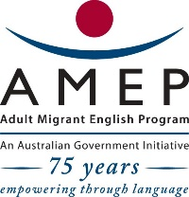

|  |
| --- |
| **English Ready**  **Course in EAL  VU22355 Recognise shape and design in simple, highly familiar situations** |

**Teacher Resources**

**Design team:** Vicki Hambling, Sue Paull, Frida Dean, Janice Langley, Dhammika Fernando, Glenise Kleehammer and Mary Wallace

**Illustrations:** Madelena Scott

**Acknowledgements:** The design team would like to thank the AMEP service providers and practitioners who participated in the trial and gave valuable feedback. The team would also like to acknowledge the use of the EAL Framework which underpins the design of this book.

Copyright of the EAL Framework is reserved to the Crown in the right of the State of Victoria. © State of Victoria (Department of Education and Training) 2018.  
_________________________________________________________________________________________

This English Ready Resource is licensed under a Creative Commons Attribution-NoDerivs 3.0 Australia licence (More information is available [here](http://creativecommons.org/licenses/by-nd/3.0/au/)). You are free to use, copy and distribute to anyone in its original form as long as you attribute Department of Home Affairs as the author and you license any derivative work you make available under the same licence.  
  
© Commonwealth of Australia 2023

With the exception of the Commonwealth Coat of Arms, the department’s logo, any material protected by a trade mark and where otherwise noted all material presented in this document is provided under a Creative Commons Attribution 4.0 International (<https://creativecommons.org/licenses/by/4.0/>) licence.

The details of the relevant licence conditions are available on the Creative Commons website (accessible using the links provided) as is the full legal code for the CC BY 4.0 licence (<https://creativecommons.org/licenses/by/4.0/legalcode>).

Use of all or part of this document must include the following attribution:   
© Commonwealth of Australia 2023

As far as practicable, material for which the copyright is owned by a third party will be clearly labelled.  The department has made all reasonable efforts to ensure that this material has been reproduced in this document with the full consent of the copyright owners.

Copyright requests and enquiries concerning usage not addressed by the CC BY 4.0 licence should be addressed to:

[*comms@homeaffairs.gov.au*](mailto:comms@homeaffairs.gov.au) *at the Department of Home Affairs.*

The terms of use for the Commonwealth Coat of Arms are available from the [It's an Honour](http://www.itsanhonour.gov.au/) website.

Where a copyright owner, other than the Commonwealth, is identified with respect to this material, please contact that third party copyright owner directly to seek permission.

**Introduction**

**The Teacher Book**

This book is an electronic reference. Print pages as only needed. It includes materials and activities for:

* pair work and class work
* revision and homework
* pronunciation
* extension.

**The Student Workbook**

This book requires teacher direction and is **not** intendedfor independent learning. It is also not intended to be the only material used to teach these units. The activities included are not suitable to be used for assessment.   
The book is available as a Word document so that teachers can:

* localise and update the content
* adjust the material to suit the requirements of particular classes
* delete or add materials as required

**Table of Contents**

1. What shape is that? 5

2. What colour is that? 6

3. How many shapes? 12

4. Are the lines straight or curved? 14

5. Are the sides long or short? 16

6. Are the shapes big or small? 17

7. Are the lines thick or thin? 18

8. Cut it in half. 19

9. What shapes are in the classroom? 21

10. What shape are the road signs? 22

# What shape is that?

**Activity – Use body language to make shapes**

Teacher demonstrates how to use fingers, arms or mouth to make shapes.

Students work in small groups:

1. One student mimes a shape and the group guesses the shape. Every student needs to mime a shape.
2. On their second turn, students take turns to mime a shape and spell the name. The group check the spelling from their workbooks.

**Additional shapes**

A limited number of 2D shapes are essential for this unit, but other shapes in *familiar situations* could be introduced:

* Oval [Footy oval]
* Star [on the Australian flag]
* Hexagon [Stop sign]

**2D or 3D**

Distinguishing between 2D and 3D is also **not** part of the unit. However, comparing 2D and 3D shapes heightens students understanding of the characteristics of each shape. For some students, particularly those familiar with 3D movies, it might be of interest. The difference between the two can be demonstrated with a piece of paper and a box:

* The paper has ‘two dimensions’ – length and width
* The box has ‘three dimensions’ - length, width and depth.

# What colour is that?

**Activity 1 - Pair work**

* Students colour the shapes on their worksheet
* They then work in pairs.
* Student A asks a question and before beginning to draw, answers Students B’s question. In this way, both can be drawing and colouring   
  at the same time.

**Student A**

**Colour** the shapes different colours.

________________________________________________________

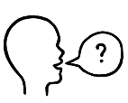

What is in **E1**?

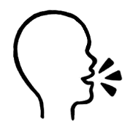**Ask** your partner

It’s a red triangle.

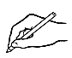

**Draw** it.

**Colour** it.

|  |  |  |  |  |  |  |
| --- | --- | --- | --- | --- | --- | --- |
|  | **A** | **E** | **I** | **O** | | **U** |
| **1** |  |  |  | |  |  |
| **2** |  |  |  | |  |  |
| **3** |  |  |  | |  |  |
| **4** |  |  |  | |  |  |

**Student B**

**Colour** the shapes different colours.

______________________________________________________________



What is in **A1**?

**Ask** your partner

It’s a green circle.



**Draw** it.

**Colour** it.

|  |  |  |  |  |  |
| --- | --- | --- | --- | --- | --- |
|  | **A** | **E** | **I** | **O** | **U** |
| **1** |  |  |  |  |  |
| **2** |  |  |  |  |  |
| **3** |  |  |  |  |  |
| **4** |  |  |  |  |  |

**Tessellations –squares, rectangles, triangles and circles**

Students can be given a choice of tessellation templates which can be enlarged or reduced in size. Show examples of tessellations online to guide and inspire students in the use of colour. Once the tessellations have been completed, students can compare their work with others and discuss the colours used.

**Squares**

|  |  |  |  |  |  |  |  |  |  |
| --- | --- | --- | --- | --- | --- | --- | --- | --- | --- |
|  |  |  |  |  |  |  |  |  |  |
|  |  |  |  |  |  |  |  |  |  |
|  |  |  |  |  |  |  |  |  |  |
|  |  |  |  |  |  |  |  |  |  |
|  |  |  |  |  |  |  |  |  |  |
|  |  |  |  |  |  |  |  |  |  |
|  |  |  |  |  |  |  |  |  |  |
|  |  |  |  |  |  |  |  |  |  |
|  |  |  |  |  |  |  |  |  |  |
|  |  |  |  |  |  |  |  |  |  |

**Rectangles**

|  |  |  |  |  |  |  |  |  |  |  |
| --- | --- | --- | --- | --- | --- | --- | --- | --- | --- | --- |
|  |  |  |  |  | | | | | |  |
|  | | | | | |
|  | | | | | |
|  | |  | |  |  |  | | |  |
|  | |  | |  | | |
|  | |  | |  | | |  |
|  | | | |  | | |
|  | |  | |  | | |
|  | | | | |  | |  | |
|  | | | | |  | | |  | |

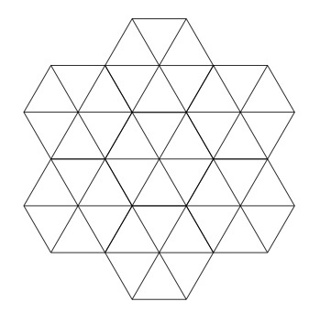**Triangles**

**Triangles**

|  |  |  |  |  |  |  |  |  |  |  |  |  |
| --- | --- | --- | --- | --- | --- | --- | --- | --- | --- | --- | --- | --- |
|  |  |  |  |  |  |  |  | | | | | |
|  |  |  |  |  |  |  |  | | | | | |
|  |  |  |  |  |  |  |  | | | | | |
|  | | |  | | | |  |  |  |  |  |  |
|  | | |  | | | |  |  |  |  |  |  |
|  | | |  | | | |  |  |  |  |  |  |

**Triangles and squares in a circle**

# How many shapes?

**Optical illusions – for counting and colouring**

How many squares?

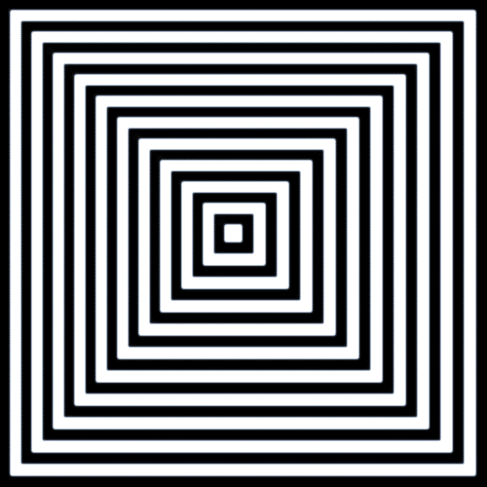

How many triangles?



How many triangles?

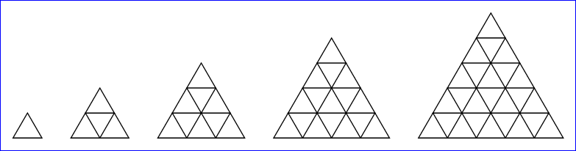

**A**

**B**

**C**

**D**

**E**

How many rectangles?

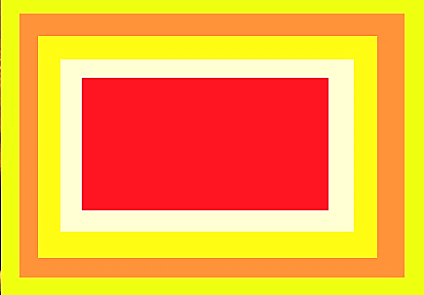

# Are the lines straight or curved?

Project the following images and ask questions.

The meaning of the road signs could be demonstrated with a combination of body language and drawings on the whiteboard.

**Are the arrows straight or curved**?

|  |  |
| --- | --- |
|  |  |
|  |  |
|  |  |

|  |  |
| --- | --- |
| 1. Icon     Description automatically generated | 1. A yellow triangle sign     Description automatically generated with low confidence |
| 1. Text, logo     Description automatically generated with medium confidence | 1. A yellow sign with a black arrow     Description automatically generated with low confidence |
| 1. A picture containing text, sign, outdoor, right     Description automatically generated | 1. Shape, icon     Description automatically generated |

# Are the sides long or short?

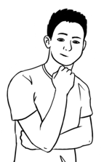

Rectangles have two **long** sides and two **short** sides.



The long sides of the white rectangle are **longer** **than**   
the long sides of the grey rectangle.

**Draw** rectangles with a ruler.



Make the long sides **longer than** the long sides   
in the grey rectangles.

# Are the shapes big or small?

**Create big and small squares**

Project the grid and demonstrate how different size squares can be created making sure that all the sides are of equal length. Two squares have been drawn to demonstrate.

How many big and small squares can you make?

Use a ruler to make straight lines.

|  |  |  |  |  |  |  |  |  |  |
| --- | --- | --- | --- | --- | --- | --- | --- | --- | --- |
|  |  |  |  |  |  |  |  |  |  |
|  |  |  |  |  |  |  |  |  |  |
|  |  |  |  |  |  |  |  |  |  |
|  |  |  |  |  |  |  |  |  |  |
|  |  |  |  |  |  |  |  |  |  |
|  |  |  |  |  |  |  |  |  |  |
|  |  |  |  |  |  |  |  |  |  |
|  |  |  |  |  |  |  |  |  |  |
|  |  |  |  |  |  |  |  |  |  |
|  |  |  |  |  |  |  |  |  |  |

# Are the lines thick or thin?

**Follow up the exercise in the workbook.**

Project the road signs below and compare the signs in pairs. e.g. Signs 1 & 2

Ask:

* What shape is sign 1? What shape is sign 2?
* Which sign has thinner/thicker lines?

e.g. The rectangle has thinner lines than the circle.   
The circle has thicker lines than the rectangle.

|  |  |
| --- | --- |
| 1. Shape     Description automatically generated with low confidence |  |
|  | 1. A red and white sign     Description automatically generated with medium confidence |
| 1. Icon     Description automatically generated |  |
| 1. A picture containing text, sign, clipart     Description automatically generated |  |
|  | 1. Icon     Description automatically generated |
| 1. A picture containing text, clipart     Description automatically generated | 1. A picture containing text, clipart     Description automatically generated |

# Cut it in half.

**Activity - Cutting in half**

This is a teacher led activity. Students follow instructions and join halfway points in their workbook. They will need a ruler and a pencil. Instruct students to:

1. Draw a line from the start button to the half sandwich.   
   Ask ‘What shapes can you see? How many? Are they the same size or different?’
2. Draw a line from the half orange to the clock.   
   Ask ‘What shapes can you see? How many? Are they the same size or different?’
3. Draw a line from the half pizza to the pause button.  
   Ask ‘What shapes can you see? How many? Are they the same size or different?’
4. Ask students to colour the shapes e.g. *Colour two smaller triangles blue. Colour two smaller triangles red. Colour the two smaller squares yellow.*

**Student grid**

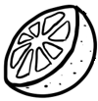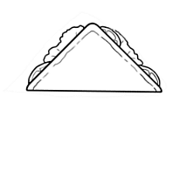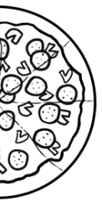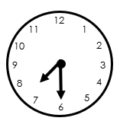

|  |  |  |  |  |  |  |  |  |  |  |  |
| --- | --- | --- | --- | --- | --- | --- | --- | --- | --- | --- | --- |
|  |  |  |  |  |  |  |  |  |  |  |  |
|  |  |  |  |  |  |  |  |  |  |  |  |
|  |  |  |  |  |  |  |  |  |  |  |  |
|  |  |  |  |  |  |  |  |  |  |  |  |
|  |  |  |  |  |  |  |  |  |  |  |  |
|  |  |  |  |  |  |  |  |  |  |  |  |
|  |  |  |  |  |  |  |  |  |  |  |  |
|  |  |  |  |  |  |  |  |  |  |  |  |
|  |  |  |  |  |  |  |  |  |  |  |  |
|  |  |  |  |  |  |  |  |  |  |  |  |
|  |  |  |  |  |  |  |  |  |  |  |  |
|  |  |  |  |  |  |  |  |  |  |  |  |

**Teacher model**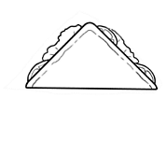

|  |  |  |  |  |  |  |  |  |  |  |  |
| --- | --- | --- | --- | --- | --- | --- | --- | --- | --- | --- | --- |
|  |  |  |  |  |  |  | **2** |  |  |  |  |
| **3** |  |  |  |  |  |  |  |  |  |  |  |
|  |  |  |  |  |  |  |  |  |  |  |  |
|  |  |  |  |  |  |  |  |  |  |  |  |
| **1** |  |  |  |  |  |  |  |  |  |  |  |
|  |  |  |  |  |  |  |  |  |  |  |  |
|  |  |  |  |  |  |  |  |  |  |  |  |
|  |  |  |  |  |  |  |  |  |  |  |  |
|  |  |  |  |  |  |  |  |  |  |  |  |
|  |  |  |  |  |  |  |  |  |  |  |  |
|  |  |  |  |  |  |  |  |  |  |  |  |
|  |  |  |  |  |  |  |  |  |  |  |  |

# What shapes are in the classroom?

**Activity - Shapes outside the classroom.**

* Revise shapes by looking around the classroom.
* Organise students into groups of three.
* Ask students to take their phones outside and look for shapes   
  in the area near their classroom.
* Set a time limit e.g. 15 minutes [one student in each group could be responsible for keeping time]
* One student in each group takes photos of different shapes outside the room. e.g., signs, buildings, posters, outside furniture
* When students return to the class, they count the number of shapes they have photographed.
* Each group tells the class the number and types of shapes they found.
* The number and types of shapes could be recorded on a table similar to the one below on the whiteboard. Each group of students or the teacher could write the number of shapes found.

|  |  |  |  |
| --- | --- | --- | --- |
|  |  |  |  |
|  |  |  |  |

# What shape are the road signs?



What shapes are the road signs?

**Match** the shapes.

**Write** the shapes.

circle square rectangle triangle

|  |  |
| --- | --- |
| This Photo by Unknown Author is licensed under CC BY-SA | ____________ |
|  | ______________ |
|  | _____________________ |
|  | _____________ |

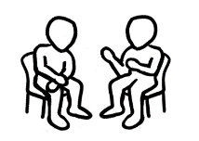

**Work** with a partner.

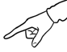**Point to** a road sign.

**Tell** your partner about the **shape**, **colour** and **sides.**

This road sign is a **rectangle**.

It’s **black** and **white**.

It has two **long sides** and two **short sides**.

