

|  |
| --- |
| **English Ready**  **Course in EAL  VU22584 Develop language learning objectives with support** |

**Teacher Resources**

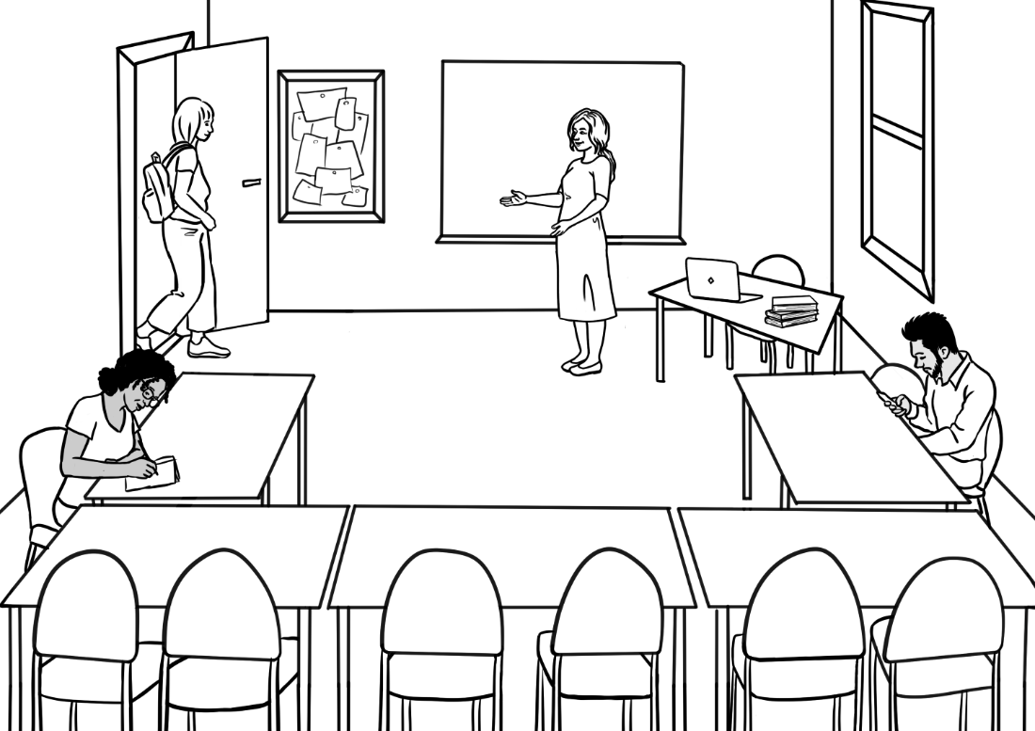

**Design team:** Vicki Hambling, Sue Paull, Frida Dean, Janice Langley, Glenise Kleehammer and Mary Wallace

**Illustrations:** Madelena Scott

**Acknowledgements:** The design team would like to thank the AMEP service providers and practitioners who participated in the trial and gave valuable feedback. The team would also like to acknowledge the use of the EAL Framework which underpins the design of this book.

Copyright of the EAL Framework is reserved to the Crown in the right of the State of Victoria. © State of Victoria (Department of Education and Training) 2018.  
_________________________________________________________________________________________

This English Ready Resource is licensed under a Creative Commons Attribution-NoDerivs 3.0 Australia licence (More information is available [here](http://creativecommons.org/licenses/by-nd/3.0/au/)). You are free to use, copy and distribute to anyone in its original form as long as you attribute Department of Home Affairs as the author and you license any derivative work you make available under the same licence.  
  
© Commonwealth of Australia 2023

With the exception of the Commonwealth Coat of Arms, the department’s logo, any material protected by a trade mark and where otherwise noted all material presented in this document is provided under a Creative Commons Attribution 4.0 International (<https://creativecommons.org/licenses/by/4.0/>) licence.

The details of the relevant licence conditions are available on the Creative Commons website (accessible using the links provided) as is the full legal code for the CC BY 4.0 licence (<https://creativecommons.org/licenses/by/4.0/legalcode>).

Use of all or part of this document must include the following attribution:   
© Commonwealth of Australia 2023

As far as practicable, material for which the copyright is owned by a third party will be clearly labelled.  The department has made all reasonable efforts to ensure that this material has been reproduced in this document with the full consent of the copyright owners.

Copyright requests and enquiries concerning usage not addressed by the CC BY 4.0 licence should be addressed to:

[*comms@homeaffairs.gov.au*](mailto:comms@homeaffairs.gov.au) *at the Department of Home Affairs.*

The terms of use for the Commonwealth Coat of Arms are available from the [It's an Honour](http://www.itsanhonour.gov.au/) website.

Where a copyright owner, other than the Commonwealth, is identified with respect to this material, please contact that third party copyright owner directly to seek permission.

**Introduction**

**The Teacher Book**

This book is an electronic reference. Print pages as only needed. It includes materials and activities for:

* pair work and class work
* revision and homework
* pronunciation
* extension.

**The Student Workbook**

This book requires teacher direction and is **not** intendedfor independent learning. It is also not intended to be the only material used to teach these units. The activities included are not suitable to be used for assessment.   
The book is available as a Word document so that teachers can:

* localise and update the content
* adjust the material to suit the requirements of particular classes
* delete or add materials as required

**Table of Contents**

1. Meet the people 5

2. Can you ask for help? 6

3. Instructions 8

4. The Alphabet 11

5. School 15

6. What can you do? 16

7. What do you want to learn? 19

8. When do you go to class? 20

9. Who can help you learn? 22

10. Where can you learn? 23

11. What helps you learn? 24

12. Learning steps 27

13. At the end of the term 31

# Meet the people

**Activity**

Use the names of the characters to focus on word stress.   
Sort the names into columns on the whiteboard according to their stress pattern. e.g:

Ming Sahra Carim Fatima

Lan Hani Anika

Mai Tahiil

Bao Abdi

Dev Nisha

Pari

Read and clap the stressed syllable. Add student names to the lists.

# Can you ask for help?

**Activity 1 - Make requests for repetition or clarification**

* Teach students the requests for clarification and repetition
* Print these three requests [in grey, on the following page], laminate and cut up.
* Build confidence in using the expressions through regular class practice:
* Give the three expressions to three students. Select the most confident students at first.
* Ask these students to use their expression at least once during the class – initially with the teacher and later with each other.
* Give the expressions to different students in following classes.
* Teach the additional expressions when appropriate.

|  |
| --- |
| I don’t understand. |
| Can you help me please? |
| Can you say that again please? |
| Can I record you on my phone please? |
| Can you speak slowly please? |

# Instructions

**Activity 1**

Project the workbook icons on the board and elicit the instruction.  
Slide the yellow textbox down to reveal the instruction as shown for *Read* below. [To do this, you will need to open this activity in the Word document rather than the PDF.]

**Activity 2**

Copy icons and words without the yellow text boxes for students to cut up and match.

**Activity 3**

* Enlarge and cut up the icons.
* Hand them out to 12 students and ask them to take turns to stand and mime the instruction for the class to guess.
* Repeat the activity the next day with different students.



**read**

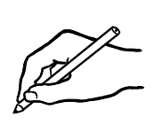

**write**



**copy**



**circle**

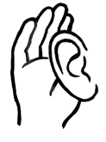

**listen**

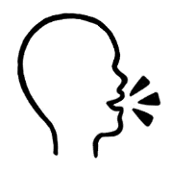

**say**

**🗸**

**tick**

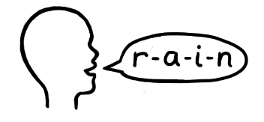

**spell**

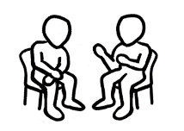

**Work with   
a partner.**



**Ask questions.**

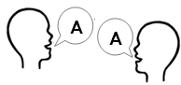

**repeat**



**record**

# The Alphabet

**Activity1 - The letters of the alphabet – spoken**

Copy the worksheet below. Read one of the three letters in each group and the students circle the letter. Do two rows in each class.

Aa Bb Cc Dd Ee Ff Gg Hh Ii Jj Kk Ll Mm

Nn Oo Pp Qq Rr Ss Tt Uu Vv Ww Xx Yy Zz

**Listen**. **Circle**.

|  |  |  |  |  |  |
| --- | --- | --- | --- | --- | --- |
|  | **A** | **B** | **C** | **D** | **E** |
|  | A L M | S K T | B R Z | M L J | P F E |
|  | O D W | G L V | X H J | Q G P | O W Z |
|  | Q T M | G C K | S C L | M E D | K S V |
|  | Q O C | F M N | P B Z | O E A | Z S X |
|  | J G P | E C O | X F S | G J D | W V T |

|  |  |  |  |  |  |
| --- | --- | --- | --- | --- | --- |
|  | m n o | k c s | j g q | l e p | r i w |
|  | a e i | o u y | u a e | y o a | e y u |
|  | b p d | t y u | d b k | w v t | p b g |
|  | s c x | k c t | k g d | t d v | s z c |
|  | f v d | t g v | s z v | f s c | g d v |

**Activity 2 - Introductions and learning names**

Student names provide a practical vocabulary for building many skills.

1. **Word stress** – When recording student and teacher names in alphabetical order on page 9 in the student book, repeat the stress activity done with the character names on page 4 in this book. Write student names on the board in lists according to the number of syllables and the stress pattern. Mark the stressed syllable with a large circle and the unstressed syllable with a small circle. e.g.

Thi Zainab Kristina

1. **Build class connection by learning names - name cards**   
   - With ½ A4 page, fold and create name cards for each student.

Mark the stress pattern on the cards and collect at the end of class.

1. **Teach how to introduce someone.**

* Write on the board, ‘*My name is___________.*’ Go round the class, with students introducing themselves.
* Next, on the board write, ‘*My name is______________, and this is ______________.’* Demonstrate how to introduce someone with an outstretched hand towards the person, palm up. Round the class, students introduce themselves and the person next to them. This introduction can be extended to add where a student comes from, their likes and dislikes, favourite colour etc.
* A ball is needed for this activity. Get students to stand in a circle. The student with the ball introduces themselves, then says ‘and this is ______________’ and throws the ball to the student named.

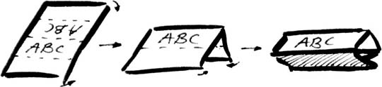

**3. Handwriting guide** *A practice writing book is available at Initial level.*

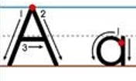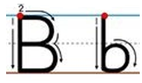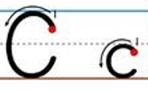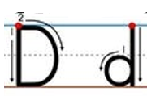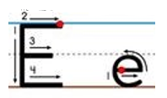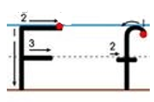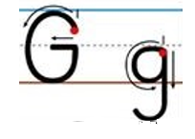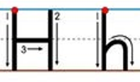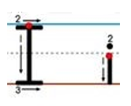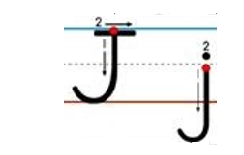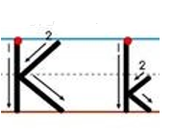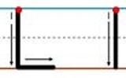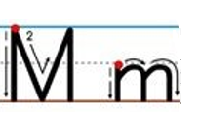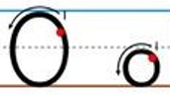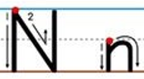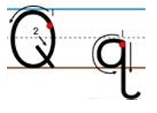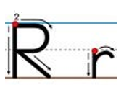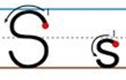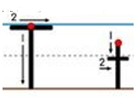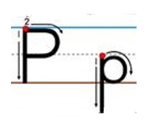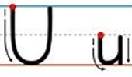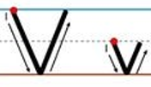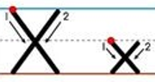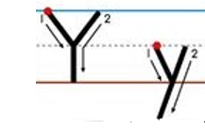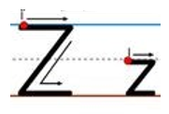

Lined page for handwriting practice

……………………………………………………………………………………………………………..

……………………………………………………………………………………………………………..

……………………………………………………………………………………………………………..

……………………………………………………………………………………………………………..

……………………………………………………………………………………………………………..

……………………………………………………………………………………………………………..

……………………………………………………………………………………………………………..

……………………………………………………………………………………………………………..

……………………………………………………………………………………………………………..

……………………………………………………………………………………………………………..

……………………………………………………………………………………………………………..

# School

**Activity**

1. Project the drawings on the whiteboard. Students refer to their books to answer questions about each character:   
    *How old is _____*? *Where does he/she study*?
2. Practise and clap the stress patterns of:

Primary school secondary school university



|  |  |  |
| --- | --- | --- |
|  | Pari is _____ years old.  Dev is ____ years old.  They go to **___________ ______.** | |
|  | | Mai and Fatima are ______.  They go to **___________ _________**. |
|  | | Bao and Abdi are ______.  They go to **________________**. |

# What can you do?

**Activity**

* Enlarge and copy a class set of the activities – it doesn’t matter if some students have a similar activity.
* Give each student a drawing of an activity.
* Students practise all the questions by repeating each after the teacher.
* Students then walk round the room asking different students their own question.
* Finally each student asks the teacher their question.

The two spare boxes allow for the addition of activities relevant to the student group.

|  |  |
| --- | --- |
| **Can you drive a car?** | **Can you cook?** |

|  |  |
| --- | --- |
| **Can you garden?** | **Can you use a computer?** |
| **Can you speak other languages?**    Oromo  Somali  Arabic | **Can you swim?** |
| **Can you sew?** | **Can you repair things?** |

|  |  |
| --- | --- |
| **Can you play soccer?** | **Can you play games?** |
| **Can you play  an instrument?** | **Can you ride a bike?** |
| **Can you ____________?** | **Can you ______________?** |

# What do you want to learn?

**Common class objectives**

The objectives selected by the students in their workbook *[Page 15]* need to be validated by a clear focus on those skills in class work. A summary of student objectives can be done by:

* Projecting the table below onto the whiteboard
* Inviting students to come to the board and tick [in the text boxes] the three objectives they’ve selected in their workbooks.

This summary will reveal common class objectives, and make students aware of the objectives of their classmates.

|  |  |  |  |  |
| --- | --- | --- | --- | --- |
|  | **listen**  **🗸** |  | **speak clearly** | |
|  | **read** |  | **write** | |
|  | **learn new words** |  | | **spell** |
|  | **use a computer** | Hello.  Hi. | | **have conversations** |

# When do you go to class?

**Listening activity**

Print the worksheet on the next page. Slowly read the following sentences:

1. Sahra goes to class on Monday and Tuesday.
2. Tahill goes to class on Tuesday and Thursday evening and Saturday morning.
3. Ming goes to class on Tuesday, Wednesday and Friday
4. Anika goes to class on Monday, Tuesday, Wednesday and Thursday**.**
5. Carim goes to class on Monday, Tuesday, Wednesday, Thursday and Friday.

**When do they go to class?**

**Listen**.

**Tick** the days.

|  |  |  |  |  |  |  |
| --- | --- | --- | --- | --- | --- | --- |
| **Day** | **Sahra** | **Tahiil** | **Ming** | **Anika** | **Carim** | **You** |
| Monday | **🗸** |  |  |  |  |  |
| Tuesday | **🗸** |  |  |  |  |  |
| Wednesday |  |  |  |  |  |  |
| Thursday |  |  |  |  |  |  |
| Friday |  |  |  |  |  |  |
| Saturday |  |  |  |  |  |  |

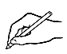

**Write** the days.

1. **Sahra** goes to class on Monday and Tuesday .
2. **Tahiil** goes to class on _________________ and _______________

evening and ________________ morning.

1. **Ming** goes to class on _________________, ___________________

and _________________.

1. **Anika** goes to class on _________________, __________________,

______________________ and ____________________.

1. **Carim** goes to class on ____________________, _______________, __________________, __________________ and ________________.
2. **I** go to class on ___________________________________________  
   _________________________________________________________.

# Who can help you learn?

**Activity**

Project the images below on the whiteboard. Students refer to their books to answer questions about who can help with learning. Point to a picture and ask:

***Who can help you learn?***

|  |  |  |  |  |
| --- | --- | --- | --- | --- |
|  |  | |  | |
|  |  | |  | |
|  |  | |  | |
|  | |  | |  |

# Where can you learn?

**Activity**

Project the images below on the whiteboard. Students refer to their books to answer questions about where they can learn. Point to a picture and ask:

***Where can you learn?***

|  |  |  |
| --- | --- | --- |
|  |  |  |
|  |  |  |
|  |  |  |
|  |  |  |

# What helps you learn?

**AMEP resources**

Students need to be made aware of the useful resources offered by the AMEP. Check the AMEP website for information and links to these services.

1. Volunteer tutor service.
2. Distance learning program.
3. On-line units.
4. Free childcare
5. Youth classes
6. Classes for mothers
7. Conversation clubs

**Activity – How different things aid learning**

Project the following and demonstrate how the timetable, the library, the computer and the phone can assist learning.

|  |  |  |  |  |  |  |  |  |  |  |  |  |  |  |
| --- | --- | --- | --- | --- | --- | --- | --- | --- | --- | --- | --- | --- | --- | --- |
|  | |  |  | | --- | --- | | **Mon** | **9 am- 3 pm school** | | **Tues** | **9 am – 3 pm school** | | **Wed** | **9 am - 3 pm school** | | **Thurs** | **10 am Doctor** | | **Fri** | **Shopping** | | |  | | --- | | **Centrelink**  Wednesday at 4pm | | **Doctor**  Thursday at 10 am | |
| I come to class on time. | I plan my week. | I make my appointments. |

1. The **timetable** helps me.
2. The **library** helps me.

|  |  |  |
| --- | --- | --- |
|  |  |  |
| I borrow books. | I listen to the audio. | I use the computer. |

|  |  |  |
| --- | --- | --- |
|  |  |  |
| I use AMEP online. | I find new words. | I use English programs. |

1. The **computer** helps me.
2. My **phone** helps me.

|  |  |  |
| --- | --- | --- |
|  | Square  Description automatically generated with medium confidence  I have  a pencil. | I have  a pencil. |
| I use AMEP online. | I record my teacher. | I listen to my teacher. |

# Learning steps

**Activity 1**

The worksheet about Sahra includes practice in recording the teacher’s voice so that students can listen and repeat the words or sentences at home. Adapt the sentences in the student workbook to suit the class.

**Activity 2**

The worksheet about Ming and Anika could be used for homework.

The worksheet gives an opportunity to build a word list.

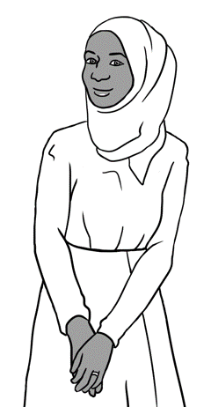**How can Sahra learn to have conversations in English**?

These are my steps.



**Listen**.

**Write**.

|  |  |  |
| --- | --- | --- |
| **1** | | I talk to my classmates  and my _______________. |
| **2** | I talk to my _____________________. | |
| **3** | I record my _____________________  on my ______________. | |
| **A picture containing linedrawing  Description automatically generated4** | I listen and repeat at ____________. | |

neighbour

phone

classmates**🗸**

teacher

teacher

home



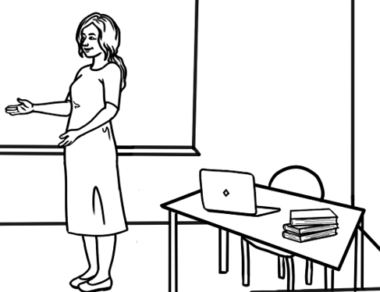 **Put your phone** on the teacher’s table.

**Press** record.

 **Record** the teacher.

**Listen** and **repeat** at home.

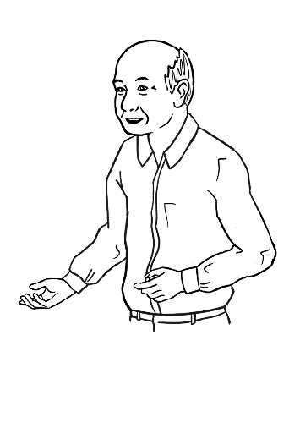 **How can Ming learn to read?**

These are my steps.

** Listen** and **repeat.**

|  |  |
| --- | --- |
| **1** | I borrow books from the library. |
| **2** | I read and listen to the audio. |
| **3** | I read and listen every day. |

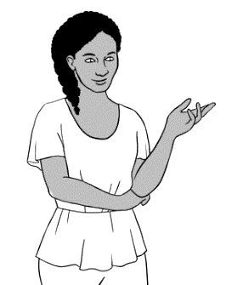**How can Anika learn new words?**



These are my steps.

**Listen**.

**Write**.

|  |  |
| --- | --- |
| 1** | I copy words from the board into my __________________. |
| **A picture containing text, wrench, tool  Description automatically generated2** | I copy ____________ from my workbook again and _________. |
| **3** | I write _______ words  on my word list. |

words**🗸**

words

notebook

again

new

 **Write** newwords on your wordlist.

|  |  |  |
| --- | --- | --- |
|  |  |  |
|  |  |  |
|  |  |  |
|  |  |  |
|  |  |  |
|  |  |  |
|  |  |  |
|  |  |  |
|  |  |  |
|  |  |  |
|  |  |  |
|  |  |  |
|  |  |  |

**My Word List**

# At the end of the term

**Post review interview**

If a student has made limited progress through the term, a one-to-one interview could reveal the student’s particular difficulties and open a discussion about ways to overcome any barriers to learning.

Possible interview topics and questions:

* Class environment - *Are you happy in the class?*
* Transport - *Is it easy to get to class on time?*

*Do you drive?*

*Do you catch a bus/train?*

*Do you walk here?*

* Study at home – *Can you study at home?* –

*Do you have a quiet place to study?*

*Do you have time to study at home?*

*Do you have a computer?*

*Do you have the internet?*

**Developing independent study skills at home**

Some students may need structured guidance to develop independent learning skills. The following pages could be given to such students as a ‘Homework Book’ which could provide a framework to develop effective study practice outside the classroom.

The teacher may initially need to guide this practice by prescribing the words to be learned, sentences to be copied or the formation of letters to be practised for homework.

When practising spelling, the copying of words is easier if students copy down rather than across. Saying the word aloud each time when copying will also support memory retention.

**Homework**

**1**

Name _______________________________________________

Day and date _______________________________________



**Copy** the capital letters from your workbook.



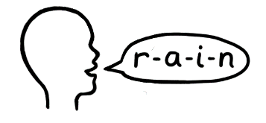**Read** the capital letters aloud.

**Spell**  **Copy** 3 words from your workbook.

|  |  |  |
| --- | --- | --- |
|  |  |  |
|  |  |  |
|  |  |  |
|  |  |  |
|  |  |  |

**New words Write** 2 new words.

|  |  |
| --- | --- |
| English | Your language |
|  |  |
|  |  |

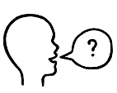

Can you check my work please?

**Ask** the teacher

**Homework**

Name _______________________________________________

Day and date _______________________________________

**2**



**Copy** the small letters from your workbook.



**Read** the small letters aloud.

**Spell Copy** 3 words from your workbook.

|  |  |  |
| --- | --- | --- |
|  |  |  |
|  |  |  |
|  |  |  |
|  |  |  |
|  |  |  |

**New words Write** 2 new words.

|  |  |
| --- | --- |
| English | Your language |
|  |  |
|  |  |



Can you check my work please?

**Ask** the teacher

**Homework**

Name _______________________________________________

Day and date _______________________________________

**3**



**Copy** a sentence from your workbook again and again.



**Read** the sentence aloud 4 times.



**Spell Copy** 3 words from your book.

|  |  |  |
| --- | --- | --- |
|  |  |  |
|  |  |  |
|  |  |  |
|  |  |  |

**New words Write** 2 new words.

|  |  |
| --- | --- |
| English | Your language |
|  |  |
|  |  |

 **Ask** the teacher

Can you check my work please?

**Homework**

Name _______________________________________________

Day and date _______________________________________

**4**



**Copy** a sentence from your workbook again and again.



**Read** the sentence aloud 4 times.



**Spell Copy** 3 words from your book.

|  |  |  |
| --- | --- | --- |
|  |  |  |
|  |  |  |
|  |  |  |
|  |  |  |

**New words Write** 2 new words.

|  |  |
| --- | --- |
| English | Your language |
|  |  |
|  |  |



Can you check my work please?

**Ask** the teacher  
**Homework**

Name _______________________________________________

Day and date _______________________________________

**5**



**Copy** a sentence from your workbook again and again.



**Read** the sentence aloud 4 times.



**Spell Copy** 3 words from your book.

|  |  |  |
| --- | --- | --- |
|  |  |  |
|  |  |  |
|  |  |  |
|  |  |  |

**New words Write** 2 new words.

|  |  |
| --- | --- |
| English | Your language |
|  |  |
|  |  |

 **Ask** the teacher

Can you check my work please?