

|  |
| --- |
| **English Ready**  **Course in EAL  VU22585 Use beginning language learning strategies with support** |

**Teacher Resources**

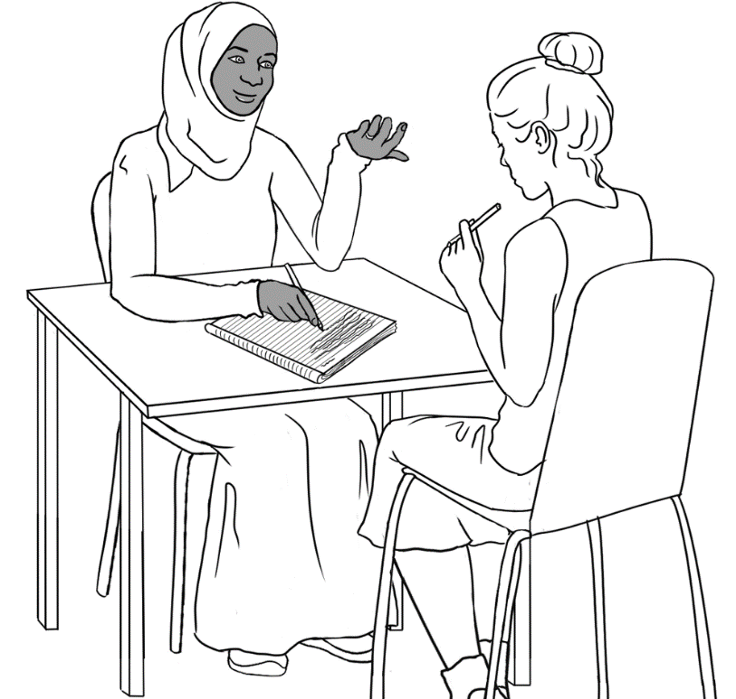

**Design team:** Vicki Hambling, Sue Paull, Frida Dean, Janice Langley, Glenise Kleehammer and Mary Wallace

**Illustrations:** Madelena Scott

**Image acknowledgements:**Keyboard - Blank generic keyboard vector image | Free SVG Creative Commons — CC0 1.0 Universal

**Acknowledgements:** The design team would like to thank the AMEP service providers and practitioners who participated in the trial and gave valuable feedback. The team would also like to acknowledge the use of the EAL Framework which underpins the design of this book.

Copyright of the EAL Framework is reserved to the Crown in the right of the State of Victoria. © State of Victoria (Department of Education and Training) 2018.  
_________________________________________________________________________________________

This English Ready Resource is licensed under a Creative Commons Attribution-NoDerivs 3.0 Australia licence (More information is available [here](http://creativecommons.org/licenses/by-nd/3.0/au/)). You are free to use, copy and distribute to anyone in its original form as long as you attribute Department of Home Affairs as the author and you license any derivative work you make available under the same licence.  
  
© Commonwealth of Australia 2023

With the exception of the Commonwealth Coat of Arms, the department’s logo, any material protected by a trade mark and where otherwise noted all material presented in this document is provided under a Creative Commons Attribution 4.0 International (<https://creativecommons.org/licenses/by/4.0/>) licence.

The details of the relevant licence conditions are available on the Creative Commons website (accessible using the links provided) as is the full legal code for the CC BY 4.0 licence (<https://creativecommons.org/licenses/by/4.0/legalcode>).

Use of all or part of this document must include the following attribution:   
© Commonwealth of Australia 2023

As far as practicable, material for which the copyright is owned by a third party will be clearly labelled.  The department has made all reasonable efforts to ensure that this material has been reproduced in this document with the full consent of the copyright owners.

Copyright requests and enquiries concerning usage not addressed by the CC BY 4.0 licence should be addressed to:

[*comms@homeaffairs.gov.au*](mailto:comms@homeaffairs.gov.au) *at the Department of Home Affairs.*

The terms of use for the Commonwealth Coat of Arms are available from the [It's an Honour](http://www.itsanhonour.gov.au/) website.

Where a copyright owner, other than the Commonwealth, is identified with respect to this material, please contact that third party copyright owner directly to seek permission.

**Introduction**

**The Teacher Book**

This book is an electronic reference. Print pages as only needed. It includes materials and activities for:

* pair work and class work
* revision and homework
* pronunciation
* extension.

**The Student Workbook**

This book requires teacher direction and is **not** intendedfor independent learning. It is also not intended to be the only material used to teach these units. The activities included are not suitable to be used for assessment.   
The book is available as a Word document so that teachers can:

* localise and update the content
* adjust the material to suit the requirements of particular classes
* delete or add materials as required

**Table of Contents**

1. Meet the people. 5

2. Instructions 8

3. The alphabet 14

4. The sounds of the alphabet 32

5. English class 45

6. Who can help you learn English? 49

7. Sahra can’t come to class today. 50

8. Important words 52

9. Learning in Australia 60

# Meet the people.

**Activity**

Project the drawings of the families on the whiteboard. Students refer to their books to answer questions about each character and family:   
***Who is this***? ***Where do they come from***?

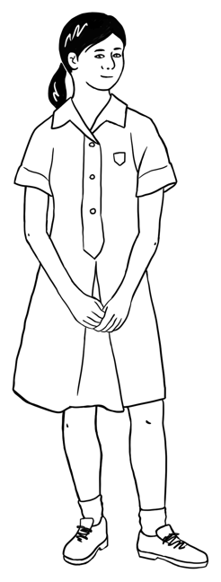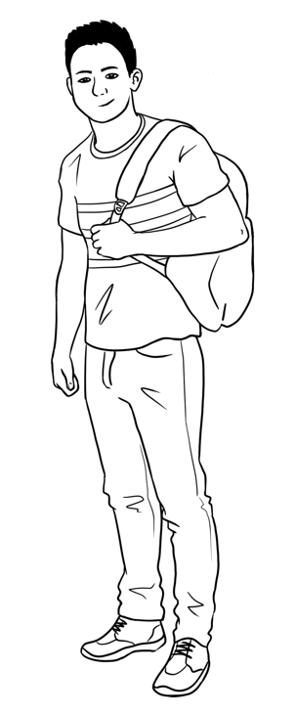

This is **______**.This is **_____**.This is **______**.This is **_____**.

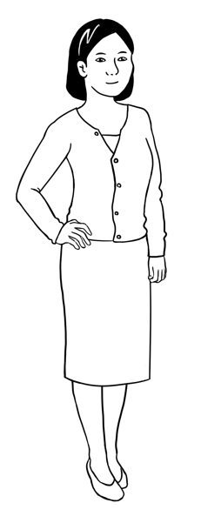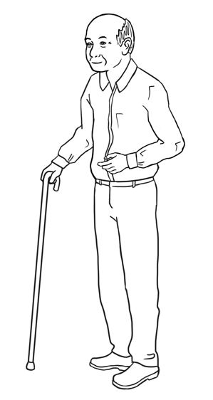

Ming’s family comes from ______.

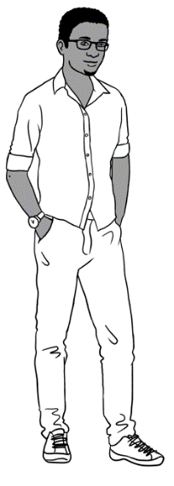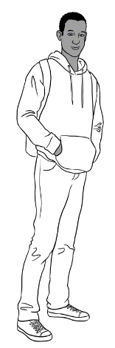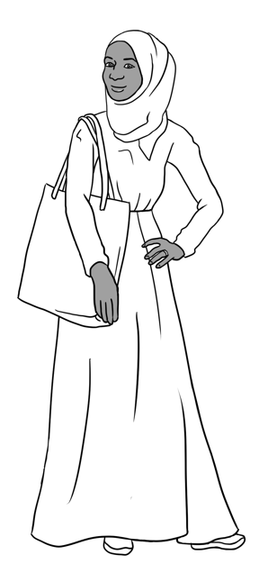

Sahra’s family comes from ___________.

This is **______**.

This is **_____**.

This is **______**.

This is **_____**.

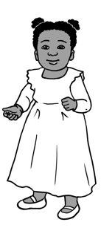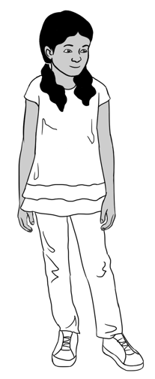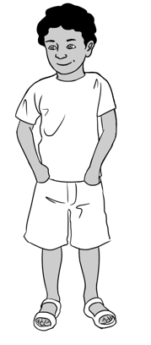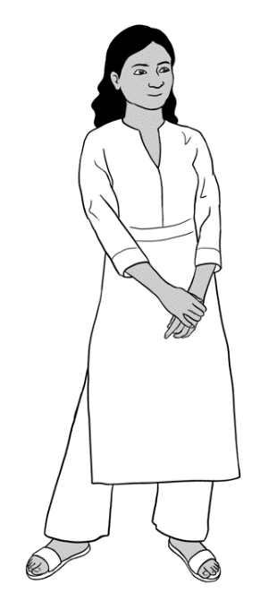

This is **________**. This is **_______**.This is **______**.

Nisha’s family comes from __________.

Carim’s family comes from _____.

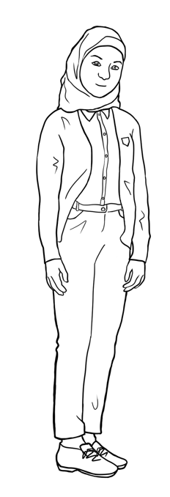

This is **_______**. This is **______**.

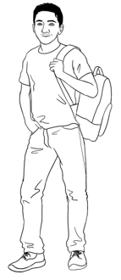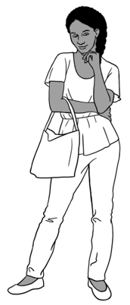

This is **_______**_.

Anika’s family comes   
from ____________.

Jenny is a teacher.   
She is from ___________. neighboureighbourneigh

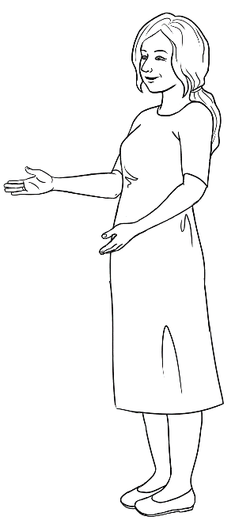

This is **Jenny**.

# Instructions

**Activity 1 – Workbook instructions**

1. Project the table below with the instruction symbols and the words   
   on the board. Read the instructions and ask students to repeat.
2. Project the table on the following page with only the instruction symbols, and ask students to guess the instruction.
3. Students then complete the matching activity on page 6 in their workbook.

|  |  |
| --- | --- |
| read | write |
| listen | repeat |
| copy | say |
| **🗸**  tick | spell |
| circle | ask |
| Work with   a partner. | record |

|  |  |
| --- | --- |
|  |  |
|  |  |
|  |  |
| **🗸** |  |
|  |  |
|  |  |

**Activity 2– Following workbook instructions**

Read each instruction slowly. Students follow and complete each instruction on the numbered table on the following page.

1. **Circle** the eggs.
2. **Write** your first name.
3. **Copy** the word - *student.*
4. **Tick** yes or no. Is it hot today?
5. [Write address on the board.]   
   **Read** the word on the board.   
   **Write** the missing letters.
6. **Circle** the letter **m**.
7. **Tick** yes or no. Is it Monday today?
8. **Copy** the word - *teacher*
9. **Ask** your partner. Please spell your name.   
   **Write** your partner’s name.

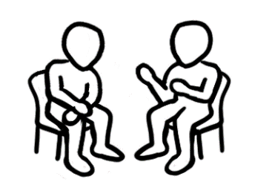**Instructions**

**Read** with a partner.

|  |  |  |  |
| --- | --- | --- | --- |
| 1. read | 1. listen | 1. repeat | 1. tick |
|  |  |  |  |
| 1. copy | 1. write | 1. spell | 1. say |
|  |  |  |  |
| 1. Work with a partner. | 1. circle | 1. ask | 1. record |

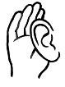

**Listen** and **follow** the instructions.

|  |  |  |
| --- | --- | --- |
|  | __________________ | student  ________________ |
| Yes  No | a__dr___ss | n a m e |
| Yes  No | Teacher  __________________ | Please spell your first name.  _________________ |

**Activity 3 – Classroom instructions**

1. **Listening to instructions**

* Read the instruction. Students listen and follow the instruction.
* Ask a student to choose and read an instruction. Students listen and follow the instruction.

1. **Extending the use of the instruction verbs**

* Project the following page.
* Brainstorm one or two instructions often used in the classroom

for each verb and write them on the board. e.g.

* *open the door, open the window*
* *close the door, close the window*
* *listen to your partner, listen to me, listen to the song*
* *look at your workbook, look at the clock*
* *stand here, stand there, stand next to me*
* *come in, come to me, come to the desk etc*
* Give students the following page.
* Students write one or two different classroom instructions

for each verb.

* Practise these variations in following classes.

[Additional verbs could be added to the list e.g. ***bring*** and ***borrow***, ***turn on*** and ***turn off***]

|  |  |
| --- | --- |
| **A picture containing text  Description automatically generatedopen** |  |
| **Diagram  Description automatically generated with medium confidenceclose** |  |
| **listen**  Listen. |  |
| **Diagram  Description automatically generated with medium confidencelook** |  |
| **stand** |  |
| **come**  Come in. |  |
|  |  |
|  |  |

# The alphabet

1. **Upper and lower-case letter tiles**

Print the four pages of letter tiles, enough for each student to cut up and have their own set. Distribute envelopes for students to store their tiles for regular use. Some ideas for use:

* Students match upper and lower-case letters.
* Say **the name** of a letter [or a letter sound] ; students hold it up or place it on their desk.
* Ask, *What is the first letter in a word?* eg. *computer* Students hold up ***C***
* Write a word on the board e.g. _ encil. Read the word; students hold up the first letter.
* Lay out the alphabet cards on a table in a row. Students work in groups and roll a dice to move along the path. Each time they stop they say the letter. If they make a mistake, they move back 2 places.
* Spell a word and students find the letters and make the word. They then scramble the word and put it back correctly.
* Students work in pairs with one set of either capitals or small letters. They put their letters into alphabetical order. One student turns their back and the other removes one letter, and pushes the cards together to disguise the gap. The other student must say which letter is missing.
* Separate the vowels [in grey] from the consonants. Write a number of familiar words from the sound chart or classwork on the board. Students use their tiles to assemble the words. Show that in every word there is a vowel, or a *y* playing the role of a vowel.
* Game of concentration/memory – in groups of three or four, students mix a set of upper and lower-case letters face-down on the table. The goal is to form pairs of letters. Students take turns to turn over two cards to form a pair. If the letters match, the student keeps the pair and has another turn. If the letters don’t match, the student turns the letters over in the same place on the table. When all the pairs have been matched, the student with the most pairs is the winner.
* The game of ‘Go Fish’ – Create sets of alphabet tiles. Students play in small groups following the rules of the old card game. The game can be adapted with the alphabet pictures, number and vocab tiles, or a mixture of tiles.
* Print grids similar to the ones below. Each student in a group is given a grid with two different pictures. Working with three or four sets of lower- case letter tiles turned face down, students take turns to select a letter. They need to spell out the words on their grid. [They can use their workbooks to check the spelling.] If they can’t use a letter, they return it to a space next to the pile face up. The next student can pick a new letter or the discarded one. The first to complete their two words wins.

e.g.

|  |  |  |  |  |  |  |  |
| --- | --- | --- | --- | --- | --- | --- | --- |
|  | **s** | **t** |  |  |  |  | **t** |
|  | **e** |  |  |  |  |  |  |

|  |  |  |  |  |  |  |  |
| --- | --- | --- | --- | --- | --- | --- | --- |
|  | **f** |  | **v** | **e** |  |  |  |
|  | **o** |  |  |  |  |  |  |

|  |  |  |  |  |  |  |  |
| --- | --- | --- | --- | --- | --- | --- | --- |
|  | **a** | **p** |  | **l** |  |  |  |
|  |  | **o** |  |  |  |  |  |

|  |  |  |  |
| --- | --- | --- | --- |
| **A** | **B** | **C** | **D** |
| **E** | **F** | **G** | **H** |
| **I** | **J** | **K** | **L** |
| **M** | **N** | **O** | **P** |
| **Q** | **R** | **S** | **T** |
| **U** | **V** | **W** | **X** |
| **Y** | **Z** |  |  |

|  |  |  |  |
| --- | --- | --- | --- |
| **a** | **b** | **c** | **d** |
| **e** | **f** | **g** | **h** |
| **i** | **j** | **k** | **l** |
| **m** | **n** | **o** | **p** |
| **q** | **r** | **s** | **t** |
| **u** | **v** | **w** | **x** |
| **y** | **z** |  |  |

**2. Bingo – Upper-case letters**

**Teacher call chart**

|  |  |  |  |  |  |  |  |  |  |
| --- | --- | --- | --- | --- | --- | --- | --- | --- | --- |
| A | B | C | D | E | F | G | H | I | J |
| K | L | M | N | O | P | Q | R | S | T |
| U | V | W | X | Y | Z |  |  |  |  |

**Student Bingo cards**

|  |  |  |  |  |  |  |
| --- | --- | --- | --- | --- | --- | --- |
| A | F | B |  | K | U | O |
| M | E | I |  | Z | G | A |
| P | H | G |  | T | D | X |

|  |  |  |  |  |  |  |
| --- | --- | --- | --- | --- | --- | --- |
| Z | T | K |  | N | M | D |
| B | A | O | E | F | J |
| I | J | P | R | L | I |

|  |  |  |  |  |  |  |
| --- | --- | --- | --- | --- | --- | --- |
| E | J | I |  | Q | A | G |
| T | C | H | P | H | I |
| L | F | S | M | K | B |

|  |  |  |  |  |  |  |
| --- | --- | --- | --- | --- | --- | --- |
| F | M | P |  | Y | E | L |
| Z | A | W | F | D | J |
| Y | B | E | H | Z | M |
| S | J | I |  | R | I | E |
| V | G | H | L | H | N |
| L | E | P | M | C | G |

|  |  |  |  |  |  |  |
| --- | --- | --- | --- | --- | --- | --- |
| C | U | I |  | E | Y | P |
| E | S | J | M | B | U |
| Q | M | F | V | O | H |

|  |  |  |  |  |  |  |
| --- | --- | --- | --- | --- | --- | --- |
| T | Y | V |  | H | H | T |
| E | A | M | J | E | L |
| H | J | W | K | M | V |

|  |  |  |  |  |  |  |
| --- | --- | --- | --- | --- | --- | --- |
| W | S | U |  | F | R | P |
| B | C | P | M | H | I |
| R | O | D | Y | A | J |

|  |  |  |  |  |  |  |
| --- | --- | --- | --- | --- | --- | --- |
| A | T | P |  | Y | U | P |
| D | F | I | L | F | M |
| U | G | H | Q | O | T |

|  |  |  |  |  |  |  |
| --- | --- | --- | --- | --- | --- | --- |
| E | X | H |  | E | X | S |
| J | B | K | J | C | Z |
| G | I | M | N | I | A |

**3. Bingo – Lower-case letters**

**Teacher call chart**

|  |  |  |  |  |  |  |  |  |  |
| --- | --- | --- | --- | --- | --- | --- | --- | --- | --- |
| a | b | c | d | e | f | g | h | i | j |
| k | l | m | n | o | p | q | r | s | t |
| u | v | w | x | y | z |  |  |  |  |

**Student bingo cards**

|  |  |  |  |  |  |  |
| --- | --- | --- | --- | --- | --- | --- |
| a | f | b |  | k | u | o |
| m | e | i |  | z | g | a |
| p | h | g |  | t | d | x |

|  |  |  |  |  |  |  |
| --- | --- | --- | --- | --- | --- | --- |
| z | t | k |  | n | m | d |
| b | a | o | e | f | j |
| i | j | p | r | l | i |

|  |  |  |  |  |  |  |
| --- | --- | --- | --- | --- | --- | --- |
| e | j | i |  | q | a | g |
| t | c | h | p | h | i |
| l | f | s | m | k | b |

|  |  |  |  |  |  |  |
| --- | --- | --- | --- | --- | --- | --- |
| f | m | p |  | y | e | l |
| z | a | w | f | d | j |
| y | b | e | h | z | m |

|  |  |  |  |  |  |  |
| --- | --- | --- | --- | --- | --- | --- |
| s | j | i |  | r | i | e |
| v | g | h | l | h | n |
| l | e | p | m | c | g |

|  |  |  |  |  |  |  |
| --- | --- | --- | --- | --- | --- | --- |
| c | u | i |  | e | y | p |
| e | s | j | m | b | u |
| q | m | f | v | o | h |

|  |  |  |  |  |  |  |
| --- | --- | --- | --- | --- | --- | --- |
| t | y | v |  | h | h | t |
| e | a | m | j | e | l |
| h | j | w | k | m | v |

|  |  |  |  |  |  |  |
| --- | --- | --- | --- | --- | --- | --- |
| w | s | u |  | f | r | p |
| b | c | p | m | h | i |
| r | o | d | y | a | j |

|  |  |  |  |  |  |  |
| --- | --- | --- | --- | --- | --- | --- |
| a | t | p |  | y | u | p |
| d | f | i | l | f | m |
| u | g | h | q | o | t |

|  |  |  |  |  |  |  |
| --- | --- | --- | --- | --- | --- | --- |
| e | x | h |  | e | x | s |
| j | b | k | j | c | z |
| g | i | m | n | i | a |

**Student Bingo cards - Blank**

|  |  |  |  |  |  |  |
| --- | --- | --- | --- | --- | --- | --- |
|  |  |  |  |  |  |  |
|  |  |  |  |  |  |
|  |  |  |  |  |  |

|  |  |  |  |  |  |  |
| --- | --- | --- | --- | --- | --- | --- |
|  |  |  |  |  |  |  |
|  |  |  |  |  |  |
|  |  |  |  |  |  |

|  |  |  |  |  |  |  |
| --- | --- | --- | --- | --- | --- | --- |
|  |  |  |  |  |  |  |
|  |  |  |  |  |  |
|  |  |  |  |  |  |

|  |  |  |  |  |  |  |
| --- | --- | --- | --- | --- | --- | --- |
|  |  |  |  |  |  |  |
|  |  |  |  |  |  |
|  |  |  |  |  |  |

|  |  |  |  |  |  |  |
| --- | --- | --- | --- | --- | --- | --- |
|  |  |  |  |  |  |  |
|  |  |  |  |  |  |
|  |  |  |  |  |  |

|  |  |  |  |  |  |  |
| --- | --- | --- | --- | --- | --- | --- |
|  |  |  |  |  |  |  |
|  |  |  |  |  |  |
|  |  |  |  |  |  |

**4. Handwriting guide** *A practice writing book is available at Initial level.*

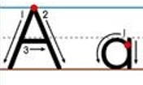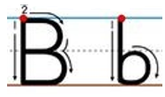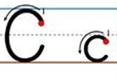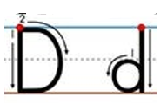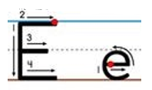

……………………………………………………………………………………………………………..

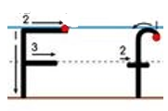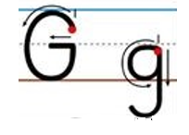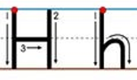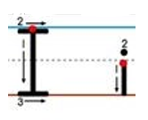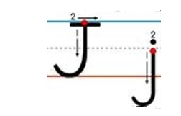

……………………………………………………………………………………………………………..

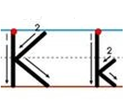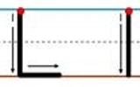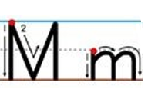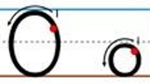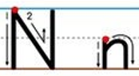

……………………………………………………………………………………………………………..

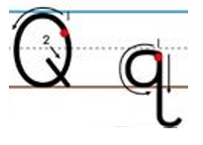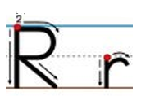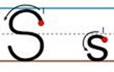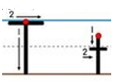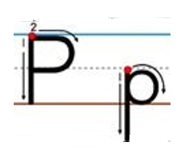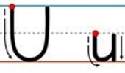

……………………………………………………………………………………………………………..

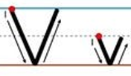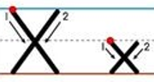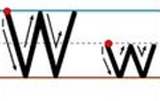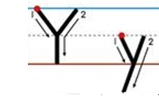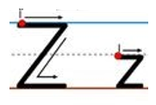

……………………………………………………………………………………………………………..

**5. Dictation of letters [Pair work]**

This is a student-to-student dictation.

* Print a page of either the upper or lower-case table for each student.
* Students work in pairs and sit back-to-back. They each need a pencil and a pen.
* In the first dictation, use a pencil.
* Student A begins at the first row and calls out the number of the row and then one letter in the row. Student A circles the letter on their table with a pencil.
* Student B listens and circles the letter on their table with a pencil.
* Student A & B continue in this way to the final row of pictures.
* Student A nominates one of the pictures to circle.
* Student B checks their table with Student A’s table to see the correct letters have been circled.
* Swap roles and in the second dictation, use a pen to circle the letters.

|  |  |  |  |  |  |  |
| --- | --- | --- | --- | --- | --- | --- |
|  | S | W | A | B | T |  |
|  | N |  | T | M |  | Q |
|  | D | K | B | G | Z | L |
|  | A | O |  | J | C | S |
|  | Z | I | F | D | H | R |
|  | X |  | U | Y | T | F |
|  | M | H | J | W | I | E |
|  | P | C | B | L |  | Y |
|  |  | S | O | A | G |  |
|  | C | F | N | B | R | V |
|  | Q | U | E | V | Z | A |
|  |  |  |  |  |  |  |

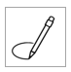



|  |  |  |  |  |  |  |
| --- | --- | --- | --- | --- | --- | --- |
|  | s | w | a | b | t |  |
|  | n |  | t | m |  | q |
|  | d | k | b | g | z | l |
|  | a | o |  | j | c | s |
|  | z | e | i | d | h | r |
|  | x |  | u | y | t | f |
|  | m | h | j | w | i | e |
|  | p | c | b | l |  | y |
|  |  | s | o | a | g |  |
|  | c | f | n | b | r | v |
|  | q | u | e | v | z | a |
|  |  |  |  |  |  |  |

**7. The Computer Keyboard**

**On paper**

* Print the keyboards on the following page and repeat the activity in Student Book using different letters of the alphabet
* Print the large keyboard on Page 29 and ask students to write the keyboard letters [or copy the letters from their workbook]

**On a computer**

* Choose 10 words from the student book and write on whiteboard
* Students type in upper-case – 5 times
* Students type in lower-case – 5 times
* Students type in upper and lower-case – 5 times
* Repeat activity daily or weekly using different words
* Typing practise https://www.typing.com/student/lessons

***Note:*** *Additional computer activities are on pages 56 - 59.*

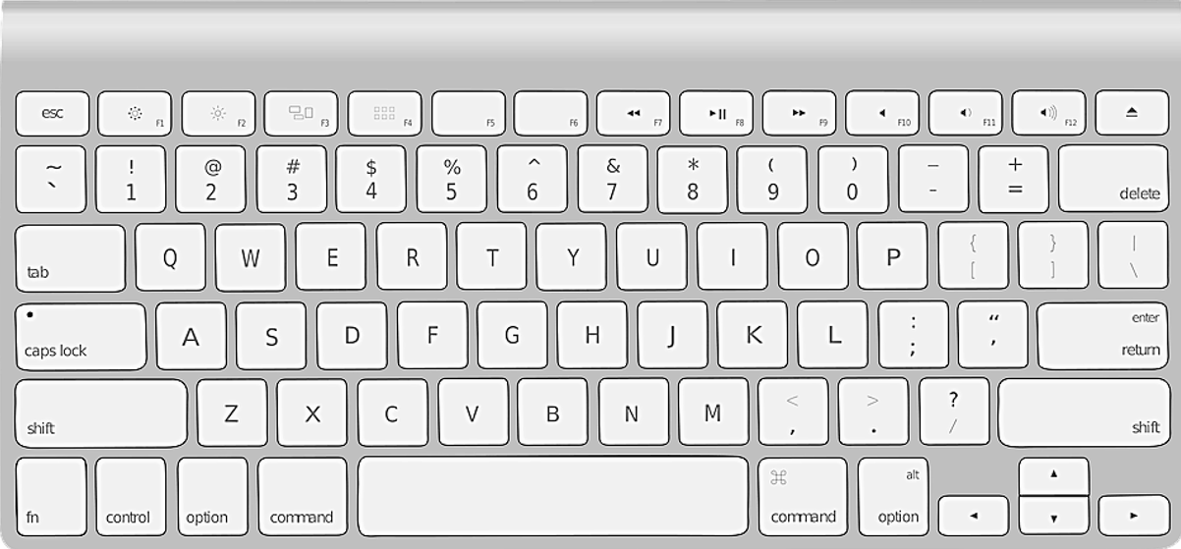

**The computer keyboard**

# The sounds of the alphabet

A book that covers the sounds in more detail is available at Initial level.

**Activity 1 – Matching initial sounds**

The following pictures, initial sounds and words can be printed and cut up by the students and used for a variety of class and pair work.

|  |  |  |  |
| --- | --- | --- | --- |
|  |  |  |  |
|  |  |  |  |
|  |  |  |  |
|  |  |  |  |
|  | Rubber |  |  |
|  |  |  |  |
|  |  |  |  |

|  |  |  |  |
| --- | --- | --- | --- |
| **a** | **b** | **c** | **d** |
| **e** | **f** | **g** | **h** |
| **i** | **j** | **k** | **l** |
| **m** | **n** | **o** | **p** |
| **q** | **r** | **s** | **t** |
| **u** | **v** | **w** | **x** |
| **y** | **z** |  |  |

|  |  |  |  |
| --- | --- | --- | --- |
| **a**pple | **b**ackpack | **c**omputer | **d**oor |
| **e**ggs | **f**ive | **g**lasses | **hi**ghlighter |
| **i**nsect | **j**acket | **k**ey | **l**amp |
| **m**oney | **n**otebook | **o**range | **p**encil |
| **q**uestion | **r**ubber | **s**tudent | **t**able |
| **u**mbrella | **v**an | **w**ater | **x**-ray |
| **y**am | **z**ero |  |  |

**Activity 2 – Listening for single initial sounds**

* Print the worksheet on the following page, one for each student.   
  It’s a variation of a similar worksheet in the student book.
* If possible, project the worksheet for easy correction.
* Say a sound for each line of pictures; students circle the sound. The first sound ***c*** is circled as an example.
* Repeat the activity at other times choosing different sounds.



**Listen** to the teacher. **Circle** the sound.

|  |  |  |  |
| --- | --- | --- | --- |
| **1** | **s** student | **y** yam | **c** computer |
| **2** | **f**  five | **v** van | **k** key |
| **3** | **o** orange | **u** umbrella | **a** apple |
| **4** | **z** zero | **s** student | **j** jacket |
| **5** | **l** lamp | **t** table | **d** door |
| **6** | **e** eggs | **a** apple | **u**  umbrella |

**Activity 3 – Consonant blends**

*Some of the words in the worksheet are taken from other units at this level.*

* Print the worksheets on the following two pages, back-to-back,   
  one for each student.
* If possible, project the worksheet for easy correction.
* The first example is completed on each sheet.

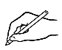**Two letters**

**Listen** and **repeat. Underline** the sound.

|  |  |  |  |
| --- | --- | --- | --- |
| **bl** | black | blue | table |
| **br** | brown | bread | umbrella |
| **ck** | tick  **🗸** | jacket | backpack |
| **cl** | clock | clap | cloudy |
| **fr** | Friday  Wednesday  Thursday  **Friday**  Saturday | friends | fruit |
| **pl** | play | plate | apple |
| **st** | stop | student | stand |

**Write** the letters.

|  |  |  |  |
| --- | --- | --- | --- |
| **bl** | b l ack | _ _ue | ta_ _e |
| **br** | _ _ own | _ _ead | um_ _ella |
| **ck** | ti_ _  **🗸** | ja_ _et | ba_ _pa_ _ |
| **cl** | _ _ock | _ _ap | _ _oudy |
| **fr** | _ _iday  Wednesday  Thursday  **Friday**  Saturday | _ _riends | _ _uit |
| **pl** | _ _ay | _ _ate | ap_ _e |
| **st** | _ _op | _ _udent | _ _and |

**Activity 4 – Two letters = one sound**

*Some of the words in the worksheet are taken from other units at this level.*

* Print the worksheet on the following page, one for each student.
* If possible, project the worksheet for easy correction.
* Read the word and student listen for the sound.
* The first example is completed as a guide for student.

**Two letters = one sound**



**Listen** to the teacher. **Circle** the sound.

|  |  |  |  |
| --- | --- | --- | --- |
| **1** | **sh** sharpener | **th** three  3 | **ch** child |
| **2** | **ch** chips | **sh** shoe | **th** Thursday  Wednesday  **Thursday**  Friday  Saturday |
| **3** | **th** thank | **ch** children | **sh** shop |
| **4** | **ch** chicken | **sh** shirt | **th** thirteen  13 |
| **5** | **sh** fish | **th** fourth | **ch** teacher |

# English class

**Activity 1 - Syllables**

Use the words on the timetable page to introduce syllables.

* Create a table on the board similar to the one below, initially without the words in the columns.
* Begin by slowly adding each key word on page 18 in the student book.
* Demonstrate the syllables physically by:
  + tapping your hand, a pen or a ruler on the table
  + clapping
  + punching the air
  + stamping your feet
  + taking a step for each syllable.
* Ask students to repeat each word with an action several times, counting the syllables while clapping etc
* In later classes:
* the words could be enlarged and written on paper. Students could attach the words to the board with magnets or copy the words into the columns.
* Repeat the process with the stationery items - ‘What do you need in class?’ on page 19.

|  |  |  |  |
| --- | --- | --- | --- |
| **Syllables** | | | |
| **1** | **2** | **3** | **4** |
| start  room  day  date  term  last | Monday  Tuesday  Wednesday*  Thursday  Friday  Sunday  finish  public  special | Saturday  holiday  excursion |  |

* *Wednesday has two syllables when spoken. To learn the spelling of the word,   
 it’s helpful to clap the silent third syllable as well.*

**Activity 2 – Word Stress**

Follow up work on syllables with regular work on word stress.

* Create a table on the board similar to the one below, initially without the words in the columns.
* Say each stationery item, placing clear stress on the strong syllable. Clap or tap the table more loudly on the strong syllable.

Large rubber bands are useful to demonstrate and help students remember the stressed syllable. Give each student a rubber band, hold with the fingers, stretch the band out on the stressed syllable and bring the fingers together on the unstressed one. The stressed syllable is said a little louder and longer.

* Write each stationery item in the correct column on the table.
* Add the timetable vocabulary to the table.
* Add the stress pattern dots over all new words when first introduced.   
  e.g. student names.

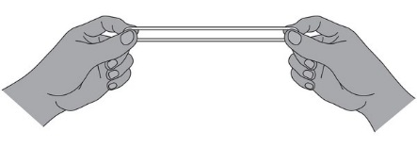

|  |  |  |  |
| --- | --- | --- | --- |
| **Word stress** | | | |
|  |  |  |  |
| case  pen  phone | pencil  rubber  workbook  notebook  ruler  glasses  water |  | sharpener  highlighter |

**Activity 3 – Sound dictation**

* Print the worksheet on the following page for each student.
* Read the dictation to the class; read again phrase by phrase and students repeat; students read the dictation in pairs.
* Students underline or highlight the bolded sounds.
* Ask students to fold over or cover the dictation.   
  *[Cheating if necessary is perfectly fine!]*
* Read the text slowly while students add the missing sounds.
* Read again before the students check their work against the original text.

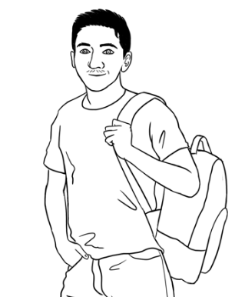

It’s **M**onday. Carim is **r**eady for  **cl**ass.

He **h**as 10 **th**ings in his **b**ackpa**ck** today.

He **h**as a **p**encil, a **r**ubber, a **sh**arpener, a **h**ighlighter,

a **p**en, a **w**orkbook, a **n**otebook, a **r**uler, **g**lasses and **w**ater.

|  |  |  |  |  |  |  |  |  |  |  |  |  |
| --- | --- | --- | --- | --- | --- | --- | --- | --- | --- | --- | --- | --- |
| a | b | c | d | e | f | g | h | i | j | k | l | m |
| n | o | p | q | r | s | t | u | v | w | x | y | z |

_ _ _ _ _ _ _ _ _ _ _ _ _ _ _ _ _ _ _ _ _ _ _ _ _ _ _ _ _ _ _ _

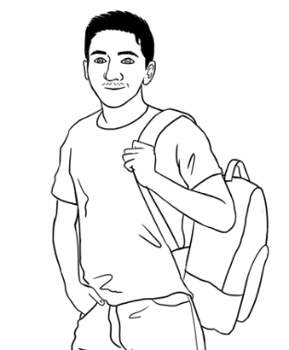

**Dictation**

It’s Monday. Carim is _eady for __ass.

He _as 10 __ings in his _ackpa__ today.

He _as a _encil, a _ubber, a __arpener,

a _ighlighter, a _en, a _orkbook,

a _otebook, a _uler, _lasses and _ater.

# Who can help you learn English?

**People who may be able to assist students learn English outside the formal learning environment**

Extend students awareness of the range of people who can help. Make

a short list initially and add to this at appropriate times. The list may include:

**Family members** - children, grandchildren, siblings, parents, aunts etc

**Friends** - classmates, neighbours,

**Local library** - librarians, conversation groups

**Community groups** - playgroups, neighbourhood houses, community centres, church or other faith groups, sports teams, local school parents and friends organisations etc

# Sahra can’t come to class today.

**Activity – Text messages**

Use the templates on the following page to practise writing simple text messages.

* Write a text message on the board.

e.g.

* Students copy the message onto one of the phone templates   
  on the next page.
* They then type the text on their phone and send the text message   
  to the teacher.

***Note:*** *Punctuation in text messages is especially flexible, but it’s important students are aware of the rules before they adapt them. For that reason, a comma has been added after the greeting here and also in the student book.*

Hi **________________**,

teacher’s name

My daughter is sick.

I’m sorry. I can’t come to class.

student’s name

______________________________________________________________________________________________________________________________________________________________________________________________________

______________________________________________________________________________________________________________________________________________________________________________________________________

______________________________________________________________________________________________________________________________________________________________________________________________________

______________________________________________________________________________________________________________________________________________________________________________________________________

# Important words

**Teach students different ways to memorise new words.**

1. **Copy and say** the word three times, translate it, draw a picture. e.g.

|  |  |  |
| --- | --- | --- |
| **word** | **translation** |  |
| **family**  family  family |  |

1. **Make a word card**. On one side write the word in English and on the other side, write the word in your language or put a picture.

e.g.

1. **Learn five new words**.

* At the end of the lesson, write 5 new words on the board e.g.
* Students copy the words on a small card or sticky note.
* Read each word and spell it aloud together.
* Students put their phones on the front desk to record   
  the words. Read each word twice leaving time for   
  students to be able to repeat the words at home.
* Encourage students to look at the card as often   
  as they can through the day. Look and say the words.  
  When saying the words use movement to aid memory.  
  e.g. clap hands or slap the thighs for each syllable.

1. **Learning to spell words**

* Students can create a spelling list at the back of their notebooks. Add the new words to this list.
* Go over the technique suggested in the student book - **Say** the word, **Copy** the word, **Spell** aloud.
* Copy each word three times, and repeat every day for at least four days.

family

name

address

phone

country

family



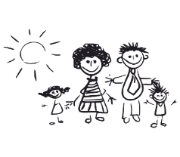

**Activity – Following workbook instructions, Part A & B**

Read each instruction slowly. Students follow and complete each instruction on their numbered table on page 55.

**Part A - Teacher instructions**

Instructions (to be read in no particular order)

1. Write the number **3** in the circle.
2. Write your **family name** on the line.
3. Copy the word **pencil***.*
4. Write **capital R** on the board.
5. Put a **tick** in the box.
6. Put a **cross** in the box.

|  |  |  |
| --- | --- | --- |
| **1** | **2** | **3** |
|  | Elmi . | pencil  pencil . |
| **4** | **5** | **6** |
|  |  |  |

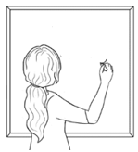

**R**

**🗸**

x



**Part B - Teacher instructions**

Instructions (to be read in no particular order)

1. Write number **1** in the **listen** box**.**
2. Write number 2 in the **read** box
3. Write number 3 in the **spell** box.
4. Write number 4 in the **circle** box.
5. Write number 5 in the **write** box.
6. Write number 6 in the r**epeat** box.

|  |  |  |
| --- | --- | --- |
| 4 | Diagram  Description automatically generated  3 | A picture containing hanger  Description automatically generated  5 |
| 1 | A picture containing text, weapon  Description automatically generated  6 | Icon  Description automatically generated  2 |

**Classroom instructions – Student**

|  |  |  |
| --- | --- | --- |
| **1** | ***2*** | ***3*** |
|  | ______________ | pencil  ____________ |
| **4** | **5** | **6** |
|  |  |  |

|  |  |  |
| --- | --- | --- |
|  |  |  |
|  |  |  |

**Computer instructions – Part 1**

* Print the keyboard on the following page, one for each student.
* Project the keyboard if possible, to guide the students
* Give the following instructions:

1. Write **left** in the box on the top left.
2. Write **right** in the box on the top right.
3. Circle these keys:

* 4
* 7
* Space bar
* Delete
* Enter /return
* Shift on the left
* Shift on the right
* The arrow to the left
* The arrow to the right
* The arrow going up
* The arrow going down
* Show students the finger to use on the mouse and   
  instruct students to follow these mouse movements on their table:

1. Click
2. Double click
3. Click and hold
4. Click, hold and drag down
5. Click, hold and drag up
6. Click, hold and drag to the left
7. Click, hold and drag to the right

Left

Right

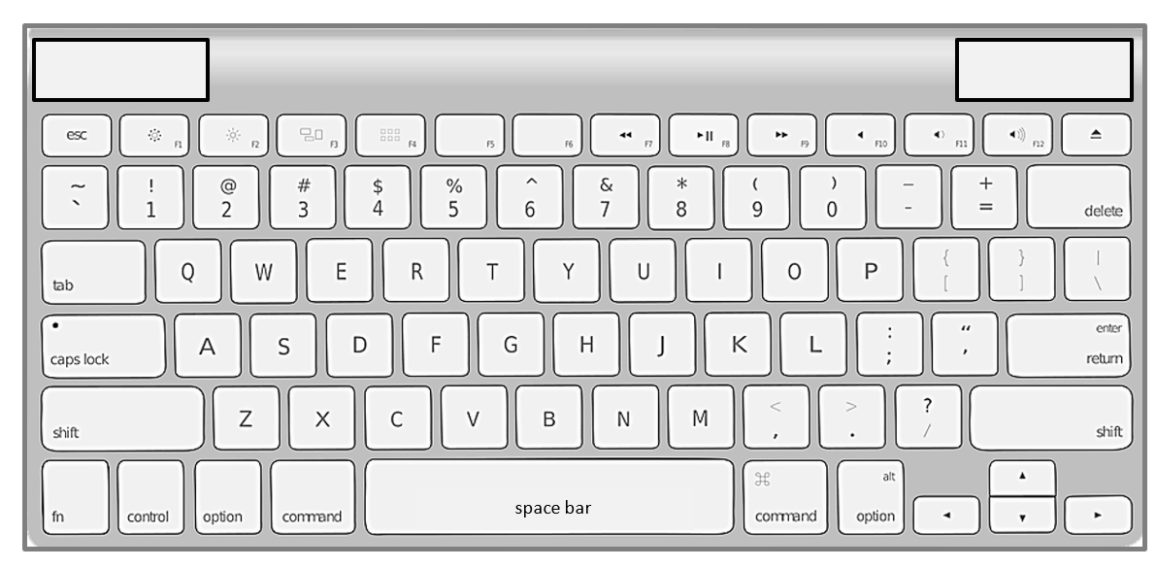

**Computer instructions – Part 2**

Print the icons and instructions on the following page. The first two activities below can be done in the classroom; the third requires access to computers.

1. **Syllable work**

* Draw a table on the board such as the one below
* Clap words with students
* Ask students to count the syllables

|  |  |  |
| --- | --- | --- |
| **1 syllable** | **2 syllables** | **3 syllables** |
| click | scroll down | double click |
|  |  |  |
|  |  |  |

1. **Concentration game**

* Cut up 2 sets of images,(Laminate if possible) enough for students to play in groups of 3 or 4.
* Students spread the cards face down on the table and take turns   
  to turn over 2 cards to find a match.
* If they find a match, they keep the pair and have another turn.  
  If they don’t find a match, the turn passes to the next student.

1. **Listening to Instructions**

* Write the instructions below on the board
* Read the instructions to the students
* Students listen and follow instructions.
* Ask a student to read an instruction. Students listen and follow.

|  |  |  |
| --- | --- | --- |
| 1. **Click** the mouse |  | **8. Press** Delete |
| 1. **Hold** your finger on the mouse | **9. Press** Enter |
| 1. **Hold** and **drag** your mouse | **10. Press** the space bar |
| 1. **Hold** and **scroll** down the page | **11. Hold** the **shift key** down and **type** a letter e.g. letter A |
| 1. **Left** click on your mouse | **12. Arrow** left |
| 1. **Type** your name | **13. Arrow** right |
| 1. **Press** Backspace |  |

|  |  |  |
| --- | --- | --- |
| **left click** | **double left click** | **scroll up**  **scroll down** |
| **hold** | **left click, hold and drag** | **type** |
| **Backspace**  **Backspace** | **Delete**  **Delete** | **Enter**  **Enter** |
| **space bar** | **Shift key**  **Shift** | **arrow left/ right** |

**Computer instructions**

# Learning in Australia

**Activity**

The pictures and text can be printed and then:

* Students cut them up and match them in pairs.
* Each student is given either a picture or the text. Students then find the student with the matching picture/text. This can be an alternative way for students to find a partner for pair-work.

|  |  |  |  |
| --- | --- | --- | --- |
|  | | | Excuse me.  What does this mean? |
|  | |  | |
| Do you understand? | | Sorry. I don’t  understand. | |
| **Thank you**.  Can you  help me **please**? | Good morning Alina.  Good morning Jenny. | | |

|  |  |
| --- | --- |
|  |  |
|  |  |

|  |  |
| --- | --- |
| Teachers and students  say please and thank you. | Students work  in groups. |
| Men and women  work together. | Students and teachers work together. |
| Students say,  Sorry. I don’t understand. | Students go on excursions. |
| The teacher says,  Do you understand? | Students study at home. |

|  |  |
| --- | --- |
| Teachers and  students use  their first names. | Students ask questions. |
| Students come to class on time. | Students work  with a partner. |